Face Recognition Based Real Time Attendance System Using Machine Learning

Prof. Ansar Sheikh¹, Nivedita Sanyal² ,Payal Ninawe³,Sanjana Waghe⁴,Shruti Waghmare⁵

Assistant Profesor¹, Dept. of CE
St.Vincent Pallotti College of Engineering & Technology, Nagpur, India,440024
Student^{2,3,4,5,} Dept. of CE,
St, Vincent Pallotti College of Engineering & Technology, Nagpur, India,440024

asheikh@stvincentngp.edu.in

Received on: 05May, 2024 Revised on: 03 July, 2024 Published on: 06 July, 2024

Abstract— In contemporary educational and workplaces are changing quickly these days, so it's important to have an easier way to track who shows up. This study explores a new system that uses special face- scanning technology to automatically take attendance. This technology focus on the implementation of the Haar cascade method, to revolutionize and optimize attendance management protocols. By harnessing the power of computer vision and machine learning, our system can accurately detect and recognize faces in real- time. The Haar-cascade method , known for its robustness and speed, serves as the backbone of our facial recognition algorithm, enabling rapid and accurate identification of individuals within a given dataset. Our system boasts a user-friendly interface, making it accessible and intuitive for both administrators and end-users. Through seamless integration into existing infrastructures, such as educational institutions or corporate environments, our solution offers a hassle-free approach to attendance recording. Furthermore, by automating the identification process, our system significantly reduces the likelihood of manual errors associated with traditional attendance tracking methods. This not only saves valuable time but also enhances overall accuracy and reliability. our attendance system utilizing face recognition technology and the Haar cascade method represents a cutting-edge solution for modern attendance management needs. With its efficiency, reliability, and user-friendly interface, our system promises to revolutionize the way attendance is tracked and managed across various sectors.
Keywords— Face-scanning technology, Haar cascade method, Computer vision, Machine learning, Real-time detection.
- INTRODUCTION
In today's fast-paced world, traditional methods of attendance tracking often fall short in terms of accuracy, efficiency, and security. To address these challenges, the integration of facial recognition technology into attendance systems has emerged as a cutting-edge solution. Leveraging the power of Python and advancements in computer vision, a Face Recognition Attendance System offers a robust and reliable means of accurately tracking attendance.
This innovative system operates by capturing and analyzing facial features of individuals to uniquely identify them. Python, with its extensive libraries such as OpenCV and dlib, provides a solid foundation for developing such applications. OpenCV offers tools for image processing and computer vision tasks, while dlib provides advanced recognition capabilities.
The process begins with the acquisition of facial data through a camera feed. The captured images are then preprocessed to enhance the quality and extract key facial features. Next, the system utilizes sophisticated algorithms to match the extracted features with those stored in a database. This database typically contains pre-registered facial templates of individuals associated with their respective identities.
Upon successful recognition, the system logs the attendance of the identified individual. This information can be stored locally or in a centralized database for further analysis and management. Additionally, the system may incorporate features such as real-time monitoring, notifications, and reporting functionalities to enhance its utility.
The benefits of a Face Recognition Attendance System are manifold. It eliminates the need for manual attendance marking, reducing administrative overhead and the likelihood of errors. Moreover, it provides a more secure means of authentication, mitigating issues of buddy punching or proxy attendance. Additionally, the system offers scalability, making it suitable for various environments ranging from educational institutions to corporate offices.
In this project, we will explore the implementation of a Face Recognition Attendance System using Python. By leveraging the capabilities of Python's libraries and techniques in facial recognition, we aim to develop a robust and efficient solution that revolutionizes traditional attendance tracking methods. Through this endeavor, we endeavor to showcase the power of technology in addressing real-world challenges and enhancing productivity in diverse settings.
A Haar cascade classifier is a machine learning-based object detection method used to identify objects in images or video streams. It operates by analyzing features extracted from images, such as edges, lines, and textures, through a series of predefined filters known as Haar-like features. These features are trained on large datasets to recognize specific patterns associated with the target objects. The classifier works by sliding a window over the image and applying these filters to detect the presence of the object within the window.

- LITERATURE REVIEW
Nirmalya Kar, Mrinal Kanti Debbarma, Ashim Saha, and Dwijen Rudra Pal. [1] have discussed about this paper
describes a method for Student’s Attendance System which2 will integrate with the face recognition technology using Personal Component Analysis (PCA) algorithm.

Ajinkya Patil, Mrudang Shukla [2] they are using face detection & face recognition system.The Raspberry pi module is used for face detection & recognition. The camera will be connected to the Raspberry pi module.The database includes name of the students, there images & roll number. This raspberry pi module will be installed at the front side of class in such a way that we can capture entire class.
Abhishek Jha [3] The system described in this paper aims to deviate from traditional systems and introduce a new approach to identify a student using a face recognition system i.e. the generation of a 3D Facial Model ,an Automated Attendance System in a classroom environment.

Akshara Jadhav, Akshay Jadhav Tushar Ladhe, Krishna Yeolekar [4] They have used Viola-Jones Algorithm face detection which detect human face using cascade classifier and PCA algorithm for feature selection and SVM for classification. When compared to traditional attendance marking this system saves the time and also helps to monitor the students.
Mayur Surve, Priya Joshi, Sujata Jamadar, Minakshi Vharkate [5] In this paper, RFID cards and fingerprint scanners are used. RFID cards and fingerprint scanners are physical options, while face recognition software offers a camera-based solution. This software uses techniques like the Haar cascade algorithm to identify students and combat proxy attendance.
Samridhi Dev , Tushar Patnaik [6] ,In this proposed system Haar cascades are used for face detection and generative adversarial networks for image amelioration and for feature extraction Gabor filters were used. For face recognition, different algorithms were used. These algorithms have been compared on the grounds of time complexity accuracy in various conditions
Sakshi Patel , Prateek Kumar, Shelesh Garg, Ravi Kumar
[7] This system have openCV, face recognition, STMP, Raspberry pi3 for the implementationof the robust and automated face recognition system for smart attendance.

- METHODOLOGY
We have created GUI to mark the attendance of the students. To develop the live attendance system, some steps are required to be followed for accomplishing this task successfully. The steps can be defined in the following ways:
- Initialization
- Loading Face Images
- Encoding Faces
- Creating Widgets
- Marking Attendance
- Updating the GUI
- Conversion of Image to PhotoImage
- Initialization:
The program starts by initializing the user interface using the tkinter library, setting up the window and its title.Additionally, it establishes a connection to a MySQL database named "attendance_system" to store attendance data.
- Loading Face Images:
The application loads face images from a specified directory, likely containing images of students or individuals enrolled in the class.
These images are converted into numerical arrays using numpy, which is a standard numerical computing library in Python.
- Encoding Faces:
After loading the face images, the program utilizes the face_recognition library to encode the facial features of each individual.
This encoding process generates numerical representations of facial features, which are used for comparison during face recognition.
- Creating Widgets:
The application creates graphical user interface (GUI) elements, such as a canvas for displaying the webcam feed and a button for marking attendance. These widgets are essential components for user interaction with the attendance system.
- Marking Attendance:
When the user clicks the "Mark Attendance" button, the program captures the current frame from the webcam.
It then identifies faces in the captured frame and compares them with the encoded face images to recognize individuals.
If a recognized face is detected and not already marked for attendance, the program records the individual's name along with the current timestamp in the database.
- Updating the GUI:
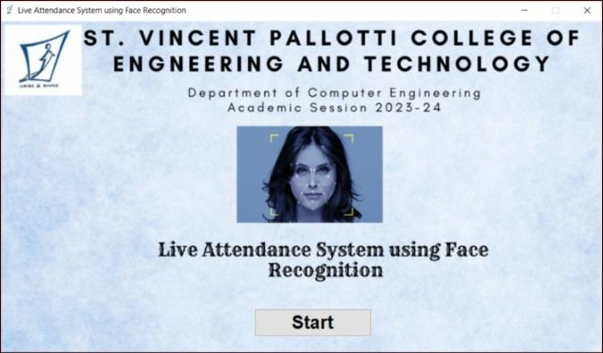
This step involves continuously updating the GUI to provide real-time feedback to the user.
The program captures frames from the webcam, detects faces, and overlays graphical elements such as rectangles around recognized faces and labels with the detected names.
These updated frames are displayed on the tkinter canvas to provide visual feedback to the user.
- Conversion of Image to PhotoImage:
Before displaying images on the tkinter canvas, the program converts them from OpenCV format to PIL Image format and then to Tkinter PhotoImage format.
This conversion ensures compatibility and proper display of images within the GUI.
- Main Loop:
Finally, the program enters the main event loop using root.mainloop(), which continuously listens for user input and updates the GUI accordingly.

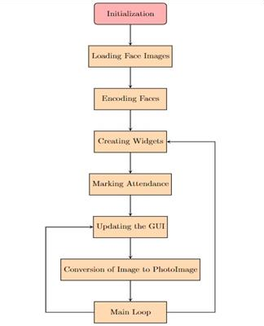
This loop ensures the smooth operation of the tkinter application, allowing users to interact with the attendance system seamlessly.

Fig 1. Working of Attendance system

- RESULT

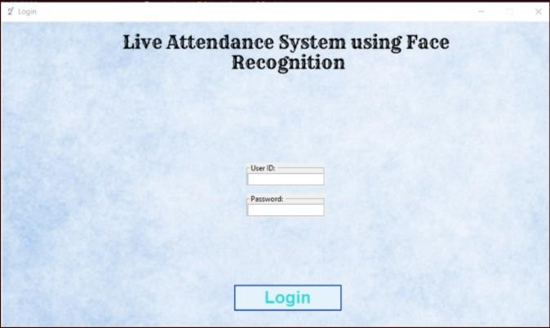
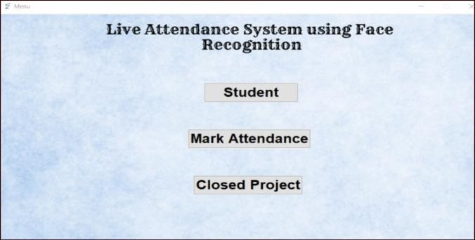
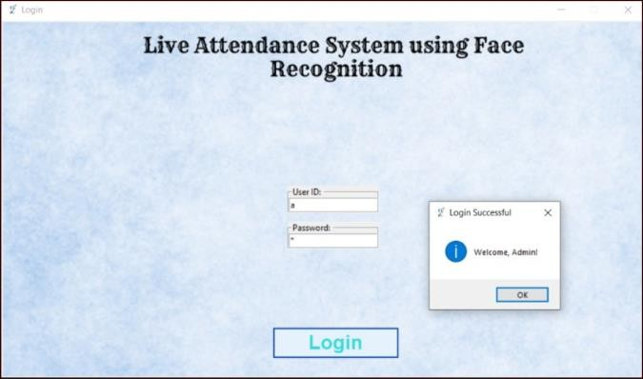
Fg 3. Login Page

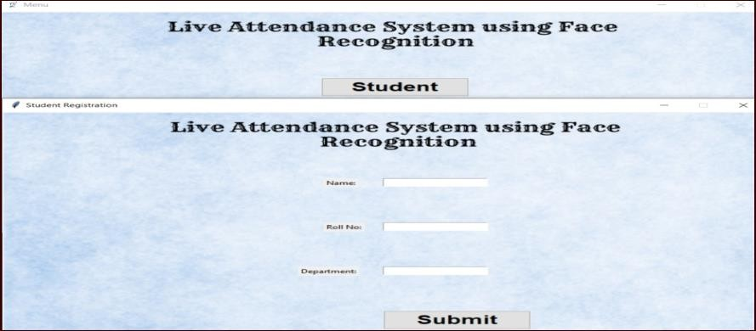

Fig 4. Attendance Management System

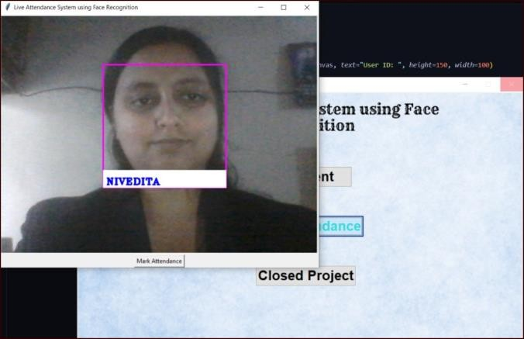

Fig 6. Marking Attendance

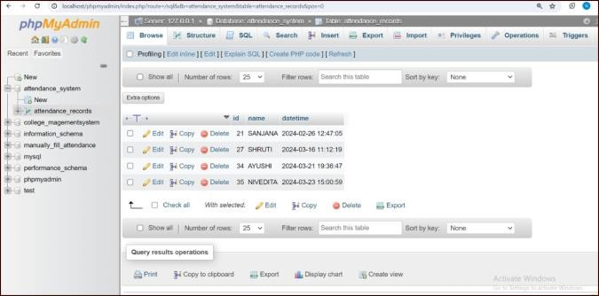

Fig 7. Storing Attendance in Database

- CONCLUSION

In conclusion, the implementation of a face recognition attendance system using a Haar Cascade classifier provides a simple yet effective solution for automating attendance management processes. Despite its simplicity, the Haar Cascade classifier offers decent accuracy in detecting and recognizing faces in images or video streams. This system's advantages include its ease of implementation, low computational requirements, and real-time processing capabilities. While it may not match the accuracy levels of more advanced face recognition algorithms, the Haar Cascade-based approach remains a viable option for scenarios where real-time performance and simplicity are prioritized over intricate feature detection. With its straightforward implementation and reliable performance, the Haar Cascade-based face recognition attendance system serves as a practical solution for organizations and educational institutions seeking to streamline attendance tracking processes.
In future developments, the implementation of facial recognition technology and the Haar cascade method in attendance management systems could explore several avenues for improvement and innovation. Firstly, efforts could be directed towards enhancing security features to fortify the system against potential vulnerabilities or spoofing attempts, possibly through the integration of multi-factor authentication or liveness detection mechanisms. Secondly, scalability considerations should be addressed to ensure the system can efficiently handle larger datasets and accommodate growing user bases without compromising performance or accuracy.

REFERENCES

- Nirmalya Kar, Mrinal Kanti Debbarma, Ashim Saha, and Dwijen Rudra Pal,” Study of Implementing Automated Attendance System Using Face Recognition Technique”, International Journal of Computer and Communication Engineering, Vol. 1, No. 2, July 2012, PP-100-103.
- Ajinkya Patil, Mrudang Shukla,” IMPLEMENTATION OF CLASSROOM ATTENDANCE SYSTEM BASED ON
FACE RECOGNITION IN CLASS”,International Journal of Advances in Engineering & Technology, July, 2014,Vol. 7, Issue 3, pp. 974-979.
- Abhishek Jha ,”Class Room Attendance System Using Facial Recognition System”The International Journal of Mathematics, Science, Technology and Management Vol. 2 Issue 3,pp. 4-7.
- Akshara Jadhav, Akshay JadhavTushar Ladhe, Krishna Yeolekar,”AUTOMATED ATTENDANCE SYSTEM
USING FACE RECOGNITION” International Research Journal of Engineering and Technology (IRJET) ,Volume: 04 Issue: 01 | Jan -2017, pp.1467-1471.
- Mayur Surve, Priya Joshi, Sujata Jamadar, Minakshi Vharkate ,”Automatic Attendance System using Face Recognition Technique”,International Journal of Recent Technology and Engineering (IJRTE) ISSN: 2277-3878 (Online), Volume-9 Issue-1, May 2020,pp.2135-2138.
- Samridhi Dev , Tushar Patnaik , “Student Attendance System using Face Recognition”, Proceedings of the International Conference on Smart Electronics and Communication (ICOSEC 2020),pp. 90-97.
- Sakshi Patel , Prateek Kumar, Shelesh Garg, Ravi Kumar ,”Face Recognition based smart attendance system using IOT “International Journal of Computer Sciences and Engineering,Vol.-6, Issue-5, May 2018 , pp.871-877.
- Siti Ummi Masruroh , Andrew Fiade ,melda Ristanti Julia ,”NFC Based Mobile Attendence System with Facial Authorization on Raspberry pi and cloud server”, The 6th International Conference on Cyber and IT Service Management (CITSM 2018) Inna Parapat Hotel – Medan, August 7-9, 2018.
- Naveed Khan Balcoh, M. Haroon Yousaf, Waqar Ahmad and M. Iram Baig,” Algorithm for Efficient Attendance Management: Face Recognition based approach”, IJCSI International Journal of Computer Science Issues, Vol. 9, Issue 4, No 1, July 2012,pp. 146-150.
- Yohei KAWAGUCHI Tetsuo SHOJI Weijane LIN Koh KAKUSHO Michihiko MINOH ,” Face Recognition- based Lecture Attendance System”, Department of Intelligence Science and Technology, Graduate School of Informatics, Kyoto University, Academic Center for Computing and Media Studies, Kyoto University,pp.1-5.
[11] Chandrashekhar Goswami, Amit K Gaikwad, Ansar Sheikh, Swapnil Deshmukh, Jayant Mehare, Shraddha Utane "Study of Key Agreement Protocol Implementation in Constraint Environment" International Conference on Information and Communication Technology for Competitive Strategies Springer Nature Singapore,16 March 2024.

