Intellichair: A Smart Wheelchair
Ankita Ghavghave¹, Arti Wagh², Abhishek Shudhalwar³, Maitreya Kale⁴
Department of electronics Engineering, ycce, Nagpur^{1,2,3,4}
ghavghaveankita76@gmail.com¹, wagharti1997@gmail.com², Abhishudhalwar@gmail.com³ , maitreyakale97@gmail.com⁴

Abstract:
According to WHO (World Health Organization) the peoples with disabilities are nearly 10% of world’s population. That roughly 650 million peoples globally lives with disabilities. Also 82% of peoples are becomes disabled at their later age (old age). So to take care of such disabled persons one needs to be there with them always. For such peoples a powered wheel chair is a mobility-aided device. In order to take care for different disabilities, various kinds of interfaces have been developed for powered wheelchair control, such as joystick control, head control and sip-puff control. Many people with disabilities do not have the ability to control powered wheel chair using the above mentioned interfaces and also this is so expensive that the common peoples can’t take its benefits. So we are trying to provide the cutting-edge solution in the form of eye movement based wheelchair. One of the main goals for Eye Movement controlled wheelchair is to enable completely paralyzed patients to make their life more accessible and to provide them more opportunity of independence and movement. The image of the eye is captured by the camera and is given to the PC. Here after doing image processing the decision is made on the basis of the location of eye (pupil) and accordingly the chair is moved.
I. Introduction:
The ability to move freely is highly valued by all people. However, it is sometimes difficult for a person with a physical disability to move. The great scientist Stephen Hawking who was inspite of being paralysed, discovered many things which proved to be backbone for the modern science. This shows physical disability is not an obstacle for gaining great heights of success. This example is main source for our motivation. Through this project activity we wish to apply contextual knowledge of related domains to help the society and handle consequent responsibilities towards society, relevant to our professional engineering knowledge. Hence for aiming to provide a novel way to develop wheelchair to enable a disabled person so that they can enjoy a higher quality of life. These method uses the movement of pupil and iris of the eye as the input, then according to the direction of the eye movement the wheelchair moves in that particular direction. The transmitting module capture the image and transmit to the pc/laptop for further processing. The captured signal is processed and analysis is done on the basis of previous data stored within a memory and the decision (output) is given to the next block. The processor of the Arduino will take an output from the laptop and convert the digital output to electric signals that will be sent to the wheelchair wheels for movement.
Block Diagram:
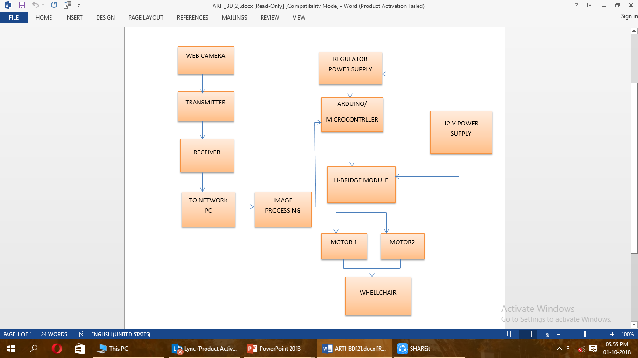
Fig 1: Basic block diagram of Intellichair: A smart wheelchair.
II. METHODOLOGY:
- Image capture and image Processing

- Image capture: Image is captured using webcam the image resolution is 640x480, skipping 30 frames to get image. After image is captured the image is send to the PC/LAPTOP through raspberry pi.
- Image processing: Image after given to the LAPTOP/PC it is first read by the MATLAB software. After this the eye portion from the complete image is segmented out. This segmented portion is turn into the black and white image (i.e. Grayscale image). The particular threshold is set to identify the position of the pupils. Now again the position of the pupil is compared with the threshold value to know the position of eye (pupil). This position of the eye is stored in the output variable as result of image processing.
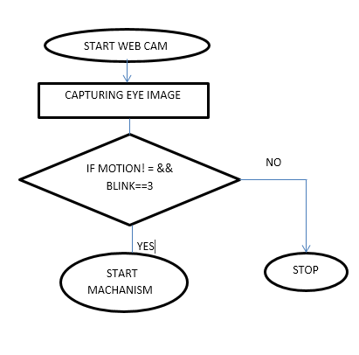
Fig 2: Flowchart of working in A Smart Wheelchair.
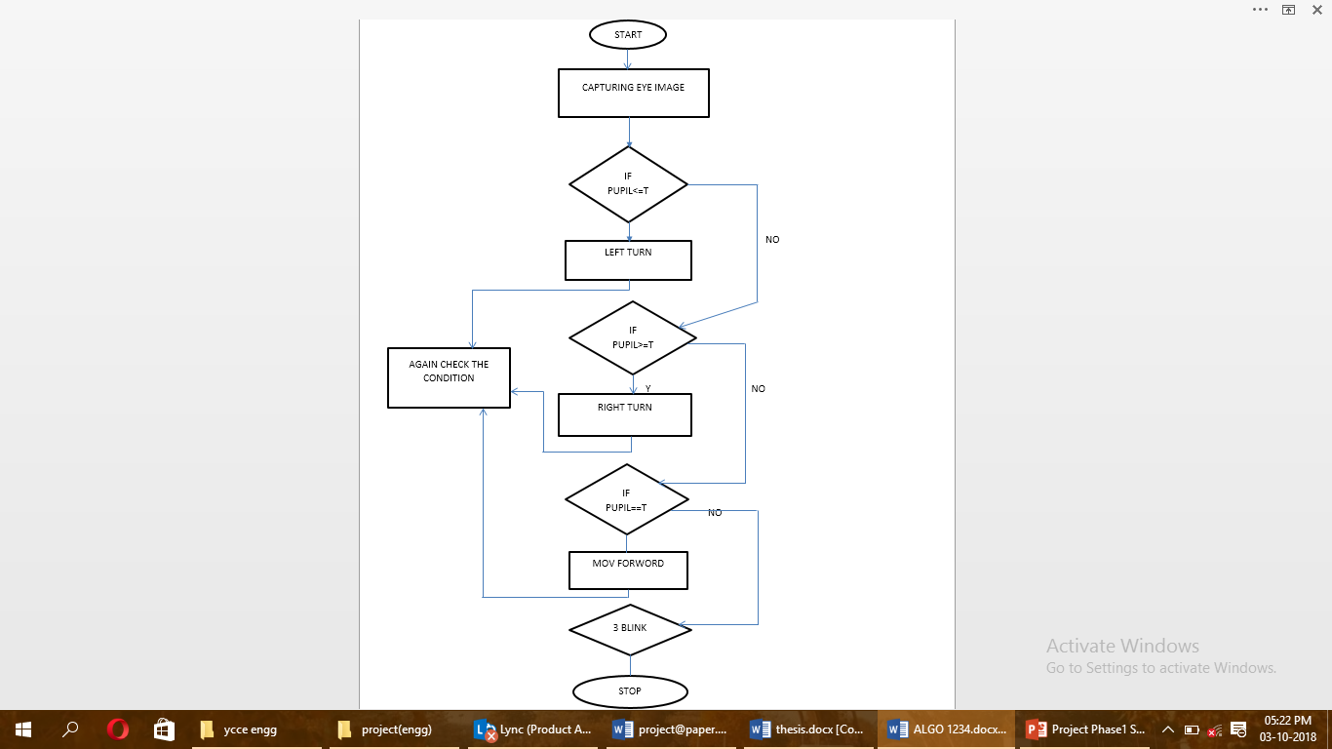
Fig 3: Flowchart of image processing in A Smart Wheelchair.

B. Data Transmit to PIC:
The data stored in the output variable is transmitted to the PIC CONTROLLER for further processing. Here the PIC uses the Detected position of eye and accordingly the decision will be taken by the processor and it convert the digital output to electric signals that will be sent to the wheelchair wheels for movement. For the movement of the wheels the H bridge principle is use.

C. Motion of the wheelchair:
According to the digital output of the MATLAB the PIC will generate the instructions. The PIC will control the wheels of the wheelchair by actuating the L298D IC which is embedded in the H bridge module. The H bridge module will control the wheels of the wheelchair according to the instructions given by the PIC CONTROLLER.

III. DESIGN IMPLEMENTATION

Table 1: Components used in project
Component | Specification
RF Module | - Some of the most exciting BASIC Stamp applications can be accomplished with Radio  - Frequency (RF) transmitters and receivers.  - The best part is that RF communication is all around! Every time you listen to the radio, use a cell phone, or watch television, RF transceivers are at work.  - RF communication uses radio waves instead of wires for exchanging signals, which is where the name “wireless communication” comes from.  - RF modules use frequencies (measured in Hz) to distinguish different radio signals, so in order  - for RF modules to “talk”, they must be operating on the same frequency.  - This activity uses the 433 MHz Parallax RF Transceiver modules.
Camera | - 5MP Omnivision 5647 Camera Module  - Still Picture Resolution: 2592 x 1944  - Video: Supports 1080p @ 30fps, 720p @ 60fps and 640x480p 60/90 Recording  - 15-pin MIPI Camera Serial Interface - Plugs Directly into the Raspberry Pi Board  - Size: 20 x 25 x 9mm  - Weight 3g
PIC MICROCONTROLLER | - It has RISC architecture.  - It contain ROM of size 2Mb.  - It has On chip program ROM in the form of flash memory.  - It contain RAM between 256 bytes to 4096 bytes.  - It has Data EEPROM (Electrical Erasable Programmable Read Only Memory).  - It include Timers.  - It has ADC.  - It include USART PROTOCOL for PC communication.  - It contains I/O port between 16 to 72 pins.  - All I/O port register are bit accessible and port accessible both.  - It include SPI PROTOCOL and I2C PROTOCOL for memory communication.
DC Motors | - Output Power: 250 Watt.  - For Chain Size: Pitch 0.5in.  - Roller Diameter 0.3in.  - Roller Width 0.16in.  - Torque Constant: 8 N.m (80 kg-cm).  - Torque stall: 40 N.m (400 kg-cm)

IV. OBSERVED OUTCOMES OF PROJECT:

- First the position of the eye is captured by the camera and converted to the grayscale.
- Eye position is extracted from the image.
- According to the eye position the instructions are given to the Arduino.
- Distance between the eye and the camera is 38-42cm.

V. CONCLUSION

EYE MOVEMENT BASED WHEELCHAIR can detect the eye movement with the performance that is high enough and accordingly the wheelchair makes its motion. The wheelchair we developed is more useful for the patient who paralyzed from waist down and even can’t move their finger. This wheelchair can be controlled in many languages with any prior training and there is not limitation of number of commands.

ACKNOWLEDGMENT
WE WOULD LIKE TO EXPRESS OUR GRATITUDE TO ALL THE FACULTY MEMBERS AND SENIORS WHO HELPED US DURING THE RESEARCH.

REFERENCES
[1]. YUN-HAI ZOU, JING WEN, HAO-YANG XING*, YU ZHU RAPID EYE MOVEMENT TRACKING METHOD BASED ON FPGA, Proceedings of the 2016 International Conference on Machine Learning and Cybernetics, Jeju, South Korea, 10-13 July, 2016
[2]. Navpreet Kaur Review of Face Recognition System Using MATLAB, International Journal of Computer Science Trends and Technology (IJCST) – Volume 4 Issue 3, May - Jun 2016
[3]. E.D.CoFle ELECTRONIC WHEELCHAIR CONTROLLER DESIGNED FOR OPERATION BY HANDOPERATED JOYSTICK, ULTRASONIC NON-CONTACT HEAD CONTROL AND UTTERANCE FROM A SMALL WORD-COMMAND VOCABULARY.
[4]. Q.X. Nguyen and S. Jo, Electric wheelchair control using head pose free eye-gaze tracker‘, Electronics Letters, Vol. 48 No. 13, 21st June 2012.
[5]. K. T. V. Grattan, A. W. Palmer, and S. R. Sorrell, ‗Communication by Eye Closure-A Microcomputer-Based System for the Disabled‘, IEEE Transactions on Biomedical Engineering, Vol. BME-33, No. 10, October 1986.

