Kitchen Closet Automation(KCA)
Trupti Hagawane¹, Dr. Anjali S. Bhalchandra²
¹Assistant system Engineer- Trainee,
TATA Consultancy Services, Nagpur, India, 441108
²Assistant Professor, Professor
Government college of Engineering,Aurangabad, India, 431005

Abstract –This project deals with the advancement in automation technology. Home automation is no longer limited to simply switching appliances on/off with a remote control. The Internet of Things (IoT) has taken home automation to the next level. IoT based smart kitchen systems can monitor and control home appliances from anywhere in the world using the Internet. IoT is playing important role in industries, organizations, smart home for remote switching applications.
An attempt has been made to implement concept of IoT based smart kitchen is for household operations smart kitchen. Smart kitchen is a completely automated kitchen closet designed for easy access of ingredients to anyone in the kitchen. It includes Android application for selection of a particular ingredient on app and checking the level of each ingredients whether it is about to deplete or not.This is of great help while preparing the grocery list. The Smart Kitchen mobile application allows us to create a list within itself and send it to a shopkeeper using SMS or whatsapp or any messaging medium.
Keywords- Internet of things(IOT), Kitchen Closet Automation(KCA).
1. INTRODUCTION

Present scenario of IoT application in home appliances technology have brought a sea change in human life. The present day society is moving towards the adaptation of the digital environment. The earlier ‘internet of computers’ transformed into ‘internet of people’ by introduction of social websites.

The further advancement of this technology is the ‘Internet of Things’ through which, the interoperability and intelligence can be achieved. Many companies are making ventures into the field with internet connected kitchen appliances, clothing, home security systems.This is possible through communication between certain devices that are connected through the internet, wireless sensor networks (WSN) and smartphones. These devices in the system are able to perceive, process and deliver the product as per the programming. The technologies such as RFID, WSN, Cloud Computing, Networking Technology and Nanotechnology have been used. The applications of IoT can be observed in number of areas such as kitchen, agriculture, health, and so on. Generally these are prefixed by the word “smart”, Ex. Smart Kitchen.
2. METHODOLOGY
The Smart kitchen is a completely automated kitchen closet designed for easy access of ingredients to anyone in the kitchen. With so many ingredients, it is always difficult to remember which ingredient is placed where, especially if one doesn’t use them often. The Smart kitchen closet lets the user choose and locate the ingredient. This is particularly very useful for senior citizens and for people with back problems like Spondylitis. It is also useful for the user to locate the required container because the required container comes forward on the request of the user. This feature saves time of the user to locate the particular ingredient from multiple ingredients. In the Smart kitchen Android application, on selection of a particular ingredient on app the particular ingredient appears in front of the user.
Fig. Design model of KCA.
Another feature of the Smart kitchen closet is its Smart Container. The containers used in the Smart Kitchen are designed to measure the level of ingredients in them. The level of ingredients is continuously updated on the IoT platform (ThingSpeak cloud server) and thus the user can know from any place what quantity of ingredient is available at any instant on the mobile application. This is of great help while preparing the grocery list. It also notifies the user if quantity of any ingredient has reached below the minimum set limit. Thus, the user will always know in advance which food item is to be bought before it is over. The Smart Kitchen mobile application allows us to create a list within itself and send it to a shopkeeper using SMS or whatsapp or any messaging medium.
Further in order to save the time of the user a Google Assistant Voice recognition system is used in the application, since in a hurry if the user needs to request the closet, from a distance for a particular ingredient to come forward before he/she covers the distance. This feature would save the time of the user since the required container is available already.
We can also control various kitchen appliances using Smart Kitchen application (eg: refrigerator, lights, microwave etc.)
3. DESIGN
The smart kitchen is installed with all computing system to exhibit smart behavior based on sensors, actuators and interactive devices that are built in or embedded with in the household articles such as dinning set, refrigerators, cooking range, coffee machine, oven , sink and so on. The integral components of the computing system will sense and model contextual information and apply it for providing smartservices for a chosen application.
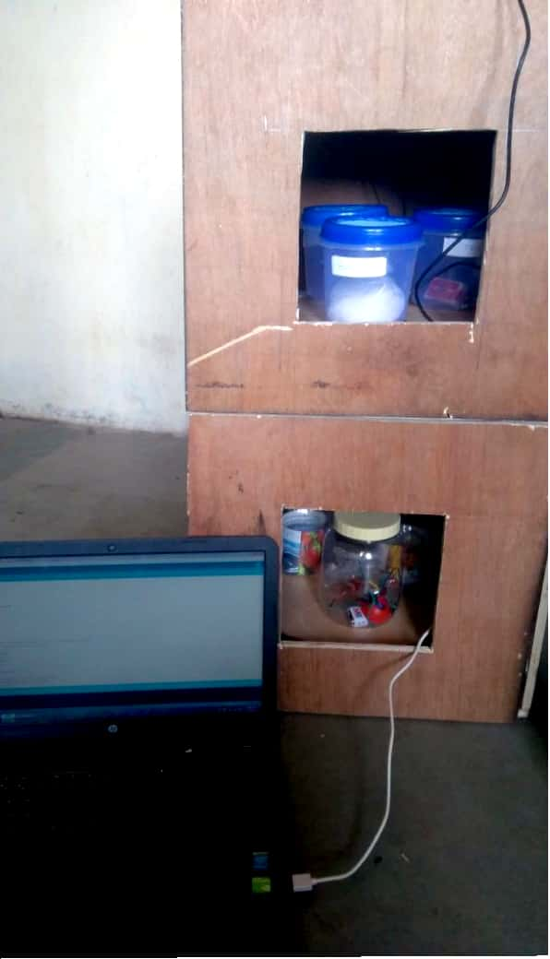
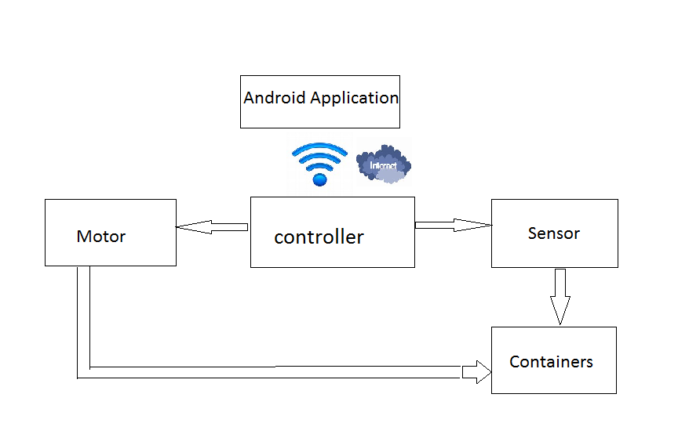
Fig. Block diagram of KCA.
Nodemcu is an open source IoT platform. It includes firmware which runs on the ESP8266 Wi-Fi SoC from (Espressif Systems, and hardware which is based on the ESP-12 module. Ultrasonic sensors are used in smart kitchen to monitor the level of ingredients in a container. Stepper motor is used to move the containers forward when clicked on application.
ThingSpeak is an open source Internet of Things (IoT) application and API to store and retrieve data from things using the HTTP protocol over the
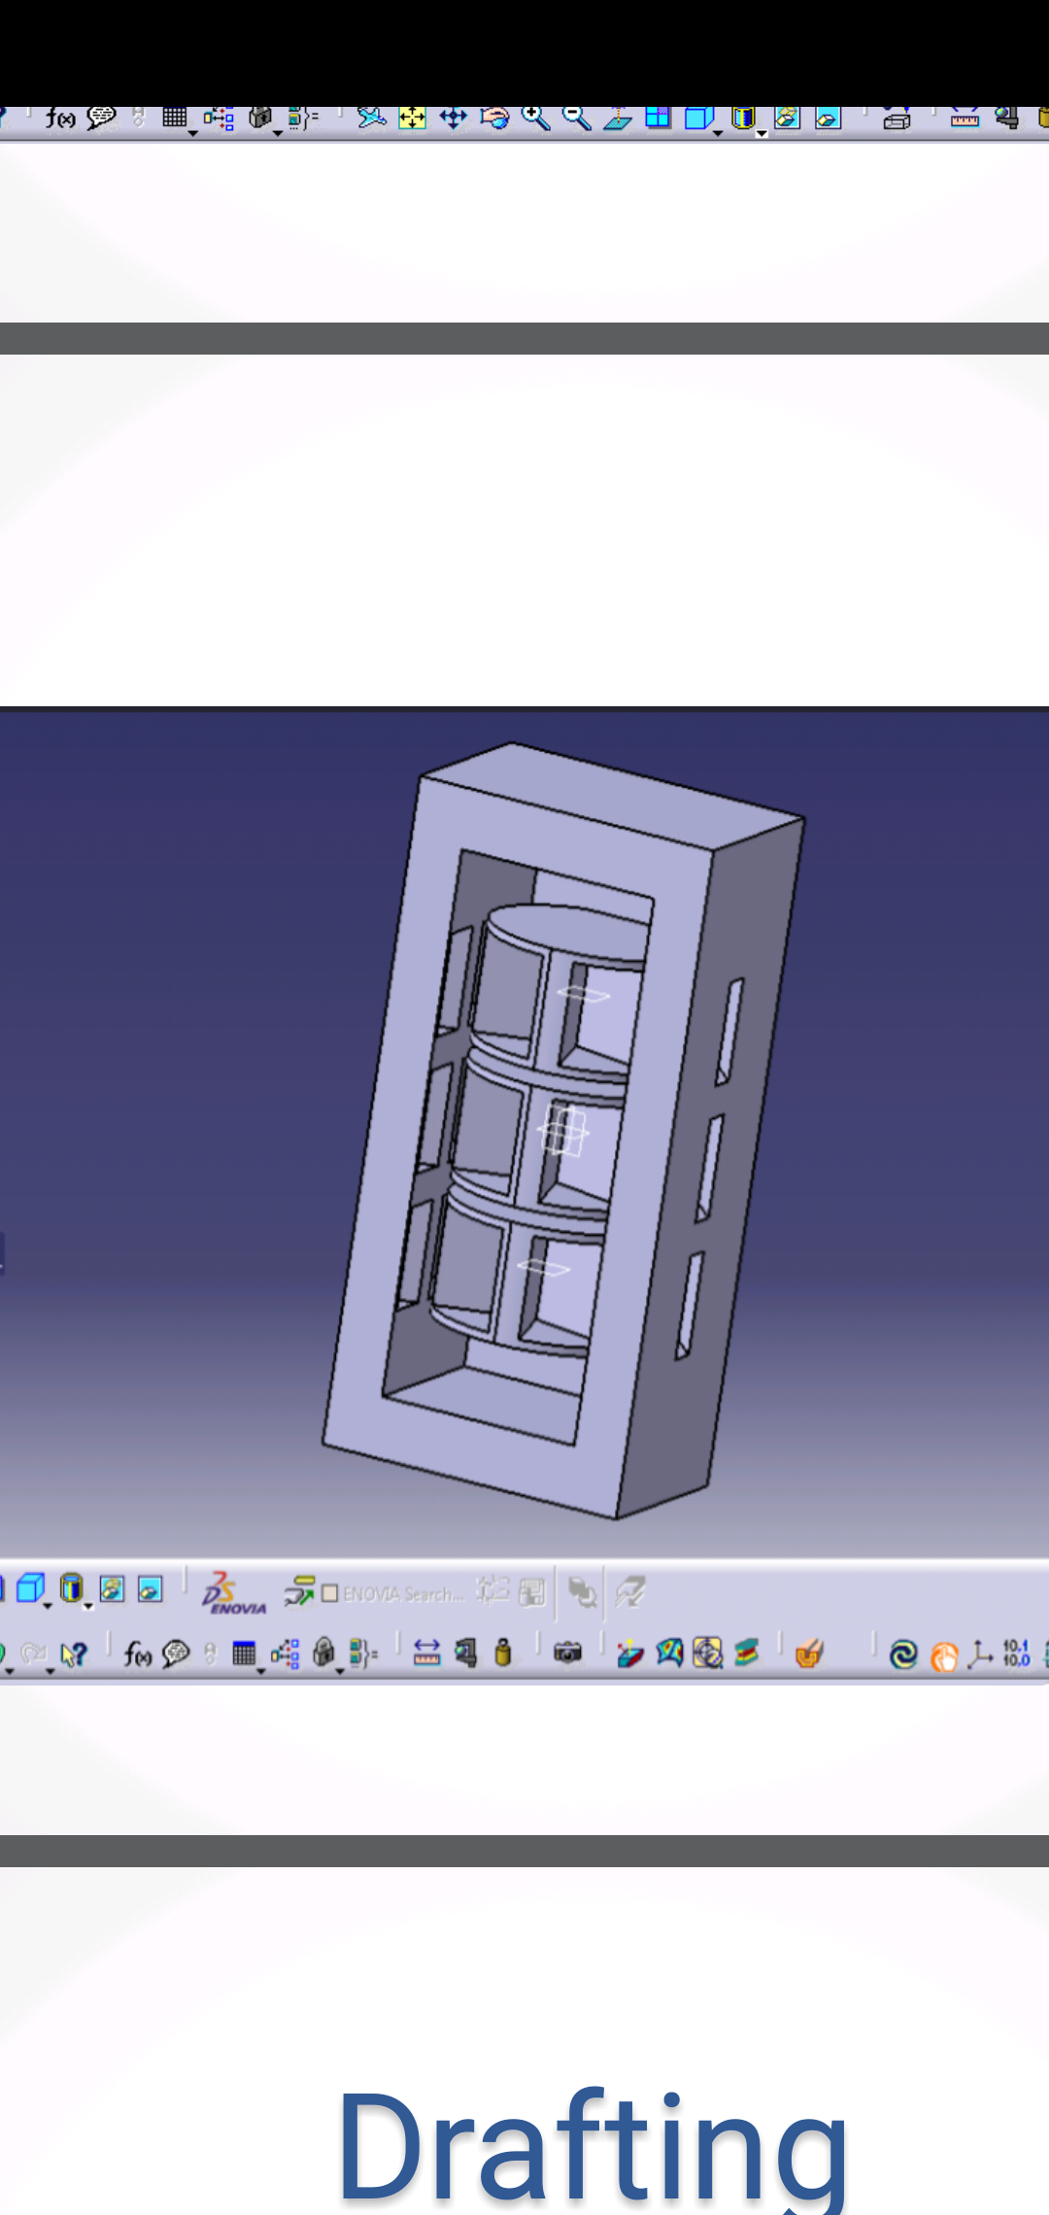

Fig. AutoCAD model of KCA.
Internet or via a Local Area Network. ThingSpeak enables the creation of sensor logging applications, location tracking applications, and a social network of things with status updates. Ultrasonic Sensor’s data uploaded on the Thingspeak and that data is fetched to android application.
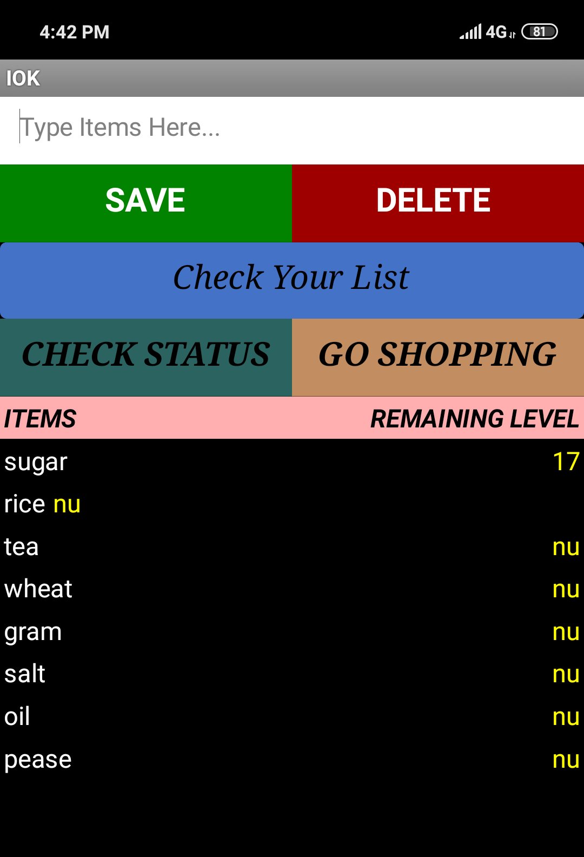
App Inventor for Android is an open-source web application originally provided by Google and maintained by Massachusetts Institute of
Fig. Android Application.
Technology (MIT). It uses a graphical interface, very similar to scratch and StarLogo TNG user interface, which allows users to drag and drop visual objects to create an application that can run on Android devices.
4. CONCLUSION
The internet of things is a system in which number of objects are interconnected over the internet which can perceive the data and transmit and receive information. It is made possible by low voltage, low cost components and sensors that can be added to appliances. The different applications of IoT in Kitchen ranks the highest when compared with other domains.
The Smart Kitchen Closet is portable and can be customized according to the needs of the user. They are very user-friendly and can be used by anyone in the kitchen. With the increasing pace of life and decrease in the availability of labour, these IoT based Home Assistants will make home management easy for everyone, especially the working women or the ones working in busy kitchens (eg. restaurants).

5. ACKNOWLEDGMENT
I would like to express gratitude toward people who have provided guidance in the generation of the paper. I would like to thank my guide Dr.A.S.Bhalchandra for her guidance, support and enthusiasm.

6. REFERENCES
- Home Automation & Wiring (1 ed.). New York: McGraw-Hill/TAB Electronics. 1999-03-31. ISBN 9780070246744.
- www.internet-of-things.com
- www.iot-analytics.com/10-internet-of-things-applications[1].
- Abreu, Vilmar; Santin, Altair; Xavier, Alex; Lando, Alison; Witkovski, Adriano; Ribeiro, Rafael; Stihler, Maicon; Zambenedetti, Voldi; Chueiri, Ivan (2018). "A Smart Meter and Smart House Integrated to an IdM and Key-based Scheme for Providing Integral Security for a Smart Grid ICT". Mobile Networks and Applications. 23 (4)
- www.itu.int/dms_pub/itu-t/oth/0b/15/T0B150000153301PDFE.pdf[1]
- www.design.ils.org.tw/IS-1216E_Smart_home_t_4103.pdf[3]
- Hill, Jim (12 September 2015). "The smart home: a glossary guide for the perplexed". T3. Retrieved 27 March 2017.

()

