Experimental Investigation of Auto Tracking Solar Operated Air Cooler with Cooling Cabin

Harsha G. Nathjogi¹, Tushar A. Koli², Vijay H. Patil³

¹P.G. Student, Department of Mechanical Engineering,
Godavari College of Engineering, Jalgaon, India.
² Assistant Professor, Department of Mechanical Engineering,
Godavari College of Engineering, Jalgaon, India.
³Associate Professor and HOD, Department of Mechanical Engineering,
Godavari College of Engineering, Jalgaon, India.

Abstract: Energy saving mechanism is the reason of project that led to design, develop and build a new solar energy feed air cooler unit with low power consumption. Solar Energy is stored in the battery and used to run the system. The present air cooling systems are dehumidifier, evaporating coolers. But using these products required a source called electricity and the production of electricity is responsible for very hot and humid condition like global warming. In very hot and extreme humid condition there is a need to feel relaxed, cool and comfortable so it has become one of the few needs and for this purpose the use of systems like air cooler and conditioners has increased rapidly. Solar powered systems are considered as one of the system having efficient energy. This technology can efficiently serve large and greatly improve indoor air quality by providing more ventilation while tightly controlling humidity. The design tracker has precise control mechanism which will provide the controlling system.
Keywords: Solar energy, Centrifugal fan,Solar battery,air cooler, global warming, humidity.

1 - INTRODUCTION

Energy is the prime factor for the development of a nation an enormous amount of energy is extracted, distributed, converted and consumed in the global society daily. 85% of energy of the fossil fuels are limited and their use results in global warming due to emission of greenhouse gases. To provide a sustainable power production and safe world to the future generation there is a growing demand for energy from sources like solar, wind, ocean tidal wave.
The sun is the prime source of energy, directly or indirectly, which is also the fuel for most renewable systems. Among all renewable system, photovoltaic system is the one which has a great chance to replace the conventional energy resources.India is a tropical country in which most of the region experience very low temperature during the winterand very high temperature during the summer seasons. The present air cooling methods are evaporative coolers, air conditioning, fans and dehumidifiers. But running these products need a source called electricity. The producing of electricity is ultimately responsible for hot and humid conditions, i.e., global warming. Need of such a source which is abundantly available in nature, which does not impose any bad effects on earth. There is only one thing which can come up with these all problems is solar energy.
Evaporative cooling is the process bywhich the temperature of a substance is reduced due to the cooling effect from the evaporation of water. The conversion of sensible heat to latent heat causes a decrease in the ambient temperature as water evaporated provide useful cooling. This cooling effect has been used on various scales from small space cooling to large industrial applications. As water evaporates, it draws energy from its surroundings which produce cooling effect. Evaporative cooling occurs when air, that is not too humid, passes over a wet surface so that the faster the rate of evaporation the greater the cooling and the efficiency of an evaporative cooler depends on the humidity of the surrounding air. Dry air can absorb moisture faster and no cooling occurs in the extreme case of air that is totally saturated with water. Generally, an evaporative cooler is made of a porous material that is fed with water. Hot, dry air is drawn over the material. The water evaporates into the air raising its humidity and at the same time reducing the temperature of the air. For better human comfort, cooling of living or work environment is vital in tropical climates. Researches carried out till date in evaporative air cooling process focus mainly on reducing the dry bulb temperature of the incoming air. Theoretical efficiency of 100% can be realized when dry bulb temperature of the room is equal to wet bulb temperature of the outside ambient air; Evaporative cooling efficiency is defined as the ratio between drop in dry bulb temperature across the cooler and the difference between inlet DBT and inlet WBT. Many researchers have worked on improving evaporative cooling efficiency to the maximum possible extent.

2 -COMPONENTS OF THE MODERN SOLAR AIR COOLER SYSTEM

The set-up consisted of the following components:
- Exhaust Fan
- Motor
- DC pump
- Cooling Pad
- Cooling Cabin
- Body frame
- Dehumidifier
2.1Exhaust Fan:
Air cooling systems in Cooler most commonly rely on forced air. Forced air is passed through cooling elements and circulated to the desired locations. Exhaust Fan provides this air movement. Blower Fan Fan efficiency is the ratio between the power transferred to the air stream and the power delivered by the motor to the fan. The power of the airflow is the product of the pressure and the flow, corrected for unit consistency. Another term for efficiency that is often used with fans is static efficiency, which uses static pressure instead of total pressure in estimating the efficiency. When evaluating fan performance, it is important to know which efficiency term is being used. The fan efficiency depends on the type of fan and impeller. As the flow rate increases, the efficiency increases to certain height.
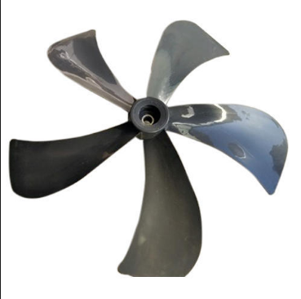
Fig 1: Fan

2.2 DC Motor:
Feature:
- Easy to maintain
- Elevated Performance
- Easy Handling

Specifications:
- Size: 8mm
- Material Use: Aluminum Winding
- Usage: Cooler Motor
- Speed (RPM) : 3000

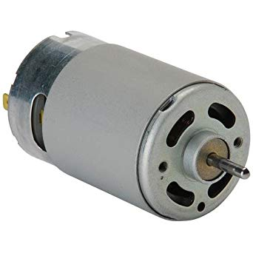
Fig 2: Motor

Application:
- Desert Cooler,
- Climate Cooler,
- Double Blower Cooler,
- Single Blower Cooler

Speed:
3000 rpm

Voltage:
12 V

Forced air is passed through heating or cooling elements and circulated to the desired locations. Blower motors provide that air movement. A blower motor is a term that actually describes a combined unit-- an electrical motor and a fan. Most often, a centrifugal fan, which looks like a 6- to 10-inch hamster cage, is used. These fans--mounted in "housings"--are used to force hot or cold air through ducting and vents. These blower motors are compact in structure and elegant in design, and highly demanded due to their minimum energy consumption and requirement of low maintenance. These Cooler Motors are commonly installed in a variety of coolers.

2.3 Re-circulating DC water pump:
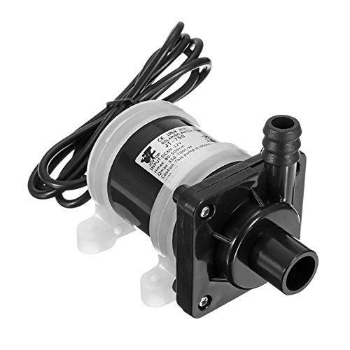
Fig 3: Re-circulating water pump
Voltage:12V
Output:500-600 L/H
A re-circulating pump draws water from the basin under the pumps it through a system of sprays (or water distributors) from which the water is directed onto the tube surfaces. Air is induced or forced over the wetted tube surfaces and through the rain of water droplets. By intimate contact of the air with the wetted tube surfaces and water droplets evaporation of part of the water occurs thus cooling both the tube surfaces and the water simultaneously. In this manner evaporation is used to increase the rate of heat transfer from the tubes to the air. Pump body and casing are made of high quality plastic which is anti corrosive and highly durable Pumps have excellent insulation and it is combines pumping, filtration, oxygenation and fountain in one.
2.4 Cooling Pad:
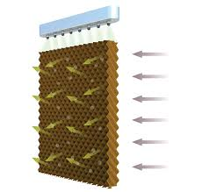
Fig 4: Cooler Pad

Most of the cooling pads are made of either aspen fibre or cellulose. A cellulose pad typically needs more air and water flow than does an aspen pad. More evaporation can take place through a 6-inch pad than a 4-inch pad. Wide Range of Evaporative Cooling Pads is available in the market. Evaporative Cooling is the process in which air is cooled by using the heat in the air to evaporate the water from an adjacent surface. Atemperature reduction of 10 to 200 C (50-68 degree F) can be achieved by passing the hot fresh air through the wetted pads. Eco Cool Evaporative Cooling Pads that were manufactured using special cellulose material. Top quality material is useful in achieving high cooling efficiency and ensuring degradation resistance. The pads are known for their exceptional wetting properties and airflow to achieve maximum cooling.

2.5 Cooling Cabin :
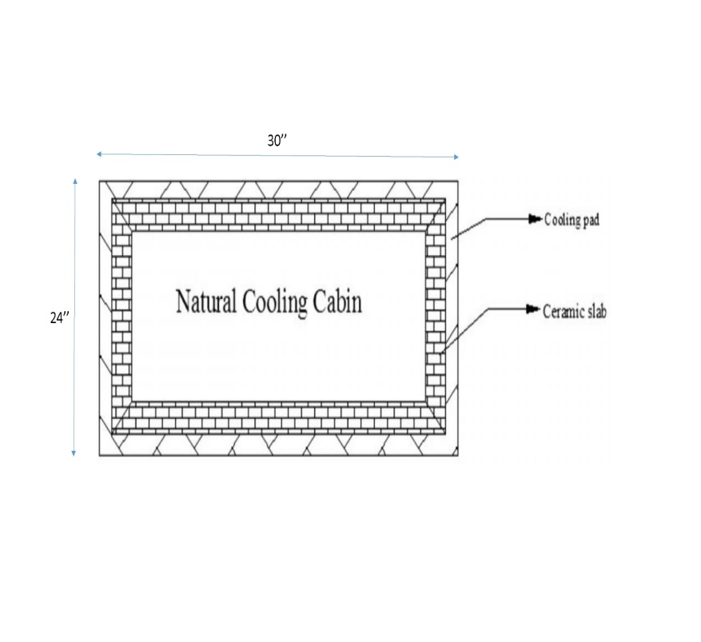
Fig 5: Cooling Cabin
First thing, here it is natural cooling process. Cooling cabin is provided just below the air cooler section. This cabin built is up with cooling pads and ceramic slabs. Ceramic slabs are surrounded by cooling pads through continuous water supply is provided. This process leads to producing cooler region in the cabin. So this cabin can be used for preservation of food.

2.6 Body Frame: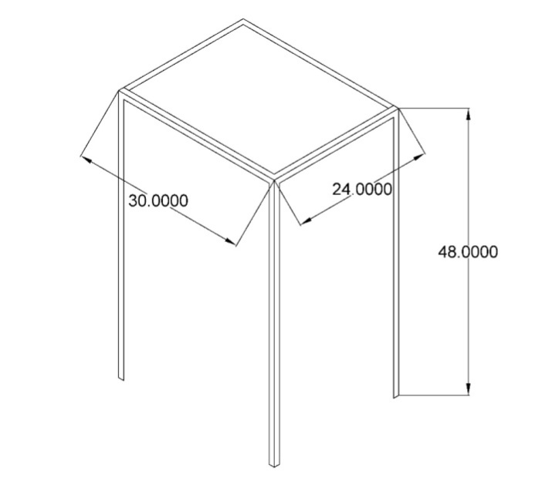
Fig 6: Body Frame
This is the main frame for the solar cooler having mentioned dimension in figure. This is of mild steel material. All other parts are mounted on this frame.

2.7 Desiccant-based dehumidifier:
Desiccants are solid or liquid materials that attract moisture. Materials for desiccation are selected on the bases of their ability to hold large quantities of water, their ability to reactivated and cost.
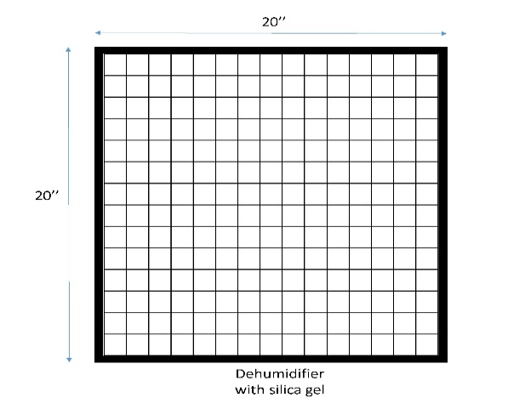
Fig 7: Dehumidifier
3 - WORKING PRINCIPAL

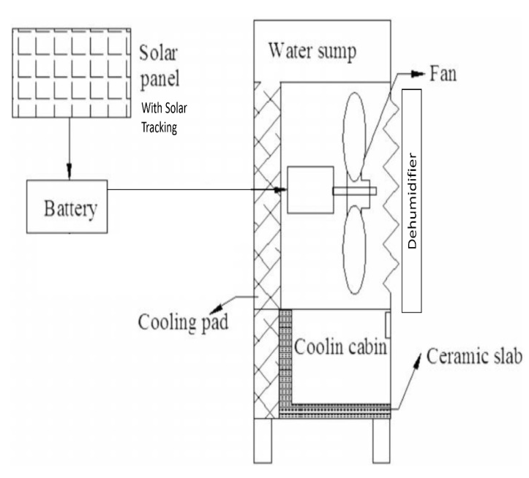

Fig 8: Solar Air Cooler With Cooling Cabin
The above shown model consists of solar energy conversion unit with solar tracking system, air cooler unit and cooling cabin. As the electrical energy supplied to the DC motor fan from battery, it starts to produce airflow to the room at the same time water passed through the cooling pads. Fan sucks the outside air through the cooling pads, so heat transfer occur between air and water. Also there is dehumidifier installed at the front of the fan, so the cool and dehumidified air enters into the room. Next thing is cooling cabin provided just below the air cooler section. This cabin built is up with cooling pads and ceramic slabs. Ceramic slabs are surrounded by cooling pads through continuous water supply is provided. This process leads to producing cooler environment in the cabin. So this cabin can be used for preservation of food.

4 -CALCULATIONS
Size Of Cooler :-
Air delivery or Air displacement(in Cubic feet per minute CFM) = [Area of room in square feet ] x [height of room]
= 10*10*10 = 500 CFM
i.e. V1 = 14 cub m/min
[1 CFM = 0.028 cub m/min]
The factor 2 in denominator denotes that the air in the room is changed once in every 2 minutes.
Heat Load Calculations:-
1.1BTU/hr=0.293 Watt Area of room (BTU )
= L*W*31.25 = 10*10*31.25
= 3125 BTU/hr
= 915.625 Watt
2. North window without shading(BTU) = L*W*1.4 = 2*2*1.4
=5.6 BTU/hr
= 1.6408 W
3. South window without shading (BTU) = L*W*1.4 =2*2*1.4
=5.6 BTU/hr = 1.6408 W 4. Occupant (BTU)
= No. of People *600
= 3*600 =1800 BTU/hr
= 527.4 W
Note:- assuming 600 BTU per person
Heat gain:-
4. Color TV =100w/24hr =4.1667w/hr
Computer = 6.25w
Lighting Equip. = 2(22)+40 = 84W/24hr =3.5 W/hr
5. Equipment (BTU)
= Total equipment Watts*3.4 =(4.1667+6.25)*3.4
= 35.4167 BTU = 10.3771 W
6. Lighting (BTU) = Total Lighting Watts*4.25
= 3.5*4.25
= 14.875 BTU p
= 4.3583 W
7. Total (BTU) = eqn (1+2+3+4+5+6)

= 1461.042 W Air delivery
= 500 CFM Through air cooler
= 500*163.17 BTU/hr
= 500*16317*0.293 =23904.405W >HeatLoad (i.e. 1461.04 W)
Required condition =20 degree c DBT & 55%.

Capacity Solar Panel and Battery Required
Hence selected Blower (Fan) Specification: 230 v, 50 Hz, 35 WSo to run 35 W blower on for 1 hour will take
35*1 = 35 W/h from the battery (Battery capacity is measured in Amp hours)
Convert this to watt hours by multiplying the Ah by the battery voltage
For 10 Ah, 12 v battery the watt hours is given by
P = V*I ...(2)
V = 12 v and I = 10 Ah
P = 10*12 = 120 Wh
So, the 35 W centrifugal fan runs for 120/35 = 3.42 = 3.5 h
This means the battery could supply 35 watt fan for 3.5 hours
Energy generating capacity of solar panel over a period of timeto calculate the energy it can supply to the battery multiplied by the hours expected to the sunlight then multiply the result by 0.85 this factor allows for natural system losses
For the Solar 40 watt panel in 4 hours,
40*4*0.85 =136 watt hours
For 1 hour show the solar panel of 40 watt and battery of 10 ah are selected
5 -EXPECTED OUTCOMES.
- So as comparing the cost of this product with the existing products in the market is, solar product appeals better and affordable by common people.
- This solar product will perfectly suits for villages, schools and offices and thus prevention from the power cut problems.
- It will comprises of many attractive features such as usage of solar energy, cooler and cooling cabin at lower cost.
- This method is eco-friendly and natural, electricity savers.
- Durability of our product is more thus minimizing the cost.
- No electricity will spent so this product saves the energy and saves environment from getting polluted.

6.1 - ADVANTAGES
- This system is ecofriendly in operation.
- It is portable, so it can be transferred easily from one place to other place.
- Non conversional source as fuel.
- Maintenance cost is low.
- More amount of energy is capture by auto tracking.

6.2 - DISADVANTAGES
- Initial cost is high
- Solar panel saves the energy during day only

6.3 - APPLICATION
- Home
- Industries
- Meeting halls
- Seminar halls
- By adding control circuit, we can maintain the room temperature at required level.

7.RESULTS AND CONCLUSION
The output of the project is Comfort thermal conditions achieved in the living room. That is room temperature up to 20.7 °C and relative humidity of 52%. At lower cost natural cooling cabin for preservation of food has been developed. So as comparing the cost of this product with the existing products in the market is, solar product appeals better and affordable by common people. This solar product perfectly suits for villages, schools and offices and thus prevention from the power cut problems. It comprises of many attractive features such as usage of solar energy, cooler and cooling cabin at lower cost. The above method is eco-friendly and natural, electricity savers. Durability of our product is more thus minimizing the cost. No electricity is spent so this product saves the energy and saves environment from getting polluted.

8. REFERENCES
[1]Miss.NamrataGovekar, Mr.AkshayBhosale, Mr.AmolYadav, ‘Modern Evaporative Cooler’, Novateur Publications International Journal Of Innovations In Engineering Research And Technology [Ijiert] , Issn: 2394-3696, Volume 2, Issue 4, Apr.-2015

[2] VijaykumarKalwa and R Prakash, ‘‘Modelling and fabrication of solar power air cooler with cooling cabin for household food items’’,International journal of Mechanical Engineering And Robotics Research,Vol.3,No.3,pp.45-52,July 2014.
[3] FarhanKhmamas (2012), “Improving the Environmental Cooling for Air- Coolers by Using the Indirect-Cooling Method”, ARPN Journal of Engineering and Applied Sciences, Vol. 5, No. 2, pp. 66-73.
[4] S.P.Sukhtme,J.K.Nayak, ‘‘Solar Energy- Principles of thermal collectonand storage’’,Third Edition, pp.1-460.
[5] FabianPineda,and Carlos Andres Arredondo, ‘‘Design and Implementation of Sun Tracker Prototype for Solar Module Positioning’’,978-1-4673-0066-7 IEEE,2011,PP.2905-2910.
[6] Tao Yu, GuoWencheng, ‘‘Study on tracking strategy of automatic sun tracking system based on CPV generation’’,IEEE international conference on Intelligent System Design and Engineering Application 2010,pp. 506-509.
[7] Alosaimy A S (2013), “Application of Evaporative Air Coolers Coupled with Solar Water Heater for Dehumidification of Indoor Air”, International Journal of Mechanical & Mechatronics Engineering, Vol. 13, No. 01, pp. 60-68.
[8] Prof. Pooja K. Chhatwani,Prof.JayshreeSomani, ‘‘Intelligent Solar tracker system implemented on 8051 microcontroller’’,Inteernational Journal of Engineering Trends and Technology, vol.4 ,Issue 9, pp 4267-4271,sep.2013.
[9] http://www.solar- facts.com/ panels/panel-types.php.
[10] J,K,Jain and Hindoliya D.A, ‘‘Development and Testing of Regenerative Evaporative Cooler’’,International Journal of Engineering Trends and Technology, Vol.3, No.6,pp 694-697,2012.
[11] Arora and Domkundwar, A text book, ‘‘The course on Power Plant Engineering’’.
[12] B.SrinivasReddy,K. Hemanchandra Reddy, ‘‘Thermal Engineering data hand book.

