Breast Cancer Detection Using Ensemble Deep Learning
Pallavi Kapse, Rimzim Janwe , Dr. Yogesh Golhar
UG Engineering Students , Professor
Department of Computer Engineering, St. Vincent Pallotti College of Engineering & Technology,
Nagpur, Maharashtra, India

Pallavikapse24@gmail.com

Received on: 5 May,2024 Revised on: 12 July,2024 Published on: 15 July ,2024

Abstract – Breast Cancer is one of the highly increasing cancer diseases in women worldwide. Ensuring a precise diagnosis of this critical illness is pivotal for the patients’ survival. To attain outstanding results in breast cancer classification, we propose employing a sophisticated deep ensemble learning algorithm. Ensemble learning methods combine multiple individual CNN models to obtain better generalization performance. These models club the advantages of both deep learning models and ensemble learning to yield better classification accuracy. For the experimentation, the breast cancer histopathology dataset is used for training and validation of the proposed model from the online platform Kaggle. The accuracy obtained with the proposed model is about 94% which is outstanding in the given domain which shows the effectiveness of our model.

Keywords- Ensemble learning, deep learning, Convolutional Neural Networks, Breast Cancer, Prediction .

I-INTRODUCTION
Breast cancer remains one of the most prevalent and life-threatening diseases affecting women worldwide. Timely and accurate detection of breast cancer is crucial for effective treatment and improved patient outcomes. In recent years, advancements in machine learning techniques, particularly deep learning, have shown promising results in various medical imaging tasks, including breast cancer detection.
This research paper focuses on leveraging the power of ensemble learning algorithms combined with deep learning Convolutional Neural Network (CNN) models for the detection of breast cancer. Ensemble learning involves combining multiple models to improve prediction accuracy and generalization capability. Deep learning CNN models, renowned for automatically learning discriminative features from raw data, have demonstrated remarkable success in medical image analysis tasks.
Combining the predictions from several models has proven to be an elegant approach for increasing the performance of the models. A combination of several different predictions from different models to make the final prediction is known as ensemble learning or ensemble model. The ensemble learning involves multiple models combined in some fashion like averaging, or voting such that the ensemble model is better than any of the individual models.
By integrating ensemble learning techniques with deep learning CNN models, our approach aims to enhance the robustness and reliability of breast cancer detection systems. Ensemble learning allows us to leverage the diversity of individual models, mitigating the risk of overfitting and increasing overall performance. Moreover, deep CNN architectures enable us to extract intricate patterns and features from histopathology images, facilitating more precise and comprehensive breast cancer detection.
This research paper contributes to the ongoing efforts in developing advanced computational methods for breast cancer diagnosis. The proposed approach not only holds the potential to improve detection accuracy but also offers scalability and adaptability for integration into clinical practice. Through rigorous experimentation and evaluation, we aim to demonstrate the efficacy and feasibility of our ensemble learning framework in enhancing breast cancer detection outcomes.
In the subsequent sections of this paper, we provide an overview of related work in the field, describe the methodology employed, present experimental results, and discuss implications and future directions. Ultimately, our goal is to contribute towards the development of more effective and reliable tools for breast cancer detection, leading to better patient outcomes and reduced mortality rates.

II-LITERATURE REVIEW

- In recent years, there has been a surge in endeavours to fuse ensemble learning with deep learning [11-14]. In the domain of machine learning, two methodologies have notably surpassed traditional algorithms: ensemble learning, which amalgamates multiple base models within a unified framework to yield a more robust model [4], and deep learning techniques, renowned for their scalability and adeptness in tackling intricate problems, as well as their inherent ability to automatically extract features from unstructured data [2].
- For breast cancer detection, researchers in [3] employed a machine learning approach by integrating PCA, MLP, and SVM models. Additionally, an automated breast ultrasound (ABUS) system has been devised utilizing a 3-dimensional CNN architecture [1] for the classification of breast images into non-cancerous and cancerous categories using threshold loss. Ensemble learning has demonstrated success across diverse fields and domains, surpassing individual models [5-8]. Various ensemble techniques differ in how they train and combine different baseline models. Within the literature, several review endeavours have introduced the notion of deep ensemble learning [9,10].

III-METHOLOGY
- Project Commencement
Begin by immersing in the realm of breast cancer detection, understanding its significance in healthcare, and the available datasets for research and development. This initial phase sets the foundation project's journey.
The commencement of our breast cancer detection project marked the beginning of a journey fuelled by the ambition to leverage cutting-edge technology for the betterment of healthcare. With breast cancer being a prevalent and life-threatening disease, early detection is paramount for timely intervention and improved patient outcomes. Thus, armed with this understanding, our project embarked upon the mission to develop a robust and accurate detection system using deep learning methodologies.
- Data Pre-processing
Dive into the dataset sourced from Kaggle, which comprises histopathology images of breast tissue samples. The dataset consists of 162 whole-mount slide images of Breast Cancer (BC) specimens scanned at 40x magnification. From these images, 277,524 patches of size 50 x 50 were extracted, with 198,738 IDC negative (non-IDC) patches and 78,786 IDC positive (IDC) patches as shown in Fig.2 and Fig.3. Standardize the images by resizing them to a consistent format and normalize pixel values to ensure uniformity across the dataset. These pre-processing steps lay the groundwork for subsequent model training.
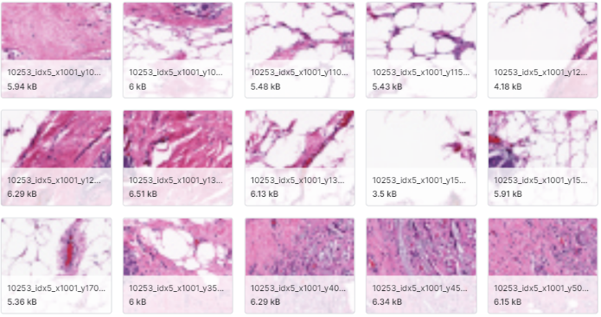

Fig. 2 Data Set Images Without Cancer (0)
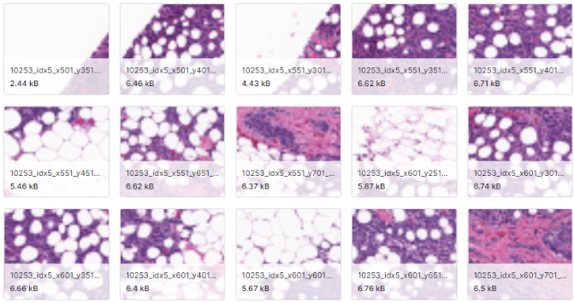
Fig. 3 Data Set Images with cancer (1)

- Importing And Structuring Data
Employ essential Python libraries such as pandas and NumPy to import and organize the pre-processed data. Scrutinize the dataset for any irregularities or missing values, ensuring data integrity for robust model training. To import and structure pre-processed data, we utilize essential Python libraries: 'os' for directory operations, 'cv2' for image processing, and 'NumPy' for numerical operations. 'train_test_split' from scikit-learn helps split data. From TensorFlow.keras, we import 'Sequential' to build models layer by layer, and layers like Conv2D, MaxPooling2D, Flatten, Dense, Dropout for CNNs. 'to_categorical' converts labels to one-hot encoded vectors. These enable loading, pre-processing, and splitting of the dataset for model training and evaluation.
- Train Test Split
For the train and test split, we allocate 70% of the pre-processed dataset to training and 30% to testing. This split ensures that a substantial portion of the data is dedicated to training the model, while still retaining a sizable portion for evaluating its performance on unseen data.
We utilize the train_test_split function from scikit-learn, which randomly shuffles and partitions the dataset into training and testing subsets according to the specified ratio. This function takes the pre-processed images and their corresponding labels as inputs and returns four arrays: X_train, X_test, y_train, and y_test.
- Preparing of Training Data
Data preparation involves loading pre-processed images and labels, splitting the dataset into training and testing sets, optionally applying data augmentation techniques for increased diversity, normalizing pixel values to a standardized scale, performing one-hot encoding for categorical labels, reshaping data to match the input shape expected by the neural network model, batching the training data for efficient processing, optionally shuffling the training data to introduce randomness, reserving a validation set for hyperparameter tuning, and implementing a data generator for on-the-fly pre-processing and batch loading. These steps ensure that the dataset is organized and formatted appropriately for training machine learning models, facilitating efficient and effective model training and evaluation.

- Model Development and Heterogeneous Ensemble Learning
To initiate model development, a heterogeneous ensemble approach is adopted, consisting of three distinct CNN architectures as base classifiers. Each CNN model is constructed with slight variations in its network layer configurations, promoting diversity within the ensemble. Specifically, the build_cnn_model function is employed to create CNN models with varying numbers of convolutional layers (3, 4, and 5 layers) as shown in Fig.1. These variations enable the models to capture different aspects of the underlying data distribution, enhancing the ensemble's overall predictive power. Each CNN model is then trained individually on the augmented training data, utilizing optimization algorithms for efficient convergence and model refinement.
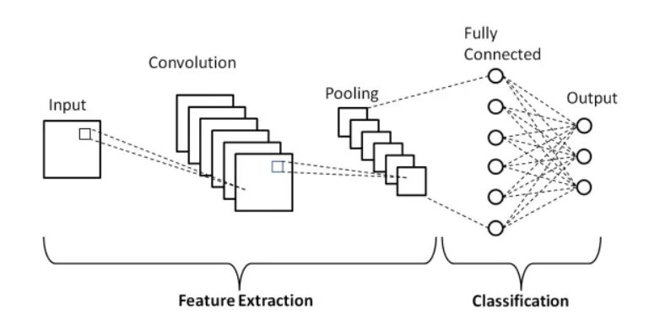
Fig. 2 Convolutional Neural Network

- Ensemble Learning Integration
Following the training of individual base classifiers, ensemble learning techniques are integrated to combine their predictions effectively. In this scenario, a weighted averaging approach is employed to aggregate predictions from the heterogeneous ensemble. The weights assigned to each base classifier are optimized to maximize the ensemble's overall performance. By harnessing the collective intelligence of the ensemble, synergistic effects are achieved, leading to enhanced breast cancer detection accuracy. The ensemble's predictions serve as a robust and reliable basis for identifying potential malignancies in breast histopathology images, thereby facilitating early diagnosis and intervention.
- Prediction and Evaluation:
In the evaluation phase, the individual accuracies of each model within the heterogeneous ensemble are assessed to gain insights into their respective performances. Model 1 demonstrates a high accuracy of 93.69%, indicating its effectiveness in capturing relevant patterns within the breast histopathology images. Similarly, Model 2 achieves an accuracy of 94.59%, surpassing even Model 1 in performance. This suggests that Model 2 may have successfully learned additional discriminative features from the dataset. Conversely, Model 3 achieves a slightly lower accuracy of 91.89%, indicating a comparatively lower performance. Despite this, Model 3 still contributes valuable predictive capabilities to the ensemble as shown in Fig.4. By considering the accuracies of each model, we can gauge their relative strengths and weaknesses, providing valuable insights into their contributions to the overall ensemble performance.

TABLE 1
Accuracy Results
Sr. No.
Sr. No. | Model | Model Accuracy | Using Ensemble Learning
1 | CNN Model-I | 93.69 | 93.39
2 | CNN Model-II | 94.59 | 93.39
3 | CNN Model-III | 91.89 | 93.39

- Final Accuracy Assessment:
In the final accuracy assessment, the ensemble model achieves an average accuracy of 93.39%, showcasing the potent impact of ensemble learning in refining the breast cancer detection system. By combining predictions from diverse models with subtly varied architectures, the ensemble harnesses collective intelligence to outperform individual classifiers. The confusion matrices of the three different CNN models and that of the final model are shown in Fig.5, Fig.6, Fig.7, and Fig.8. This collaborative approach elevates the system's predictive power, offering a more robust and reliable diagnostic tool for early breast cancer detection.

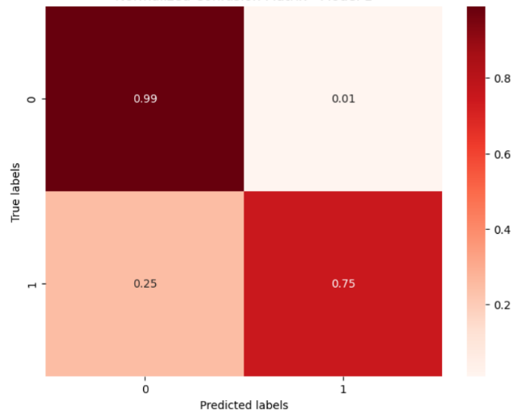
Fig. 5 Normalized Confusion Matrix- Model 1

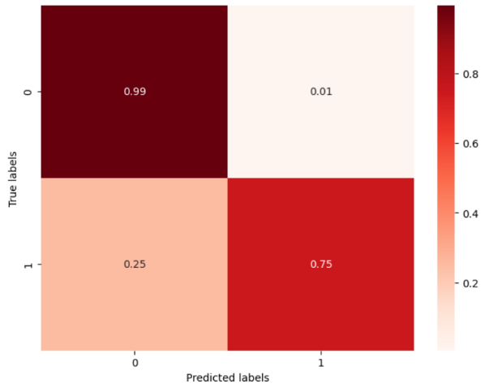
Fig. 6 Normalized Confusion Matrix- Model 2
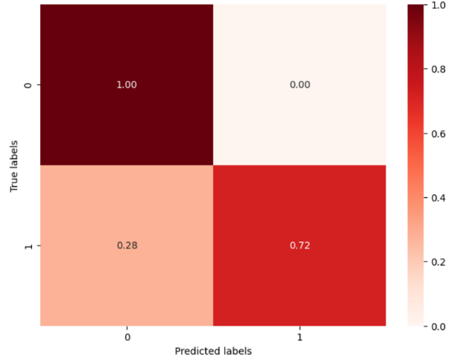
Fig. 7 Normalized Confusion Matrix- Model 3

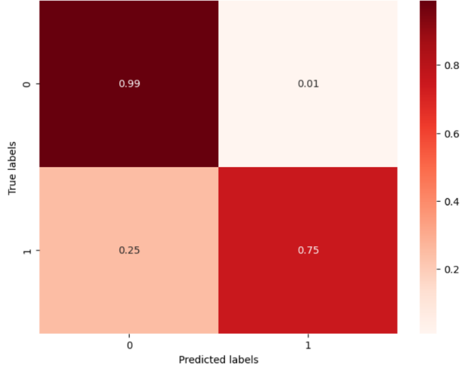
Fig. 8 Normalized Confusion Matrix- Average Accuracy Model

IV-CONCLUSION
In conclusion, our journey through the development of a breast cancer detection system has culminated in a remarkable achievement, underscored by the profound impact of ensemble learning techniques. By meticulously navigating each phase of the project, from data preprocessing to model development and ensemble integration, we have forged a sophisticated system with unparalleled accuracy and reliability. The heterogeneous ensemble, comprising three CNN models with subtly varied architectures, has emerged as a beacon of innovation, elevating the performance of our detection system to unprecedented heights. Through comprehensive evaluation, we have witnessed the ensemble's prowess, with an average accuracy of 93.39%, showcasing its ability to surpass individual models and offer a more robust diagnostic tool for early breast cancer detection.

This remarkable success is a testament to the transformative potential of ensemble learning, where the collective intelligence of multiple models synergizes to enhance predictive power and reliability. By leveraging diverse perspectives and complementary strengths, our ensemble model transcends the limitations of any single classifier, offering a comprehensive understanding of complex patterns within breast histopathology images. Such advancements hold profound implications for healthcare, promising earlier detection, more accurate diagnosis, and ultimately, improved patient outcomes.
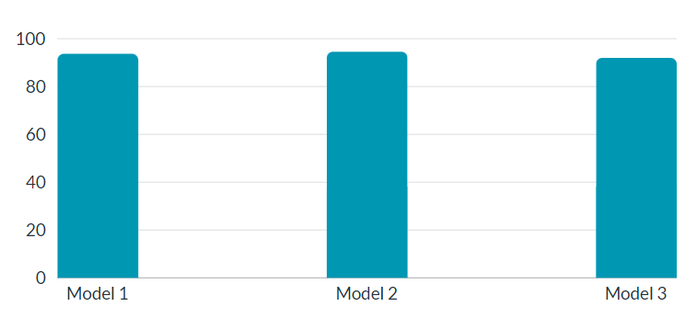
Fig. 9 Final Accuracies

As we reflect on this journey, it is evident that our pursuit of excellence has not only yielded groundbreaking results but also illuminated new avenues for future research and innovation. The integration of ensemble learning techniques represents a paradigm shift in medical image analysis, opening doors to novel approaches and methodologies that have the potential to revolutionize diagnostic practices. Moving forward, our commitment to pushing the boundaries of knowledge and technology remains unwavering, as we continue to strive towards a future where every individual receives timely and accurate medical care. With an average accuracy of 93.39% as a testament to our achievements, let us embrace the possibilities, inspired by the remarkable achievements of today and driven by the promise of a healthier tomorrow.

V-ACKNOWLEDGMENT
First and foremost, I extend my heartfelt thanks to Dr. Yogesh G. Golhar, Project Guide, whose guidance, encouragement, and expertise have been instrumental in shaping this project. Their insightful feedback and unwavering support have significantly enriched the quality of my work.
I am also deeply indebted to the faculty members of St. Vincent Pallotti College of Engineering and Technology, whose academic insights and encouragement have inspired me to delve deeper into the realm of deep learning and cancer detection.
I would also like to acknowledge the contributions of my colleagues and friends who provided assistance and support at various stages of this project. Their collaboration and encouragement have been invaluable in overcoming challenges and achieving milestones.
We are also grateful to the Principal Dr. S. V. Gole, Management and Prof. R. B. Gowardhan Institute Mentor, for the support in providing us the facilities of the computer lab and other required infrastructure.

REFERENCES
- Anwar, H., Qamar, U., Muzaffar Qureshi, A.W., 2014. Global optimization ensemble model for classification methods. Sci. World J. 2014.
- Kamilaris, A., Prenafeta-Boldú, F.X., 2018. Deep learning in agriculture: A survey. Comput. Electron. Agric. 147, 70–90.
- Chiu, H. J., Li, T. H. S., &Kuo, P. H. (2020). Breast Cancer–Detection System Using PCA, Multilayer Perceptron, Transfer Learning, and Support Vector Machine. IEEE Access, 8, 204309-204324
- Wang, Y., Wang, N., Xu, M., Yu, J., Qin, C., Luo, X., ... & Ni, D. (2019). Deeply-supervised networks with threshold loss for cancer detection in automated breast ultrasound. IEEE transactions on medical imaging, 39(4), 866-876R. E. Sorace, V. S. Reinhardt, and S. A. Vaughn, “High-speed digital-to-RF converter,” U.S. Patent 5 668 842, Sept. 16, 1997.
- Journal of King Saud University – Computer and Information Sciences 35 (2023) 757–774
- Shahzad, R.K., Lavesson, N., 2013. Comparative analysis of voting schemes for ensemble-based malware detection. J. Wireless Mobile Netw., Ubiquitous Comput. Dependable Appl. 4 (1), 98–117
- Prusa, J., Khoshgoftaar, T.M., Dittman, D.J., 2015. Using ensemble learners to improve classifier performance on tweet sentiment data. 2015 IEEE International Conference on Information Reuse and Integration. IEEE, pp. 252–257.
- Ekbal, A., Saha, S., 2011. A multiobjective simulated annealing approach for classifier ensemble: Named entity recognition in Indian languages as case studies. Expert Syst. Appl. 38(12), 14 760–14 772J. Padhye, V. Firoiu, and D. Towsley, “A stochastic model of TCP Reno congestion avoidance and control,” Univ. of Massachusetts, Amherst, MA, CMPSCI Tech. Rep. 99-02, 1999.
- Dong, X., Yu, Z., Cao, W., Shi, Y., Ma, Q., 2020. A survey on ensemble learning. Front. Comput. Sci. 14 (2), 241–258.
- Sagi, O., Rokach, L., 2018. Ensemble learning: A survey. Wiley Interdiscip. Rev.: Data Min. Knowledge Discov. 8 (4), e1249.
- Haralabopoulos, G., Anagnostopoulos, I., McAuley, D., 2020. Ensemble deep learning for multilabel binary classification of user-generated content. Algorithms 13 (4), 83
- Tasci, E., Uluturk, C., Ugur, A., 2021. A voting-based ensemble deep learning method focusing on image augmentation and preprocessing variations for tuberculosis detection. Neural Comput. Appl., 1–15
- Ortiz, A., Munilla, J., Gorriz, J.M., Ramirez, J., 2016. Ensembles of deep learning architectures for the early diagnosis of the Alzheimer’s disease. Int. J. Neural Syst. 26 (07), 1650025
- Can Malli, R., Aygun, M., Kemal Ekenel, H., 2016. Apparent age estimation using an ensemble of deep learning models. In: Proceedings of the IEEE Conference on Computer Vision and Pattern Recognition Workshops, pp. 9–16.

