Design and Analysis of Square Printed Patch Antenna with Transmission Line Feed
A. Harika^{*1}, Samiran Chatterjee^{#2}, Jitty Ramesh^{#3}, B. Soumya^{*4}, A Madhuri^{*5}, J Sai Kiran^{*6}
^{*1, 4, 5,6}Student, ECE Department, ECE Department, Jyothishmathi Institute of Technology & Science (Affiliated to JNTU, Hyderabad), Nustulapur, Karimnagar, Telangana-505481
^{#2, 3}Associate Professor, ECE Department, Jyothishmathi Institute of Technology & Science (Affiliated to JNTU, Hyderabad), Nustulapur, Karimnagar, Telangana-505481
¹aharikasweety1997@gmail.com
²samiranengineer@gmail.com
³ ramesh.jitty@gmail.com
⁴soumyabolli1804@gmail.com
⁵madhuriakireddy78@gmail.com
⁶ saikiranjilla1234@gmail.com

Abstract: A single layer, transmission line feed compact size square printed patch antenna is proposed for communication. Resonant frequency has been achieved by use of simple inverted L-shaped patch and adding rectangular slit. We achieve proposed antenna with good return loss of about -35.8 dB at 9.20 GHz frequency and low VSWR of about 1.07 which is much closer to its minimum value. The characteristics of the proposed antenna are designed by using MoM based electromagnetic solver, IE3D. The proposed printed patch antenna provides good resonant frequency, return loss, VSWR, radiation pattern and the antenna gain. We also achieved beam-width of about 167.55⁰ which is a very broad bean for the application for which it is intended. Practically the proposed antenna is applicable for satellite communication. In recent era of communication, micro-strip antenna is suitable due to simple configuration, low profile and easy fabrication in nature. This paper proposes the design of a Microstrip Square-Patch antenna with enhanced bandwidth and directive gain. The simulated results give significant improvement in terms of VSWR and beam-width.
Index Terms- Compact, Transmission Line Feed, Printed, Gain, VSWR, Beam Width
Introduction
To talk about a new era of communication, the microstrip micro-antenna design creates a lot of attention among young engineers especially for microwave engineers [1]. For microwave transmissions, we need a small, lightweight, compact antenna and on this ground the Microstrip Antenna is the most suitable device.
For microwave connectivity as well as for wireless communication, more than one operating frequency is required per day for many reasons. Operating frequencies are mainly required because most microwave and wireless engineers use different communication bands and engineers use different frequency bands. Therefore, engineers have recently designed antennas with multiple characteristics. Another standard needed to design the antenna is to reduce the size. Reducing size is the new technique. In this method, the size of the antenna is the same for the conventional antenna as well. To reduce size, the most useful technique is to cut different structures in the correct position on the traditional microstrip antenna [2-5]. Reducing the size of the antenna means a very low resonance frequency of the cleaved antenna compared to the traditional antenna [6-8]. Unlike slotted antennas, there are other antennas such as DRA (aerial resonance buffer), fractal antenna, etc. to reduce the size of antenna [15-20]. Fractal antennas are difficult to design and DRA require high dielectric substrates which are not readily available.
Today, the compact microstrip size of the antenna is very small and can be reduced to increase the demand for applications in various communications, especially microwave and mobile communications [9-10]. The work to be presented in this paper is also the design of a built-in microstrip antenna by cutting three inverted L-shaped patch and adding one rectangular slit with transmission line feed to increase the return loss and performance gain antenna bandwidth. To reduce the size of the antenna substrates, a higher value is selected from the dielectric constant [11-14]. Our goal is to design the antenna with multi-band operation and increase the frequency ratio as well as increase the operational bandwidth. The simulation was performed by IE3D [21] using the MoM method. Due to its small size, low cost and light weight, this antenna is a good candidate for the application of satellite communication systems and microwave relay systems.
Antenna Structure
Proposed antenna configurations designed in Figure 1 displayed with the PTFE substrate. Three unequal slots of inverted L shaped (L1, L2, L3) are cut in the left and right side of the patch edge in the upper layer shown in Figure-1. One rectangular slit is added with the top layer as shown in Figure 1. Dimensions and position of the transmission line feed indicated in figure. The insulation materials specified for this design are epoxy FR4 substrate with electrostatic dielectric constant (ε_{r}) = 4.4 and height of substrate (h) = 1.6 mm.
The transmission line feed is used for a waveguide arm of three (3) cells with extension of MMIC. Figure 1 illustrates the configuration of the top layer display of the proposed antenna.
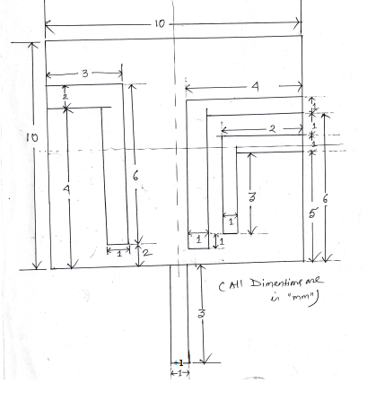
Figure 1: Proposed Antenna Configuration
The proposed antenna configuration is designed with a similar PTFE substrate. The proposed antenna is a square patch 20 mm x 20 mm. The upper layer of the proposed antenna is fully designed in the middle of the top layer, i.e. 10 mm x 10 mm of square patch.
Simulated Results and Analysis
In this section, a different parametric analysis of the proposed antenna is performed and displayed. Several antenna parameters have been investigated for improved bandwidth and gain and return loss of antenna. Figure 2 shows the simulated return loss of the proposed antenna.
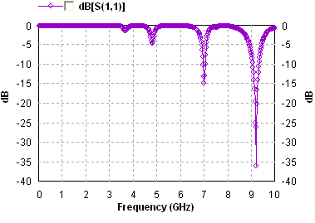
Fig 2: Simulated return loss of proposed antenna
Because the slot is cut in the correct position of the antenna, the resonance frequency operation is obtained with large values ​​of the frequency ratio with a large return loss of antenna. The first resonance frequency of a proposed antenna is obtained at f₁ = 7.01 GHz with a return loss of about -14.81 dB. The second resonance frequency is obtained at f₂ = 9.20 GHz with a return loss of -35.8 dB. The 10 dB corresponding bandwidth obtained for the proposed antenna in f₁ and f₂ is 83.60 MHz and 264.07 MHz, respectively.
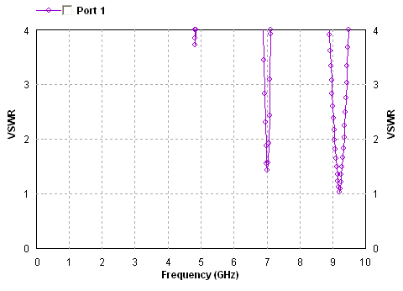
. Fig 3: VSWR vs. Frequency Plot for Proposed Antenna
Figure 3 shows the VSWR simulation scheme against the proposed resonant with respect to frequency. VSWR for the first resonance frequency (7.01 GHz) is 1.44. The second resonance frequency is obtained at f₂ = 9.20 GHz with a value of 1.07. These values ​​are within a 2: 1 range.

Simulated Radiation Pattern
Figure 4 to Figure 7 shows the proposed E-plane and H-plane radiation patterns for each of the resonance frequencies obtained for the proposed antenna.
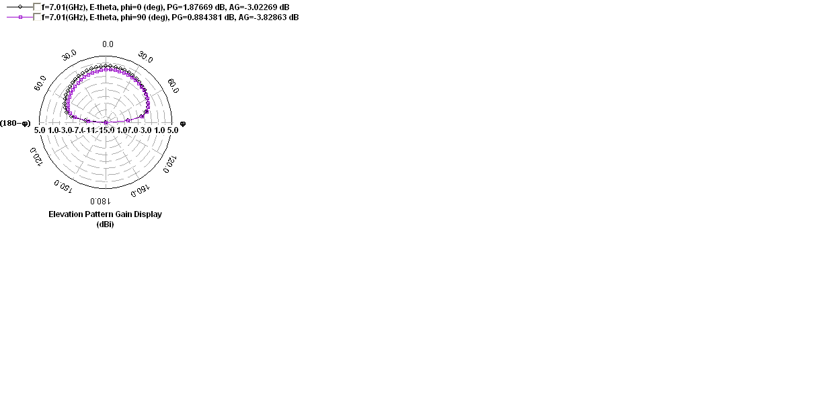
Fig 4: Simulated E-field radiation pattern at 7.01 GHz
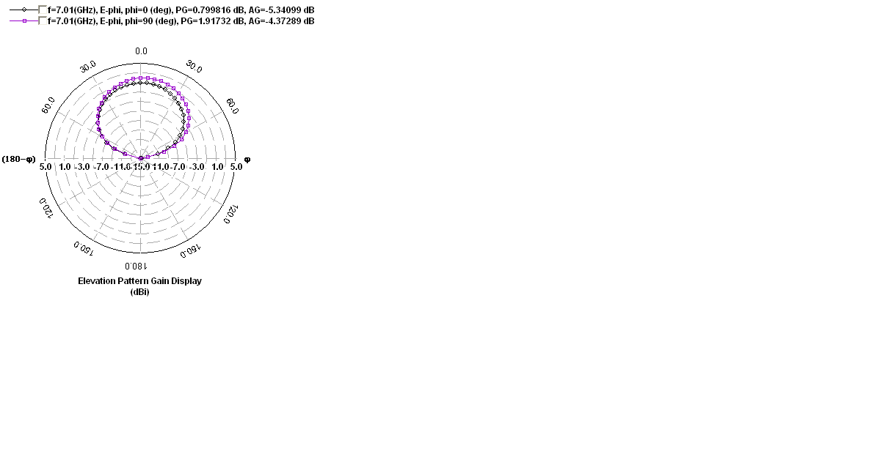
Fig 5: Simulated H-field radiation pattern at 7.01 GHz

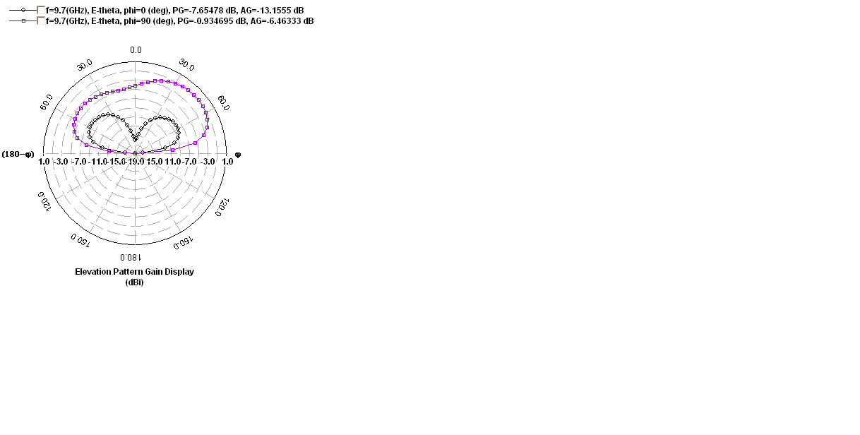
Fig 6: Simulated E-field radiation pattern at 9.20 GHz
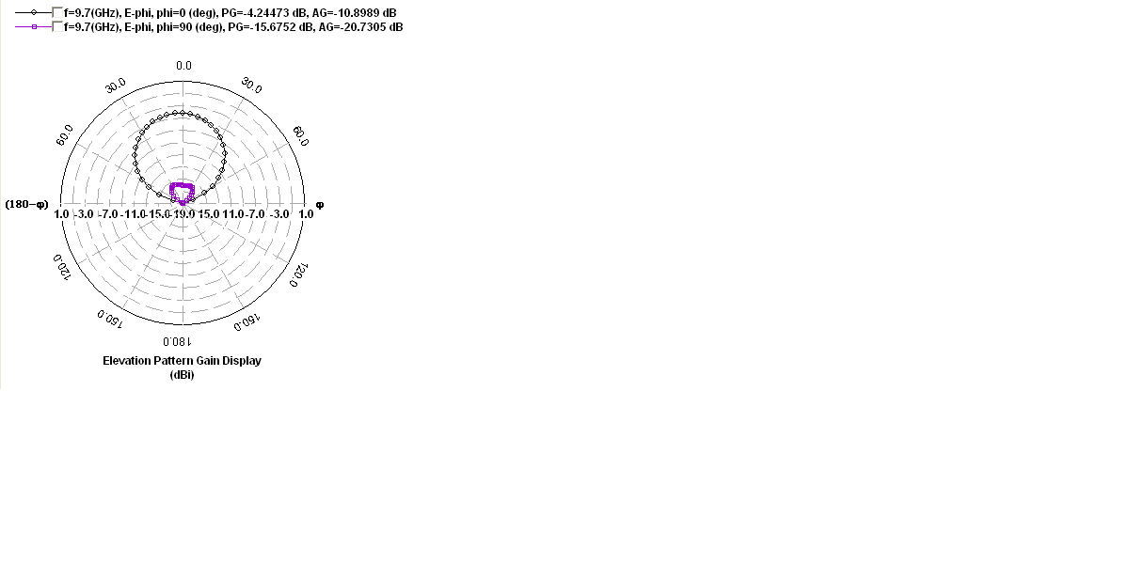
Fig 7: Simulated H-field radiation pattern at 9.20 GHz
Figure 8 show the current distribution pattern obtained for the proposed antenna.

Fig 8: Simulated current distribution pattern
All simulated results are summarized with the help of Table I and Table II which is discussed below:
Table I: Simulated results for proposed antenna with respect to Radiation Pattern
Resonant Frequency(GHz) | Frequency  Ratio | 3 dB Beam Width (⁰) | Absolute Gain (dBi)
f₁= 7.01 |  | 167.55⁰ | 4.35
f₂= 9.20 | f₂/ f₁=1.312 | 136.94⁰ | -0.86
Table II: Simulated results for proposed antenna with respect to Return Loss
Resonant Frequency(GHz) | Return Loss  (dB) | 10 dB Bandwidth (MHz)
f₁= 7.01 | -14.81 | 83.60
f₂= 9.20 | -35.80 | 264.07

Conclusion
Single layer, single transmission line feed square printed microstrip patch antenna whose theoretical investigations were performed using an Method of Moment based program using IE3D. When three unequal slots of inverted L shaped (L1, L2, L3) are cut in the left and right side from the edge of the patch, the significant improvement shows a maximum return loss of about -35.80 dB as well as the VSWR value of about 1.07 which is much closer to its minimum value. Another result was also observed that for the proposed antenna, the three-dimensional beam width of the radiation pattern of about 264.07° which is sufficiently wide beam for the applications for which it is intended. If we change the location of the transmission line feed point, the results give a narrower bandwidth of 10dB and fewer signals.
ACKNOWLEDGEMENT
We are grateful for the financial support for this work provided by the JYOTHISHMATHI INSTITUTE OF TECHNOLOGY AND SCIENCE and all faculty members of the ECE department to carry out this work successfully.
REFERENCES
- I. Sarkar, P. P. Sarkar, S. K. Chowdhury A new compact printed antenna for mobile communication. 2009 Loughborough Antennas & Propagation Conference 16-17 Nov. 2009, Loughborough, UK.
- J.-W. Wu, H.-M. Hsiao, J.-H. Lu and S.-H. Chang, “Dual broadband design of rectangular slot antenna for 2.4 and 5 GHz wireless communication”, IEE Electron. Lett. Vol. 40 No. 23,11th November 2004.
- Samiran Chatterjee, Joydeep Paul, Kalyanbrata Ghosh, P. P. Sarkar, D.Chanda (Sarkar) and S. K. Chowdhury “A Compact Microstrip Antenna for WLAN Communication”, National Conference of Electronics, Communication and Signal Processing, 2011, Paper ID: 116
- Rohit K. Raj, Monoj Joseph, C.K. Anandan, K. Vasudevan, P. Mohanan, “ A New Compact Microstrip-Fed Dual-Band Coplaner Antenna for WLAN Applications”, IEEE Trans. Antennas Propag., Vol. 54, No. 12, December 2006, pp 3755-3762.
- U. Chakraborty, S. Chatterjee, S. K. Chowdhury, and P. P. Sarkar, “Triangular Slot Microstrip Patch Antenna for Mobile Communication”, India Conference (INDICON), 2010 Annual IEEE, pp 4-7, Paper ID: 511
- J. -Y. Jan and L. -C. Tseng, “ Small planar monopole Antenna with a shorted parasitic inverted-L wire for Wireless communications in the 2.4, 5.2 and 5.8 GHz bands” , IEEE Trans. Antennas and Propag., VOL. 52, NO. 7, July 2004, pp -1903-1905.
- S. Chatterjee, U. Chakraborty, I.Sarkar, S. K. Chowdhury, and P. P. Sarkar, “A Compact Microstrip Antenna for Mobile Communication”, India Conference (INDICON), 2010 Annual IEEE, pp 1-3, Paper ID: 510
- Danideh, A., R. S. Fakhr, and H. R. Hassani, “Wideband coplanar microstrip patch antenna,” Progress In Electromagnetics Research Letters, PIER 4, 81–89, 2008.
- Samiran Chatterjee, Joydeep Paul, Kalyanbrata Ghosh, P. P. Sarkar and S. K. Chowdhury “A Printed Patch Antenna for Mobile Communication”, Convergence of Optics and Electronics conference, 2011, Paper ID: 15, pp 102-107
- J. Bahl and P. Bhartia, “Microstrip Antennas”, Artech House, Dedham, MA, 1980.
- U. Chakraborty, S. Chatterjee, S. K. Chowdhury, and P. P. Sarkar, "A compact microstrip patch antenna for wireless communication," Progress In Electromagnetics Research C, Vol. 18, 211-220, 2011
- R.Fallahi, A.-A.Kalteh, M. Golparvar Roozbahani, "A novel UWB elliptical slot antenna with band-notched characteristics," Progress In Electromagnetics Research C, Vol. 18, 211-220, 2011
- Samiran Chatterjee, Santosh Kumar Chowdhury, Partha Pratim Sarkar and Debasree Chanda Sarkar, “Compact Microstrip Patch Antenna for Microwave Communication”, Indian Journal of Pure & Applied Physics, Vol. 51, November 2013, pp 800-807.
- C. A. Balanis, “Advanced Engineering Electromagnetic”, John Wiley & Sons., New York, 1989.
- Werner, D.H and S.Ganguly, “An overview of fractal antenna engineering research”, IEEE Antennas and Propagation Magazine, Vol. 45, No. 1, 38-57, 2003
- A.Aggarwal and M.V.Kartikeyan, “Pythagoras Tree: A Fractal Patch Antenna for multi-frquency and ultra Band-Width Operations”, Progress in Electromagnetics Research C, Vol. 16, 25-35, 2010
- Gianvittorrio, J.P and Y. Rahmat-Samii, “Fractal Antennas: A novel antenna miniaturization technique and applications”, IEEE Antennas and Propagation Magazine, Vol. 44, No. 1, 20-36, 2002
- Carles Puente Baliarda, Jordi romeu and Angel Cardama, “The Koch Monopole: A small fractal antenna”, IEEE Transactions on antennas and propagation, Vol. 48, No. 11, 1773-1781, November-2000
- M. Saed and R. Yadla, “Microstrip fed low profile and compact dielectric resonator antenna”, Progress in Electromagnetics Research, PIER-56, 151-162, 2006
- Aldo Petosa and Apisak Ittipiboon, “Dielectric Resonator Antennas: A Historical review and the current state of the Art”, IEEE Antennas and Propagation Magazine, Vol. 52, No. 5, pp 91-116, October 2010
- Zeland Software Inc. IE3D: MOM-Based EM Simulator. Web: http://www.zeland.com

