Real-time Safety Management Through Gas Leakage Detection and Automated Response System
Dr. Neha Gupta¹, Atharva Gour², Abbas Mandleshwar Wala³, Rohit Manna⁴, Sarthak Agrawal⁵
¹Deputy Director, Symbiosis University of Applied Sciences, Indore, India, 453112
- 0000-0003-0052-2653
² Student, Symbiosis University of Applied Sciences, Indore, India, 453112, 2022btcs013@student.suas.ac.in,
³ Student, Symbiosis University of Applied Sciences, Indore, India, 453112, 2023btcs001@student.suas.ac.in,
⁴ Student, Symbiosis University of Applied Sciences, Indore, India, 453112, rohitmanna55@gmail.com,
⁵ Student, Symbiosis University of Applied Sciences, Indore, India, 453112, 2022btcs046@student.suas.ac.in

Email of Corresponding Author: neha.gupta@suas.ac.in
Received on: 7 May,2025 Revised on: 08 June,2025 Published on: 10 June,2025

Abstract – Gas leaks pose a significant safety hazard in residential and commercial environments, particularly when utilizing liquefied petroleum gas (LPG). To prevent incidents caused by LPG leakage, this paper proposes establishing an automated system for detecting gas leaks and providing alerts. [1] To monitor gas concentration levels in real time, the system integrates an Arduino Uno microcontroller with a Figaro TGS2612 gas sensor, a GSM 800 module, and a GPS module. The system automatically alerts the authorized personnel via SMS, providing them with precise location information, whenever it identifies that the gas density has surpassed a set limit. This technology reduces the likelihood of explosions and health risks by offering a cost-effective and efficient solution for the early identification of LPG leaks. [2] The proposed system serves as an effective tool for enhancing safety at home and in the workplace, as it has demonstrated accuracy, reliability, and responsiveness. This study enhances safety systems based on the Internet of Things and provides a scalable answer to issues related to gas leaks.
Keywords- Arduino Uno, GSM 800 Module, GPS Module, IoT-Based Safety, Figaro TGS2612 Sensor, Automated Alert System
- INTRODUCTION
The integration of smart automation technologies into everyday processes has become a critical focus in the fields of IoT (Internet of Things) and industrial development. With increasing demand for intelligent, reliable, and efficient systems, sectors such as environmental monitoring, industrial automation, and smart homes are leading this transformation. The main challenge in deploying smart automation is ensuring seamless communication, flexibility, and real-time responsiveness, all while maintaining low energy consumption and high accuracy. Additionally, concerns over scalability, security, and data privacy further complicate the development of intelligent automation systems. [3]
To address these challenges, the use of sensors, actuators, and advanced algorithms has grown significantly, enhancing the effectiveness of automated processes. [4] [5] Gas sensors, in particular, have garnered attention due to their ability to detect hazardous gases such as methane, carbon monoxide, and LPG, offering a powerful solution for improving safety and efficiency in smart environments. Integrating these sensors into automated systems allows for real-time monitoring, ensuring quick responses when dangerous gas concentrations are detected. This integration not only promotes energy-efficient solutions but also significantly enhances safety, advancing sustainability goals.
This research explores the role of gas sensors, like the Figaro TGS 2612, in smart automation systems, focusing on hazard detection and environmental monitoring. The proposed approach aims to improve the efficiency of automated systems while reducing reliance on traditional power grids, by integrating smart gas sensing technologies with renewable energy sources, such as solar and wind power [6]. The subsequent sections will detail the system architecture, automation framework, simulation results, and the potential impact of these technologies on smart urban and industrial applications.

II. COMPONENTS USED
- Arduino Uno
The Arduino Uno is the central controller in this project. It processes sensor data, performs calculations, and outputs the results. The Uno has an ATmega328P microcontroller, with 14 digital input/output pins, 6 analog inputs, and various communication interfaces. It is ideal for prototyping and controlling hardware components in embedded systems.

Figure 1: Arduino UNO
- Gas Sensor: Figaro TGS2612
The Figaro TGS2612 is an analog gas sensor that detects gases like methane (CH₄). It works by measuring changes in resistance caused by the presence of gas molecules in the air. The sensor’s analog output is fed into the Arduino’s analog input, where the data is processed to estimate the gas concentration in ppm (parts per million).
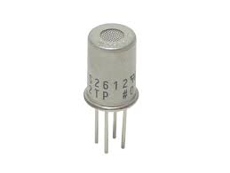
Figure 2: Gas Sensor: Figaro TGS2612
- GSM Module: SIM800
The SIM800 is a GSM/GPRS module that allows the Arduino to send data over cellular networks. It is used in this project to send SMS notifications, which can include gas concentration levels or alerts when a high concentration is detected. The GSM module communicates with the Arduino using UART (Tx, Rx).
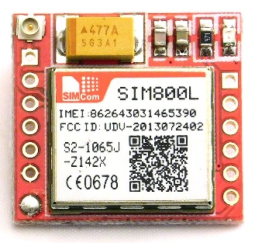
Figure 3: GSM Module: SIM800
- GPS Module: NEO-6M
The GPS module is used to determine the geographical location of the device. This allows the project to include location data when sending alerts via the GSM module, which could be important for tracking gas leakages in a certain area.
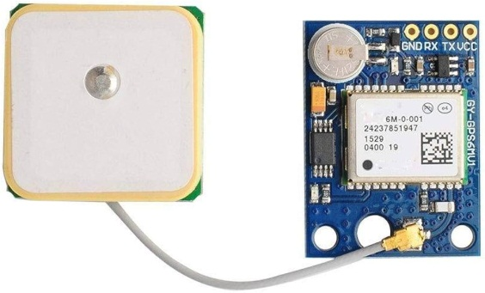
Figure 4: GPS Module: NEO-6M
III. METHODOLOGY
This project utilizes the TGS 2612 gas sensor, which detects resistance changes when exposed to gases like butane and propane, to create an LPG detection system. The sensor has two types of pins: detecting element pins (Pins 2 and 5), which output an analog voltage proportional to gas concentration, and heater pins (Pins 1 and 3), which power the internal heating element. The sensor requires a 24-hour preheating period for optimal performance. To assemble the system, the following components are needed: an Arduino Uno, TGS 2612 sensor, a 10kΩ resistor for the voltage divider circuit, a breadboard, jumper wires, and optionally, an LED and alarm buzzer. The Arduino's 5V and GND pins are connected to the heater pins, and the sensor’s detecting pins are part of a voltage divider circuit that connects to the Arduino’s analog input pin.
When the gas concentration exceeds a set threshold, such as 2.0V, the Arduino reads the sensor’s output, converts it to a 0-5V range, and triggers the LED and buzzer. Calibration involves preheating the sensor for 24 hours in clean air to establish a baseline voltage. The system can be enhanced by adding a display for real-time gas concentration, data logging, and power optimization after successful testing with controlled LPG exposure. The system should be used with alarms and automatic gas shut-off mechanisms, placed in well-ventilated areas, and calibrated regularly to ensure accuracy and safety.
SCHEMATIC DIAGRAM

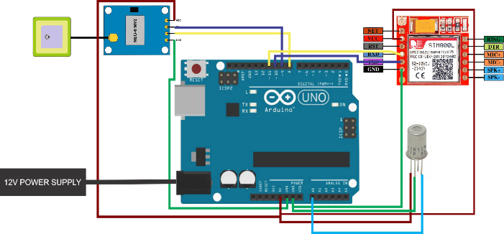
Figure 5: Schematic Diagram of Real-time Safety Management Through Gas Leakage Detection and Automated Response System
IV. RESULT & DISCUSSION
The system was tested in three stages to evaluate its effectiveness in detecting gas leaks & triggering appropriate responses. Actions escalated from notifying the user to alerting emergency services, based on gas concentration levels. The system consistently detected leaks, with prompt notifications ensuring timely safety measures.

Table 1: Observation of prototype at different stages
Stage | Condition | Action Taken | Response Time | Observation
1 | Low-level gas leakage detected (10-30% threshold) | SMS notification sent to the user | 2-3 seconds | Prompt notification was received by the user, ensuring awareness of the situation.
2 | Moderate gas leakage detected (30-70% threshold) | Automated call placed to the user | 3-5 seconds | Call connected successfully, providing an audible alert for immediate action.
3 | High-level gas leakage detected (>70% threshold) | Calls to electric department and fire brigade | 5-8 seconds | GPS location was accurately sent; authorities were informed for emergency intervention.

V. CONCLUSION
The gas leak detection system provides a reliable, scalable solution for industrial and residential use, addressing critical safety concerns. By combining gas sensors with GSM, GPS, and microcontroller technology, the system detects leaks and initiates tiered responses, reducing accident risk and ensuring timely intervention. Future improvements could incorporate AI for predictive maintenance and expand the system's capabilities to detect additional hazardous gases, further advancing IoT-based safety solutions.
VI. FUTURE SCOPE
The LPG detection system has a wide range of applications, including pollution monitoring, emission tracking, climate change studies, and animal methane monitoring. The device can be used in industries to track dangerous gas emissions, guaranteeing adherence to environmental standards and enhancing air quality. The tool can also be used to investigate emission trends in various settings, such as industrial, rural, and urban areas, yielding useful information for environmental management. Additionally, the system can support climate change research by tracking emissions and developing efficient mitigation measures by monitoring greenhouse gasses like methane. The technique may be used to measure methane emissions in agriculture, especially in animal management, which will help with carbon credit calculations and encourage sustainable farming methods.
REFERENCES

- S. G. Niranjana, "Experimental design of IoT-based LPG gas leakage detection and accident prevention mechanism using intuitive sensors," IEEE, Chennai, pp. 1-9, 2023.
- J. V. A. S. K. J. S. S. Murali, "IoT-based smart kitchen with enhanced and automated safety measures," IEEE, Noida, pp. 1-5, 2024.
- R. T. P. (Cholke) Chavan, "LPG transport tracking and leakage detection with accident prevention alert system," IEEE Pune, pp. 1-8, 2024.
- M. N. S. Z. Yahaya, "IoT-based system for monitoring and control of gas leaking," IEEE Pulau Pinang, pp. 1-6, 2020.
- G. B. B. S. K. G. A. T. Pawar, "GSM Based LPG Gas Leakage Detection & Alert," JAIMLNN, vol. 3, no. 5, pp. 1-8, 2023.
- K. A. S. V. S. G. V. Munusami, "High Sensitivity LPG and H2 Gas Sensing Behavior of MoS2/Graphene Hybrid Sensors Prepared by Facile Hydrothermal Method," Ceram. Int., vol. 48, no. 19, pp. 29322-29331, 2022.

