A Cryptographic Enhancement for strengthened AES Resilience

Sunil Kishor Khode¹, Dr. Manish P. Deshmukh²

¹Research Scholar, :  0009-0001-1705-6460,
SSBT’s COET, Bambhori, Jalgon, India, Pin-425001,
²Professor & Head, E & TC Engg. Dept., : 0009-0001-2557-2596
SSBT’s COET, Bambhori, Jalgaon, India, Pin-425001, rushimd@yahoo.com

Email of corrsponding Author : khodesunil@gmail.com
Received on: 7May,2025 Revised on: 08 June,2025 Published on: 10 June,2025

Abstract– AES is a widely used encryption technique for securing digital data. This study presents a new method aimed at improving the avalanche effect in the AES algorithm., which is a critical factor for ensuring data security. However, enhancing its security further remains a topic of interest. This paper explores an optimized method to improve the avalanche effect in AES by incorporating modifications in the S-Box transformation. The proposed approach demonstrates an increased diffusion rate, leading to improved security against cryptanalysis. Comparative analysis with conventional AES highlights the advantages of the modified model.
Keywords—Cryptography, AES, Avalanche effect, Add round Key
INTRODUCTION
Security concerns in digital communication have led to extensive research in cryptographic algorithms. AES, as a symmetric block cipher, is known for its efficiency and security. The avalanche effect, a crucial property in cryptographic systems, ensures that minor changes in input lead to significant alterations in output. This study aims to enhance this effect by refining the S-Box structure in AES.
Previous studies have underscored the significance of the avalanche effect in strengthening cryptographic algorithms. Research indicates that enhancing substitution and permutation processes can lead to better security outcomes. Notably, modifications in S-Box designs have been a focal point for achieving improved diffusion characteristics. This paper builds upon these foundational

insights, proposing a refined method for enhancing AES's resistance to differential and linear cryptanalysis. The S-Box, a nonlinear substitution stage, plays a pivotal role in enhancing security. In the current digital era, transmitting plain (readable) data over the internet poses significant security risks due to potential intrusions by unauthorized entities aiming to access sensitive information. Such critical data may include e-banking credentials, confidential emails, or private conversations on social media platforms. To safeguard this information, various security measures are employed, with cryptography being one of the most essential techniques. Cryptography plays a key role in protecting sensitive information by transforming readable data into an unintelligible format known as ciphertext through a process called encryption. To make the data understandable again, the ciphertext is converted back into its original form using decryption. This process takes place at the receiver's end and effectively reverses encryption. A cryptosystem refers to the overall setup that supports both encryption and decryption functions. Figure 1 illustrates the basic concept of how these processes are carried out. [1].
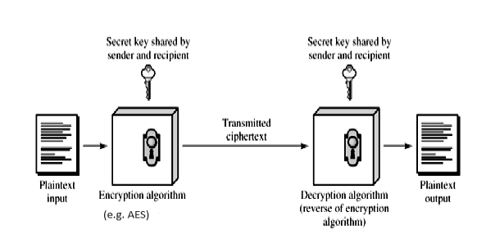
Fig.1 AES Encryption system

- A Concise Overview of Cryptography:
Cryptography aims to achieve several core objectives as follows:
, one of which is confidentiality—ensuring that information is accessible only to those with the proper authorization.which are explained
•Confidentiality: It ensures that information is accessible only to those with the proper authorization, which are explained
• Integrity: Guarantees that the data remains unaltered during its transmission from sender to receiver.
•Authentication: Verifies the origin of the data and confirms the identity of the sender, helping to prevent disputes regarding the data's origin or delivery path.

•Non-repudiation: Ensures that the sender cannot deny having sent the information.. Cryptographic techniques are broadly categorized based on the type of security keys used, primarily into symmetric and asymmetric encryption. These techniques are discussed in the following sections.

- Symmetric (Private Key) Encryption
In symmetric key encryption, the same secret key is shared between the sender and the receiver for both encrypting and decrypting the information must agree on the encryption algorithm before initiating data exchange. They also share a single secret key used for both encrypting and decrypting the data. Once the algorithm and key are agreed upon, the sender transmits the encrypted data along with the key. The receiver applies the identical secret key to convert the encrypted data back to its original form. A key challenge in this approach is securely sharing the secret key. If unauthorized entities discover the key, the confidentiality of the data is compromised. Additionally, effective key management becomes more complex as the number of users increases. For instance, if n participants are communicating, a total of n(n - 1)/2 unique secret keys are required to maintain secure communication between all parties.
- Asymmetric (Public Key) Encryption
Asymmetric encryption uses two separate keys: one public and one private. The public key is available to anyone, while the private key is kept secure by its owner. To begin communication, both parties share their public keys. When transmitting data, the sender encrypts it using the recipient’s public key, allowing only the recipient—who holds the matching private key—to decode the message. This method effectively addresses key management challenges, as there is no need to share private keys. However, asymmetric encryption requires more computational resources and is significantly slower—approximately 1,000 times slower—than symmetric encryption. This limitation makes it less efficient for devices with limited processing power, such as mobile phones or tablets.
To overcome this challenge, a hybrid encryption approach is often adopted. In this method, asymmetric encryption is used solely for securely exchanging the secret key, while symmetric encryption handles the actual data transfer, optimizing both security and performance.
C. Hashing
Hashing in cryptography plays a vital role in verifying that data has not been altered and confirming the identity of its source. It involves applying a hash function to the input data, generating a fixed-length output known as a hash or digest. This output serves as a unique identifier, much like a digital fingerprint of the original content.Upon receiving the data, the recipient can apply the same hash function to verify the integrity of the message. If the computed hash matches the original hash value, it confirms that the data has not been altered during transmission. Any mismatch indicates potential tampering or corruption.

- Internal structure of AES
AES is a symmetric block cipher that processes data in 128-bit blocks and allows key lengths of 128, 192, or 256 bits. These key sizes were selected to align with the security criteria outlined by NIST during the development of the standard. The number of encryption rounds carried out by the algorithm depends on the length of the key, as detailed in Table 1 [2].
Table 1: Key length and number of rounds of AES
Block Size (Bits) | Key Length (Bits) | No. of Round
128 | 128 | 10
128 | 192 | 12
128 | 256 | 14

Key Addition Layer: At this stage, a 128-bit subkey is derived from the original key through a key scheduling method. This subkey is then merged with the current data state using the XOR operation.

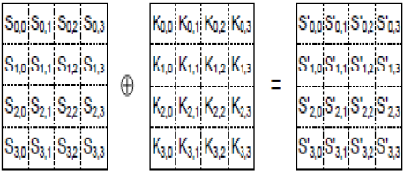
Fig. 2 Add round Key operation

  - Confusion Layer:
The Confusion Layer enhances security by altering the relationship between the plaintext and the ciphertext. It achieves this by substituting elements within the state table, effectively transforming the original content into a more complex and less predictable form.

Byte Substitution layer (S-Box):
In the Byte Substitution phase, every byte in the data block is replaced using a predefined lookup table called the S-Box. This non-linear substitution disrupts patterns between the original data and the encrypted output, enhancing resistance to various cryptographic attacks [2].

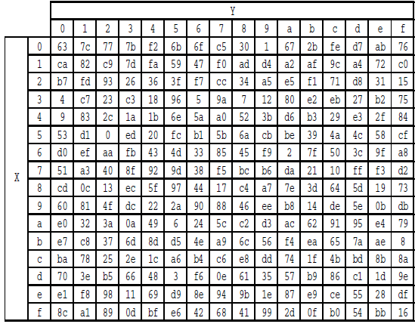
Fig. 3 S- Box

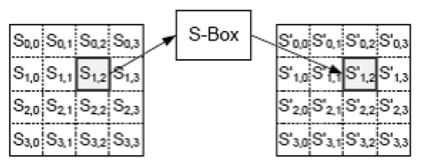Fig.4 Byte Substitution Process

1.3 Diffusion Layer: The Diffusion Layer ensures that the influence of each input bit is spread across multiple output bits, enhancing the complexity of the cipher. This layer consists of two sub-layers, both performing linear transformations to achieve diffusion:
Shift Rows layer: In this stage, each row of the state matrix is rotated by a certain number of positions in a circular manner.This step helps in dispersing the data across columns, increasing the diffusion effect and contributing to the overall strength of the encryption This defines the method used to rotate the rows, as illustrated in Figure 5. based on the output of the previous layer.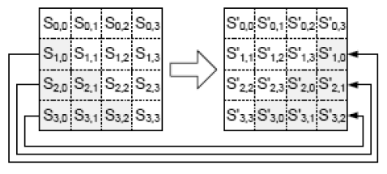
Fig.5 Shift Row Process
Mix Column layer: In the Mix Columns stage, each column of four bytes from the state is considered as a vector and is transformed through multiplication with a fixed 4×4 matrix composed of constant values. This transformation enhances the diffusion property by ensuring that each byte of a column affects all four bytes of the resulting column. The matrix used for this operation is illustrated in Fig. 6.
The overall AES encryption process is depicted in Fig. 7. Notably, the final round of AES excludes the Mix Columns step, which contributes to the cipher's strength and complexity.
Decryption reverses the encryption steps by applying operations like inverse substitution, inverse row rotation, and inverse column transformation to restore the original plaintext.
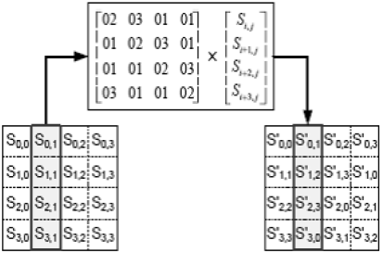
Fig.6 Mix Column Process

Proposed architecture :
This research introduces an enhanced encryption algorithm designed to strengthen key security objectives—Integrity, Availability, and Confidentiality—during data transmission. The proposed method builds upon the symmetric key encryption framework, similar to the Advanced Encryption Standard (AES), by incorporating an additional step to enhance security [1].
Figure 8 depicts the structure of the modified AES algorithm. To assess its performance, multiple plaintext inputs were encrypted using both the conventional AES and the modified version (M-AES). The resulting ciphertexts were then examined and compared by quantitatively measuring the avalanche effect [3]. It was observed that the avalanche effect is influenced not only by the algorithm's complexity but also by the characteristics of the encryption key & plaintext [4].

Table 2 shows a comparison of the performance between the standard AES and the modified AES.. The results indicate that the inclusion of the additional Add Round Key step leads to a negligible increase in execution time. Specifically, for larger block sizes, the difference in execution time is approximately 0.13 seconds, demonstrating that the security enhancement does not substantially compromise efficiency [5][15]. Table 2. Performance Comparision
 | BLOCKSIZE | OAES ENCRYPTION TIME | OAES DECRYPTION TIME | MAES ENCRYPTION TIME | MAES DECRYPTION TIME
0 | 0 | 0 | 0 | 0 | 0
1 | 200 | 0.07306695 | 0.144130468 | 0.078723431 | 0.150136471
2 | 400 | 0.144131184 | 0.288996458 | 0.157142639 | 0.298270941
3 | 600 | 0.212802649 | 0.426130772 | 0.232753038 | 0.444164991
4 | 800 | 0.286910772 | 0.569517136 | 0.309027433 | 0.594110966
5 | 1000 | 0.357120514 | 0.711867571 | 0.388439655 | 0.74558115
6 | 1200 | 0.431531429 | 0.85889554 | 0.464734077 | 0.886425018
7 | 1400 | 0.498572111 | 1.001305819 | 0.543958187 | 1.037644386
8 | 1600 | 0.571002483 | 1.146540165 | 0.618527889 | 1.181308985
9 | 1800 | 0.648367643 | 1.294424295 | 0.705809116 | 1.347166538
10 | 2000 | 0.718652487 | 1.439751625 | 0.777841568 | 1.482756615
11 | 2200 | 0.789165974 | 1.575108528 | 0.861928225 | 1.638389587
12 | 2400 | 0.859639406 | 1.725492477 | 0.941195965 | 1.798029661
13 | 2600 | 0.933243036 | 1.873767138 | 1.021160603 | 1.936397552
14 | 2800 | 1.013615608 | 2.016579628 | 1.237341166 | 2.339947224
15 | 3000 | 1.081787348 | 2.166396141 | 1.164149284 | 2.241556168
16 | 3200 | 1.148303032 | 2.296367645 | 1.248567104 | 2.383872271
17 | 3400 | 1.225673199 | 2.453509569 | 1.33632946 | 2.540692329
18 | 3600 | 1.304152012 | 2.593055487 | 1.421662569 | 2.693468332
19 | 3800 | 1.372518063 | 2.731688261 | 1.477969885 | 2.82988286
20 | 4000 | 1.444795132 | 2.901023626 | 1.560515404 | 3.043602705
 | 4200 | 1.502748251 | 2.991802454 | 1.656993151 | 3.155423403
22 | 4400 | 1.575759411 | 3.142236233 | 1.70720768 | 3.27212286
23 | 4600 | 1.660069942 | 3.379750729 | 1.78350544 | 3.409239531
24 | 4800 | 1.813122749 | 3.453919411 | 1.862156391 | 3.575967789
25 | 5000 | 1.787180901 | 3.587009668 | 1.936036348 | 3.712869167
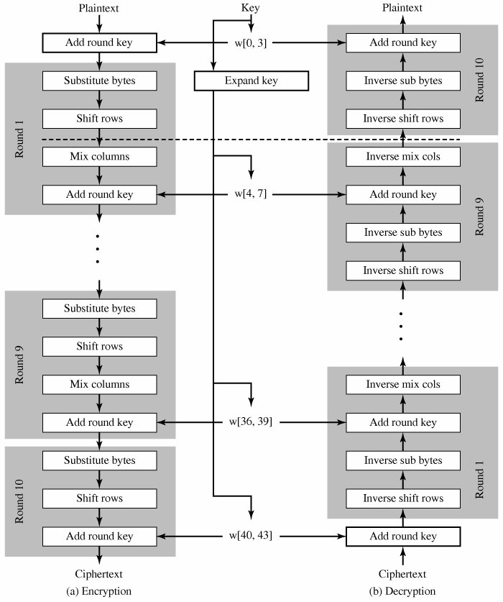 Fig.7 AES Encryption and Decryption

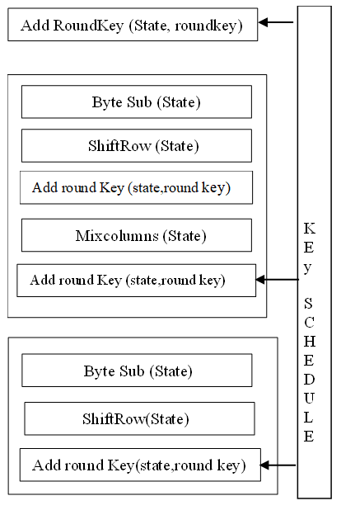
Fig. 8 Modify AES Architecture

Avalanche Effect and Testing : In cryptography, the avalanche effect is a key characteristic of encryption algorithms, where a minor alteration in the plaintext or encryption key results in a substantial and unpredictable change in the cipher text [6]. This property is essential for maintaining the robustness and security of cryptographic systems [16].Simply put, the avalanche effect measures how significantly the cipher text changes when even a single bit of the plaintext or key is altered. Ideally, changing a single bit in the input should cause at least half of the bits in the ciphertext to be altered [7]. The results of these experiments are presented in Tables 3 and 4 [8][12][17].
Table 3 Avalanche effect for Key

Table 4 Avalanche effect for plain Text
 | key | Cipher text | bits flipped | avalanche effect
0 | A9B5ED7585C8B15D7454ED271AA3A3A3 | AD512E36316802EFF789587EE2EFA6BB | 0 | 0
1 | 29B5ED7585C8B15D7454ED271AA3A3A3 | E44EC5EADB225DF51DF995859EAE6AF6 | 57 | 44.53125
2 | 69B5ED7585C8B15D7454ED271AA3A3A3 | 369FF04CF3D35BBD5683E29CA0F41F03 | 62 | 48.4375
3 | 49B5ED7585C8B15D7454ED271AA3A3A3 | F1D646890A379C3E40C7F87854E78491 | 65 | 50.78125
4 | 59B5ED7585C8B15D7454ED271AA3A3A3 | 76488C9CB6C573005FBF6E69F19FF3BC | 64 | 50
5 | 51B5ED7585C8B15D7454ED271AA3A3A3 | 00B3EF1EB598D856A10313D7669B2DD5 | 68 | 53.125
6 | 55B5ED7585C8B15D7454ED271AA3A3A3 | 2D4F16BDEEC5E7A899F00769823FD72E | 62 | 48.4375
7 | 57B5ED7585C8B15D7454ED271AA3A3A3 | C0CBFDD936870623E792569214006E82 | 59 | 46.09375
8 | 56B5ED7585C8B15D7454ED271AA3A3A3 | BC1429B4F6C619F700F34BFAF9CDD177 | 69 | 53.90625
9 | 5635ED7585C8B15D7454ED271AA3A3A3 | 3D44B310A4D180D373DF314507BD4778 | 69 | 53.90625
10 | 5675ED7585C8B15D7454ED271AA3A3A3 | 36FEBFFBB1EBA11E9D6E63E1A012AB2A | 60 | 46.875
11 | 5655ED7585C8B15D7454ED271AA3A3A3 | 7B29242647969BF572EE5468F37F2737 | 75 | 58.59375
12 | 5645ED7585C8B15D7454ED271AA3A3A3 | FDB751DB2190666E8A1899B8C09FB278 | 70 | 54.6875
13 | 564DED7585C8B15D7454ED271AA3A3A3 | 700F5471A4DF1596D4A62BC144851849 | 50 | 39.0625
14 | 5649ED7585C8B15D7454ED271AA3A3A3 | 64A3BAE3560A192101653F9A6DDC6024 | 55 | 42.96875
15 | 564BED7585C8B15D7454ED271AA3A3A3 | 2D0FA8366FF47027E4B3C3BA2C10162C | 67 | 52.34375
16 | 564AED7585C8B15D7454ED271AA3A3A3 | D07C0EC51B5FFF8D404C7812F3A78713 | 69 | 53.90625
17 | 564A6D7585C8B15D7454ED271AA3A3A3 | 13D478C8DEC1C819894F291CF8EFA35F | 61 | 47.65625
18 | 564A2D7585C8B15D7454ED271AA3A3A3 | E761BC212DCE6AD5983ED2B4AE00A56E | 66 | 51.5625
19 | 564A0D7585C8B15D7454ED271AA3A3A3 | 9BD668E0DB520F355033841EAA8A9D6B | 64 | 50
20 | 564A1D7585C8B15D7454ED271AA3A3A3 | 3680A89B9F9AE8A0D52CF3BBD8532D9D | 60 | 46.875
 | plaintext | Cipher text | bits flipped | avalanche effect
0 | B9B5ED7585C8B15D7454ED271AA3A3A3 | AD512E36316802EFF789587EE2EFA6BB | 0 | 0
1 | 39B5ED7585C8B15D7454ED271AA3A3A3 | B7FFC781D85BB0AB7C26EB15B8D5F807 | 56 | 43.75
2 | 79B5ED7585C8B15D7454ED271AA3A3A3 | B0876BCDCC9AA995DE1372C0F2E7F075 | 60 | 46.875
3 | 59B5ED7585C8B15D7454ED271AA3A3A3 | B2AFCF4B18D21B7069D0BD76A4F5F63C | 62 | 48.4375
4 | 49B5ED7585C8B15D7454ED271AA3A3A3 | BF3ABBDFFDC5E305FA06DB61AF86615D | 60 | 46.875
5 | 41B5ED7585C8B15D7454ED271AA3A3A3 | 116CA34D8D490529EB3898FD1DF7EB9C | 64 | 50
6 | 45B5ED7585C8B15D7454ED271AA3A3A3 | 25BDF7FE322D24AA9B58F6A0D7826459 | 67 | 52.34375
7 | 47B5ED7585C8B15D7454ED271AA3A3A3 | 88453CA26E1C88E84724FB48F5E76D9F | 74 | 57.8125
8 | 46B5ED7585C8B15D7454ED271AA3A3A3 | E19D2F35CCDF12477ED52744CB513C08 | 65 | 50.78125
9 | 4635ED7585C8B15D7454ED271AA3A3A3 | EDC5CB74833F572E14C80D8E2590A71F | 70 | 54.6875
10 | 4675ED7585C8B15D7454ED271AA3A3A3 | CF501F588D190F6A02467AB96936F0E6 | 64 | 50
11 | 4655ED7585C8B15D7454ED271AA3A3A3 | C9238742F4DB3BD1D2D4F4C4952299DB | 59 | 46.09375
12 | 4645ED7585C8B15D7454ED271AA3A3A3 | 51F4A47C39E06BE3B0390223EF3E6165 | 69 | 53.90625
13 | 464DED7585C8B15D7454ED271AA3A3A3 | C707B1B3AECDB5F7E1350CBF243F0C47 | 62 | 48.4375
14 | 4649ED7585C8B15D7454ED271AA3A3A3 | 20C00205B590DC14919EC77AED94D330 | 60 | 46.875
15 | 464BED7585C8B15D7454ED271AA3A3A3 | AE66E4479643D4AEB65A695656BB75A3 | 71 | 55.46875
16 | 464AED7585C8B15D7454ED271AA3A3A3 | E8D211134AA68FE63D57EE9985D47789 | 58 | 45.3125
17 | 464A6D7585C8B15D7454ED271AA3A3A3 | F1FC4759A2A892C7E46E404D1904375B | 65 | 50.78125
18 | 464A2D7585C8B15D7454ED271AA3A3A3 | 03C510B1508B6A3398A0F641E81347ED | 59 | 46.09375
19 | 464A0D7585C8B15D7454ED271AA3A3A3 | E8A76BC950AC08EC1262141452E4A3CC | 66 | 51.5625
20 | 464A1D7585C8B15D7454ED271AA3A3A3 | 7BD8FDFB54B9748156DBA37251C93FC7 | 60 | 46.875

- Conclusion
The AES algorithm offers a robust level of security combined with efficient implementation, making it a reliable encryption standard for the foreseeable future [9]. The analysis in this paper demonstrates that even a small change, such as flipping a single bit in the plaintext or key, leads to a substantial change in the ciphertext [13].
Performance evaluations indicate that the additional encryption step introduced does not significantly impact the overall processing time. The experimental results demonstrate an avalanche effect of approximately 52.34% when altering a single bit in the plaintext and about 53.90% when modifying one bit in the key. These outcomes confirm that the encryption process exhibits strong sensitivity to input changes, ensuring that the ciphertext is substantially different with each minor variation, thereby enhancing overall security [10][14][18].

- References

- Rohit Verma, Aman Kumar Sharma, “Cryptography: Avalanche effect of AES and RSA”, International Journal of Scientific and Research Publications, Volume 10, Issue 4, April 2020.
- Jayant P. Bhoge, Dr. Prashant N. Chatur, “Avalanche Effect of AES Algorithm”, International Journal of Computer Science and Information Technologies, Vol. 5 (3) , 2014, 3101 – 3103
- Amish Kumar , Mrs. Namita Tiwari, “EffectiveImplementation andAvalanche Effect Of AES”, International Journal of Security, Privacy and Trust Management ( IJSPTM), Vol. 1, No 3/4, August 2012.
- Ajeet Singh, “A New Approach to Enhance AvalancheEffect in Aes to ImproveComputer Security” , Journal ofInformation Technology & Software Engineering, ISSN:2165-7866, Volume 5 • Issue 1 • 1000143.
- Md. Enamul Haque, SM Zobaed, Muhammad Usama Islamy, and Faaiza Mohammad Areef, “PerformanceAnalysis of Cryptographic Algorithmsfor Selecting Better Utilization on ResourceConstraint Devices”, https://www.researchgate.net/publication/330879356.
- T. Jamil, “The rijndael algorithm,” IEEE potentials, vol. 23, no. 2, pp. 36–38, 2004.
- A. Sachdev and M. Bhansali, “Enhancing cloud computing security using aes algorithm,” International Journal of Computer Applications, vol. 67, no. 9, 2013.
- I. M. A. Fadul and T. M. H. Ahmed, “Enhanced security of rijndael algorithm using two secret keys,” International Journal of Security and its applications, vol. 7, no. 4, pp. 127–134, 2013.
- S. Zobaed, M. A. Salehi, A. Zomaya, and S. Sakr, “Big data in the cloud.” 2019.
- K. Akhil, M. P. Kumar, and B. Pushpa, “Enhanced cloud data security using aes algorithm,” in 2017 International Conference on Intelligent Computing and Control (I2C2). IEEE, 2017, pp. 1–5.
- M. S. A. Forhad, S. Riaz, M. S. Hossain, and M. Das, “An improvement of advanced encryption standard,” International Journal Of Computer Science And Network Security, vol. 18, no. 11, pp. 159–166, 2018.
- R. Mehla and H. Kaur, “Different reviews and variants of advance encryption standard,” International Journal of Science and Research (IJSR), ISSN (Online), pp. 2319–7064, 2014.
- P. Pimpale, R. Rayarikar, and S. Upadhyay, “Modifications to aes algorithm for complex encryption,” IJCSNS International Journal of Computer Science and Network Security, vol. 11, no. 10, p. 183, 2011.
- R. Arora, A. Parashar, and C. C. I. Transforming, “Secure user data in cloud computing using encryption algorithms,” International journal of engineering research and applications, vol. 3, no. 4, pp. 1922–1926, 2013.
- G. N. Selimis, A. P. Fournaris, and O. Koufopavlou, “Applying low power techniques in aes mixcolumn/invmixcolumn transformations,” in 2006 13th IEEE International Conference on Electronics, Circuits and Systems. IEEE, 2006, pp. 1089–1092.
- P. Kumar and S. B. Rana, “Development of modified aes algorithm for data security,” Optik, vol. 127, no. 4, pp. 2341–2345, 2016.
- P. Deshmukh and V. Kolhe, “Modified aes based algorithm for mpeg video encryption,” in International Conference on Information Communication and Embedded Systems (ICICES2014). IEEE, 2014, pp. 1–5.
- Y. Khatri, R. Chhabra, N. Gupta, A. Khanna, and D. Gupta, “Secure modified aes algorithm for static and mobile networks,” in International Conference on Innovative Computing and Communications. Springer, 2020, pp. 389–399.
- F. M. Amine and G. Abdelkader, “Hybrid approach of modified aes,” in Cryptography: Breakthroughs in Research and Practice. IGI Global, 2020, pp. 129–141.
- M. E. Haque, S. Zobaed, M. U. Islam, and F. M. Areef, “Performance analysis of cryptographic algorithms for selecting better utilization on resource constraint devices,” in 2018 21st International Conference of Computer and Information Technology (ICCIT). IEEE, 2018, pp. 1–6.

