BLDC Speed Control Using PID, PWM & Hardware Development

Pratik Phirke¹, Prof. Neha Zope², Bharat Kolhe³

¹PG student, MIT ADT University, Pune, India, 412201
²Asstt. Professor, MIT ADT University, Pune, India, 412201
¹PG student, MIT ADT University, Pune, India, 41220

pratikrphirke99@gmail.com, neha.zope@mituniversity.edu.in, bharatkolhe82@gmail.com

Received on: 01 May, 2023 Revised on: 24 May 2023 Published on: 26 May 2023

Abstract – This study sheds light on different types of speed control of a Motor with a powerful simulation model for MATLAB/SIMULINK-based PID-controlled, PWM hysteresis & Hardware Development using IR sensor based brushless direct current motor drive. Using a PID controller, PWM hysteresis & Hardware the Brushless direct current (BLDC) motor can be effectively managed. The BLDC motor mathematical modelling will be confirmed. Using all these models, it is simple to observe and analyze the dynamic properties of BLDC motors (speed and torque), as well as the current and voltages of the inverter components.
Keywords- BLDC Speed Control. PID, PWM hysteresis & hardware & MATLAB/SIMULINK.
I -INTRODUCTION
Controlling Motor speed is necessary to overcome problems in the field, such as avoiding machine damage and avoiding moderate ascent times and high overshoot. This is on account of when the beginning voltage is high, it isn't reasonable for a machine as it can cause machine harms. In this way, a controller like PID, PWM hysteresis & hardware is created to beat this issue [1].
Sometimes, control of engine & motors becomes important as it cannot be controlled manually but in some environments with the ease of technology it is intended. In this case, it is desirable to control a BLDC Motor quickly using Hardware & PID methods. Recently, in order to cope with catastrophic Industry related applications, research on Control robots has advanced in many countries. Hence, it is desirable to control the speed of the BLDC Motor robots using a MATLAB Simulink system & hardware Method. [1]
II- LITERATURE REVIEW
In 2013 Aditya Pratap Singh in this article, a PID controller is designed to monitor and regulate the speed response of a DC motor. Simulation and computation are performed using the MATLAB program. PID controllers are frequently employed in industrial plants due to their reliability and simplicity. Industrial processes are impacted by parameter variation and disturbances. PID parameters are being selected and debated.
1) The proposed PID approach's solution time is just a small portion of the time required by the conventional algorithm, which is one of the key findings from the experiments.
2) A proportional controller Kp will lower the rising time and the steady state inaccuracy, but it will never completely do so.
3) An internal controller Ki may worsen the transient response while having the effect of eliminating the steady state inaccuracy.
4) A derivative controller Kd will result in an improvement in transient responsiveness, a decrease in overshoot, and an increase in system stability.
5) The normalized value in PID produces output performance that is extremely close to precision.
6) MATLAB is a powerful and user-friendly piece of software that is used to simulate the complete project [7].
In 2015 Pratap S Vikhe, Neelam Punjabi, Chandrakant B Kadu have investigated the most popular and widely recognized control algorithm for industrial control is proportional-integral-derivative (PID) control. Controlling the speed of the DC motor is one of the applications employed here. Controlling a DC motor's speed is crucial since even a little variation might cause the closed loop system to become unstable. The purpose of their study is to demonstrate how a PID controller in LabVIEW can be used to control a DC motor. An ATmega 8A microcontroller will be used to integrate a DC motor with LabVIEW. By designing a Graphic User Interface (GUI) for PID Controller in LabVIEW, the speed of the DC motor will be controlled. Using the PWM pins on the Microcontroller board, LabVIEW will transmit serial commands to the DC motor. The user can set the speed of a DC motor in LabVIEW. The IR sensor will be used to measure the speed of the DC motor. The ATmega Microcontroller in LabVIEW receives the output from the sensor and sends it to the PID Controller. PID Controller compares the DC motor's actual speed to the target speed [8].
In 2013 Walaa M. Elsrogy has Aimed to create a DC motor speed controller by choosing PID parameters with the use of a genetic algorithm (GA) and an adaptive neuro-fuzzy inference system (ANFIS). When nonlinearities like magnetic saturation are taken into account, a nonlinear model of a DC motor may be possible. Nonlinearities and model uncertainties must be taken into account in the control design in order to provide effective control. A DC motor model is regarded as a third order system. Additionally, this study contrasts three different types of PID controller parameter tuning techniques. The first is the Ziegler and Nichols controller design, the second is the Genetic Algorithm approach, and the third is the Adaptive Neuro-Fuzzy Inference System controller design (ANFIS) [9].
Muhammad Rafay Khan has studied, a method for managing DC motor speed under different load conditions is presented. Using a PID controller, the linear system model of a separately stimulated DC motor with torque variation is created. To observe the system reaction, a Matlab simulation of the proposed system under no-load and full-load conditions is run on the Simulink platform. In this experiment, the motor speed is maintained constant. According to the experiment's modelling results, a motor runs roughly at a constant speed regardless of motor load. According to the Simulink data, the full load only causes the motor's speed to drop down by roughly 270 rpm (9%) in 980 milliseconds. On unloading, the motor speed is hunting for 200 rpm (6.66%) in 900 milliseconds. We conclude that a PID controller works well for regulating motor speed when there are load disruptions [10].
It is frequently utilized in many variable speed systems where broad speed ranges are necessary. The computer controller is incompatible with the conventional controller. A straightforward discrete PID controller for DC motor speed control was developed to address the shortfalls of traditional controllers. The simplicity of the discrete controller's design and ease of access to the control action through computer systems are advantages. By using the root locus approach, the system dynamics are determined as well as the controller parameters. The focus of this study is on designing a straightforward digital control system that integrates a discrete PID controller with a direct current (DC) motor. Software from MATLAB and SIMULINK is used to run the entire simulation [11].
In order to regulate the speed of a DC motor whose parameters are unknown, the design and execution of a PID control strategy utilizing simulation software are described in this article. By applying an input signal to the system, a system identification is used to obtain the mathematical model of the control system. A single input/single output configurator was created using the mathematical model that was acquired with Bode diagramming techniques. P, I, and D values for the PID control algorithm parameters are determined automatically. Here, new control parameters are established using an online identification system. In this study, a microcontroller integrated control board and simulation software are used to create a PID controller. The outcomes of the motor parameter experiments attest to the precision of the study [12].
For system identification, a simulation model of PID closed loop control is created, and the PID parameters are automatically defined. Finally, tests were performed using the integrated control board for the microcontroller. The approach has been discovered to be quite effective and suitable for the construction of the current motor control system. The precision and dynamic performance of the control system are good. Additionally, we have discovered through experimentation that accuracy decreases with speed. The collected encoder signal is not taken into consideration in a smooth enough manner. For additional research, a low pass filter can be considered [12].
At the beginning of this study, we learned from this study about the fundamental building components of the control system. Both open loop and closed loop control systems were topics of our studies. We also study the steady state reaction and transient response. We have learned many methods for using PID controllers to assess the effectiveness of dc motor control. We gained knowledge about the dc motor's mathematical modelling. We researched the various dc motor parameters. The transfer functions of angular speed and position are also included in the mathematical modelling of dc motors along with the various parameters. The PID controller in the LABWIEW is provided the motor transfer function. [13].
(PID) controllers due to their straightforward design and reliable performance across a variety of operating situations. Three parameters must be specified in order to create such a controller: proportional gain, integral time constant, and derivative time constant. Up until this point, a lot of work has gone into developing techniques to shorten the time spent optimizing the controller parameter selection.
Tuning is the process of adjusting the PID settings, and the traditional tuning approach uses the well-known Ziegler-Nichols tuning formula. This tuning method, however, is not always effective because it may utterly miss the mark when it comes to processes having, for instance, a lot of dead time. [14].
An enhanced adaptive fuzzy PID controller is suggested in this study to regulate the speed of the BLDCM. An overview of the performance of traditional PID controllers, fuzzy PID controllers, and adaptive fuzzy PID controllers is given in this study. Using a standard, traditional PID controller makes it challenging to fine-tune the parameters and obtain satisfactory control characteristics. Because it is simple to compute and has the potential to satisfy control criteria, adaptive fuzzy systems The experimental results demonstrate that an adaptive fuzzy PID controller outperforms both fuzzy and conventional PID controllers in terms of control performance. The software program MATLAB/SIMULINK was used to model, control, and simulate the BLDC motor. Results of simulations of three-phase BLDC motors using a normal PID controller, a fuzzy PID controller, and an adaptive fuzzy PID controller. It is not essential to alter the control factors in conservative PID control as the reference speed changes. According to simulation findings, it is evident that the BLDC speed control utilizing the adaptive fuzzy PID controller technique outperformed the conservative PID controller and fuzzy PID controller under the identical operating conditions, especially when the motor was operating at lower and higher speeds. Additionally, even when the load changes, the motor speed must remain constant. [16]
DC motors must be controlled by a circuit in order to perform more effectively. Numerous controller circuits and algorithms are employed for this goal. The most effective controller circuit for a BLDC motor among them is the PID controller, though. The proportional, integral, and derivative blocks of circuits make up the majority of the PID controller. According to their names, each circuit block is utilized to carry out various mathematical operations. The suggested controller for a three-phase brushless DC motor's entire MATLAB design. Interconnected components include the reference source, PID controller, driving circuit, sensors, converter circuit, inverter circuit, display scope, and motor. [17]
The PID controller's fundamental frequency transferring capabilities, G(s), can be represented by (10) and (11),
$G\left(s\right)=Kp+\frac{Ki}{s}+Kd.s$……. (10)
$$G\left(s\right)=\frac{Kd.s2+Kp.s+Ki}{s}……..(11)$$
Were,
$$Kp=Propotional gain coefficeint$$
$$Ki=Intergal gain coeffecient$$
$$Kd=derivative gain coefficient$$
$$s=Complex frequency$$
Kp times the time derivative output U(t) of the controller for controlling the plant Kd times the derivative of the error signal's time function and Ki times the integral can be used to indicate the error pulse's magnitude in equation (12).
$$U\left(t\right)=Kp.e\left(t\right)+Ki∫e\left(t\right).dt+Kd.\frac{de\left(t\right)}{dt}……(12)$$
The goal of this study is to demonstrate the dynamic reaction to the quick tuning results of the modified PID controller that has been suggested in order to control motor speed and maintain constant speed under changing loads. Thus, the PID regulator can improve the BLDC motor's overall performance. The simulation results demonstrated that a better control performance may be supplied for the PID controller's functions. [17].
III- METHODOLOGY
PID controllers are generally used to control the speed of a DC engine. By monitoring certain electric parameters, the speed is managed. Similarly, some methods that are used for bldc motor’s speed management are studied [1].
- Speed control using PID MATLAB/SIMULINK.
A BLDC motor's modelling can be created in a similar way to how a preface synchronous machine. Some dynamic properties are altered since the rotor has a permanent magnet installed on it. Similar to that, the BLDC motor's armature winding model is expressed as follows [2].
$$Vr=R.ir+L\left(\frac{dir}{dt}\right)+er$$
$$Vy=R.iy+L\left(\frac{diy}{dt}\right)+ey$$
$$Vb=R.ib+L\left(\frac{dib}{dt}\right)+eb$$
Were,
$$er,ey \& eb=Motor back-EMF in (V)$$
$$ir, iy \& ib=Motor input current in (A)$$
$$Vr, Vy \& Vb=terminla Phase voltage in (V)$$
$$L=Armature self-inductance in \left(H\right)$$
$$R=Armature resistance (Ω)$$
The equation for each phase is given below, as the rotors are 120 degrees apart in phase with each other:
$$er=Kw.f\left(θe\right)ω$$
$$ey=Kw.f\left(θe-\frac{2π}{3}\right)ω$$
$$eb=Kw.f(θ+\frac{2π}{3})ω$$
Were,
$$θe=Electrical rotor angle in (^{o}el.)$$
$$ω=Rotor speed in (rad.s^{-1})$$
$$Kw=Back EMF constant of one phase in (\frac{V}{rad.s^{-1}})$$
For rotor angle,
$$θe=\frac{p}{2}θm$$
Were,
$$θm=Mechanical rotar angle in \left(rad\right).$$
The total of the torque outputs from each phase can be used to represent the overall torque. The following equation shows the overall torque output [2].
$$Te=\frac{er.ir+ey.iy+eb.ib}{ω}$$
- PWM hysteresis
Unipolar and bipolar drives are the two different types of driving techniques available for BLDC motors. As seen in Fig. 1, a three-phase bridge circuit made up of IGBTs powers a three-phase (brushless) motor. Here the efficiency—is at its best. Bipolar drive is a common name for this drive. Bipolar in this context refers to a winding that receives alternate polar energization. Both sensor-based and sensor-less strategies can be used in the bipolar driving strategy. Sensor-less techniques employ back EMFs and position encoders. In contrast, sensor-based approaches incorporate optical and hall sensors. EMFs can have sinusoidal or trapezoidal waveforms [3].
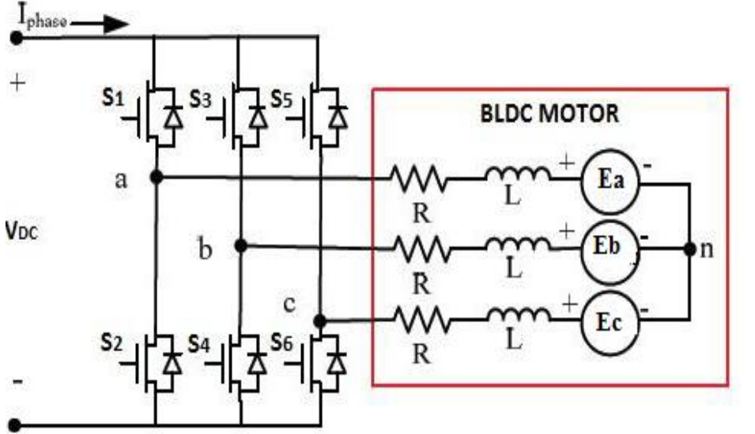
Fig.1 Equivalent circuit of a BLDC motor connected to an inverter [3]
A three-phase BLDC motor with a trapezoidal flux distribution and typical back EMF waveforms are illustrated in Fig. 3.
As can be seen, the back EMF created per phase of the motor winding changes linearly with rotor angle before and after the constant section of 120°. The BLDC motor's phase voltage equations can be expressed as,
$$Va=Ra.Ia+L\left(\frac{dIa}{dt}\right)+Ea…….\left(1\right)$$
$$Vb=Rb.Ib+L\left(\frac{dIb}{dt}\right)+Eb…….\left(2\right)$$
$$Vc=Rc.Ic+L\left(\frac{dIc}{dt}\right)+Ec…….\left(3\right)$$
Were,
$$Ia, Ib \& Ic=Phase current$$
$$Va, Vb \& Vc=Phase voltage$$
$$Ea, Eb \& Ec=Back EMFs$$
The expression for Back EMFs are expressed as
$$Ea=Ke.ωm.F\left(θe\right)……\left(4\right)$$
$$Eb=Ke.ωm.F\left(θe-\frac{2π}{3}\right)…….\left(5\right)$$
$$Ec=Ke.ωm.F\left(θe+\frac{2π}{3}\right)…….\left(6\right)$$
Were,
$$ωm=angular speed of the rotor$$
$$θm=Mechanical angle of rotor$$
$$θe=electrical angle of rotor$$
$$F\left(θe\right)=Back-EMF reference function of rotor position.$$
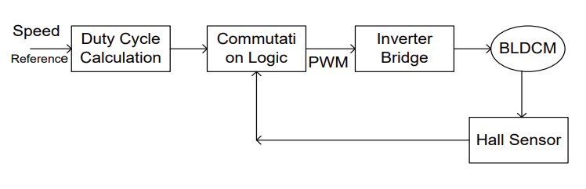Fig.2 Open Loop control of BLDC Motor [3]
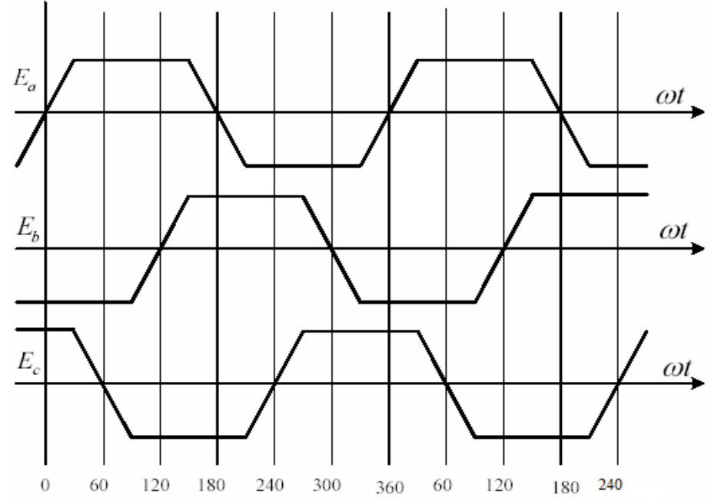Fig. 3 Trapezoidal back EMF of three phase BLDC motor [3]
In this study, they assume that hall sensors are being used to gather the rotor data. The real rotor position is sensed by the 120-degree-apart Hall position sensors [3].
- Hardware development using arduino
This method demonstrates how to use an Arduino and the PWM technique to control the speed of a brushless direct current (BLDC) motor. There are various methods for controlling the speed of BLDC motors, but they are often rather expensive and have significant operational restrictions. An Arduino Uno board is utilized along with PWM approach because they are cutting-edge, affordable, and can be used in numerous appliances, robotic automation, small-scale companies, etc. Between the Arduino and the BLDC motor is an ESC. It is a motor driver circuit that is used to modify an electric motor's speed. The Arduino is powered by the regulated 5V provided by this ESC. Stator and rotor are the two components that make up a BLDC motor. The stator winding needs be energized in a specific order to turn the BLDC motor. The potentiometer can be used to control the motor speed via Arduino. We can control the current that is sent to drive a BLDC motor in the form of PWM waves with the aid of a potentiometer [4].
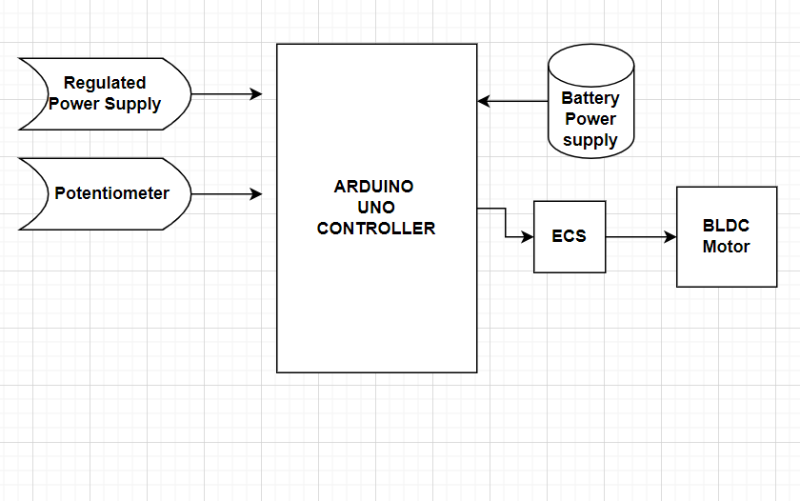
Fig.4 Proposed Schematic Diagram of Hardware Development [4]
- Tuning of PID using Simulink
Finding the ideal value for three unknown controller parameters is Known as of PID tuning. ZNM is frequently used to adjust PID controllers. The procedures used in this method are:
1. Switch the control to P-only, which turns off the integral and derivative controls.
2. Gradually increase the controller gain, Kc, and watch the output reaction.
Fig 5 defines and displays the values of Kc, and. An alternative to the numbers mentioned above has also been established for PI and PID, and is known as the TLC tuning guidelines. These numbers typically lessen oscillatory effects while enhancing robustness. The guidelines for TLC tweaking are outlined in Fig 6 [5].
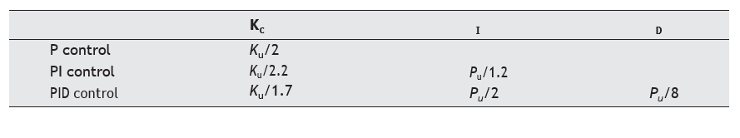
Fig.5 Values for Es, I and D using €NM [5]
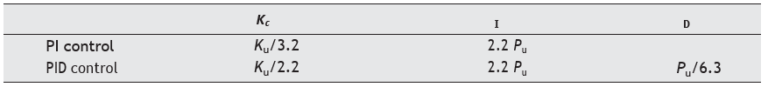
Fig.6 Values of I and D using TLC [5]
- Simulink Modelling
For modelling, simulating, and analyzing dynamical, linear, and non-linear systems that are modelled in continuous time, sampled time, or a combination of the two, SIMULINK is a MATLAB-based software suite. Simulink offers a graphical user interface (GUI) for creating block diagram models by clicking and dragging with the mouse [5].
Figure 7 depicts the structure of a typical feedback control system
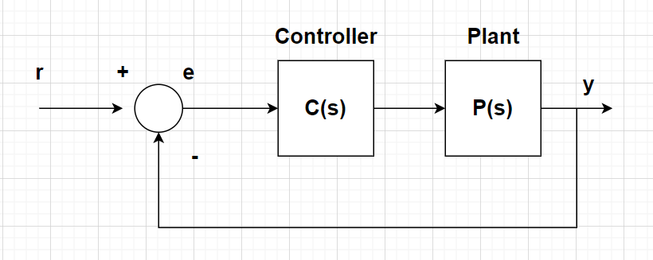
Fig. 7 Feedback control system [4]
The speed control using PID controller consists of 3 components namely K_{p}, K_{i} and K_{d} Equation 7 describes them and their role in speed control [4].
$u(t)=K_{p}e(t)+K_{i}∫e(t)dt+K_{p}\frac{de}{dt}$…. (7)

IV- RESULT & DISCUSSION
This review article helps in determining the various types of Speed Control for DC as well BLDC Motor under different Modeling condition, to know the Speed control ratio of different types of method with its boundary’s one can research most unique way to control the speed.
In order to improve the speed control of these kinds of motors, the Proportional Integral Derivative (PID) algorithm is the simplest form to control the speed, in this study to describe the design of the BLDC & DC motor speed control system. The overview of the PID & other logics was derived for controller's functionality and to design is the review’s main goal. When compared to other controllers, the PID regulator is much more applicable, better operational, and effective at attaining sufficient control performance, according to the study's final set of well-functioning tests.
V-CONCLUSION
Most of the journal were reviewed and different analysis were studied on the control of Speed for DC & BLDC Motor and were illustrated on PID, PWM hysteresis & Hardware development using Arduino uno each of the results shows different criteria of Controlling with its unique strategy condition MATLAB/SIMULINK software’s and other software helps in Analyzing the Control of speed criteria with minimum cost on Analyzing. Hence the paper reviewed are sorted with Equations.
REFERENCES
- Aditya Pratap Singh, Udit Narayan & Akash Verma “Speed Control of DC Motor using Pid Controller Based on Matlab” SSN 2222-1727 (Paper) ISSN 2222-2871 (Online) Vol.4, No.6, 2013 - Selected from International Conference on Recent Trends in Applied Sciences with Engineering Applications.

- Aditya Pratap Singh, Udit Narayan & Akash Verma “Speed Control of DC Motor using Pid Controller Based on Matlab” SSN 2222-1727 (Paper) ISSN 2222-2871 (Online) Vol.4, No.6, 2013 - Selected from International Conference on Recent Trends in Applied Sciences with Engineering Applications.

- IoanDoroftei; Victor Grosu and VeaceslavSpinu; “Omnidirectional mobile robot- Design and Implimentation” from “Gh.Asachi” Technical university of lasi, Romania.

- Olaf Diegel, AparnaBadave, Glen Bright, Johan Potgieter, Sylvester Tlale, (2002) “Improved Mecanum Wheel Design for Omni-directional Robot”, Australasian Conference on Robotics And Automation, Auckland.

- S. Balamurugan, A. Umarani,” Study of Discrete PID Controller for DC Motor Speed Control Using MATLAB”, 2020 International Conference on Computing and Information Technology, University o f Tabuk, Kingdom o f Saudi Arabia.Volume: 01, Issue: ICCIT- 1441, Page No.: 358 - 363, 9th & 10th Sep. 2020.

- Yavuz Bahadır Koca, Yılmaz Aslan & Barış Gökçe” Speed Control Based PID Configuration of a DC Motor for An Unmanned Agricultural Vehicle”, 2021 8th International Conference on Electrical and Electronics Engineering.

- Sagar J. Dahile “ DC MOTOR CONTROL USING PID CONTROLLER”, International Research Journal of Engineering and Technology (IRJET) e-ISSN: 2395-0056 Volume: 07 Issue: 06 | June 2020.

- Fatiha Loucif” DC MOTOR SPEED CONTROL USING PID CONTROLLER” ICCAS2005 June 2-5, KINTEX, Gyeonggi-Do, Korea.

- V. V. Kulkarni, Dr. V. A. Kulkarni & Romharshal Talele “PID Controller based DC Motor Speed Control” International Journal on Recent and Innovation Trends in Computing and Communication ISSN: 2321-8169 Volume: 5 Issue: 9

- Kapil Ghuge1, Prof. Manish Prajapati & Prof. Ashok Kumar Jhala “DESIGN OF ADAPTIVE FUZZY PID CONTROLLER FOR SPEED CONTROL OF BLDC MOTOR” IJIRSE march 2016 Vol. No.2.

- Md Mahmud, S. M. A. Motakabber, A. H. M. Zahirul Alam, Anis Nurashikin Nordin “Control BLDC Motor Speed using PID Controller” (IJACSA) International Journal of Advanced Computer Science and Applications, Vol. 11, No. 3, 2020.

- Hardik S Jain, AkshatPalak, SandeshAgrawal, Krishnam Tibrewal, Malaya Kumar Hota “DC Motor Speed Control using PID Controller, IR Sensor and PWM Hysteresis” International Journal of Innovative Technology and Exploring Engineering (IJITEE) ISSN: 2278-3075, Volume-8 Issue-6, April 2019.

- R.G.Rajesh, C.Balaji “Speed Control of BLDC Motor Using PID Controller” International Journal of Advanced Research in Electrical, Electronics and Instrumentation Engineering (An ISO 3297: 2007 Certified Organization) Vol. 3, Issue 4, April 2014

- R. M. Pindoriya, S. Rajendran, P. J. Chauhan “ Speed Control of BLDC Motor using PWM Technique" International Journal of Advance Engineering and Research Development (IJAERD) ETCEE-2014 Issue, March 2014, e-ISSN: 2348 - 4470 , print-ISSN:2348-6406.
- Dr.B.Venkata Prasanth,M.Tech., Ph.D., V.Venkata Swathi, N.Niranjan, N.Vamsi “SPEED CONTROL OF BLDC MOTOR USING ARDUINO & PWM TECHNIQUE” Volume 12, Issue 7, 2021 ISSN NO: 0898-3577 Compliance Engineering Journal.

- Hari om bansal “ Tuning of PID Cotrollers using Simulink. IJMMSA ISSN: 0973-8355 Vol. 2 2009pp.

- Mirza Muhammad Sabir1 and Junaid Ali Khan “Optimal Design of PID Controller for the Speed Control of DC Motor by Using Metaheuristic Techniques” Hindawi Publishing Corporation Advances in Artificial Neural Systems Volume 2014, Article ID 126317, 8 pages

