Lithium-Ion Batteries for Electric Vehicles: Capacity Improvement and Extended Backup Techniques
Vijay Santosh Tawar¹, Machchhindra Jibhau Garde², Deepa Bansilal Maheshwari³
¹Assistant Professor – Department of Electronics & Telecommunication Engineering,  0009-0001-4093-7020
SSVPS’ B. S. Deore College of Engineering, Dhule, India, 424002
²Assistant Professor – Department of Electronics Engineering, 0009-0007-1882-5878
SSVPS’ B. S. Deore College of Engineering, Dhule, India, 424002
³Assistant Professor – Department of Electronics & Telecommunication Engineering, 0000-0002-6685-3909
Government College of Engineering, Amravati, India, 444604

Email of Corresponding Author: kvtawar@gmail.com
Received on: 6 May,2025 Revised on: 08 June,2025 Published on: 10 June,2025

Abstract – The swift advancement of lithium-ion batteries (LIBs) is central to the performance and sustainability of electric vehicles (EVs). The paper documents considerable improvements in cathode and anode materials, electrolyte design, and new manufacturing processes like nanotechnology and 3D printing. Intelligent battery management systems (BMS) and thermal management maximize longevity and efficiency, while wireless and fast charging solutions enhance convenience. The future of LIBs is solid-state batteries and AI-based diagnostics that meet the safety requirements and energy density. Recycling and sustainability are also significant to reduce the environmental impact further. All of these technologies are converging into the next-generation high-performance, long-duration, and sustainable EV battery.
Keywords – lithium-ion batteries (LIBs), Battery Management System (BMS), State of Charge (SOC), State of Health (SOH), Electric Vehicle (EV).
- INTRODUCTION

The global trend toward environmentally friendly transport has seen tremendous research and development of electric vehicles (EVs). At the core of this technology is the lithium-ion battery (LIB), which is celebrated for its high energy density, efficiency, and long cycle life [5]. Despite all these advances, however, issues of limited driving range, long charging times, and battery degradation still persist [6]. This paper summarizes notable advances in enhancing the capability and prolonging the backup of LIBs for EV use, providing an overall discussion of material development, manufacturing processes, and management technologies [7].
II. LITHIUM-ION BATTERY FUNDAMENTALS
LIBs consist of a cathode, anode, electrolyte, and separator. The performance of the batteries relies on the design and material of these components [8, 9]. The physical structure of Lithium-Ion Battery is as shown in Figure 1.

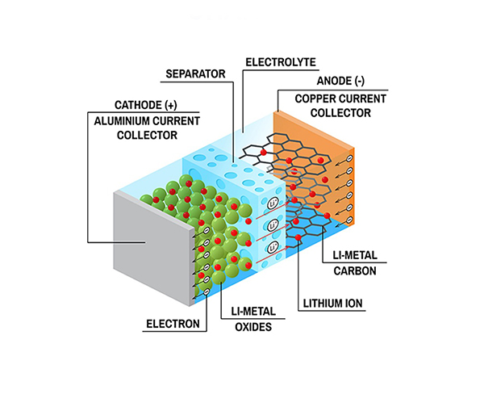

Figure 1: Lithium-Ion Battery Components
II [A] CHEMICAL CONSTITUENTS OF EV BATTERY
Cathode Materials: Common materials are lithium cobalt oxide (LCO), lithium manganese oxide (LMO), and lithium iron phosphate (LFP). New advancements center on nickel-cobalt-manganese (NCM) and nickel-cobalt-aluminum (NCA) cathodes, capacity offering enhancement [10]. NCM and NCA materials also demonstrated staggering gains in energy density and stability, critical to increasing EV range [11].
Anode Materials: Graphite is widely utilized due to its stability and capacity. Silicon anodes are under investigation for their higher theoretical capacity, although volume expansion problems exist [12]. Silicon-carbon composite and other new materials are being studied to solve such issues and provide improved performance [13]. Comparison Cathode and Anode Materials on the basis of Energy Density and Life Cycle of materials is as shown in Figure 2.
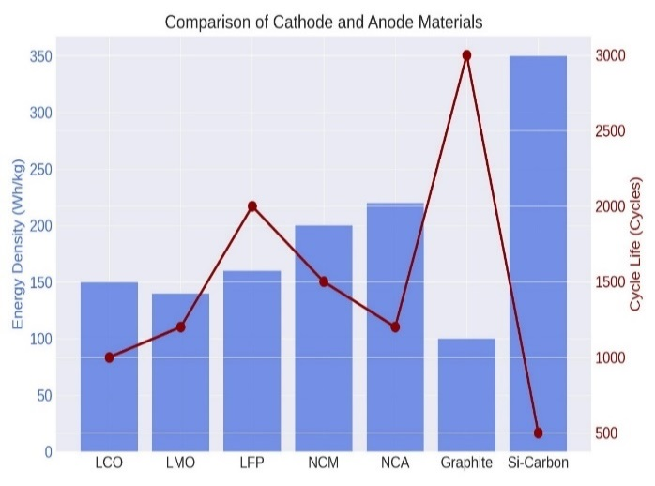

Figure 2: Comparison of Cathode and Anode Materials

II [B] ELECTROLYTE AND SEPARATOR
Electrolyte: Liquid electrolytes, usually lithium salts in organic solvents, enable the ion transport. Solid electrolytes are also under investigation to enhance safety and thermal stability [14]. Developments in electrolyte additives also contribute significantly to the improvement of battery performance and life.
Separator: This feature prevents short circuits but allows for ion flow. New technologies focus on improved mechanical strength and thermal stability. Technologies involve ceramic-coated separators and multi-layer separators that improve performance and safety [15].
III. BATTERY CAPACITY IMPROVEMENT TECHNIQUES
Boosting the LIB capacity is essential to improve the EV range [3]. Techniques can be compared with numerous methods, but mostly done with respect to selection of materials, advance manufacturing strategies and optimization of electrolytes.
III [A] HIGH-CAPACITY CATHODE AND ANODE MATERIALS
Cathode: High-capacity material research involving NCM811 and NCA has indicated significant gains in terms of raising energy density [6]. More nickel is added in these materials, which contributes to capacity but raises issues about thermal stability as well as cycle life [9].
Anode: Silicon anodes are under development to substitute graphite with much better capacity but with problems of cycle life and stability. Advances in nanostructured silicon and silicon-carbon composites are overcoming these problems, enhancing capacity and cycling stability [8].
III [B] ADVANCED MANUFACTURING METHODS
Nanotechnology: Addition of nanomaterials can enhance electrode performance by adding surface area and enabling electrochemical reactions. Nanostructured materials provide enhanced ion diffusion and electron conductivity, resulting in higher capacities and longer life cycles [12].
3D Printing: This method enables accurate control of electrode structure, improved energy density, and lower production cost [5]. Electrodes printed with 3D technology can have complex geometries that maximize performance and utilization of materials.
III [C] ELECTROLYTE OPTIMIZATION
Solid-State Electrolytes: They are energy-dense and safer than liquid electrolytes [13]. They are looking for materials that are highly stable and ionic in nature. Solid-state batteries are safer and energy-dense but difficult to manufacture and unstable in interfaces [10].
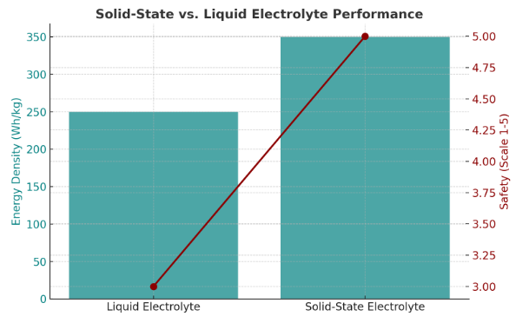
Liquid-State Electrolyte: In lithium-ion batteries (LIBs), liquid-phase electrolytes are usually non-aqueous systems made of organic solvents such as ethylene carbonate (EC) and dimethyl carbonate (DMC) mixed with LiPF₆ salt to aid ion transport. Such electrolytes are stable under voltage (>4V) but are hazardous due to flammability and toxicity [11]. Ionic liquid electrolytes promote increased power density and safety at the expense of high viscosity and cost. Future development seeks improvements in safety, conductivity, and cycle life accompanied by risk diminution associated with organic solvents [14]. Performance based comparison of Solid-State vs. Liquid Electrolyte with respect to safety and energy density is as shown in Figure 3.

Figure 3: Solid-State vs. Liquid Electrolyte Performance
IV. LONG-TERM (EXTENDED) BACKUP METHODS
Increasing the extension of the backup, or functional lifespan, of LIBs is central to the economic and environmental sustainability of EVs [6].
IV [A] THERMAL MANAGEMENT SYSTEMS
Active Cooling: Liquid cooling technology is effective in managing battery temperature, avoiding overheating and prolonging battery life [7]. Active cooling technologies like liquid or air cooling can keep operating temperatures at their best level, increasing performance and longevity [9].
Passive Cooling: Heat sinks and phase change materials are used to spread heat without requiring any additional energy [4]. Passive cooling technologies, such as the use of phase change materials and novel thermal management coatings, keep battery temperatures at safe levels, which increases safety and longevity. Thermal management system on the basis of temperature control efficiency and battery degradation reduction is as shown in Figure 4.
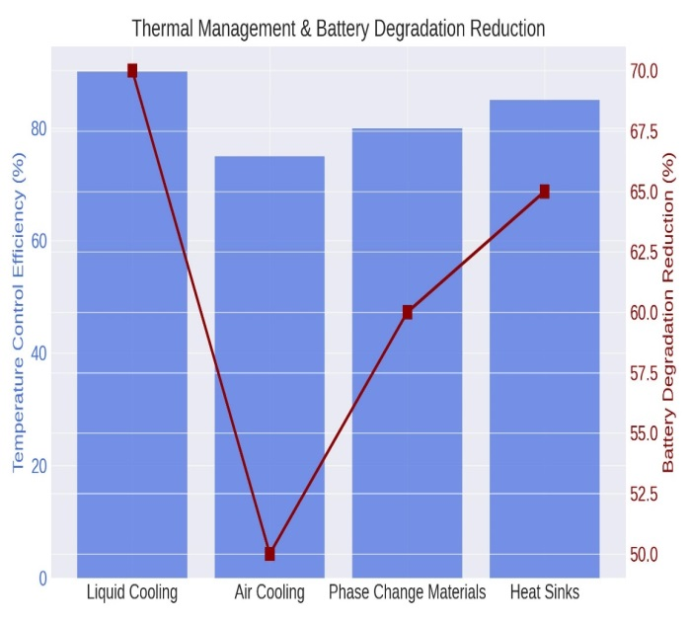

Figure 4: Thermal Management Systems
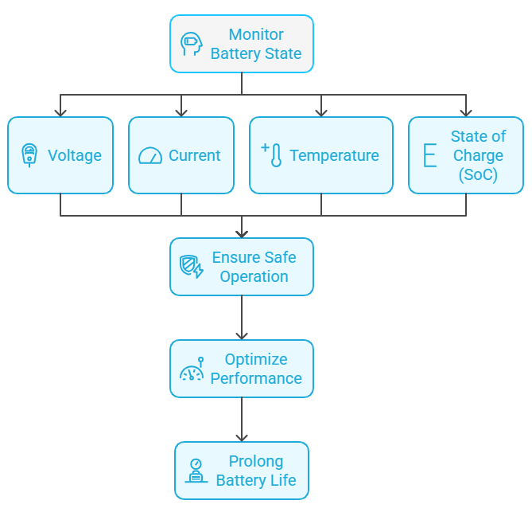
IV [B] BATTERY MANAGEMENT SYSTEMS (BMS)

Figure 5: Battery Management Systems Components

State of Charge (SOC) Estimation: Proper SOC estimation guarantees optimal battery utilization and avoids overcharging or deep discharge [1]. More advanced algorithms and machine learning methods are being created to enhance SOC accuracy, which contributes to improved better battery performance and safety [11].
State of Health (SOH) Monitoring: Online monitoring of the battery's health predicts and avoids degradation, hence prolonging the lifecycle of the battery [10]. Impedance spectroscopy and data models are utilized in BMS to offer online health diagnosis and predictive maintenance [15]. A typical system flow diagram for Battery Management System (BMS) Components is as shown in Figure 5.
IV [C] CHARGING TECHNIQUES
Fast Charging: Convenient, yes, but life-degrading on the battery [2]. Better charging protocols and technologies in the works are going to make trade-offs between speed and life [8]. Smart charging algorithms that learn about the battery condition and environment, minimize stress, and maximize life are one of them.
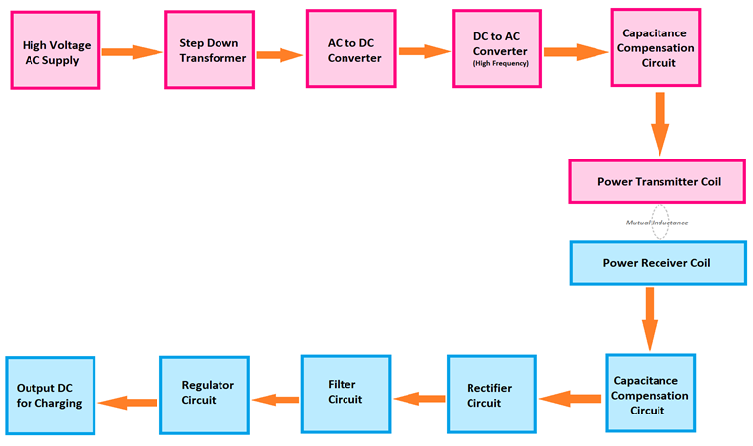
Wireless Charging: Inductive charging is convenient and potentially could provide greater battery life with the removal of physical connector wear and tear [5]. Efforts aim to improve efficiency and power transfer rates, and wireless charging holds potential for EVs [6]. A typical wireless charging system is as shown in Figure 6.

Figure 6: Wireless Charging System Components

V. FUTURE PERSPECTIVES
The future of LIBs for EVs is in ongoing material innovation, more effective manufacturing technologies, and better management systems. Studies are underway on areas like solid-state batteries, advanced anode materials, and integrated BMS technologies [9].
V [A] SOLID-STATE BATTERIES
Solid-state batteries are the future of LIBs, with outstanding improvements in safety and energy density [12]. Studies now focus on addressing issues of ionic conductivity, interfaces, and scaling up manufacture.
V [B] ADVANCED ANODE MATERIALS
The progress in high-performance anode materials, like lithium metal and silicon anodes, holds great future capacity and energy density gain potential [8]. These materials exhibit stability and cycling performance concerns, which need innovative solutions in material science and electrolyte engineering.
V [C] INTEGRATED BATTERY MANAGEMENT SYSTEMS
Next-generation BMS will possess sophisticated diagnostic and prognostic functions based on big data and machine learning to maximize battery performance and longevity. These will offer real-time monitoring and adaptive control with better safety and efficiency [7].
V [D] RECYCLING AND SUSTAINABILITY
With greater EV adoption and increasing supply chain stress, LIB sustainability is more important than ever [14]. Improving recycling technology and developing green materials will be essential to reducing the environmental footprint of LIB manufacturing and disposal.
VI. RESULT & DISCUSSION
Lithium-ion battery (LIB) technology in electric vehicles (EVs) has made improvements in energy density, safety, and cycle life much greater [14]. High-capacity cathode materials such as NCM811 and NCA contribute to energy storage capacity, and silicon-based anodes promise high capacity with stability issues [11]. Electrolyte technologies such as solid-state ones boost performance and safety but are impacted by production complexity. Advanced manufacturing technologies, nanotechnology, and 3D printing enhance the efficiency of electrodes by increasing capacity and life [5]. Active and passive cooling for effective thermal management avoids degradation, and intelligent battery management systems (BMS) maximize State of Charge (SOC) and State of Health (SOH), providing extended battery life [15]. Wireless and quick charging technologies offer improved user experience but must be optimized with great care to meet demands of performance and longevity [11]. Studies of the future will focus on solid-state batteries, advanced anode materials, and AI-powered BMS for on-time diagnostics. Recycling operations also will be environment-friendly for curtailing environmental prints and for maximizing resource preparedness.
VII. CONCLUSION
Electric cars keep improving due to lithium-ion batteries. Capacity and backup advancements have come from improvements in material, manufacturing, and management system ends. More capability remains to be developed to enhance performance and in-road realization since LIBs only serve intended sites and atmospheric conditions. This in-depth overview recapitulates the main developments and findings on the evolution towards the advancements, emphasizing the need for a multimodal design strategy towards improving LIB performance for electric vehicle (EV) applications.
REFERENCES
- Silva-Vera, E. D., & Valdez-Resendiz, J. E. (2025), Data-Driven Modeling of Battery-Based Energy Storage Systems, IEEE Transactions on Vehicular Technology.
- Dey, A., Mondal, S., Chakraborty, B., & Dalai, S. (2025), Online Internal Resistance Computation Based Early Sensing of Thermal Runaway for Smart Fault Handling System (FHS) of Li-ion Batteries, IEEE Embedded Systems Letters.
- Karmakar, S., Bohre, A. K., & Bera, T. K. (2025), Recent Advancements in Cell Balancing Techniques of BMS for EVs: A Critical Review, IEEE Transactions on Industrial Electronics.
- Ruiz, P. L., Damianakis, N., & Mouli, G. R. C. (2025), Physics-based and Data-driven Modeling of Degradation Mechanisms for Lithium-Ion Batteries: A Review, IEEE Access.
- Li, W., Lin, C., Hosseininasab, S., Bauer, L., & Wu, H. (2025), Lithium-ion Battery SOH Estimation Based on a Long Short-Term Memory Model Using Short History Data, IEEE Transactions on Power Electronics.
- Xie, Y., Ma, W., Li, W., Yang, R., & Hu, X. (2025), A Mechanism-Data Driven Self-Adaptive Online Estimation Algorithm for Three-Dimensional Temperature Distribution of Battery, IEEE Transactions on Power Electronics.
- Wang, Y., Sun, L., Wang, S., Zhu, Y., & Hilal, A. (2025), An Integrated Heating-Charging Method for Lithium-Ion Batteries at Low Temperature, IEEE Transactions on Energy Conversion.
- Zhu, R., Peng, W., Yang, F., & Xie, M. (2025), Fast Charging Protocols Design of Lithium-ion Battery: A Multiple Objective Bayesian Optimization Perspective, IEEE Transactions on Smart Grid.
- Fereydoonian, M., Lee, K., & Kiriella, C. (2025), Closing the Loop on Circular Economy in Transportation Electrification: Reuse, Repurposing, and Recycling of Batteries, Power Electronics, and Electric Machines, IEEE Journal of Emerging and Selected Topics in Power Electronics.
- Bao, Z., He, Z., Wang, C., Lin, H., & Wu, X. (2025), An Exponential Transformer for Learning Interpretable Temporal Information in Remaining Useful Life Prediction of lithium-ion Battery, IEEE Transactions on Industrial Electronics.
- Fan, Y., Zhang, Z., Tian, J., Kuang, H., & Li, M. (2025), Online Estimation of Model Parameters and State of Charge for Lithium-Ion Battery Using Multitimescale Recurrent Neural Networks, IEEE Transactions on Power Electronics.
- Xie, R., Liu, C., Zhou, M., Chen, X., & Mao, X. (2025), An Interoperable Receiver With Reconfigurable LCC Compensation for Wireless Charging of 400 and 800V Batteries in Electric Vehicles, IEEE Transactions on Transportation Electrification.
- Ghosh, N., Garg, A., Warnecke, A., & Meliopoulos, A. P. S. (2025), Transfer Adaptive Digital Twin for Cross-Domain State of Health Estimation of Li-ion Batteries, IEEE Transactions on Smart Grid.
- Ipek, E., Bilgin, C., Yordem, M., & Iscanoglu, Y. (2025), Impact of Driving Cycles and Terrain on the Performance and Cost of EV Battery Chemistries: A Comparative Analysis and Evaluation, IEEE Access.
- Mendu, B., Malele, R. H., & Monchusi, B. B. (2025), Microcontroller-Driven Battery Management in Hybrid Energy Systems: A Systematic Review of Applications, Control Strategies, and Emerging Trends, IEEE Access.

