ANALYSIS AND DESIGN OF FLAT SLABS USING DIFFERENT CODES AND SOFTWARE – A COMPARATIVE STUDY

S.R.Gajbhiye¹, P.E. Sangode²
(Assistant professor, Department of civil engineering),
Smt. Radhikatai Pandav College of Engineering Nagpur-440009

Abstract – Flat chunks arrangement of development is one in which the shafts utilized in the traditional techniques for developments are discarded. The section straightforwardly lay on the segment and burden from the chunk is specifically exchanged to the segments and afterward to the establishment. To help overwhelming burdens the thickness of piece close to the help with the section is expanded and these are called drops, or segments are for the most part given developed heads called segment heads or capitals. Nonattendance of pillar gives a plain roof, hence giving better structural appearance and furthermore less defenselessness if there should be an occurrence of flame than in common situations where bars are utilized. Plain roof diffuses light better, less demanding to develop and requires less expensive structure work. According to nearby conditions and accessibility of materials diverse nations have received distinctive strategies for plan of level sections and given their rules in their individual codes. The point of task is to attempt and show the strategies utilized for level section configuration utilizing IS 456:2000, ACI-318 and NZS:3101 configuration codes and near dialog with in them. For completing venture an inside board of a level piece with measurements 6.6 m x 5.6 m and very forced burden 7.75 kN/m2 was structured utilizing the codes given above and level chunk of a current structure.
Keywords- Flat slab with type, IS 456:2000, ACI-318, NZS: 3101, SAP: 2000 etc…
INTRODUCTION
Flat chunks arrangement of development is one in which the shafts utilized in the traditional techniques for developments are discarded. The section straightforwardly lays on the segment and burden from the chunk is specifically exchanged to the segments and afterward to the establishment. To help overwhelming burdens the thickness of piece close to the help with the section is expanded and these are called drops, or segments are for the most part given developed heads called segment heads or capitals. Nonattendance of pillar gives a plain roof, hence giving better structural appearance and furthermore less defenselessness if there should be an occurrence of flame than in common situations where bars are utilized. Plain roof diffuses light better, less demanding to develop and requires less expensive structure work. According to nearby conditions and accessibility of materials diverse nations have received distinctive strategies for plan of level sections and given their rules in their individual codes. The point of task is to attempt and show the strategies utilized for level section configuration utilizing IS 456:2000, ACI-318 and NZS:3101 configuration codes and near dialog with in them. For completing venture an inside board of a level piece with measurements 6.6 m x 5.6 m and very forced burden 7.75 kN/m2 was structured utilizing the codes given above and level chunk of a current structure.
In level piece basic frameworks, the issue of punching shear because of high transverse shear worry at the slab– segment associations emerges. The chunk segment associations in structure have strengthening point of interest proper for gravity load plan and consequently might not have the ability to continue disfigurement amid the tremor. The presence of openings in the region of a segment decreases the territory of solid that can oppose transverse shear, which makes the slab– segment association considerably more fragile. In any case, the innovation has seen substantial scale utilize just in the most recent decade and is one of the quickly creating advances in the Indian structure industry today. Material advances in solid quality accessible for development, improvement in nature of development; simpler structure and numerical procedures has added to the fast development of the innovation in India. Flat sections arrangement of development is one in which the bars utilized in the customary strategies for Constructions. The piece legitimately lay on the segment and burden from the section is straightforwardly exchanged to the segments and after that to the establishment. To help substantial burdens the thickness of chunk close to the help with the section is expanded and these are called drops, or segments are by and large furnished with developed heads called segment heads or capitals. Nonattendance of bar gives a plain roof, in this manner giving better design appearance and furthermore less weakness. According to nearby conditions and accessibility of materials diverse nations have embraced distinctive techniques for plan of level sections and given their rules in their particular codes. The point of this undertaking is to attempt and delineate the techniques utilized for level chunk configuration utilizing IS 456:2000, ACI-318 and NZS:3101 and configuration codes. Level sections are less work escalated, streamline the establishment of administrations and can suit more floors inside confined statures. In any case, the range affecting their structure is the longest and they require more steel contrasted with two-way pieces. Different disadvantages of level sections are helplessness to punching shear disappointment and higher redirections. To abstain from punching shear disappointment drop boards, segment heads or shear fortification are utilized. On the off chance that range in level pieces is diminished, at that point both redirection and punching shear issues can be evaded. Be that as it may, planners want to have few uncovered sections in usable regions. This unavoidably prompts sections in an unpredictable design, covered up inside segments or dividers.
OBJECTIVE
This project is organized in to 3 chapter, the contains of chapter are as follow.
- Plan of existing building located at Nagpur will be study by IS-456,ACI-318,NZS:3101.
- Analysis and design existing building by SAP 2000.
- Comparing the results of manual calculation and software.

METHODOLOGY
Selection of site

Observation of type of slab
Designing of Existing Building by IS:456, ACI-318, NZS:3101

Analysis of Building by using Software (SAP-2000)

Comparison between by results obtained between by manually (By IS: 456, ACI-318, NZS:3101) and Software(SAP-2000)
Selection of site
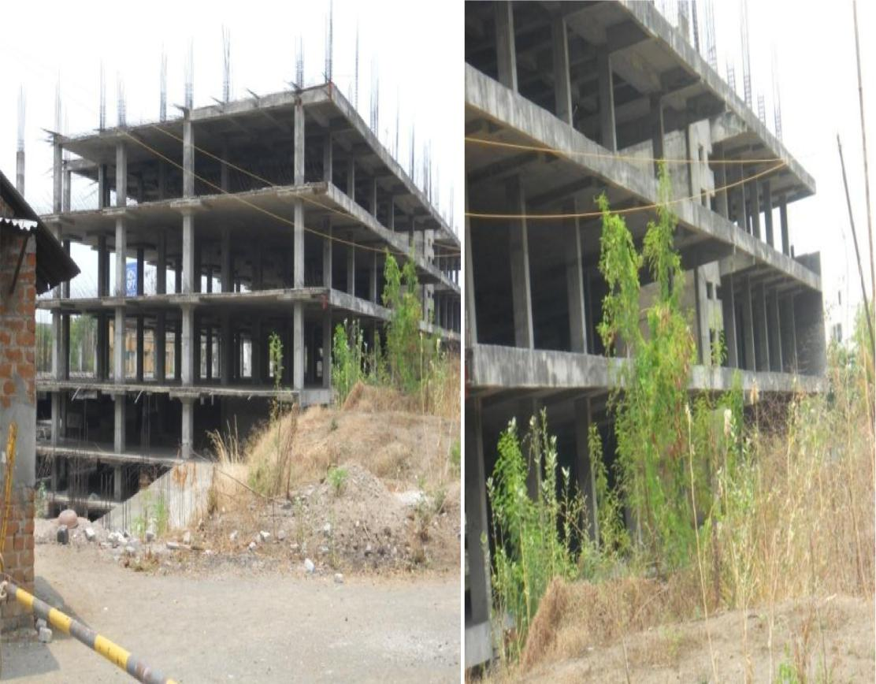
This building is N Kumar building located as Khambla road Nagpur, flat slab with drop panel for comparison of this system with conventional beam column framed system.

Fig.1 Flat slab with Drop panel

Fig.2 Flat slab with Drop panel

Observation of type of slab
The building floors are provided with flat slab with drop panel with no column head. It has a good architectural appeal. The building floor is 42mx42m, having five equal panels of 8.4mx8.4m in each direction. The edge beams of size 500x400 mm deep are provided. For analysis and design purpose an interior panel is selected.
The analysis & design is carried out with the help of design given in IS456: 2000 Revised. The Direct Design method is adopted for the analysis & design purpose. The calculation details of analysis and design of Flat slab with Limit State Method.
Designing of Existing Building by IS: 456, ACI-318, NZS:3101
Table: comparison of existing building by above 3 codes
Sr.No |  | IS 456: 2000 | ACI-318 | NZS: 3101 | by  software
1 | -ve moment  (kN-m) | 665.23 | 434.91 | 494.65 | 681.17
2 | +ve moment  (kN-m) | 286.56 | 187.34 | 415.51 | 116.129
3 | Ast for –ve B.M  (mm²) | 5296.1 | 7225.9 | 8229.7 | 5002
4 | Ast for +ve B.M  (mm²) | 3704.4 | 3569.8 | 3563.6 | 3801

CONCLUSION
From the investigation consequence of level chunk it is discovered that the outcome acquired by programming is almost same as that of manual examination result. The estimation of section strip, center strip, drop measurement and segment head measurement is same in IS 456:2000, ACI-318 and NZS: 3101 codes.
Evaluation of cement in IS: 456 and ACI-318 code is 20 N/mm2 yet relatively in NZS-3101 code the evaluation of cement is 30 N/mm2. Evaluation of steel in IS: 456 and ACI-318 code is 415 N/mm2 yet relatively in NZS-3101 code the quality of steel is 300 N/mm2.
In IS 456:2000 steel required is not exactly other 2 codes. Shear quality relies upon an intensity of fc' under 0.5 and progressively like the solid shape root relationship. ACI code overestimates the impacts of cement compressive quality on the punching opposition of HSC chunks.
REFERENCES
1. Ahuja V., Ahuja B.M., 2009, “Post tension flat slabs earthquake engineering & misc aspects in high seismic zones in the india environment”, pp 2-4.
2. Baskaran K.,2007, “Irregular flat slabs designed according to structural membrane Approach”, department of civil engineering. University of Moratuwa., Sri Lanka., No.23, july 2007, pp 27-33.
3. Bharath G.N., Gowda S. B. R., Chandrashekar A.V.,2012, “Review and Design Flat plate/Slabs Construction in India”.,Basaveshwara Nagar., Bangalore.,pp 1-4
4. Durate I., Ramos A.M.P., Lucio V.J.G.,2008, “strengthening of flat slabs with transverse Reinforcement”, UNIC - Research Center in 7. George E.L., Athina T.B., Stergios A.M., Theodoros A.C., Ioannis A.T., “Applications of flat-slab r/c structures in seismic regions”, Aristotle University of Thessaloniki., Department of Civil Engineering,pp 1-5.
8. Gerard C.,Feldmann.,2012, “Non destructive testing of reinforced concrete”.
9. Gilbert R.I.,1985 “Deflection control of slabs using allowable span to depth ratio”, Institute publication policies., Department of civil engineering.,pp 1-6 10.Jonathan H., 2009, “Accurate Long-Term Deflection Prediction in Flat Slabs Using Linear Elastic Global Analysis”, Development Manager, Bentley Systems, Inc.
11. Kim J., Kim T., Choi H., 2000, “Performance Evaluation of Non-seismic Designed Flat-Plate structures”, Department of Architectural Engineering, Sungkyunkwan University, Republic of Korea, pp 1-3.
12. Losilevskii Y.A.,1978, “Density of status of quasiparticles in an anisotropic flat slab”, Iarael institude of technology.
13. Luo Y.H.,Durrani A.J., Conte J.P.,1994, “Equitant frame analysis of flat plate buildings for seismic loading”, journal of structural engineering.,vol.120, pp 2137-2153
Structures and Construction of UNL Department to de Engenharia Civil Faculdade de Ciencias e Tecnologia., Universidade Nova de Lisboa.
5. Erberik M.A., Lnashai A.S., 2004, “Vulnerability analysis of flat slab structures”, 13th World Conference on Earthquake Engineering., Vancouver, B.C., Canada.,pp 2-14
6. Finze E.S., Jeffrey M. Trop J.M., RidgwayK.D., Enkelmann E.,2005, “Upper plate proxies for flat-slab subduction processes in southern Alaska”, Dept. of Earth and Atmospheric Sciences, Purdue University, West Lafayette, IN 47907, USA.
14. Mehanny S.S.F.,Sobhy B.M.,Bakhoum M.M., 2008, “Strength versus drift limitation effects on code-compliant seismic-resistant flat slab buildings”, Associate Prof., 2Post-Graduate Researcher, 3Professor, Structural Engg. Dept., Cairo University, Egypt, pp 1-2.
15. Nguyen-minh N., Rovňák M., Tran-quoc T., Nguyen-kim K., “Punching shear resistance of steel fiber reinforced concrete flat slabs”, Division of Structural Design, Faculty of Civil Engineering.
16. Menon, D., Pillai, S.U., 2008, “reinforced concrete design”, second edition
17. Murali G., Jayavelu K.R., Jeevitha N., Rubini M., and Saranya N.R., 2012,
18.Robertson I.N.,Kawai T., Lee J.,Enomoto B.,2000, “Seismic performance of flat-slab shear reinforcement”, Associate Professor., University of Hawaii at Manoa., Hawaii, USA.
19. Ruiz M.F., Muttoni A.,Kunz J.,2010, “Strengthening of flat slabs against punching shear using post-installed shear reinforcement”, ACI structural journal., vol.107,no 4

