Object Based Vehicle Track Navigation System
Divyaprakash Shamrao Koli¹, V. D. Chaudhari², Dr. A. D. Vishwakarma³, H. T. Ingale⁴
¹PG student, VLSI&ESD. ^{2,4}Asstt. Professor, ³Asso. Professor
^{1,2,3,4} E&TC Engg Dept, GF’s Godavari College of Engineering, Jalgaon, India, 425003,

dp.divy@live.in¹, vinuda.chaudhari@gmail.com²

Received on: 17 November, 2023 Revised on: 19 December, 2023 Published on: 21 December, 2023

Abstract- An Intelligent object and tracing autonomous vehicles are required in various applications such as space, transportation, industry and defense. Mobile robot vehicles can also handle material handling, disaster relief, patrolling, and rescue operations. Therefore, a simple and reliable vehicle is required to travel freely in a static or dynamic environment. Smooth and safe navigation of mobile vehicles through the cluttered environment from the start position to the goal position with following a safe path and producing optimal length is the main aim of tracking object navigation. Regarding this matter, researchers have explored several techniques for navigation path planning, out of which this sensor and tracing of already decided track navigation is adopted here in the implementation. This system has tried to develop navigation techniques that are well-suited for static and dynamic environments and can be implemented for the real-time navigation of mobile vehicles.
Keywords- Navigation, track, object, vehicle, path.
I- INTRODUCTION
The vehicle can transport the load to a pre-decided location using navigation and delivering the material. The system introduced here has a specialty as it can track and manoeuvre the path given to it, i.e. it is a self-guided vehicle. As it has the self-guiding ability, it can be implemented in industry to complete the specified task without manual intervention, i.e. a person doesn’t have to keep watch on the activity. If suppose one task of sending one object from one place to another is specified, it will do with utmost accuracy if the path is set to it. The heart of the system is a microcontroller capable of efficiently

performing complicated tasks. This vehicle uses two motors for the left and right side for effective manoeuvring for sideways turning and forward and reverse direction movement.
Application in medical field can implement the system to deliver medications from the medicine storage area directly to patient beds. This ensures timely administration of medications and minimizes disruptions in the ICU.
Application in hotel can utilize the navigation system to autonomously deliver room service orders to guest rooms, ensuring timely and accurate delivery of food, beverages, or other requested items.

II- LITERATURE REVIEW

This literature presents a new approach to integrating semantic information for vision-based vehicle navigation. Although vision-based vehicle navigation systems using pre-mapped visual landmarks can achieve submitter-level accuracy in large-scale urban environments, a typical error source in this type of system comes from visible landmarks or features from material objects in the background, such as cars and pedestrians. We propose a gated factor graph framework to use semantic information associated with visual elements to make decisions on outlier/ inlier computation from three perspectives: the feature tracking process, the geo-referenced map-building method, and the navigation system using pre-mapped landmarks. The visual feature's class category is extracted from a pre-trained deep learning network trained for semantic segmentation. Our implementations demonstrate the feasibility and generality of our approach on top of two vision-based navigation systems. Experimental evaluations validate that using our method to inject semantic information associated with visual landmarks substantially improves accuracy on GPS-denied navigation solutions for large-scale urban scenarios[1].

In this literature, a novel navigation system for commercial vehicles using laser range sensors is presented, which in particular supports backward driving of trucks and truck-trailer combinations to approach target objects or positions precisely and collision-free. The system can be used in an autonomous or semi-autonomous manner and is aimed at relieving drivers of the stress of manoeuvring tasks and helping them avoid damage. A laser range scanner mounted at the vehicle's rear measures the pose of all objects in the scene. After target selection, the system generates a navigable path from the current position to the final target position. During the approach, the system tracks the target object using a hierarchical, multi-phase object model and continuously computes the current vehicle pose. It controls the vehicle along the planned path by generating commands for autonomous steering and speed limitation, braking at the final target position, and collision avoidance. The driver only supervises the approach and confirms vehicle motion using the throttle pedal. A very challenging application example for system evaluation has been implemented: backwards driving under a swap body for picking it up and interchanging it. The prototypical application has been successfully tested with a truck and a truck-trailer combination under varying environmental conditions. The results prove the system's suitability for further applications[2].

In urban environments, detecting moving obstacles and free space determination are vital issues for driving assistance systems or autonomous vehicles. This literature presents a lidar-based perception system for passenger cars, able to do simultaneous mapping and moving obstacles detection. Nowadays, many lidars provide multi-layer and multi-echo measurements. An intelligent way to handle this multi-modality is to use grids projected on the road surface in global and local frames. The global one generates the mapping and the local one deals with moving objects. An approach based on positive and negative accumulation has been developed to address the remnant problem of quickly moving obstacles. This method is also well-suited for multi-layer and multi-echo sensors. Experimental results carried out with an IBEO Alasca and an Applanix positioning system show the performance of such a perception strategy[3].

We address the problem of vision-based navigation in busy inner-city locations using a stereo rig mounted on a mobile platform. In this scenario, semantic information becomes essential. Rather than modelling moving objects as arbitrary obstacles, they should be categorized and tracked to predict their future behaviour. To this end, we combine classical geometric world mapping with object category detection and tracking. Object-category-specific detectors serve to find instances of elementary object classes (in our case, pedestrians and cars). Based on these detections, multi-object tracking recovers the objects’ trajectories, making it possible to predict their future locations and employ dynamic path planning. The approach is evaluated on challenging, realistic video sequences recorded at busy inner-city locations[4].

A modular system architecture has been developed to support visual navigation by an autonomous land vehicle. The system consists of vision modules performing image processing, three-dimensional shape recovery, geometric reasoning, and modules for planning, navigating, and piloting. The system runs in two distinct modes, bootstrap and feed forward. The bootstrap mode requires analysis of entire images to find and model the objects of interest in the scene (e.g., roads). In the feed forward mode (while the vehicle is moving), attention is focused on small parts of the visual field as determined by prior scene views to continue to track and model the objects of interest. General navigational tasks are divided into three categories, all contributing to planning a vehicle path. They are called long-, intermediate-, and short-range navigation, reflecting the scale to which they apply. The system has been implemented as a set of concurrent communicating modules and used to drive a camera (carried by a robot arm) over a scale model road network on a terrain board. A large subset of the system has been re- implemented on a VICOM image processor. It has driven the DARPA Autonomous Land Vehicle (ALV) at Martin Marietta's test site in Denver, CO[5].

This literature describes an approach for different data fusion tasks in an autonomous vehicle. One fusion system is designed for the fusion of data from the object-detecting sensors of the vehicle to increase the accuracy and reduce the large amount of sensor data. Another approach uses navigation data to obtain accurate vehicle state information. It is based on information provided by the ego-position sensors of the vehicle as well as on the object-detecting sensors. The vehicle guidance system uses the output of both fusion systems to determine the desired path of motion for the autonomous vehicle [6].

In the last decade, Global Navigation Satellite Systems (GNSS) have taken a key role in vehicular applications. However, GNSS-based systems are inoperable in enclosed areas like car parking areas. To overcome this problem, we developed an infrastructure-based positioning system that utilizes customary monocular surveillance cameras to determine the position of vehicles within a car parking area. The position information is also provided via car-to-infrastructure communication to the appropriate vehicle to substitute the in-vehicle positioning system. This literature focuses exclusively on this system's visual detection and positioning component for detecting and locating moving objects in car parking areas. A detailed evaluation demonstrates that the proposed approach can meet the requirements of common vehicular use cases such as navigation, obstacle warning or autonomous driving [7].

Vehicle tracking data can be helpful for the timely and efficient control and management of traffic. They may constitute a verifiable real-world platform for comparing traffic simulation outputs. The acquisition of vehicle tracking data is expensive and technically complex, frequently requiring costly traffic monitoring systems. “Infrastructure-based” and “Non-infrastructure-based” techniques are currently used to obtain traffic data worldwide. This literature presents a methodology for tracking moving vehicles that integrates Unmanned Aerial Vehicles with video processing techniques. The authors investigated the usefulness of Unmanned Aerial Vehicles in capturing reliable individual vehicle data by using GPS technology as a benchmark. A video processing algorithm for vehicle trajectory acquisition was introduced. The algorithm is based on Open CV libraries. An instrumented vehicle was equipped with a high-precision GPS to assess the accuracy of the proposed video processing algorithm. The video capture experiments were performed in two case studies. From the field, about 24,000 positioning data were acquired for the analysis. The results of these experiments highlight the versatility of the Unmanned Aerial Vehicles technology combined with video processing techniques in monitoring real traffic data [8].

Autonomous vehicles promise numerous improvements to vehicular traffic: increased highway capacity and traffic flow because of faster response times, less fuel consumption and pollution thanks to more foresighted driving, and hopefully fewer accidents thanks to collision avoidance systems. In addition, drivers can save time for more valuable activities. For these vehicles to safely operate in everyday traffic or harsh off-road environments, many problems in perception, navigation, and control must be solved. This literature overviews the most current trends in autonomous vehicles, highlighting the concepts common to most successful systems and their differences. It concludes with an outlook on the promising future of autonomous vehicles [9].

Some aspects of these early achievements have reached series production through car driver assistance systems. Lane detection facilitates lane departure warnings (LDWs) for the driver. It augments the driver's heading control in lane-keeping assist systems (LKAS). The detection and tracking of vehicles driving ahead are used in adaptive cruise control systems (ACC) to keep a safe and comfortable distance. More recently, precrash systems emerged that trigger full braking power to lessen the damage if a driver reacts too slowly. Meanwhile, the attention of research in autonomous vehicles has switched its focus from the well-structured environments encountered on highways as studied in the beginning to more unstructured environments, like urban traffic or off-road scenarios. This trend has been boosted by the 2001 National Defence Authorization Act, in which the U.S. Congress mandated that by 2010, one-third of the aircraft fleet in 2015 and one-third of the operational ground combat vehicles were unmanned. Especially for unmanned ground vehicles (UGVs), the Defence Advanced Research Projects Agency (DARPA) is still powering development at universities and in the industry to reach this goal[10].

This literature addresses the modelling of the static and dynamic parts of the scenario and how to use this information within a real sensor-based navigation system. The contribution in the modelling aspect is a formulation of the Detection and Tracking of Mobile Objects and the Simultaneous Localization and Map Building in such a way that the observations' nature (static/dynamic) is included in the estimation process. This is achieved by a set of filters tracking the moving objects and a map of the static structure constructed online. In addition, this literature discusses how this modelling module is integrated with a real sensor-based navigation system, taking advantage of the dynamic and static information selectively. The experimental results confirm that the complete navigation system can move a vehicle in unknown and dynamic scenarios. Furthermore, the system overcomes many of the limitations of previous systems associated with distinguishing the nature of the parts of the scenario [11].

2.1 Problem Statement

To develop efficient less hardware-based track vehicle which can detect object as well as track independently to navigate seamlessly. Which can navigate and control the vehicle at moderate working speed despite of atmosphere light and other changing parameters.

2.2 Proposed Method/System
We proposed a way for the system using Raspberry Pi and IR sensors involves creating an intelligent and autonomous vehicle navigation system designed for precise movement along a predefined track towards object. The core components of this project include Raspberry Pi which processes real-time data from the IR sensors, interpreting the surroundings to make navigation decisions. A castor wheel ensures stability and smooth movement. The algorithm implemented on the Raspberry Pi guides the vehicle, allowing it to follow the track while responding dynamically to divergence in angle. Key functionalities include path detection, precise navigation, and the ability to adapt to changes in the track environment. This proposed method aims to create a versatile and efficient autonomous navigation system applicable in various scenarios, such as hospitals, hotels, or industrial settings, contributing to automation and streamlined operations. Regular testing, calibration, and fine-tuning of the system are integral parts of the development process to ensure optimal performance and safety.
III- METHODOLOGY
One simple, useful task for a robot is to follow a track. Sometimes, it's not that simple. "Track following" is a rather general term, and can include a wide variety of topics. The method used would depend on the equipment available (number of sensors) and the type of track/course to be followed.
1-front object track navigation sensor – it is a special type sensor in which the reflective and objects are detected, there is stream of data defines the track and other objects which help to microcontroller to define the motion of motor to move the vehicle.
Sensors- The number of sensors will have a huge effect on the method of track following used.
- With only 1 light sensor, the robot will have to know where the track is, or spend time to searching to find it.
- With 2 light sensors, it's possible to remember which direction the track went.
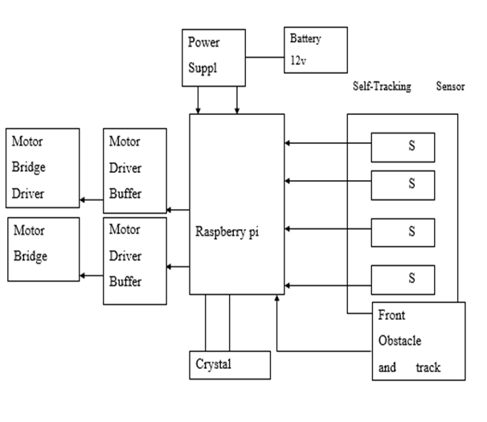
Fig (3.1.1) System Block Diagram
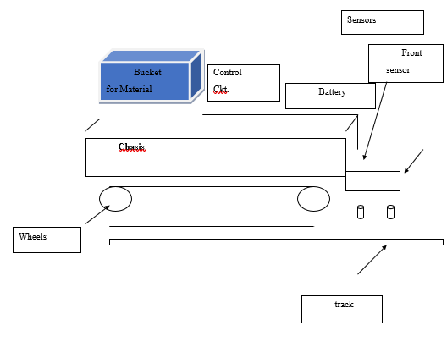
Fig (3.1.2) Vehicle arrangement
3.1 Block diagram Description:
3.1.1 Microprocessor:
Raspberry Pi is a series of small single-board computers (SBCs) developed in the United Kingdom by the Raspberry Pi Foundation in association with Broadcom. The Raspberry Pi project initially leaned towards the promotion of teaching basic computer science in schools and developing countries. The original model became more popular than anticipated, selling outside its target market for uses such as robotics. It is widely used in many areas, such as weather monitoring, because of its low cost, modularity, and open design. It is typically used by computer and electronic hobbyists due to its adoption of the HDMI and USB standards.
- Broadcom BCM2711, Quad core Cortex-A72 (ARM v8) 64-bit SoC @ 1.5GHz
- 1GB, 2GB, 4GB or 8GB LPDDR4-3200 SDRAM (depending on model)
- 2.4 GHz and 5.0 GHz IEEE 802.11ac wireless, Bluetooth 5.0, BLE
- Gigabit Ethernet
- 2 USB 3.0 ports; 2 USB 2.0 ports.
- Raspberry Pi standard 40 pin GPIO header (fully backwards compatible with previous boards)

3.1.2 Power supply:
We require a 5V D.C. supply for all our IC, which a step-down transformer can generate, a full wave bridge rectifier, filter condenser & voltage regulator IC7805. 12V supply for the relay is generated separately using the same procedure as above. This supply requirement can be fulfilled in our case by using the battery backup and providing a recharge facility for it.
3.1.3 Self track sensing arrangement:
This arrangement consists of four differently placed sensors at a specified distance enabling slight deviation in the path tracking. The one + four sensor works in pairs to govern the centre position. One pair governs the horizontal deviation, while the other governs the vertical deviation. The four sensors are placed so that their sensing path converges simultaneously. That enables highly accurate path tracking.
3.1.4 Motor buffer driver:
This stage provides the needed isolation from the main driver stage and a current boost of the microcontroller signal, as microcontrollers don’t have the driving capability. It can only drive up to 4mA.
3.1.5 Motor bridge driver:
This is the final driver stage. It incorporates the H bridge configuration to achieve total control over the motor in both directions, that is, the forward and reverse directions.
3.2 Flow chart of the system:
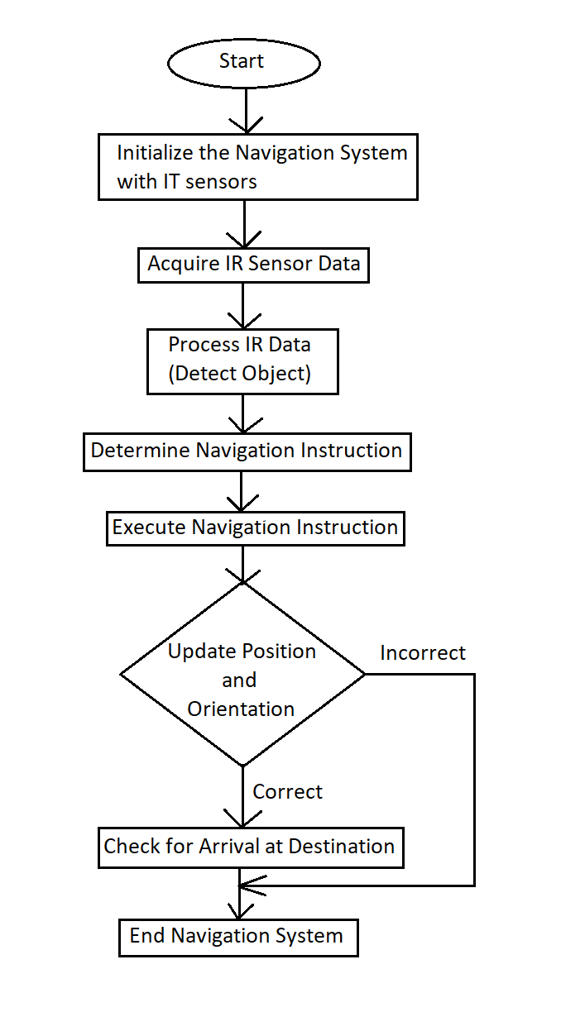 Fig (3.2.1) Fig shows the flow chart
3.3 Algorithm Steps:
Step 1: Start
Step 2: Initializes the navigation system with IR sensors and sets up the Raspberry Pi.
Step 3: Reads data from IR sensors connected to the Raspberry Pi.
Step 4: Processes the IR sensor data to identify and locate objects in the vehicle's path.
Step 5: Analyzes the detected object to determine appropriate navigation instructions.
Step 6: Carries out the navigation instructions, which may involve controlling motors connected to the Raspberry Pi.
Step 7: Continuously updates the vehicle's position and orientation based on sensor feedback.
Step 8: Determines whether the vehicle has reached its destination based on predefined criteria.
Step 9: Concludes the navigation system and stop.
IV- RESULT & DISCUSSION
The vehicle can transport the load to a pre-decided location using navigation and delivering the material. The system introduced here has a speciality as it can track and manoeuvre the path given to it, i.e. it is a self-guided vehicle. As it has the self-guiding ability, it can be implemented in industry to complete the specified task without manual intervention, i.e. a person doesn’t have to keep watch on the activity. Suppose one task of sending one object from one place to another is specified. It will do with utmost accuracy if a path is set.The heart of the system is a microcontroller capable of easily performing complicated tasks. This vehicle uses two motors for the left and right side for effective manoeuvring for sideways turning and forward and reverse direction movement.
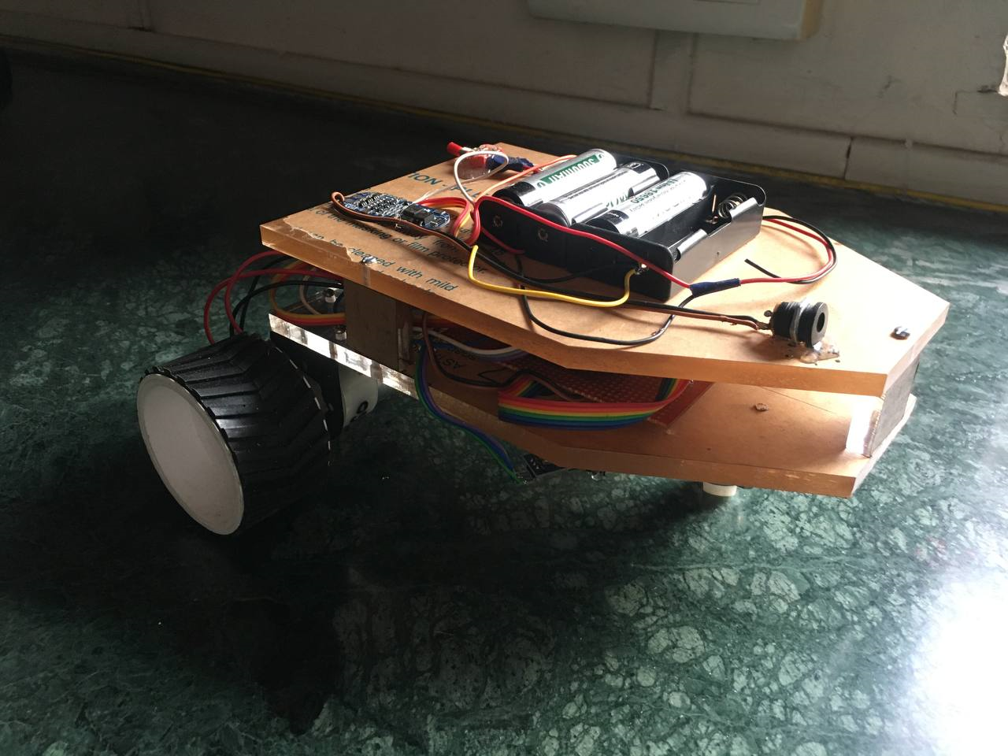
Fig (4.1.1) Hardware arrangement of project
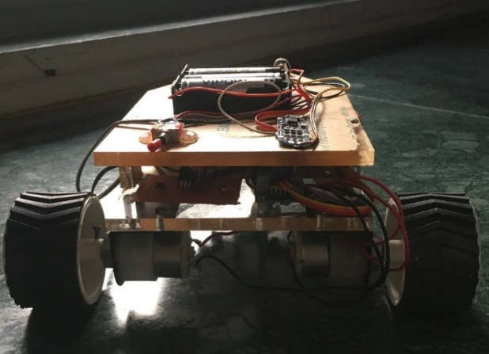
Fig (4.1.2) Toggle switch to power on the system at rear view.
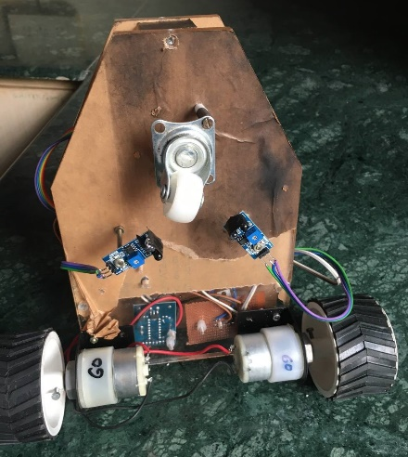
Fig (4.1.3) IR Sensors and castor wheel at bottom view.
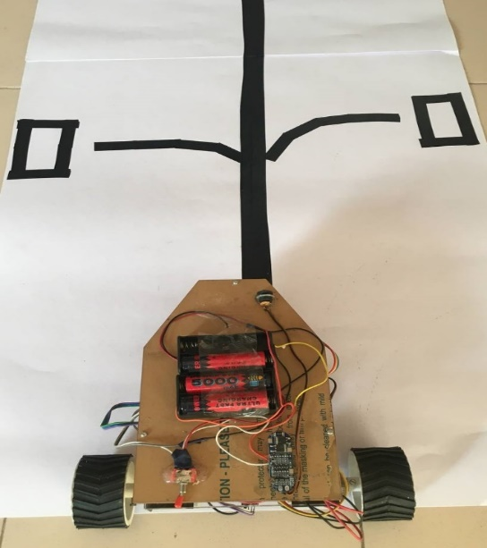
Fig (4.1.4) Initiation of the system.
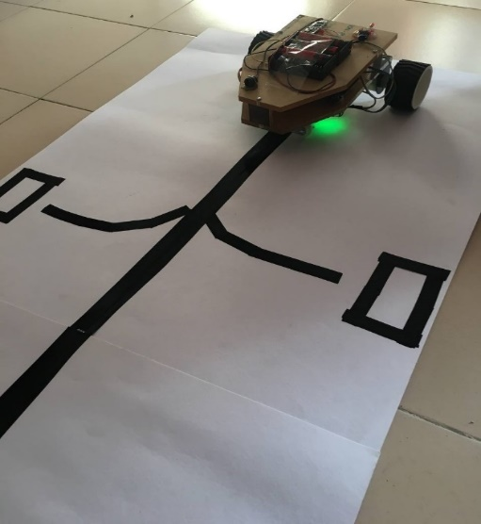
Fig (4.1.5) Moving on straight path, green LED represents active state.
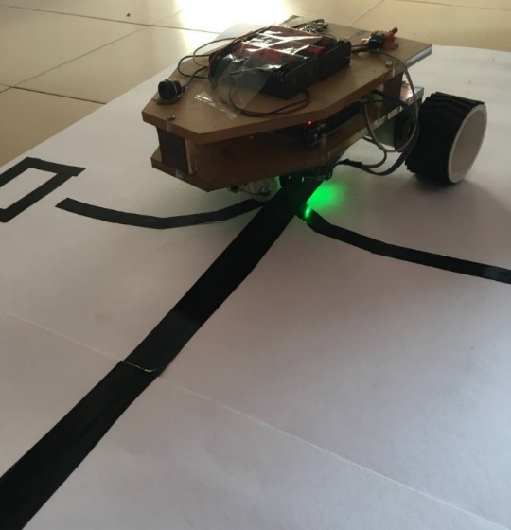
Fig (4.1.6) Navigating towards right track towards destination.
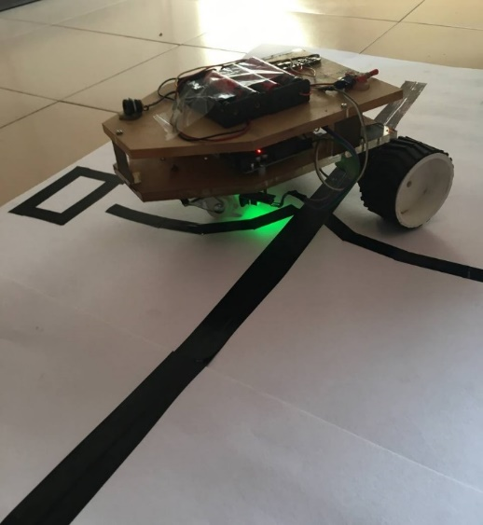
Fig (4.1.7) Approaching to the destination.
V- CONCLUSION
We have developed a system in which all challenges of guidance and navigation are taken care of in a defined manner. To obtain the navigation, we have selected track-based navigation because it is a simple form of navigation with visual and clear sensing methods. At the same time, tuning the sensor with defined track material is simpler. Developed algorithms will program the distinguishing of the track or no track detection. A special purpose and very reliable sensor will be developed and deployed to the lower side of the vehicle suitable to detect the track material. Also, to detect the front and side objects, the non-contact sensor are implemented in front of the vehicle. The complete system is developed with the microcontroller, the most cost-effective and reliable high-performance control programmable device.
VI- FUTURE SCOPE
Many improvements can be done in future such as optimize the power consumption of the system by selecting energy-efficient components and implementing power-saving measures. This not only reduces costs but also contributes to sustainability. Identify specific components that are critical to the system's performance and focus on optimizing or upgrading those components. This targeted approach allows for performance improvements without unnecessary expenses. Connect the system to the internet for remote monitoring and control. This could include accessing navigation data, receiving real-time updates, and remotely controlling the vehicle. Develop a user-friendly interface for interacting with the system. This could include a mobile app or a web interface for monitoring the vehicle, setting destinations, and receiving notifications.
REFERENCES
- “Utilizing semantic visual landmarks for precise vehicle navigation” by varun murali, han-pang chiu, supun samarasekara, rakesh teddy kumar, Yokohama, Japan.
- “Laser Scanner-Based Navigation for Commercial Vehicles”by Roland Stahn, Gerd Heiserich, Andreas Stopp 2007 IEEE Intelligent Vehicles Symposium.
- “A lidar perception scheme for intelligent vehicle navigation”by Julien Moras ,Véronique Cherfaoui ,Phillipe Bonnifait 04 February 2011 Published in: 2010 11th International Conference on Control Automation Robotics & Vision.
- “Object Detection and Tracking for Autonomous Navigation in Dynamic Environments”by Andreas Ess ,Konrad Schindler ,Bastian Leibe ,Luc Van Gool.
- “A visual navigation system for autonomous land vehicles” by A. Waxman; J. LeMoigne; L. Davis; B. Srinivasan; T. Kushner; Eli Liang; T. Siddalingaiah IEEE Journal on Robotics and Automation Volume: 3, Issue: 2, April 1987.
- “Sensor and navigation data fusion for an autonomous vehicle” by J.C. Becker; A. Simon Proceedings of the IEEE Intelligent Vehicles Symposium 2000 (Cat. No.00TH8511).
- “External visual positioning system for enclosed carparks” by Jens Einsiedler; Daniel Becker; Ilja Radusch 2014 11th Workshop on Positioning, Navigation and Communication (WPNC).
- “Evaluating the accuracy of vehicle tracking data obtained from Unmanned Vehicles” by Giuseppe Guido, Vincenzo Gallelli, Daniele Rogano, Alessandro Vitale.
- “Autonomous Ground Vehicles—Concepts and a Path to the Future” by Thorsten Luettel; Michael Himmelsbach; Hans-Joachim Wuensche ,Proceedings of the IEEE ,Volume: 100, Issue: Special Centennial Issue, 13 May 2012.
- “Autonomous Ground Vehicles V Concepts and a Path to the Future” by T. Luettel, M. Himmelsbach, Hans-Joachim Wünsch.
- “Modeling the Static and the Dynamic Parts of the Environment to Improve Sensor-based Navigation”by L. Montesano; J. Minguez; L. Montano Proceedings of the 2005 IEEE International Conference on Robotics and Automation.

