Rider Cat-Based Chicken Swarm Optimization Algorithm for Hand Vein Recognition
Mr. Kiran Ananda More¹, Mr. Machchhindra Jibhau Garde², Mr. Amol Amarrao Patil³
¹Assistant Professor – Department of Electronics Engineering, :  0009-0009-6675-5530
SSVPS’ B. S. Deore College of Engineering, Dhule, India, 424002
Email of Corresponding Author:kiranmore.dhule@gmail.com
²Assistant Professor – Department of Electronics Engineering, Engineering: 0009-0007-1882-5878
SSVPS’ B. S. Deore College of Engineering, Dhule, India, 424002
Email of Co-Author: mchgarde@gmail.com
³Assistant Professor – Department of Electronics Engineering,, : 0009-0006-0715-7897
SSVPS’ B. S. Deore College of Engineering, Dhule, India, 424002

Email of Co-Author:amol4823@gmail.com

Received on:05 May,2025 Revised on: 07June,2025 Published on: 10 June ,2025

Abstract – Biometric recognition is an automated method for identifying individuals based on their physiological or behavioral traits. Behavioral characteristics refer to patterns in a person’s actions, such as gestures, voice, or signature. In contrast, physiological characteristics are based on physical traits like fingerprints, facial features, DNA, hand geometry, retina, and vein patterns. Biometric systems are increasingly favored over traditional security methods like passwords, which are vulnerable to attacks and can lead to the loss of sensitive data. Among various biometric techniques, hand vein identification is gaining significant attention from researchers. This is due to the uniqueness, stability, permanence, and universality of human vein patterns, which are also difficult to forge. Additionally, vein patterns can be captured using contactless methods an important advantage in modern hygienic and non-intrusive authentication systems.
However, developing an effective vein-pattern-based authentication system presents challenges. The image quality and variability of vein patterns due to different conditions can lead to reduced performance. To address these issues, a novel method called Rider Cat-based Chicken Swarm Optimization (RCCSO) is proposed for hand vein recognition.
For vein detection, two techniques are used: Repeated Line Tracking and Maximum Curvature Points in Image Profiles. The extracted vein features are then combined both statistical features and CNN-derived features and fed into a Deep Convolutional Neural Network (DCNN) for classification. The training of this DCNN is optimized using the proposed RCCSO algorithm, which integrates Chicken Swarm Optimization and Cat Swarm Optimization within the framework of the Rider Optimization Algorithm (ROA). This classification system considers various influencing factors, such as translation and rotation in hand posture, as well as thickened veins due to aging or health conditions, ensuring a more robust and adaptable vein recognition system.
Keywords- Vein Extraction, Rider-Cat Based chicken Swarm Optimization, Bio-inspired Optimization.
I INTRODUCTION
Security has become a critical concern in the modern era, especially with the rapid advancements in information technology. Over the past few years, IT has revolutionized our lives creating a wave of automation in everyday tasks, from unlocking smartphones to marking attendance and conducting financial transactions. All of these automated processes require user authentication, which traditionally relied on passwords or keywords [1]. However, these conventional methods often fall short in ensuring the required level of security, especially when dealing with highly sensitive or confidential data. This shortcoming has necessitated a shift towards more secure and user-friendly authentication methods.
Security can be significantly improved through advanced identification and verification techniques. Biometrics is one such discipline that focuses on authenticating or verifying individuals based on their physiological or behavioral characteristics. Examples of physiological biometrics include fingerprints, iris patterns, facial features, and vein structures, while behavioral biometrics encompass traits such as gait, voice, and DNA. Many large-scale systems today, particularly in access control and management, require accurate and reliable identification methods, thereby emphasizing the need for biometric identification systems. A crucial component in these systems is the verification of an individual’s claimed identity, which serves to protect vital resources from unauthorized access or impersonation attempts [2]. Traditionally, this was achieved using identity cards or passwords, but these methods are prone to being lost, stolen, shared, or forged. In contrast, biometric authentication offers a robust solution that is inherently secure, automated, and non-transferable, and cannot be shared, stolen, forged, or forgotten [3]. Figure 1.1 shows the classical and biometrics-based authentication approaches.
Additionally, a biometric system is suitable for every user as any identity card or password need not be kept safe or remembered all the time. Mere forgetting the password or losing the identity card may deny the genuine user to forbid the access.

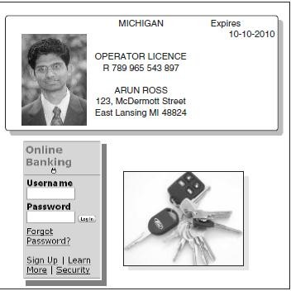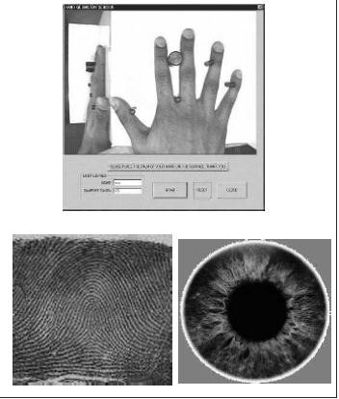

Figure 1.1: Authentication Approaches (a) Classical Approach Using IDs and Password (b) Biometric-based Authentication Approach

II LITERATURE REVIEW
Lin and Fan proposed a biometric system based on thermal imaging of palm-dorsal veins. Thermal images were captured using an infrared camera, and the region of interest (ROI) was defined and extracted by automatically selecting two-finger webs as datum points. A modified watershed transformation was applied to extract key feature points, from which multiple features were subsequently derived. These features were integrated using a hierarchical strategy to produce a multi-resolution representation of the vein patterns. An optimal threshold was determined using a logical and data-driven approach. Experimental results on a dataset of 30 palm-dorsal images showed a False Acceptance Rate (FAR) and False Rejection Rate (FRR) of 2.3% [4]. Miura et al. developed an algorithm to extract vein patterns from finger images affected by non-uniform shading due to varying thickness in bones and muscles. The algorithm was based on tracing dark lines, as veins appear darker than surrounding tissues. Starting from random positions, the method identified these lines by analyzing the cross-sectional intensity profiles, where veins appeared as valleys. This approach effectively extracted vein patterns even from unclear or low-quality finger vein images. Experiments on 678 images achieved an impressively low Equal Error Rate (EER) of 0.145% [5].
To address challenges related to rotation and size variability in dorsal hand images, Wang et al. proposed a method that first converts the input grayscale image into eight-bit planes, thus mitigating interference from brightness and noise. The ROI was determined using the maximum inscribed circle method centered around the image’s centroid. Rotation- and scale-invariant texture features were then extracted by computing the mutual information between textures across individual bit planes. Each bit plane was analyzed under three modes horizontal, vertical, and eight-neighborhood to identify the optimal block. The similarity between blocks was quantified using block mutual information and classified using the Euclidean distance classifier. The method was evaluated on a dataset of 2000 dorsal hand vein images from 50 individuals, demonstrating strong performance in cross-device recognition scenarios. A maximum recognition rate of 93.33% was achieved using the 6th-bit plane [6]. However, a key limitation was the independent processing of each bit.
Chin et al. aimed to enhance the performance of dorsal hand vein pattern-based biometric identification systems. Their approach involved the matching of statistical features and features derived from the Gray-Level Co-occurrence Matrix (GLCM) using an Artificial Neural Network (ANN). To improve image quality, mean filtering and histogram equalization were applied. The region of interest (ROI) was enhanced, cropped, and then segmented using binarization. The proposed method was evaluated on 240 images from the Bosphorus Hand Vein Database, achieving a high recognition accuracy of 99.32% [7]. Liu et al. proposed a dorsal hand vein authentication system capable of handling incomplete or occluded hand images, such as those affected by tattoos, injuries, or skin pigmentation. The system employed an enhanced biometric graph matching algorithm, which incorporated edge attributes to extract discriminative features an improvement over conventional shape-based methods. The robustness of the algorithm was assessed across three categories: normal hand images, partially occluded images, and tattooed images. To facilitate this, three separate databases were created using a NIR-based CMOS camera, comprising 7630 normal images, 1840 partially occluded images, and 250 tattooed images [8].
III METHODOLOGY
A hand vein recognition system consists of several steps on the same line as a fundamental biometric system with each step employing a particular technique to make the system an efficient and accurate one. The detailed steps with the technique employed at each step in the proposed system are portrayed in Figure 3.1.
The proposed system employs a combination of statistical features and Convolutional Neural Network (CNN) features, optimized using a hybrid optimization technique. Initially, the original Near-Infrared (NIR) images are passed to the Region of Interest (ROI) extraction block, where relevant regions are identified and extracted. These regions are defined as the maximum inscribed circle within the hand area. Prior to ROI extraction, the images are enhanced using median filtering and Contrast Limited Adaptive Histogram Equalization (CLAHE) to effectively reduce noise and optical blurring, ensuring better feature extraction in later stages. Based on the extracted region, hand vein extraction is performed using two established methods: the Repeated Line Tracking method and the Maximum Curvature Points in Image Profiles technique [9], both tailored for accurate vein pattern detection. Once the vein patterns are extracted, the system proceeds to the feature extraction phase. In this phase, two types of features are derived. Deep features are extracted using Convolutional Neural Networks (CNNs), while statistical features including mean, variance, entropy, information gain, and energy are computed to capture additional discriminative characteristics. These features are then combined and fed into a Deep Convolutional Neural Network (DCNN) for classification.
To enhance classification performance, the DCNN is trained using the proposed Rider Cat-based Chicken Swarm Optimization (RCCSO) algorithm. This hybrid metaheuristic algorithm is developed by integrating three optimization techniques: Cat Swarm Optimization, Chicken Swarm Optimization, and the Rider Optimization Algorithm (ROA). The system’s performance is evaluated under various conditions, including age-related variations, disease-induced changes, and translational or rotational effects in hand posture, ensuring the robustness and adaptability of the hand vein recognition system.
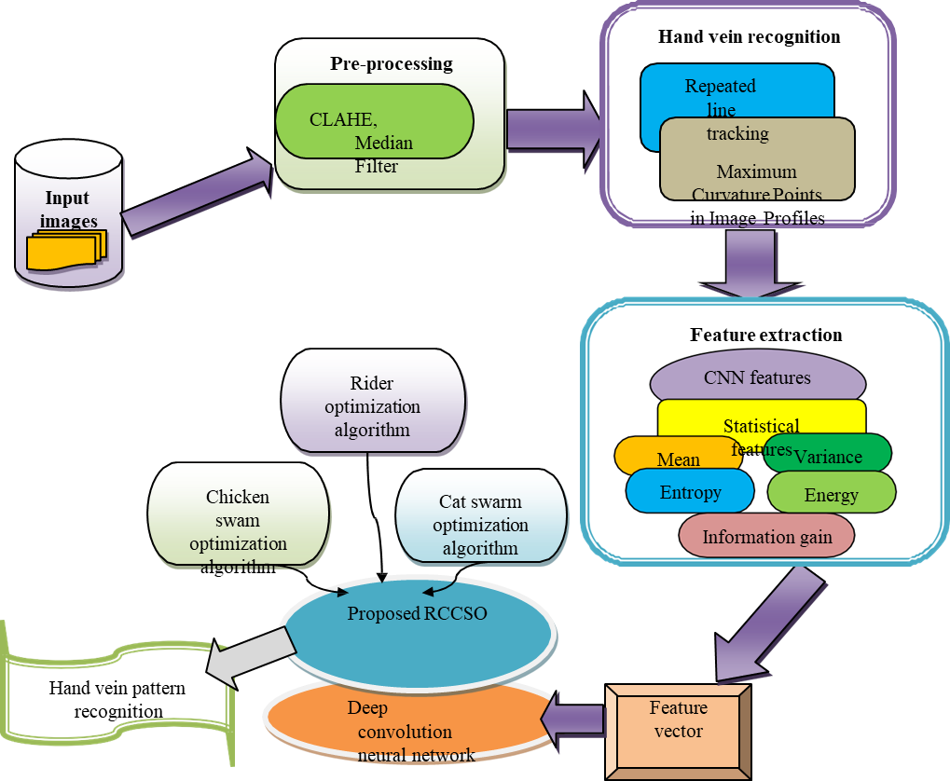
Figure 3.1: Block Diagram of Proposed RCCSO-Based DCNN for Hand Vein Pattern Recognition
The sample images obtained from different persons for normal hand, translated hand, rotated hand, and thick veins hand are shown in Figure 3.2. Each image undergoes ROI extraction to extract interesting regions from dorsal hand vein (DHV) images to perform hand vein recognition.
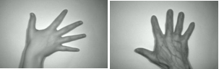

Figure 3.2 Sample Images for (a) Normal Hand (b) Translated Hand (c) Rotated Hand (d) Thick Vein Hand
Image Pre-processing and extraction of ROI:-
The images acquired using Near-Infrared (NIR) cameras are typically not immediately suitable for processing, as they often suffer from significant noise and quality degradation. Several factors contribute to this degradation, including optical blurring, uneven illumination, the presence of hair on the skin, variations in hand posture, and subsurface skin scattering all of which can obscure or distort vein patterns [10]. To address these challenges, the images undergo a series of pre-processing operations designed to enhance image quality and improve the reliability of subsequent stages in the recognition system.
Once enhanced, the next critical step is the extraction of the Region of Interest (ROI), which focuses the analysis on the most relevant portion of the image. Processing the entire image is both computationally intensive and unnecessary, as only specific regions typically contain valuable vein information. The ROI is defined as the area that encompasses the majority of the discriminative features, and its extraction helps in eliminating irrelevant background, thereby reducing processing time and increasing efficiency.
Given that ROI characteristics may appear similar across individuals, especially in consistent imaging setups, it is crucial to implement an automatic and accurate ROI extraction mechanism. This ensures not only consistency across samples but also improves the robustness and scalability of the hand vein recognition system.

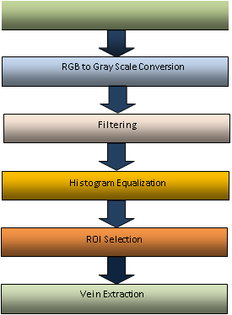
Figure 3.3: Pre-processing of Hand Vein Images
IV. RESULT & DISCUSSION
The proposed method has been evaluated using the Bosphorus Hand Vein Dataset, which includes 1,575 images comprising both left and right-hand samples captured under various hand postures. Additionally, 219 images were collected after a time gap of several months to assess the system’s robustness over time. The performance of the proposed framework was measured using standard evaluation metrics, including accuracy, sensitivity, specificity, False Acceptance Rate (FAR), False Rejection Rate (FRR), and Equal Error Rate (EER). The system was tested under different combinations and sizes of training and testing datasets to ensure comprehensive analysis.
The model’s effectiveness was also assessed across diverse conditions, such as normal, translated, rotated, and thick vein images, which simulate real-world variations in hand posture and vein visibility. A Deep Convolutional Neural Network (DCNN) was employed as the primary classifier. To train the classifier, four optimization techniques were implemented and compared: Chicken Swarm Optimization (CSO), Cat Swarm Optimization (CatSO), Rider Optimization Algorithm (ROA), and the proposed hybrid Rider Cat-based Chicken Swarm Optimization (RCCSO). A comparative analysis demonstrates the superiority of the proposed RCCSO method over the existing techniques in terms of classification performance and robustness across varying image conditions.
V. CONCLUSION
Biometrics has become an integral part of modern security systems, with widespread applications across personal, governmental, and private sectors to enhance authentication reliability. Various biometric modalities are currently in use, each offering distinct advantages and limitations. However, maintaining long-term reliability and ensuring resilience against forgery remain significant challenges for many of these modalities.
In this context, hand vein recognition has emerged as a promising solution. Veins, located beneath the skin and invisible to the naked eye, offer a high level of security as they are difficult to replicate and remain stable over time. Additionally, in the wake of the COVID-19 pandemic, the importance of contactless biometric systems has increased, and hand vein recognition meets this demand by allowing acquisition without physical contact with the sensor.
Despite these advantages, variations in hand posture and vein thickness which may be influenced by factors such as age or medical conditions can significantly affect the quality of the captured images and, consequently, the system’s performance. The proposed study addresses these challenges by developing a method capable of accurately detecting veins of varying thickness, extracting robust features that are invariant to posture changes, and classifying the vein patterns using a Deep Convolutional Neural Network (DCNN). The classifier is trained using a novel hybrid optimization algorithm, designed to learn optimal weights and produce highly accurate recognition results.
REFERENCES
- J. N. Pato and L. I. Millett, Biometric recognition: Challenges and opportunities. 2010.
- D. Bhattacharyya, R. Ranjan, F. A. a, and M. Choi, ―Biometric Authentication : A Review,‖ Int. J. Serv. Sci. Technol., vol. 2, no. 3, pp. 13–28, 2009.
- K. Shaheed, H. Liu, G. Yang, I. Qureshi, J. Gou, and Y. Yin, ―A systematic review of finger vein recognition techniques,‖ Inf., vol. 9, no. 9, 2018.
- C. L. Lin and K. C. Fan, ―Biometric verification using thermal images of palm- dorsa vein patterns, IEEE Trans. Circuits Syst. Video Technol., vol. 14, no. 2, pp. 199–213,2004.
- N. Miura, A. Nagasaka, and T. Miyatake, ―Feature extraction of finger-vein patterns based on repeated line tracking and its application to personal identification,‖ Mach. Vis. Appl., vol. 15, no. 4, pp. 194–203, Oct. 2004.
- Wang, H. Cao, X. Jiang, and Y. Tang, ―Recognition of dorsal hand vein based bit planes and block mutual information, Sensors (Switzerland), vol. 19, no. 17, 2019.
- S. Chin, K. Tay, A. Chuang and C. Chew, ―Dorsal hand Vein Pattern Recognition Using Statistical Features and Artificial Neural Networks, IEEE Student Conference On Research and Development (SCOReD), pp. 217-221, 2020.
- F. Liu, S. Jiang, B. Kang, and T. Hou, ―A Recognition System for Partially Occluded Dorsal Hand Vein Using Improved Biometric Graph Matching,‖ IEEE Access, vol. 8, pp. 74525–74534, 2020.
- N. Miura, A. Nagasaka, and T. Miyatake, ―Extraction of finger-vein patterns using maximum curvature points in image profiles, IEICE Trans. Inf. Syst., vol. E90-D, no. 8, pp. 1185–1194, 2007.
- R. B. Trabelsi, A. D. Masmoudi, and D. S. Masmoudi, ―Hand vein recognition system with circular difference and statistical directional patterns based on an artificial neural network, Multimed. Tools Appl., vol. 75, no. 2, pp. 687–707, 2016.

