Medicinal Leaf Identification Using Deep Learning

Jay Khapare , Dimple Kumar , Komal Bhende, Aarya Babhulkar, Prof.Roshan Kotkondawar

Dept. of Computer Engineering, St. Vincent Pallotti College of Engineering & Technology
Gavasi Manapur, Nagpur, Maharashtra, India

jaykhapare18@gmail.com

Received on: 05May, 2024 Revised on: 03 July, 2024 Published on: 06 July, 2024

Abstract: Identification of medicinal plants or leaves plays an important role in many fields such as medicine, agriculture and conservation. The routine process of plant identification is often time consuming and requires botanical knowledge. In recent years, deep learning techniques have emerged as a promising method to study these processes. This article provides a comprehensive review of recent research on the use of machine learning techniques to identify leaf patterns. We discuss the problems with traditional methods and how machine learning can solve these problems. We also examine various ML algorithms and techniques used in the recognition process, such as Convolutional Neural Networks (CNN), Resnet50V20. We also highlight the importance of data in training ML models and discuss strategies for data collection and development. We also analyze the images used to evaluate the effectiveness of ML models in page analysis. Finally, we discuss future research directions and potential applications of machine learning in the identification of medicinal plants.
Keywords: Medicinal Plant, CNN, Image Processing, classification and identification.
- INTRODUCTION
Ayurveda is a traditional Indian medicinal system that traces its origins back to the Vedic period around 5,000 years ago. It relies heavily on natural ingredients sourced from plants, including leaves, roots, bark, and other plant parts. India boasts a rich diversity of flora, with over 8,000 plants exhibiting medicinal properties. Out of these, around 1,500 herbs are commonly used in various herbal remedies across the country. Commercial Ayurvedic preparations typically involve 500 species of plants.

Interestingly, over 70% of these medicinal plants are harvested from forests and wastelands, while the remainder is cultivated in agricultural fields. In ancient times, Ayurvedic practitioners would personally select and gather medicinal plants for preparing remedies tailored to individual patients' needs.

Identification of these plants primarily relies on examining their leaves. The process involves capturing leaf images, reducing noise interference, extracting relevant features, employing classification techniques, and ultimately identifying the plants. This meticulous process ensures the accuracy and efficacy of Ayurvedic medicines derived from these natural sources.
- LITERATURE SURVEY

In their study, A. Gopal et al. [1] developed a system based on image processing technology, using images of plant leaves as the primary factor for classification. This software functions by analyzing the input image and returning the closest match from its database. To assess its effectiveness, the researchers conducted tests on 10 distinct plant species. The algorithm was trained using 100 leaves (10 from each plant species) and subsequently tested with 50 leaves, which were from different plant species. Through their experiments, the researchers determined that the system's implementation achieved an impressive accuracy rate of 92%. This demonstrates the potential of image processing techniques in accurately identifying plant species based on their leaf characteristics.

Umme Habiba et al. [2] A new method called multi-channel modified local gradient model (MCMLGP) was introduced for automatic classification of medicinal plants. This method uses multiple color image methods to remove more important features, thus improving classification.The authors use Support Vector Machine (SVM) classifiers with different kernels (i.e. linear, polynomial and nonlinear) to demonstrate their method. Hello. They also made a comparison with MCMLGP using multiple descriptors. By rigorously testing crop data, the authors show that their plan has a higher success rate of 96.11% compared to other strategies. This study provides a better pathway to a better understanding of the distribution of medicinal plants, providing opportunities for research and advancement in the field.

R. Janani [3]and colleagues have developed a method to analyze leaf images by extracting size, color, shape and texture features quality and then using an artificial neural network (ANN) to classify them accurately. The main challenge they faced was selecting the most effective image features to achieve high accuracy with minimal computational complexity. They experimented with different combinations of input features and found that their method achieved 94.4% accuracy using just 8 input features on a test set of 63 leaf images. This approach is particularly advantageous for leaf identification systems as it requires minimal input and computational time.
Vijayashree.T [4]and colleagues have established a database containing 127 types of herbal leaves. They incorporated 11 texture parameters to create this database, including Sum of inverse Inverse Difference of Moment, Aspect Ratio, Correlation, Sum of Entropy, Mean, and also the Sum Average. Gray Level Co-occurrence Matrix (GLCM) analysis was employed to determine additional parameters such as enthalpy, heterogeneity, and energy. During testing, a sample text or image is compared against the database, and its similarity is computed based on the extracted parameters. The leaf with the lowest dissimilarity is then identified, and the result is displayed as the output.

Venkataraman [5] and colleagues have devised a system aimed at identifying plants and uncovering their medicinal properties, offering a natural remedy for various ailments. Their work focuses on gathering datasets and employing techniques such as texture analysis and Histogram of Oriented Gradients (HOG) for feature extraction. The classification of plants is accomplished using the Support Vector Machine (SVM) algorithm. This approach enables the system to not only recognize different plant species but also provide valuable information about their medicinal benefits.

3.PROPOSED METHODOLOGY

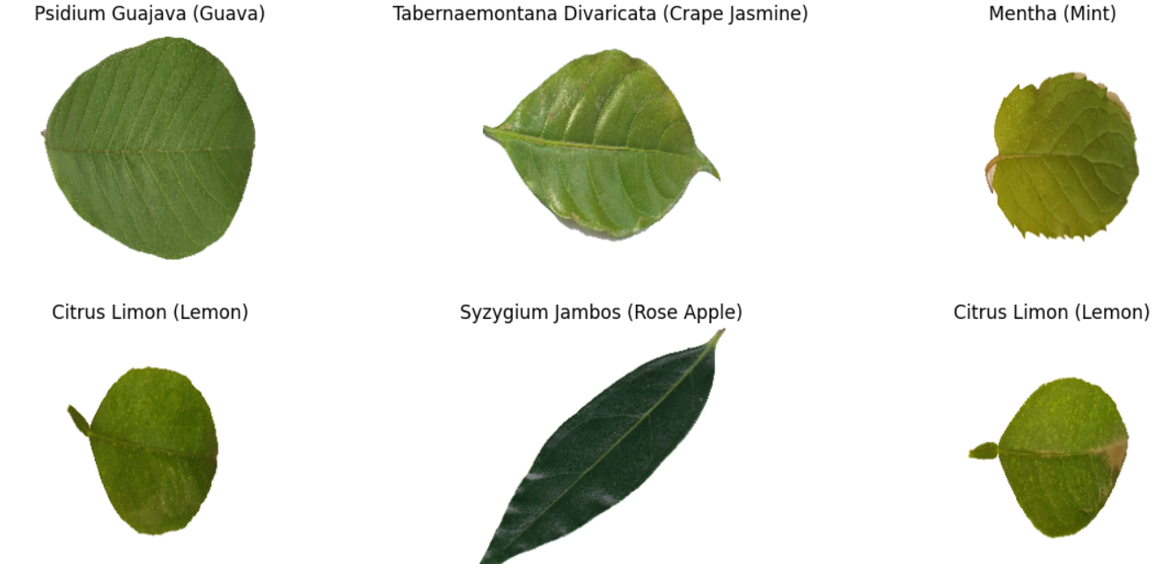

Fig: leaves a-Guava ,b-Crape jasmine ,c-mint,d-lemon, e-rose apple, f-citrus lemon.
Convolutional Neural Network (CNN):
CNN stands for Convolutional Neural Network. It's a type of artificial neural network inspired by the biological visual cortex of animals and plants designed to process data that has a grid-like topology. It's particularly powerful for tasks like image recognition and classification because it can automatically learn hierarchical patterns and features from the input data through a process called convolution. This makes CNNs very effective in tasks such as image classification, object detection, and even in some cases, natural language processing.
ResNet:
Resnet is a powerful deep learning architecture used for several image classification tasks. Resnet stands for "Residual Network" and it's known for its ability to train and test very deep neural networks with improved performance. It introduces the concept of residual connections, which allow the network to bypass certain layers and retain important information.

Optimization Parameters Used:
- Batch size : 64
- Epoch cycles : 20
- Learning Rate: 1e-2
- Optimizer used: ADAM

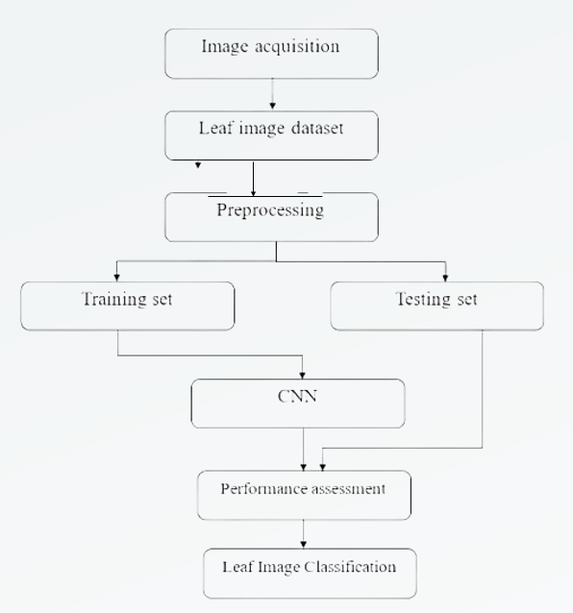
From the above flow chart showing the work plan of the model.

4.RESULT

Fig 4.1: Front Page
In this Fig 4.1 user will upload an image from the given dataset and after uploading the image the model will process the image and will give its scientific name, common name and its medicinal information of the particular leaf that is being selected from the given dataset.

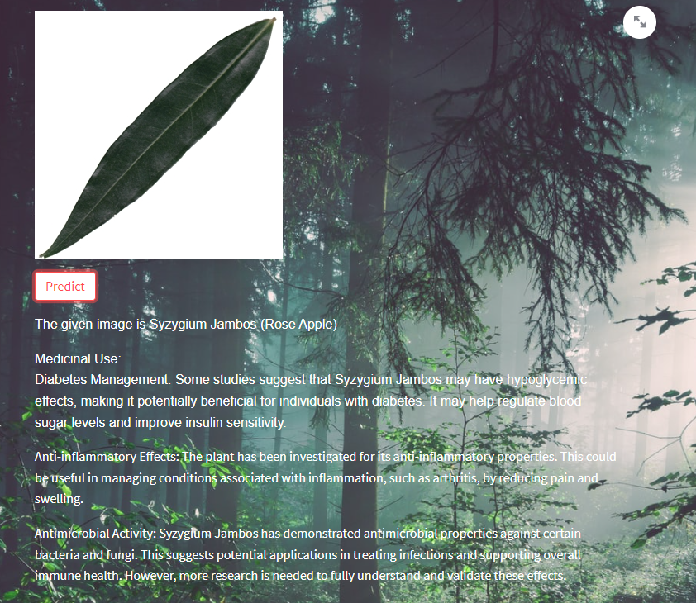
Fig 4.2: Out Put Page
In this the output is shown as mentioned in the above figure. Once we click on the predict button the model will give the exact output of the leaf being selected along with its common name, scientific name and the medicinal information.

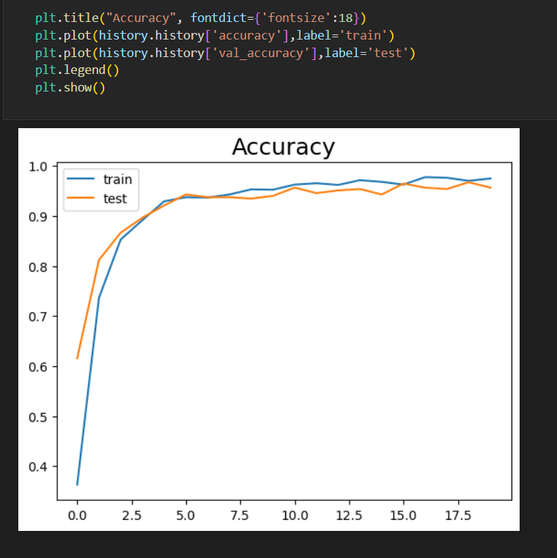
Fig 4.3: Testing Performance
Fig 4.3 shows the accuracy graph of the model that is being trained and tested after running certain epoch cycles.

- CONCLUSION
In this research, we've developed a method for identifying medicinal plants using Convolutional Neural Network (CNN), which is renowned for its effectiveness in classifying images. CNNs act as an ensemble supervised machine learning tool, incorporating color, texture, and geometric attributes to precisely recognize medicinal plant species based on their leaf features. By combining shape, color, and texture characteristics, we achieved an impressive accuracy of 94.54% in identifying leaves. The outcomes of this method exhibit great promise, highlighting the CNN's suitability and effectiveness in medicinal plant identification systems. Moreover, this study sets a solid groundwork for future endeavors aiming to expand to a broader scope, covering a more extensive variety of medicinal plant species.
REFERENCES

[1] A. Gopal, S. Prudhveeswar Reddy and V. Gayatri, "Classification of selected medicinal plants leaf using image processing," 2012 International Conference on Machine Vision and Image Processing (MVIP), Coimbatore, India, 2012, pp. 5-8,
doi: 10.1109/MVIP.2012.6428747.

[2] Umme Habiba, Md. Rasel Howlader, Md. Aminul Islam, Rahat Hossain Faisal and Md. Mostafijur Rahman"Automatic "Medicinal Plants Classification using Multi-channel Modified Local Gradient Pattern with SVM Classifier" published in Joint 2019 8th International Conference on Informatics, Electronics & Vision (ICIEV) & 3rd International Conference on Imaging, Vision & Pattern Recognition (IVPR)

[3] R.Janani, A.Gopal "Identification of selected medicinal plant leaves using image feature and ANN" published in 2013 international conference on advanced electronic system (ICAES K. Elissa, “Title of paper if known,” unpublished.

[4] Vijayashree.T, Dr. A. Gopal "Leaf Identification for the Extraction of Medicinal Qualities Using Image Processing Algorithm" published in 2017 International Conference on Intelligent Computing and Control (I2C2)

[5] D Venkataraman, Mangayarkarasi N "Support Vector Machine Based Classification of Medicinal Plants Using Leaf Features" published in 2017 International Conference on Advances in Computing, Communications and Informatics (ICACCI)
[6] Shitala Prasad, Pankaj P Singh"Medicinal Plant Leaf Information Extraction Using Deep Features" published in Proc. of the 2017 IEEE Region 10 Conference (TENCON), Malaysia, November 5-8, 2017

[7] Dileep M.R., Pournami P.N."AyurLeaf: A Deep Learning Approach for Classification of Medicinal Plants" published in TENCON 2019 - 2019 IEEE Region 10 Conference (TENCON)

[8]C.Amuthalingeswaran,Mr.M.Sivakumar,Dr.P.Renuga"IDENTIFICATION OF MEDICINAL PLANT’S AND THEIR USAGE BY USING DEEP LEARNING" Published in Proceedings of the Third International Conference on Trends in Electronics and Informatics (ICOEI 2019) IEEE Xplore Part Number: CFP19J32-ART; ISBN: 978-1-5386-9439-8

[9] Manojkumar P., Surya C. M., Varun P. Gopi "Identification of Ayurvedic Medicinal Plants by Image Processing of Leaf Samples" Published in 2017 Third international conference on research in computational Intelligence and communication network (ICRCICN)
[10] Sujit A. , Aji. S "An Optimal Feature set With LPB for Leaf Image classification" Published in Proceedings of the Fourth International Conference on Computing Methodologies and Communication (ICCMC 2020) IEEE Xplore Part Number:CFP20K25-ART; ISBN:978-1-7281- 4889-2

