Flutter Based Frontend Using Dart

Ifatnaaz Sheikh , Gayatri Satyakar , Amey Tumsare, Animesh Dhalwale , Prof. P. V. Bhagat

Department of Computer Engineering
St. Vincent Pallotti College of Engineering and Technology Nagpur, India
ifatnaaz.21@stvincentngp.edu.in
Received on: 05May, 2024 Revised on: 03 July, 2024 Published on: 06 July, 2024

Abstract—In ultra-modern speedy-paced virtual technology, the call for for handy and efficient ways to book tickets for movies, shows, and events continues to rise. This research paper introduces BookandGo, a cutting-edge ticket booking application developed using the Flutter framework and Dart programming language. BookandGo aims to streamline the ticket booking process, providing users with a seamless and personalised experience for accessing and reserving tickets for a wide range of entertainment options. Leveraging Flutter's cross-platform capabilities, the application ensures a consistent experience across various devices and platforms, including smartphones, tablets, and desktops. Key features of BookandGo include intuitive navigation, personalised recommendations based on user preferences and past booking history, real-time availability updates for events, secure payment gateways for seamless transactions, and interactive seat selection for entertainment options.
Keyword— Flutter Framework, Widgets

- INTRODUCTION

Flutter is a popular open-source UI framework developed by Google for building natively compiled applications for mobile, web, and desktop from a single codebase. Flutter is a software development kit (SDK) created by Google under an open-source license. Initially, it was presented at the Dart Conference in 2015, and was called "Sky". It was designed as the main method of developing applications for the Fuchsia operating system (the operating system that later and gradually merged Android and ChromeOS). The latest Flutter version has three main components: - Embedder – specific to the platform (iOS or Android) [1]. DART supports the programming utilities like interface, collections, classes, dynamic and optional typing. DART used for Mobile and Web applications. It is used for the creation of frontend user interface for mobile and web applications [3]. Flutter gives a wealthy set of customizable widgets that permit builders to create stunning and responsive consumer interfaces.
It follows a reactive programming version, wherein UI components mechanically update in reaction to statistics adjustments. certainly one of Flutter's key strengths is its capability to create apps that run seamlessly on a couple of systems, such as iOS, Android, net browsers, and-even desktop operating structures like windows, macOS, and Linux.

- LITERATURE REVIEW

Here humans are constantly on the cross and looking for handy answers to their normal wishes, reserving tickets for extensive range of events, tour, and leisure can indeed be a hard and time-eating undertaking. The method frequently involves multiple steps, exceptional systems, and ramification of fee options, making it cumbersome for users. To address this trouble and beautify user enjoy, we intention to increase a complete and user-pleasant price ticket booking. In growing years, there has been a significant increase in usage of application which without much efforts books the seat. In this industry of entertainment, keeping track of tickets present in theatre has been a somewhat outdated and often inefficient process. The conventional methods involve relying on individuals to manually buy tickets, whether it's one-on-one or from the box office. These techniques come with a lot of challenges. These challenges can result in inefficiencies and often lead to missing out on our favourite movies and shows.
. Google has developed and maintained a programming language called Dart [4]. Dart language or DartLang as an open source, object-oriented language which can also be compiled into JavaScript code. It is a dynamically typed, class based language and supports single inheritance [5].

- EXISTING SYSTEM

BookMyShow is a well-known and often used website and mobile app that offers a comprehensive ticket buying platform for a range of entertainment events and activities. Movies, live performances, concerts, sporting events, and other types of entertainment are its main areas of interest. Customers can choose from a variety of selections, check event specifics, pick their seats, and safely pay online to purchase tickets. Platforms such as Netflix, Hotstar, and Amazon Prime are providing alternate entertainment options to the consumers [2].
Event planners may also list and manage their events with the help of the platform, which offers tools for tracking ticket sales and establishing ticket prices.During COVID-19 BookMyShow gave its best participation responding to the changing environment by introducing features including contactless admission, safety recommendations, and streaming alternatives for virtual events.
Community Engagement: By giving event planners, artists, and performers a way to communicate with their audiences and sell tickets, the platform has benefited the entertainment and events sector. In particular, this contribution has been crucial in advancing the Indian entertainment sector.

- RESEARCH METHODOLOGY

- Design: The first step in research methodology is designing the screens of the application. We have used Figma to design UI/UX. Figma design is for people to create, proportion, and take a look at designs for websites, cellular apps,and different digital products and studies. It offers a range of features for design creation, including layout design, component customization, and interaction design.
- Structure: Once the designs are ready, we move on to structure of project files. The structure of the project is defined for the purpose of keeping out business logic separate from the UI.
- Frontend: In the frontend development phase of the project, we have set up the foundational structure of our project files, laying the groundwork for the actual development work. We have made
- Backend: With the development of frontend, the development of backend also needs to get started as the development of frontend and backend goes hand in hand. Because minor changes in frontend might affect the backend or vice versa.
- Integration: The front-end and back-end components work together in a typical software architecture to deliver a complete and functional application. While a person interacts with the front-stop, such as filing a shape or clicking a button, the frontend give up sends a request to the returned-cease. Backend operates this request, does necessary operation renovate the data from database if required and responds backs to frontend. The front-end and back-end components work together in a typical software architecture to deliver a complete and functional application. While a person interacts with the front-stop, such as filing a shape or clicking a button, the frontend give up sends a request to the returned-cease. Backend operates this request, does necessary operation renovate the data from database if required and responds backs to frontend.
- Testing and validation: Testing and validation are essential to ensure the software’s accuracy, speed, and robustness. System testing evaluates the entire system's functionality and performance in a controlled environment. Validation involves confirming that the software meets user needs and is fit for its intended purpose.
- OBJECTIVES

- Customer Comfort: Offer a convenient and hassle-free method for customers to reserve tickets for a variety of events and sports, including movies, shows, concerts, sporting activities, and events.

- Customer-friendly carousel: Make sure that the interface is easy to use and intuitive so that users can explore activities, choose seats, and make reservations with the least amount of effort.
- Advertising and Promoting: Through targeted marketing, social media integration, and email campaigns, assist event organizers with advertising and promoting their events.

- RESULT

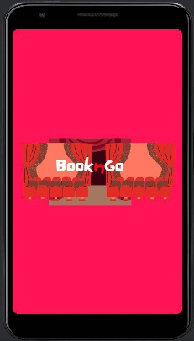
Fig. 1. Splash Screen

Splash screen is the first screen that will appear when we open the application. It provides a smooth transition from the app launch to the main interface, giving the app time to load resources in the background without leaving users staring at a blank screen.

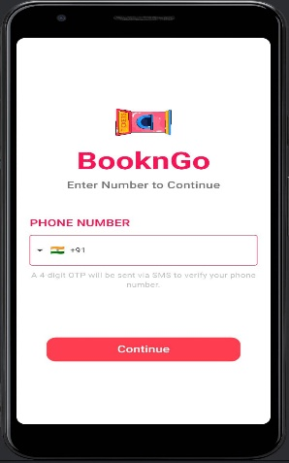
Fig. 2. Login Screen

The user will need to login into the application. It allows the app to personalise the user experience by retrieving and displaying user-specific data, preferences, and settings.

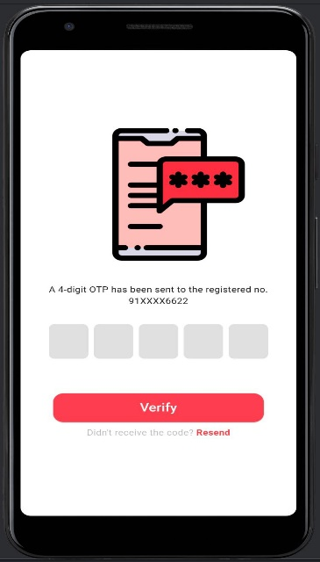
Fig. 3.OTP screen

A 5-digit Otp number will be sent on the mobile number the user has provided to verify the login process.

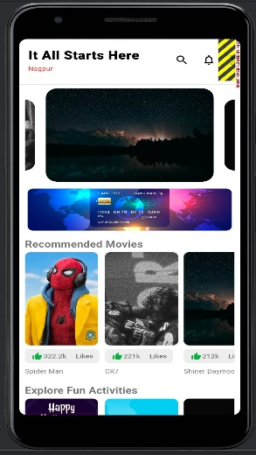

Fig. 4. Home Page

After logging into the application, the first screen that will be displayed is the home page from where the user can navigate to any section for booking tickets for movies or shows.

- CONCLUSION

Moreover, the paper has accentuated the importance of Flutter's rich widget library, which extends an extensive range of pre-built additives for building complex UI handily. This, mixed with Dart's robust kind gadget and solid performance, makes the Dart-Flutter mixture a perfect desire for contemporary app improvement. Dart's reactive programming version enables developers to create responsive and interactive use that provides an unbroken consumer enjoy across exclusive devices and screen sizes standard. Flutter and Dart integrate to provide a robust and green answer for growing current and engaging applications.

REFERENCE

[1] C. C. M. P. Alexandru TĂBUȘCĂ, "FLUTTER TECHNOLOGY AND MOBILE SOFTWARE APPLICATIONS," vol. 16.2, 2022.
[2] ,. C. P. M. G. ,. D. H. G. K. Vikas Kumar Tyagi, "A STRATEGIC ANALYSIS OF ONLINE MOVIE AND EVENT TICKETING PLATFORM: BOOKMYSHOW," vol. volume 21, no. issue 13, p. 332, 2019.
[3] M. P. V. V. S. Dr. U. Urathal Alias Sri Swathiga, "AN INTERPRETATION OF DART PROGRAMMING LANGUAGE," Dogo Rangsang Research Journal, vol. 11, no. 10, 2021.
[4] N. S. G. G. C. Aakanksha Tashildar, "APPLICATION DEVELOPMENT USING FLUTTER," International Research Journal of Modernization in Engineering Technology and Science, vol. 02, no. 08, 2020.
[5] M. Jalolov, "Analyzing JavaScript frameworks and Dart for Front-end Development," 2018.

