Plc Based Liquid Mixing Device

Abhay Shukla1, Aditya Gohite2, Janvi Nandeshwar3, Sudhanshu Tiwade4, Jishnu Venugopal5 ,Shradha Banode6
1,2,3,4 ,5Student of SVPCET Engineering College, Dept of Electrical Engineering, Nagpur Maharashtra, India
6Assistant Professor at SVPCET Engineering College, Dept of Electrical Engineering, Nagpur Maharashtra, India

Received on: 05May, 2024 Revised on: 03 July, 2024 Published on: 06 July, 2024

Abstract - In nowadays's modern fast moving, competitive in industrial worlds, cost effective for its survival. This paper presents the design and implementation of a programmable logic controller (PLC)-Based Liquid Mixing device tailored for industrial application and SCADA is use for visualizing the system. In the manufacturing industrial machine there is a great demand for industrial automation machine. The industrial automation is essential for streamline operation in term of speeds, reliability,sensitivity and system output. In today’s world, automation plays a vital role. This is the prototype of “ PLC Based Liquid Mixing Device”.The main aim of the paper plan, developed and test the accurate and efficient mixing of paint and reduction of time, data logging and monitoring, reducing waste during mixing process which can lead to cost saving and environmental benefits.

Key Words: PLC, SCADA, Sensor, Automation.

INTRODUCTION

This system is designed and developed for “PLC based liquid mixing device”. The pressure of continuously increase production volumes has stressed older systems and has increased maintenance requirements. For manufacturers, this creates two problems: higher costs and increased production time. Nowadays industries are being challenged to reduce cost, wastage and production time. New technologies are required that will reduce water usage, increase energy efficiency and minimize the production time for beverage industries .In order to systematize a liquid mixing plant and minimize human intervention, we are using supervisory control and data acquisition system. The SCADA used for monitoring the plant and helps in reducing the errors caused by humans. For monitoring the internal storage of instruction for the implementing function such as logic, sequencing, timing, counting and arithmetic to control through digital or analog input output modules various types of machines are programmed by PLC (programmable logic controller). objective of our project is to make a different colors by mixing three basic colors in different proportions.

WORKING
When the pulse from the PLC comes to the driver circuit of the pressure pump,and there is a three separate
H bridge diver
Connected to SMPS which provide a power supply to the motor, Each H bridge driver connecting separate pressure
Pump.
This three containers consist a three different colors. simultaneously the paint from the container with the help of pressure pump goes into the bucket mounted on the BLDC motor.
Paint from the 3 containers go in to the bucket and then the Paint mixing will start.

BLOCK DIAGRAM
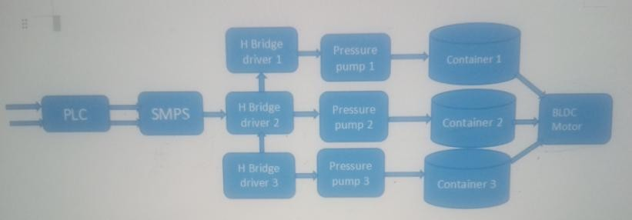

Fig -1: Block Diagram

PLC(Programmable Logic Controllers)

PLC is known as programmable logic controller. it is a digitally operated electronic device which is design to perform control function such as control various machine through digital to analog. In our project we use SIMATIC S7-1200 model PLC, it give the input supply 24V DC 200mA to H bridge diver provide pulse to the plc .
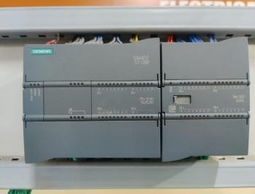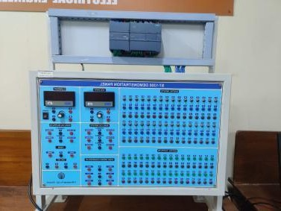

Fig 2 :- PLC

SMPS

The SMPS full form is switched mode power supply
It is an electronic power supply system it is the efficient Power conversion and it taking a main voltage AC 230V input and converting low voltage output is 12 v DC 60 w power rating.
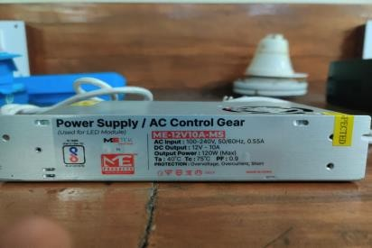

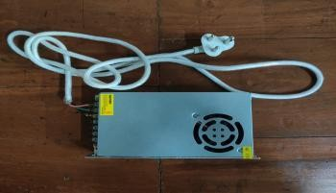

Fig 2 :- SMPS

  - Pressure pump
A pressure pump is also known as a booster pump and this device is use to increase the pressure of water in our project we use this for increase the pressure of paint from the container.
Pressure pumps work by drawing paint form the container and boosting its pressure using a motor driven and paint from three container goes into the bucket it means the booster paint is delivered to desired outlet at a higher pressure than the incoming paint pressure.
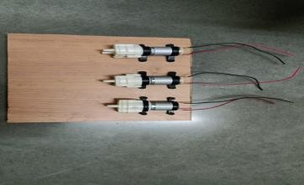

Fig 4:- Pressure pump

H Bridge driver
An H Bridge diver is a device that use to control the direction and speed of the motor in electronic applications.
It consist of four output switches and this switches are use to drive the motor in forward and reverse modes. It allow control over the motor’s rotation and direction and 3 driver circuit is use in this project. H bridge I/o voltage 12v Current rating is 6 to 48A .
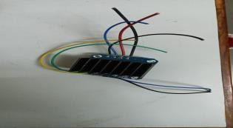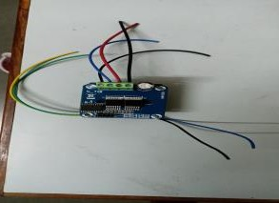

Breadboard

A breadboard is a fundamental prototyping tool used in electronic to create and test circuits without the need for soldering it has rectangular in shape and it is a plastic board with a number of holes arrange in grid pattern in this project we use this breadboard for short the connection of H bridge driver to 5V to the circuit .

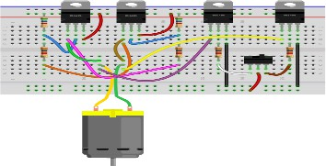

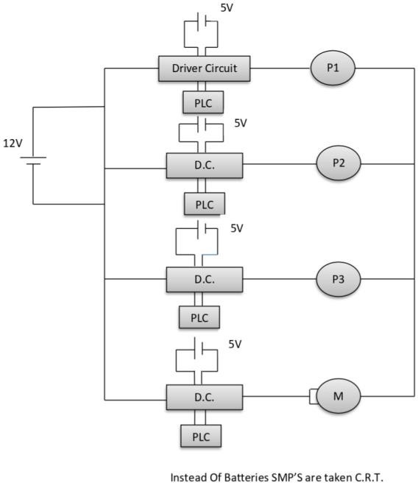
- Connection Diagram

Prototype
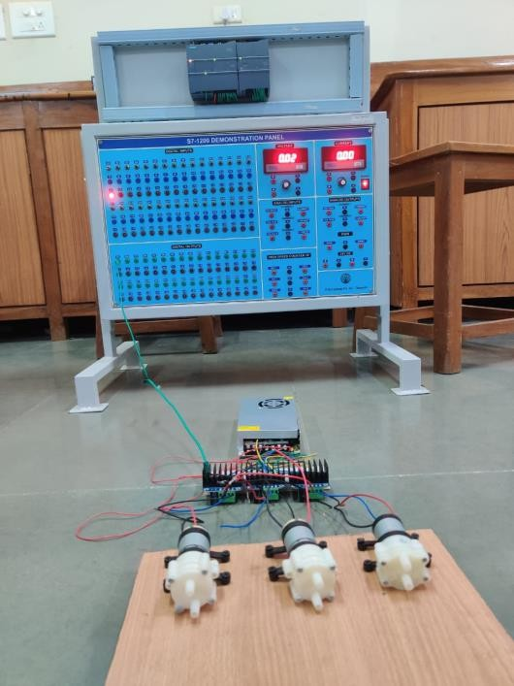

Result
A paint mixing machine with PLC (Programmable Logic Controller) integration would allow for precise control over the mixing process, ensuring consistent and accurate colour formulations. The PLC would manage various parameters such as paint types, quantities, and mixing durations, providing automation and efficiency in the production process. Additionally, it could offer features like recipe storage, data logging, and remote monitoring for enhanced productivity and quality control.

CONCLUSION

In conclusion, a PLC-based paint mixing device offers numerous benefits for the paint manufacturing industry. By integrating PLC technology, the mixing process becomes more precise, efficient, and automated. This leads to improved consistency in color formulations, reduced material waste, and increased productivity. Features such as recipe storage, data logging, and remote monitoring further enhance operational control and quality assurance. Overall, PLC-based paint mixing devices represent a modern and reliable solution for achieving high- quality paint production with minimal manual intervention.

REFERENCES

- N. Shaukat, “ A PLC Based Automatic Liquid Filling Process,” IIEEE, 2002, pp.226-233.

- Kalaiselvi and Praveena, “PLC Based Automatic
Bottle Filling and Capping System With User
Defined Volume Selection,” International Journal of Emerging Technology and Advanced Engineering, 2012.

