Enhancement of Strength of Concrete Using CNC‘S And AR Glass Fibre
Mustaq Khan 1 , Shubham S. Shukla 2 , Nikhil R. Pradhan 3 , Crystal Nadar 4, Naveen Hanchinahal 5
1,2,3,4(UG Students), 5 Associate Professor, Department of Civil Engineering, St John College of Engineering & Management, Palghar. Maharashtra 401404

Abstract – Concrete is most versatile building material. Concrete is brittle, composite material that is strong in compression and weak in tension. When external load are apply then tensile stress produced and cracks are occurred. Hence reinforcement are added in concrete to increase its flexural strength. The use of different types of fibre and their orientation in matrix have shown positive responses among the researchers. Also cellulose fibres are also found to be giving promising results, which works on much nano dimensions in concrete. In present study, Alkali Resistant glass fiber and cellulose Nano crystals are used as a composite enhancement support system in concrete mix. A total of 25 concrete cubes specimen and 12 beam specimen were prepared by adding varying percentages of CNC's and a constant percentage of AR Glass fiber. Based on the laboratory results teh compressive and flexural strength was reported to increase up to a maximum value of 13% and 28% respectively. The different dosage of CNC's ar 0.5%,1%,1.5% and that of AR Glass fiber is 1% throughout the concrete.

Keywords- AR- Glass Fiber, Cellulose Nano Crystals, Compressive Strength, Flexural Strength, Composite Enhancement System.

INTRODUCTION
Concrete is the most versatile construction material of use next to water. The simplest reason for its extensive use in the construction of almost all civil engineering works is that the properties can be controlled within a wide range by using appropriate ingredients and by

special mechanical, physical and chemical processing techniques. Concrete is the most widely used construction material having several desirable properties like high compressive strength, stiffness and durability under usual environmental conditions. Plain concrete possesses a very low tensile strength, limited ductility and little resistance to cracking. This shortcoming is offset by providing steel bars at appropriate locations at the time of casting the members to take up the tensile stresses and sometimes the compressive stresses if required. Normally reinforcement consists of continuous deformed steel bars or pre- stressing tendons. The advantage of reinforcing and prestressing technology utilizing steel reinforcement as high tensile steel wires have helped in overcoming the incapacity of concrete in tension but the durability and resistance to cracking is not improved. These properties can be improved by the use of fibres and cellulose Nano crystals materials in the concrete. It has been revealed that concrete reinforced with a permissible amount of cellulose nano-crystals and fibre acquires better performance in compression, flexure, toughness and energy absorption, in which the degree of improvement relies on the types of fibres and cellulose used. Experiments have been carried out by several investigators using fibres of glass, carbon, asbestos, polypropylene etc. Moreover cellulose and fibre also helps in restricting the growth of micro-cracks at the mortar-aggregate interface thus transforming an inherently brittle matrix into a strong composite with superior crack resistance, improved ductility and distinctive post-cracking behavior prior to failure.

EXPERIMENTAL PROGRAMME
The experimental Programme involves various processes of material testing, mix proportioning, mixing, casting and curing of test specimens which is elaborated in the following sections. All the experiments were done in the material testing laboratory, St John College of engineering and management Palghar , Maharashtra .

A. Materials Used
The materials used in the preparation of concrete mix includes cement, fine aggregates, coarse aggregates glass fibre and cellulose nano crystal .

Cement

Ordinary Portland cement of 53 grade were used, conforming to recommendations stated in IS 4031(1999). The normal consistency and initial setting time of cement was 30% and 30 minutes respectively.

Fine Aggregate

Coarse sand locally available to us was used as fine aggregate. The test procedures as mentioned in IS- 383(1970) were followed to determine the physical properties of fine aggregate as shown in Table 1.

Coarse Aggregate

Two single sized crushed stone aggregates ranging from
12.5 mm to 2.36 mm and 20 mm to 4.75 mm (10mmand 20mm sizes) were used in respective proportions in concrete mixes. The aggregates were tested in accordance to IS-383: (1970). The results obtained are tabulated in Table 2.

Glass Fibre

Cem-Fil Anti-Crack, HD-6 mm, Alkali Resistant glass fibres were used throughout the experimental work. From the micro to the macro fibre range, these fibers control the cracking processes that can take place during the life- span of concrete. The specifications of these fibres are presented in Table 3.

Water

As per recommendation of IS: 456 (2000), the water to be used for mixing and curing of concrete should be free from deleterious materials. Therefore potable water was used in the present study in all operations demanding control over water quality.

Cellulose Nano Crystal

Cellulose nanocrystals are unique nanomaterials derived from the most abundant and almost inexhaustible natural polymer, cellulose. Cellulose nanocrystals primarily obtained from naturally occurring cellulose fibers are biodegradable and renewable in nature and hence they serve as Sustainable and environmentally friendly material for most application. The main sources of cellulose required for generation of CNCs are plants; however, algae, bacteria, and some sea animals are also capable of producing cellulose in large quantities. As the emerging industrial extraction process to achieve greater yield of CNC has not yet developed in India so it was hard to obtain these material. Though we found out these material from CENTRAL INSTITUTE FOR RESEARCH ON COTTON TECHNOLOGY (CIRCOT),
MATUNGA, MUMBAI. Details of the properties of CNCs are tabulated below in table no.4.

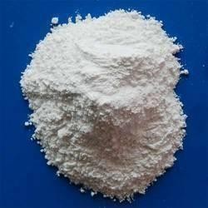

fig. 2 Powdered CNCs

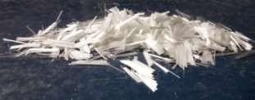
‘’’’’

fig .1 Glass Fiber

Tensile Strength (Mpa) | 1700
Length (mm) | 12


fig .3 CNC as suspension

Table 1: Physical Properties of Fine aggregate

Physical Properties | Observed values | Recommended values
Grading Zone | 2 | -
Fineness modulus | 3.31 | 2.9-3.2
Specific Gravity | 2.71 | 2.6-2.67

Table 2: Physical Properties of coarse aggregate

Physical Properties | Observed values |  | Recommend values
Physical Properties | 10mm aggregate | 20mm aggregate | Recommend values
Fineness Modulus | 6.28 | 7.11 | 6.5-8.0
Aggregate  crushing value (%) | 18.15 | 25.13 | Not more than 45 %
Aggregate  impact value (%) | 28.63 | 22.10 | Not more Than 45 %

Table 3: Physical Properties of Glass fibre

Physical Properties | Recommended values by the supplier
Specific gravity | 2.68
Elastic Modulus (Gpa) | 72

Table 4 : Properties of Cellulose Nano Crystal

Form | Suspension
Specific Gravity | 0.63-0.67
Diameter | 2nm-10nm
Length | 100nm-200nm
Nature | Pseudo plastic
Geometry | Thixotrophy
Strength | Stronger than Kevlar and carbon fibers

- Methodology

The mix proportioning procedure for the concrete was done according to IS 10262: 2009. The proportioning is carried out to achieve specified characteristics at specified age, workability of fresh concrete and durability requirements. Concrete grade M 60 was proportioned according to the procedure as mentioned in the code.

Mix Proportioning

The basic mix proporting for M60 grade of concrete is cement, Fine aggregate, Coarse aggregate, Water and Admixture : 1.0 : 1.05 : 2.09 : 0.28 : 0.01 repectively. The Glass fibre content both compressive strength in cube and flexural strength in beam is 1% throughout. The Concrete Mix CNC Content Are 0.5%, 1% and 1.5% For cubes and beams.

Mixing of Concrete, Casting and Curing of test Specimens
Machine mixing was done during the entire process of casting of specimens. Initially the dry mix constituents of the mix namely cement, fine aggregate and coarse aggregate was mixed for two minutes in the mixer and then the water were added and mixing continued for

another 2 minutes. The total mixing time was kept at 4 minutes until a homogeneous mixture was obtained. Compaction was achieved by means of vibration table. All specimens were de molded after 24 hours and stored in water until the age of testing.
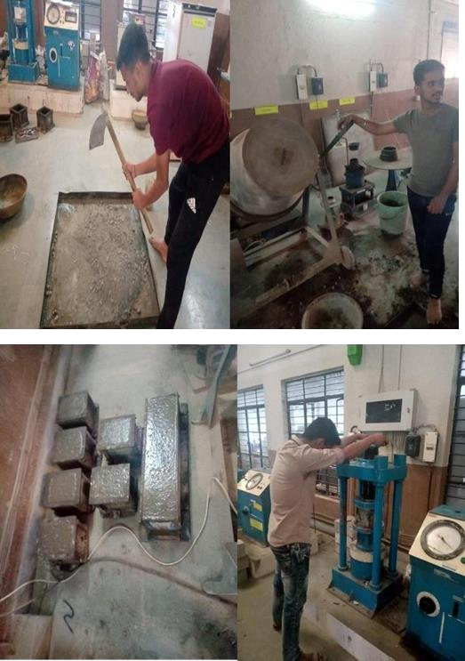

fig. 4 . Prepration of mould and testing

- Test methods

The fresh concretes were tested for slump. However the hardened concrete were tested for compressive strength and split tensile strength discussed below.

Compressive Strength Test

Compressive strength test was performed according to IS 516: 1959.Cubes of specimen of size 150 mm x 150 mm x 150 mm were prepared for each mix. After 24 hours the specimens were de molded and cured in water for 28 days until testing. For specimens with uneven surfaces, capping was used to minimize the effect of stress concentration. The compressive strength reported is the average of three results obtained from three identical cubes.

Flexural Strength Test

Flexural strength is one of the measure of the tensile strength of concrete . it is a measure of un-reinforced concrete beam of slab to resist failure in bending. it is measured by loading 6x6-inch (150x150) Concrete beams with span length of at least three times the depth . Flexural strength is expressed as modulus of rupture (MR) In psi (Mpa) and is deteremined by standard test methods ASM C 78 (third-point loading.
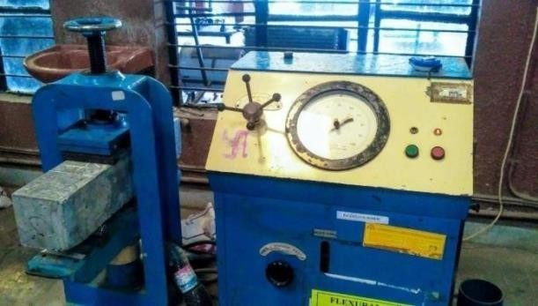

fig .5.Flexural testing Machine

RESULTS AND DISCUSSION

The results obtained are presented in Table 5. Result shows that as the percentage of glass fibers increases in the mix there is corresponding increase in the strength.Apart from this workability of the mixes is also affected by the addition of fibers.

Table 5 : Compressive Strength of CNC and AR Glass Fiber Reinforced concrete
Specimen (M60) | Test Sample | AR  glass fibre content | Compressi  -ve Strength (Mpa) | Mean Compressi - ve Strength (Mpa)
Plain | S-1 |  | 55.150
Concrete | S-2 |  | 54.070 | 55.195
 | S-3 |  | 53.526
Concrete | S-1 |  | 57.260
CNC0.5% | S-2 | 1% By | 57.636 | 57.755
 | S-3 | Weight | 58.310
Concrete | S-1 | Of | 59.420
CNC 1% | S-2 | cement | 62.220 | 60.880
 | S-3 |  | 61.000
Concrete | S-1 |  | 62.280
CNC1.5% | S-2 |  | 63.570 | 63.547
 | S-3 |  | 64.120

fig.6.Graph Showing the strength with samples
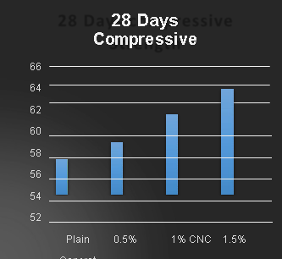

- Effect of CNC and glass fiber on Compressive strength of concrete

Addition of 1% CNC’s and AR Glass Fibre in concrete increased the compressive strength of concrete near to 8% while 1.5% CNC and 1% AR Glass Fibre addition showed increase of 13% compressive strength.

Effects of CNC and glass fibre on Flexural Strength of concrete

Addition of CNC and AR Glass Fibre in concrete beam showed significant increase in the flexural strength. Concrete specimen with 1% CNC and 1% AR Glass Fibre showed 13% increase in flexural by strength and that of concrete with 1.5% CNC and 1% AR Glass Fibre gave 28% increase in flexural strength.

Table 6: Flexural Strength of CNC and AR Glass Fiber Reinforced concrete

Specim- en (M60) | Test Sample | AR  glass fibre content | Flexu- ral Streng  -th (Mpa) | Mean Flexur- al Streng- th  (Mpa)
Plain | S-1 |  | 3.890
Concrete | S-2 |  | 4.160 | 4.101
 | S-3 |  | 4.250
Concrete | S-1 |  | 4.157
CNC0.5% | S-2 | 1% by | 4.632 | 4.530
 | S-3 | Weight | 4.711
Concrete | S-1 | of | 4.430
CNC 1% | S-2 | Cement | 5.180 | 4.805
 | S-3 |  | 5.200
Concrete | S-1 |  | 5.250
CNC1.5 % | S-2 |  | 5.920 | 5.483
 | S-3 |  | 5.280

fig.7.Graph Showing the 28 days flexural strength with samples
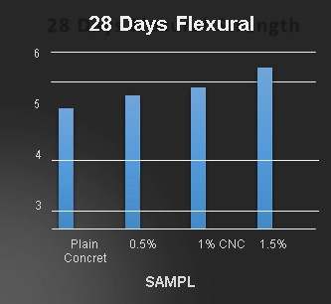

CONCLUSION

Based on the experimental study on concrete mixes, the following conclusions could be made:

  - The percentage increase in strength for higher grade of concrete is marginally high.

  - Concrete without CNC’s suspension was found to be less workable and moreover flexural strength was less. Addition of CNC’s made the concrete more workable compared to conventional one. Concrete with CNC’s showed increase in compressive strength and flexural strength of concrete.
  - It improved the heat of hydration of cement and hence attained high strength in lesser time. CNC’s in concrete acted as Nano Sized Reinforcement to concrete thus providing higher flexural strength.
  - Generation of cracks in the concrete was reduced as addition of CNC’s improved hydration of cement. Water required for concrete was decreased as it get absorbed on the cement particle and thus providing dispersion of cement particles, so that it gets less water and highly workable concrete is obtained.
  - Addition of 1% CNC’s and AR Glass Fibre in concrete increased the compressive strength of concrete near to 8% while 1.5% CNC and 1% AR Glass Fibre addition showed increase of 13% compressive strength.
  - While addition of CNC and AR Glass Fibre in concrete beam showed significant increase in the flexural strength. Concrete specimen with 1% CNC and 1% AR Glass Fibre showed 13% increase in flexural by strength and that of concrete with 1.5% CNC and 1% AR Glass Fibre gave 28% increase in flexural strength.

FUTURE SCOPE

  - Glass Fibre and CNC both are providing promissable enhancement in concrete strength.
  - When used in proper proportion, concrete’s durability has considerably increased by these material.
  - The approach of adding CNC’s with reinforcement of AR Glass Fibre can be used for pre-cast construction, facades, heat insulation panels, railroads slabs, etc
REFERENCES

- Xu S, Liu J, Li Q Mechanical properties and microstructure of multi-walled
carbon nanotubereinforced cement paste. Construction and Building Materials 2015; 76: 16–
23.
- Chung DDL () Cement reinforced with short carbon fibers- a multifunctional material. composites: 2001; 31: 511 - 526.
- Johnsy George and SN Sabapathi Cellulose Nanocrystals: synthesis, fuctional properties, and applications. Nov 4, 2015
- Moon, R.J.; Martini, A.; Nairn, J.; Simonsen, J.;
Youngblood, J. Cellulose Nanomaterial
review: Structure, properties and nanocomposites. Chem. Soc. Rev. 2011; 40: 3941-3994.
- Moon, R.J.; Martini, A.; Nairn, J.; Simonsen, J.; Overview of cellulose nanomaterials, Their capabilities and applications. JOM 2016; 68: 2383- 2394
- Retnakar, A., Aswin, S., Hussain, S. S. K, Shilpa, T. S., Varun, V., Kumar, M. D. S.“Performance Evaluation of Glass Fiber Reinforced Concrete”, IRJET, March 2017, 04 (03):950–954.
- Alam, Md. A., Ahmad, I., Rahman, F.,“Experimental Study on Properties of Glass Fiber Reinforced Concrete”, IJETT, June 2015, 24 (06): 297–301.
- Prasanti, B., Vidya, Sagar, Lal, V.,
“Study on Mechanical Properties and Stress Strain Behaviour of Glass Fiber Reinforced Concrete (GFRC)”, IJRAT, June 2017, 5 (06): 23–29.
- Löber, P., Holschemacher, K.,
“Structural Glass Fiber Reinforced Concrete for Slabs on Ground”, World Journal of Engineering and Technology, September 2014, 2: 48–54.
- Kiran, S. T., Srinivasa, R. K., “Comparison of Compressive and Flexural Strength of Glass Fiber Reinforced Concrete with Conventional Concrete”, International Journal of Applied Engineering Research, 2016, 11(6): 4304–4308.

