Understanding Stock Market, Cryptocurrency and Its Various Aspects

Vedika Fulzele , Sanjana Sanjai , Akansha Bhajipale

Dept of CSE (Cyber Security), SVPCET Nagpur

vedikafulzele05@gmail.com

Received on: 05May, 2024 Revised on: 03 July, 2024 Published on: 06 July, 2024

Abstract: The stock market serves as a vital platform for capital raising and investment, with this research aiming to explore its intricate structure, operational mechanisms, participant diversity, investment strategies, and socioeconomic impact. Blockchain technology has gained significant attention, particularly in the financial and banking sectors, expanding beyond its origins in cryptocurrency. It offers secure data governance and eliminates middlemen through peer-to-peer networking, enhancing efficiency and cost-effectiveness. Accurate stock market models aid investors in making data-driven decisions, reducing risk, and maximizing profits. This paper aims to identify blockchain's applications and contributions in finance, particularly in payment systems, highlighting its potential to revolutionize traditional financial processes. By examining market dynamics, regulations, and emerging trends, the report provides insights for navigating the stock market landscape, empowering investors to make informed decisions and contribute to economic growth and societal well-being.

The stock market serves as a vital platform for capital raising and investment, with this research aiming to explore its intricate structure, operational mechanisms, participant diversity, investment strategies, and socioeconomic impact. Blockchain technology has gained significant attention, particularly in the financial and banking sectors, expanding beyond its origins in cryptocurrency. It offers secure data governance and eliminates middlemen through peer-to-peer networking, enhancing efficiency and cost-effectiveness. Accurate stock market models aid investors in making data-driven decisions, reducing risk, and maximizing profits. This paper aims to identify blockchain's applications and contributions in finance, particularly in payment systems, highlighting its potential to revolutionize traditional financial processes. By examining market dynamics, regulations, and emerging trends, the report provides insights for navigating the stock market landscape, empowering investors to make informed decisions and contribute to economic growth and societal well-being.The stock market serves as a vital platform for capital raising and investment, with this research aiming to explore its intricate structure, operational mechanisms, participant diversity, investment strategies, and socioeconomic impact. Blockchain technology has gained significant attention, particularly in the financial and banking sectors, expanding beyond its origins in cryptocurrency. It offers secure data governance and eliminates middlemen through peer-to-peer networking, enhancing efficiency and cost-effectiveness. Accurate stock market models aid investors in making data-driven decisions, reducing risk, and maximizing profits. This paper aims to identify blockchain's applications and contributions in finance, particularly in payment systems, highlighting its potential to revolutionize traditional financial processes. By examining market dynamics, regulations, and emerging trends, the report provides insights for navigating the stock market landscape, empowering investors to make informed decisions and contribute to economic growth and societal well-being.窗体底端
- INTRODUCTION:

We have heard and read about the term “Stock Market” a lot of times. The financial landscape has undergone significant transformations specially in recent years, with the emergence of cryptocurrencies alongside the traditional stock market. The term stock market refers to several exchanges in which shares of publicly held different companies are bought and sold. Such financial activities are conducted through formal exchanges and over-the-counter (OTC) marketplaces that operate under a defined set of regulations. This research report gives a comprehensive analysis of both markets, examining their structures, functioning, regulation, volatility, investment strategies, and future prospects.
- OBJECTIVES:

The objectives of this research report are as follows:
- To analyze the market structure of both the stock market and cryptocurrency market & regulatory frameworks governing each market.
- To assess the volatility levels exhibited by both markets & explore investment strategies employed by investors in both markets.
- Applications and contributions of blockchain technology in finance and to new areas where the technology can make a larger impact in payment systems.
- To discuss potential future trends in both the stock market and cryptocurrency market.

- LITERATURE SURVEY:

The data in [1] from the reference provides definition of the term "stock market." This page offers a comprehensive overview of the stock market, detailing its definition, purpose, functions, and various components. It covers essential concepts such as stocks, exchanges, indices, trading mechanisms, and the role of investors.
The article in [5] provides a comprehensive overview of Bitcoin, covering its definition, history, features, functioning, and mining process. It explains Bitcoin as a decentralized digital currency based on blockchain technology, highlighting its peer-to-peer transaction mechanism and cryptographic security features.
In [15] variety of information related to the index, including current price and performance data, historical charts, constituent stocks, and news articles impacting the Indian equity market. This information can be valuable for investors seeking to track the performance of major Indian companies and gauge overall market sentiment.
The reference[14] provides reliable and up-to-date financial data, making it a useful platform for investors, traders, and financial professionals looking to stay informed about the Indian stock market and make informed investment decisions.
On the website in [19], users can explore thousands of cryptocurrencies and tokens, ranging from well-known coins like Bitcoin and Ethereum to emerging projects and altcoins. The platform allows users to track the performance of individual cryptocurrencies, compare prices across different exchanges, and stay updated on market trends and developments. It also features educational resources, news articles, and analysis to help users understand the cryptocurrency market and make informed investment decisions. Additionally, the website offers tools for portfolio tracking, cryptocurrency market research, and market analysis.

- Methodology:

This research report employs a qualitative analysis approach, drawing upon a review of relevant literature, regulatory documents, and market data. Information gathered from reputable sources such as financial publications, regulatory agencies, and industry reports forms the basis of the analysis presented in this report.

- DETAILS About the Stock Market:

Market Structure:

The stock market operates as a complex ecosystem of exchanges, where an extensive array of financial instruments, including stocks, bonds, mutual funds, and derivatives, are traded. These exchanges, such as the New York Stock Exchange (NYSE), NASDAQ, and London Stock Exchange (LSE), function as regulated marketplaces where companies can list their securities for public trading. Understanding the underlying structure of the stock market is paramount to comprehending how assets are bought, sold, and valued within this dynamic marketplace.

Functioning:

At its core, the stock market functions as a dynamic arena where myriad participants interact to facilitate the exchange of securities. From corporations seeking to raise capital through initial public offerings (IPOs) to individual investors making buy or sell decisions, brokers executing trades, and regulators ensuring compliance with established laws and regulations, each entity plays a crucial role in maintaining the market's integrity and efficiency.

Participants:

The stock market boasts a diverse spectrum of participants, ranging from individual retail investors to institutional powerhouses and market makers. Retail investors, often comprising individual traders and small investors, form the foundation of the market's activity, while institutional investors, including hedge funds, pension funds, and mutual funds, wield significant influence with their substantial capital. Market makers and high-frequency traders contribute further to market liquidity and price discovery, enhancing overall market efficiency.

Investment Strategies:

Successful navigation of the stock market necessitates the adoption of sound investment strategies tailored to individual preferences, risk tolerance levels, and financial objectives. From the timeless principles of value investing, which entails identifying undervalued stocks based on fundamental analysis, to the growth-oriented approach focusing on companies with robust earnings growth potential, investors have a plethora of strategies at their disposal. Additionally, dividend investing, momentum trading, and sector rotation strategies offer alternative avenues for capital appreciation and wealth accumulation.

Market Impact:

The stock market exerts a profound influence on both economic activity and societal well-being, transcending its role as a mere financial marketplace. By providing companies with access to capital, the stock market fosters innovation, entrepreneurship, and job creation, driving economic growth and prosperity. Furthermore, movements in stock prices serve as vital economic indicators, reflecting investor sentiment and confidence in the broader economy. Positive stock market performance often correlates with heightened consumer confidence, leading to increased spending and economic expansion.

Challenges and Risks:

Despite its pivotal role in the global economy, the stock market is beset with numerous challenges and inherent risks that can pose significant obstacles for investors. Market volatility, driven by factors such as economic data releases, geopolitical tensions, and investor sentiment, can lead to substantial price fluctuations and investment losses. Regulatory changes, liquidity constraints, and systemic risks associated with global economic events further compound the challenges faced by market participants, underscoring the importance of prudent risk management strategies and diversified investment portfolios.

Future Trends:

Looking ahead, the stock market is poised to witness continued evolution and transformation, driven by technological advancements, regulatory reforms, and shifting investor preferences. From the integration of artificial intelligence and machine learning algorithms to enhance trading efficiency and market transparency, to the growing emphasis on sustainable investing and environmental, social, and governance (ESG) factors, the future promises a myriad of opportunities and challenges for market participants.

- Cryptocurrency:

Cryptocurrency is a rapidly evolving field with the potential to disrupt traditional financial systems.The main concept of crypto is unlike traditional currencies issued by governments, cryptocurrencies are decentralized, meaning they are not controlled by a single entity.Transactions are recorded on a distributed public ledger called a blockchain, which ensures transparency and security. Due to the open and transparent nature of blockchain, cryptocurrency transaction records containing rich information and complete traces of financial activities are publicly accessible, thus providing researchers with unprecedented opportunities for data mining in this area. As of rapid development of blockchain technology, these blockchain-based cryptocurrencies have also gained increasing popularity and attention in the past decade. As of the second quarter of 2020, more than 7000 cryptocurrencies are actively traded and their total market cap has exceeded 300 billion U.S. dollars. This is a recent analysis of crypto trade . As the technologies are emerging people tend to advance more and aims to go cashless and this has spiked the levels in cryptocurrency.
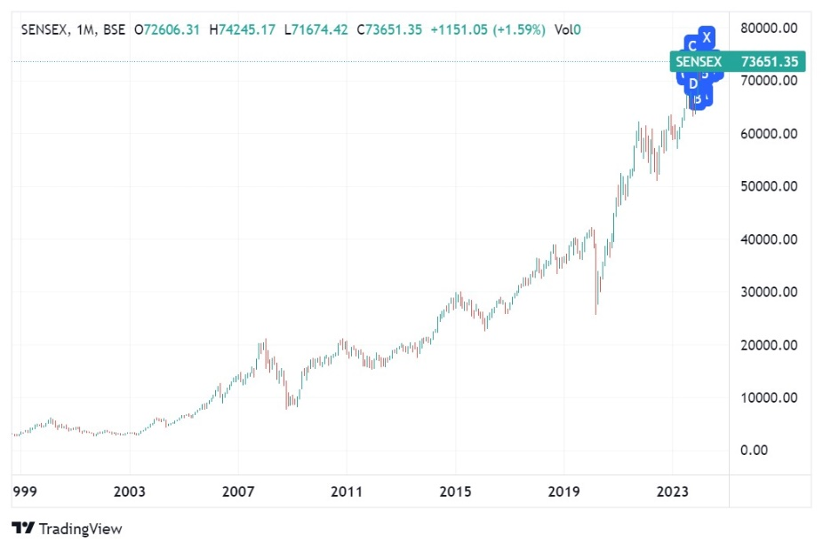

Types of Markets:

BSE | NSE
NSE (National Stock Exchange) and BSE (Bombay Stock Exchange) are the two leading stock exchanges in India. BSE, established in 1875, is Asia's oldest stock exchange and traditionally functioned with a paper-based trading system. BSE boasts a wider range of listed companies (over 5,500) compared to NSE (around 1,600).So some lesser-known companies listed only on BSE.  If looking for a specific company only listed on BSE, then we need to use that exchange. | NSE (National Stock Exchange) and BSE (Bombay Stock Exchange) are the two leading stock exchanges in India. NSE, founded in 1992, was India's first fully electronic exchange. NSE is the larger exchange by trading volume, making it more liquid for investors. This means it's easier to buy and sell stocks quickly on NSE. NSE has a significant edge in the derivatives segment with popular products like NIFTY 50 and Bank Nifty. NSE's electronic platform is considered more advanced and user-friendly compared to BSE's BOLT (BSE On-Line Trading) system.  If faster execution and better liquidity is our priority , NSE might be preferable.

Comprehensive Analysis and Tools:

- Economic Times Markets : The Economic Times (ET) is a comprehensive resource for Indian financial markets. They include Market News, Indices, Company Information, Money Market, Analysis and Opinion, Live Updates, Mutual Funds and IPOs. So in conclusion, The Economic Times is a valuable resource for staying informed about the Indian stock market and broader financial landscape.
- Screener.in: It is a website focused on stock analysis and screening, particularly for investors in the Indian stock market.It mainly includes topics like Stock Screening, Fundamental Analysis Tools, Company Performance Overview. Overall, screener.in is a useful platform for Indian investors conducting research and identifying potential investment opportunities through fundamental analysis.

- Trendlyne: Trendlyne is a platform primarily focused on providing financial data, analysis, and tools for the Indian stock market. It offers features such as stock screeners, financial ratios, stock comparison, and portfolio tracking for Indian equities.

Easy and Simple Interface:

- Moneycontrol: Moneycontrol does cover cryptocurrency news and analysis, but it might not be as in-depth or comprehensive as some cryptocurrency-specific platforms. Some of the information includes Cryptocurrency News, Limited Analysis Tools.
- Investing.com India: It is a financial website that provides a variety of resources for Indian investors, including those interested in the Indian stock market and global markets. It includes Market Data and News like Indian Stock and MarketGlobal, MarketsInvestment Tools and Analysis like Stock Screeners, Technical Charts, Financial News and Analysis and some Additional Features like Investing.com India 50 , IndexEducational , ResourcesCalculators.
- Value Research Online [VRO]: Value Research Online (VRO) is a popular Indian financial website catering to investors. Value Research Online can be a valuable resource for Indian investors, particularly those interested in mutual funds and basic stock analysis. Their free resources and educational content are a plus. However, be mindful of the limitations of the free tier and the potential bias towards premium services.

- Bitcoin:

Bitcoin, a digital currency existing solely in electronic form, revolutionizes transactions by eliminating the need for physical coins or notes. Unlike traditional currencies such as the Rupee, Dollar, Pound, Euro, and Yen, Bitcoin operates independently of central authorities or governments, ensuring decentralization and immunity to third-party control.
Introduced in 2009 as a peer-to-peer payment system, Bitcoin has gained widespread acceptance as a revolutionary form of currency. Stored electronically on mobile devices, computers, or other media, it enables users to trade and transact securely without intermediaries.

Acquiring Bitcoin involves three primary methods:

- Purchasing: Users can buy Bitcoin on various cryptocurrency exchanges using fiat currency, exchanging their local money for Bitcoin at prevailing exchange rates.
- Mining: Individuals or companies can obtain Bitcoin through mining, a process where powerful computers solve complex mathematical problems to earn new Bitcoins as a reward.
- Trading Goods: Goods or services can be exchanged directly for Bitcoin, with the transaction value determined by the current market rate.

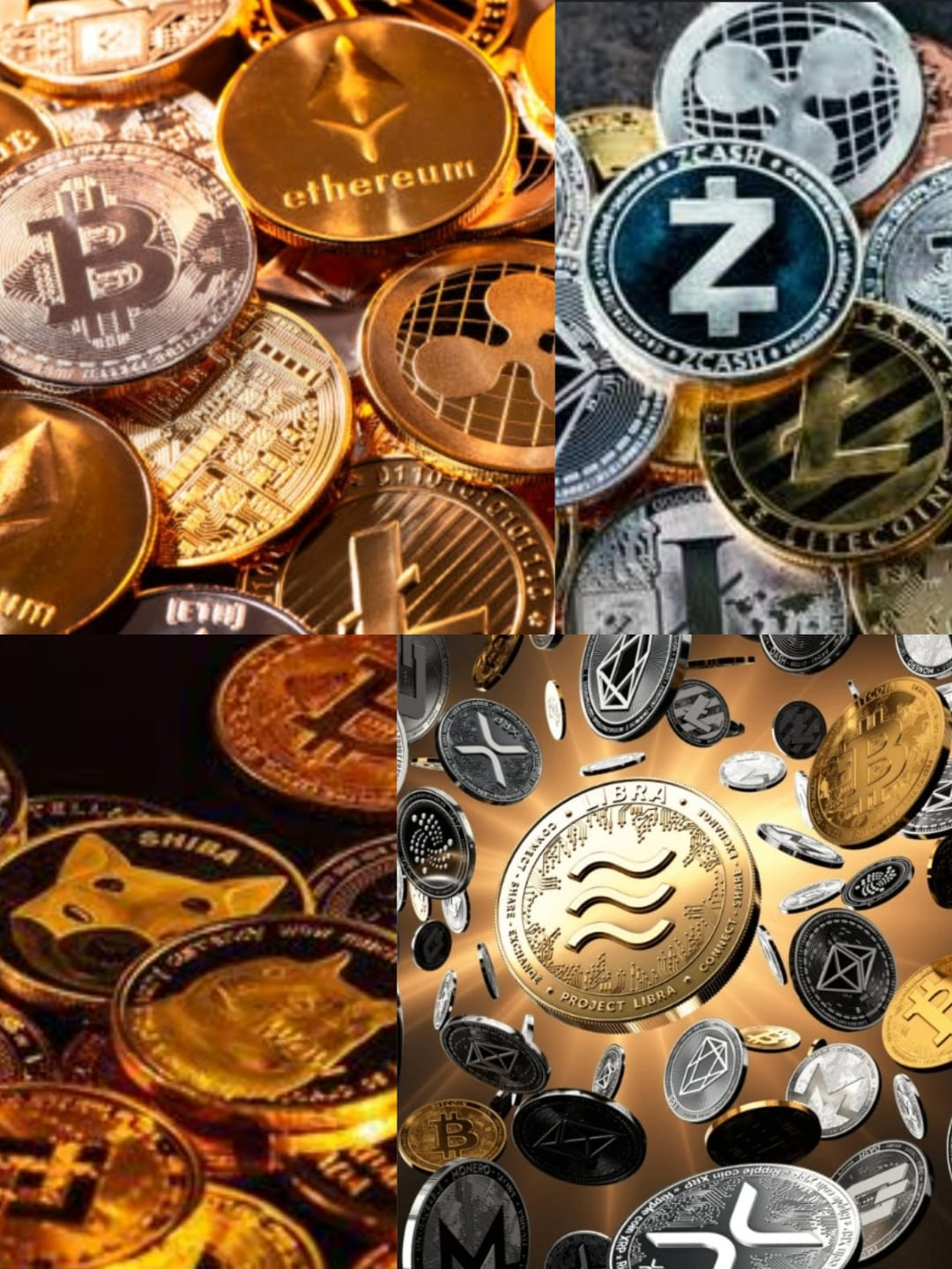

- Bitcoin transactions occur through digital wallets containing a public key for receiving Bitcoin and a private key for authorizing transactions. These transactions are recorded on a public ledger called the blockchain, ensuring transparency and security.
- Despite its innovative features, Bitcoin has drawbacks. Its value is highly volatile, and transactions are irreversible, posing risks for users. Additionally, its widespread acceptance as a form of payment is limited, and regulatory concerns persist.
- Overall, Bitcoin represents a significant advancement in digital currency technology, offering users a decentralized, transparent, and accessible means of financial exchange. Its adoption and integration into mainstream finance continue to evolve, shaping the future of digital currencies.

- CENTRALIZATION:

What is Centralization?
Centralized organizations concentrate decision-making authority at the highest levels. This means top management makes most strategic choices, while lower-level managers primarily focus on implementing those plans.
This phrasing emphasizes the core aspects:

- Top-level control over decision-making
- Limited decision-making power for lower managers who focus on execution

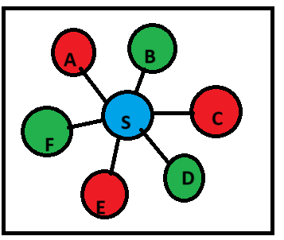

What is Decentralization?
Decentralization spreads decision-making authority throughout an organization. Lower-level managers gain more power to make decisions, increasing their autonomy and responsibility.
This phrasing avoids redundancy and focuses on the key points:
- Authority is dispersed throughout the organization, not just at the top.
- Lower-level managers have more freedom to make decisions.
- This increases their autonomy (independence) and responsibility.

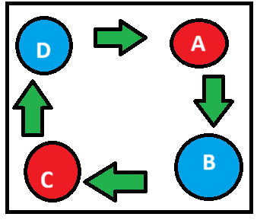

- Blockchain:

Blockchain is a digital ledger shared across a network of computers, not unlike a database. While it's popular for cryptocurrencies like Bitcoin and Ethereum, its applications extend far beyond finance. Blockchain can be used in various systems and applications, creating a decentralized network.
Two key features underpin blockchain's security: cryptography and consensus algorithms. Cryptography scrambles information, ensuring user privacy and data integrity. Consensus algorithms, on the other hand, make sure all participants in the network agree on the validity of transactions.
In essence, blockchain creates a permanent and unalterable public record. Transactions are grouped into blocks, which are then cryptographically linked together in a chain. New blocks are added through a process where network participants reach an agreement.

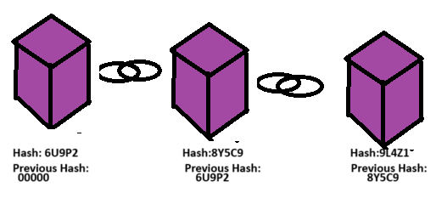

The following is the process of Blockchain:

- A node (computer on the network) initiates a transaction.
- This transaction is grouped with other transactions into a block.
- The block is then broadcasted to all the other computers in the network.
- These computers verify the validity of the transactions within the block.
- The block is then broadcasted to all the other computers in the network.
- These computers verify the validity of the transactions within the block.
- Once approved, the block is permanently added to the end of the blockchain, finalizing the transaction.

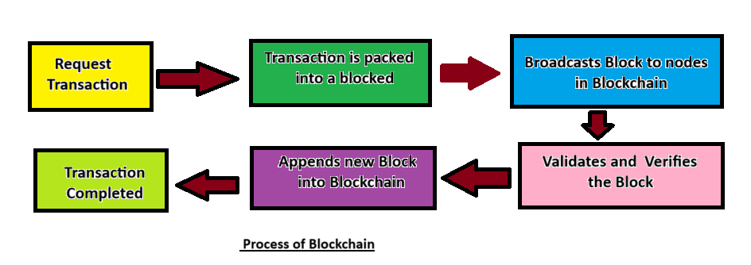

- The block is then broadcasted to all the other computers in the network.
- These computers verify the validity of the transactions within the block.
- Once approved, the block is permanently added to the end of the blockchain, finalizing the transaction.

Blockchain for Decentralization:

Blockchain offers a path towards a distributed internet structure by enabling trust to be shared across connected networks. This fosters a "web of trust" between nodes participating in the blockchain.
Furthermore, blockchain shares characteristics with the decentralized internet projects mentioned in Section 2.3[1]. These projects emphasize peer-to-peer (P2P) communication, data storage, and encryption – all of which are core principles of blockchain as well. Due to these shared features, this paper positions blockchain as the most promising candidate for achieving internet decentralization.
The specific components that enable these functionalities within blockchain are detailed in Figure 3 [1] and will be explored further in [1]

- Conclusion:

In summation, the stock market stands as a linchpin of the modern financial system, serving as a vital conduit for capital formation, wealth creation, and economic progress. By gaining a nuanced understanding of its intricacies and dynamics, investors can navigate the market landscape with confidence, leveraging its potential to achieve financial goals while contributing to the broader prosperity of society. Furthermore, the advent of cryptocurrency has sparked new avenues for investment and financial transactions, challenging traditional monetary systems and fostering innovation. As we navigate the dynamic landscape of finance, it is imperative to recognize the symbiotic relationship between the stock market, blockchain, and cryptocurrency, each contributing to the evolution of financial ecosystems worldwide.
By leveraging insights from this report, stakeholders can harness the potential of these technologies to make informed decisions, mitigate risks, and contribute to economic growth and prosperity. As we embrace the opportunities presented by the stock market, blockchain, and cryptocurrency, we pave the way for a more inclusive, efficient, and resilient financial future.

Recommendations: To thrive in the stock market environment, investors are advised to:
1.Cultivate a solid understanding of market fundamentals, investment strategies, and risk management principles.
2.Diversify their investment portfolios across asset classes, sectors, and geographies to mitigate risk and enhance returns.
3.Stay abreast of market trends, regulatory developments, and economic indicators that may impact investment decisions.
4.Seek professional guidance when necessary and remain disciplined in their investment approach, adhering to long-term financial objectives.

- Acknowledgement:
I extend my sincere gratitude to all the anonymous readers and reviewers who dedicated their time and attention to carefully peruse this research paper. Your commitment to reviewing and providing feedback is deeply appreciated. I hope that the insights and findings presented in this paper prove to be valuable and worthwhile to you. Your constructive feedback and insights contribute significantly to the refinement and enhancement of this research work.
Once again, thank you for your valuable time and contribution.

References

- https://www.investopedia.com/terms/s/stockmarket.asp
- https://www.sciencedirect.com/science/article/abs/pii/S0957417420302888
- https://papers.ssrn.com/sol3/papers.cfm?abstract_id=1004353
- https://www.emerald.com/insight/content/doi/10.1108/MF-09-2018-0451/full/html
- https://www.geeksforgeeks.org/what-is-bitcoin/
- http://www.moneycontrol.com/
- https://www.moneycontrol.com/news/broker-research-reports-13.html
- https://youtu.be/3UF0ymVdYLA?si=bGggqjILGaKZO-Jb
- https://www.kotaksecurities.com/ksweb/research/Kotak-research-center/latest-stock-market-research-reports-tips-recommendations
- ]https://onlinelibrary.wiley.com/doi/abs/10.1111/j.1467-6419.2009.00611.x
- https://youtu.be/Xn7KWR9EOGQ?si=RD8XD8rQ9fYiJGj_
- Bhuriya, Dinesh, Girish Kausha, Ashish Sharma, and Upendra Singh. 2017. Stock Market Prediction Using a Linear Regression. Paper presented at the 2017 International Conference of Electronics, Communication and Aerospace Technology (ICECA), Coimbatore, India, April 20–22; vol. 2. [Google Scholar]
- https://chat.openai.com
- https://www.taylorfrancis.com/chapters/edit/10.1201/9781003336624-7/financial-banking-services-using-blockchain-open-security-issues-shivam-kumar-vikas-kumar-priyanshi-sharma
- https://in.investing.com/indices/investing.com-india-50](https://in.investing.com/indices/investing.com-india-50)

