Design Motion Robot for Vision to Carry Underground Power Cable

Amit Lakhadive
UG researcher scholar Electronics & Telecommunication Department Wainganga College Of Engineering And Management, Nagpur amitlakhadive09@gmail.com
Divya Ganorkar
UG researcher scholar Electronics & Telecommunication Department Wainganga College Of Engineering And Management, Nagpur sweetyganorkar9@gamil.com

Komal Ghumde
Assistant Professor Electronics & Telecommunication Department
Wainganga College Of Engineering And Management, Nagpur kmlborkar@gmail.com

Abstract— At numerous locations Maintenance of divided infrastructures requires periodic measurement of many physical changing. This job can probably be execute with autonomous robotic platform. Field test in the underground cable system represent the capacity of designed platform to travel along the cable. In this paper check the underground power cable fault and carry to vision and implement the power cable in underground system.
Keywords—Underground cable, Esp32 cam, L298 motor driver

I.Introduction
The underground distribution requires to be checked out regularly for extend and safe-use. Various mobile inspection systems are widely used, but some necessary problems with the limited inspection distance still live due to the unstable wireless communication and cable restriction in complicated facilities. The results show that the planned system could extend the inspection range with larger communication quality [1]. The developing concern for safety and infrastructural addition in the dull populated cities and domestic areas as well as the quest to protect the elegance values in many current places has required the need for underground instalment. The underground cabling installations are lacking of faults common to the overhead transmission lines but are connect with certain kinds of faults such as short circuit and open circuit faults. Detect the exact position of any of these kinds of faults is very exhausting, costly and time-dominate [8]. The cables where made to put overhead and currently the situation is to put underground cable, which is larger to the previous method. This is because the underground cables are not overdone by the negative weather condition; neither the hot sunny day nor the rain is to affect it. But when the cable breaks due to some reasons it’s tricky to locate that. Presently what is done is they find the exact location and dig the cables out from the location and check it manually to find the exact point of break. Thus it saves a lot of time, money and allow to service underground cable lines faster [10]. This project is used for detecting failing in underground cables. This paper presents a book underground cable fault finder that has the capacity to assess the resistance of the cable, find out the type of failing in a cable, and also exact calculate the location of the failing using inexpensive materials [11]. From the last few years, after the transformation of Optical fibre cables communication has been modern. Whenever there is a fault in the OFC that may be because of common problems like temperature difference cable failure or break-up etc. [12]. This paper express the check failing in underground cable and carry power cable to implement the cable in underground system using motion robot.

II. RELATED WORK

The underground facilities require to be investigated continuously for expanded and safe-use. Multiple mobile inspection systems are widely used, but some mandatory problems with the limited examination distance still live due to the unstable wireless communication and cable limitation in complicated facilities. To resolve these problems, we demonstrate a wheeled robot chain control system (RCCS) for underground facilities inspection based on visible light communication (VLC) and solar panel receivers. The RCCS comprises of a leader and follower robot and can extend the inspection range with special ‘optical signal relay’ technology. VLC can create not only illumination for observation but also less attenuation, higher information security, and stronger anti-electromagnetic participation capability, compared with traditional radio communication in complexes underground facilities. Using solar panels can expand the receiving area of optical signals, environmental adaptability, and system toughness, compared with traditional photodiode (PD) receivers [1].

Govt. of India has aimed to generate 100 smart cities with the help of new technological advancements. In the state of Tamil Nadu, the capital and an industrial city Chennai is going to become a smart city soon. At this time most of the electrical systems used in Chennai are overhead systems, and these systems were rarely damaged by Vardah cyclone on Dec 2017. It took more than a weeks’ time to put back the power supply to the city. The idea after smart city is to monitor and save the system from unpredicted disconnection. By changing the overhead systems into underground systems, constant power supply can be supplied. EMI studies have become an necessary part in planning & implementation of power systems, design of high voltage power device, healthcare etc. In case underground systems are organised, it is necessary to execute EMI studies as a part of design method. The aim of this paper is to examine the EMI create by these underground power cables and to decide the developed value of the radius of the cable using Genetic Algorithm (GA) also understand the remedies to suppress the exposures within safe limits [3].

Pipeline inspection robots are recently expected to be located to pipelines with longer distance and more complex organization. These robots require high performance in wireless communication between robots and outside. The radio frequency or infrared radiation frequency can be one of the adverse wireless communication methods, but they would have disadvantage in pipeline environments, such as electromagnetic involvement and low energy efficiency. In this study, we focus on visible light communication (VLC), which has a high transmission rate, strong anti-interference capability, and large bandwidth, compared with the above methods. VLC also has an exciting factor that can together realize data communication and illuminating dark pipeline environment for pipe robot. As a advance study of VLC application, we developed a control system based on VLC for a wheeled robot, which consists of a VLC transmitter and receiver. The transmitter and receiver can encode and decode the light signals [6].

A mobile unconventional robot for detection of initial faults in electric power cables has been developed and examine in laboratory and in field conditions. Mechanical design and unconventional control system of the robot are progressed for the conditions of the operating environment, namely, underground tunnels of distribution power systems. The examination of appreciable physical phenomena led to a selection of compulsory sensing concept. Four types of sensors for measurement of physical effects of the distributed infrastructure were combining into the mobile platform and examined in laboratory situations. The presented mobile observation method delivers a workable solution to the task of monitoring and maintaining underground cable systems [15].

Gas pipeline requires being inspection regularly for leakages generated by natural disaster. Robots are widely used for pipeline inspection since they are more suitable than manual inspection. Some problems, additionally, exist due to the obstacle by complex pipe networks. The most significant one is limited inspection range caused by limitation of cable length or wireless signal weakness. In this paper, we offer an idea of wireless relay communication to help robot to extend the inspection range, and we newly succeed a tracked robot chain system. In this system, each robot serves as a relay communication node. Leakage information of pipes are transmitted via these relay nodes. To secure the stability of relay communication in the between of adjacent robots, we accept RSSI (received signal strength indication)-based evaluation method for combined and correlate movement of robot chain system [9].

III. methodology

ESP32 CAM

Table1: ESP32 CAM specification

Operating parameter | Specification range
Operating voltage | 2.2v to 3.6v
GPIO | 36 Ports
ADC | 14 Ports
DAC | 2 Ports
Flash Memory | 16 MB
SRAM | 250 Kb
Wi fi | 2.4 GHz
Sleep current | 2.5 μA

ESP32 is a series of low-cost, low-power system on a chip microcontrollers with integrated Wi-Fi and dual-mode Bluetooth. The ESP32 series employs either a Tensilica Xtensa LX6 microprocessor in both dual-core and single-core variations, Xtensa LX7 dual-core microprocessor or a single-core RISC-V microprocessor and includes built-in antenna switches, RF balun, power amplifier, low-noise receive amplifier, filters, and power-management modules. ESP32 is created and developed by Express if Systems, a Shanghai-based Chinese company, and is manufactured by TSMC using their 40 nm process. It is a successor to the ESP8266 microcontroller.

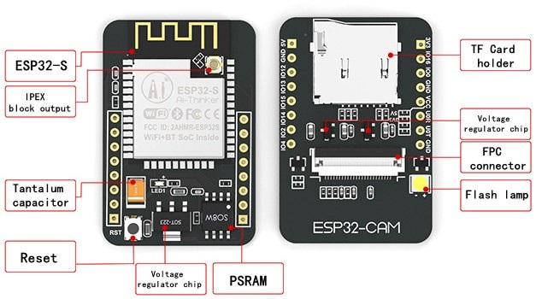
Fig.1. ESP 32

DC Motor
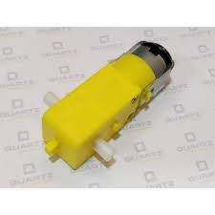
Fig.2. DC Motor

Table2: DC Motor Specification

Operating parameter | Specification range
Rpm | 30
Oprating voltage | 12volts dc
shaft diameter | 6mm with internal hole
torque | 2kg-cm
No- load current | 60mA(max)
load current | 300mA(max)

An electric motor is an electrical machine that converts electrical energy into mechanical energy. Most electric motors operate through the interaction between the motor's magnetic field and electric current in a wire winding to generate force in the form of rotation of a shaft. Electric motors can be powered by direct current (DC) sources, such as from batteries, motor vehicles or rectifiers, or by alternating current (AC) sources, such as a power grid, inverters or electrical generators. An electric generator is mechanically identical to an electric motor, but operates in the reverse direction, converting mechanical energy into electrical energy.

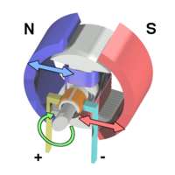
Fig.3. Permanent magnet stators

Voltage regulator 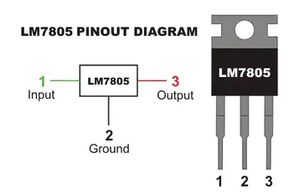

Fig.4. 7805 voltage regulator IC with pin diagram

Table3: 7805 IC Specification

Operating parameter | Specification range
Output voltage | 5V
Output Current | Up to 1A
Dropout voltage | 2V
Output Resistance | 15 m Ω
Peak Current | 2.2 A
7805 is 5V, positive voltage regulator. The 7805 of three terminal regulators is available with several fixed output voltages making them useful in a wide range of applications. One of these is local on card regulation, eliminating the distribution problems associated with single point regulation. The voltages available allow these regulators to be used in logic systems, instrumentation, HiFi, and other solid state electronic equipment. Although designed primarily as fixed voltage regulators these devices can be used with external components to obtain adjustable voltages and currents.

DHT 11
DHT11 is a low-cost digital sensor for sensing temperature and humidity. This sensor can be easily interfaced with any micro-controller such as Arduino, Raspberry Pi etc… to measure humidity and temperature instantaneously. DHT11 humidity and temperature sensor is available as a sensor and as a module. The difference between this sensor and module is the pull-up resistor and a power-on LED. DHT11 is a relative humidity sensor. To measure the surrounding air this sensor uses a thermistor and a capacitive humidity sensor.

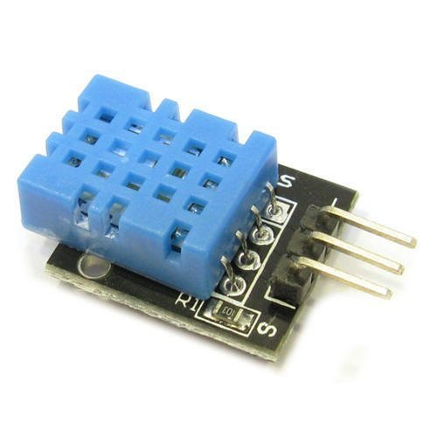
Fig.5. DTH 11 Sensor

Camera Module

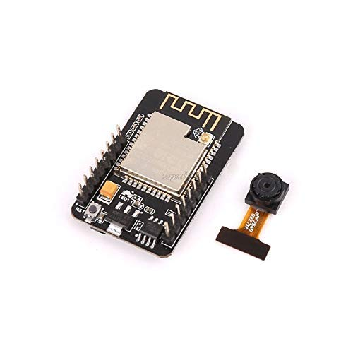
Fig.6. Camera Module

The ESP32 CAM Wi-Fi Module Bluetooth with OV2640 Camera Module 2MP For Face Recognization has a very competitive small-size camera module that can operate independently as a minimum system with a footprint of only 40 x 27 mm; a deep sleep current of up to 6mA and is widely used in various IoT applications.
Table 4: Camera module

Operating parameter | Specification range
Clock speed | 160MHz
SRAM | 520 KB
Flash Memory | 32 MB
Bluetooth | 4.2 BR/ EDR
Wi-Fi | 802.11b/g/n/

Working of Project

In this project, firstly connect mobile Wi-Fi and hotspot to the ESP 32 cam module. After the Wi-Fi had connected the IP address of the ESP 32 cam has been obtained. This IP address is put on the browser on mobile phone. After the IP address has been obtained the control panel opens on screen to control the robotic platform. The output logic of the ESP 32 cam transmits to the input of the L298 motor driver IC. The 7805 voltage regulator IC converts 12V/ 7.4V converts into stable +5 Volts. The motor driver IC and ESP 32 Cam have been worked on +5 Volts. The motor driver IC converts. We use our project system with the sensors on the robot with a camera. The sensors are the temperature sensor DHT11, Gas sensor and BMP module. ESP32 cam is used which is connected to the Wi-Fi network so we can access the robot online. And when we put the IP address on the browser we can see the camera vision which is live and have the control buttons on the same page. By that we can control the motion of the robot. A PM motor does not have a field winding on the stator frame, instead relying on PMs to provide the magnetic field against which the rotor field interacts to produce torque. Compensating windings in series with the armature may be used on large motors to improve commutation under load. Because this field is fixed, it cannot be adjusted for speed control. PM Fields (stators) are convenient in miniature motors to eliminate the power consumption of the field winding. Larger DC motors are of the "dynamo" type, which have stator windings. Historically, PMs could not be made to retain high flux if they were disassembled; field windings were more practical to obtain the needed amount of flux. However, large PMs are costly, as well as dangerous and difficult to assemble; this favors wound fields for large machines.

IV.output

Table 5: Output of L298 motor driver IC

Input |  |  |  | Output
A | B | C | D | M1 | M2 |  | Direction
0  0  1  1  0  1 | 0  1  0  1  1  0 | 0  0  1  1  1  0 | 0  1  0  1  0  1 | Stop  Clockwise  Anticlockwise  Stop  Right  Left |  | Stop  Clockwise  Anticlockwise  Stop  Right  Left |  | Stop  Forward  Reverse  Stop  Right  Left

V.results

Table 6: Result compared to existing work

Sr. no | Parameter | Article name & year | Existing work | Proposed work
1. | Information  Transmission using radio frequency | “A wheeled robot chain control system (RCCS) inspection based on visible light communication (VLC) and solar panel receivers”.  Wen Zhao, Mitsuhiro Kamezak (2021). | Wireless Radio frequency range from 234 Hz to 1417 Hz | Wireless radio frequency range from 80 MHz to 240 MHz
2. | Flash memory | “An Underground Pipeline Water Quality Monitoring Using IoT Devices”  S. Angel vergina (2020) | 256KB | 4MB,8MB,16MB
3. | Microcontroller used | “Smart Underground Wireless Cable Fault Detection and Monitoring System”. Rao Muhamma Asif,  Syed Rizwa Hassan  Ateeq Ur Rehman  Asad Ur Rehman  Bilal Masood (2018). | ATmega328/P, 8 bit , 2KBytes Internal  SRAM | ESP32-CAM, 32-bit,  520 KB SRAM.
4. | Output current | “Design and Detection of Underground Cable Fault Using Raspberry Pi & IoT System”.  Mr. M. Dinesh, Mr. K. Vairaperumal, Mr. P. Senthilkumar (2018). | 1A | 1.2A

VI.conclusion

This paper designed and implementation of a microcontroller based underground cable failing detector. We have successfully designed, implemented and tested an inexpensive underground cable failing detector. Our proposed method can locate both open and short circuit in underground cables with a maximum distance. In this, method we used camera for locate the fault using real time video and also vision to carry cable in underground system for implementation of cable in underground system.

VII.reference

[1] Wen Zhao, Mitsuhiro Kamezak (2021). “A Wheel Robot Chain Control System for Underground Facilities Inspection using Visible Light Communication and Solar Panel Receivers.” DOI10.1109/TMECH.2021.3060189.

[2] Pragati, S., Arti, P., Nutan, P. and Bhagyashri, V. (2021). “Video Surveillance Robot.” International Journal of Innovative Research in Electrical, Electronics, Instrumentation and Control Engineering 9(6), 107-111. DOI: 10.17148/IJIREEICE.2021,9624.

[3] Balaji S, Vidhyasagar Devendran, Sharmeela Chenniappan (2020). “Electromagnetic Analysis of Underground Cables for Upcoming Smart City: Case StudyDOI: 10.1109/PECon48942.2020.9314306.

[4] Roshani Shingrut, Shubham Shelar, Dakshata Mokal, “Underground Cable Fault Detection”, Vol.9 Issue 02, February-2020.

[5] Srikanth Aldi, Kiran Thallapally, Deepika Bussa, Sisindri Tejas Rayini, Shekar, “Detection and Location of Faults in Underground Cables,” Volume 3 Issue 2, March 2020.

[6] Wen Zhao, IEEE Student Member, Mitsuhiro Kamezaki, IEEE Member, Kento Yoshida, Kaoru Yamaguchi, Minoru Konno, Akihiko Onuki, and Shigeki Sugano, IEEE Fello.(2019). “A Preliminary Experimental Study on Control Technology of Pipeline Robots based on Visible Light Communication.” 978-1-5386-3615-2/19/$31.00 ©2019 IEEE.

[7] Samuel A. Isaac, Olajube Ayobami, Awelewa Ayokunle, Utibe Bassey. “Arduino Microcontroller Based underground Cable Fault Distance Locator,” Volume 10, Issue 03, March 2019, pp.890-902. Article ID: IJMET_10_03_092.

[8] Emmanuel Gbenga Dada, Abdulkadir Hamidu Alkali, Stephen Bassi Joseph, Umar Abba Sanda, “Design and Implementation of Underground Cable Fault Detector,” vol. 8, issue 87, April 2019.

[9] Wen Zhao, IEEE Student Member, Mitsuhiro Kamezaki, IEEE Member, Kento Yoshida, Minoru Konno, Akihiko Onuki, and Shigeki Sugano, IEEE. “An Automatic Tracked Robot Chain System for Gas Pipeline Inspection and Maintenance Based on Wireless Relay Communication.” 978-1-5386-8094-0/18/$31.00 ©2018 IEEE.

[10] Mr. M. Dinesh, Mr. K. Vairaperumal, Mr. P. Senthilkumar, “Design and Detection of Underground Cable Fault Using Raspberry Pi & amp; IoT System,” Volume 3 | Issue 1 | Nov-Dec 2018.

[11] Meiwei Kong , Bin Sun , Rohail Sarwar , Jiannan Shen , Yifei Chen , Fengzhong Qu Jun Han , Jiawang Chen , Huawei Qin d, Jing Xu,“Underwater wireless optical communication using a lens-free solar panel receiver,” Volume 426, 1 November 2018.

[12] Soubia Noorain, Mamatha M, and Zohra Jabeen, “Under Ground Cable Fault Detection Using A Robot,” Volume: 05 Issue: 05 May-2018
[13] Abhishek Pandey, Nicolas H. Younan, “Underground Cable Fault Detection and Identification via Fourier Analysis.” 978-1-4244-8286-3/10/$26.00 ©2010 IEEE.
[14] Amir A. F. Nassiraei, Yoshinori Kawamur, Alireza Ahrary, Yoshikazu Mikuriya and Kazuo Ishii. “Concept and Design of a Fully Autonomous Sewer Pipe Inspection Mobile Robot KANTARO” 1-4244-0602-1/07/$20.00 ©2007 IEEE.
[15] Bing Jiang, Student Member, IEEE, Alanson P. Sample, Student Member, IEEE, Ryan M. Wistort, Student Member, IEEE and Akexander V. Mamishev , Member, IEEE, “Atonomous Robotic Monitoring of Underground Cable System”. 0-7803-9177-2/05/$20.00/ ©2005 IEEE.

