Static Seismic Analysis of RCC Building as per IS 1893:2002 by Using STAAD-Pro Software
Hiteshkumar D. Mishra¹, Prof. D.L.Budhlani², Prof.B.N.Ramteke³
¹M.Tech-Student Appearing (Structural Engineering)
Guru Nanak Institute Of Technology, Dahegaon, Nagpur, India, 441501
^{2,3}Assistant Professor,
Guru Nanak Institute Of Technology, Dahegaon, Nagpur, India, 441501

Abstract – In this paper seismic response of (G+7)R.C. framed building is analyses for different load cases by using STAAD-Pro software as per IS1893:2002 part-1.This paper consider different seismic parameter like seismic zone, response reduction factor, importance factor & other parameters like rock/soil type, structure type, damping ratio etc. This paper provides complete guidelines for STAAD-Pro software analysis & STAAD –Pro gives the results after run analysis in the STAAD output viewer which shows joint displacements, support reactions, member forces base shear and lateral load.
Keywords- Static analysis, IS 1893:2002, reinforced structure, Earthquake, STAAD-Pro, Seismic loads, multistory building, RCC building.
INTRODUCTION
From the history of earth, Earthquake is sudden violent shaking or Vibrations of the ground. Earthquake caused by tectonic movement in earth Crust and also caused by sudden slip on a fault or rupture of geological faults, But also by other events (natural & artificial causes) such as volcanic activity, Landslides, mine blasts and nuclear tests. In recent studies geologist claim that global warming is one of the Reason for seismic activity. According to these studies melting glaciers and Rising sea level disturb the balance of pressure on earth tectonic plates thus causing increase in frequency and intensity of earthquakes results in Damages structure & property of nation. Hence, earthquake is a major problem by development of nation & great Challenge for structural engineer to construct building in seismic region (Zones). Hence, structure should be analyzed for earthquake forces to avoid the damages.

Generally Structure having two types of loading that is static loading and dynamic loading. Static loads are Constant and dynamic loads are change with time. In maximum civil buildings or structures only static loads are considered and dynamic loads are not calculated because of more complications in calculation. In this paper complete static analysis is performed by using STAAD-Pro software.
METHODOLOGY
Consider (G+7) storey building located in new Delhi zone IV, the soil conditions is medium stiff soil, entire building is supported on raft foundation, RC frame infill with brick masonry, lumped weight due to dead load is 12kN/m² on floors and 10kN/m² on roof, floors carry live load of 4kN/m² on floors and 1.5kN/m² on roof, span of building 5m in X and Z direction, Floor to floor height is 3.1m, bottom floor height is 4.2m, size of beam is assume to be as 0.35X0.45m And size of column as 0.35X0.5m, material assume to be concrete. All the supports are assigning as fixed supports,
- Lumped Weight:-A lumped mass is a load that can be applied to a node in a static stress, natural frequency (modal) or modal superposition analysis. A lumped mass can be used to resist the translation or rotation of a node.
- Seismic parameter:-
- Seismic zone IV, zone factor Z is 0.24
………… (Table no. 2 of IS1893:2002 Part-1)
- Response reduction factor, R is 5
………… (Table no. 7 of IS1893:2002 Part-1)
- Importance factor, I is 1.0
.………... (Table no. 6 of IS1893:2002 Part-1)
Here, I explain how to define IS1893:2002 Seismic loading definitions. Further we will apply that all loads to the buildings and analyses the building by using STAAD-Pro software.
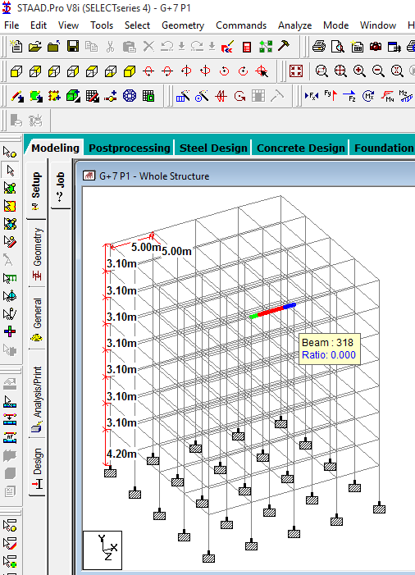
Fig. 1- fig shows the Structural model of building in STAAD-Pro software.
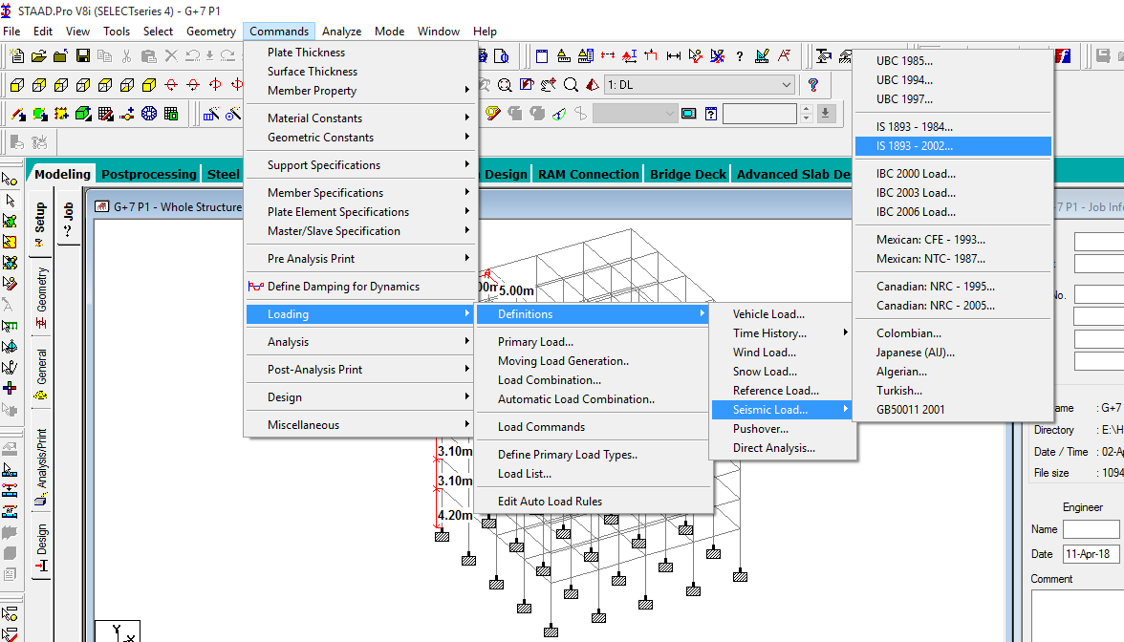
Fig. 2- fig shows the seismic definition
The natural vibration characteristics of a structure play a significant role in estimation of seismic behavior of a structure. The design guidelines of different countries also provide some estimate of the natural period by prescribing empirical expressions.
Since our building is made of moment resisting frame with break in fill panels, we should use empirical expression the fundamental natural period is as follows:
T=0.09h/sqrt (d)
…… (Clause 7.6.2 of IS 1893:2002)
By default STAAD-Pro calculates the fundamental natural period by using the expression. We will have to calculate natural period manually for this building using following equation:
T=0.075h ᵔ (0.75)
…… (Clause 7.6.1 of IS 1893:2002)
Hence approximate fundamental natural period in both X and Z direction is as follows:
T = 0.09(25.9) / sqrt (20)
T = 0.5212 sec… (Since X and Z direction value D = 20)
Add Damping Ratio as 0 to get the accurate result. In engineering, the damping is dimensionless measure describing how oscillations in a system decay after a disturbance.
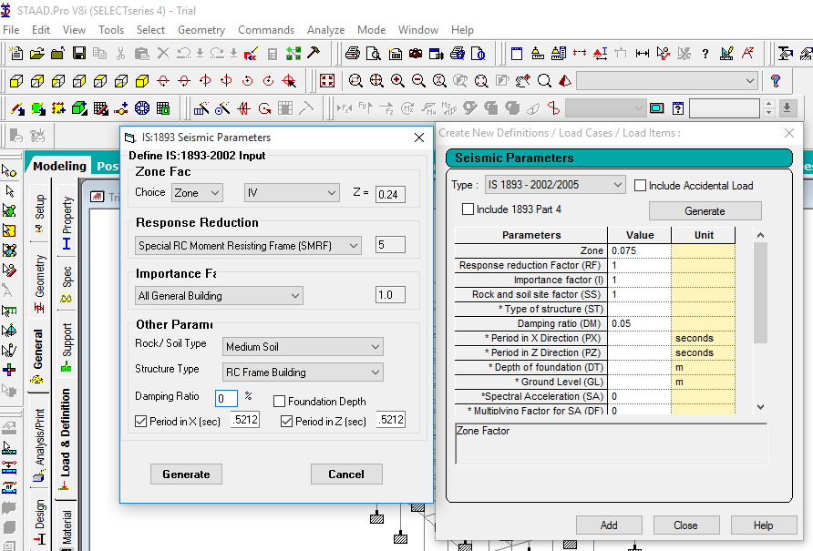Fig. 3- fig shows the seismic parameter.
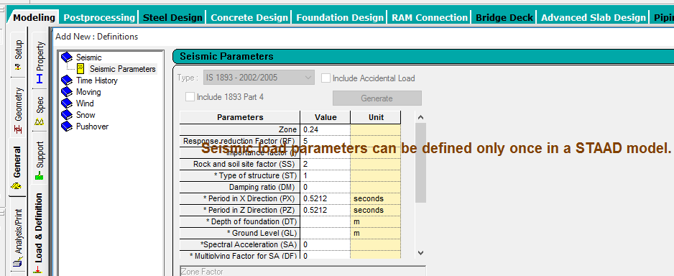
Fig. 4- fig shows the seismic parameter can be defined only once in STAAD model.
Seismic definition is generated to help STAAD-Pro to obtain the value for Ah
VB = Ah*W
Where,
VB = Seismic base shear,
Ah= Horizontal acceleration spectrum value as per 6.4.2 of IS 1893:2002
W = Seismic weight of building.
To help STAAD-Pro to calculate W (Seismic weight)
We will define floor weight in the building
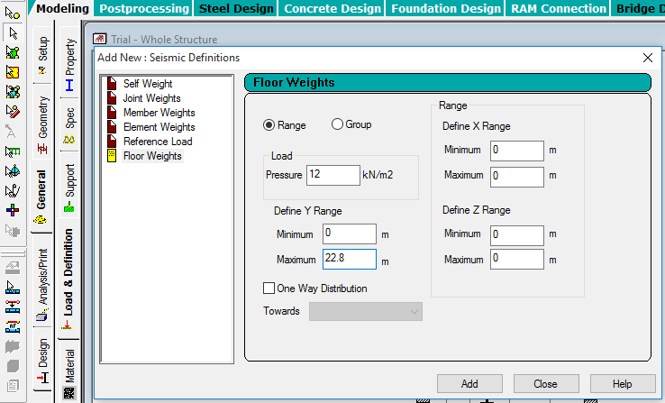
Fig. 5- fig shows the seismic floor weight of building for dead load.
For roof only
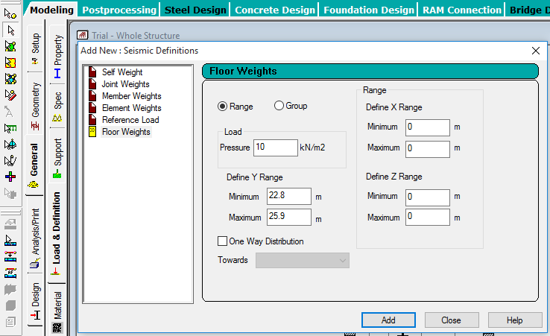
Fig. 6- fig shows the seismic floor weight of building for dead load.
Now floor carry a live load 4 KN/m².Since the value of live load is more then 4kN/m², 50% of live load will be lumped on floors, hence 50% of live load that will be 2kN/m²
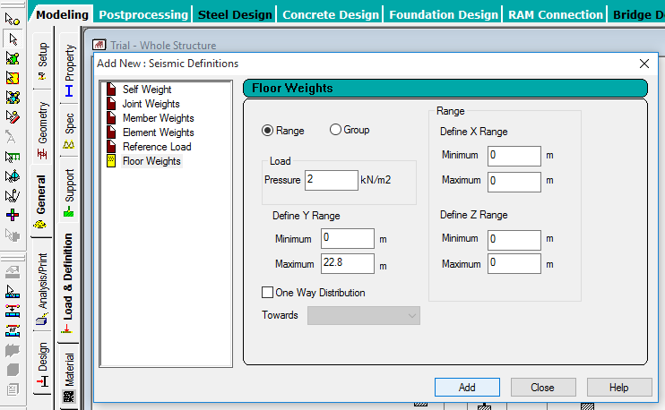
Fig. 7- fig shows the seismic weight of building for live load.
This completes the seismic definition as per IS 1893-2002.
Defining Dead Load Case- First of all we will have to define earth quake load case.
Dead load cases: - For floors shown in fig.
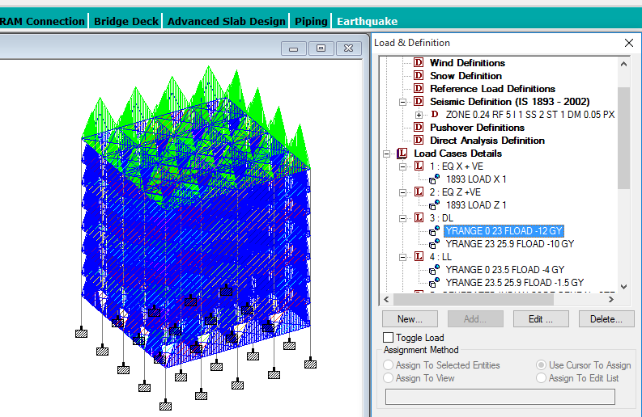Fig. 8- fig shows the D.L. case for floors.
Live Load case: -for Floors
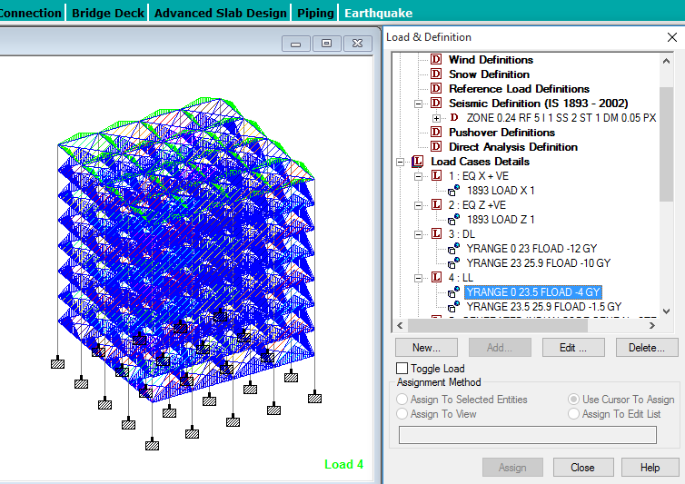Fig. 9- fig shows the L.L. case for floors.
Before applying auto load combinations we will have to define analysis and print data command between load case 1 and 2 and then load case 2 and 3.
This will help STAAD-Pro to calculate loads for load cases 1 and 2 in x direction and z direction before doing the combinations. After Perform analysis- we will use the "Change" command to reset Stiffness Matrix.
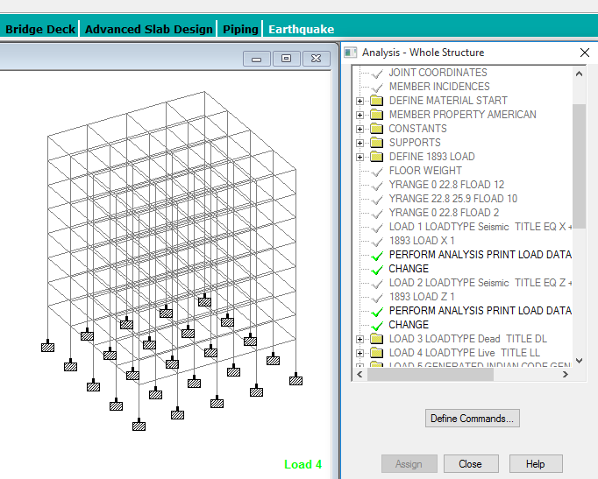
Fig. 10- fig shows perform analysis.
Partial safety factors for limit state design of reinforced concrete structures, the following load combinations shall be accounted for:
- 1.5(DL + LL)
- 1.2(DL + IL +_ EL)
- 1.5(DL +_EL)
- 0.9 DL +_ 1.5 E
……. (clause 6.3.1.2 of IS1893:2002Part-1)
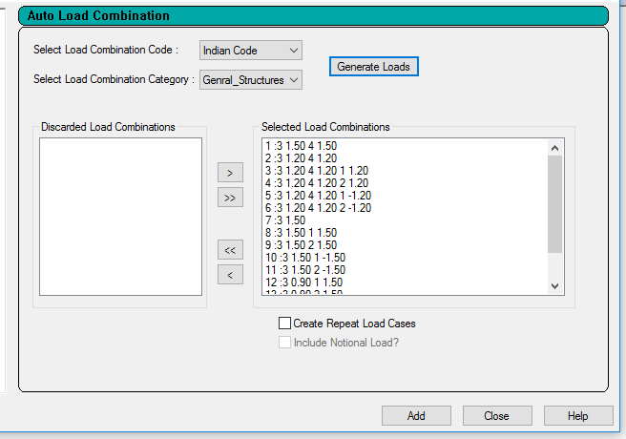
Fig. 11- fig shows the auto load combination as per IS 1893:2002
By check in "Create Repeat load cases" it will create auto load combinations with repeat command, which help STAAD-Pro to analyze building with simultaneous effects of all load cases.
Now again apply command "Perform Analysis" then Click "Post print" from Analysis Toolbar. Now Click "Define command"
Add load cases from 5 to 12.So STAAD-Pro consider only this load cases to print data.
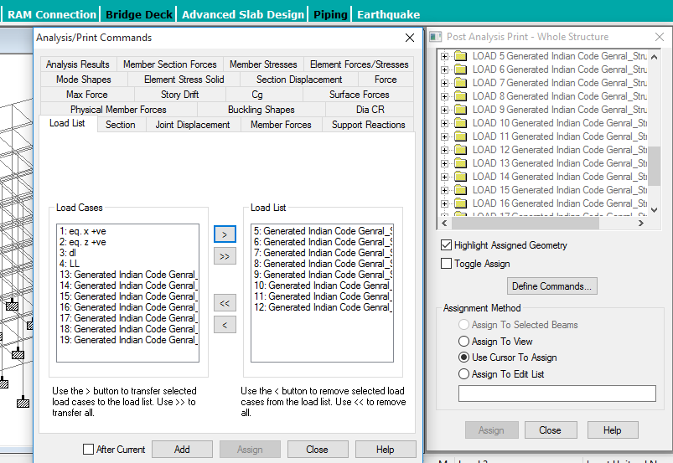
Fig. 12- fig shows the add load list 5-12
Likewise add "Joint displacement”, Support reactions" and Member forces" also
Assign Joint displacement command to "Assign to view"
Assign Support reactions command to "Assign to view"
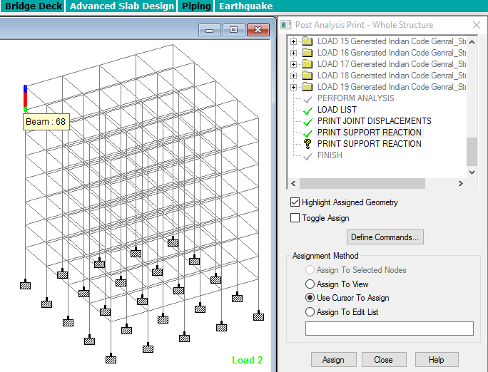Fig. 13- fig shows adding joint displacement, support reaction and member forces for assigning.
Assign Member forces command to Columns at bottom only shown in fig:-
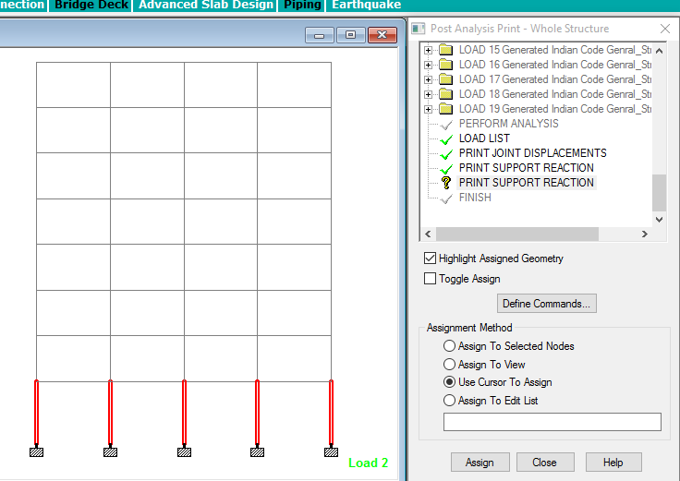Fig. 14- fig shows the Assign member forces
Now "Run Analysis".
STAAD-Pro gives the results after run analysis in STAAD output viewer which shows the joint displacement, support reactions and member forces as shown in fig.
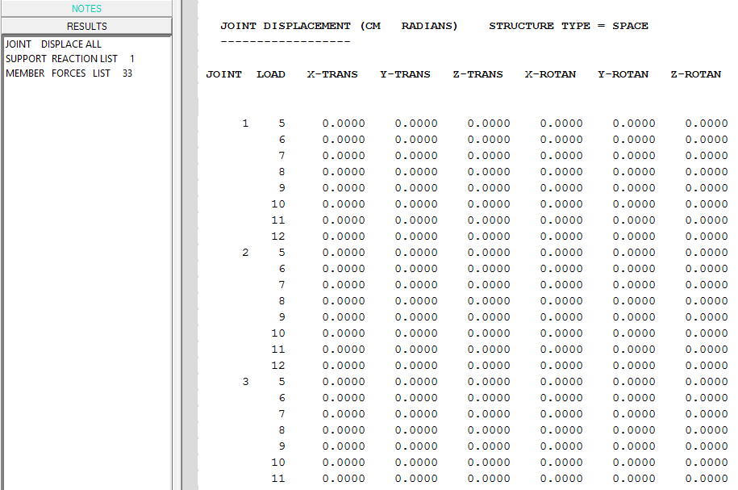
Fig. 15- fig shows the Joint displacement of first 5 joint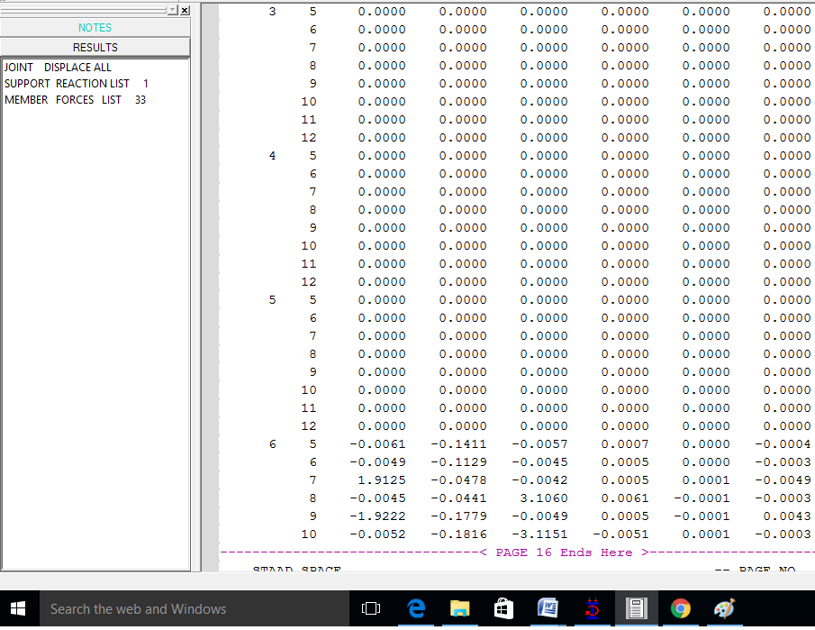 Fig. 16- fig shows the Joint displacement of first 5 joint
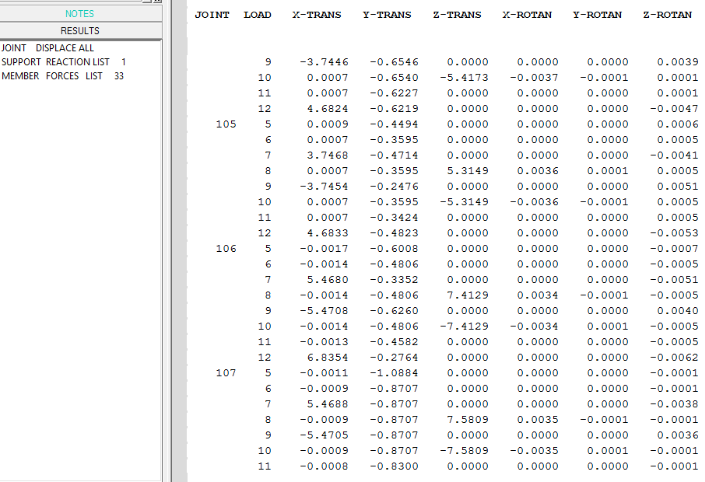
Fig. 17- fig shows the Joint displacement
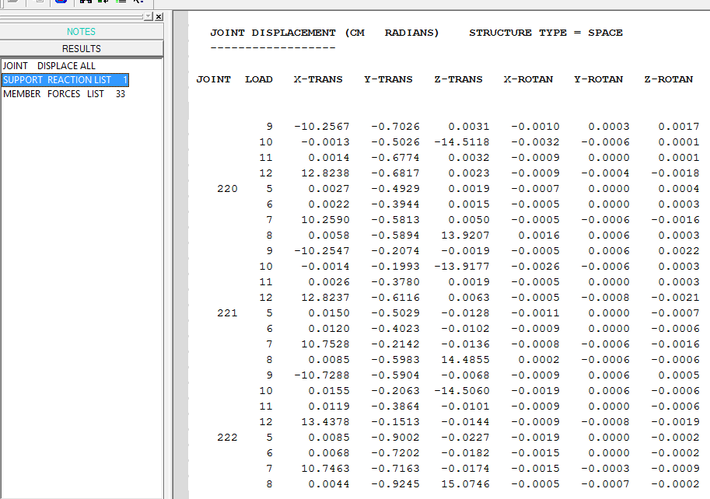
Fig. 18- fig shows the Joint displacement
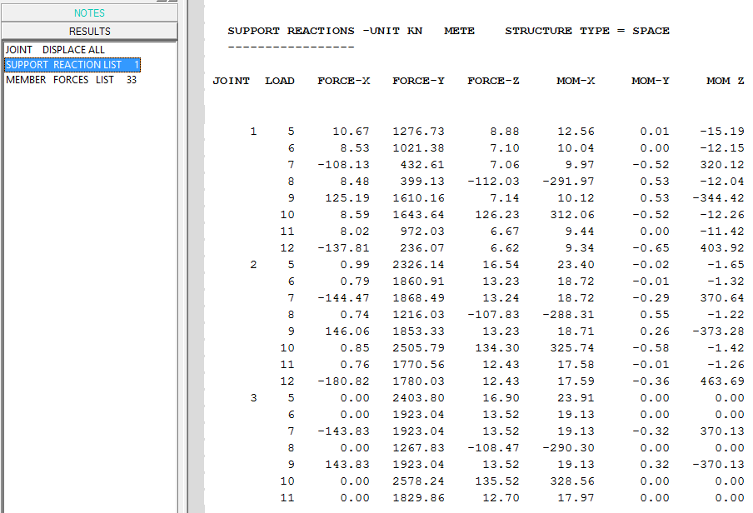
Fig. 19- fig shows the Support reaction
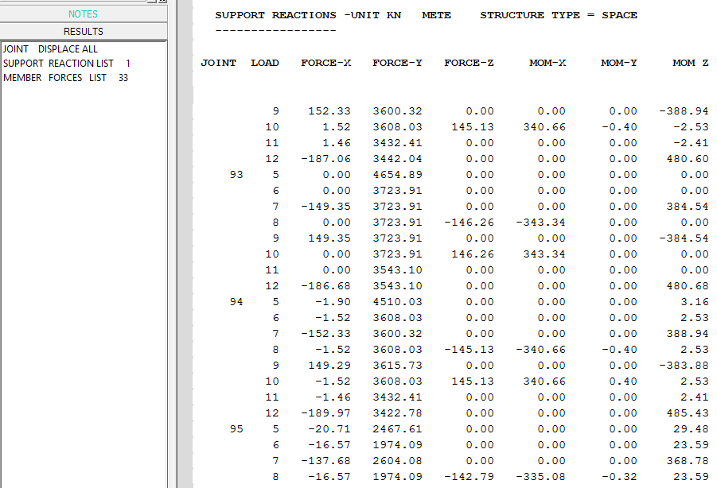
Fig. 20- fig shows the Support reaction

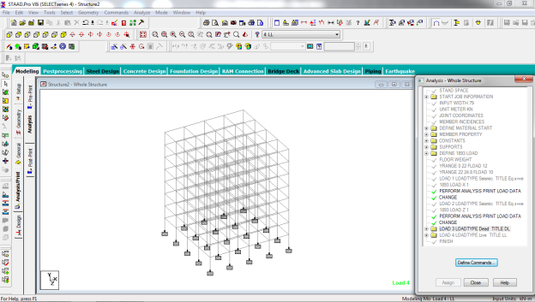
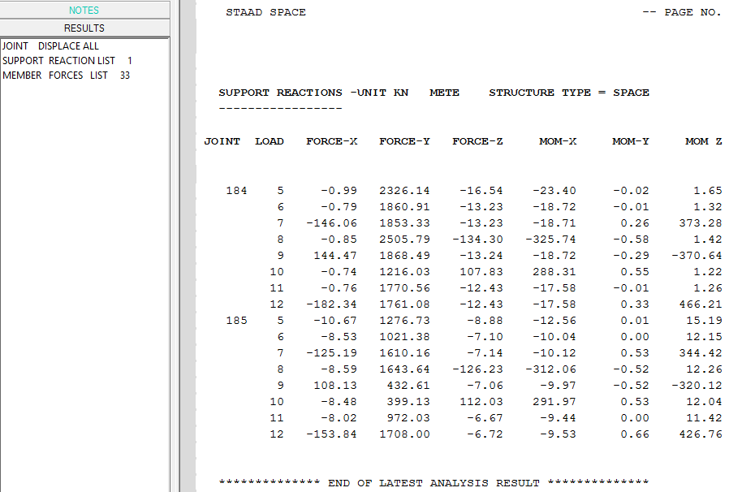
Fig. 21- fig shows the Support reaction
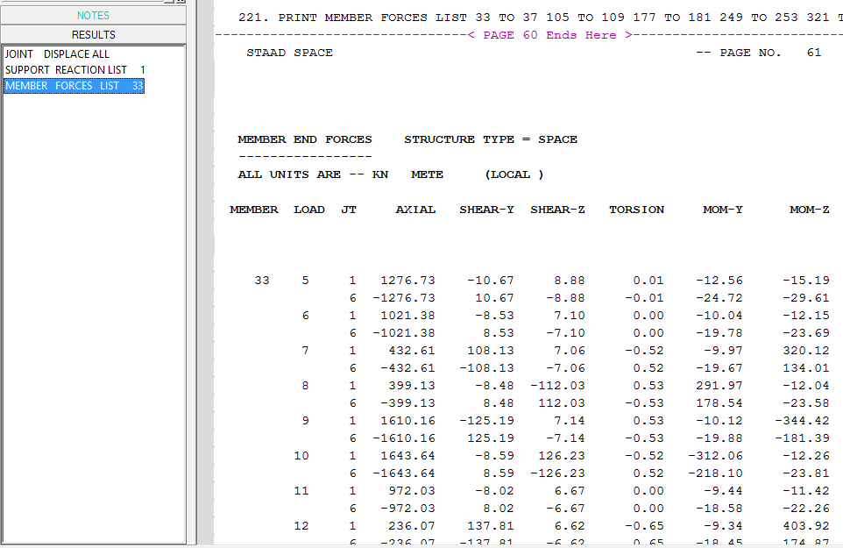
Fig.22- fig shows the Member forces
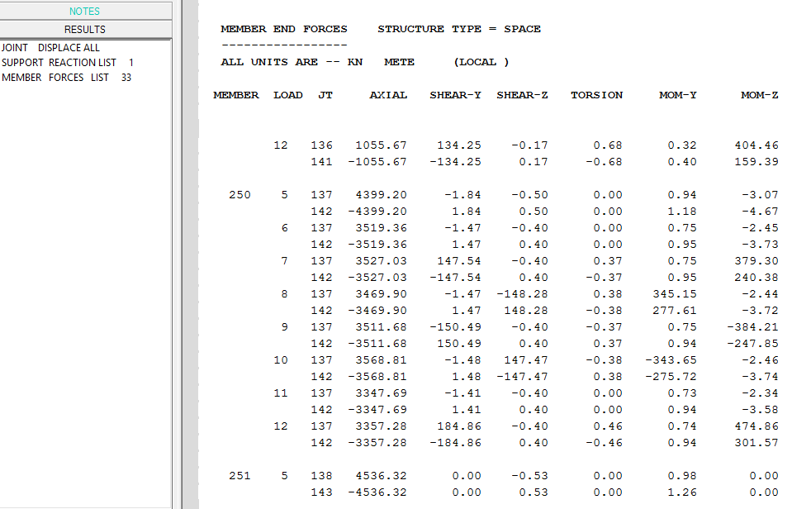
Fig. 23- fig shows the Member forces
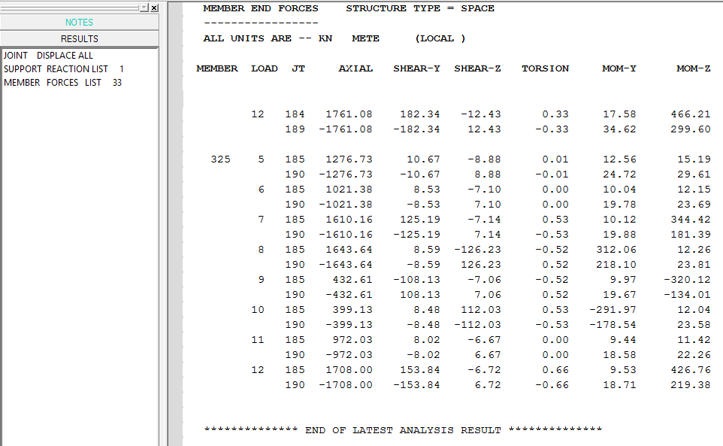
Fig. 24- fig shows the Member forces

CONCLUSION
The response of (G+7) storey RC building under seismic load as per IS1893:2002 (Part-1) by using software STAAD -Pro has been studied. The building is modeled as 3D space frame using STAAD-Pro software. The building for different load cases such as DL, LL and Seismic load has been analyzed. This analysis provides complete guidelines for STAAD-Pro software analysis of static method. STAAD-Pro gives result very quickly as compared to manual calculation. Also Base shear, Lateral load, Joint displacement, support reaction and member forces for all the joints of a building has been calculated and printed further. .
REFERENCES
- Bureau of Indian standards: IS 875(Part 1):1987,dead load on 7 structures, new Delhi, india
- Paulay T and Priestley M. J. N, Seismic Design of Reinforced Concrete and Masonry Buildings, Willy Interscience, Canada, 1992
- Li Qiusheng, Cao Hong and Li Guiqing, “Static and Dynamic Analysis of Straight Bars with Variable Cross – Section”, Computers & Structures, Volume: 59, No: 6. Page: 1185 - l 191, 1996.
- Bureau of Indian standards: IS 1893(Part 1):2002indian standard criteria for earthquake resistant design of structure part 1 general provisions of building (fifth revisions), new Delhi india
- Bungale S. T, Wind & Earthquake Resistant Buildings Structural Analysis and Design, Monticello, New York 12701, U.S.A, 2005.
- Agarwal Pankaj, Shrikhande Manish, “Earthquake resistant design of structures”, PHI learning private limited, New Delhi, 2009.
- BahadornBagheri, Ehsan SaliminFiroozabad, and MohammadrezaYahyaei, “Comparative Study of the Static and Dynamic Analysis of Multi-Storey Irregular Building”, International Journal of Civil, Environmental, and Structural, Construction and Architectural Engineering, Volume: 6, No: 11, 2012.
- A.K Chopra "Dynamic of structures theory and Earthquake Engineering" fourth edition,Prentice Hall, 2012
- P.p.Tapkire, S.J.(2013) Comparative study of highrise building using Indian standards and EURO standards under seismic forces. International journal of science and research(IJSR),1-4.
- B. Srikanth, V.Ramesh, “Comparative study of seismic response for seismic coefficient and response spectrum methods” al Int. Journal of Engineering Research and Applications ISSN: 2248-9622, Vol. 3, Issue 5, Sep-Oct2013, pp.1919-1924G.
- E. Pavan Kumar1, A. Naresh2, M. Nagajyothi3, M. Rajasekhar, “Earthquake Analysis of Multi Storied Residential Building - A Case Study”, 2014.
- A.K.Chopra , V.S.(2014).Design as per Indian standards and also to determine the effect of providing shear wall to building Mr. Gururaj B. Katti, Dr. Basavraj Balapgol “Seismic Analysis of Multistoried RCC Buildings Due to Mass Irregularity By Time History”, IJERT, Vol: 3(7), pg 2278-0181, 2014
- Mr. S.Mahesh, M. D. (NOV-DEC 2014). Comparison of analysis and design of regular and irregular configuration of multi Story building in various seismic zones and various types of soils using ETABS and STAAD. IOSR Journal of Mechanical and Civil Engineering (IOSR-JMCE), 1-8.
- AnirudhGottala, Kintali Sai Nanda Kishore and Dr. Shaik Yajdhani “Comparative Study of Static and Dynamic Seismic Analysis of a Multistoried Building” International Journal of Science Technology & Engineering, Volume 2, Issue 01, July 2015
- Vinit Dhanvijay , P>D.(2015). Comparative study of different codes in seismic assessment. International research journal of engineering and technology (IRJET),1-13.
- Mahesh N. Patil, Yogesh N. Sonawane, “Seismic Analysis of Multistoried Building”, International Journal of Engineering and Innovative Technology (IJEIT) Volume 4, Issue 9, March 2015.
- Chetan Raj, Vivek Verma, Bhupinder Singh, Abhishek ,“Seismic Analysis of Building with Mass and Vertical Geometric Irregularity by Response Spectrum and Seismic Coefficient Method in Zone V and II”, International Journal of Recent Research Aspects ISSN:2349-7688, Vol. 2,Issue 2, June 2015, pp. 204-211.
- Jun Chen, G.l.(2016). Accelaration response spectrum for predicting f;oor vibration due to occupants jumping.
- Kumar C.S. (n.d.). Comparision of seismic vulnerability of building designed for Higher force versus Higher ductility.1-13
- “Comparative Study of the Static and Dynamic Analysis of Multi-Storey Irregular Building” Bahador Bagheri, Ehsan Salimi Firoozabad, and Mohammadreza Yahyaei
- Document No. :: IITK-GSDMA-EQ21-V2.0 Final Report :: A - Earthquake Codes IITK-GSDMA Project on Building Codes.
- Staad. Pro Help Menu & Bentley Student Server.
AUTHOR PROFILE
Sr.No | Photo | Details
1 |  | Hiteshkumar D. Mishra received the B. E. (Civil Engineering) in the year 2015 from MGM’S College of Engineering (SRTMNU Nanded University), Maharashtra State, India. Now he is M.tech. – Student appearing (Structural Engineering) from Gurunanak Institute of Management and Technology, kalmeshwar road, Dahegaon, Nagpur (RTM Nagpur University), Maharashtra State, India.
2 |  | Prof.D.L.Budhlani is working as Assistant Professor, department of civil engineering, Guru Nanak institute of Technology, Dahegaon, Nagpur, Maharashtra, India
3 |  | Prof.B.N.Ramteke is working as Assistant Professor, department of civil engineering, Guru Nanak institute of Technology, Dahegaon, Nagpur, Maharashtra, India

