Cyberbullying Detection on Social Media

Vinay Bawane¹, Vikas Gaupale², Aniket Wakalkar³, Kartik Rathod⁴, Prof. Sujal Shelke⁵

^{1,2,3,4}Students, ⁵Assistant Professor
Wainganga College Of Engineering & Management, Nagpur, Maharastra,441108

aniketwakalkar23@gmail.com

Received on: 20 April, 2023 Revised on: 16 May, 2023 Published on: 18 May, 2023

Abstract –According to a survey done by the Cyberbullying Research Center more than 80% of teens use a cell phone, making them highly susceptible to cyberbullying. Cyberbullying is harassment done through the use of technology and could be anything from nasty cell phone text (SMS) messages to posting hurtful messages on social networking sites. Making use of technology as a medium to bully someone is called cyberbullying. Social networking sites provide a fertile medium for bullies, and teens and young adults who use these sites are vulnerable to attacks. Through machine learning, we can detect language patterns used by bullies and their victims, and develop rules to automatically detect cyberbullying content.

I -INTRODUCTION
In the current era, with the popularity of Web, people are highly depended on social networking sites. With the recent development of social media, people have adopted new ways of spreading hate speech through sites such as Twitter, Facebook, and MySpace which finally led to cybercrime. Therefore, any form of bullying through the internet can be detected by extracting from micro blogs, social media sites performing sentiment analysis on them. Sentiment analysis (LSA) is generally denoted as techniques used to determine the pre disposition of text, usually expressed in free text form. Subjective information in source materials is recognized

and extracted by the means of natural language processing and text analysis.
Our work covers all features from mining texts from social media, applying sentiment analysis based on opinion of the people that is expressed on social media to finally assigning polarity to them as positive, negative or neutral. We are working on Facebook as our social network. Facebook is one of the most popular online social networks to date, where users post their opinions in short text called “Comments/POST”.
II -METHOLOGY
With the increasing popularity of social media in recent years, cyberbullying has emerged as a serious problem afflicting children and young adults. Previous studies of cyberbullying focused on extensive surveys and its psychological effects on victims, and were mainly conducted by social scientists and psychologists.
Although these efforts facilitate our understanding for cyberbullying, the psychological science approach based on personal surveys is very time-consuming and may not be suitable for automatic detection of cyberbullying. Since machine learning is gaining increased popularity in recent years, the computational study of cyberbullying has attracted the interest of researchers. Several research areas including topic detection and affective analysis are closely related to cyberbullying detection
III - DESIGN

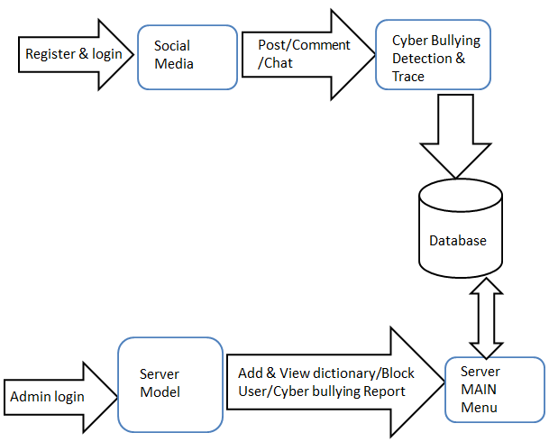
Fig 1. System flow

In system we represent the level 0 of our project, in this project two major involvement is client and admin i.e., server.

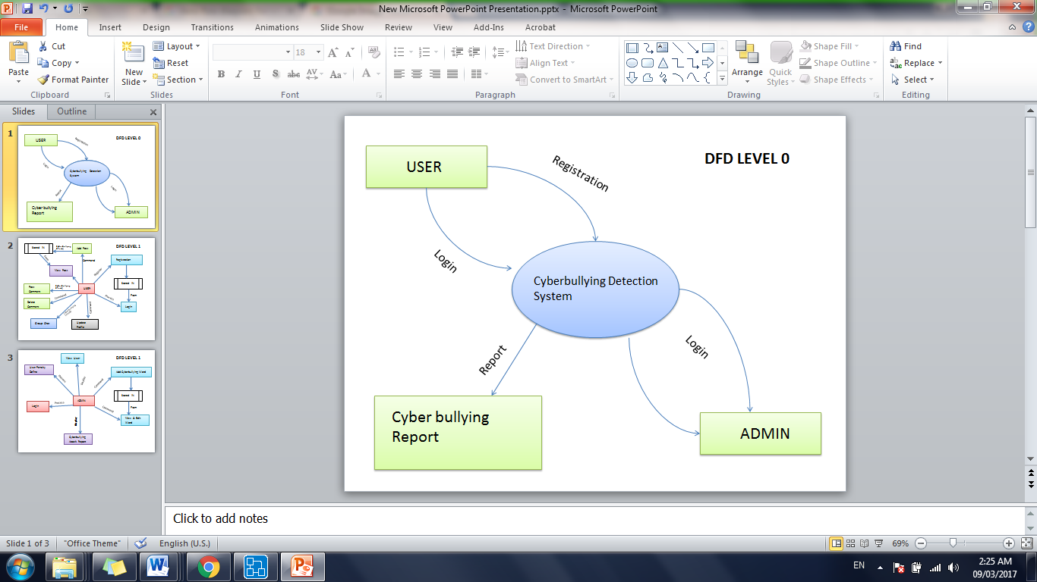
Fig 2. DFD level 0
In our project client register itself in Facebook client application, client can post status, delete status, group chart, feedback etc. Our main aim is to detect cyber bullying word present in client type in status box or group chat or comment box.

IV -CONCLUSION
This paper addresses the text-based cyber bullying detection problem, where robust and discriminative representations of messages are critical for an effective detection system. By designing semantic dropout noise and enforcing scarcity, we have developed semantic-enhanced LSA as a specialized representation learning model for cyber bullying detection.
In addition, word embedding has been used to automatically expand and refine a bullying word list that is initialized by domain knowledge. The performance of our approaches has been experimentally verified through two cyber bullying corpora from social Medias: Twitter and MySpace.
ACKNOWLEDGMENT
Acknowledgment to person or the organization supported to the author for the research work. This is not mandatory for all.
REFERENCES
[1] A. M. Kaplan and M. Haenlein, “Users of the world, unite! The challenges and opportunities of social media,” Business horizons, vol. 53, no. 1, pp. 59–68, 2010.

[2] R. M. Kowalski, G. W. Giumetti, A. N. Schroeder, and M. R. Lattanner, “Bullying in the digital age: A critical review and meta-analysis of cyberbullying research among youth.” 2014.

[3] M. Ybarra, “Trends in technology-based sexual and non-sexual aggression over time and linkages to nontechnology aggression,” National Summit on Interpersonal Violence and Abuse Across the Life span: Forging a Shared Agenda, 2010.

[4] B. K. Biggs, J. M. Nelson, and M. L. Sampilo, “Peer relations in the anxiety–depression link: Test of a mediation model,” Anxiety, Stress, & Coping, vol. 23, no. 4, pp. 431–447, 2010.

[5] S. R. Jimerson, S. M. Swearer, and D. L. Espelage, Handbook of bullying in schools: An international perspective. Routledge/Taylor& Francis Group, 2010.

[6] G. Gini and T. Pozzoli, “Association between bullying and psychosomatic problems: A meta-analysis,” Pediatrics, vol. 123, no. 3, pp. 1059–1065, 2009.

