An Indian Tour Advisor App

Dhanashree Badhe¹, Pallavi Regundawar², Vaishnavi Todkar³, Ravindra Kale⁴

^{1,2,3 ,}Student G.H.Raisoni Academy of Engineering and Technology,Nagpur,Maharashtra,440016
⁴Assistant Professor, G.H. Raisoni Academy of Engineering and Technology,Nagpur,Maharashtra,440016

7dhanashreebadhe@gmail.com

Received on: 11 June ,2022 Revised on: 07 August ,2022, Published on: 09 August, 2022

Abstract –This era of new generation is totally dependent on technologies for most of the daily tasks like messaging, paying bills, bookings, entertainment, and all these are possible due to android technology from which one can develop android apps for various purposes, taking it as a motivation the idea of Indian Tourist guide app is proposed. The app is developed using android and to make it more flexible and unique Memetic Algorithm is implemented, in short this algorithm is used as a local search database where the search optimization for local to global Evolutionary Computation (EC) occurs. And for more accuracy and suggestion to the app use of Content-based image retrieval (CBIR) is also implemented so that more accurate results can be reached. This app is designed in a way that a user can set budget and seasonal wise tour with multi feature like booking of hotels as well as nearby utilities.
Keywords–Android Technology, CBIR techniques, Memetic Algorithm, Linear Search.

INTRODUCTION
Tourism is consequential in India for the economical magnification of the country. India has a wide range of tourism across the world, where one can get to all the different destinations. Providing the best accommodations in tourism India has contributed around 4.9 % to the total GDP of the country. People from other countries visit India to explore tourist destinations along with families and partners and for guiding them they hire a tourist guide to let them explore each and every corner.
This will introduce you to all the aspects that are required so that you can enjoy the place and will never forget the experience. This is the best trip planner and avails to engender an experience for you as authoritatively mandated, by the conception and consequentiality of the destination that is to be peregrinate. The tourist app makes people peregrinate to sundry places so easily enabling all kinds of information at their fingertips. Many peregrinators come to visit from outside India, they face an abundance of quandaries in finding an exact location so this app provides them with all kinds of information regarding locations. These applications provide you with all the avail that your peregrinate needs, such as hotel booking, nearest places, restaurants, travel booking ,location etc.

- LITERATURE SURVEY

1] TOUR GURU: Tour Guide Mobile Application for Tourist: -The paper discusses a tour guide mobile application. This application includes amazing features for the travelers in across the country. It makes use of Machine Learning and Cloud Computing. This application would guide tourists by providing the location of an particular city and recommendation of the nearest famous places to visit.

2] Model for Mobile Application Development on Travelling Guide.: -Today, tourism is the fastest growing industry in India as India is blessed with many beautiful monuments, sanctuary, hill stations etc. Now a days, people like to travel and explore the new places but the information of the tourist destination is not adequate. The lack of information will impact the decline in tourist visit.
This model will help to make the policies in digital tourism.
3] A touristic virtual guide: -If we take analysis of last few years, the concept of smart phones and applications for mobile phones are developing rapidly. The new mobiles technology has very important influence on tourism industry. The main aim of this research is to promote the famous tourist places for the travelers through mobile technology. The main aim of this research is to provide all the information to the tourist for knowing the city better even in the absence of local information.

III - METHODOLOGY
Existing System:-
There are already tourist apps available in the app stores which provide information about various places but a single app is not fulfilling the requirements of the user like providing facilities of searching different places, restaurants, etc. And users get confused while using the app. To overcome this issue we came up with this new idea.
Proposed System:-
The app proposed here is a multifunctional app that provides various options for the user while planning a trip to India’s amazing places from different states and cities. It has features of filtering via age, budget, seasons etc. This app provides all the information about the particular place or spot with nearby restaurants and travelling information and hotel room booking facility. The app also has search history panel where user can quickly go with the recent searches and get the access easily. Places like beaches, educational, religious, honeymoon, hill stations, waterfalls, islands, monuments, wild life, and sporty all these categories are implemented in the E-Tour app, below is the flowchart representing the complete flow of the E-Tour App from user side.
STEP 1: First start the app
STEP 2:Display Introscreen
STEP 3:Registration in Login/ Signup page
STEP 4:Then select option “Tourist Guide” or “Tourist”
STEP 5:After selecting “Tourist Guide” it will display the “Add Service” button, this button shows all services.
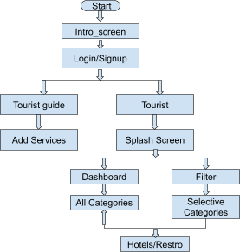

Fig. 1 System Flow Diagram

STEP 6:After selecting “Tourist” it displays the “Splash Screen” button.
STEP 7:Splash screen has two categories “Dashboard” and “Filter”
STEP 8:In the dashboard page display tourist places, select locations to visit and it will display all Information regarding the place.
STEP 9:In “Filter” page it will shows you various categories for e.g.Hills-stations, lakes, historical places, waterfalls etc.
STEP 10: Select the “Hotels” button where one can find details regarding hotel booking and restaurant.
Android Studio:
It is an Integrated Development Environment (IDE) used for developing android and IOS based platforms and uses java, kotlin, flutter and dart programming as its backend. We have made use of java for the backend implementation.

CBIR Technique:
Content Based Image Retrieval (CBIR) technique is a commonly used technique to implement content based search. This technique works on visual analysis of similar look alike contents. With the help of this technique the system can look for similar searches and suggest places according to that.

Memetic Algorithm:
These days’ intelligent applications become fully flexible for the tourism industry and the travelers. Applications made of algorithms and filter techniques are more reliable and provides accuracy. This algorithm provides facility of implementing into account the tourist budget and Clustered Points of Interest (POIs), it allows the system to perform Tabu Search procedure for Team Orienteering Problem with Time Windows (TOPTW). This will surely help tourists visiting different cities of a country, and are confronted to the challenges of choosing point of interest.

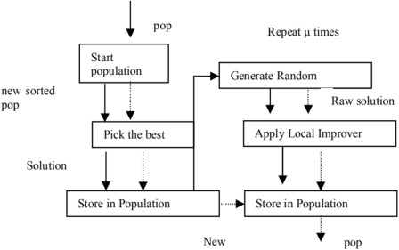

Fig. 2 -Memetic Algorithm Mechanism
The uniqueness of the app is its filtering facility which provides sundry filter options. Among interpolation, binary search, sub list search exponential search, Fibonacci search, etc. The linear search is widely used when any kind of search filter is to be applied in an app. It works on an array.The list is related with similar items for every different search like age categories, season wise options in a list and different budget categories. The search mechanism of linear search algorithm is presented below.
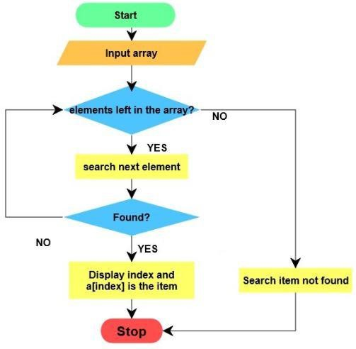
Fig. 3- Linear Search Mechanism
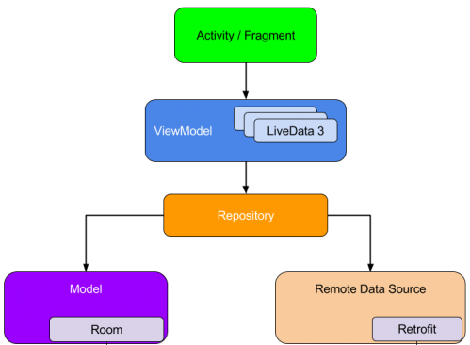
Fig. 4- App Filter Mechanism
Among all the search algorithm, linear search algorithm is one basic and elementary algorithm in which a sequential search is made among all the items, in other words it's search the items one by one. Its worst-case time complexity is O(n).The best-case time complexity of is O(1). There is no need to sort in linear search algorithm and it can work on any length of array.
IV-DESIGN

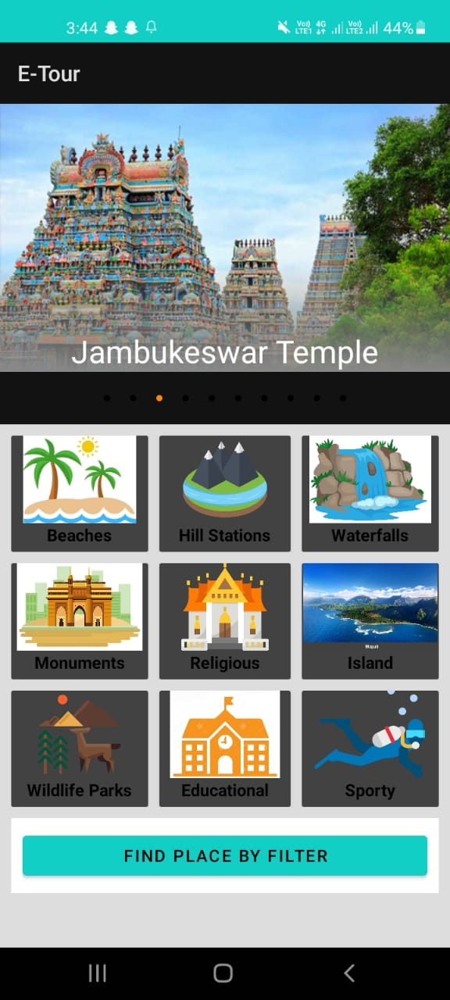
Fig. 5-Dashboar

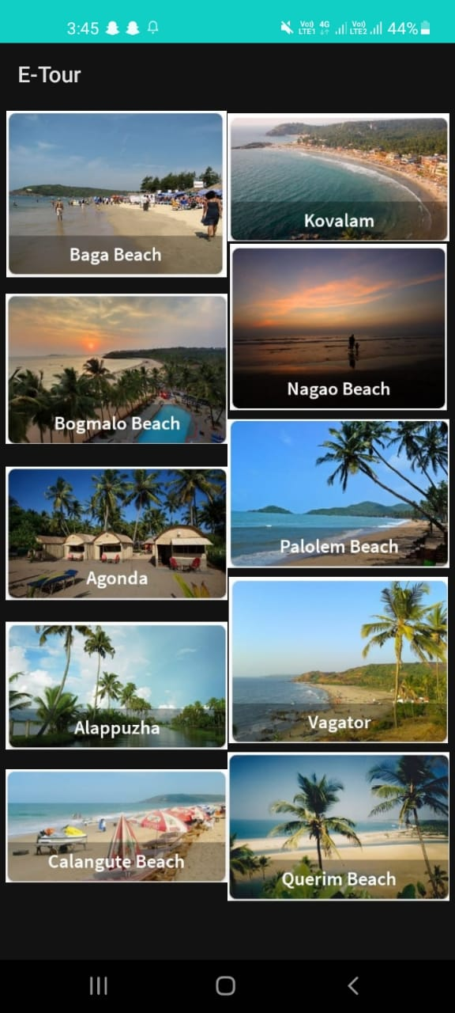
Fig. 6--Places

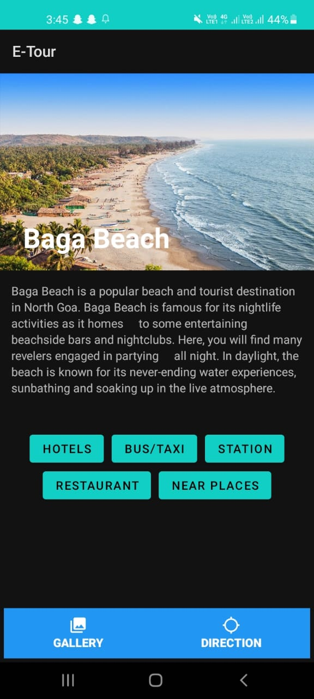
Fig. 7-Place Details

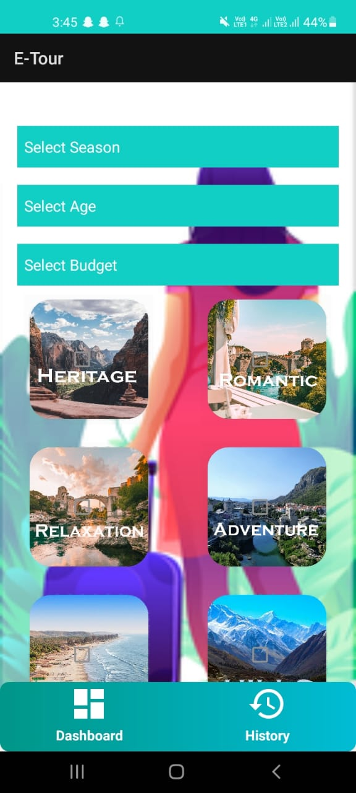
Fig. 8-Filter

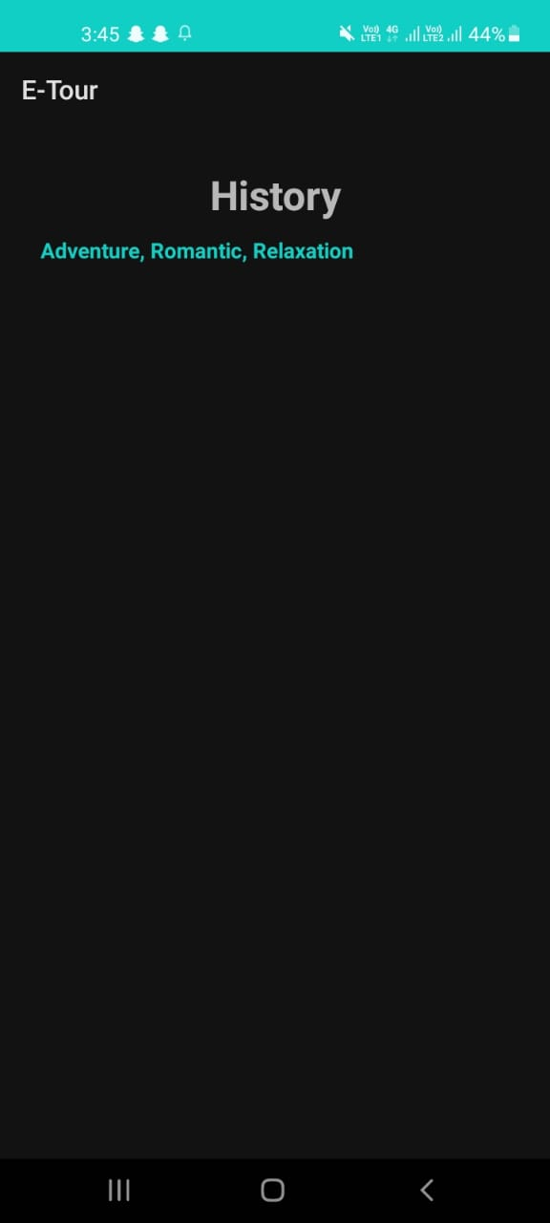
Fig. 9-History
V-CONCLUSION
This Application is a subsidiary for tourists who want to explore and go on vacation. It will provide all kinds of information that is compulsory to peregrinate in India, whoever wants to go for a trip it will make the trip easier to find the best location, to find hotel and restaurant. It shows all hotels and restaurants nearby locations and it will provide you with online hotel booking as well. Being a facile and time efficacious application process, anyone can handle it. It's free of cost.no need to pay for it. Reasons abaft this to avail tourists that they can relish their vacation and enhance travelling experience.
REFRENCES

- M. S. B. W. T. M. P. S. B. Thennakoon, R. D. T. N. Rajarathna, S. P. B. Jayawickrama, M. P. D. S. M. Kumara, A. M. Imbulpitiya and N. Kodagoda, "TOURGURU: Tour Guide Mobile Application for Tourists," 2019 International Conference on Advancements in Computing (ICAC), 2019, pp. 133-138, doi: 10.1109/ICAC49085.2019.9103380.
- U.Ependi, A. Muzakir, F. Fatoni, M. Bunyamin, D. Irawan and I. Effendy, "Model for Mobile Application Development on Travelling Guide: A General Proposal," 2019 International Conference on Electrical Engineering and Computer Science (ICECOS), 2019, pp. 122-126, doi: 10.1109/ICECOS47637.2019.8984548
- R. Fatima, I. Zarrin, M. A. Qadeer and M. S. Umar, "Mobile travel guide using image recognition and GPS/Geotagging: A smart way to travel," 2016 Thirteenth International Conference on Wireless and Optical Communications Networks (WOCN), 2016, pp. 1-5, doi: 10.1109/WOCN.2016.7759893.
- I. de Farias, N. LeitaoJúnior and M. M. Teixeira, "Urbis: A touristic virtual guide," 2017 12th Iberian Conference on Information Systems and Technologies (CISTI), 2017, pp. 1-6, doi: 10.23919/CISTI.2017.7975918.
- Y. Liu, X. Xie, J. Lv and X. Jie, "Tour Guide Online Independent Learning Study from the Virtual Community Perspective," 2020 International Conference on E-Commerce and Internet Technology (ECIT), 2020, pp. 281-287, doi: 10.1109/ECIT50008.2020.00071.
- L. Liu and Y. Jing, "Android city tour guide system based on Web service," 2012 2nd International Conference on Consumer Electronics, Communications and Networks (CECNet), 2012, pp. 3118-3121, doi: 10.1109/CECNet.2012.6201621.
- H. Anegg, H. Kunczier, E. Michmayr, G. Pospischil and M. Umlauft, "LoL@: Designing a Location Based UMTS
- Application", Elecktrotechnik und Informationstechnik, vol. 191, no. 2, pp. 48-51, 2002.
- J. Baus, C. Kray and A. Krueger, "Visualization of Route Descriptions in as Resource-Adaptive Navigation Aid", Cognitive Processing, vol. 2, no. 2–3, pp. 323-245, 2001.
- B. Brown and M. Chalmers, "Tourism and Mobile Technology", Proceedings of the European Conference on Computer Supported Collaborative Work (CSCW‘2003), pp. 335-355, 2003.
- A. Smirnov, A. Kashevnik, S. I. Balandin, and S. Laizane, “Intelligent mobile tourist guide: Context-based approach and implementation,” Lect. Notes Comput. Sci. (including Subser. Lect. Notes Artif. Intell. Lect. Notes Bioinformatics), vol. 8121 LNCS, pp. 94–106, 2013
- S. Wagner, T. Franke-Opitz, C. Schwartze and F. Bach, "Mobile Travel App Guide: Edition 2013 powered by ITB", Pixell
- Online Marketing GMBH, 2013, [online] Available: http://www.itb-berlin.de/me-dia/itb/itb_media/itb_pdf/publikationen/MTAG_2013.pdf.
- . Borras, A. Moreno and A. Valls, "Intelligent Tourism Recommender Systems: A Survey", Expert Systems with
- Applications, vol. 41, no. 16,2014, pp. 7370-7389.
- S. Karanasios, S. Burgess and C. Sellitto, A Classification of Mobile Tourism Applications Chapter in book: Global Hospitality and Tourism Management Technologies, 2012.
- C. Emmanouilidis, R. Koutsiamanis and A. Tasidou, "Mobile Guides: Taxonomy of Architectures Context Awareness Technologies and Applications", Network and Computer Applications, vol. 36, pp. 103-125, 2013.
- A. Smirnov, N. Shilov, A. Kashevnik, N. Teslya and M. Shchekotov, "Intelligent Tourist Guiding Service Based on Smart-M3 Plat-form", Proceedings of 13th Conference of Open Innovations Association FRUCT, pp. 121-131, April 2013.
- D. Gavalas, C. Konstantopoulos, K. Mastakas and G. Pantziou, "Mobile Recommender Systems in Tourism Network and
- Computer Applications", vol. 39, no. 2014, pp. 319-333.
- R. Anacleto, L. Figueiredo, A. Almeida and P. Novais, "Mobile application to provide personalized sightseeing tours", Network and Computer Applications, vol. 41, no. 2014, pp. 56-64.
- A. Vdovenko, A. Lukovnikova, S. Marchenkov, N. Sidorcheva, S. Polyakov and D. Korzun, "World Around Me Client for Windows Phone Devices", in Proc. 11th FRUCT Conf.,
- J. Honkola, H. Laine, R. Brown and O. Tyrkko, "Smart-M3 Information Sharing Platform", Proc. IEEE Symp. Computers and Communications (ISCC'10)., pp. 1041-1046, June 2010.
- A. Smirnov, A. Kashevnik, A. Ponomarev, N. Shilov, M. Shchekotov and N. Teslya, "Smart Space-Based Intelligent Mobile Tourist Guide: Service-Based Implementation", Proceedings of the 15th Conference of Open Innovations Association FRUCT St.Petersburg Russia ITMO university publisher house, pp. 126-134, 21–25 April 2014.
Bibliography of Authors

