Comparative Study of RC Shear Resisting Structure By Non Linear Time History Analysis
Gaurav Kapgate ¹, Prof. D.L.Budhlani ²
¹M-tech student(Structural Engineering)
Guru Nanak Institute of Technology, Nagpur
Dahegaon, Nagpur-441501
²Associate Professor
Guru Nanak Institute of Technology, Nagpur
Dahegaon, Nagpur-441501

Abstract – Structures need to have suitable earthquake resistant features to safely resist large lateral forces that are imposed on them during frequent earthquakes. Ordinary structures for houses are usually built to safely carry their own weights. Lateral forces can produce the critical stresses in a structure, set up undesirable vibrations and, in addition, cause lateral sway of structure, which could reach a stage of discomfort to the occupants. Shear wal, Steel bracings, infill wall, stiffer size columns are one of the most commonly used lateral load resisting element in high rise building. In this study, the non-linear El-centro time history analysis is carried out for special moment resisting frame under earthquake loading using computer software E-TAB 2016.
Keywords- Shear wall, steel bracing, infill wall, stiffer column, Non-linear time history, E-TAB 2016.

INTRODUCTION
Tall building developments have been rapidly increasing worldwide. The growth of multistory building in the last several decades is seen as the part of necessity for vertical expansion for business as well as residence in major cities. It is observed that there is a need to study the structural systems for R.C. framed structure, which resists the lateral loads due to seismic effect. Safety and minimum damage level of a structure could be the prime requirement of tall buildings. To meet these requirements, the structure should have adequate lateral strength, lateral stiffness and sufficient ductility. Among the various structural systems, shear wall frame or braced concrete frame and stiffer column could be a

point of choice for designer. Therefore, it attracts to review and observe the behavior of these structural systems under seismic effect. Hence, it is proposed to study the dynamic behavior of reinforced concrete frame with and without shear wall or bracings, RC frame with infill wall effect and RC frame with stiffer column size. The purpose of this study is to compare the seismic response of above structural systems. Axial forces and moments in members and floor displacements will be compared.
The most effective and practical method of enhancing the seismic resistance is to increase the energy absorption capacity of structures by combining bracing elements in the frame. The braced frame can absorb a greater degree of energy exerted by earthquakes.
The present study is an effort towards analysis of the structure during the earthquake. G+15 stories residential building is considered. Nonlinear time history method is carried out. For all the models mentioned above the base shear result are compared.

METHODOLOGY
In order to examine the exact nonlinear behavior of structures, nonlinear time history analysis has to be carried out. In this method, the structure is subjected to real ground motion records. This makes this analysis method quite different from all of the other approximate analysis methods as the inertial forces are directly determined from these ground motions and the responses of the building either in deformations or in forces are calculated as a function of time, considering the dynamic properties of the structure.
In Etabs 2016, the nonlinear time-history analysis can be carried out as follows:
1. The models representing the buildings are created and vertical loads (dead load and live load), member properties and member nonlinear behaviours are defined and assigned to the model.
2. The ground motion record is defined as a function of acceleration versus time.
Here after, the analysis and the time history parameters are defined in order to perform a nonlinear time history analysis. The total time of the analysis is the number of output time steps multiplied by the output time-step size. To match time history to target response spectra, there are two options in ETABS 2016.

PROBLEM STATEMENT
The building is analyzed is G+15 R.C framed building of symmetrical rectangular plan configuration. Complete analysis is carried out for dead load, live load & seismic load using ETAB 2015. Non linear time history analysis is used. All combinations are considered as per IS 1893:2016.
Site Properties:
Details of building:: G+15
Plan Dimension:: 30m x 20m , 5m span in each direction.
Outer wall thickness:: 230mm
Inner wall thickness:: 230mm
Floor height ::3 m
Parking floor height :: 3m
Seismic Properties
Seismic zone:: IV
Zone factor:: 0.24
Importance factor:: 1.2
Response Reduction factor R:: 5
Soil Type:: medium
Material Properties
Material grades of M35 & Fe500 is used for the design.
Loading on structure
Dead load :: self-weight of structure
Live load :: Floor :: 2.5 kN/m²
Roof:: 1.5 kN/m²
Seismic load:: Seismic Zone IV
Preliminary Sizes of members
Column::850mm x 350mm
Beam:: 300mm x 600mm
Slab thickness:: 125mm
Shear wall thickness:: 250mm
Steel bracing section::ISMB 350

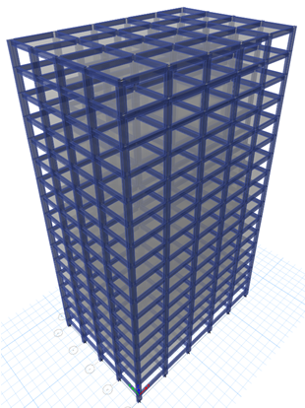
Fig.1- 3D view of G+15 RC frame building

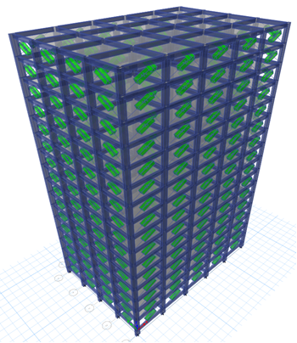
Fig.2- 3D view of G+15 RC frame building with infill wall

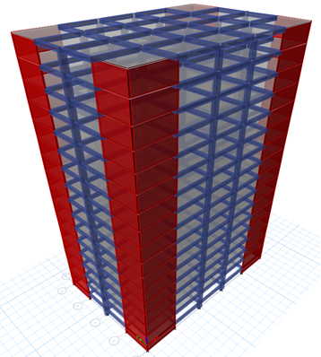
Fig.3- 3D view of G+15 RC frame building with outer shear wall
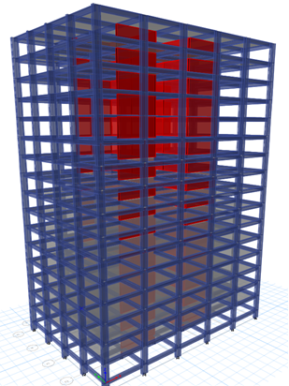
Fig.4- 3D view of G+15 RC frame building with inner shear wall

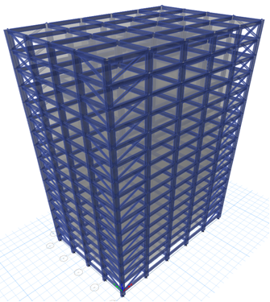
Fig.5- 3D view of G+15 RC frame building with outer diagonal steel bracing

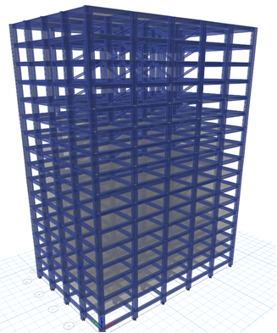
Fig.6- 3D view of G+15 RC frame building with inner diagonal steel bracing
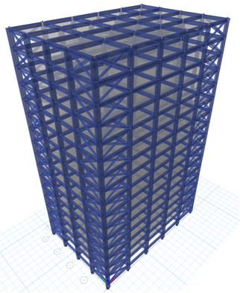
Fig.7- 3D view of G+15 RC frame building with outer X type steel bracing

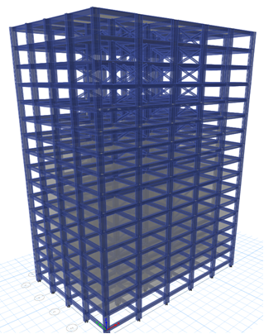
Fig.8- 3D view of G+15 RC frame building with inner X type steel bracing

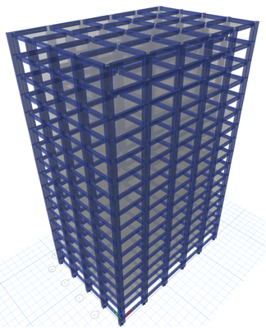
Fig.9- 3D view of G+15 RC frame building with stiffer column

RESULTS
Table 1- Base shear (kN) in X-direction
Type of Model | Base shear (kN)
Bare Frame | 2625.722
Infill wall | 3755.236
Outer shear wall | 2729.949
Inner shear wall | 4588.213
outer Diagonal Brace | 1981.139
Inner Diagonal Brace | 2012.569
outer X Brace | 2391.413
Inner X Brace | 2892.142
Stiffer Column | 2751.883

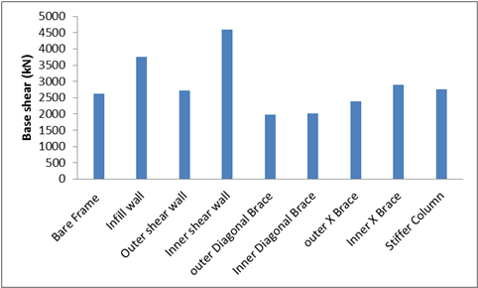
Fig. 10 - Base shear (kN) in X-direction
Table 2 - Base shear (kN) in Y-direction
Type of Model | Base shear (kN)
Bare Frame | 1817.95
Infill wall | 2533.7
Outer shear wall | 2104.625
Inner shear wall | 2077.236
outer Diagonal Brace | 2784.128
Inner Diagonal Brace | 2485.21
outer X Brace | 2886.541
Inner X Brace | 1958.452
Stiffer Column | 2872.971

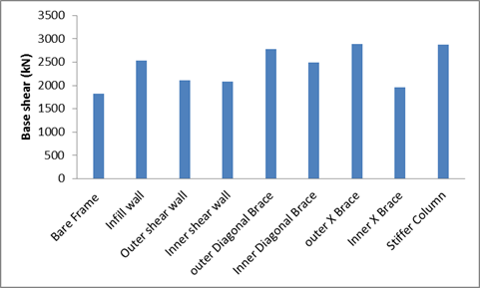
Fig. 11 - Base shear (kN) in Y-direction
Table 3 - Maximum Lateral Displacement (mm) in X-direction
Type of Model | Ux (mm)
Bare Frame | 35.457
Infill wall | 16.095
Outer shear wall | 15.747
Inner shear wall | 22.749
outer Diagonal Brace | 20.657
Inner Diagonal Brace | 19.044
outer X Brace | 21.555
Inner X Brace | 22.633
Stiffer Column | 28.224

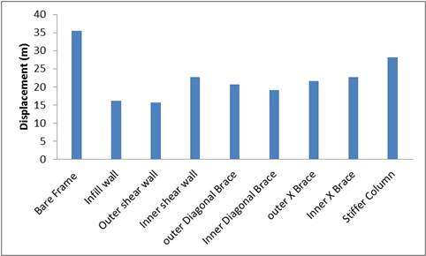
Fig. 12 - Maximum Lateral Displacement (mm) in X-direction
Table 4 - Maximum Lateral Displacement (mm) in y-direction
Type of Model | Uy (mm)
Bare Frame | 45.803
Infill wall | 18.473
Outer shear wall | 18.106
Inner shear wall | 6.106
outer Diagonal Brace | 43.074
Inner Diagonal Brace | 30.409
outer X Brace | 37.405
Inner X Brace | 19.404
Stiffer Column | 37.595

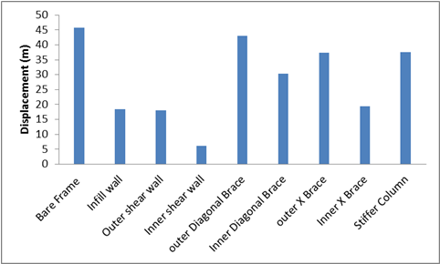
Fig.13-Maximum Lateral Displacement (mm) in Y-direction
Table 5- Axial Force in columns (kN)
Type of Model | Axial Force (kN)
Bare Frame | 3974.255
Infill wall | 3715.238
Outer shear wall | 3924.92
Inner shear wall | 2737.464
outer Diagonal Brace | 3970.048
Inner Diagonal Brace | 4090.676
outer X Brace | 3968.875
Inner X Brace | 3986.89
Stiffer Column | 3952.34

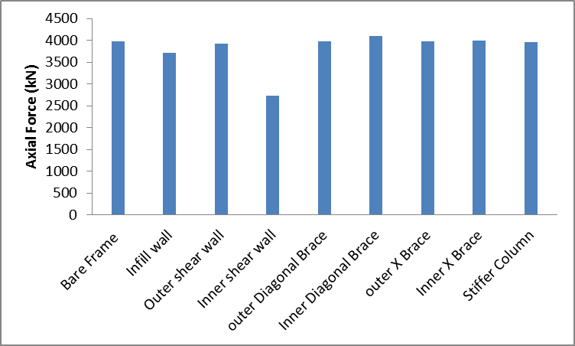
Fig.14 - Axial Force in Columns (kN)
Table 6.- Shear Force in columns (kN)
Type of Model | Shear Force V2(kN)
Bare Frame | 131.2473
Infill wall | 194.1598
Outer shear wall | 102.2299
Inner shear wall | 66.587
outer Diagonal Brace | 213.5637
Inner Diagonal Brace | 230.3087
outer X Brace | 224.7055
Inner X Brace | 259.6161
Stiffer Column | 152.34
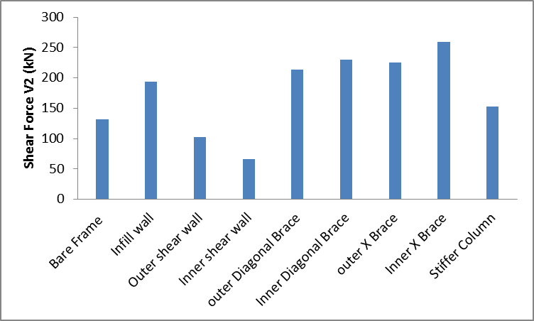
Fig. 15 - Shear Force V in Columns (kN)

Table 6 - Moment in columns (kNm)
Type of Model | Moment M3 (kNm)
Bare Frame | 276.0882
Infill wall | 292.0555
Outer shear wall | 129.4382
Inner shear wall | 102.116
outer Diagonal Brace | 348.2895
Inner Diagonal Brace | 340.554
outer X Brace | 326.5206
Inner X Brace | 347.4251
Stiffer Column | 295.61

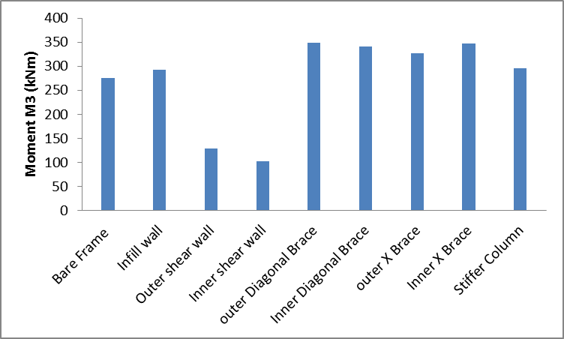
Fig. 16 - Moment in Columns (kNm)

CONCLUSIONS
- Base Shear - Buildings with inner shear wall increased base shear upto 50% as that of bare frame in X direction. Also base shear is increased upto 40% in outer brace frame as compared to bare frame in Y direction and base shear is increased to 50% in vertical direction by adding inner shear wall.
- Lateral Displacement – Maximum lateral displacement is reduced to 60% by adding infill wall in X direction and upto 85% by adding inner shear wall.
- Column Forces - The critical axial force in columns is reduced to 30% by adding inner shear wall as compared to bare frame. Also shear force and moments in columns is reduced to 80% by adding inner shear wall as compared to bare frame
REFERENCES
- Himalee Rahangadle, S. R. Satone,(2013) “Design and Analysis of Multistoried Building with Effect of Shear wall”, International journal of Engineering Reserch and Applications, Vol 3, pp-223-232, ISSN:2248-9622.
- Arlekar J. N., Jain S. K. and Murty C. V.R.,(1997) “Seismic Response of RC Frame Building with Soft First Storey”, proceeding of CBRI Golden Jubliee Conference on Natural Hazards in Urban Habitat, New Delhi, pp.13-24.
- Anand. N., Mightraj. C., Prince Arulraj G.(2012) “Seismic Behaviour of RCC shear wall Under Different Soil Conditions”, Indian Geotechnical Conference-2012, GEO trendz , IGS Mumbai chapter ant IIT Bombay.
- FEMA 356, Presented and Commentry for the Seismic Rehabilitation of Buildings, Federal Emergency Management Agency , Washington, 2000.
- Nabin Raj C. , S. Elavenil,(2012) “ Analytical Study on Seismic Performance of Hybrid (Dual) Structural System Subjected to Earthquake”, International Journal of Modern Engineering Research. Vol.2,pp2358-2363, ISSN:2249-6645.
- Kumar, S. R. and kumar, G. R.,(2003) “Seismic Retrofit of Soft Storey Building using Steel Bracing”, Workshop on retrofitting of structures, Oct 10-11,IIT Roorkee,pp. 148-158.
- Agarwal P., Shrikhande M.,(2007)“ Earthquake Resistant Design of Structures”, Prentice Hall of India pvt. Ltd. New Delhi.
- IS 875 (1987-Part 1), ―code of practice for design loads (other than earthquake)for buildings and structures ,Dead loads,‖ Bureau of Indian standards (BIS), New Delhi.
- IS 875(1987-Part2) , ― code of practice for live loads,‖ Bureau of Indian Standards (BIS), New Delhi.
- IS 456, (2000)“Plain & Reinforced Concrete Structures Code of Practice” Four Revision, Bureau of I.S., New Delhi, India.
- IS 1893:2016, “Criteria for Earthquake Resistant Design of Structure Part I: General 1993. Provision for Buildings”, seventh Revision, Bureau of India Standards (BIS), New Delhi, India
- Chopra, A. K., “Dynamics of Structures”, Earthquake Engineering Research Institute, Berkeley, California’s

Details of authors
Sr.No | Photo | Details
1 |  | Gaurav D. Kapgate is Mtech - student appearing (Structural Engineering) from Gurunanak Institute of Management and Technology, kalmeshwar road, Nagpur (RTM Nagpur University), Maharashtra State, India
2 |  | Prof. D.L.Budhlani is working as Associate Professor, Department of Civil Engineering,Guru Nanak Institute of Technology (Formerly known as Guru Nanak Institute of Engineering & Management )Dahegaon, Nagpur and Dean,Research &Development,Guru Nanak Institutions,Nagpur, Maharashtra State, India.

