Design and Development of an approach for Human Behavior Analysis
Shubham Dalwani¹, Darshana Deshkar², Sarang Prajapati³, Rashmi Nair^{4,} Nabanita Gharai^{5,}
^{1,2,3,4,5}Student
S.B. Jain Institute of Technology, Management and Research, Nagpur 441501, Maharashtra, India

Abstract – Social Media is used by large number of people to share opinions and express their views which directly or indirectly reflects the character sketch of the person. Nowadays companies while recruiting and hiring process check the social media profile, review an applicant’s own public postings and accounts, providing a better picture of him or her as a potential employee. The number of quality and effective employees in a company plays a major role in the future growth and success of the company. Employee selection process is a tough and important procedure. It takes patience, proper screening and careful analysis. Not only will time be lost by not making correct decisions when it comes to the hiring process but a lot of financial resources will have been wasted trying to find someone who fits the bill.
In our project we are developing a mobile application that would take the social media feed of a person as input and by analysing it, creates a character sketch of that person. It would involve the candidates go through a systematic set of questions and even skills tests to determine if candidates are able to fulfill the job needs. This would help to establish confidence in knowing that you have logically gone through a good recruiting process and have selected people based on defined metrics rather than gut feelings.
Keywords- Employee, Interview procedure, selection, sentimental analysis, twitter, information, data cleaning, questionnaires, Application, Mobile-based
INTRODUCTION

The number of quality and effective employees in a company plays a major role in the future growth and success of the company. Employees not only deal with

customers on a regular basis but also are the essential cogs in the machine when it comes to delivering goods and providing any relevant services. Each person being hired brings something unique to the business and it is important to seek out those with the best qualities. Not only are the right employees key to keeping clients happy and establishing a lasting reputation, they are also central to a company’s internal business culture. Employee selection process is the backbone of finding appropriate hires and getting the company off the ground. Hiring is a tough procedure. It takes patience, proper screening and careful analysis. Not only will time be lost by not making correct decisions when it comes to the hiring process but a lot of financial resources will have been wasted trying to find someone who fits the bill.
One of the easiest ways to use social media is for recruiting to review an applicant’s own public postings and accounts, providing a better picture of him or her as a potential employee. Go through a systematic set of questions and even skills tests to determine if candidates are able to fulfill the job needs. This helps establish confidence in knowing that you have logically gone through a recruiting process and choose people based on defined metrics rather than gut feelings. When you do this, you increase your chances of having someone succeed in the job.
METHODOLOGY
The whole mobile application is divided into the four modules.
Module 1: GUI Development
In GUI there will be various input fields which will collect information like user-id, username and search domain of a candidate on which sentimental analysis has to be perform.
Module 2: Data Collection and Cleaning
Data of a candidate will be collected from social media sites using their API. After the collection of data, the collected data will be processed for cleaning purpose to remove unwanted special characters, links and tags. Then sentimental analysis will be performed on clean data.
Module 3: Questionnaire Generation
After analyzing the sentiments of a candidate a questionnaire will be generated for a candidate. The questionnaire will be designed in such a manner that it will help in figuring out whether a candidate is faked or doubled faced on social media.
Module 4: Analysis
In this module the detailed sentimental analysis of that candidate will be given with the help of graphical charts and recommendation whether to opt for a candidate or not.
DESIGN
The mobile application takes the username of the candidate by the registered user, using which the application retrieves posts and statuses from social media platform i.e. Twitter. The flow and working of the system is as follows:
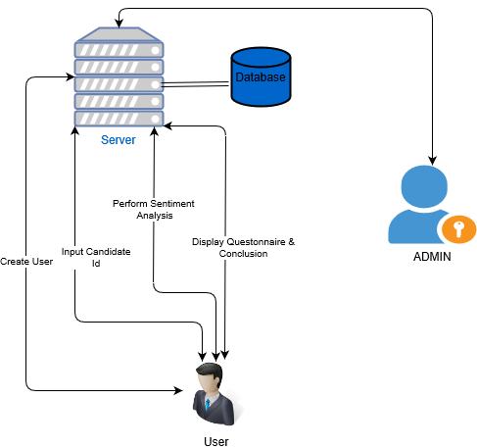
Fig. System Architecture of Sentimental Analyzer
A. Flow of the system
The application starts from the new user registering on the application by entering the details. After user verification and authentication, he/she can login into the application where he can to feed the username of candidate then the application will collection data (post and statuses) of the candidate and does data cleaning and data extraction. On the acquired data analysis is performed and intermediate results will be displayed will would depict the character sketch of the candidate. Now the user can select whether he/she wants to generate questionnaires based on the intermediate results. If the user selects to generate questionnaire, then on the basis of the answers given by the candidate conclusion is generated depicting whether the person is fake or not.

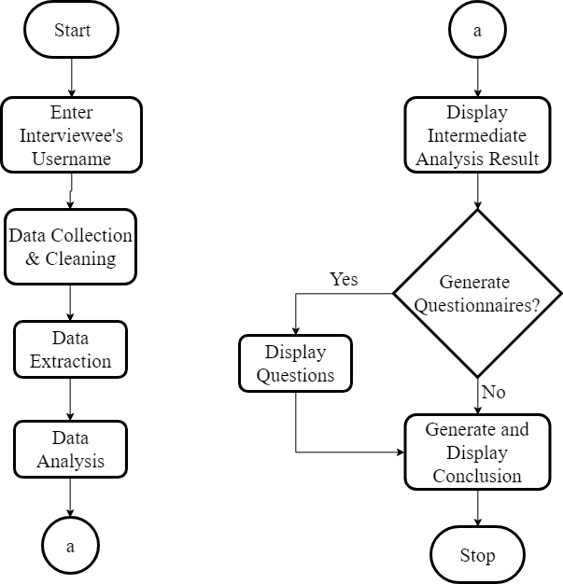
Fig. Flow of Sentimental Analyzer

CONCLUSION
Design and Development of an Approach for Human Behavior Analysis would result in a mobile application that will use social media for human behavior analysis. It would assist in making the decisions and assessment of applicant during the hiring process for executive, managerial and other upper level positions which solves the societal problem of identifying applicants who fake themselves on an interview. It will analyze the applicant’s social media profile and based on the calculation it will generate a questionnaire for the proper assessment of the candidate.

ACKNOWLEDGMENT
We would like to express deep sense of gratitude to our Project Guide, Mr Nisarg Gandhewar, Department of Computer Science & Engineering, for being the cornerstone of our project. It was his incessant motivation and guidance during periods of doubts and uncertainties that has helped us to carry on with this project.
We would like to thank Mr. Animesh Tayal, Head of Department, Computer Science & Engineering for providing necessary guidance, support, motivation and inspiration without which this project would not have been possible. We would like to extend our special thanks to Dr. S.L. Badjate, Principal of S.B. Jain Institute of Technology, Management & Research for his encouragement and best wishes. We would like to extend our sincere thanks to the Management of S.B. Jain Institute of Technology, Management & Research for providing all the necessary infrastructure and laboratory facilities. We also like to acknowledge the help extended by the faculty members and non-teaching staff of Computer Science & Engineering Department for successful completion of our project. Last but not the least we would like to thank our family and friends for incessant support while making of this project.

REFERENCES
[1] Wei Yen Chong, Bhawani Selvaretnam, Lay-ki Soon, “Natural Language Processing for sentiment Analysis, An exploratory analysis on Tweets”.
[2] Anees UL Hassan, Jamil Hussain, Musarrat Hussain, Muhammad Sadiq, Sungyoung Lee, “Sentiment analysis of social networking sites data using machine learning approach for the measurement of depression”.
[3] Bo Pang, Lillian Lee, “Opinion mining and sentiment analysis”, The Essence of knowledge.
[4] Judith Holdershaw, Philip Gendall, “Understanding and predicting human behaviour”, Massey University Journal, ANZCA08 Conference, Power and Place, Wellington.
[5] Jianbo Yuan, Quanzeng You, Jiebo Luo, “Sentiment analysis using social multimedia”, Springer International Publishing, Switzerland, 2015

[6] Saqib Iqbal, Ali Zulqurnain, Yaqoob Wani, Khalid Hussain, “The survey of sentiment and opinion mining for behavior analysis of social media”, International Journal of Computer Science and engineering(IJCSES), Vol 6, No. 5, October 2015.
[7] Umesh Rao Hodeghatta, “Sentiment analysis of Hollywood movies on Twitter”, 2013 IEEE/ACM International Conference on Advances in Social Network Analysis and Mining.
[8] S Seshathri Aathithyan, M. V. Sriram, S. Prasanna, R. Venkatesan, “Affective Hierarchical Classification of Text – An Approach using NLP Toolkit”, 2016 International Conference on Circuit, Power and Computing.
[9] Umne Aymun Siddqua, Tanveer Ahsan, Abu Nowshed Chy, “Combining a Rule-based Classifier with Weakly Supervised Learning for Twitter Sentiment Analysis”, 2016 International Conference on Innovations in Science, Engineering and Technology(ICISET).

Details of All Authors
Sr.No | Photo | Details
1 | 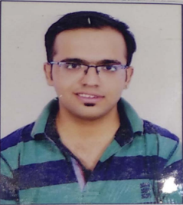 | Name: Shubham Dalwani  Year: 4th year  Branch: Computer Science and Engineering  College: S.B Jain Institute of Technology, Management and Research
2 |  | Name: Darshana Deshkar  Year: 4th year  Branch: Computer Science & Engineering  College: S.B Jain Institute of Technology, Management and Research
3 |  | Name: Sarang Prajapati  Year: 4th year  Branch: Computer Science and Engineering  College: S.B Jain Institute of Technology, Management and Research
4 |  | Name: Rashmi Nair  Year: 4th year  Branch: Computer Science and Engineering  College: S.B Jain Institute of Technology, Management and Research
5 |  | Name: Nabanita Gharai  Year: 4th year  Branch: Computer Science and Engineering  College: S.B Jain Institute of Technology, Management and Research

