Design of Domestic Pellet Burners: A Comprehensive Review

Suresh Khadtare^{*1}, Prathamesh Joshi^{*2}, Aditya Nagargoje^{*3}, Rajashree Kurhade^{*4}, Himanshu Burande^{*5}, Om Ingale^{*6}, Er.Ganesh Badgujar^{*7} Prof.S.M Wani^{*8},Prof.Dr.S.T Vagge^{*9}
*1,2,3,4,5,6 Student, Department of Mechanical Engineering, GCOE Jalgaon, Maharashtra, India *7 Lecturer, Department of Mechanical Engineering, GCOE Jalgaon, Maharashtra, India *8 Assistant Professor, Department of Mechanical Engineering, GCOE Jalgaon, Maharashtra, India  0000-0003-2694-0335 *9 Professor & Hod, of Mechanical Engineering, GCOE Jalgaon, Maharashtra, India

Email of Corresponding Author: surukhadtare@gmail.com

Received on: 19 April, 2025 Revised on: 1 June ,2025 Published on: 06June ,2025

Abstract -The rising demand for sustainable and energy-efficient heating solutions has propelled significant advancements in domestic pellet burner technology. Utilizing biomass pellets as a renewable energy source, these systems offer high thermal efficiency, reduced emissions, and cost-effectiveness, positioning them as viable alternatives to traditional biomass stoves. This review comprehensively explores recent developments in pellet burner design, combustion technology, material selection, control systems, environmental impact, and economic viability. Key findings reveal that forced-draft pellet burners outperform natural-draft models by achieving up to 25% higher efficiency through optimized airflow control [3, 7]. Additionally, circular burner designs demonstrate enhanced combustion stability and lower emissions compared to rectangular counterparts [7, 13]. Despite notable progress, challenges such as fuel variability, emission control, and cost barriers persist, necessitating further research. The future of pellet burner technology lies in optimizing combustion processes, standardizing fuel quality, and enhancing thermal performance to ensure consistent efficiency and broader adoption [20].
Keyword - Domestic Pellet Burners, Biomass Energy, Renewable Energy, Thermal Efficiency, Pellet Combustion, Forced-Draft Systems, Air-Fuel Ratio Optimization, Biomass Pellet Fuel, Sustainable Heating Solutions, Burner Design Optimization, Emission Reduction, Energy-Efficient Heating, Fuel Variability, Smart Combustion Systems, and Renewable Heating Technologies.

INTRODUCTION
Energy demand is increasing globally, driving the urgent need for sustainable and cost-effective energy solutions. The overreliance on fossil fuels such as coal, oil, and natural gas has led to severe environmental concerns, including greenhouse gas emissions, global warming, and resource depletion. In response, renewable energy sources have become a focal point in the pursuit of eco-friendly alternatives. Among these, biomass energy, particularly in the form of domestic pellet burners, has emerged as a promising solution due to its ability to reduce carbon footprints and utilize renewable resources efficiently. Domestic pellet burners are designed to provide clean and efficient combustion by using compressed biomass pellets derived from agricultural residues, wood waste, and other organic materials. These pellets not only offer a sustainable energy source but also contribute to waste management by repurposing by-products that might otherwise go unused. Compared to conventional heating systems reliant on fossil fuels, pellet burners significantly lower greenhouse gas emissions and reduce dependency on non-renewable resources.
In recent years, the design and fabrication of domestic pellet burners have undergone significant advancements.

Researchers and manufacturers have focused on improving combustion efficiency, reducing harmful emissions, and enhancing user convenience. Innovations in burner geometry, air-fuel mixing mechanisms, and automated control systems have led to more efficient energy conversion and cleaner combustion processes. Moreover, modern pellet burners now incorporate features such as automatic ignition, self-cleaning mechanisms, and real-time monitoring, improving both performance and user experience.
Despite these advancements, several challenges remain in the widespread adoption of pellet burner technology. Issues such as fuel variability, maintenance requirements, and initial investment costs can hinder consumer acceptance. Additionally, optimizing burner designs to handle different biomass types and achieving consistent combustion efficiency remain key research areas.
This review paper aims to provide a comprehensive assessment of the latest research and technological developments in domestic pellet burners. It explores key aspects such as design considerations, fabrication techniques, combustion efficiency, and environmental impact. Furthermore, it highlights existing challenges and outlines potential opportunities for future research and innovation, aiming to contribute to the ongoing effort of developing sustainable heating solutions that align with global energy and environmental goals.
1. Combustion Technology
Combustion efficiency is a critical factor in the performance of domestic pellet burners. Recent studies have explored various approaches to optimize combustion processes. For example, Pettersson et al. [1] investigated the use of multi-stage combustion chambers with optimized airflow dynamics, achieving a combustion efficiency of over 90%. Another study introduced secondary combustion zones to minimize unburned particulate matter, resulting in a 20% reduction in emissions [9, 14]. Additionally, the integration of swirl burners to enhance fuel-air mixing further improved combustion efficiency and reduced fuel consumption [16, 18].
2. Material Selection
The choice of materials for constructing pellet burners significantly impacts their durability, thermal efficiency, and maintenance requirements. Research by Kunjan
Patel et al. [2] compared the performance of stainless steel, cast iron, and ceramic-lined combustion chambers. The study found that ceramic-lined chambers exhibited superior thermal insulation properties, reducing heat loss by 15% [22]. However, stainless steel remains the preferred material due to its balance of cost, durability, and resistance to corrosion. Furthermore, advanced coatings have been explored to protect critical components from high-temperature degradation, extending the lifespan of pellet burners [20, 23].
3. Environmental Impact
The environmental performance of domestic pellet burners is a key consideration in their adoption. Research by Lee et al. [5] conducted a life cycle assessment (LCA) of pellet burners, comparing their environmental impact to that of fossil fuel-based heating systems. The study found that pellet burners have a 50% lower carbon footprint over their lifecycle. However, the environmental benefits depend on the sustainability of biomass sourcing and the efficiency of the combustion process [17, 19]. To address emissions, the use of electrostatic precipitators and catalytic converters achieved a 30% reduction in particulate matter (PM) emissions [10, 24]. Another study explored the potential of co-firing biomass pellets with low-carbon additives to further reduce greenhouse gas emissions [18, 25].
4. Economic Viability
The economic viability of domestic pellet burners is a critical factor influencing their adoption. A study by Ribeiro et al. [10] analyzed the cost-effectiveness of pellet burners compared to traditional heating systems. The results showed that while the initial investment is higher, the long-term savings on fuel costs make pellet burners economically attractive, with a payback period of 3–5 years. Additionally, financial incentives, such as tax rebates and grants, can significantly reduce the payback period and increase market penetration [15, 26].
5. Role of Moisture Content in Biomass Palletization
Moisture content plays a pivotal role in biomass palletization, significantly influencing pellet quality, energy efficiency, and combustion performance. Optimal moisture levels, typically between 10% and 15%, are essential for effective binding, density, and durability of pellets [21, 25]. High moisture increases energy consumption during drying and reduces the calorific value, leading to inefficient combustion and higher emissions [27]. Conversely, low moisture can cause dust formation and poor pellet integrity.
6. Emission Control
Multiple studies focus on the emissions from pellet burners, showing that these systems produce significantly lower levels of carbon monoxide (CO) and particulate matter (PM) compared to traditional wood stoves [4, 11]. Researchers advocate for the adoption of pellet burners as a clean energy solution to reduce household carbon footprints and contribute to air quality improvement [17, 28].
7. Design Principles of Pellet Burners
Research on pellet burners highlights the critical role of optimizing the air-fuel ratio and achieving uniform heat distribution to ensure efficient combustion [8, 12]. An optimal air-fuel mixture not only maximizes energy output but also minimizes fuel consumption and harmful emissions. Studies have shown that the incorporation of a forced-air system significantly enhances combustion efficiency by ensuring a consistent supply of oxygen, which promotes more complete fuel burning and reduces the formation of pollutants [12, 20].
Furthermore, integrating heat exchangers into pellet burner designs has proven effective in improving thermal performance by maximizing heat transfer and minimizing energy losses. Adjustable air inlets also play a vital role, allowing for precise control of airflow based on combustion needs, which enhances overall efficiency and adaptability to varying fuel qualities. Together, these design elements contribute to the development of high-performance domestic pellet burners that are both energy-efficient and environmentally friendly.
LITERATURE SURVEY
The research on domestic pellet burners has explored various dimensions to improve efficiency, user convenience, and adaptability while minimizing operational challenges. A major focus has been on optimizing burner shapes, fuel types, and control systems to enhance overall performance.
1. Burner Design and Configuration: -
Pellet burner geometry significantly influences combustion stability and efficiency. Circular burners have been found to offer better combustion performance and lower emissions compared to rectangular designs. Studies by Rastvorov et al. [7] highlight that circular shapes promote uniform heat distribution and improved airflow dynamics, leading to higher thermal efficiency. On the other hand, rectangular burners, while simpler to manufacture, often face challenges in achieving complete combustion due to uneven airflow [16].
2. Fuel Variability and Impact on Performance: -
The type of biomass used in pellet burners affects combustion quality and emission levels. Research by Pełka et al. [13] shows that wood pellets generally outperform agro-based pellets, offering higher combustion efficiency and lower particulate emissions. However, agro-pellets, being more moisture-prone, often result in incomplete combustion and increased emissions, posing challenges for consistent performance [18].
3. Draft Systems and Airflow Optimization: -
Draft systems play a pivotal role in regulating oxygen supply for efficient combustion. Forced-draft systems have demonstrated up to 25% higher thermal efficiency compared to natural-draft burners, as they provide better oxygen control and reduce carbon monoxide emissions [15]. Getahun et al. [26] emphasize that forced-draft burners are particularly effective in ensuring consistent combustion, especially when handling pellets with varying moisture content [19].
4. Control Systems and Automation: -
Modern pellet burners are increasingly integrating smart control systems to optimize performance. Automated feeding mechanisms, real-time temperature monitoring, and adaptive air-fuel ratio adjustments have been explored to enhance user convenience and operational efficiency. Studies by Holubcik et al. [6] showcase the benefits of rotary burners equipped with automated controls that adapt to fluctuating fuel conditions, leading to consistent heat output and reduced maintenance [11].
5. Challenges and Research Gaps: -
While significant advancements have been made, several challenges persist. Fuel quality inconsistency remains a critical issue, as variations in pellet size, moisture, and composition can drastically affect burner performance. Additionally, the lack of standardized testing methods makes it difficult to compare efficiency and emission data across studies. Rastvorov et al. [7] highlight the need for uniform testing protocols, such as standardized Water Boiling Tests, to enable accurate performance benchmarking [14].
6. Future Research Directions:-
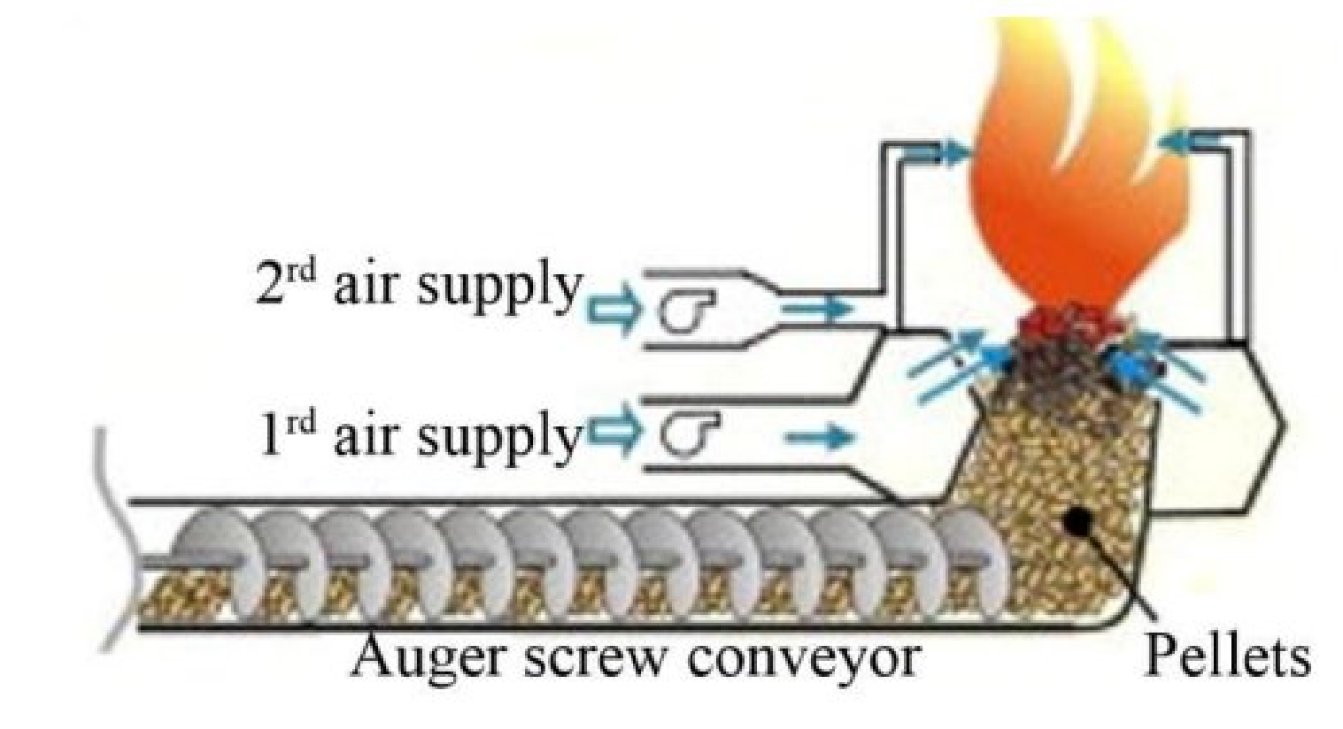
To address existing gaps, researchers are exploring the integration of AI-driven smart combustion systems that use real-time data to optimize air-fuel ratios. Hybrid fuel burners capable of handling various biomass types are also being developed to increase fuel flexibility. Furthermore, advanced emission reduction technologies, including enhanced catalytic converters and electrostatic precipitators, are under investigation to minimize NOx and particulate emissions [17, 25].
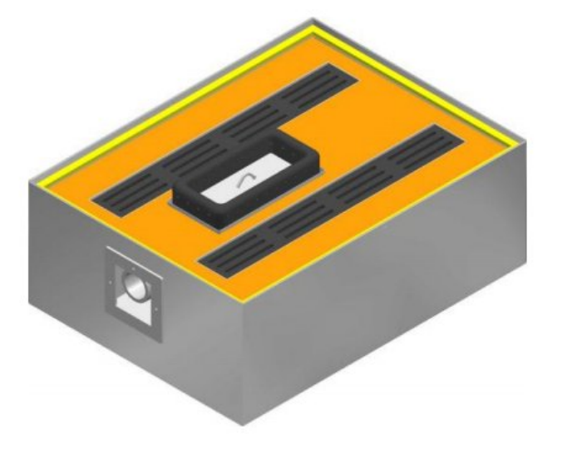
Different Types Of pellet Burner

Fig.1. The Pellet Burner with Lower Feeder [7]
Fig.1 illustrates the working mechanism of a domestic pellet burner equipped with an auger screw conveyor and a dual air supply system for efficient combustion. The auger screw conveyor ensures a consistent and controlled flow of biomass pellets into the combustion chamber, preventing fuel surges or gaps that could disrupt combustion stability. The primary air supply is introduced at the base of the combustion zone, providing essential oxygen for the initial burning of pellets and enabling the breakdown of solid fuel into heat and volatile gases. To achieve complete combustion and reduce emissions, the secondary air supply is introduced above the primary zone, aiding in the burning of volatile gases and resulting in a cleaner, more efficient flame [15].
This dual air system enhances combustion efficiency, reduces harmful emissions, and ensures a steady heat output [9]. The controlled feeding and optimized airflow create stable combustion conditions, leading to better thermal efficiency and lower carbon emissions[7]. Additionally, modern pellet burners often incorporate smart control systems that adjust pellet feed rates and airflow in real time, further improving performance and user convenience[13]. This design makes the pellet burner a sustainable and cost-effective alternative to traditional heating systems[6].
Fig.2. The Rectangular Shaped Pellet Burner [7]

Fig.2 depicts a rectangular-shaped pellet burner designed for efficient heat distribution and controlled combustion. The burner features a robust outer casing, likely made of metal, providing durability and heat resistance [6]. The top surface includes strategically placed vent slots for uniform airflow and effective heat dissipation [7]. At the center, a designated pellet feeding area, possibly connected to an auger screw system, ensures a steady supply of biomass pellets into the combustion zone [9]. Surrounding this central area, the arrangement of ventilation slots facilitates optimal air circulation, enhancing combustion efficiency and maintaining consistent heat output [12]. The side opening likely serves as an air intake or an access point for maintenance [13]. This compact, rectangular design is ideal for domestic heating applications, offering a balance between space efficiency, heat performance, and ease of use[15].
DISCUSSION
Comparisons in Research Findings:
- Burner Shapes: Circular burners offer better combustion and lower emissions than rectangular ones.
- Draft Systems: Forced-draft burners improve thermal efficiency (up to 25%) and reduce CO emissions due to better oxygen control.
- Fuel Types: Wood pellets outperform agro-based pellets in efficiency and emission control, though higher moisture in agro-pellets increases emissions.
Challenges and Limitations:
- Fuel Quality: Inconsistent biomass pellet quality affects efficiency and emissions; standardization is needed.
- Emission Control: While better than traditional stoves, NOx and fine particulate emissions remain concerns, especially in poorly ventilated areas.
- Testing Methods: Lack of standardized testing (like varying Water Boiling Tests) makes comparing studies difficult.
- Cost Barriers: High initial costs of automated burners limit accessibility, especially in developing regions.
Future Research Directions:
- Smart Combustion Systems: Use AI and smart sensors to optimize fuel-air control in real time.
- Hybrid Fuel Compatibility: Develop burners that can use different biomass types, including agricultural residues.
- Advanced Emission Reduction: Improve catalytic converters and electrostatic precipitators to cut NOx and particulate emissions.
- Standardized Testing: Create global testing methods for accurate performance comparisons.
CONCLUSION
The development of domestic pellet burners has emerged as a sustainable and energy-efficient solution for residential heating, significantly reducing reliance on fossil fuels while minimizing environmental impact. This review highlights key advancements in burner design, combustion technology, material selection, and emission control strategies. Forced-draft systems have demonstrated superior thermal efficiency, while optimized burner geometries, such as circular designs, have improved combustion stability and reduced emissions.
Despite these advancements, challenges such as fuel variability, emission control, and initial investment costs remain barriers to widespread adoption. Addressing these issues requires further research into standardized fuel quality, advanced emission reduction techniques, and cost-effective manufacturing solutions. The integration of smart combustion systems, AI-driven optimization, and hybrid fuel adaptability presents promising future directions for enhancing efficiency and user convenience.
Overall, the continued evolution of domestic pellet burner technology holds great potential for contributing to global sustainability goals by offering cleaner, more efficient, and economically viable heating solutions. Further interdisciplinary research and policy support will be crucial in driving the widespread adoption of these technologies.
REFERENCES
- Pettersson et al., "Design Changes in a Fixed-Bed Pellet Combustion Device," Energy Fuels, 2010, 24, 1333-1340.
- Kunjan Patel, Hardik Rathod, and Prof. Dharmendra Sapariya, "Design and Fabrication of Pellet Stove," in Proceedings of the International Journal of Engineering Research & Technology (IJERT), Vol. 9, Issue 05, May 2020, pp. 1222-1224.
- D. Büchner, C. Schraube, E. Carlon, J. von Sonntag, M. Schwarz, V. K. Verma, and A. Ortwein, "Survey of modern pellet boilers in Austria and Germany – System design and customer satisfaction of residential installations," in Proceedings of the Applied Energy Conference, Austria and Germany, 2015, pp. 390–403.
- R. Mack et al., "Effect of Pellet Properties on Emissions in Stoves and Boilers," Biomass Conv. Bioref. Conf., Germany, 2024, pp. 26827–26844.
- Y.-W. Lee, C. Ryu, W.-J. Lee, and Y.-K. Park, "Assessment of wood pellet combustion in a domestic stove," in Proceedings of the 6th International Conference on Combustion, Incineration/Pyrolysis and Emission Control (6th i-CIPEC), Kuala Lumpur, Malaysia, 2010, pp. 165–172.
- M. Holubcik, P. Durcansky, J. Jandacka, J. Najser, and A. Klacko, "Novel design for rotary burner for low-quality pellets," in Proceedings of the Applied Sciences Conference, Zilina, Slovakia, 2023, pp. 3053.
- D V Rastvorov et al, "Influence of burner form and pellet type on domestic pellet boiler performance" In Proceedings of the IOP Conference Series: Earth and Environmental Science, 2017.
- J C Teixeira et al, "Development and optimization of a small scale pellet burner" in Proceedings of the ASME 2012 International Mechanical Engineering Congress & Exposition, Houston, Texas, USA, 2012, pp. 88381–88390.
- D Eskilsson et al, "Optimisation of efficiency and emissions in pellet burners" in Proceedings of the Biomass and Bioenergy, 2004, pp. 541–546.
- Ribeiro et al, "Strategies for the design of domestic pellet boilers" in Proceedings of the International Conference on Sustainable Solid Waste Management, Porto, Portugal, 2018, pp. 668–674.
- Holubčík et al, "Operation of the automatic heat source on pellets with various burner types" in Proceedings of the International Scientific Journal about Technologies, 2019, pp. 81–85.
- Kararmarkovic et al, "Design and experimental investigation of a top-fed pellet burner" In Proceedings of the 7th International Conference on Sustainable Energy Technologies, SET 2018, Bologna, Italy, 2018, pp. 88381–88390.
- G. Pełka, M. Jach-Nocoń, and M. Paprocki, "Effect of fuel type on pellet burner efficiency and emissions," Energies, vol. 16, p. 1695, 2023.
- M. I. I. Rabby, M. W. Uddin, M. R. Sheikh, et al., "Thermal performance of gasifier cooking stoves: A systematic literature review," F1000Research, vol. 12, p. 38, 2023.
- E. Getahun, N. G. Habtu, and D. T. Ebissa, "Design and development of household gasifier cooking stoves: Natural versus forced draft," Bahir Dar University, 2018.
- D. V. Rastvorov, K. V. Osintsev, and E. V. Toropov, "Influence of burner form and pellet type on domestic pellet boiler performance," IOP Conference Series: Earth and Environmental Science, vol. 87, p. 032034, 2017.
- E. M. Carter, M. Shan, X. Yang, J. Li, and J. Baumgartner, "Pollutant emissions and energy efficiency of Chinese gasifier cooking stoves," Environmental Science & Technology, vol. 48, no. 11, pp. 6461-6467, 2014.
- Pełka, G., et al., "Comparison of emissions and efficiency of two types of burners when burning wood pellets," Energies, vol. 16, p. 1695, 2023.
- Rabby, M. I. I., et al., "Thermal performance of gasifier cooking stoves: A systematic literature review," F1000Research, vol. 12, p. 38, 2023.
- G. Jia, L. Li and D. M. Zhang, "Effect Analysis on Combustion and Emission Characteristics of a Rotary Burner Fueled by Biomass Pellet Fuel," Journal of Chemistry, China, 2020, pp. 1-12.
- A. Price-Allison et al., "Impact of Fuelwood Moisture on Emissions from a Wood Stove," Combust. Sci. Technol., UK, 2021, pp. 1-15.
- J. L. Vossler and W. K. Tomooka, "High Efficiency Wood Pellet Stove," US5873356, United States, 1999, pp. 1-27.
- M. A. Jarvi, "Natural Draft Automatic Feed Pellet Stove," US6397833, United States, 2002, pp. 1-22.
- G. Wisener, "Gravity Feed Natural Draft Pellet Stove," US20070186920A1, United States, 2007, pp. 1-14.
- G. Pełka et al., "Comparison of Emissions and Efficiency of Two Wood Pellet Burners," Energies, Poland, 2023, pp. 1-18.
- E. Getahun et al., "Design of Household Gasifier Stoves: Natural vs. Forced Draft," Int. Conf. Adv. Sci. Technol., Bahir Dar, 2018, pp. 298-314.

