Enhancing CAD Design for Additive Manufacturing by Integrating Research Studies and Guidelines Using DFMPro

Omkar Kadam ¹*, Gopala Madne ¹, Atul Kulkarni ¹, Baburaj Iyer ², Saurabh Baranwal ², Yogiraj Dama ², Mandar Magdum ², Shrushti S. Shete ³, Anuli Malalikar ⁴
¹ Department of Mechanical Engineering, Vishwakarma Institute of Information Technology, Pune- 48, Maharashtra, India.
² HCL Software Ltd, Hinjewadi, Pune, Maharashtra, India.
³ Department of Computer Science and Engineering, Shree Siddheshwar Women's College of Engineering, Solapur.
⁴ Department of Computer Science, S. G. Balekundri Institute of Technology, Shivabasavanaga Belagavi

Email of Corresponding Author: kadamomkarsatyawan@gmail.com
 0000-0002-6452-6349, 0009-0008-5404-4347

Received on: 19 April, 2025 Revised on: 01Juney ,2025 Published on: 06 June,2025

Abstract–This paper focuses on enhancing the manufacturability of CAD designs by integrating established machining guidelines from research studies and guidelines instead of conducting new experiments. Rather than manually determining optimal design parameters, the study involves proven guidelines into the design process. These guidelines were implemented within DFMPro, a software that automatically Examine CAD models against manufacturing constraints, reducing the need for manual modifications and streamlining the design workflow. Research findings suggest small design adjustments—such as increasing wall thickness and refining curved edges—can lead to significant improvements in machining performance. These modifications help lower cutting forces, resulting in smoother machining and reduced tool wear. Additionally, optimized designs improve tool accessibility, making the manufacturing process more efficient and cost-effective.
By embedding research-backed machining parameters into CAD software, this study provides a structured approach to connect the research with industrial applications. Designers can create products that are inherently optimized for manufacturability, reducing production costs while maintaining high-quality standards. This approach ensures that CAD models align with industry best practices, leading to more efficient production processes and improved overall manufacturing outcomes.

Keywords: Manufacturing, DFMPro, Designers,
Manufacturability, Industrial applications

INTRODUCTION

Computer-Aided Design (CAD) has revolutionized modern manufacturing with the capability to attain precise, efficient, and innovative product development. Yet, one of the biggest challenges of CAD-based design is to make sure that components are optimized in functionality and are producible with low cost and errors [9]. The majority of conventional CAD processes tend to focus on product functionality at the expense of inadequate consideration of the machining process limitations and constraints. This is largely due to a lack of attention, and as a consequence, the production cost is increased, and material is wasted unnecessarily with repeated design loops [9]. To overcome these challenges, the implementation of research-based machining guidelines in CAD environments using software such as DFMPro is becoming a necessary practice. One of the greatest challenges of CAD-based manufacturing is the usual disconnect between design and production. Engineers create intricate geometries that, theoretically, are correct but can be expensive or hard to machine [12]. Typical issues in designs that ignore machining constraints include improper tolerances, excessive surface roughness, impossible machining features, and material waste. Traditional design validation methods are iterated back-and-forth between manufacturing and design groups, resulting in huge delays and additional cost. Additionally, without an automated process to evaluate manufacturability, mistakes usually are not caught until production, resulting in last-minute and expensive changes. Failure to give real-time manufacturability feedback in typical CAD workflows leads to these problems, and it is hard to optimize designs for cost, material efficiency, and machinability [12]. DFMPro a software developed by HCL Software PVT LTD is designed to solve such issues by incorporating automated manufacturability checks in the CAD environment. This technology significantly reduces the necessity for manual verification and rework, thus saving time and resources [1]. DFMPro also enables the inclusion of advanced computational methods like topology optimization and generative design. These methods optimize component geometries for improved performance and manufacturability, such that the final design is not only lightweight and strong but easy to manufacture and assemble as well [1]. The benefits of integrating DFMPro with CAD go beyond just improving design efficiency. It encourages design and manufacturing teams to work together more closely by enforcing standardized manufacturability checks. The innovation minimizes communication lag and production variability and thus leads to quicker time-to-market and aggregate manufacturing cost reductions. By anticipating manufacturability limitations ahead in time through forward thinking at design time, businesses can reduce material wastage, improve production efficiency, and accommodate sustainability goals.
The main aim of this paper is to clarify how research Studies and guidelines where integrated through DFMPro deployment in CAD design, improves CAD design, reduces flaws, and aids manufacturable and cost-effective manufacturing.

LITERATURE REVIEW
The Computer-Aided Design (CAD) systems has greatly improved product development, specifically in manufacturability [2]. In the recent years, CAD systems were mostly centered on design representation, but since industries were requesting more economical and efficient ways to produce products, it was vital for CAD systems to include manufacturability constraints during the design phase [2]. This prompted the development of Design for Manufacturability (DFM), which allows designers to maximize products by taking manufacturing processes, materials, and assembly needs into account from the start [11]. Conventional DFM practices, however, tended to demand manual labor and did not possess the automation needed to keep up with contemporary design complexity. To counter this, software was created to make the DFM process in CAD systems automatic, enhancing efficiency and ensuring manufacturability during the design phase [1].
2.1 DFMPro
DFMPro Design for Manufacturing Professional, which is integrated with leading CAD software platforms like SolidWorks and PTC Creo, has become a must-have for automating manufacturability checks. The software gives immediate feedback to designers regarding manufacturability problems that might arise, enabling the early detection of design errors before turning into expensive issues during production [5]. By implementing a broad database of best practices for manufacturing processes such as casting, machining, injection molding, and additive manufacturing, DFMPro assists designers in choosing the most suitable methods for production, saving on design revisions and overall production costs [5].
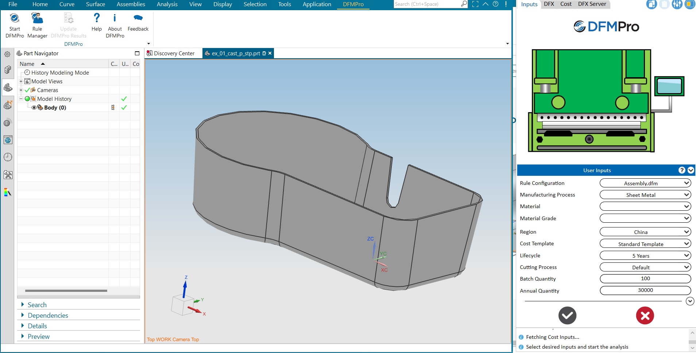
Figure 1. DFMPro Analysis on a CAD Model

In DFMPro, the rules are implemented so that they will check many dimensions of a design, including geometry, material behavior, and manufacturing feasibility. These rules, which are particular requirements of the project or sector, give instant feedback into manufacturability of the design, such as the ability to manufacture it efficiently on a given manufacturing process. The Virtual Rule Module (VRM) is a system where the designers can Create, change, update, and manage the rules.
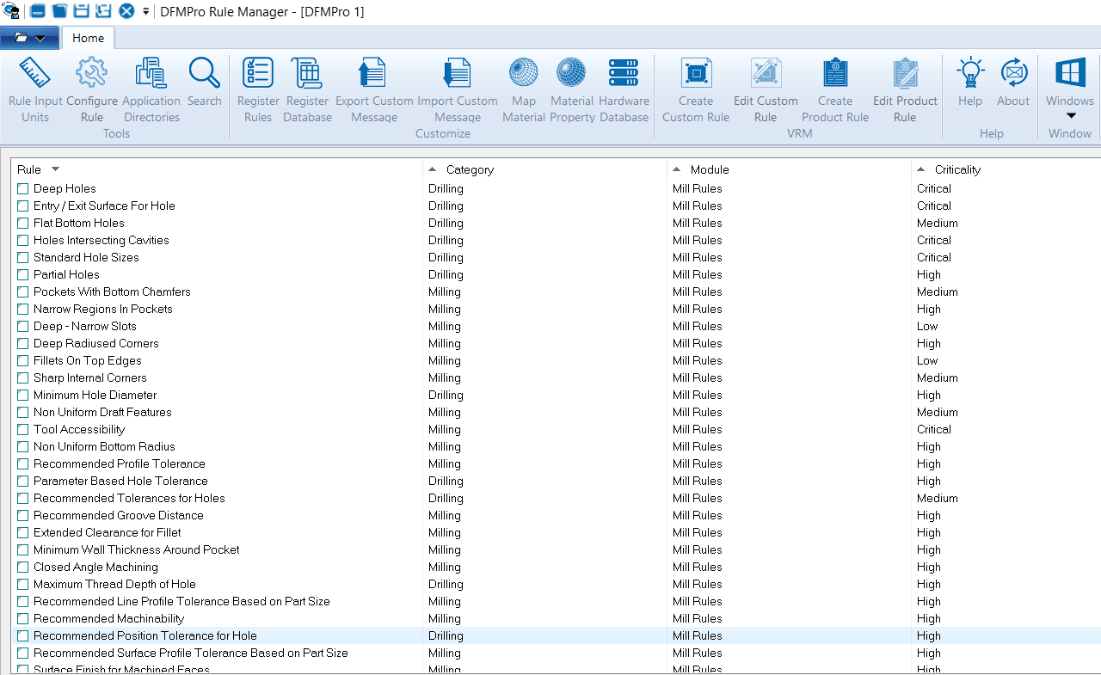
Figure 2. Virtual Rule Module DFMPro

VRM enables the establishment of specialized rules for diverse manufacturing processes to keep the software flexible to accommodate various industrial requirements. These rules, underpinned by empirical research data, enable designers to guarantee that their models are optimized in terms of both performance and manufacturability.

The incorporation of research data into CAD design via DFMPro is pivotal towards making product manufacturability better. Research information and guidelines contains descriptive data on the properties of the material, methods of manufacturing, and state-of-the-art technologies. Designers can utilize the information to base material selection and manufacturing methods decisions on facts rather than assumptions. For instance, material properties of tensile strength, thermal conduction, and fatigue resistance allow designers to select materials most applicable for particular applications in products so that performance improves while manufacturability is achieved. Including this research data in DFMPro also enables the system to suggest design changes based on new manufacturing capabilities like additive manufacturing or precision machining.

Additionally, applying research Based data and guidelines with the rule’s engine in DFMPro makes the design process adoptable for modern manufacturing methods [16]. With the aid of VRM, DFMPro is able to automatically review and optimize designs based on the newest industrial standards by incorporating experimental data and research findings into the rules. Not only does this accelerate the development process, but it also makes the manufacturing process more cost-effective. The use of rules derived from research results ensures that designs are optimized for the most effective methods of production, minimizing the chances of defects, improving product quality, and eventually resulting in an improved production process.
In this paper, the study will be on how users can integrate research data, experimental findings and guidelines into DFMPro to enhance design manufacturability. In particular, the study will investigate how rules and VRM in DFMPro can be customized to incorporate these findings in real-time and be used in industrial applications. Through the application of DFMPro to the implementation of the research data, the design process will be improved, resulting in more efficient, reliable, and cost-effective industrial applications.

METHODOLOGY
This research incorporates manufacturability restrictions—obtained from published literature—into the CAD design process through the Virtual Rule Manager (VRM) capability of DFMPro. This will be done in three steps:
1. Mining Manufacturability Rules: We examine research literature to determine most influential design changes that enhance manufacturability.
2. Implementing Rules in DFMPro: We translate these research-based guidelines into custom design checks using DFMPro’s VRM.
3. Testing and Validating Designs: We test the automated rules on sample CAD models and compare against baseline designs to measure manufacturability improvements.
Rules are enforced in DFMPro to check for different attributes of a design, including geometry, material characteristics, and manufacturability. These rules are made from data like module features, parameters, and dimensions. Designers are aided by the tool to recognize potential manufacturing problems in the CAD model or that could occur after manufacturing, thereby guaranteeing design feasibility and production constraint compliance.

3.1 Researched based data and Guidelines

Based on research and guidelines, some design modifications have been identified to enhance manufacturability and improve production efficiency. Research data suggests that increasing the wall thickness from 0.3 mm reduces tool deflection and improves machining stability, ensuring better accuracy [16]. Similarly, an increase in the fillet radius from 0.3 mm to 0.5 mm significantly lowers stress concentrations, facilitating smoother tool movement and reducing tool wear. Additionally, maintaining an overhang angle within 45° minimizes the need for support structures in additive manufacturing, thereby optimizing material usage and post-processing efforts [13]. To prevent excessive cutting forces and tool breakage, thread depth constraints have been established to regulate machining loads effectively. Furthermore, simplifying internal cavities enhances tool accessibility, reducing machining complexity and improving overall manufacturability [14].

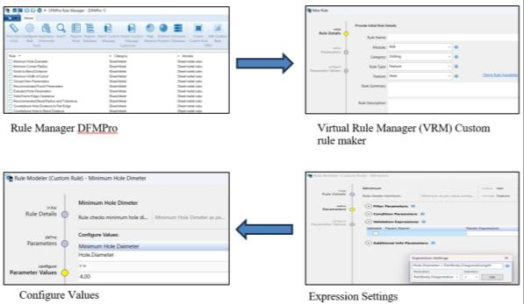
3.2 Implementation and Rule creation based on Research Data and guidelines in DFMPro

- Open DFMPro and Open the Rule Manager: Start by opening the DFMPro software and accessing the Rule Manager to begin creating your own custom rules.
- Create a Custom Rule: After accessing the Rule Manager, click on "Create Custom Rule" to bring up the Virtual Rule Module (VRM) screen.
- Provide a Rule Name: Provide a descriptive and easy-to-understand Rule Name to quickly determine the purpose of the rule, such as "Wall Thickness Optimization" or "Fillet Radius Enhancement."
- Select the Appropriate Module: Select the correct Module (e.g., Milling, Additive Manufacturing, Threading, etc.) for which the rule will be used in the manufacturing process.
- Select an Organization Category: Select an appropriate Category by which to organize your rule so that it belongs to a reasonable group for better management, such as "Machining Guidelines" or "Structural Integrity."
- Specify the Rule Type: Choose whether the rule is "Feature-based" or "Module-based" based on the scenario of your rule's usage. For instance, Wall Thickness and Fillet Radius rules would be "Feature-based," while Overhang Angle in additive manufacturing could be "Module-based."
- Specify the Feature: Identify the Feature the rule is applicable to, e.g., Wall Thickness, Fillet, Thread Depth, or Overhang Angle, to define its scope and applicability.
- Give a Rule Summary and Description: Create a concise Summary and Description that describes the purpose and use of the rule. For example, "Increasing wall thickness from 0.5 mm to 0.7 mm reduces tool deflection and improves machining stability, ensuring better dimensional accuracy," or "Limiting overhang angles to 45° minimizes the need for support structures in additive manufacturing."
- Define the Criticality Level: Set a Criticality value for the rule, determining its level of importance in the design or manufacturing process. For instance, wall thickness constraints may be marked as "High" criticality to avoid machining failures, while fillet radius optimization may have a "Medium" criticality.
- Define Parameters and Parameter Values: Define the Parameters like dimensions (e.g., Wall Thickness, Fillet Radius, Overhang Angle, Thread Depth) and enter Parameter Values such as:

Figure 3. Research Based Rule Creation in DFMPro

3.3 Rule implementation in DFMPro considering the Guidelines and Data
After reviewing various research papers and industry guidelines, several key design rules were identified to enhance manufacturability. As one example, we referred to the paper regarding Additive Manufacturing Guidelines to establish rules related to maintaining appropriate wall thickness, following the recommended height-to-diameter ratio, using standard hole sizes, and incorporating grooves where necessary. [16]. These rules were formulated to ensure better design practices, particularly for additive manufacturing and machining processes, helping to improve the overall structural integrity and manufacturability of components. The details of the rule are given in table 1.

Table 1. Dimension of the Research Based Rules
Wall Thickness | >= 0.3
Height to Pin Diameter | >=0.4
Grooves | >=0.4
Hole Size | >=1.2

The same rules were applied in DFMPro and run on a 3D CAD model widely used in industries. The test was performed in Creo Parametric, where the model was checked for adherence to the rules defined. The analysis done by DFMPro gave a comprehensive review of the design, highlighting areas where the component complied with or did not comply with the manufacturing guidelines.
The outcome revealed that certain requirements were Satisfied while others were not. As Shown in figure 4, the red color shows that rule is failed and the green colors show that the rule is passed like the minimum thickness of the wall, height-to-diameter ratio, and hole size were failed, meaning that the dimensions of the component does not meet the prescribed standards. Such variations would influence the manufacturability, material utilization, and structural integrity of the part, and thus cause manufacturing defects or added production cost.

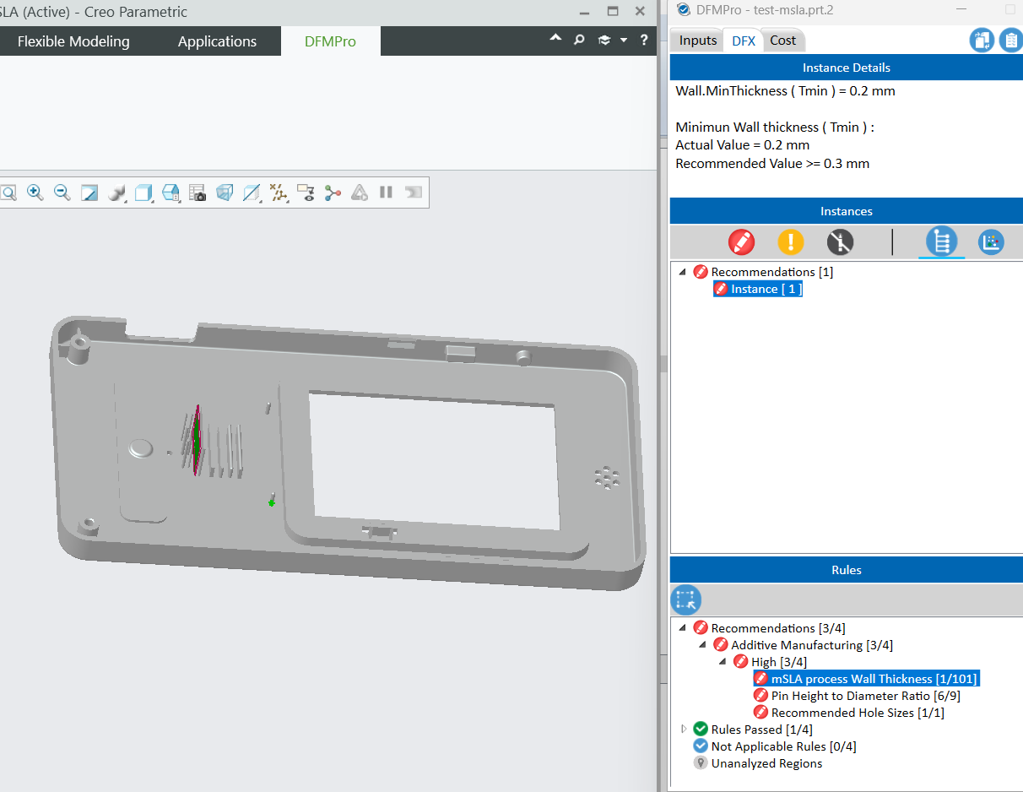
Figure 4. Research Based rules run on CAD Model

To enhance manufacturability and sustainability, the users must incorporate necessary changes in the CAD model according to the DFMPro suggestions. With these design features being improved upon in Creo Parametric, the component is optimized for increased performance, less material wastage, and greater manufacturability, making it industry standard and production compliant.

RESULT
Manufacturability analysis run in DFMPro in Creo Parametric gave essential information regarding the compliance of the design with the specified guidelines. Analysis showed successful and failed cases based on several rules of design, highlighting areas for changes to be made for enhanced manufacturability, table 2 give overall Idea of the analysis done in DFMPro. The results suggest that while some aspects of the design are well-optimized, adjustments are needed in areas like wall thickness, height-to-diameter ratio, and hole sizes.

Table 2 Summary of the Analysis done on DFMPro

Rule Name | Passed / Failed | Number of failure Instances | Rule Importance
Wall Thickness | Failed | 1/101 | Rule checks MSLA process wall thickness.
Height to Diameter Ratio | Failed | 6/9 | Rule checks wire height to diameter ratio. Also Checks Minimum Diameter
Recommended Hole Sizes | Failed | 1/1 | For good hole quality maintain a diameter-to-wall thickness ratio > 2.0. Holes on vertical faces should not exceed 10 mm to avoid difficult-to-remove support.
Grooves | Passed | 1/64 | Rule checks grooves.

CONCLUSION
This study demonstrates the application of research-based data and guidelines in CAD software using DFMPro to achieve optimal manufacturability and optimize design productivity. Instead of relying on manual design adjustments, the process integrates tested design rules—ideal wall thickness, Hole Size, and Height to Hole Diameter—into the design process to allow automated manufacturability checking. The study confirms that application of these guidelines produces improved machining stability, reduced tool wear, improved tool accessibility, and overall cost-effective production. Th rules utilized in DFMPro enhance manufacturability through the delivery of structural stability, stress concentration reduction, support structure minimization, and preventing excessive cutting forces. With the help of Virtual Rule Manager (VRM), real-time validation reduces late-stage changes, increasing production efficiency and product quality with optimized workflows and less material waste. Through the Virtual Rule Manager (VRM) of DFMPro, these rules provide real-time manufacturability checking, preventing costly late-stage modifications and improving production efficiency. Closing the gap between manufacturing operations and CAD design, this research results in productive workflows, reduced material waste, and improved product quality.

REFERENCES
- Magdum, M. U., Jalwadi, S. N., Dama, Y., & Pulujkar, P. (2017). Development and Implementation of Guideline for Die Casting Process in DFMPro Software. International Journal of Scientific & Engineering Research, 8(4).
- Campi, F. (Ph.D. Dissertation). (n.d.). CAD-integrated Design for Manufacturing and Assembly: A Method and a Tool for Manufacturing-Compliant and Cost-Effective Products. Università Politecnica delle Marche.
- Favi, C., Mandolini, M., Campi, F., & Germani, M. (2021). A CAD-based Design for Manufacturing Method for Casted Components. Procedia CIRP, 100, 235–240.
- Barnawal, A., Peters, F., Frank, M., & Dorneich, M. (2016). Design and Evaluation of Designer Feedback System in Design for Manufacturability. Proceedings of the Human Factors and Ergonomics Society Annual Meeting.
- CIMdata. (2021). HCL DFMPro: A Critical Digital Transformation Element. CIMdata Commentary, 16 November 2021.
- Vhangade, H. B., Patil, B. T., Vhangade, B. U., & Desai, J. (2017). Design for Manufacturing Integration: Ontologies and Analysis in Computer-Aided Designing. International Journal of Innovative Research in Science, Engineering and Technology, 6(6).
- Favi, C., Mandolini, M., Campi, F., Cicconi, P., Raffaeli, R., & Germani, M. (2021). Design for Manufacturing and Assembly: A Method for Rules Classification. JCM 2020, Lecture Notes in Mechanical Engineering, 354–359.
- Hunde, B. R., & Woldeyohannes, A. D. (2022). Future Prospects of Computer-Aided Design (CAD) – A Review from the Perspective of Artificial Intelligence (AI), Extended Reality, and 3D Printing. Results in Engineering, 14, 100478.
- Gupta, S. K., Regli, W. C., & Nau, D. S. (1994). Integrating DFM with CAD through Design Critiquing. Concurrent Engineering: Research and Applications, 2(2).
- Dalvi, N. (2015). PART 304 DFM Considerations During Design: Perspective Change from Reactive to Proactive. Honeywell Aerospace.
- Țîțu, A. M., & Pop, A. B. (2024). Implementation of CAD/CAM/CAE Systems for Improved Design and Manufacturing Processes in Industrial Organizations. Proceedings of the 18th International Conference on Business Excellence 2024, 3069–3078. DOI: 10.2478/picbe-2024-0253
- Budi, Y. E. P., & Sukmono, T. (2023). Effectiveness of CAD-CAM Application for the Development, Design, and Implementation of Maintenance Tools. Jurnal Penelitian Pendidikan IPA, 9(9), 671–680. DOI: 10.29303/jppipa. v9i9.4859
- Mirzendehdel, A. M., Behandish, M., & Nelaturi, S. (2020). Topology Optimization with Accessibility Constraint for Multi-Axis Machining. Palo Alto Research Center (PARC), Palo Alto, California, U.S.A.
- Jost, E., Berez, J., & Saldaña, C. (2022). A Case Study in Component Redesign for Additive Manufacturing Process Workflows. Proceedings of the 33rd Annual International Solid Freeform Fabrication Symposium – An Additive Manufacturing Conference.
- Benoist, V., Baili, M., & Arnaud, L. (2019). Design for Additive Manufacturing Including Machining Constraints: A Case Study of Topology Optimization Including Machining Forces. First International Conference on Innovative Materials, Manufacturing, and Advanced Technologies (IMMAT’2019), Monastir, Tunisia, pp. 202-207.
- Junk, S., & Bär, F. (2023). Design guidelines for Additive Manufacturing using Masked Stereolithography mSLA. Procedia CIRP, 119, 1122–1127. Elsevier.

