DFMPRO: An Expert System to Build and Evaluate of Additive Manufacturing Checks for Industrial Use

Gopala Madne ¹*, Omkar Kadam ^{1,} Sahil Hande ^{1,} Atul Kulkarni ¹, Baburaj Iyer ², Saurabh Baranwal ², Yogiraj Dama ², Mandar Magdum ², Shrushti S. Shete ³, Anuli Malalikar ⁴

¹ Department of Mechanical Engineering, Vishwakarma Institute of Information Technology, Pune- 48, Maharashtra,
² HCL Software Ltd, Hinjewadi, Pune, Maharashtra, India.  0000-0002-6452-6349
³ Department of Computer Science and Engineering, Shree Siddheshwar Women's College of Engineering, Solapur.
⁴ Department of Computer Science, S. G. Balekundri Institute of Technology, Shivabasavanaga Belagavi
Email of Corresponding Author: madnegopala07@gmail.com  0009-0008-5404-4347

Received on: 19 April, 2025 Revised on: 01 June ,2025 Published on: 06 June,2025

Abstract - Additive manufacturing (AM) plays an important role in modern manufacturing industries. This study aims is to establish a platform for designing components made for AM production. By identifying critical design parameters and formulating guidelines required to additive manufacturing, the research seeks to organized the design-to-production workflow. This will ensure manufacturability and performance of AM-produced parts. The approach is critically aiming to develop precise design rules for AM processes, increasing the capabilities of DFMPro software. DFMPro is an automated solution which provides design recommendations from manufacturing aspects and other downstream right at the component design stage. This expert system can be further enhanced by learning real-time manufacturing challenges, process and build guidelines as a checklist for further validation. In current research work, based on real-time 3D Printing and testing outcome certain design and manufacturing checks are extracted and built in DFMPro software of automatic validation. In conclusion we found, DFMPro software can be used as knowledge repository to build the different checklist based on real-time 3D Printing experience. This expert system helps designers for quick design validation, predict possible 3D Printing rework. The outcomes of this research are expected to have significantly effect on various industries related on additive manufacturing technologies, contributing to innovation and maintainable growth in the global manufacturing sector.
Keywords: Additive Manufacturing, DFM, Design for Manufacturing, DFMPro software, Design Guidelines

INTRODUCTION

1.1 Additive manufacturing
Additive manufacturing (AM) represents a highly advanced process within the manufacturing industry, characterized by its technique of adding material layer by layer on a substrate [1].
Unlike conventional subtractive manufacturing method, which removes material from a solid block to create the final shape, AM is consider far more accurate and precise method for making material to make components [1]. Comparing AM with other manufacturing process AM pro- vides more customization, complexity, and rapid prototyping this thing make AM more preferable in comparison with other process .AM methods are classified into seven categories: material extrusion, material jetting, binder jetting, sheet lamination, vat photo polymerization, and directed energy deposition, etc. These methods are further classified into sub-categories depending on the type of materials used and the process of material deposition like FDM and DIW in Material Extrusion SLS, SLM and electron Beam Melting in powder Bed Fusion, etc. The materials may be in the form of powder, filaments, liquid, hydrogels or ink, and sheets [4]. Additive Manufacturing (AM) has key benefits for enhancing production flexibility. Compared to full digitization, AM requires a lower initial funding, making it a more productable option for businesses. [7] Additionally, AMs allows for easy expansion of production capacity by simply adding more printers. The technology enables rapid production of new designs, accelerating product development and time-to-market. By creating complex, functional parts with fewer components, AM simplifies product design and reduces manufacturing complexity [7].

1.2 Challenges
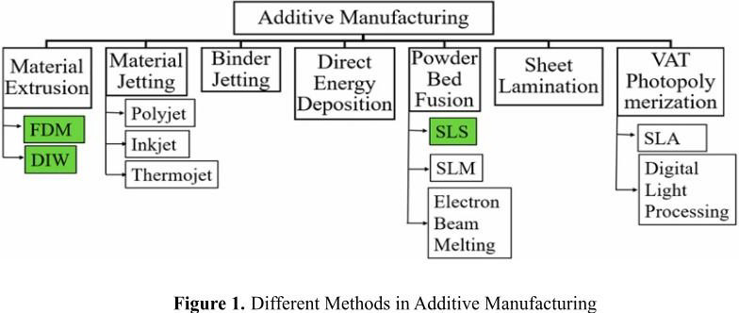
Component Qualification: Ensuring AM-produced parts meet quality standards. Lack of Expertise: Limited

under- standing of AM technology. Integration Difficulties: Inte- grating AM machines with existing production systems. Series Production Readiness: AM machines may not be fully prepared for large-scale production
Safety Regulations: Lack of safety guidelines for working with AM materials. Quality Assurance: Insufficient quality control processes for AM parts. Process Chain Integration: Connecting AM with other production steps. Program Planning: Difficulties in planning and executing AM production.

1.3 Working Principal of Additive Manufacturing

Initially, a Computer-Aided Design (CAD) model is created using software such as SolidWorks or CATIA. This model is then exported in STL format and imported into the 3D printing machine. The STL file is sliced into thin layers, providing instructions for the additive manufacturing machine. The machine gradually adds material layer by layer to construct the physical object [4].
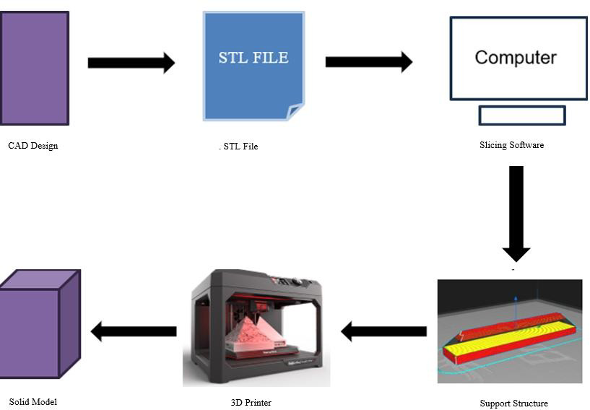

Figure 2. Working principal of Additive Manufacturing Process

1.4 Applications in Additive Manufacturing

Additive Manufacturing (AM) has a wide range of uses in everyday life and various industries. In healthcare, AM is used to make biomaterials such as prosthetics, dental devices, and patient-specific implants. In the aerospace and defense sectors, it plays a key role in creating lightweight and complex parts, which helps reduce the weight of aircraft and spacecraft, leading to better fuel efficiency [1]. AM is used in automotive industry for rapid prototyping, customized parts, and lightweight components, as well as producing tooling and jigs that improve manufacturing workflows. In construction, it helps build architectural models, detailed structural elements, and even whole sections of buildings [4].AM also contributes in 3D Food printing, 3D Large scale printing, and 4D printing [1]. These applications contribute to the global economy, driving technological advancements and the introduction of new innovations in AM [5]. DFMPRO
Design for Additive Manufacturing (DfAM) is an engineering approach that helps designers create effective solutions for parts made using Additive Manufacturing (AM)[5]. It encourages creativity in the initial design phases and provides clear guidelines for designing parts specifically for AM. The main goal of DfAM is to help designers take full advantage of AM’s unique design possibilities. [5] DFMPro, a tool created by HCL Technologies, for improving the Design approach. It helps engineers and designers identify and fix manufacturing issues early in the design process. By integrating with popular CAD systems, DFMPro enhances product quality, lowers costs, and speeds up the time-to-market by making the design and manufacturing process more efficient. Additionally, DFMPro supports various manufacturing processes and modules, such as machining, injection molding, sheet metal fabrication, casting, additive manufacturing, etc. For additive manufacturing, DFMPro provides guidelines for optimizing part orientation, minimizing support structures, and ensuring material efficiency, which helps make the process more cost-effective and sustainable. The primary aim of this paper is to identify the challenges encountered during the additive manufacturing of three-dimensional parts, analyze the resulting defects and faults, and propose effective solutions to these issues. Additionally, the findings and recommendations will be tailored for industrial application.

2.1 Rules creation in DFMPro

Open Rule Manager in DFMPro: Start by opening DFM- Pro and going to the Rule Manager. Click on” Create Custom Rule” to open the Virtual Rule Manager (VRM) screen. Here, you’ll define all the necessary details for your new rule. Provide Rule Details: Rule Name: Give your rule a clear name. Module: Select the relevant module (e.g., Milling, Injection Molding). Category: Choose a category to organize your rules. Rule Type: Select” Feature-based” or” Module-based.” Feature: Specify the feature the rule applies to (e.g., Hole, Hole Chain). Summary and Description: Briefly explain the rule’s purpose. Criticality: Set the importance level of the rule. Define Parameters: Parameter Names: Specify the dimensions or attributes to be measured (e.g., PartBody.WidthW, Hole.Diameter). Expressions: Define how parameters will be calculated or compared using mathematical operators. Configuration: Set minimum, maximum, range, or operator-based conditions. Specify Parameter Values: Parameter Values: Enter specific values for dimensions, tolerances, or other specifications. For instance, if a Hole Diameter must be 4 mm, specify this value.

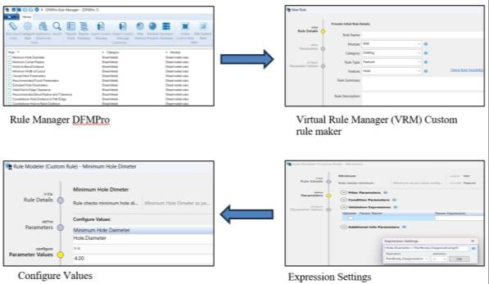

Fig 3. Rule creation in VRM

2.2 Step-by-Step Process for Analyzing CAD Models

Using DFMPro Software.
Open the DFMPro software. If using standalone mode, import the CAD model or create or import a model in the appropriate format. Go to the rule manager and select the rule to check against the CAD model features. Standard rule values are available; modify them if necessary and save. Choose the relevant module for analysis (e.g., injection molding, die casting, sheet metal, additive manufacturing). Click ’Run’ to start the analysis. For specific applications, specify the pulling direction. View the analysis results by selecting the result option and its sub-options. Export the results in for- mats like Excel, e-Drawing, or XML. Modify features that impact functionality and ignore those that don’t require changes. Rerun the analysis to check for any rule failures.

Case Study
Additive manufacturing vendors frequently encounter several technical challenges when producing parts. Key issues include insufficient nozzle temperature leading to poor material adhesion, the requirement for a minimum material thickness of 1 mm to maintain print integrity, the necessity of support structures to prevent the collapse of overhanging sections, and the design constraint that prohibits sharp edges due to limitations of the Laser Powder Spray (LPS) method. A recent analysis conducted using DFMPro evaluated a laptop stand designed by a vendor for a customer. This stand, intended for use in various environments such as offices and homes, was assessed to determine its compatibility with additive manufacturing processes. The DFMPro analysis revealed that the CAD model of the laptop stand did not comply with two critical design rules: the” Faces Requiring Support” rule and the” Sharp Edges” rule.
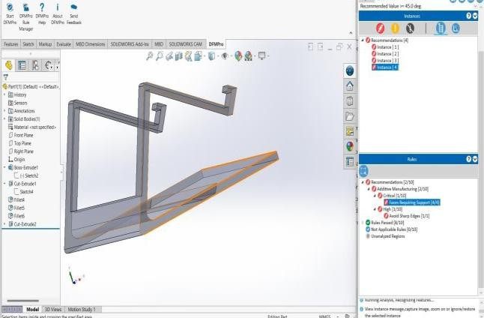

Fig 4. Analyzing laptop stand in DFMpro

The Faces Requiring Support” rule is crucial for minimizing the need for additional support structures during the additive manufacturing process. As illustrated in Figure 5, certain portions of the model require support due to their overhang angles. These temporary supports are essential to prevent the deformation or collapse of overhanging sections caused by gravitational and thermal stresses. Effective design should prioritize the reduction or elimination of these support structures to enhance efficiency and improve print quality.
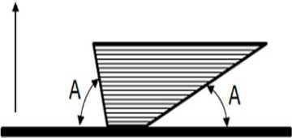

Fig. 5 Faces required support while printing
Similarly, the figure 6 shows that the sharp edges should be avoided while designing some CAD model” Sharp Edges” rule dictates that edges in the design must be smooth rather than sharp. Sharp edges are problematic for methods such as Laser Powder Spray (LPS) and Laser Powder Bed (LPB), as these techniques are not suited to handling intricate, sharp geometries. This rule ensures that the printed part maintains structural integrity and meets the process requirements of the se specific additive manufacturing methods.
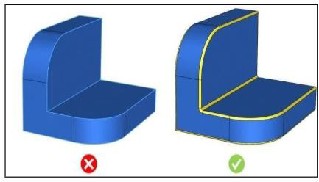

Fig. 6 Avoid sharp edges in model
Additionally, providing external support during the printing phase is another crucial aspect. Especially additive manufacturing, require additional support structures to ensure the integrity of the model throughout the build process. These supports prevent deformation, sagging, or collapse of the material, particularly for overhangs or intricate geometries. One adjustment involves modifying sharp edges within the model. Sharp edges can pose challenges during the manufacturing process, particularly in additive manufacturing processes. To resolve these issues, it is important to incorporate chamfers sloped edges that replace sharp corners. Chamfering feature enhances the manufacturability of the design but also reduces the risk of potential damage or stress concentration at these edges, ultimately leading to a more robust and reliable product. Implementing these supports in the design phase helps maintain the accuracy and quality of the final product. By suggesting modifications like edge chamfering and external supports, DFMPro ensures that the design adheres to manufacturing best practices. This proactive approach optimizes the manufacturing process while improving the precision and functionality of the final product, minimizing potential production issues and increasing overall efficiency.

RESULT

In the analysis of the laptop stand designed for additive manufacturing, DFMPro identified some design issues in the CAD model. The” Faces Requiring Support” and” Sharp Edges” rule suggests minimizing the need for temporary support structures while the” Sharp Edges” rule necessitates smooth edges to accommodate additive manufacturing techniques like Laser Powder Spray (LPS). These adjustments are important to enhance the printing standards, sustaining durability, and improving overall manufacturing efficiency.

CONCLUSION
The challenges and problems faced by vendors and customers in additive manufacturing can be effectively solve with the use of DFMPro and its applications. DFMPro plays an important role in identifying and solving design issues and the defects by integrating into the design process. This approach enhances the manufacturability, sustainability, and reliability of the production process and contributes in cost reduction and improved efficiency in manufacturing of complex parts by optimizing design elements such as support structures and edge geometries, DFMPro helps to streamline production workflows and minimize material wastage. The integration into additive manufacturing practices aligns with the objective of advancing technological innovations and achieving industrial outcomes. Ultimately, the use of DFMPro fosters a more robust and effective approach to additive manufacturing, driving progress and excellence in the industry.

REFERENCES
- Zhou, L., Miller, J., Vezza, J., Mayster, M., Raffay, M., Justice, Q., Al Tamimi, Z., Hansotte, G., Sunkara, L. D., & Bernat, J., 2024. Additive Manufacturing: A Comprehensive Review, Sensors, 24(9), 2668. https://doi.org/10.3390/s24092668
- Schlesinger, L., Koller, J., Pagels, M., & D¨opper, F., 2023. Alignment of design rules for additive manufacturing and re-manufacturing, Journal of Remanufacturing,13(1),99-119. https://doi.org/10.1007/s13243-022-00122-9
- Valjak, F., Bojˇceti´c, N., & Luki´c, M., 2018. Design for Additive Manufacturing: Mapping of Product Functions, International Design Conference – DESIGN 2018, pp. 1369-1378.
https://doi.org/10.21278/idc.2018.0364
- Jayswal, A., & Adanur, S., 2022. An overview additive manufacturing methods, materials, and applications for flexible structures, Journal of Industrial Textiles, 52(1),1-42.
https://doi.org/10.1177/15280837221114638
- Mani, M., Witherell, P., & Jee, J., 2024. Design rules for additive manufacturing: A categorization.
Retrieved from
https://tsapps.nist.gov/publication/getpdf.cf m?pubid = 921515
- Pereira, T., Kennedy, J. V., & Potgieter, J., 2019. A comparison of traditional manufacturing vs additive manufacturing, the best method for the job, Procedia
- Manufacturing, 30, 11-18. Luft, A., Gebhardt, A., & Balc, N., 2019. Challenges of additive manufacturing in production systems, in MTeM 2019: MATEC Web of Conferences, 299, No. 01003, EDP Sciences.
https://doi.org/10.1051/matecconf/201929901003
- Magdum, M. U., Jalwadi, S. N., Dama, Y., & Pulujkar, P., 2017. Development and implementation of guideline for die casting process in DFMPro software, International Journal of Scientific & Engineering Research, 8(4).
- Jain, R., & Meghwal, M., 2022. Additive manufacturing, International Journal for Research in Applied Science & Engineering Technology (IJRASET), 10(6).
https://doi.org/10.22214/ijraset.2022.44072
[10] Wong, K. V., & Hernandez, A., 2012. A review of additive manufacturing, ISRN Mechanic.

