Addressing the challenges in feeding Railway Platform Roof-Top PV Generation to 25 kV AC Overhead Traction
Nagesh S Pande¹, Dr Atul R Phadke², Dr Prashant J Gaidhane³
¹ Research Scholar  0000-0002-1011-3581, ² Professor, ³Asst Professor
^{1,3} Govt College of Engineering, Jalgaon India, 425001 ^{, 2} COEP Technology University, Pune India 411005.

Email of corresponding Author: nagesh.pande@gmail.com

Received on: 19 April, 2025 Revised on: 01 June ,2025 Published on: 06 June,2025

Abstract- Indian Railway has intended to harness 1000 MW of solar energy in the upcoming five years. 500 MW will come from the rooftops of railway platforms while the remainder will be sourced from other official ancillary complexes to support traction load. TSS in railway traction power supply is installed for every 50 to 90 km segment along the railway track for both UP and DOWN routes. Given a rooftop area of 1000 to 5000 sq-metre, it is feasible to install solar panels capable of producing 100 kW to 500 kW, resulting in savings on conventional energy consumption from utilities of approximately 30 to 40%. Neutral sections help ensure balanced loading across all three phases of utility, as the phases R, Y, and B are loaded sequentially. This paper investigates the continuously attempted model of directly feeding solar power from railway platform rooftops to 25 kVAC traction supply employing dynamic inter-phase power flow techniques in real-time with all related equipment balance. To address the challenges associated with neutral sections in the electric railway traction system, interphase power controllers (IPC) are utilized. Consequently, the Gannet optimizer-based fuzzy fractional order proportional integral derivative (G-F2PID) controller is suggested in this study for phase synchronization.
Keywords RE (Renewable Energy), OHE (Overhead Electric Equipment), IR (Indian Railway) .IPH (Inter-phase power flow), IPC (Inter-phase power flow Controller)

INTRODUCTION
Transport mode of the Railway network in India consists of 66,000 kilometers of track routes. To date, only 42% of this network is Electrified. It ranks among the largest networks globally, making it the second-largest single consumer of electricity. In relation to environmental sustainability and the outcomes of the Rio de Janeiro conference in 1992, the Kyoto COP 3 in 1997, the Paris summit in 2015, and the latest COP 27 in Egypt, protocols have been established to raise funds and support underdeveloped as well as developing nations. Indian Railways have initiated measures to harness Green Energy. The Vision 2020 document outlines a plan to utilize 10% of Renewable Energy. The Indian Railways utilize 2100 MW of power, translating to 18 billion units. Green Energy can be categorized into two types: solar thermal and solar photovoltaic. The solar photovoltaic resource in the Indian subcontinent benefits from 300 clear sky sunny days annually, with an anticipated green power potential of around 1000 MW to be realized in the next five years. Reducing the carbon footprint by focusing on the second largest consumer presents a logical strategy moving forward. Therefore, it is crucial to investigate options that enable solar green power to satisfy traction load demands by directly linking it to a 25 kV AC Power supply system. The National Government has established an ambitious Renewable Energy target of 175 GW by 2022 and has urged various governmental agencies to consider the deployment of solar energy. Indian Railways has stepped up by launching a 50 MW solar rooftop initiative, primarily aimed at decreasing long-term energy costs. The Solar PV Source is set to serve as an alternative energy supply to diminish energy expenses and reliance on utility sources, given that the capacity addition rate in various state utilities is about 7%, compared to the demand growth rate of approximately 11% each year. The current Indian grid generates 300,000 MW and will require about 900,000 MW by the year 2030. With recent demographic data indicating the global population at 800 million, and India being the second most populous country after China, sustainable development survival will hinge on viable options, either nuclear or renewable energy. Optimizing energy costs is a primary concern for Indian Railways, which pays between Rs 6 to 7 per unit of electricity consumed. It relies on state DISCOMs that charge more than they do their agricultural, industrial, or commercial clients. Furthermore, the universal responsibility to reduce carbon footprints suggests maximizing the use of clean green energy, such as solar, for consumers like traction.

LITREATURE REVIEW

A significant amount of research has been conducted in the power quality domain concerning traction, as noted in [1], where the author discusses the issue of transients caused by the cyclic load of railway traction. In [2], efforts are made to identify solutions for the challenges faced by Green Buildings equipped with solar rooftop resources in order to achieve a seamless interface and effective operation. The author elaborates on the concerns related to energy conversion and storage in [3], aiming to address the inertia issue when connecting small, fragmented solar sources to larger grid utilities. In [4], a model is presented that includes dual single five-level inverters with Lee Blank Transformers, designed to support two single-phase loads at 750 V for train traction from utilities. In [5], the author discusses power quality challenges in distributed generation concerning railway traction, which has a slight impact on the traction drive system. The hybrid network with a wind source, detailed in [6], emphasizes power quality challenges for traction applications. Despite the advancements, energy storage devices still face cost-effectiveness limitations, as observed in [7].In [8], initiatives launched by the railway institution regarding green power represent only a modest beginning aimed at auxiliary loads. The interface of SPV for utility integration is depicted in [9]. In [10], the author investigates the impact assessment of rooftop solar energy. The transients experienced while high-speed railway trains pass through neutral sections are discussed in [11]. The integration of solar energy with storage systems is again detailed in [12]. The SPV integration within African Railways is described in [13], highlighting the DC to DC interface referenced in paper [14]. Power quality issues attributed to small capacity lead to challenges associated with synchronous inertia, specifically the rate of change of frequency, as noted in [15].
Hybrid topology, as mentioned in [16], once again depends on the DC-to-DC interface. High-speed multiple units [17] applications offer solutions for the load side but not the source side concerning green power interception. Quality issues are thoroughly discussed in [18], yet they are considered secondary when compared to the dynamic interface for traction loads utilizing the IPC Technique. Auto passing alleviates the switching complexities of the train pantograph at the neutral section, as detailed in [19]. The co-phased traction power system still relies on traditional, mature utility services [20]. The effects of SPV systems are examined in [21], for which measures are being developed to address issues like synchronous inertia in utility grids. In [22], my paper was published, presenting the proposed concept, and further progress has been made in conjunction with this paper [23]. In this paper, a novel hybrid algorithm that combines the grey wolf optimizer (GWO) and artificial bee colony (ABC) algorithm, termed GWO-ABC, is introduced to leverage their benefits and address their limitations [24]. This paper presents a systematic strategy for optimizing the controller parameters along with scaling factors and the antecedent MF parameters to minimize the performance metric integral time absolute error (ITAE) [25]. This research study introduces the nonlinear fractional order PID (NL-FOPID) controller for a 5-DOF redundant robot manipulator aimed at joint trajectory tracking tasks [26]. The goal of this paper is to compare the performances of the new fuzzy fractional order (FO) PID (fuzzy PIλDµ) controller with both integer order fuzzy PID and PID controllers in controlling a redundant robotic system for trajectory tracking challenges [27]. This paper provides a simple design and parameters tuning method utilizing multi-objective optimization for the two-degree of freedom fractional order proportional-integral-derivative (2-DOF-FOPID) controller applied to a magnetic levitation system [28]. This paper outlines a multi-objective robust design and parameters tuning approach for the two-degree of freedom fractional order proportional-integral-derivative (2-DOF-FOPID) controller tailored for MLS applications [29]. In this paper, the newly proposed hybrid grey wolf optimizer and artificial bee colony algorithm (GWO-ABC) is utilized for parameter optimization of fractional-order fuzzy PID (FO-FPID) controllers focused on the trajectory tracking problem for a two-link robotic manipulator with a payload [30]. This paper proposes a reference point-based controller tuning strategy to incorporate the designer’s preferences into the multi-objective optimization (MOO) process. Indian Railways must incur substantial expenditures for energy consumption related to traction loads in addition to their staff wages, pensions, etc. [31]. This paper emphasizes Preference Oriented Multi-Objective Optimization for Tuning of Controllers: A Reference Point Based Approach, PJ Gaidhane, MJ Nigam, 2019 5th International Conference on Signal Processing, Communication and Electronics Engineering 2019. The structure of this paper is organized as follows: - Sec I Introduction, Sec II Literature Survey, Sec III Methodology, which includes techno-economic feasibility, simulation results, and hardware experiments based on actual 132 kV Utility Substations, Railway Traction Substations, Neutral Sections of Railway Track, etc. Sec IV elaborates on experimental setups, Sec V discusses Results and Discussion, and Sec VI presents the Conclusion, followed by Section VII Acknowledgment and References.

METHODOLOGY

Railway possesses adequate potential to utilize areas on track sidings along with platform rooftops. It is technically possible to employ an average of 4 platforms (650 meter length facilitating 650 x 20 = 13000 sq-meter Area) at each Railway station such as Bhusaval, Jalgaon, Pachora, Nandgaon, Manmad, Lasalgaon, Niphad, Nashik Road, Deolali, Igatpuri, and Kasara latform rooftops producing 100 to 200 kW solar energy and hen integrating it directly into the 25 kV AC OHE system of traction. Observations made during a visit to the Igatpuri 132 kV EHV station of SETCL indicate that moving train, while just rolling, draws 13A, equating to 325 kW on the 25 kV side, and the load further escalates to 250A, resulting in a consumption of 6. 25 MW. This suggests that solar integration can reduce conventional power consumption from utilities by 30% to 40%. Two Traction Transformers, as depicted in figure 1, were examined as welding transformers and loaded with a water load to determine drooping characteristics with the water load. It has been observed that the voltage changes from 50 to 46 volts at a current ranging from 0A to 80A, as outlined in Table 1. In the subsequent attempt, the phase angle in the secondary phase was analyzed concerning the primary phase at 60 degrees and relative to neutral, indicating that the angle between On 11th Nov 2021 Set-up of Two PT’s 440 / 110 volts AC was arranged with DSO to evaluate the voltage difference & phase angle between secondary phases. Initially Primary side was fed with RY phases to both & output seen at secondary. It was observed that the phase angle was zero as Waveforms seen overlapping each other as synchronized phases & the voltage between phases zero when checked with multimeter. This attempt ensured healthiness of wiring setup.

TABLE I. Transformer Voltage Variation with Load
Sr.  No. | Transformer 1 |  | Transformer 2
Sr.  No. | Load Amps | Voltage | Load Amps | Voltage
1 | 0 | 45.5 | 0 | 51
2 | 15 | 45.3 | 15 | 50
3 | 30 | 34.2 | 30 | 48
4 | 48 | 34.3 | 48 | 47
5 | 60 | 34.7 | 60 | 46.7
6 | 65 | 34.5 | 65 | 46.5
8 | 80 | 34.2 | 80 | 47

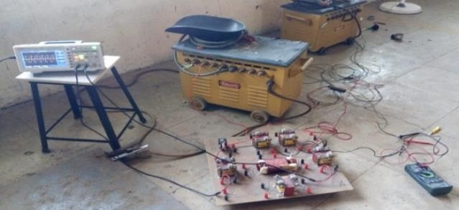

Fig 1:- System Set Up with Transformers PT’,s
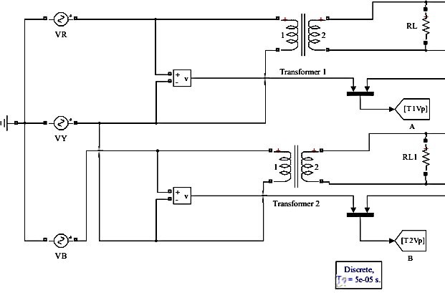
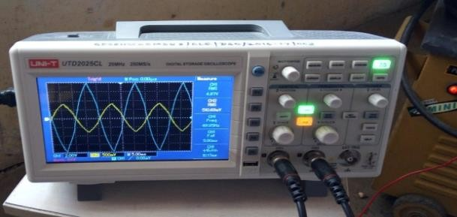
Fig 2:- R & Y phase waveforms for phase Angle

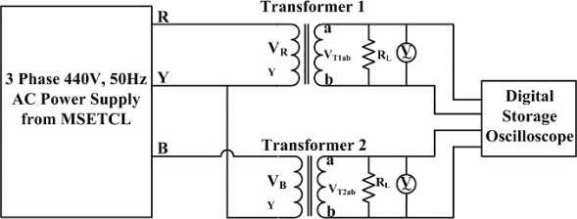
Fig. 3 Utility Supply to Railway Traction Downsized Model
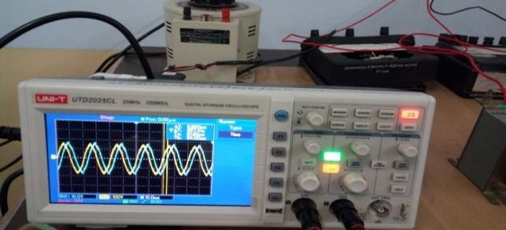
On 13th Nov 2021, an experiment was conducted in the GESCOE Nashik College workshop by connecting two PTs to R and Y 440 Volts as the primary supply according to Fig 3 above. The Y phase was connected common to one terminal of both PTs. The secondary terminals were linked to a DSO to examine the waveforms as depicted in Fig 4 below. It was noted that the voltage between the phases was 108 volts and the angle was 64 degrees against the 3. 6 msec scale on the DSO.
Fig-4- Wave forms on DSO indicating phase shift
Additionally, one common terminal of the secondary was grounded, and the voltage between the phases was found to reduce to 64 volts, i. e. , 108/1. 732 (Root Three). Consequently, it was concluded that the phase angle was 60 degrees between the secondary phases, and the voltage measured was 110 volts, indicating that in an actual traction system, the phase angle will be 60 degrees and the phase voltage difference will be 25 kV.
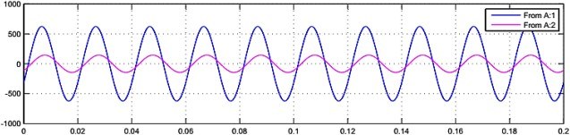
Fig. 5: Matlab Simulation for R & Y Phases
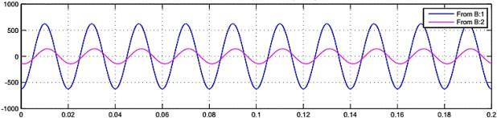
Fig. 6 Transformer 1 Primary & Secondary voltage
Fig. 7 Transformer 2 Primary & Secondary Voltage
RESULTS & DISCUSSION

The experimental results are validated with the help of MATLAB simulation Block Diagram Fig 5 shows the MATLAB Simulink model setup for measuring the phase angle difference between Transformer 1 & Transformer 2. The Fig 6 & Fig 7 shows the primary and secondary output voltage waveforms of Transformer 1 & Transformer 2 respectively. The above results therefore again inferred that the phase angle is 60 degrees between secondary phases of both the transformers.
On 16th Nov 2021 Railway Traction supply from Utility sources Viz. .MSEB from Igatpuri via..220 kV OCR (RY Phase) ..132 kV Lasalgaon (RY Phase) ..220 kV Manmad (RYPhase) ..132 kV Pimpharkhed (RY) ..132 kV Chalisgaon (RB Phase) ..132 kV Pachora (RB Phase) ..220 kV Bhadli (RY Phase) ..132 kV Deepnagar Bhusawal (RY Phase) as shown in Fig 8 above.
On 17th of Nov 2021 Simulation on MATLAB was tried selecting 440 / 110-volt PT’s & confirmed that the physical measurements above are correct & with proper interfacing components values it is possible to import or export the solar power to adjacent sides of neutral section depending on the loading on that section. Interphase power flow will optimize the solar source utilization to its fullest measure. Interphase power flow facility will enhance the optimization of power utilities since a train departing from the neutral section will require a robust source to handle the acceleration, as at that point, the mass momentum of the train would have diminished due to being in coasting and retarding operation mode. Additionally, it will enhance power quality and stability to overcome the cyclic nature of traction load.

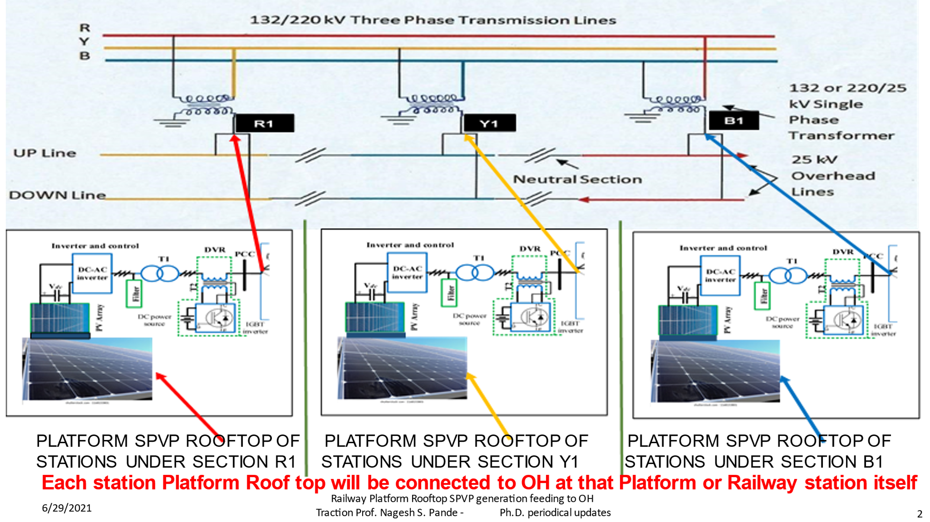
Fig 8 :- Solar System Interface Diagram
The idea of one sun one Traction and one Nation can be accomplished if the interface for solar power on railway platform rooftops successfully operates in sync at railway stations with appropriate upgrades of IPC or PST using ZCD or PLL systems at railway TSS. The solar system Interface logic diagram for the Railway Traction at railway station is illustrated in Fig. 8 above.
Fig 9 & 10 below shows the IPC Block Diagram & Output waveforms respectively
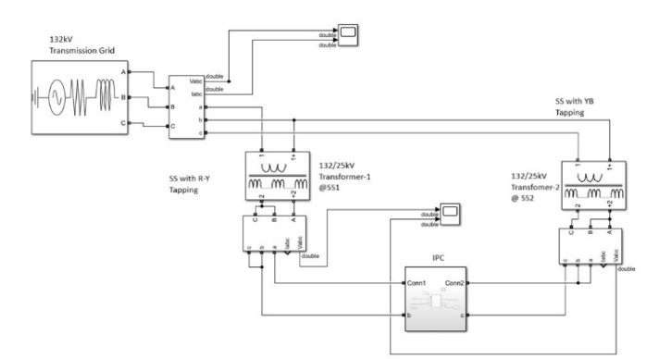
Fig 9 -IPC Block Diagram

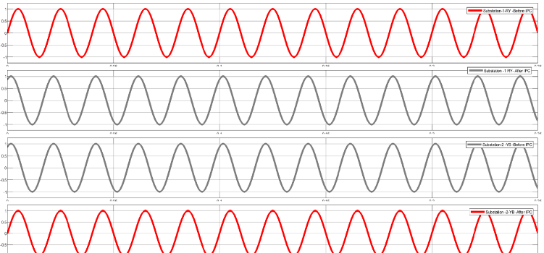
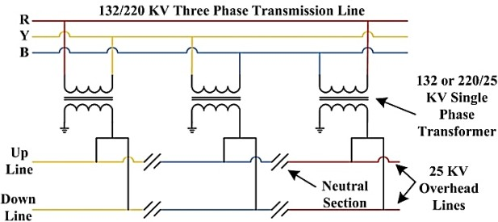
Fig: 10 - IPC Output Waveforms R & Y Phases

Fig 11 -Utility Supply System to Railway Traction

CONCLUSION
The phase angle and voltage difference in neighboring traction overhead phases were physically verified in the Two PT Model of 440 / 110-volt AC rating. A practical setup was obtained from the Testing Engineer of Railway Bhusawal and confirmed that a 60-degree angle is set on relays to safeguard against faults. Therefore, as illustrated in fig 11 above, it was feasible to check the magnitude and phase angle of the secondary phasor using PT’s 440 / 110 volts AC for primary and secondary, equivalent to 132 / 25 kV Railway Traction. This is essential to guarantee the synchronizing of neutral bus sections in R, Y, or B Phases when the Train travels through neutral sections along the overhead Traction line. Solar power from the Railway Platform Roof-Top can be interfaced at the Railway station itself to the 25 kV AC Catenary, and corresponding generation via a data logger can be sensed for that amount of generation from either side of the neutral section dynamically in real-time R to Y, Y to B, or B to R. Having noted the above fact on DSO waveforms, the angle measured is 60 degrees and the voltage is 110 volts; as such, both aspects appear validated with the support of MATLAB Simulations as well. Fig 10 and 11 demonstrate that the output waveform of IPC from the R phase of the Traction bus is in phase and magnitude with the Y phase waveform, indicating a seamless interphase power flow of parallel load sharing for the Traction system.

ACKNOWLEDGEMENT
We, the writers, owe our thanks to the prompt assistance of MSETCL (Maharashtra State Transmission CO LTD) at the 132 Kv Receiving Station in Igatpuri for enabling the recording of the live data of Train load from its start to cruising mode. We note the live train's passage in the neutral zone and also thank the Railway Authorities for supplying us with inputs such as interphase angle Relay settings, among others. We also extend our sincere appreciation to the GES College of Engineering administration for allowing us to conduct the experiments in their labs and providing access to the library for our references.
REFERENCES
- Radovan Dolecek, Ondrej Cerny, Zdenek Nemec and Jan Pidanic,“The Behaviorofthe Traction Power Supply System of AC 25KV 50Hz During Operation”,addressing transients Springer International Publishing AG,2017.
- Neel Mathews, Narendar Rao, Gowrisankar and Biswajit Pattnaik,\GridtiedRooftop solar: Problems, learnings and solutions", First International Conference onSustainable Green Buildings and Communities (SGBC), Dec. 18-20, 2016.
- Hitoshi Hayashiya, Shinya Kikuchi, Kazushi Matsuura and Masami Hino,\Possibility of energy saving by introducing energy conversion and energy storage technologies intraction power supply system", 15thEuropean Conference on Power Electronics and Applications (EPE), Sep. 2-6, 2013.
- Ming Meng1*, Yaning Yuan1, Mingwei Guo1, Li Jiang2, Jian Liu2, Dalong Hu2, Haiyang Cong3, and Dan Hao4, (2014). A Novel DC Microgrid Based on Photovoltaic and Traction Power Supply System, IEEE Conference and Expo Transportation Electrification Asia-Pacific (ITEC Asia-Pacific)
- Weijie Pan, Surya Chandan Dhulipala and Arturo Suman Bretas, (2017). A Distributed Approach for DG Integration and Power Quality Management in Railway Power Systems, IEEE International Conference on Environment and Electrical Engineering.
- LaxmanSingh; Chandan Vaishnav; Vivek Shrivastava, (2016). Performance Analysis of Hybrid Network of Indian Traction Power System using Renewable Energy Sources, International Conference on Micro-Electronics and Telecommunication Engineering (ICMETE)
- Satoru Sone, (2010). Improvement of traction power feeding/ regeneration system by means of energy storage devices, Electrical Systems for Aircraft, Railway and Ship Propulsion
- “International Conference on Green Initiatives & Railway Electrification", Institution of Railway Electrical Engineers, Ministry ofRailways, GovernmentofIndia, Oct27-28, 2017.
- Ashutosh V Pailwan, Indranil Chatterjee and K. Rajamani, \Roof Top Photovoltaic Grid Integration:Utility Approach", International Conferenceon Electrical Powerand Energy Systems (ICEPES), Dec. 14-16, 2016.
- Kalpesh A. Joshi and N. M. Pindoriya, \Impact investigation of rooftop Sola rPV system: A case study in India", 3rd IEEE PES Innovative Smart Grid Tec hnologies Europe (ISGT Europe), Oct. 14-17, 2012.
- Qian Wang, Jun Lu, Qingfeng Wang and Jiandong Duan, “Transient overvoltage study of auto-passing neutral section in high-speed railway",IEEE Transportation Electrification Conference and Expo, Asia-Pacific(ITECAsia-Pacific),Aug.7-10,2017.
- Abhishekh K. Singh, Amitabh Sinha , Asheesh K. Singh &R. Veeraganesan, (2016). Solar PV fed Grid Integration with Energy Storage system for Electric Traction Application” 10th. International Conference on Intelligent Systems and Control (ISCO).
- Hitoshi Hayashiya, Shinya Kikuchi, Kazushi Matsuura, Masami Hino, MasateruTojo, Tetsuya Kato, (2013). Possibility of energy saving by introducing energy conversion and energy storage technologies in traction power supply system, 15th European Conference on Power Electronics and Applications (EPE) France.
- M. J. Lencwe;S. P. Chowdhury;H. M. ElGohary, (2016). Solar Photovoltaic Integration on Locomotive Roof Top for South African Railway Industry, 51st International Universities Power Engineering Conference (UPEC).
- MohamedRageh,AugusteNdtoungou, AbdelhamidHamadi and Kamal Al-Haddad , (2018). Railway Traction Supply with PV integration for Power Quality Issues, 44th Annual Conference of the IEEE Industrial Electronics Society.
- Ming Meng1*, Yaning Yuan1, Mingwei Guo1, Li Jiang2, Jian Liu2, Dalong Hu2, Haiyang Cong3, and Dan Hao4, (2014). Hybrid Bidirectional Interactive DC Traction Power Supply System with Microgrid ”IEEE Conference and Expo Transportation Electrification Asia-Pacific (ITEC Asia-Pacific).
- Kenji Sato, Masakatsu Yoshizawa, and Takafumi Fukushima, (2010). Traction Systems Using Power Electronics for Shinkansen High-speed Electric Multiple Units, International Power Electronics Conference - ECCE ASIA.
- YevgenSokol; Volodymy rZamaruiev; VolodymyrIvakhno; Bohda nStyslo, (2018). Improving the Quality of Electrical Energy in the Railway Power Supply System, IEEE 38th International Conference on Electronics and Nanotechnology (ELNANO).
- Qian Wang; Jun Lu; Qingfeng Wang; Jiandong Duan, (2017). Transient Overvoltage Study of Auto-passing Neutral Section in High-speed Railway, IEEE Transportation Electrification Conference and Expo, Asia-Pacific (ITEC Asia-Pacific).
- Fulin Zhou; Qunzhan Li; DaqiangQiu, (2010). Co-phased traction power system based on balanced transformer and hybrid compensation, Asia-Pacific Power and Energy Engineering Conference.
- Kalpesh A. Joshi; N. M. Pindoriya,(2012). Impact Investigation of Rooftop Solar PV System: A Case Study in India,,3rd IEEE PES Innovative Smart Grid Technologies Europe (ISGT Europe).
- Nagesh S Pande;Dr Atul R Phadke;Dr Prashant Gaidhane; Connection & Control Strategy for Direct Injection of Railway Platform Roof-Top Solar Power in to Traction Network Vol 16 No
10 2021 PP.65-72 ISSN 2456-3463 International Journal of Innovations in Engineering & Science.
- A hybrid grey wolf optimizer and artificial bee colony algorithm for enhancing the performance of complex systems Dr PJ Gaidhane, MJ Nigam Journal of computational science 27, 284-302 66 2018
- Design of interval type-2 fuzzy precompensated PID controller applied to two-DOF robotic manipulator with variable payload PJ Gaidhane, MJ Nigam, A Kumar, PM Pradhan ISA transactions 89, 169-185 48 2019
- A nonlinear fractional order PID controller applied to redundant robot manipulator A Kumar, PJ Gaidhane, V Kumar 2017 6th International Conference on Computer Applications In Electrical
…16 2017
- Optimal design of fuzzy fractional order PIλDµ controller for redundant robot A Kumar, V Kumar, PJ Gaidhane Procedia Computer Science 125, 442-448 14 2018
- Tuning of two-DOF-FOPID controller for magnetic levitation system: A multi-objective optimization approach PJ Gaidhane, A Kumar, MJ Nigam 2017 6th International Conference on Computer Applications In Electrical …8 2017
- Multi-objective robust design and performance analysis of two-dof- fopid controller for magnetic levitation system PJ Gaidhane, MJ Nigam 2017 14th IEEE India Council International Conference (INDICON), 1-6 2 2017
- The Enhanced Robotic Trajectory Tracking by Optimized Fractional-Order Fuzzy Controller Using GWO-ABC Algorithm PJ Gaidhane, S Adam Soft Computing: Theories and Applications, 611-620 2022
- Connection and Control Strategy for Direct Injection of Railway Platform Rooftop Solar Power into Traction Network DPJG Nagesh Pande , Dr. Atul Phadke International Journal of Innovations in Engineering and Science 6 (10), 65 - 72 2021.

- Preference Oriented Multi-Objective Optimization for Tuning of Controllers: A Reference Point Based Approach PJ Gaidhane, MJ Nigam 2019 5th International Conference on Signal Processing, Communication and Electronics Engineering 2019.

