A Break through the State of Art: Review on Different Analysis Approaches Used for the Diagnosis of the Produced Vibration in Gear-Box

Sushant Salunkhe¹, Vikrant Konile², Tushar Khude³, Bhagyashri Patil⁴, Divya Marathe⁵, Prof. S.M. Wani⁶, Mr. Ganesh Badgujar⁷

*1,2,3,4,5 Student, *6 Assistant Professor, Department of Mechanical Engineering, Government Collage Of Engineering Jalgaon, Maharashtra, India,  0000-0003-2694-0335
*7 Lecturer, Department of Mechanical Engineering Jalgaon, Maharashtra, India

Email of Corresponding Author:vikrantkonile2025@gmail.com

Received on: 18 April, 2025 Revised on: 01June, 2025 Published on: 06 June, 2025

Abstract- This review paper presents A Comprehensive Review of styles for Gearbox Diagnostics and Prognostics through Vibration Analysis. Over the times, colorful ways, including time- sphere, frequency- sphere, sea transfigure, envelope analysis, and time- frequency sphere styles, have been developed to descry and diagnose faults in gearboxes. Vibration analysis has proven to be an essential tool for early fault discovery, condition- grounded monitoring, and the vaticination of a gearbox’s remaining useful life( RUL). This paper synthesizes findings from a wide range of studies and discusses the operation of these ways in different types of gearboxes, from worm gears to conventional spur gears. The integration of vibration analysis with ultramodern machine learning algorithms and Internet of effects( IoT) technologies offers promising directions for unborn advancements. Despite significant progress, challenges similar as noise hindrance, fault complexity, and data quality remain. This review highlights the significance of vibration analysis in perfecting the trustability and life of gearbox systems, emphasizing its part in prophetic conservation strategies across colorful diligence.
Keywords- Gearbox diagnostics, Vibration analysis, Fault discovery prophecies, Remaining useful life( RUL), Signal processing
INTRODUCTION
Gearboxes are essential factors in numerous mechanical systems, transferring power and necklace between rotating

shafts. Due to the harsh operating surroundings and mechanical complications, gearboxes are prone to faults, which can lead to expensive failures if not linked and addressed beforehand. As a result, vibration analysis has come one of the most extensively used ways for gearbox fault discovery and condition monitoring. This paper presents a review of colorful vibration analysis ways applied to gearbox diagnostics and prophecies , fastening on fault discovery, fault vaticination, and system trustability. The review draws from multitudinous studies conducted over several decades, presenting an overview of the s tate- of- the- art styles and their elaboration.
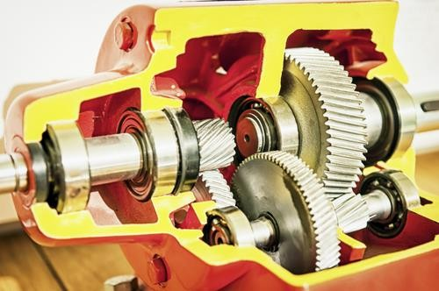
Fig 1: A cross section of gearbox

LITERATURE SURVEY

Vibration analysis involves measuring the vibration signals emitted by the gearbox during operation and analyzing these signals to identify abnormal patterns indicative of faults.

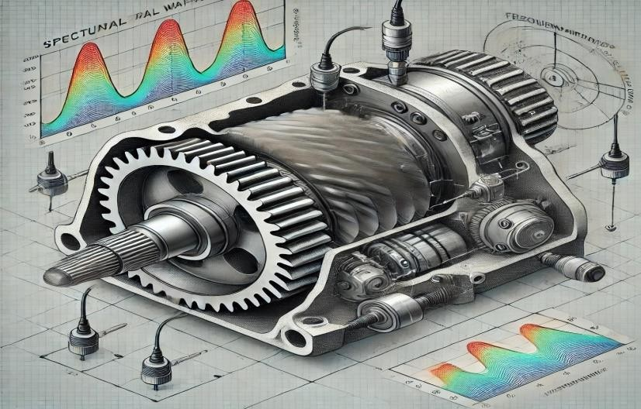
Fig 2: Vibrational Analysis of worm gear box

Time-Domain Analysis
Traditional time-domain analysis involves examining the raw vibration signal for anomalies. This method is simple and intuitive, but its capability to identify subtle faults is limited. For instance, Zakrajsek et al. (1993) highlighted that time-domain methods alone are often insufficient for detecting pitting fatigue or localized wear in gears.

Frequency-Domain Analysis
Frequency-domain analysis, typically using Fast Fourier Transform (FFT), is one of the most commonly applied techniques. By transforming the vibration signal into the frequency domain, fault signatures related to specific gear components can be easily identified. Studies by Lamani et al. (2018) and Survase et al. (2018) applied FFT analysis to detect faults in worm gears and worm wheels, revealing significant patterns of vibration associated with gear tooth wear and misalignment.

Wavelet Transform
Wavelet analysis has gained prominence due to its ability to localize both time and frequency components of a signal. Wang et al. (1996) applied wavelet transforms to gearbox vibration signals and successfully detected early-stage faults, including gear tooth cracks. The multi-resolution property of wavelets makes them highly effective in identifying non-stationary fault features in complex gearbox systems.

Envelope Analysis
Envelope analysis is particularly effective for detecting gear faults that generate modulated high-frequency vibrations, such as spalling or cracks in the gear teeth. This method extracts the modulation envelope from vibration signals to highlight the fault frequencies. According to studies by Ghodake et al. (2015), envelope analysis has proven effective in identifying gear tooth faults in various types of gearboxes.

Time-Frequency Domain Analysis
Time-frequency domain techniques, such as the Short- Time Fourier Transform (STFT) and Wigner-Ville distribution, are useful for analyzing non-stationary signals. These methods provide both temporal and spectral information, enabling better detection of transient faults. Byington et al. (1997) explored these methods for estimating the remaining useful life (RUL) of gearboxes, demonstrating their potential in predictive maintenance applications.

Fault Detection and Diagnosis
Fault detection is crucial for identifying mechanical issues at an early stage, allowing for timely maintenance and minimizing unplanned downtime. Vibration analysis plays a central role in this process, providing real-time monitoring capabilities.

Gear Fault Types
Common faults in gearboxes include gear tooth wear, pitting, misalignment, unbalance, and lubrication issues. These faults generate distinct vibration signatures, which can be detected through various analysis methods. The vibration features associated with each fault are often unique, allowing for effective differentiation between fault types.
Statistical and Machine Learning Approaches In recent years, statistical methods and machine learning algorithms have been integrated with vibration analysis to improve fault detection accuracy. Methods like support vector machines (SVM) and artificial neural networks (ANN) have been applied to classify faults based on extracted features from vibration signals. Researchers like Jagtap and Sonawane (2017) have contributed to the development of these techniques for enhanced gearbox fault diagnosis.

METHODOLOGY

Gearbox Prognostics and Remaining Useful Life Estimation

Prognostics involves predicting the future health and remaining useful life (RUL) of a gearbox based on its current condition. Vibration signals play a vital role in this area, providing insights into the progression of faults over time.

Condition-Based Monitoring (CBM)
Condition-based monitoring using vibration analysis enables real-time monitoring of the gearbox's health and provides early warnings of potential failures. By analyzing trends in vibration signatures, it is possible to forecast the onset of critical faults. Patil et al. (2015) utilized vibration data to estimate the RUL of gearboxes, demonstrating the practical application of CBM in industrial settings.

Prognostic Models
Several prognostic models have been developed to predict RUL based on vibration data. These models use historical vibration data and fault growth patterns to forecast failure times. Byington et al. (1997) applied a data-driven approach to estimate gearbox RUL using transitional data and failure indicators extracted from vibration signals.

DISCUSSION
While vibration analysis has proven to be an effective tool for gearbox diagnostics and prognostics, several challenges remain in its widespread application.

Complexity of Gearbox Systems
Gearboxes are complex systems with numerous components that can fail in different ways. The interaction between various fault modes makes it challenging to detect and diagnose all possible failures accurately. More research is needed to develop more robust and comprehensive fault detection algorithms that can handle the complexities of real-world gearbox systems.

Data Quality and Noise
Vibration signals are often affected by noise, especially in industrial environments. Ensuring the quality of vibration data is crucial for accurate fault detection. Advanced signal processing techniques and noise reduction methods are essential to enhance the reliability of the analysis.

Integration with IoT and Smart Systems
The integration of vibration analysis with the Internet of Things (IoT) and smart systems can significantly enhance gearbox monitoring capabilities. Real-time data transmission and cloud-based analysis can enable continuous monitoring and proactive maintenance.

CONCLUSION
Vibration analysis remains one of the most effective and widely used techniques for gearbox fault detection and prognostics. Over the years, various methods have been developed, ranging from traditional time-domain analysis to advanced machine learning approaches. As the industry continues to move toward predictive maintenance, the integration of vibration analysis with other diagnostic tools and smart technologies will play a key role in improving gearbox reliability and minimizing downtime. However, further research is needed to address challenges related to data quality, fault complexity, and the development of more accurate prognostic models.

REFERENCES
- Byington, C. S., & Kozlowski, J. D. (1997, April). Transitional data for estimation of gearbox remaining useful life. Proceedings of the 51st Meeting of the Society for Machinery Failure Prevention Technology (MFPT).
- Desale, A. (2015). Detection of fault in gearbox system using vibration analysis method. International Journal of Engineering and Applied Sciences, 2(1), 1–5.
- Ghodake, S. B., Mishra, A. K., & Deokar, A. V. (2015). Experimental analysis of faults in worm gearbox using vibration analysis. International Journal of Mechanical Engineering and Robotics Research, 4(3), 278–282.
- Hizarci, B., Umutlu, R. C., Kiral, Z., & Ozturk, H. (2016). Smart condition monitoring of worm gearbox. In Proceedings of the Internoise Conference.
- Jagtap, V. A., & Sonawane, P. R. (2017). A review on fault detection of gearbox using vibration analysis. International Journal of Innovative Research in Science, Engineering and Technology, 6(5), 8675–8682.
- Kale, B., & Burande, D. H. (2020). Design, manufacturing and vibrational analysis of defects in spur gear box. International Research Journal of Engineering and Technology, 7(8), 3048–3052.
- Lamani, G. S., Pawar, P. S., Ranalkar, N. G., Pawar, O. P., & Patil, S. V. (2018). Vibration analysis of worm and worm wheel gear box. IOSR Journal of Mechanical and Civil Engineering, 15(3), 23–28.
- Lebold, M., McClintic, K., Campbell, R., Byington, C., & Maynard, K. (n.d.). Review of vibration analysis methods for gearbox diagnostics and prognostics. Applied Research Laboratory, Pennsylvania State University.
- Mohiuddin, B., & Kivade, S. B. (2016). Damage identification and vibration analysis technique for gear box. International Journal of Advances in Engineering & Technology, 9(1), 83–90.
- Patil, M. S., & Patil, J. G. (2015). Vibration analysis of gearbox casing using software tool ANSYS and FFT analyzer. International Journal of Research in Aeronautical and Mechanical Engineering, 3(2), 10–17.
- Patil, R. L., Patil, R. D., Awati, S. S., & Ankalkhope, S. N. (2017). A review paper on design, optimization and testing of special purpose worm and worm wheel gearbox for butterfly valve operation. International Journal for Scientific Research & Development, 5(3), 1495–1498.
- Ranjan, R., Srinath, S., & Nagaraj, S. (2017). Harmonic response analysis of gearbox. ARPN Journal of Engineering and Applied Sciences, 12(14), 4247–4252.
- Survase, G., Sutar, S., Pawar, T., & Rajmane, A. (2018). Study & vibration analysis of worm and worm wheel gear box by using FFT analyzer. International Journal of Mechanical, Robotics and Production Engineering, 6(1), 42–45.
- Wang, W. J., McFadden, P. D., & Howard, C. Q. (1996). Application of wavelets to gearbox vibration signals for fault detection. Journal of Sound and Vibration, 192(5), 927–939.
- Zakrajsek, J. J., Townsend, D. P., & Decker, H. J. (1993). An analysis of gear fault detection methods as applied to pitting fatigue failure data. In The Systems Engineering Approach to Mechanical Failure Prevention (47th Meeting of the MFPG).

