Revolutionizing Waste Disposal: The Development And Implementation Of Self-Sealing, Self-Changing Garbage Bag Dustbin
Tanmay Patankar¹, Viraj Tejam², Anish Rathod³, Dhiraj Bhombe⁴, Vishwas Palve⁵
^{1,2,3,4}UG Engineering Students, ⁵Associate Professor
Department of Mechanical Engineering, Vidyavardhini’s College of Engineering and Technology, Vasai, Palghar, India, 401202.
Patankartanmay9@gmail.com, virutejam@gmail.com, anishrathod2003@gmail.com, dhirajbhombe333@gmail.com, vishwas.palve@vcet.edu.in

Abstract— This research study presents a novel way to waste management by creating a garbage bag dustbin that can change and seal bag by itself. Common problems with conventional waste disposal techniques, such spills, odours, and the requirement for manual bag evolving, are addressed by the suggested approach. When disposed of, the self-sealing system guarantees an airtight closure, reducing odours and stopping the release of waste-related particles. The self-changing capability further improves user comfort and hygiene by automating the process of changing full waste bags. In order to develop an effective and easy to use waste management system, the study integrates mechanical parts, intelligent control systems, and sensor technologies.
The study illustrates the viability and efficacy of the suggested system in improving general cleanliness and lowering the negative effects on the environment of conventional waste disposal techniques via testing and assessment.
Keywords: waste Management, smart Dustbin, self-sealing, self-changing

Introduction
In order to preserve both the environment and public health, effective waste management becomes increasingly important as urbanisation and population growth pick up speed. Conventional waste disposal techniques frequently face issues with user convenience, odour control, and cleanliness. This project explores and develops a unique solution to these problems: a waste bag dustbin that can change and close on its own. Through the integration of state-of-the-art sensor technologies, mechanical advances, and programmed control systems, this research aims to transform the traditional trash disposal model.
By providing a completely seamless system that not only seals trash bag tightly sealed upon dumping but also automatically replaces new garbage bag, this research aims to overcome the limitations of present waste management procedures. The objective of this innovation is to improve garbage disposal efficiency in household and business settings while reducing the environmental effect of manually replacing bags.
Concepts from the field of engineering, material research, and focused on users design concepts are combined to reveal the complex process of design and development in this study. We want to demonstrate the efficacy, dependability, and usefulness of the suggested rubbish bag dustbin that seals and changes on its own through methodical testing and thorough assessment. In the end, this study adds to the current conversation about efficient urban living and establishes the foundation for a more effective and sanitary method of handling waste in the contemporary day.
This self-sealing and self-changing benefit in automatically sealing the bags as whenever it is full it will automatically seal, dispose the bag and replace a new one this will avoid the waiting time of the cleaner to come and replace the bag and overfill of the waste
The combination of IOT technologies, Sensor & mechanical mechanism helps in automating the process of sealing & changing.
This innovative System will help in Conventional waste disposal methods like implementing dustbin on a large scale in luxurious hotels and Constructing vent like system in hotel which will direct the garbage bags to dispose Straight towards dumping pit
This dustbin will contribute huge roll in medical field or in clinic because when a waste like discarded gloves, used bandages, mask, cotton, drug strips, etc impose a high risk and this risk will be eliminated by this dustbin as it will Seal the bag automatically ensuring a tight seal preventing it from release of odour and microorganism that can Infect patients, health workers, general public or cleaners

Literature review
1. The project's primary goal is to create an eco-friendly, intelligent trashcan that will contribute to maintaining a clean environment. The Swaach Bharat Mission serves as our inspiration. Since technology is becoming more sophisticated every day, we are utilising Arduino to develop a smart dustbin that will help keep the environment clean. The ultrasonic sensors on the dustbin are part of the microcontroller-based technology that powers this intelligent trash can management system. If dustbins are not kept up, they can lead to pollution that is harmful to our health and create an uncomfortable atmosphere.
The proposed technology involves the creation of a smart dustbin using Arduino UNO, a servo motor, an ultrasonic sensor, and battery jumper wires. Once all components are connected and the software is installed, the Smart Dustbin program will activate. When someone approaches within a set distance, the lid of the dustbin will open, allowing them to dispose of trash before automatically closing. This system is designed to promote cleanliness and health socially, while commercially, it aims to be affordable to benefit a wide range of users, from the general public to affluent individuals.
2. The vertical form seal machine was designed and engineered to meet the demands of high productivity, adaptability, and flexibility. It can package pouches at speeds of up to 500 pouches per hour and nine pouches per minute. A motor, pulley, VFD, and sensors are used in this system. Improvements were made to cycle (production) rates, package quality, and product slosh control. To provide precise sealer temperature control, this comes with a type temperature controller. Other distinctive characteristics of these semi-automatic devices include sensors that improve operational speed and accuracy and a belt pulling system for pouches.
3. DC motors are used commonly because they are inexpensive, highly reliable, and available in a variety of sizes and forms, making them easy to use 8+and adaptable. Robot manipulators, household appliances, and industrial applications all need speed and position control. PID controllers have grown in importance for the process industries due to their accurate and effective parameter adjustment. They are quite reliable, have outstanding stability, and a straightforward construction. Numerous residential, commercial, military, and other systems employ electric motors.
The characteristics of electric motors vary depending on which kind is used in the right situation. The system that the motor is a part of determines how well it performs. Selecting the appropriate design for each component is crucial to achieving optimal efficiency and performance. Electric motors find applications in a variety of fields such as lifts, jacks, automobiles, trains, printers, household appliances, industrial machinery, civil infrastructure, military systems, and robotics. It may be utilised in a variety of settings that pose a risk to human safety, including mine clearance operations, explosive dismantle, and other settings. Examples of these include underwater welding.
4. This study examines an ultrasonic sensor capable of measuring the distance of motor vehicles from the ground at specific locations. Utilizing ultrasonic pulses reflected from the ground, the sensor calculates the time of flight. A threshold comparator is employed to enhance the detection of reflected pulses, employing a limited optimization strategy. This method allows for sub-wavelength detection, considering the frequency response of the ultrasonic transducers. Experimental tests using a 40 kHz piezoelectric-transducer-based sensor revealed a standard uncertainty of 1 mm at rest or moderate speeds, maintaining functionality at higher speeds of up to 30 m/s. The sensor can adapt to various conditions for optimal performance and, being predominantly composed of inexpensive components, it can serve as initial automotive equipment in many scenarios.
5. Stepper motors are best suited for applications where accuracy is crucial. Application fields include the automotive sector, tool machines, computer art (hard drives, printers), actuators of industrial robots and manipulators, etc. A control device that creates motor steps is required for stepper motor control. A specific type of synchronous motor is the stepper motor, which distinguishes itself from other synchronous motors by its ability to reach a finite number of predetermined positions. The control unit must engage in the appropriate action to achieve the motor stage. Motion is a fairly straightforward fundamental idea. A magnetic field is produced by the coil's electric current flow.
The rotor begins to revolve when this magnetic field drives on the opposite pole of the rotor magnet and appropriately generates pulses to the coils. The transient performance of the magnetic field imposes limits on the motor's angular velocity. Once the motor surpasses its maximum speed, it begins to experience step loss.
6. A lift might be a basic automaton that raises anything from the ground to a specific height in order to carry out a specific task with the greatest possible load and the least amount of effort. This research presents an examination of a mechanical lifting mechanism utilizing the lead screw mechanism. The design process takes into account the mechanical operation of the lift to reduce overall costs.. Additionally, this design is appropriate for medium-scale operations and can make the lift more compact. Traditionally, a mechanical lifting mechanism is used for a variety of purposes, such as house lifts, building lifts, material handling in industries, and vehicle lifting.
Our research focuses on enhancements to be integrated into the design of a mechanical lifting mechanism to enhance its ease of operation, efficiency, power, and safety.
7. This research presents an economical garbage container design tailored for small-scale applications. The system is built around an Arduino Nano board and an ultrasonic sensor, which monitor the container's fill level and send SMS notifications via a GSM module. A lithium battery power bank, supplemented by a solar cell panel, provides power to the system, with the added capability to charge external portable devices. During use, the system records usage events using a PIR sensor and fullness events on a memory card, while also delivering audio messages through a speaker. Ultimately, the system is successfully implemented at a reasonable total cost for its intended purpose. Test results indicate satisfactory performance of the system.
8. The escalating global waste crisis necessitates innovative solutions for effective waste management. As populations surge and urbanization accelerates, waste generation burgeons, exacerbating environmental and health concerns. Traditional waste disposal methods lead to unsightly heaps of garbage, fostering disease transmission and environmental degradation. Manual waste segregation by marginalized communities, like ragpickers, poses health risks and underscores the urgency for automated waste management systems. Smart trash bins, employing IoT and sensor technologies, offer a promising remedy. These bins not only optimize waste collection and recycling but also enhance hygiene by minimizing human contact. Additionally, IoT-enabled systems facilitate remote monitoring, enabling timely waste collection and resource conservation. Despite technological strides, the reliability and performance of such systems necessitate rigorous assessment, prompting the development of novel mathematical models to ensure optimal functionality. Thus, the integration of technological innovations and reliability-centric approaches heralds a transformative shift towards sustainable waste management practices.
9. The escalating problem of overflowing public trash cans poses significant challenges to urban cleanliness and environmental health. Traditional waste management methods often fail to address this issue promptly, leading to unsanitary conditions and environmental contamination. To tackle this challenge, the implementation of smart waste management systems, utilizing IoT technologies and ultrasonic sensors, emerges as a promising solution. These systems enable real-time monitoring of trash levels in bins, facilitating timely waste collection and resource optimization. Literature highlights the effectiveness of such systems in preventing overflowing bins and enhancing waste disposal efficiency. Furthermore, ongoing advancements in IoT technology promise further improvements in waste monitoring and management, paving the way for future innovations in urban sanitation practices.
10. The burgeoning challenge of waste management in urban areas, exacerbated by the COVID-19 pandemic, necessitates innovative solutions leveraging Internet of Things (IoT) technologies. Existing waste management systems often falter in handling the increased waste generated by growing populations and environmental concerns. This research introduces an Internet of Things (IoT) driven smart waste management system designed for households impacted by COVID-19. It integrates real-time monitoring, dynamic waste collection scheduling, and route optimization mechanisms. By employing sensors and communication networks, the system facilitates efficient waste collection while minimizing health risks and environmental pollution. The proposed framework introduces novel approaches to waste segregation, collection, and disposal, ensuring the safety and well-being of communities amidst the pandemic. Future research directions include scaling up the implementation and integrating commercial and non-commercial waste management systems for comprehensive urban sanitation solutions.
11. The integration of Industry 4.0 (I4.0) technologies into waste management, termed SWM4.0, is a burgeoning field aimed at addressing the escalating challenges posed by waste accumulation. This review evaluates the impact of Industry 4.0 (I4.0) technologies on waste management processes, focusing on various waste types, management strategies, and the 5R approach. Existing literature highlights the importance of utilizing technologies such as IoT, AI, blockchain, and big data analytics to enhance waste collection, recycling, and disposal. However, despite increasing interest in I4.0 applications, comprehensive reviews addressing its role in waste management are limited. This study addresses this gap by proposing a structured framework that integrates I4.0 technologies into solid waste management (SWM) activities, thereby facilitating enhanced waste management outcomes. The proposed SWM4.0 framework emphasizes the significance of intelligent individuals, businesses, cities, and factories in attaining sustainable waste management objectives through innovative technological interventions.

Architecture
Sr No. | Components | Quantity
1 | Stepper Motor (28byj-48) | 2
2 | Servo Motor (sg-90) | 1
3 | Transformer (220V) | 1
4 | Heating Element (Nickel-chromium alloy) | 2
5 | Teflon Cloth | 6
6 | Lead Screw | 2
7 | Ultrasonic Sensor | 1
8 | Push Button | 1
Stepper Motor Mechanism for accumulating and cutting the bag
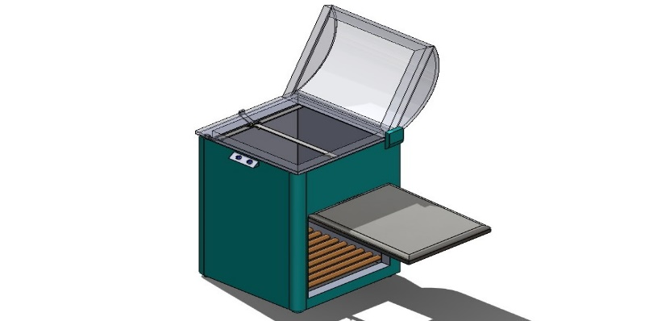
Conveyor Mechanism to remove the trash out of bin automatic
Ultrasonic Sensor
Fig No. 1 (Design of Model)
Servo motor Mechanism to open the lid
Heating Mechanism for sealing the bag

This project show that the lid will be opened automatically just by the hand movement which will be captured by the ultrasonic sensor from the center opening garbage will be disposed once the garbage bag is filled with trash then just by pressing a button garbage bag will be sealed automatically by the sliding bed where heating element is attached over on. Lead screw mechanism will help to move sliding bed coming at a point and then with thermoplastic technology the plastic bag will be sealed after this process a small blade will approach towards bag for cutting and separating the filled trash bag. Below conveyer belt is present which will deal in eliminating the garbage bag. In the refill can bunch of plastic bag is accommodated when we keep on putting garbage the new bag will automatically come down by the weight of garbage.
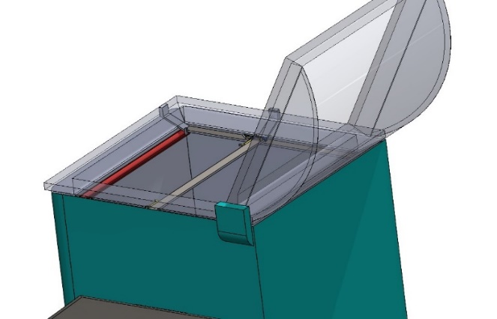
Heating Mechanism for Sealing the Bag
Fig No. 2 (Sliding Mechanism)

This Sliders will be moved by servo motor and lead screw mechanism and the heating element made of chromium alloy will be placed on sliders and Teflon cloth above nichrome wire to ensure plastic don’t stick. After sliders coming together the bag will be sealed by heating mechanism.

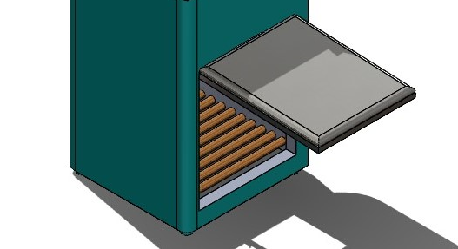
Conveying Mechanism to remove the trash out of bin
Fig No. 3 (Conveyer Belt)

Conveyer belt is present beneath the trash bag which will deal in eliminating the garbage bag.

RESULTS
The success of a self-changing and self-sealing garbage bag dustbin hinges on effective marketing, technological reliability, and addressing cost concerns. As the market evolves, consumer education and customization become critical factors, and manufacturers must stay attentive to user feedback and regulatory compliance. It can be widely used in medical field to avoid directly contact with the medical waste

CONCLUSION
The design and development of the self-changing and self-sealing garbage bag dustbin represent a significant advancement in waste management, particularly within the medical field.
This innovative solution offers several key benefits:
- Hygiene and Sanitation
- Efficiency and Convenience
- Cost Savings
- Environmental Impact
Overall, the self-changing and self-sealing garbage bag dustbin is a valuable addition to the medical field, enhancing both the operational efficiency and the safety of healthcare environments. Its potential for widespread adoption promises to improve waste management practices and positively impact patient care.

References
- Mamta Pandey , Anamika Gowala, MrinalJyoti Goswami, Chinmoy Saikia, “Smart Dustbin Using Arduino”, August 2020.
- Miss Kazi J.Y, Mr. Patil N.R, Mr. Jadhav C.P, Mr. Dawankar S.R, “Design and manufacturing of semi-automatic PVC sealing machine”, Oct 2017.

- Muhammad Ahmad Baballe, Mukhtar Ibrahim Bello, Abubakar Abdullahi Umar, “Different Types of Servo Motors and Their Applications”, May 2022
- Marco Parvis, Alessio Carullo, “Ultrasonic Sensor for Distance Measurement”, September 2001.
- Ivan Virgala, Michal Kelemen, Alexander Gmiterko, Tomáš Lipták. “Control of Stepper Motor by Microcontroller”, March 2019.
- Shivam Agrawal, Siddharth Patil, Associate Professor Ms.Sneha Shirke, “Lead Screw Mechanical Lifting Mechanism”, June 2022.
- Fady E. F. Samann, “The Design and Implementation of Smart Trash Bin”, August 217.
- Pardeep Kumar, Amit Kumar “Time dependent performance analysis of a Smart Trash bin using state-based Markov model and Reliability approach”, 2023.
- Soumyabrata Sahaa,⁎, Rituparna Chakib, “IoT based smart waste management system in aspect of COVID-19”, 2023.
- M. Karthik , L. Sreevidya , R. Nithya Devi , M. Thangaraj , G. Hemalatha , R. Yamini, “ An efficient waste management technique with IoT based smart garbage system”, July 2021

