Home Automation Using Arduino

Sushant Ninawe¹, Vipin khobragade², Aniket Yarwar³, Mangesh Thakre⁴, Akshay Gajhbhiye⁵,
Prof. H P.Thakre⁶,Prof. V S.Nandanwar⁷

⁶⁻⁷Professor, ¹⁻⁵Students,
Dept. of Electrical Engineering, Priyadarshini College of Engineering, Nagpur -440019

Abstract- Automatic system achieved great popularity in last few decades. Which are being preferred over manual system. Where manual system fails to provide the efficient solution. Automation greatly decreases the need of human sensory and mental requirement. This paper presents the flexible and low cost automation of home system using microcontroller and Bluetooth module through this project we have shown the control of house appliances as result of which power is saved to some extent. Nowadays, Most home automation system consist of wireless communication system such as Via-Bluetooth, wifi, GSM etc.
Keywords— Power supply unit, Arduino, Zero crossing detector, Sensors, Relay Driver, Bluetooth module, LCD display.
I-INTRODUCTION
The term home automation defines an automation of home appliances and amenities. I.e. home appliances are working on their own without any human’s interference with proper commands and settings given to them. And by doing so we are one step ahead to save and conserves a bit of electrical energy. It elaborates tasks by integrating devices and gadgets inside and outside the home, buildings, complexes etc. Presently for home automation we are using computer oriented programs , software’s , Bluetooth module, voice commands and obviously most important our smart phones . In future all this things can be replaced by single technology and well known as Artificial Intelligence (AI).
- Power Source:
The initial stage of any electronic circuit is source of power. This is necessary to drives the various components of circuit. Which is able to provide various characteristics required by circuit without any fluctuation As all electronic component of circuit required the DC supply hence it is necessary to constant DC supply from available A.C. Source.

Figure (1): Block diagram of power source unit

Transformer:
Transformer is step down type which steps down the voltage level from 230V to 12V. Whose output is given to the next component i.e. Rectifier.
Rectifier:
Rectifier circuit is used to convert available 12V A.C. from transformer into a 12V D.C. for the electronics components in the circuit.
Filter:
After rectification it is necessary to remove ripples from the output of the rectifier to avoid heating of components causes’ noise and distortion.
Regulator:
Regulation is a last stage comes in supply unit which makes the output of the filter more stable. It gives the constant supply to circuit. We used 7812 & 7805 for 12V and 5V constant voltage.
1. Arduino:
Arduino is an electronics an open-source platform easy-to-use hardware and software. Arduino Uno is a microcontroller board provides very inbuilt features based on the ATmega328P.The Arduino uno Rev3 provide best solution as a computer. It has 14 digital input/output pins of which 6 can be provide PWM outputs, 6 analog inputs, a 16 MHz crystal oscillator, a USB connection, a power jack, an ICSP header, and a reset button.

Arduino uno has following feature:

- Microcontroller: ATmega328
- Operating Voltage: 5V
- Input Voltage (limits): 6-20V
- Input Voltage (recommended): 7-12V
- Digital I/O Pins: 14 (of which 6 provide PWM output)
- Analog Input Pins: 6
- DC Current for 3.3V Pin: 50 mA
- DC Current per I/O Pin: 40 mA
- Flash Memory: 32 KB of which 0.5 KB used by boot loader
- SRAM: 2 KB (ATmega328)
- EEPROM: 1 KB (ATmega328)
- Clock Speed: 16 MHz

Fig (2): Microcontroller Atmega 328P

Arduino is used to take input from various sensors and to provide different output which has been pre programmed.

Pin configuration of Atmega 328P:

Fig (3): Pin configuration of Atmega328P

3. Sensors:

(1) LM35:
LM35 is a type temperature sensor in which if the voltage increases then the temperature rises and there is voltage drop between the transistor terminals of base & emitter. Difference in voltage between terminals is amplified which is directly proportional to the temperature. Means it is linearly varies with the output voltage.
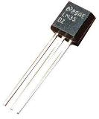
Fig (4) LM35 temperature sensor

Features:
- Calibrated directly in degree Celsius(centigrade)
- Linear +10.0mV/°C Scale factor
- Rated for full -55° to +150°C Range
- Operates for 4-30V
- Less than 60µA current drain
- Low self-heating,0.08°C
- Low impedance output, 0.1ohm for 1mA load

(2) LDR(light dependent resistor):

In order to detect the intensity of light or darkness, we use a sensor called an LDR. The LDR gives out an analog voltage when connected to VCC (5V), which varies in magnitude in direct proportion to the input light intensity on it. That is, the greater the intensity of light, the greater the corresponding voltage from the LDR will be. Since the LDR gives out an analog voltage, it is connected to the analog input pin on the Arduino. The Arduino, with its built-in ADC (analog-to-digital converter), then converts the analog voltage (from 0-5V) into a digital value in the range of (0-1023).
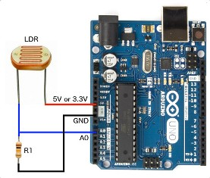
Fig (5): LDR interface with arduino

(3) Current Sensor module (ACS712):
It is type of sensor which senses the current and works on the principle of Hall Effect. which was discovered by Edwin Hall in 1879 and its states that whenever there is voltage across an electrical conductor there is transverse to an current and applied magnetic field perpendicular to the that current. Current sensor detects current in a wire or network and generates a signal which is proportional to the current flowing through the network. Signal could be analog or digital.

Specification:

Supply Voltage | 5 volt
Measuring current | 20Amp
Output type | analog
Internal conductor resistance | 1.2 m
Response time | 5 µsec
Operating Temperature Range | -40°C to +85°C
No. of Pins | 8
Bandwidth | 80KHz
Sensitivity | 66 to 185mV/A
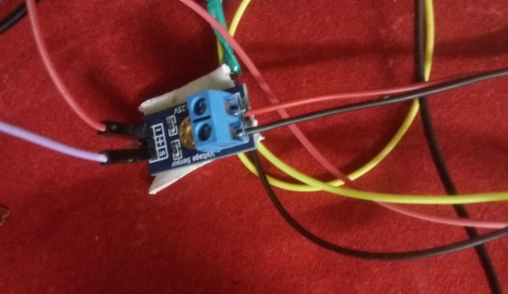

Fig (6): Current Sensor ACS712

4. Relay:

It is like electromagnetic switch which is to switch the low voltage and high current circuitry (i.e. lights, fans, relays and other electrical parameters).These are used for switching the load to respond the signal fed by Arduino commanded by Bluetooth module
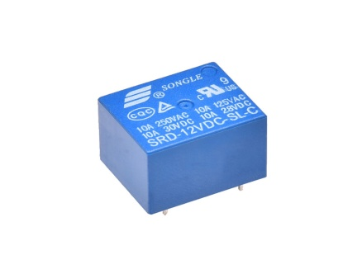

Fig (7): SPDT Relay

Features:

- 12V DC Relay coil
- Rated up to 7A at 240V

5. Bluetooth Module:
The HC-06 will work with supply voltage of 3.6VDC to 6V DC; however, the logic level of RXD pin is 3.3V and is not 5V tolerant. All data received through the serial input is immediately transmitted over the air. When the module receives wireless data, it is sent out through the serial interface exactly at it is received. It has one LED, Which shows its state. If it is blinking that means it is not connected. If it is staying in glowing condition that means it is connected. There is a pin STATE that is connected to this state LED.
Features:
- Profiles: Bluetooth serial port Profile
- Frequency: 2.4GHz ISM band
- Sensitivity: ≤-84dBm at 0.1% BER
- Speed: Asynchronous: 2.1Mbps(Max) / 160
Kbps, Synchronous: 1Mbps/1Mbps
- Security: Authentication and encryption
- Power supply: +3.3VDC 50mA
- Working temperature: -20 ~ +75Centigrad

Fig (8): Bluetooth module

6. LCD Display (16X2):
16x2 LCD display is an alphanumeric display. It is based on the HD44780 display controller, and ready to interface with most microcontrollers. It works on 5V and has a Green Backlight which can be switched on and off as desired. The contrast of the screen can also be controlled by varying the voltage at the contrast control pin (Pin 3)
Features:
- Operating Voltage is 4.7V to 5.3V
- Current consumption is 1mA without backlight
- Alphanumeric LCD display module, meaning can display alphabets and numbers
- Consists of two rows and each row can print 16 characters.
- Each character is build by a 5×8 pixel box
- Can work on both 8-bit and 4-bit mode
- It can also display any custom generated characters

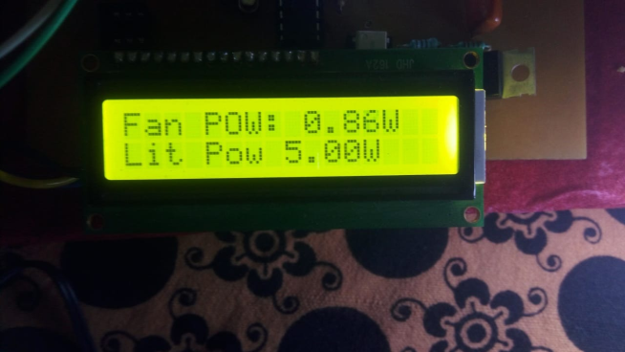
Fig (9): LCD Display

III. Methodology

- overview:
The home sytem is made automated by arduino based control system in which power unit supply the constant 5V DC supply to Ardino, other controlling component and load which gives the desired output in order to regulate it. The aurdino receive the anolog input from sensors (LM35,LDR)on it ADC pin .the Arduino is programmed .the program which burned inside the Atmega328P execute,which produce the signal to power controlling components & regulates the intensity of lamp and speed of the fan.according to values of power output to load that will produce acoording to surrounding conditions.

Fig(10) Block Diagram of Home Automation system
- Test result
According to intensity of light in room LDR gives output to the Arduino which is programmed to produced different power output for lamp and control it intensity.
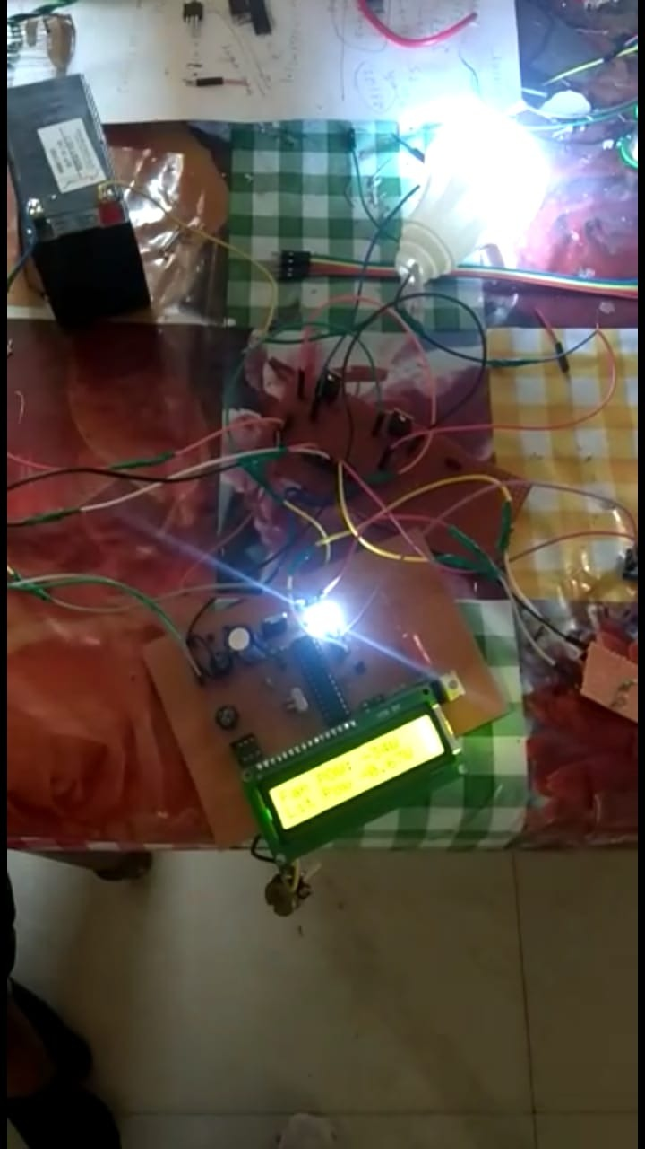
Fig(1):lamp ON

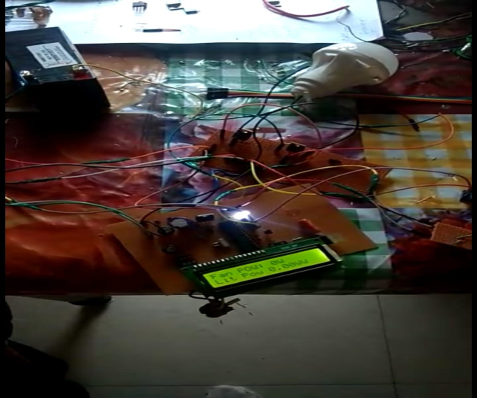
Fig(2): lamp off
- LM35 detect the temperature in room and provide signal to Arduino which regulate the speed of fan.
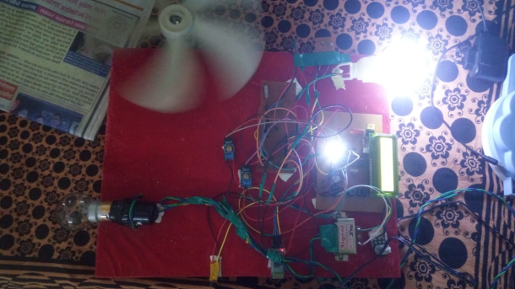
fig(3):Regulation of Fan

Sr.No. | Load | Sensors used | Input To Sensors | Variation of Parameters | Power to load
1 | Lamp | LDR | Intensity of Light | Increase/decrease | decrease /Increase
2 | Fan | LM35 | Temp. in Room | Increase/decrease | Increase/decrease
IV. Conclusion and future scope
It can be concluded that Home Automation System using Arduino has been successfully designed and prototyped. This system consists of an Arduino Uno board, a Bluetooth Module, an Android phone, home appliances and an android Application. Bluetooth (HC-06) Based Smart Home Automation System was presented in this paper. The system. PWM technique is used to control the DC motor speed, and H-Bridge driver circuit is used to control the direction of the motor. Also the system is used to control switching ON/OFF the bulb, fan and heater using a smart phone application. It is providing easy control the home appliances; it is helping the people who have locomotion difficulty. Moreover, implementation of wireless Bluetooth connection gives a simple way of system installation.

REFERENCE
[1]. Ajah, G, David, N, Abioye, A, Web Based Security System, Sch. J. Eng. Tech, 1(3):112-116, 2013.

[2]. Mahmood, S M, Abdulsattar, M, Firas, A Y; Home Automation Management with WLAN (802.11g) and RF Remote Control, Raf. J. of Comp. & Math’s, 6(1), 2009.

[3]. Aru O E ,Ihekweaba G, Opara F K, Design Exploration of a Microcontroller Based RF Remote Control 13amps Wall Socket, IOSR-JCE, 11(1), 56-60, 2013.

[4]. David, N, Design of an Internet Based Security System, NIJOTECH, 29(2) 118-129, 2010.

[5] A.A.Nippun Kumaar, Kiran.G, Sudarshan TSB,” Intelligent Lighting System Using Wireless Sensor Networks”, International Journal of Ad hoc, Sensor & Ubiquitous Computing (IJASUC) Vol.1, No.4, December 2010, pp 17-27

[6] Y. K. Tan; T. P. Huynh; Z. Wang,” Smart Personal Sensor Network Control for Energy Saving in DC Grid Powered LED Lighting System”, IEEE Trans. Smart Grid
[7] O’Reilly, Fergus, and Joe Buckley. "Use of wireless sensor networks for fluorescent lighting control with daylight substitution." Proceedings of the Workshop on Real-World Wireless Sensor Networks (REANWSN). 2005.

[8] Divya, Guddeti, et al. "Design and Implement of Wireless Sensor Street Light Control and Monitoring Strategy along with GUI." IJITR (2016): 78-81.

[9] Prasetyo, William Tandy, Petrus Santoso, and Resmana Lim. "Adaptive Cars Headlamps System with Image Processing and Lighting Angle Control." Proceedings of Second International Conference on Electrical Systems, Technology and Information 2015(ICESTI 2015). Springer Singapore, 2016.

[10] Qi, Liang, MengChu Zhou, and WenJing Luan. "Emergency Traffic-Light Control System Design for Intersections Subject to Accidents." (2016).

[11] Huynh, T. P., Y. K. Tan, and K. J. Tseng. "Energy-aware wireless sensor network with ambient intelligence for smart LED Lighting system control." IECON 2011-37th Annual Conference on IEEE Industrial Electronics Society. IEEE, 2011.

