SAFE ROUTE FINDER : A WEB APP TO NAVIGATE SAFELY
Roshni Alladwar, Vaishnavi Otekar, Naina Chahare, Shrija Bongirwar, Prof. P.V. Bhagat
UG Engineering Students, Assistant Professor
Department of Computer Engineering, St. Vincent Pallotti College of Engineering and Technology, Nagpur India, 441108

Corresponding Author email-roshnialladwar@gmail.com

Abstract- Many types of crime exist in major cities of developing countries. For example, the most serious crimes in Surabaya, Indonesia, are the 3Cs, which are robbery (curas), aggravated robbery (curat), and car theft (curanmor). 3C usually occurs on highways and residential areas. For this reason, people new to the region should be careful about such crimes. Path planning systems or routing systems such as Google Maps only consider the shortest distance when calculating the best route. In this study, choosing the best route not only determines the shortest route but also includes other factors such as safety level. This study identified the need for an app that would show travelers the safest way to travel in an area. This project offers Be-Safe Travel, a web-based application using Google APIs, accessible to people who enjoy driving in certain areas but do not yet know how to stay away from violence. Safe travel is not only beneficial for new immigrants, but also helps exporters of valuable goods choose the safest route.
Keywords: Crime prediction, machine learning algorithm, navigation application, security, risk assessment.
I-INTRODUCTION
The increased crime rate in the city has led to concerns about personal safety and security. Even everyday activities like using navigation apps like Google Maps while traveling can expose people to life-threatening and dangerous situations. Due to security concerns, many people, especially women, choose other methods rather than relying on the recommended navigation app. While local residents are familiar with the city's road safety, newcomers or visitors often rely on drivers or spend a lot of time researching road safety in various places. Solving this urgent problem requires a better and more efficient solution. The need for solutions that can advise on road safety and provide travellers with a sense of security has become urgent.
Local authorities regularly collect and update information on crime, accidents and roads; This is very useful in solving security problems. In this study, Nagpur comes into focus due to its status as an important city.
Analysis of crime data from 2010 to 2019 shows that Nagpur's crime rate is 8% higher than the Maharashtra average but still lower than the rest of the country. 20% lower than the national average. In terms of crime, Nagpur's crime rate is 45% higher than the state average and 35% higher than the national average. Compared to the national average, Nagpur's overall crime rate is 70% for non-violent crimes and 30% for non-violent crimes.
The study used arrest and incident data from the Nagpur Open Data Platform, which is maintained and updated by various local organizations and partners. The platform supports more accurate predictions as the data is updated several times a day.
The solution depends on many factors. The first involves the use of crime and accident data and takes into account places and distance between places to predict safer routes. The second involves dividing Nagpur into smaller risk areas using a clustering method, thus improving forecast accuracy by covering smaller areas. Finally, the solution also calculates the risk score of the road based on the risk score of neighbouring clusters, resulting in a comprehensive assessment of the security level of the entire city.
II-LITERATURE REVIEW

New data confirm that urban problems in developing countries face high crime and other crises [1]. Doxiadis [2] criticizes the security problems in big cities and believes that rural areas are safer than cities. Additionally, population growth in major cities increases travel, transportation and living costs. This situation reduces the quality of services offered by cities and creates serious problems in regional inequality.

The cost of living in big cities is generally higher than in rural areas or small towns, so the same money will provide less in terms of goods and services. It is also widely accepted that large cities are places where crime and physical danger are greater. According to statistics, with the expansion of cities, the number of theft and illegal transportation also increases [4].

Planning is the task of arriving at the best path to the goal. Path planning is a method that shows the right path by considering one or more specific factors. Available route planning applications include Google Maps, but this application only determines the shortest route.

So there is another thing to consider, and that is security. This problem is called the security routing problem. One of the main reasons for the increase in burglary or theft crimes is the failure to analyze security issues during planning [5]. The study warns that it is generally recommended to carefully plan cash transfers to reduce the risk of theft.

In [6] risk is defined as three important factors: (a) the probability of an event (expressed as the probability or frequency of some adverse event); (b) sensitivity, risk assessment The sensitivity of the product to adverse events; (c) Exposure risk is the weighted cost of affected persons, products and processes during and after the event.

A lot of research has been done to solve this problem. In [7], L. Talarico proposed a route selection method that takes into account the risk of theft during travel. Some of the decisions in this study are the amount of money, time and distance, and predetermined (predefined) risk limits. In addition, many methods can be created to reduce the risks of the road, which are safe but still take into account economy or costs [8]. The mathematical min-max map and the maximum similarity between solutions and the number of ARPs that need to be created for different solutions are requested.

The safe path here refers to the path without criminal history. This study set out to determine whether there was a need for an app that would provide advice on the safest route for pedestrians when passing through an area. This work presents Be-Safe Travel, a web-based application using Google APIs that can be accessed by people who like to drive in a particular area but do not yet know how to travel away from violence. Be-Safe Travel is beneficial not only for newcomers but also for exporters of valuable goods to travel using the safest route.

IV-PROPOSED MODEL
The information that the Be-Safe Travel application needs is the location of the crime and the type of crime. The keywords in the Be-Safe Travel application database were created using MySQL. The required table name is WAYPOINTS as shown in Table 1. There are 5 characters in this table, id is the primary key of each file, name is the address name, latitudes indicate the latitude and longitude of the actual location of the file. crime, criminal type is the type of the crime and the last element is the description containing the description of the crime type. Information in the WAYPOINTS table may be changed or supplemented by new crime reports in the area. In this study, we use crime data of Surabaya city as research. Table 2 provides an example of recording data in the Waypoints table.
WAYPOINTS
id (int)
area_name (varchar)
Latlongs (varchar)
criminal_type (varchar)
Description (varchar)
Table 1- The required Table for the crime data
WAYPOINTS
id | 5
area_name | Nginden Semolo
latlongs | -7.299499,112.762973
criminal_type | Crashing Mirror and Opening Door Crime
description | The criminal often crash the car’s window to steal valuable goods. Another crime was when waiting for traffic lights the criminal begin an action with approached the car and opened the door by compulsion. The criminal put a weapon and threatened the victim to provide valuable goods.
Table 2- Obtained data format

V-METHODOLOGY
To solve the problem of determining safe routes for urban pedestrians, a method for calculating and displaying routes based on factors such as distance, slope hazards and user preferences has been developed. This method uses the Google Maps Directions API and proprietary algorithms to determine the best route for the user.
The first step in this method involves using the "calculate And Display Route" function to start the route calculation and display. This function takes the start and end of the trip as parameters and creates a request object containing the start, destination, and type of the trip (in this case, driving).
After receiving the response from the Directions API, the function returns all routes and determines the shortest path based on all trips. The shortest path is highlighted in blue to indicate that it takes precedence over the best path. This is done by calculating the total distance of each route and comparing them to find the shortest route.
Additionally, roads are classified as safe or potentially dangerous according to established criteria. Safe roads are highlighted in green, while high crime crossings or other dangerous areas are highlighted in red. This classification is based on external data sources that provide information about crime and other security-related issues.
In addition, the most dangerous points on the road are determined and marked with red symbols on the map. These points are determined by comparing the hazard area data with the road with the highest hazard. The function uses the 'google.maps.geometry.poly.isLocationOnEdge' method to check whether each event is within the boundary path. If a dangerous area is found on the road, it will be marked on the map to warn the user of the potential danger of that road. This ensures that users are presented with a variety of options so they can choose the path that best suits their security preferences and risks. It also gives users an overview of the safety level of different roads, helping them make informed decisions when traveling.
Overall, this approach combines data-driven analysis with user-friendly design to provide planning solutions for urban environments, including a focus on safety and security.
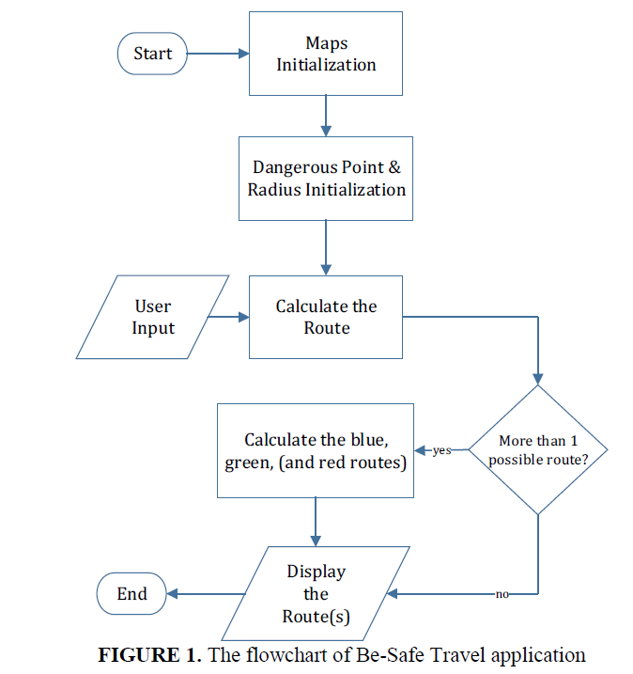
This method involves several important steps:
1. Data collection: Crash and arrest data from North Carolina Open Records, which provides information about crashes and crimes in the city.
2. Launch Google Maps API: Launch and configure the Google Maps API for more functionality.
3. File upload: Upload the incident and capture data from NC Open Data to stay up to date on incidents and breaches.
4. Preliminary data: Preliminary data includes cleaning records, removing missing values, storing outputs, preparing data for analysis and processing model, and filtering dangerous contents.
5. Determine the safest route: Determine the safest route according to the route where the most dangerous points are located. If multiple paths have the least risk, the path with the shortest path is the safest path.
VI-RESULTS
There are up to 3 ways to show your presence at Be-Safe Travel. The road is in different colors: blue, green and red. Dangerous spots or crime hotspots and their radii are marked with red circles. The first route is marked in blue, meaning it passes through the least dangerous points compared to the other routes. The green route is the second recommended route, while the red route is the most cautious among the others.
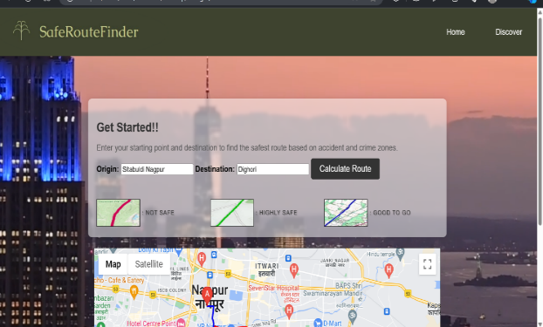Fig.2 Discover page
If more than one path passes through the same number of dangerous points, the path to the destination will be ranked as the shortest path. If there is only one possible path, the path is marked as a blue path; if there are two possible paths, the path shown has two blue and green paths. The red road will show how we can go. Images 1 to 2 are screenshots of the Be-Safe Travel web-based application. Figure 2 shows the Explore page of the website. The most interesting thing here are the two text boxes at the top for user input and the large map on the right. When the user wants to travel somewhere, he writes the starting point and destination in the relevant text. Figures 1 and 2 show an example of the Be-Safe Travel system, where the starting point is labeled A and the destination is labeled B. The red circle is the danger area and its radius. Large white boxes contain directions giving directions in blue, green or red. Figure 2 shows 3 suggested routes; the safest route is marked in blue and the second most recommended route is marked in green. As shown in Map 2, the blue route passes through many dangerous points, while the green route passes through two dangerous points. These conditions are described in the method proposed above. Figure 2 shows three routes and recommendations for safe travel along these three routes. As seen in Figure 2, the blue route passes through the least dangerous points compared to other routes. The green route passes two danger points, less than the red route, which passes three danger points.
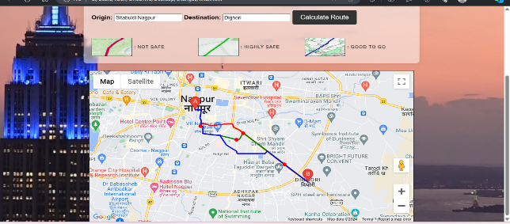
Fig.3 Route Display
The blue route must pass through the least crime hotspots compared to the green and red routes which must pass through the least crime hotspots. The red road has to pass through the most dangerous points compared to other roads. Be-Safe Travel app has been providing accurate results to various bases and locations in Nagpur region so far.
VII-CONCLUSION
In this article, we present the Be-Safe Travel application that can recommend the safest route to those who want to travel in unknown regions. This web-based geography application uses Google API technology together with a PHP hypertext preprocessor and a MySQL database. The city of Nagpur and the scene of the crime were used as a case study to gauge the credibility of Be-Safe Travel. Google API's contract is the shortest, while our implementation modifies these contracts to take security into account. Safe road here means that the first approved road passes where crime is the least. Additionally, Be-Safe Travel can recommend and sort 3 different color schemes to choose the security level. Be-Safe Travel is useful for those new to the region or those carrying valuable items to choose the safest route. This could be done in the future by working with a license to add crime data from major cities. Another next step is to create an Android version of the space application to provide easy access to passengers.
REFERENCES

- Abou-Korin, “Small-size urban settlements: Proposed approach for managing urban future in developing countries of increasing technological capabilities, the case of Egypt,” Ain Shams Eng. J., vol. 5, no. 2, pp. 377–390, 2014.
- D. Constantinos, “The role of small cities, A lecture delivered at the sixty-fifth annual commencement ceremony of Northern Michigan University.” 1965.
- V. Henderson, “How urban concentration affects economic growth. World Bank – Country Economics
- Department in its series ‘“Papers”’ with number 2326,” 2000.
- Fischer, The Urban Experience. New York: Harcourt Brace, Jovanovich, 1988.
- L. Smith and E. Louis, “Cash in transit armed robbery in Australia,” Aust. Inst. Criminal., no. 397, 2010.
- F. Russo and C. Rindone, “Planning in road evacuation: classification of exogenous activities,” Urban Transp. vol. 116, pp. 639–651, 2011.
- L. Talarico, K. Sörensen, and J. Springael, “Metaheuristics for the risk-constrained cash-in-transit vehicle routing problem,” Eur. J. Oper. Res., vol. 244, no. 2, pp. 457–470, 2015.
- L. Talarico, K. Sörensen, and J. Springael, “The k-dissimilar vehicle routing problem,” Eur. J. Oper. Res., vol. 244, no. 1, pp. 129–140, 2015.
- F. S. Tsai, “Web-based geographic search engine for location-aware search in Singapore,” Expert Syst. Appl.,vol. 38, no. 1, pp. 1011–1016, 2011.10.
- R. W. Sinnott, “Virtues of the Haversine,” Virtues of the Haversine. Sky and Telescope, vol. 68, no. 2. p. 159,1984.
- Pyle, D., 1999. Data Preparation for Data Mining. Morgan Kaufmann Publishers, Los Altos,California.
- J. B. MacQueen (1967): "Some Methods for classification and Analysis of Multivariate Observations, Proceedings of 5-th Berkeley Symposium on Mathematical Statistics and Probability", Berkeley,University of California Press, 1:281-297
- Esther Galbrun, Konstantinos Pelechrinis, and Evimaria Terzi. 2016. Urban Navigation Beyond Shortest Route. Inf. Syst. 57, C (April 2016), 160–171
- Felix Mata, Miguel Torres-Ruiz, and Giovanni Guzman. 2016. A Mobile Information System Based on Crowd-[Sensed Crime Data for Finding Safe Routes: A Case Study of Mexico City. Mobile Information Systems 2016, Article 8068209 (2016).
- Wright, Sewall. (1921): Correlation and causation. Journal of Agricultural Research 20: 557-585.
- Shankar, V. G., Jangid, M., Devi, B., Kabra, S. (2018). Mobile big data: Malware and its analysis. In Proceedings of First International Conference on SmartSystem, Innovations and Computing. Smart Innovation, Systems and Technologies (Vol. 79, pp. 831–842). Singapore: Springer https://doi.org/10.1007/978-981-10-5828-8_79.
- Shankar, V. G., Devi, B., & Srivastava, S. DataSpeak: Data extraction, aggregation, and classification using big data novel algorithm. In B. Iyer, S. Nalbalwar, & N. Pathak (Eds.), Computing, communication and signal processing. Advances in intelligent systems and computing (Vol. 810). Singapore: Springer. https://doi.org/10.1007/978-981-13-1513-8_16.
- Devi, B., Kumar, S., & Anuradha, S. V. G. (2019). AnaData: A novel approach for data analytics using random forest tree and SVM. In B. Iyer, S. Nalbalwar, & N. Pathak (Eds.), Computing, communication and signal processing. Advances in intelligent systems and computing (Vol. 810). Singapore: Springer.
- Devi B., Shankar V.G., Srivastava S., Srivastava D.K. (2020) AnaBus: A Proposed Sampling Retrieval Model for Business and Historical Data Analytics. In: Sharma N., Chakrabarti A., Balas V. (eds) Data Management, Analytics and Innovation. Advances in Intelligent Systems and Computing, vol 1016. Springer, Singapore.
- Goel V., Jangir V., Shankar V.G. (2020) DataCan: Robust Approach for Genome Cancer Data Analysis. In: Sharma N., Chakrabarti A., Balas V. (eds) Data Management, Analytics and Innovation. Advances in Intelligent Systems and Computing, vol 1016. Springer, Singapore.

