Design and Implementation of Smart Bike Helmet

Prof. Nishat Faizee
Electronics and Telecommunication.
St. Vincent Pallotti College of Engineering
and Technology Nagpur, India nfaizee@stvincentngp.edu.in

Ms. Prachi Adyalkar
(8th Sem, Sec B, Roll no.15)
St. Vincent Pallotti College of Engineering and Technology, Nagpur, India
adyalkarprachi@gmail.com

Mr. Devesh Parate
(8th Sem, Sec B, Roll no.38)
St. Vincent Pallotti College of Engineering and Technology, Nagpur, India
deveshparatedp1150@gmail.com

Mr. Kshitij Meshram
(8th Sem, Sec B, Roll no.46)
St. Vincent Pallotti College of Engineering and Technology, Nagpur, India
kshitijmeshram31@gmail.com

Ms. Bhavna Balpande
(8th Sem, Sec B, Roll no.04)
St. Vincent Pallotti College of Engineering and Technology, Nagpur, India
balpandebhavna@gmail.com

Mr. Aman Koli
(8th Sem, Sec B, Roll no.32)
St. Vincent Pallotti College of Engineering and Technology, Nagpur, India.
Aman818koli@gmail.com

Abstract— "Design and Implementation of Smart Bike Helmet" is an innovative wearable technology to increase passenger safety and comfort. It creates an essential passenger communication system by integrating a real-time IR engine sensor, a lean angle sensor, an alcohol sensor, a voice warning system and an accident sensor using an accelerometer. Proactively address engine overheating issues with early alerts while monitoring the angle to ensure safety. This will ensure the safety of the rider and also provide various functions such as notifying the family of an accident and notifying the nearest ambulance in the area, giving a voice warning about the lean angle when the bike turns towards you and giving an alert. provide Zigbee pairing to get voice command from Google map for next turn. The helmet integrates Zigbee for seamless connection to a smartphone with Google Maps. This allows the rider to relay turn-by-turn navigation instructions in real time via a bone conduction speaker or haptic feedback system, minimizing distractions and keeping focus on the road.
Sensors can detect various environmental factors and rider behavior, such as ambient light, sleepiness and potential accidents.
This integration of navigation and safety features creates a comprehensive system that enhances the rider experience and promotes road safety.

INTRODUCTION
As part of the development of safety systems, we designed a smart helmet with many functions, which became an important replacement for the old helmet model. We must be aware of the need for safety measures when riding a motorcycle, that's why we developed a smart helmet. This project will be aimed at improving the safety and comfort of passengers by making the journey more pleasant. The smart helmet aims to change the motorcycle's safety parameters by measuring engine temperature, measuring lean angle, using a voice warning system and detecting an accident using a gyroscope. Motorcycles, mostly known for their ride and efficiency, also face challenges when it comes to safety measures.
The motive behind the project is to make motorcycle riding safe by focusing on various parameters such as the temperature of the engine while riding and the voice warning of the extra lean angle. The addition of accident detection technology adds another level of safety by quickly detecting and sending messages to ambulances and family or connecting a family member directly to the helmet. As motorcycles have become a key form of transportation worldwide, the smart helmet has become an icon of innovation and the hope of reducing risk. This becomes the stage for a detailed review of individual products, features and the overall impact this smart helmet aims to overcome for the motorcycle community. The design of the smart helmet has become an important work in redesigning the old helmet model. We need to be aware of the risks that come with riding a motorcycle, that's why we developed the Smart Helmet. This new project aims to improve rider safety and comfort by combining cutting-edge technology and features. Riders navigate in a variety of ways, with handlebar-mounted smartphones being a popular choice. However, this practice creates a dilemma: the convenience of real-time navigation comes at the expense of safety, as looking down at your phone can take crucial attention away from the road. Additionally, traditional helmets, while essential for safety, lack features that could further increase rider awareness and protection. This paper proposes a revolutionary solution – a smart helmet. This innovative design harnesses power to create a comprehensive system that prioritizes both rider safety and navigation. The helmet integrates seamlessly with a smartphone running Google Maps via Zigbee, allowing detailed real-time navigation instructions to be delivered directly to the rider. This eliminates the need for a mounted phone, minimizing distractions and allowing riders to focus on the road ahead.

LITERATURE SURVEY
A) Bindu Sebastian Priyanka Kp, Hridhya Kuttikrishanan, “Smart Helmet” International Journal of Technology & Advanced Engineering, Volume5, Issue:12, December 2015.

This review paper provides an overview of IoT-based smart helmets with a focus on accident detection. It discusses the various sensors and communication technologies used in smart helmets and evaluates their effectiveness.
B)Professor Chitte P.P., Salunke Akshay S., Thorat Aniruddha, N Bhosale, “Smart Helmet & Intelligent Bike System”, International Research Journal of Engineering and Technology (IRJET) Volume: 03 Issue: 05, May 2016.
This research presents a smart helmet equipped with accelerometers and GPS for accident detection and reporting. The system uses IoT to send real-time alerts to emergency contacts.
C) Jianyun Ni; Jing Luo; "Innovation in Microcontroller-Based Engineering Education", Educational and Information Technology (ICEIT), International Conference 2010, Vol.3, No., pp. V3-109-V3-112, 17-19. September 2010.
Focusing on motorcycle safety, this study presents a smart helmet with an accident detection system. It uses IoT technology for immediate accident notification and coordination with emergency services.
D) S. Chandran, S. Chandrashekhar, E. Elizabeth N, “Konnect: An Internet of Things (IoT)-based Smart Helmet for Accident Detection and Notification”, In India Conference (INDICON), 2016 IEEE Annual.
Focused on the construction industry, this study presents a smart helmet with IoT integration. It includes features such as fall detection and emergency alerts that increase the safety of construction workers.

PROPOSED METHOD
The hardware components used in our smart bike helmet play a key role in its functionality and efficiency.
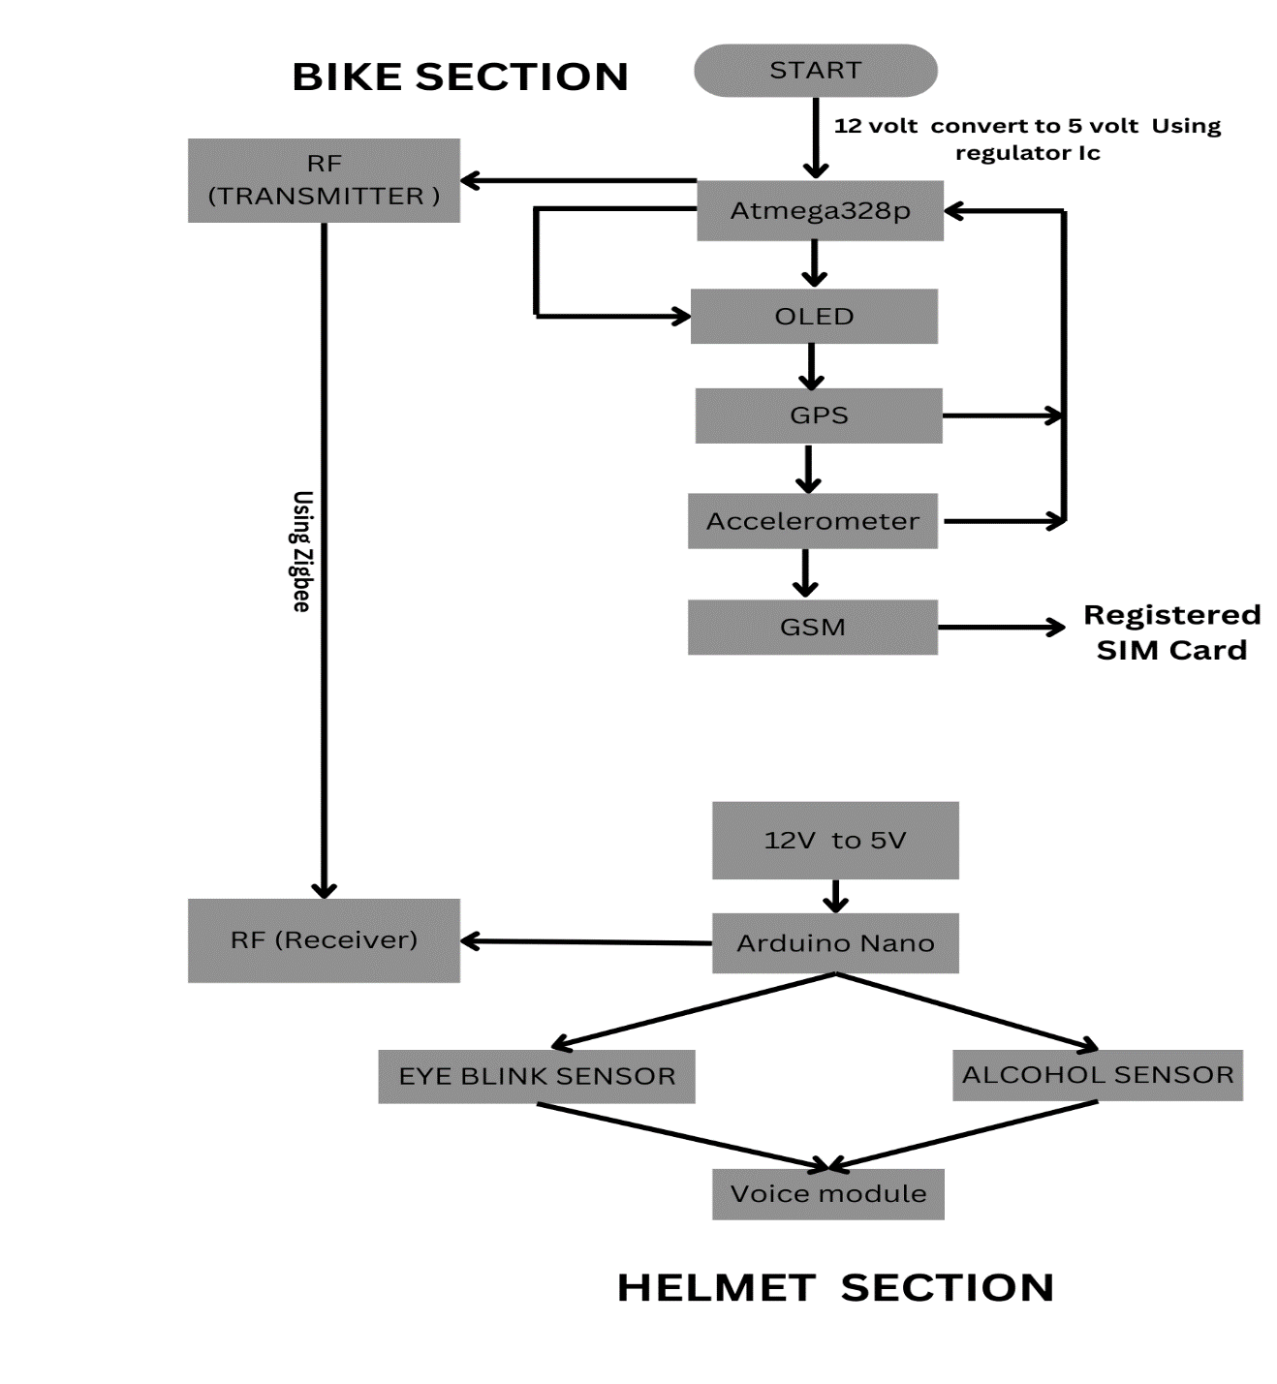
Fig 1. Flow chart
Below, we provide detailed information about the specific components integrated into our system:

The main section of the project:

Receiver Section (On Helmet): This section will receive the signal from the bike section and pass it to the microcontroller for processing, here the microcontroller decides whether the ignition should be turned off or on using the ignition control relay unit. The LCD here will also display what is happening in the project.

1.Arduino Nano:
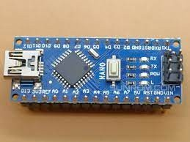
The Arduino Nano processes the data from the alcohol sensor and the eye blink sensor in real time. It analyzes sensor inputs to determine the rider's condition, such as level of intoxication or drowsiness. An eye blink sensor detects signs of sleepiness, the Arduino Nano triggers alerts to ensure the rider stays alert. The Arduino Nano controls the voice module and emits audible warnings. and rider notices. For example, if the alcohol sensor detects the presence of alcohol, the Arduino Nano can instruct the voice module to warn the driver about driving under the influence.
Fig 2. Arduino Nano

2.Alcohol Sensor:
An alcohol sensor typically works on semiconductor gas detection principles. At the output, the analog voltage is proportional to the concentration of alcohol in the surrounding air. The Arduino Nano reads this analog voltage using one of its analog input pins. Alcohol sensor calibration may be required to ensure accurate readings.
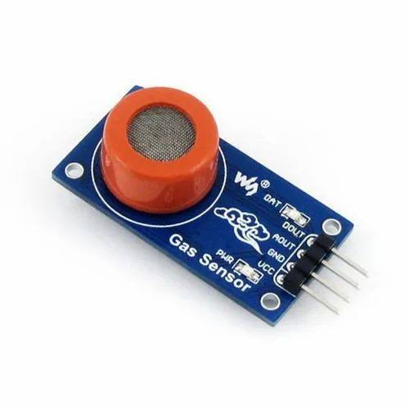
Fig. 3. MQ 3 sensor
3. Eye Blink Sensor:
An eye blink sensor in a smart bike helmet detects blink patterns to enhance safety and functionality. It alerts riders of drowsiness or inattention, enables hands-free control of features like navigation and communication, and provides safety alerts for potential dangers. It also collects data for analysis, offers customizable settings, and can integrate with helmet cameras for added functionality.
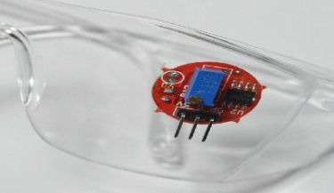
Fig 4. Eye blink sensor

4.Voice Acknowledgement Module:
The FN-M16P is a voice module that typically communicates with microcontrollers such as the Arduino Nano using a serial communication protocol such as Zigbee. You connect the TX (transmit) pin of the FN-M16P to one of the digital pins of the Arduino nano to send commands and data to the module. Ensure proper power and ground connections between the voice module and the Arduino Nano.
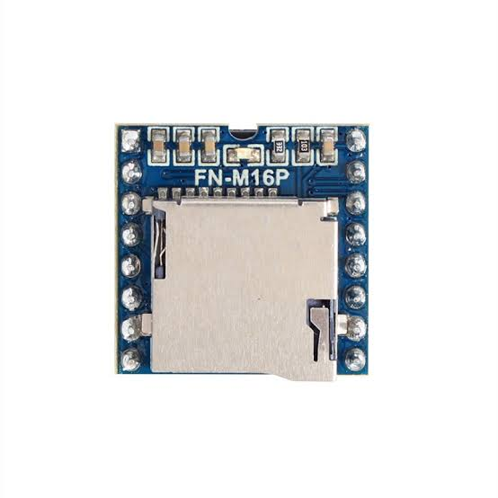
Fig 5. Voice module

Transmitter Section (On Bike): The transmitter section in a smart bike helmet serves as the pivotal link between the helmet's internal sensors and external devices, facilitating seamless communication and data transmission.
1.Atmega 328P:
The Atmega328P serves as the main control unit for the bike section. It manages communication between the GSM module, GPS, accelerometer, and any other peripherals.
Utilize the available GPIO pins for interfacing with external modules and sensors. Implement necessary hardware and software functionalities to control the modules and process data.
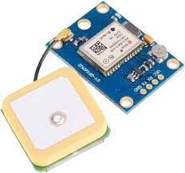
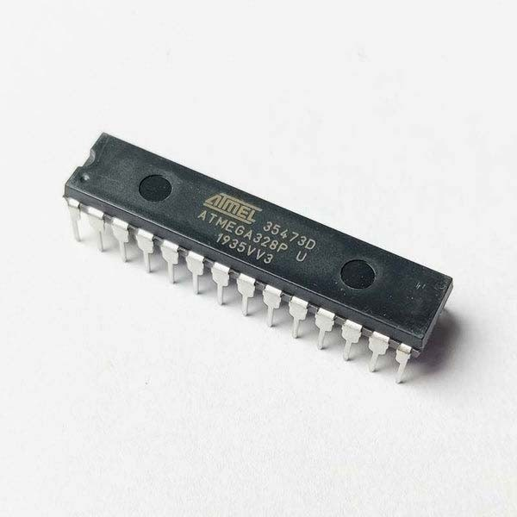
Fig 6. Atmega328P

2. GSM 800L Module:
Incorporating a GSM module allows the helmet to make emergency calls in case of accidents. It can automatically dial emergency services or predefined contacts when it detects a crash or impact. With GPS integration, the helmet can track the rider's location in real-time. This feature is useful for navigation, locating lost or stolen bikes, or for emergency services to locate the rider in case of an accident.
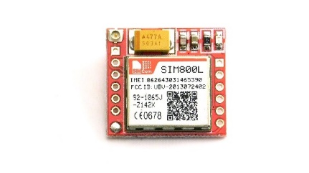
Fig 7. GSM 800L Module

3. Accelerometer:
The ADXL345 is a small, low-power accelerometer sensor produced by Analog Devices. It measures acceleration in three axes: X, Y, and Z. The sensor utilizes micro-electromechanical systems (MEMS) technology. MEMS accelerometers consist of tiny mechanical structures on a silicon chip. When subjected to acceleration, these structures generate electrical signals proportional to the acceleration.
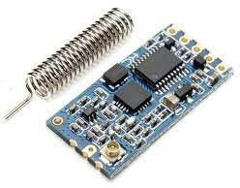
The ADXL345 can measure acceleration ranging from ±2 g to ±16 g. It communicates with microcontrollers or other devices via SPI or I2C interfaces. The sensor provides digital output and includes features like tap and double-tap detection.
It's commonly used in applications like motion sensing, tilt sensing, and robotics. The ADXL345's small size, low power consumption, and digital output make it popular in various electronic projects and products.
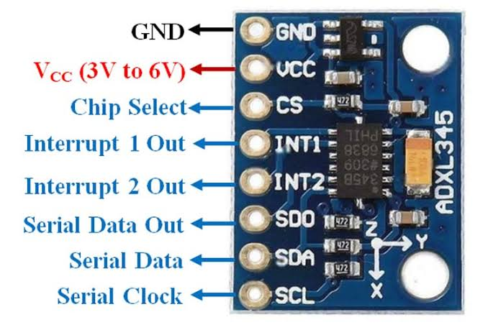
Fig 8. ADXL345

4. GPS:
In a smart bike helmet, GPS technology plays a multifaceted role in enhancing the rider's experience and safety. Firstly, the GPS system embedded within the helmet enables precise location tracking in real-time as the rider traverses various routes. This feature not only aids in navigation but also contributes to safety by alerting the rider to potential hazards and upcoming road conditions such as sharp turns or intersections. Integrated navigation features provide turn-by-turn directions either through a heads-up display (HUD) or audio cues, ensuring seamless guidance to the rider's destination.
Fig 9. GPS

5.HC-12:
In a smart bike helmet, the HC-12 wireless serial communication module serves a crucial role in facilitating seamless inter-device communication. Paired with various sensors embedded within the helmet, such as accelerometers and gyroscopes, the HC-12 enables real-time data transmission to a central processing unit or a connected smartphone app. This functionality not only allows for remote monitoring of vital metrics like speed, distance, and even the rider's health parameters but also enables rapid response in case of emergencies. Upon detecting a crash or impact, the sensors trigger an emergency signal that is swiftly transmitted through the HC-12 module to predefined contacts
Moreover, the HC-12 can enhance the rider's experience by enabling navigation assistance, where the helmet receives turn-by-turn instructions from a paired smartphone and provides intuitive feedback to the rider, promoting safer navigation during rides. Additionally, in group riding scenarios, the HC-12 facilitates seamless communication between riders, enabling coordination and enhancing safety through real-time alerts and updates.

Fig 10. HC-12
6 OLED:
The SSD1306 is a CMOS OLED (Organic Light-Emitting Diode) driver equipped with a controller tailored for OLED dot-matrix graphic display systems. Its implementation results in a reduction in the number of external components needed and a decrease in power consumption. OLED displays, facilitated by the SSD1306 driver, are adept at presenting text, images, and a diverse array of patterns with high clarity and vibrancy. This integration of the SSD1306 driver not only streamlines the design and operation of OLED displays but also enhances their efficiency and versatility in showcasing visual content across various applications.
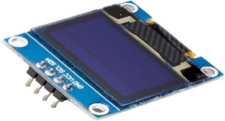
Fig 11. OLED

Implementation

1. Define Scope and Functionality:
Start by clearly defining the functionalities you want to test in the initial implementation. Here are some examples:

GPS Tracking: Integrate a GPS module to track the vehicle's location and potentially log trip data.

Remote Monitoring: If desired, consider incorporating cellular connectivity (e.g., GSM/LTE module) to enable remote access to vehicle data and location tracking.

2. Hardware Selection:

Microcontroller: Choose a microcontroller that can handle data processing, sensor communication, and any additional functionalities you plan to include. The Arduino Uno or similar options are good starting points for basic implementations due to their ease of use and large user community.

GPS Module: Choose a GPS module with good accuracy and ease of integration with your microcontroller. Consider factors like size, power consumption, and update rate.

Cellular Module: If enabling remote monitoring, select a cellular module compatible with your chosen cellular network provider and offering data connectivity.

Additional Sensors: Depending on your goals, you might consider adding sensors like accelerometers for detecting sudden movements or harsh braking.

3.Software Selection:
Develop the code for the microcontroller using an IDE like Arduino IDE:
Include necessary libraries for communication with chosen modules. If using GPS, develop code to track location data and potentially log trip details (distance, duration).
For remote monitoring implement functionalities to transmit data over the cellular network to a designated server or application.

Helmet Unit: Develop code for the Arduino IDE on the helmet unit, incorporating functionalities from the initial implementation along with communication with the vehicle module.
Vehicle Module: Develop code for the Arduino IDE on the vehicle module, incorporating functionalities from the initial implementation along with communication with the helmet unit

4.Initial Testing:
Conduct thorough testing in a safe environment.
Test communication between the microcontroller and each module. Verify the accuracy and consistency of data received. If using GPS, test its ability to track location data accurately. For remote monitoring (if applicable), test data transmission over the cellular network and ensure data reaches the intended server/application.

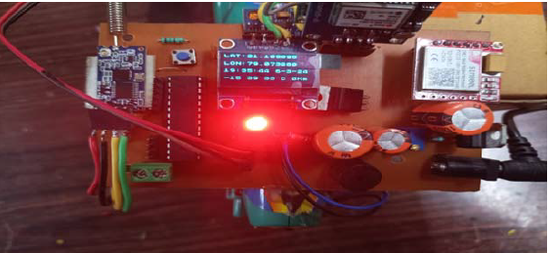
Fig 12. Vehicle module

Results
The study explores a comprehensive range of safety features integrated into a motorcycle system to enhance rider safety and prevent accidents. These features include an Alcohol Sensor, which effectively detects alcohol levels in the rider's breath, mitigating the risk of riding under the influence and ensuring the safety of both the rider and other road users. Additionally, a GPS module offers real-time navigation assistance, aiding riders in reaching their destinations securely and efficiently. The Eye Blink Sensor monitors the rider's blink patterns, identifying signs of drowsiness or distraction and alerting the rider to maintain focus, thereby reducing the likelihood of accidents. Furthermore, the inclusion of a GSM Module enables connectivity for emergency assistance and location tracking, empowering riders to call for help during emergencies. Lastly, the Accelerometer serves to detect sudden movements or impacts, promptly triggering alerts in the event of accidents and providing crucial data for post-incident analysis. Together, these integrated safety features represent a multifaceted approach to motorcycle safety, addressing various potential risks and enhancing overall rider security on the road.

Conclusion
Smart helmet systems, combining a helmet unit and a vehicle module, offer a glimpse into the future of motorcycle safety. Utilizing a powerful combination of sensors, real-time data analysis and early warnings, these systems have the potential to significantly reduce accidents and improve driver awareness. The initial implementation phase, focused on the limited scope where both the helmet and the vehicle module work together, is essential to identify potential problems early and ensure a well-integrated final product. For riders, the benefits translate into increased safety through real-time monitoring of rider position, engine vitals and even surrounding traffic. The fusion of both helmet and vehicle data allows for a more complete picture of the driving situation, including biometrics, vehicle performance metrics and navigation assistance. Furthermore, the ability of the system to detect risky maneuvers or potential hazards can prevent accidents and provide crucial assistance in an emergency.

Acknowledgments
“Acknowledgment(s)” is spelled without an “e” after the “g” in American English.
As you can see, the formatting ensures that the text ends in two equal-sized columns rather than only displaying one column on the last page.
This template was adapted from those provided by the IEEE on their own website.

References

- M. Kamruzzaman, Bangladesh: Alarming rise in road crashes, 2020, [online] Available: https: // www.aa .com.tr/eniasia pacific/ Bangladesh alarming- rise in -road-crashes/1692643.
- M. M. Islam, Mohammad Mehedi Hassan and Eui-Nam Huh, "Sensor Proxy Mobile IPv6 (SPMIPv6) - A framework of mobility supported IPWSN", 2010 13th International Conference on Computer and Information Technology (ICCIT), 2010.
- J. Santa, P. J. Fernández and M. A. Zamora, "Cooperative ITS for Two wheel vehicles to improve safety on roads", 2016 IEEE Vehicular Networking Conference (VNC), pp. 1-4, 2016.
- Archana, G. Boomija, J. Manisha and V.K.G. Kalaiselvi, "Mission on! Innovations in bike systems to provide a safe ride based on IOT", 2017 2nd International Conference on Computing and Communications Technologies (ICCCT), pp. 314-317, 2017.
- D. K. P. Gudavalli, B. S. Rani and C. V. Sagar, "Helmet operated smart E-bike", 2017 IEEE International Conference on Intelligent Techniques in Control Optimization and Signal Processing (INCOS), pp. 1-5, 2017.
- D. N., A. P. and R. E. R., "Analysis of Voice Interactive Helmets and Designing an IoT based Voice Interactive Helmet: A cost effective solution for Riders", 2019 1st International Conference on Innovations in Information and Communication Technology (ICIICT), pp. 1-4, 2019.
- Fanca POP, A. Puscasiu, S. Folea and H. Välean, "Trauma accident detecting and reporting system", 2018 IEEE International Conference on Automation Quality and Testing Robotics (AQTR), pp. 1-5, 2018.
- Lee Youngmin, YehHongjin, Kim Ki-Hyung and Choi Okkyung, "A real-time fall detection system based on the acceleration sensor of smartphone", International Journal of Engineering Business Management, 2018.

