ANALYSIS AND DESIGN OF MEDIA FILTER FOR WASTE WATER TREATMENT
Kajal V. Bhoyar¹, Neha V. Rekkawar², Hiteshkumar D. Mishra³
¹Civil Engineering Department, Jagadambha College Of Engineering and Technology Yavatmal, India, 445-001
²Civil Engineering Department, Jagadambha College Of Engineering and Technology Yavatmal, India, 445-001
³Assistant Professor in Jagadambha College of Engineering & Technology, Yavatmal, India, 445-001.

Abstract – Fresh water is a finite; naturally renewable resource received by way of precipitation, but is significantly unevenly distributed in time and space. India is facing water crisis and by 2025 it is estimated that India’s population will be suffering from severe water scarcity. This alarming situation demands effective remedies in terms of devising cost effective wastewater treatment and water reuse systems. This study was aimed at introducing the multi-media filter. Multi – media Filter refers to a filter vessel which utilizes three or more different media as opposed to a "sand filter" that typically uses one grade of sand alone as the filtration media. Experimental study was carried out to upgrade the conventional treatment processes by introducing multiple Medias. A laboratory model is constructed consisting of three reactors placed in series, packed with different sizes of aggregate. The model was operated for varying detention time. the result obtained from this experimental study showed removal efficiency of BOD as 56.01 %,COD as66.04 %, turbidity as92.10%,
Keywords- wastewater, filtration, multimedia filter.
INTRODUCTION
Fresh water is a finite; naturally renewable resource received by way of precipitation, but is significantly unevenly distributed in time and space. The current trends of population growth and deteriorating fresh water sources are expected to create huge environmental challenges. With increasing global population, the gap between the supply and demand for water is widening and is reaching such alarming levels that in some parts of the world it is posing a threat to human existence. Experts are predicting that 2/3 of the

world’s population will suffer with extreme fresh water scarcity by 2025. . In India alone the International Water Management Institute (IWMI) predicts that by 2025, one person in three will live in conditions of absolute water scarcity (IWMI, 2003). This alarming situation demands effective remedies in terms of devising cost effective wastewater treatment and water reuse systems.
The facing of fresh water challenges due to direct discharge of polluted water from domestic and industrial sources. An about 12 % of the urban wastewater is treated in municipal treatment plants and even these treatment plants are not working to their expected efficiencies. Treatment of wastewater and reduction of groundwater over drafting appear to be obvious solutions to this global problem. Water is the main component in our body. Consuming enough water in our daily life is a must to stay hydrated and healthy. Over 80% of the water used in both rural and urban areas is surface water drawn from rivers, streams, lakes, ponds and springs. The water from these sources is in most cases contaminated by human and animal wastes, as well as industrial and agricultural activities. This scenario thus calls for efficient and effective treatment of water from such sources before use to avoid instances of water-borne and water- related diseases such as typhoid fever and cholera at reasonable costs. This is important because it has been reported that 70 to 80% of water-borne diseases are spread through the unavoidable ingestion of pathogenic microorganisms and parasites in drinking untreated water especially surface water (Tebbutt, 1992).
We are silently but surely heading towards “water shock” because in the last two decades for the first time in the human history more water is being taken out across the globe than what nature is putting in.. It is therefore essential to reduce surface and ground water use in all sectors of consumption, to substitute fresh water with alternative water resources and to optimize water use efficiency through reuse options. Alternative sources of water can potentially save significant amounts of precise fresh water. The first stage is the wastewater treatment process. This process is specifically for the usage of water from the toilet/human discharge which can be called wastewater. The water is treated in the wastewater treatment process before letting the water into the stream. Water that is used in the industry such as product washing or reaction mediums is also considered as wastewater but the factory that responsible producing the wastewater have to clean the water first before letting the water flow in the stream. The second process is for water from the river/lake. The water from the river is treated in the water treatment plant to free the water from colloids/suspended solids and dangerous microorganisms.
Filtration is one of the most important treatment processes used in water and wastewater treatment. In water treatment, it is used to purify the surface water for potable use whereas in wastewater treatment, the main purpose of filtration is to produce effluent of high quality so that it can be reused for various purposes This study was aimed at introducing multistage filtration (MSF) (a combination of slow-sand filtration (SSF) and pretreatment system - horizontal flow roughing filter (HRF)) as an alternative water treatment technology to the conventional one. MSF. This system consists of a pretreatment stage followed by SSF. The main (re)uses of treated wastewater are: irrigation (both agricultural and landscape), recharge of aquifers, seawater barriers, industrial applications, dual-distribution systems for toilet flushing, and other urban uses.
MATERIAL AND METHODS
FI1TER MEDIA
The filter material should have a large specific surface in order to enhance the sedimentation process taking place in the HRF. Furthermore, it should provide high porosity necessary for the accumulation of the separated solids. Generally speaking, any inert, clean, insoluble and mechanically resistant material fulfilling the above two criteria can be used as filter medium. Filtration tests revealed that neither the surface roughness nor the shape or structure of the filter material have an appreciable influence on filter efficiency.
The following filter material can for instance be used:
- Gravel from a river bed or present in soils
- broken stones or rocks from a quarry
- broken burnt bricks made of clay
- plastic material either as chips or as modules, e.g. used in trickling filters (self-reliance as regards the use of locally-available material is no longer considered here; attention should be paid to the uplift forces of the water)
- possibly burnt charcoal (risk of disintegration when cleaning the filter material)
- possibly coconut fibre (risk of odour nuisance during longer filter operation 7periods)
A HRF is composed of 3 to 4 differently sized filter fractions which range from course to fine. The course and most of the finer suspended solids are removed by the first filter pack. A large pore volume should therefore be provided in this part of the filter. This 1s best achieved by locating a coarse filter material along a substantial part of the filter length. The subsequent filter material is of finer size and the packs of shorter length. The last filter fraction should only resume polishing functions as 1t is supposed to remove the last traces of the finest suspended solids found in the water.
Table 1 lists some general guidelines for the size and length of the different filter fractions. These guidelines should not be too rigidly applied. However, the average size of the aggregates should not be smaller than 4 mm to enable regeneration of the filter efficiency. 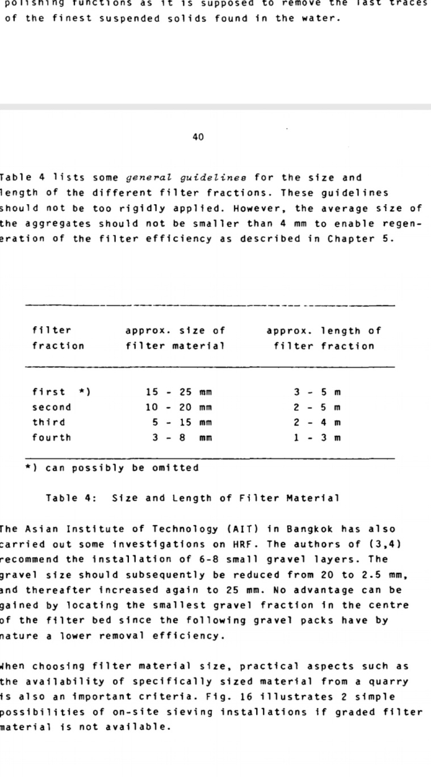 Table 1: Size and Length of Filter Material
TYPES OF ROUGHING FILTERS
Roughing filters are classified by their flow patterns in the reactor system. These include flow of roughing filters down flow roughing filters and horizontal roughing filters. A typical roughing filter consists of a series of Graded gravel beds, with the first bed having the coarsest material and the final bed having the finest material. Typical roughing filters have gravel of different sizes in different number of compartments.
1. VERTICAL FLOW ROUGHING FILTERS
2. HORIZONTAL FLOW ROUGHING FILTERS
The main advantages of horizontal roughing filters are unlimited filter length and simple layout. Horizontal roughing filters have a large silt storage capacity. Solids settle on top of the filter medium surface and grow to small heaps of loose aggregates with progressive filtration time. Part of the small heaps will drift towards the filter bottom as soon as they become unstable. This drift regenerates filter efficiency at the top and slowly silts the filter from bottom to top. Horizontal-flow roughing filters also react less sensitively to filtration rate changes, as clusters of suspended solids will drift towards the filter bottom or be retained by the subsequent filter layers. The inlet and outlet structures were flow-control installations required to maintain a certain water level and flow along the filter as well as to establish an even flow distribution along and across the filter. The filter bed was composed of three filter medium packs of different sizes. The filter medium was placed in separate compartments starting with the coarsest to the finest, in the direction of flow and operated in series Horizontal-flow Roughing Filtration might close this gap. The filter is composed of a simple box filled with gravel of different sizes (from coarse to fine) as can be seen in Fig. 1.
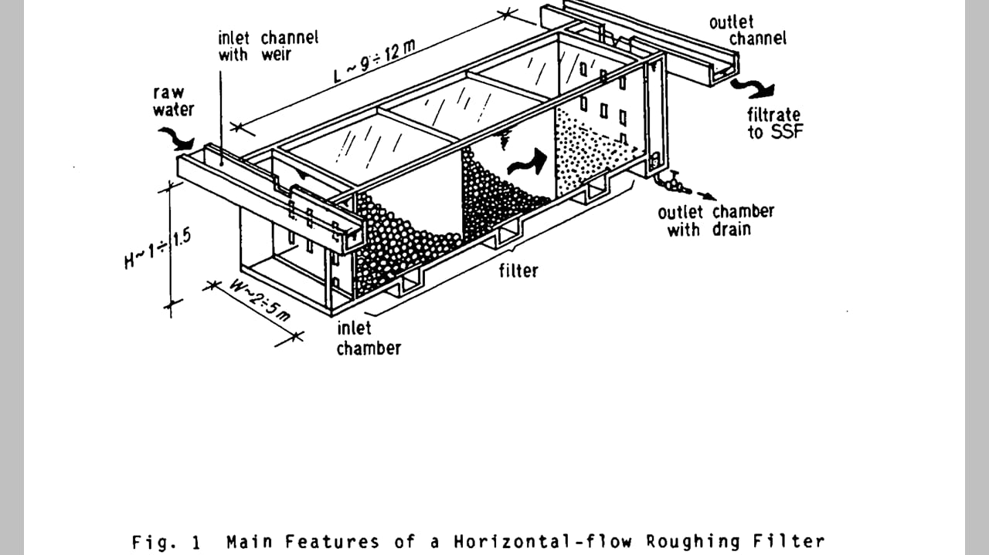 Fig 1: horizontal roughening filter
MULTI - MEDIA FILTER
Multi – media Filter refers to a filter vessel which utilizes three or more different media as opposed to a "sand filter" that typically uses one grade of sand alone as the filtration media. In a single media filter, during the "settling" cycle, the finest or smallest media particles remain on top of the media bed while the larger, and heavier particles, stratify proportional to their mass lower in the filter. This results in very limited use of the media depth since virtually all filterable particles are trapped at the very top of the filter bed or within 1-2 inches of the top where the filter media particles have the least space between them. The filter run times are thus very short before the filter “blinds” or develop so much head pressure that it must be backwashed to avoid seriously impeding or stopping the flow.
Multi-media filters for multimedia filtration typically have three layers, consisting of anthracite, sand and garnet. These are often the media of choice because of the differences in mass between the materials. Garnet is by far the heaviest per unit volume, sand is intermediate while anthracite is the lightest filtration media. The idea behind using these three media of differing densities is that anthracite media, with the largest particle size, will stratify on top following backwash while the intermediate size media (sand) will settle in the middle and garnet, the heaviest but having the smallest particle diameter, will settle to the bottom.
Multi-media filters are filled with a variety of media in order of increasing size, for example, fine sand, coarse sand, gravel, stone, and wood chips to a total depth of 0.75 m to 1 m. The inlets provided at the top so that the filtered water is collected through outlet in the bottom. This filter media arrangement allows the largest dirt particles to be removed near the top of the media bed with the smaller and smaller dirt particles being retained deeper and deeper in the media. This allows much longer filter run times between backwash and much more efficient dirt or turbidity removal. Sand filters typically remove particles down to 25-50 microns while a well-operated multi-media filter may remove particles from 10-25 microns.

HRF-AS ALTERNATIVE PRETREATMENT
Horizontal-flow Roughing Filtration copies nature. The main characteristics of the process are its horizontal flow direction and the graduation of the filter material. This specific flow direction enables to construct a shallow and structurally simple filter of unrestricted length. Three to four subsequent packs, ranging from coarse to fine material, effect a gradual removal of the solids from the water. The coarse filter material, contained in the first part of the filter, retains all the larger particles and some of the finer matter, while the last filter part with the finest filter material has to cope with the remaining smallest particles. Since the effluent of a HRF is virtually free from any solids, the standards required by SSF are easily met.
COMPONENTS AND WORKING OF HRF
The schematic lay-out of a HRF 1s illustrated in Fig. 1. The filter 1s divided into three parts: the inlet structure, the filter bed and the outlet structure. Inlet and outlet structures are flow control Installations required to maintain a certain water level and flow along the filter as well as to establish an even flow distribution across the filter. The main part of a HRF consists of the filter bed composed of 3 to 4 gravel packs of different sizes.
The laboratory scale model was fabricated with GI sheet and consists of three reactors placed in series with up flow and down flow regime (Table 2). The total reactor volume was of 28liters capacity. All three reactors were packed with different packing media of different sizes. The depth of the media was kept accordingly. The inlet and outlet arrangement were provided at appropriate locations.
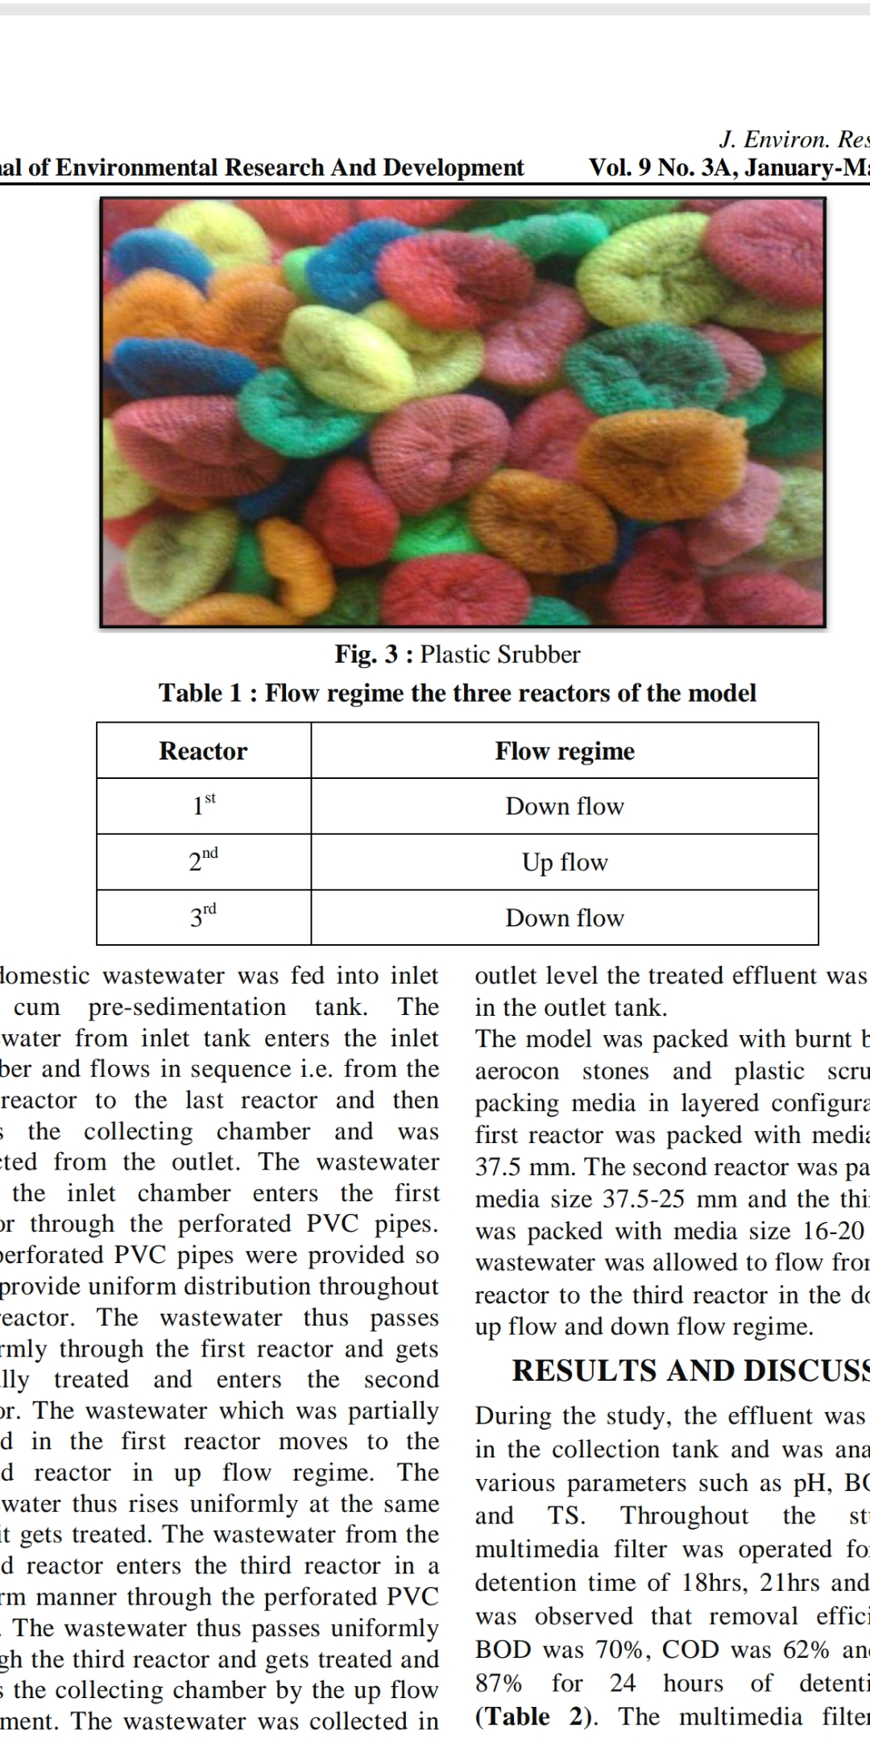 Table 2: flow regime the three reactors of the model

The domestic wastewater was fed into inlet tank cum pre-sedimentation tank. The wastewater from inlet tank enters the inlet chamber and flows in sequence i.e. from the first reactor to the last reactor and then enters the collecting chamber and was collected from the outlet. The wastewater from the inlet chamber enters the first reactor. The wastewater thus passes uniformly through the first reactor and gets partially treated and enters the second reactor. The wastewater which was partially treated in the first reactor moves to the second reactor in up flow regime. The wastewater thus rises uniformly at the same time it gets treated. The wastewater from the second reactor enters the third reactor in a uniform manner. The wastewater thus passes uniformly through the third reactor and gets treated and enters the collecting chamber by the up flow movement. The wastewater was collected in the collecting chamber and after reaching the outlet level the treated effluent was collected in the outlet tank. The model was packed with aggregates of different sizes as packing media in layered configuration. The first reactor was packed with media size 13 to 14 mm. The second reactor was packed with media size 10 to 12 mm and the third reactor was packed with media size 8 to 10 mm. The wastewater was allowed to flow from the first reactor to the third reactor in the down flow, up flow and down flow regime
DRAINAGE SYSTEM
Drainage facilities, as Illustrated 1n Fig. 2, are required for filter cleaning and filter efficiency regeneration. For manual cleaning of the filter medium, a drain, placed in the outlet chamber, enables complete drainage of the filter box. The filter bottom should thereby be slightly inclined by 1 to 2 % in the direction of flow. A side effect of this proposed slope is the saving of some filter material.
Hydraulic cleaning consists of fast filter drainage and a slow refilling of the filter with water. Drainage facilities such as perforated pipes, troughs or culverts enable hydraulic cleaning of the filter medium. The system is placed perpendicular to the direction of flow at the filter bottom. The spacing between the drains should amount to about 1-2 m. The hydraulic capacity of these Installations should permit an initial vertical filter drainage velocity of 60-90 m/h necessary for efficient cleaning. Valves, slide gates or flexible hose pipes can be used to operate the drainage system. Each drain should discharge into an open channel to allow visual supervision of any drainage operation. Facilities for safe wash water disposal are necessary to prevent erosion and water ponding.
FILTER CLEANING
Filter efficiency decreases with progressive accumulation of solid matter in the filter. Hence, periodic removal of this accumulated matter restores filter efficiency and keeps the filter in good running condition. A HRF can be cleaned in two ways, either hydraulically or manually. The natural drift of accumulated matter towards the filter bottom can be enhanced by filter drainage. The retained solids are washed down when the water level in the filter is lowered. The upper part of the filter bed is thereby cleaned and regenerated while an additional accumulation of solid matter takes place at the filter bottom. These solids can be flushed out of the filter by an adequate drainage system at initial drainage velocities ranging preferably between 60 and 90 m/h. It is very important to start the cleaning procedure at the inlet side as most of the solids are retained in this part of the filter. An initially vigorous drainage at the rear of the filter would wash the bulk of solids towards this drainage point and enhance the risk of clogging of the fine filter part.
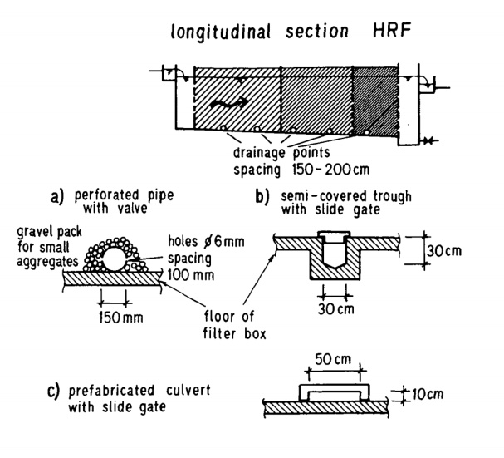 Fig2: Drainage System
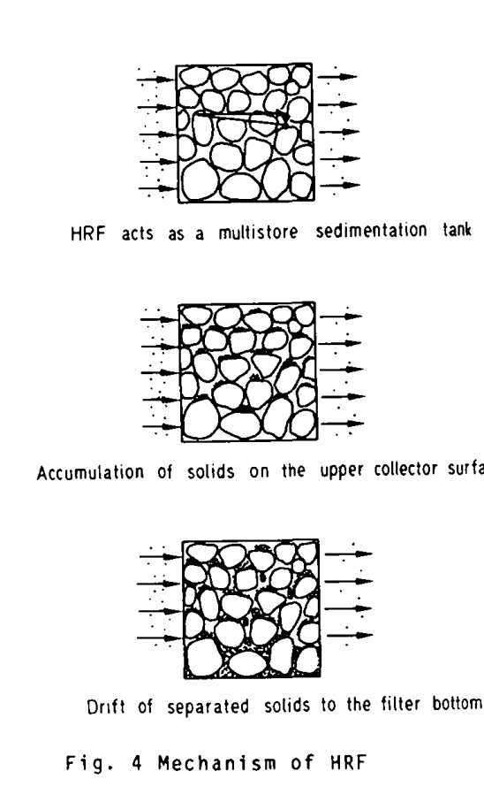 Fig 3: Mechanism of HRF
RESULT AND DISCUSSION

Performance of the model for pH at 18, 21 & 24 hours hydraulic retention time

Performance of the model for COD at 18, 21 & 24 hours hydraulic retention time.

Performance of the model for Turbidity at18, 21 & 24 hours hydraulic retention time.
Performance of the model for BOD at 18, 21 & 24 hours hydraulic retention time.

Wastewater contains a variety of inorganic and organic substances from domestic sources. The wastewater parameters namely BOD, COD, TURBIDITY and pH were analyzed. The procedure followed for calculating the parameters are the standardized methods. The raw wastewater collected from the Pioneer society and the characteristics were studied. Following conclusions are drawn by using laboratory scale model and observing the performance of the model for varying the detention time and for advancement in model.
It is claimed that, the reactors packed with Aggregates of size (12 – 14 mm, 10 - 12 mm and 8 – 10mm) with detention time of 18hrs showed poor performance with BOD and COD reduction in the range of 42.26 % and 22.45 respectively.
It is claimed that, the reactors packed with Aggregates of size (12 – 14 mm, 10 - 12 mm and 8 – 10mm) detention time of 24hrs showed satisfactory performance with BOD and COD reduction in the range of 56.01 % and 66.04 % respectively.
The reactors packed with Aggregates of size (12 – 14 mm, 10 - 12 mm and 8 – 10mm) with detention time of 24hrs showed maximum performance with turbidity reduction in the range of 92.10 %.
The reactors packed with Aggregates of size (12 – 14 mm, 10 - 12 mm and 8 – 10mm) with detention time of 18hrs showed average performance with turbidity reduction in the range of 27.37%.

CONCLUSION

It is claimed that, as aggregate size decreases the performance of reactors increases.
It is claimed that, as depth of the filter media increases the performance of the model also increases SS.
The study claims that method as suggested in the dissertation under study proves to be economical and efficient for treatment of domestic waste.
It was found that, there was a considerable increase in the treated wastewater in each case which is because of the presence of filter media assembly
ACKNOWLEDGMENT
I would like to express my greatest gratitude to those people who have contributed and supported me. I would like to thank my sir Prof. Gahalod sir, Prof. Mishra sir for his continuous support for this study. I would like to thank my parent and friends for their support without them I would have been unable to complete the study.
REFERENCES
- George Ochieng, Fred Otieno & S.M. Shitote GMM Ochieng1, FAO Otieno1*, TPM Ogada2, SM Shitote2 And DM Menzwa2 (2004) -“Performance Of Multistage Filtration Using Different Filter Media Against Conventional Water Treatment Systems”
- P.Majumdar, P. Roy &M.Barman (2006)-“Verification Of Wegelin’s Design Criteria For Horizontal Flow Roughing Filters (HRF) With Alternative Filter Material” Onyeka Nkwonta And George Ochieng (2009)-“Roughing Filter For Water Pre-Treatment Technology In Developing Countries: A Review”
- Augustine C. Affam Mohd. Nordin Adlan (2013)“Operational Performance Of Vertical Up Flow Roughing Filter For Pre-Treatment Of Leachate Using Limestone Filter Media”
- Saroj B. Parjane, Mukund G. Sane (2011) “Performance Of Grey Water Treatment Plant By Economical Way For Indian Rural Development”
- Ashwani Kumar Dubey And Omprakash Sahu (2014)“Review On Natural Methods For Waste Water Treatment”
- Abd El-Motaleb M. Ramadan1, Adel A. Nassar2, Ibrahim H. El-Sayed, Nanis G. Allam, Hamdy A. Mashaly And Osama A. Eltawab (2016)-“Performance Evaluation Of Different Wastewater Treatment Technologies”
- Onyeka Nkwonta (2010) “A Comparison Of Horizontal Roughing Filters And Vertical Roughing Filters In Wastewater Treatment Using Gravel As A Filter Media” Patil V. B., Kulkarni G.S., Kore V.S. (2012) “Performance Of Horizontal Roughing Filters For Wastewater: A Review:”
- Abdel Majid Nassar, Kamel Hajjaj (2013) “Purification of Stormwater Using Sand Filters”
- Ranjeet Sabale, Sahil Mujawar (2014) “Improved Rapid Sand Filter For Performance Enhancement”
- Soli J. Arceivala, Shyam R. Asolekar “Waste water treatment for pollution control and reuse, third edition”

Details of Authors:

Sr. No | Photo | Details
1 |  | Kajal V. Bhoyar (final year student, civil Engg. Dept.) Jagadambha College Of Engineering and Technology Yavatmal , India, 445-001
2 |  | Neha V. Rekkawar (final year student, civil Engg. Dept.) Jagadambha College Of Engineering and Technology Yavatmal , India, 445-001
3 |  | Hiteshkumar D. Mishra is working as Assistant Professor, department of civil engineering, Jagadambha College Of Engineering and Technology Yavatmal , India, 445-001

