REVIEW ON IOT BASED ENERGY METER WITH CURRENT, VOLTAGE AND COST MONITORING SYSTEM

Akanksha S Patil¹, Simran S Gondane², Pratiksha S Chavan³, Tanushree B Chamat⁴,
Shlok V Jagdish⁵

^{1,2,3,4,5} UG Engineering Students
Department of Electrical Engineering, St. Vincent Pallotti College of Engineering and Technology Nagpur, Maharashtra, India.

Abstract -- With the advent technology of the Internet of Things (IoT), there has been a paradigm shift in the way energy consumption is monitored and managed. This paper presents an IoT-based energy meter with a cost monitoring system designed to provide users with real time insights into their energy usage and associated costs. The proposed system utilizes IoT Based smart meters installed at consumer premises to monitor energy consumption at a granular level. The collected data is transmitted wirelessly to a centralized server for processing and analysis.

Keywords -- ESP32, GSM, Energy Meter, LCD Display

- INTRODUCTION

The Internet of Things (IoT) has revolutionized various industries, and the energy sector is no exception. With the increasing demand for efficient energy management and cost optimization, IoT-based energy metering systems have emerged as a solution to monitor and manage energy consumption in real-time. These systems not only provide accurate measurements of energy usage but also enable users to analyze data, identify patterns, and make informed decisions to reduce energy costs and promote sustainability.
The IoT-based energy meter with cost monitoring system integrates smart metering technology with IoT connectivity, allowing for seamless communication between energy meters and centralized monitoring platforms. By leveraging sensors, wireless communication protocols, and cloud computing, these systems enable remote monitoring and control of energy usage across different locations, whether it's residential, commercial, or industrial.
The system incorporates advanced analytics algorithms to analyze energy consumption patterns, identify energy-intensive appliances, and predict future usage trends. Additionally, the system integrates with utility tariff information to calculate real-time energy costs based on consumption. Users can access this information through a user-friendly web or mobile interface, allowing them to monitor their energy usage, track costs, and optimize consumption behavior to reduce expenses.
Furthermore, the system supports remote monitoring and control capabilities, enabling users to remotely manage their appliances, set energy usage thresholds, and receive alerts for abnormal consumption patterns. This enhances energy efficiency and enables proactive measures to mitigate energy wastage.
Overall, the proposed IoT energy meter with cost monitoring system offers a comprehensive solution for efficient energy management, empowering users with actionable insights to optimize their energy usage, reduce costs, and contribute to sustainability efforts.

- OBJECTIVE

The objective of making an IoT-based energy meter with cost monitoring system is to provide real time insights into energy consumption, enabling users to:
Real-time Data Monitoring: - The system collects and analyzes energy consumption data in real-time, providing users with up-to-date insights into their energy usage patterns.
Cost Analysis: - By integrating cost calculation algorithms, users can track their energy expenditure and identify areas for cost-saving measures.
Remote Access and Control: - Users can access the energy metering system remotely via web or mobile interfaces, allowing for convenient monitoring and control from anywhere.
Alerts and Notifications: - The system made can generate alerts and notifications for abnormal energy usage patterns, potential faults, or maintenance requirements, enabling proactive intervention to prevent costly downtime.
Historical Data Analysis: - Historical energy consumption data is stored and analyzed to identify trends, forecast future energy demands, and optimize energy usage strategies.

- PROBLEM STATEMENT

The Electricity Board has grown accustomed to the manual procedure and continues to adhere to it despite numerous associated concerns. When users receive erroneous bills due to human errors, rectifying them falls on the customer's shoulders with the energy supply board. This typically involves visiting the office, waiting in line, and requesting correction. The underlying issue stems from human intervention. To mitigate such problems, an automated meter reading system has been implemented in this contemporary age to eliminate human involvement in the billing process.

- PROPOSED METHODOLOGY

We proposed a methodology of smart energy meter shown in fig. 4. in which we show that how we made an energy meter using below main components which include the configuration of ESP32 is shown in fig. 2. we used this IC as a microprocessor and the configuration of GSM IC is shown in fig. 3. this is used for sending SMS in our mobile phone. The block diagram of energy meter is shown below in fig. 1. is used for energy meter configuration and the location of components.

- Block Diagram Configuration

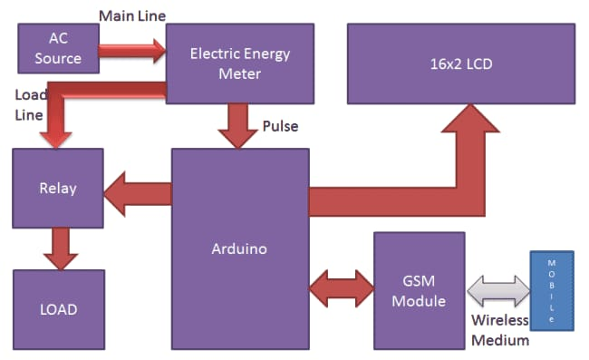
Fig. 1. Block Diaram

Esp32 is used here is as a processor for controlling the energy meter monitoring function such as cost of units consumed, current, voltage, units consumed, and total power consumed.
GSM IC used here for the purpose of sending SMS to mobile phone and daily alerts regarding power consumption and unnecessary use of electricity.
Current transformer used here for continuous monitoring of current ratings and send it to the IoT sever.
Relay is used here for monitoring and controlling function. The limit is set in the relay and if the limit is exceed then relay operates and stop all the function of energy meter so that we can reduce the wastage of electricity.
LCD display is used here for continuous monitoring and display the information of values such as current, voltage, units consumed, total power and total electricity cost.

- ESP32 IC Configuration

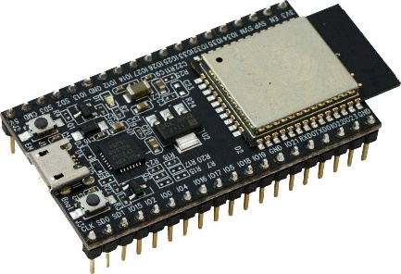
Fig. 2. ESP32 IC

The ESP32 is a powerful microcontroller we used and it is developed by Espressif Systems. It's widely used microcontroller in IoT (Internet of Things) projects due to its built-in analog to digital converter, Wi-Fi and Bluetooth capabilities, as well as its low power consumption. It has 12 bit resolution so we can measure lesser to lesser voltage and current and we also can change its bits. Its supported by a large community and has a extensive documentation and development tools available.

- GSM IC Configuration

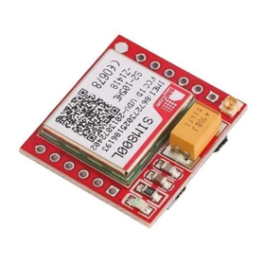
Fig. 3. GSM IC

GSM stans for Global System for Mobile Communication. GSM IC refers to an integrated circuit designed to facilitate GSM functionality in electronic devices. These ICs enable devices to communicate over cellular networks using GSM technology, which is widely used for voice and data transmission in mobile phones and other wireless devices. GSM ICs typically include components such as baseband processor, radio frequency transceivers, power management units, and protocol stacks to handle GSM network communication.

- List of Constituents

- ESP32 IC
- GSM IC
- Current Transformer (CT)
- Relay (SPDT)
- Voltage Regulators
- Potentiometer
- Transistor
- Diodes
- Rectifiers
- Electrolytic Capacitors
- LCD Display
- LED’S
- Bulb and Holder
- Wires

- Project Model

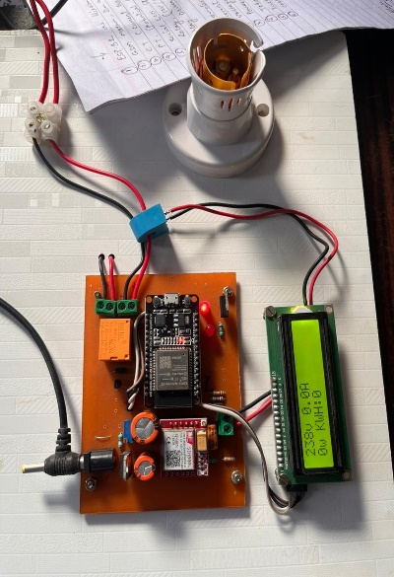
Fig. 4. Project Model

- FUTURE SCOPE

The Smart Grid Integrating the energy meter with smart grids to enable real-time communication between the meter and utility companies. This could lead to more efficient energy distribution and better load management. Predictive Analytics Implementing predictive analytics algorithms to forecast energy consumption patterns. This can help users optimize their energy usage and reduce costs further. Energy Optimization Suggestions Providing personalized energy optimization suggestions based on historical data and user preferences. This could include recommendations on when to use appliances or how to adjust settings for maximum efficiency. Renewable Energy Integration Integrating with renewable energy sources like solar panels and wind turbines to monitor their contribution to overall energy consumption and cost savings. Utilizing blockchain technology for secure and transparent transactions between energy producers, consumers, and grid operators. This could enable peer-to-peer energy trading and incentivize renewable energy generation. Enhanced user-friendly interfaces, such as mobile apps or web portals, with intuitive dashboards and visualizations for easier monitoring and management of energy usage and costs.
Machine Learning for Anomaly Detection Implementing machine learning algorithms for anomaly detection to identify unusual energy consumption patterns or potential system failures, enhancing system reliability and security. Integration with Smart Home Devices Integrating with other home devices and platforms, such as smart thermostats or lighting systems, to create a holistic home automation ecosystem focused on energy efficiency. Regulatory Compliance incorporating features to ensure compliance with evolving energy regulations and standards, such as energy efficiency mandates or carbon footprint reporting requirements. Scalability and Interoperability Designing the system with scalability and interoperability in mind to support future upgrades, integrations, and expansions without significant disruptions.

- RESULT

The accuracy of IoT-based energy meters is verified by cross-referencing the readings displayed on the LCD and the IoT server of SEM with those received via SMS. Additionally, the performance of the IoT energy meter is assessed by connecting and disconnecting various loads, including 15W, 60W, and 200W, and analysing the results captured in the provided snapshots.

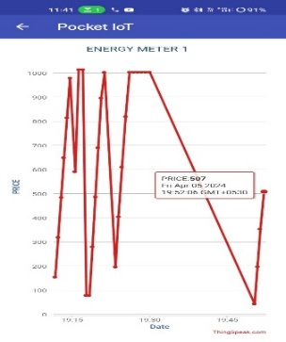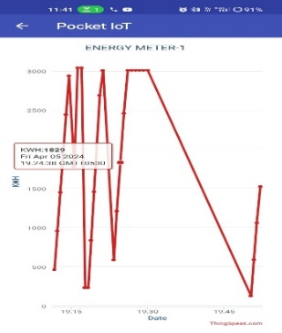

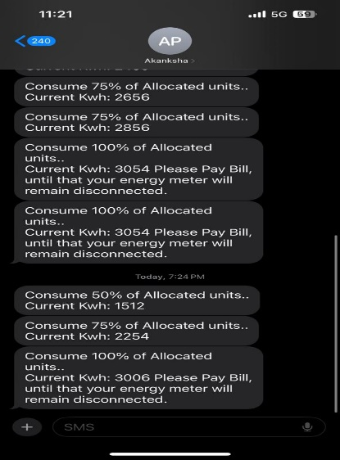

- CONCLUSION

The smart energy monitoring system integrates an ESP32, GSM Modem, relay, current transformer, and an LCD display. This innovative technology autonomously monitors the energy meter and facilitates home automation through a dedicated mobile application, offering efficient power management. Notably, the system minimizes energy consumption and decreases reliance on manual labor. Additionally, it enables remote collection of monthly energy consumption data for centralized office management. This approach significantly reduces the need for physically visiting each home to record meter readings.

REFERENCES

[1] Q. Gao et al., “Solutions for the “Silent Node” Problem in an Automatic Meter Reading System Using Power-Line Communications” , IEEE vol.23, no. 1, January 2008
[2] Subhashis Maitra et al., “Embedded Energy Meter- A New Concept To Measure The Energy Consumed By A Consumer And To Pay The Bill” , 978-1-4244-1762-9/08 IEEE 2008
[3] Nhat-Quang Nhan et al., “Improving the performance of mobile data collecting systems for electricity meter reading using wireless sensor network”, The 2012 International Conference on Advanced Technologies for Communication (ATC 2012) , pp. 241-246
[4] K. S. K. Weranga et al., “Smart Metering for Next Generation Energy Efficiency & Conservation”, IEEE PES ISGT Asia 2012, pp.1-8
[5] Sudhish N George et al., “GSM Based Automatic Energy Meter Reading System with Instant Billing”, 978-1-4673-5090-7/13 IEEE 2013, pp. 61-72
[6] Mpendulo Ndlovu et al., :An OFDM Inter-Subcarrier Permutation Coding Scheme for Power-line Communication”, 18th IEEE International Symposium on Power Line Communications and Its Applications, pp. 196-201, 2014
[7] Mohamed Chaker Bali et al., “Advanced Physical Layer for Robust Power Line Communications based on Coded Modulation”, 978-1-4799-5874-0/14, IEEE 2014
[8] “Automatic Meter Reading and Theft Control Systemby Using GSM” P. Rakesh Malhotra,
Dr.R.Seethalakshmi School Of Computing, SASTRA University, Tamil Nadu, INDIA.
[9] “GSM Based Electricity Theft Identification in Distribution Systems” Kalaivani.R1, Gowthami.M1, Savitha.S1, Karthick.N1, Mohanvel.S2 Student, EEE, Knowledge Institute of Technology, Salem, India.

