Study and Development of Roll Bender- Basic Design

Name: Mr. Anay Singh Chauhan
Mechanical Department
St. Vincent Pallotti College of Engineering & Technology, Nagpur Nagpur, India.
anaychauhan77@gmail.com
Name: Mr. Prathamesh Kirnapure
Mechanical Department
St. Vincent Pallotti College of Engineering & Technology, Nagpur Nagpur, India.
prathmeshkirnapure@gmail.com
Name: Mr. Kalpesh Khobragade
Mechanical Department
St. Vincent Pallotti College of Engineering & Technology, Nagpur Nagpur, India.
kalpesh15020200@gmail.com
Name: Mr. Rohit Bhisikare
Mechanical Department
St. Vincent Pallotti College of Engineering & Technology, Nagpur Nagpur, India.
rohitbhisikar8@gmail.com

Name: Mr. Pawan Kirnekar
Mechanical Department
St. Vincent Pallotti College of Engineering & Technology, Nagpur Nagpur, India.
pawankinekar906@gmail.com
Name: Dr. Ghanshyam Boob
Mechanical Department
St. Vincent Pallotti College of Engineering & Technology, Nagpur Nagpur, India.
gboob@stvincentngp.edu.in

Abstract— The utilization of three-roller bending machines in various industrial sectors has significantly increased owing to their versatility in shaping metal sheets and profiles. This research paper delves into a three roller bending machine's comprehensive analysis and optimization to enhance its performance and efficiency. The study encompasses a thorough investigation of the machine's mechanical structure, control system, and operational parameters. Through experimental trials and computational simulations, critical factors influencing the bending process, such as roller geometry, material properties, and roller alignment, are scrutinized.
Furthermore, advanced control strategies and automation techniques are proposed and implemented to augment the precision and repeatability of the bending process. The results of this study add to a better comprehension of three-roller bending machine dynamics and provide practical insights for optimizing its performance in industrial applications. Keywords— Put your keywords here, keywords are separated by comma.

INTRODUCTION
Within the field of metal fabrication and manufacturing, there is an ongoing pursuit of accuracy, productivity, and adaptability. The three-roller bending machine is a cornerstone of the array of machines used in this endeavor, providing a versatile solution for expertly shaping metal sheets and plates. The three-roller bending machine has become an essential tool in a variety of industries, including construction, automotive, aerospace, and more, due to its capacity to bend different materials into a wide range of shapes, from straightforward cylinders to intricate curves.
The goal of this research paper is to examine the design, working principles, capabilities, and various factors that affect the performance of three-roller bending machines. This study intends to offer invaluable insights into maximizing their utilization, enhancing efficiency, and guaranteeing precision in metal fabrication processes by thoroughly examining the mechanics underlying these machines and analyzing their applications across various industries.
The development of three-roller bending machines is a reflection of manufacturing's unwavering quest for technological innovation and advancement. It is essential to comprehend these machines' evolutionary history to fully appreciate their current capabilities and anticipate future advancements.
This paper will also examine the varied uses of three-roller bending machines in different sectors of the economy. These machines are incredibly versatile; their uses range from manufacturing cylindrical vessels for the oil and gas industry to fabricating structural elements for architectural projects. Through an analysis of actual case studies and industry examples, the goal of this research is to clarify the crucial function that three-roller bending machines play in contemporary manufacturing processes. Additionally, this study will look into the elements of material properties, roller configurations, bending forces, and geometric complexity that affect the performance of three-roller bending machines. This work aims to clarify the complex relationships between these parameters and their effects on surface finish, bending accuracy, and overall efficiency through theoretical analysis, computational simulations, and experimental validations.

To sum up, this research paper aims to clarify the many aspects of three-roller bending machines,
including their historical development, current uses, and potential future developments. The purpose of this study is to offer helpful insights for engineers, manufacturers, and researchers looking to optimize metal fabrication processes and raise the bar for accuracy and efficiency in manufacturing industries by providing a thorough analysis of these machines and their operating principles.

LITERATURE REVIEW
An For bending metal sheets, bars, and profiles into the correct shapes, roll bender machines—also referred to as angle rolls or profile bending machines—are crucial pieces of machinery in a variety of sectors. The design, applications, improvements, and challenges of roll bender machines are the main topics of this review of the literature, which offers an overview of the current research and breakthroughs in this field.
Design and Functionality:
Typically, roll bender machines consist of three triangular-shaped rollers, with the top roller being able to be modified to produce varying bending radii and angles. Their engineering and design mostly determine these machines' performance and adaptability. Ploch and Groche (2018) state that a machine's bending accuracy and repeatability are highly dependent on the structural rigidity and precision of its frame. Thus, more accurate and durable roll-bender designs have been created as a result of developments in material science and production processes.
Furthermore, Lee et al.'s (2019) research emphasizes the value of finite element analysis and numerical simulations in roll bender machine design optimization. Through the modeling of the bending process and the analysis of several elements like material behavior and contact mechanics, researchers may improve machine designs and minimize material waste.
Applications:
Roll benders are widely used in various industries, such as manufacturing, construction, aerospace, and automotive. The creation of curved structural elements like pipes, beams, and tubes is one of the main uses for it. For example, roll benders are essential in the manufacturing of curved steel sections used in bridge and architectural construction, according to Choi et al. (2020).
Additionally, a study conducted in 2017 by Patel and Gandhi investigates the usage of roll-bender machines in the automotive sector to make intricate forms in the body and chassis of vehicles. In vehicle assembly, producers can maintain strict quality standards and achieve tight tolerances by precisely controlling bending parameters.
Advancements and Challenges:
However, challenges persist, such as the complexity of bending profiles with different geometries and material qualities. Consistent bend quality across different materials and thicknesses remains a significant research field. Problems like deformation flaws, wrinkling, and spring back hinder accurate bending results.
In summary, roll bender machines are essential to the procedures used in the manufacturing of metal in a variety of sectors. To satisfy the changing demands of contemporary production, ongoing research and development initiatives seek to improve machine design, broaden applications, and solve difficulties.

OBJECTIVES
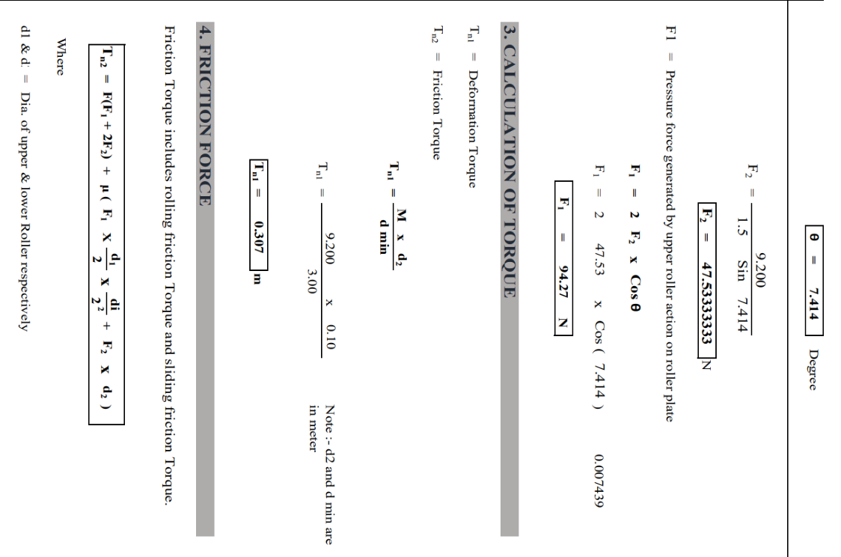
This research examines the history and evolution of roll-bending machines, focusing on technological advancements and their evolution. It evaluates modern designs, analyzing operational concepts, structural elements, and performance capacities. The study also examines roll bender machines' adaptability to various materials and geometries and the precision and efficacy of automation technologies and control systems in optimizing production procedures and reducing errors. The study explores the impact of material characteristics like elasticity, hardness, and thickness on roll bender machines' bending process, suggesting ways to improve accuracy and repeatability. It also compares the financial and environmental effects of roll bender machines to other techniques, considering energy usage, waste output, and manufacturing costs. The research also explores digital modeling and simulation approaches to minimize material waste and prototype time. It also identifies challenges in roll-bending machine technologies, such as handling intricate shapes or maintaining precise tolerances, and suggests directions for further investigation and advancement. The study explores ergonomic design and safety factors in roll bender machine maintenance and operation to minimize workplace accidents and enhance worker comfort and efficiency.
- METHODOLOGY
The research study on roll bender machines uses a complex methodology to analyze and evaluate their performance. It begins with a thorough review of literature and technical documents, followed by hands-on testing with various materials. The study will measure parameters like material thickness, rolled profile diameter, and applied forces, and observe the accuracy, efficiency, and performance of the roll bender under different working situations. The research aims to enhance our understanding of roll bender machine functionality, performance optimization, and design and operation by utilizing statistical analysis tools and qualitative evaluations. This will help identify patterns, correlations, and areas for improvement, while also providing valuable insights from experienced operators and business experts

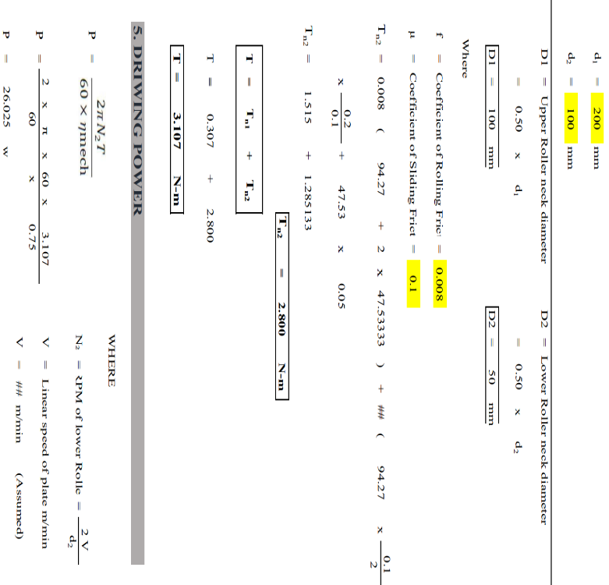

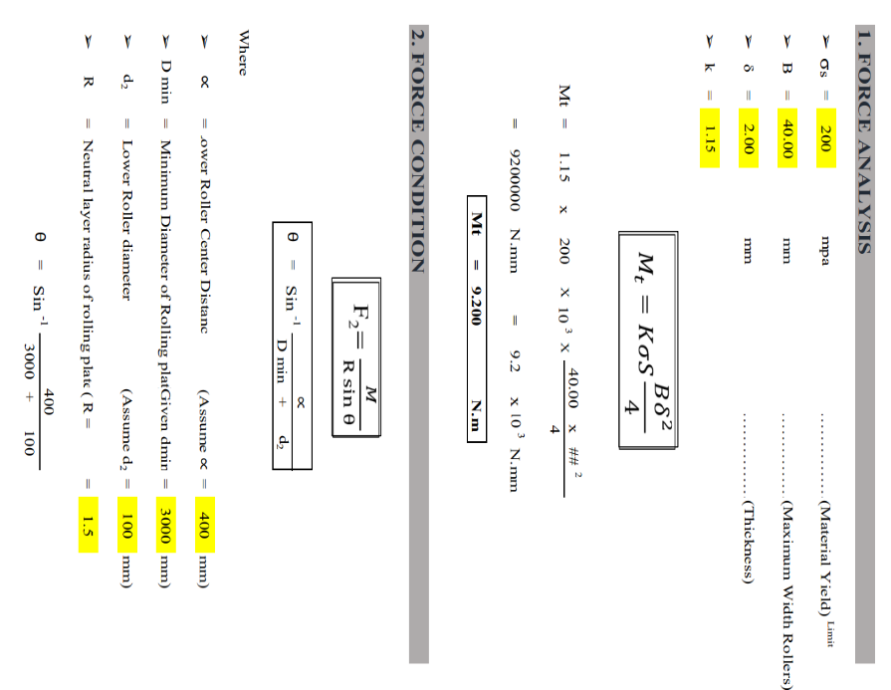
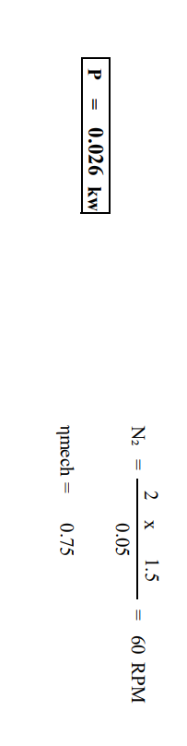
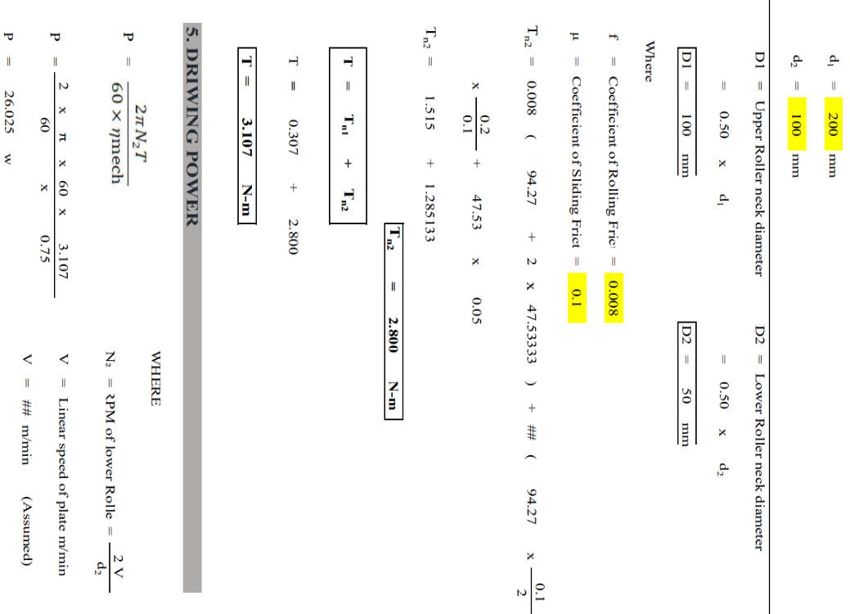
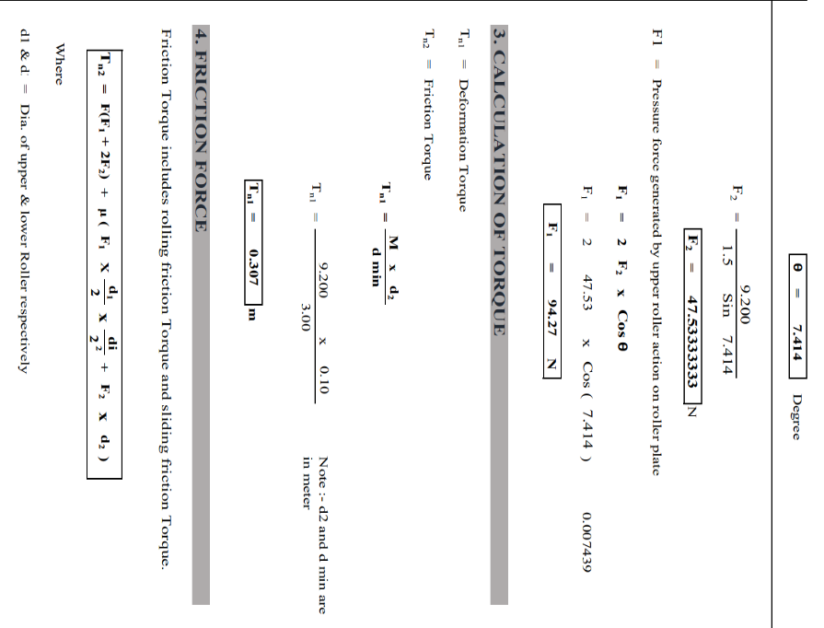
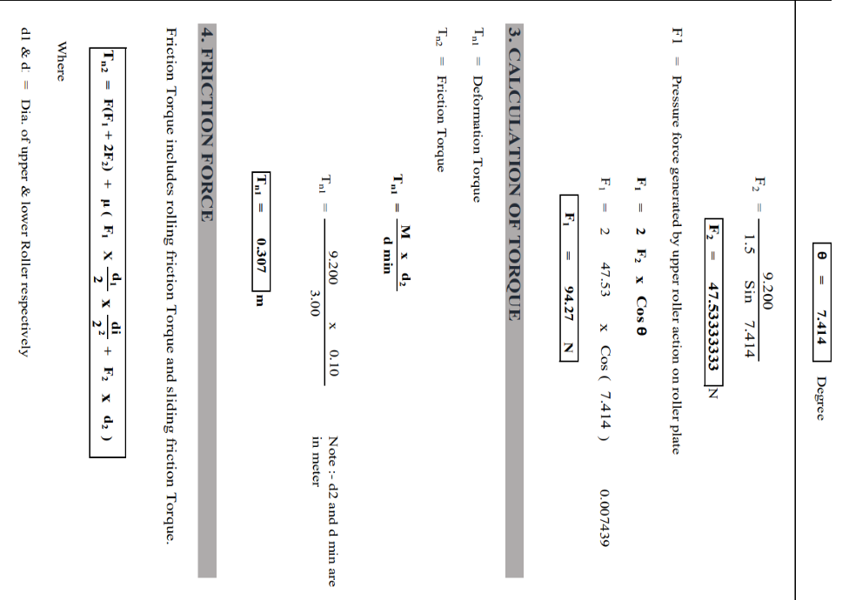

CONCLUSIONS
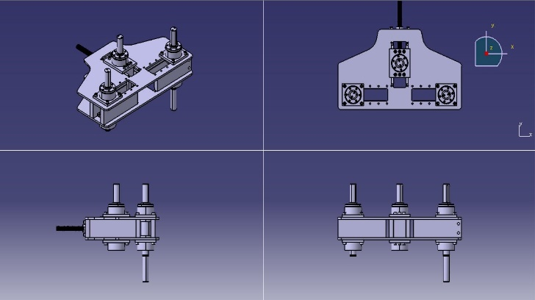
We have successfully designed and implemented a roll bender using concepts of mechanical machine design and calculation. This study explores the role roll benders play in various industries, including fabrication and metalworking. Roll benders offer flexibility and efficiency in shaping metal profiles, meeting various manufacturing needs. Technological advancements have led to sophisticated computer-controlled roll benders, improving accuracy and automation. The demand for creative manufacturing solutions like roll bender machines is expected to grow, requiring further research and development. Understanding the capabilities and limitations of roll benders can help manufacturers improve operations, boost productivity, and maintain market competitiveness.

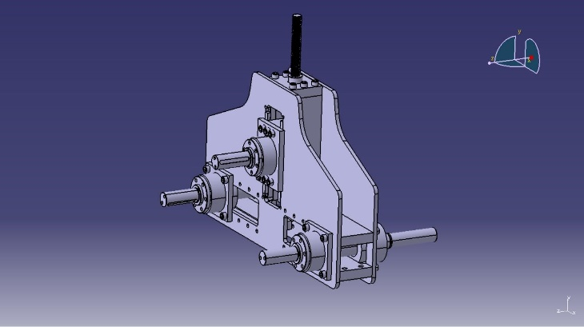
REFERENCES
- Ahn, J., Park, J., & Kim, H. (2021). Development of a CNC control system for a profile bending machine using machine learning-based trajectory prediction. The International Journal of Advanced Manufacturing Technology, 112(1-2), 331– 345.
- Choi, J., Kim, M., & Kang, S. (2020). Curved steel profile bending for architectural structures using a three-point bending machine. Journal of Constructional Steel Research, 172, 106150.
- Lee, C., Kim, H., & Bae, D. (2019). Finite element analysis of the bending process in a profile bending machine considering the frictional contact behavior. Journal of Mechanical Science and Technology, 33(5), 2389–2396.
- Patel, D., & Gandhi, P. (2017). Design and fabrication of roll bending machines. International Journal of Engineering Research and Technology, 6(4), 72–77.
- Ploch, L., & Groche, P. (2018). Finite element analysis of profile bending using the example of a hydraulic profile bending machine. Procedia CIRP, 77, 428–431.
- Wang, S., Tian, J., & Li, Z. (2021). Research on influencing factors of section distortion of roll bending machines. Materials Today: Proceedings, 47(2), 1780–1784.

