Investigation on Indirect, Direct Two Stage Evaporative Cooling System for Different Climate

Prateek S. Alur¹, Manav V. Pawar² Kunal A. Sedame³, Shashank M. Chimurkar⁴, Dr. Homeshwer Nagpure⁵

^{1, 2, 3, 4}UG Student, ⁵Assistant Professor
Department of Mechanical Engineering, St. Vincent Pallotti College of Engineering and Technology Nagpur, Maharashtra,
India
alurprateek1@gmail.com, manavvinodpawar@gmail.com

Abstract-Energy- Efficient space cooling poses a significant challenge due to the substantial energy consumption and emissions, as well as the rapidly increasing demand. The conventional system's reliance on high global warming potential chemical-based refrigerants further emphasizes the necessity for a sustainable and cost-effective alternative. Water-based cooling systems have emerged as a promising solution, offering simple operation, low energy consumption, easy manufacturing, and environmentally friendly characteristics. However, the utilization of direct evaporative cooling systems is hindered by high humidity levels, which are not conducive to human comfort and specific industrial requirements like electronics cooling. Evaporative cooling is a natural process that has been utilized for air cooling purposes since ancient times. This method achieves cooling with minimal energy consumption compared to other cooling alternatives, as it operates by reducing air temperature through water evaporation.
For applications where extremely low temperatures are not necessary, such as summer air-conditioning, evaporative cooling can serve as a viable alternative to conventional systems. This study examines different direct and indirect cooling techniques to explore the diverse methods available for achieving cooling and offering alternatives. The Indirect evaporative cooling system operates by using a heat exchanger to separate the air streams for cooling and ventilation, reducing humidity levels without direct contact between the air and the water. The direct evaporative cooling system, on the other hand, introduces water directly into the air stream, resulting in lower temperatures through the latent heat exchange process. The two-stage evaporative cooling system combines both indirect and direct methods, optimizing cooling performance and humidity control. Experiment was Carried out on Experimental indirect evaporative cooler setup and findings were maximum cooling capacity, efficiency, and heat transfer rate, were recorded with values of 4.022 kW, 64.10%, and 2.119 kW, respectively.

Keywords: air cooler, evaporation, Indirect cooling,
Heat exchanger.

I- INTRODUCTION
In recent decades, there has been a significant growth in the global energy demand for building cooling, raising concerns about the depletion of energy resources and potentially to the warming of the planet. Estimates of the current energy consumption remain at a rate of 40–50% of the total primary power used. Countries with hot climates have the largest percentage of construction energy usage is mostly caused by conventional space air-conditioning systems. In the Middle East, for instance, it accounts for about 70% of the energy used in buildings and roughly thirty percent of the entire amount consumed. These days, structures People's lives now depend on conditioning, even in plays an essential part in guaranteeing interior comfort standards. Therefore, Increasing the cooling technologies' efficiency is vital, especially those that exhibit promise, i.e., high low performance [1]. Meanwhile, studies indicate that in the near future, an indirect evaporative cooler with low energy consumption and high a range of applications would be created. Indirect evaporative cooler technology is less

harmful to the environment and has a smaller impact on global warming than traditional refrigeration [2]. There are two main kinds of evaporative cooling systems. The direct type uses cellulose media that has a water contact surface on which air is routed through uniformly. However, this approach results in an unfavorable increase in humidity [3]. By contrast, the principal air in the immediate evaporative cooling system is treated passively before coming into close proximity with the water medium. When this occurs, contact with the outermost layer of the heat exchanger or channels, which are separated by the flow of air and water, keeps the temperature lower. This air is fairly A heat exchanger with a large conveyance ability is called a heat pipeline. Additionally, as it uses passive heat transfer, no additional external power is needed [2,3]. The article presents the work done by various researchers in the field of Thermal Engineering. The reviews are discussed under design, development, analysis, optimization of indirect,
direct

A. DIRECT EVAPORATIVE COOLING
In the direct evaporative cooling, the process or conditioned air comes in direct contact with the wetted surface and gets cooled and humidified.

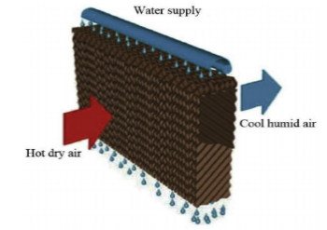

Fig 1: Direct evaporative cooling

B. INDIRECT EVAPORATING COOLING

In indirect evaporative cooling (IEC), the indoor air is cooled without any moisture addition (i.e. moisture contentment will remain constant, the temperature will decrease) and hence, the wet-bulb temperature of air decreases. Therefore, the IEC is more effective for humid climate and it is gaining popularity because it cools air more than DEC.
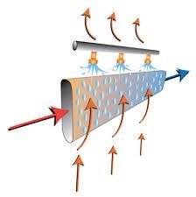
Fig 2: Indirect evaporating cooling

C. Two Stage Evaporative Cooling

Two-stage evaporative cooling combines both indirect and direct evaporative cooling processes to efficiently cool air. In the first stage, hot outside air is drawn into the system and passes through a wet cooling medium, such as cooling pads or a wetted surface. As the air comes into contact with the wet surface, water evaporates, absorbing heat from the air and reducing its temperature. This is the direct evaporative cooling stage, where the air is cooled by the evaporation of water directly into it.

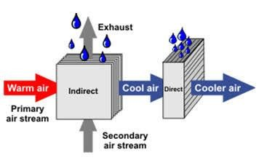
Fig 3: Two stage evaporative cooling

II- PROBLEM IDENTIFICATION

- Humidity Dependency and Performance Variation: Traditional evaporative cooling systems, including desert coolers, operate optimally in arid climates with low humidity levels. However, their efficiency diminishes in humid environments, limiting their effectiveness and applicability. This dependence on humidity levels poses challenges in regions with varying climatic conditions, where consistent cooling performance is essential for comfort and productivity.
- Environmental Impact: The refrigerants used in air conditioners have high global warming potential, contributing to ozone depletion and climate change. Additionally, the energy consumption associated with these systems leads to higher greenhouse gas emissions, exacerbating the global warming crisis. While desert coolers consume less energy, their significant water usage raises concerns about sustainability, particularly in regions facing water scarcity.
- Energy Inefficiency: Traditional cooling systems like air conditioners and desert coolers are notorious for their high energy consumption. Air conditioners rely on energy-intensive refrigeration processes, while desert coolers use powerful fans to circulate air. This results in increased electricity bills for consumers and places strain on power grids, contributing to environmental degradation and carbon emissions.

III- LITERATURE SURVEY

Dr. John R. Watt, a respected scientist at the Research Laboratory of the U.S. Navy, focused on developing and studying four models of plate evaporative coolers. Particularly, a notable prototype included dual stages, in addition to a cooling tower and coil. By conducting thorough analysis, Dr. Watt evaluated the effectiveness and cooling capabilities of these advanced systems.
Interestingly, during the Middle Ages, the Islamic civilization played a pivotal role in disseminating this technology across Western countries. Consequently, evaporative cooling systems began to be widely utilized in Mediterranean regions.
Furthermore, it is believed that Leonardo da Vinci, a renowned figure from history, may have constructed the initial mechanical air-cooler. The device incorporated a hollow wheel which enabled the smooth movement of air, alongside a water curtain that descended into distinct compartments, efficiently cooling and cleansing the nearby environment.
To regulate this system, da Vinci incorporated wooden valves. Ultimately, his design aimed to provide a cooling effect within rooms.

Presently, the work undertaken by Dr. Donald Pescod encompasses a comprehensive compilation of various studies pertaining to plate evaporative coolers.

IV- OBJECTIVES

- To Develop an indirect evaporative air cooler prototype suitable for both residential and commercial applications, focusing on simplicity, efficiency, and affordability.
- To Conduct experimental testing to assess the prototype's cooling performance, energy consumption, and environmental impact under various conditions, including humidity levels and ambient temperatures.
- To Compare the performance of the developed indirect evaporative air cooler with traditional desert coolers and air conditioners through quantitative analysis, highlighting advantages such as lower energy consumption and reduced environmental footprint.
- To Evaluate the economic feasibility and market potential of the indirect evaporative air cooler compared to traditional cooling systems.

V- COMPONENTS

The main components used in this project are listed below:

- FD fan (force draft) - For the provision of pressurized air necessary for systems or boilers, fans are utilized, commonly referred to as forced draft fans or multi-purpose centrifugal fans.

- ID fan (induce draft) - An induced draft fan, also known as an ID fan, is installed to uphold a negative pressure within the furnace. It accomplishes this by extracting the combustion byproducts from the furnace and creating a slight positive pressure at the discharge end in comparison to the base of the chimney or stack.

- Axial Fan -The brushed motor fan incorporates brushes that are connected to its rotor, enabling the creation of electrical contacts through friction. These contacts establish the current path necessary for the fan's operation. On the other hand, brushless motor fans eliminate the need for brushes altogether. Instead, an electronic controller drives the permanent magnets on the rotor, facilitating the movement of the rotor.
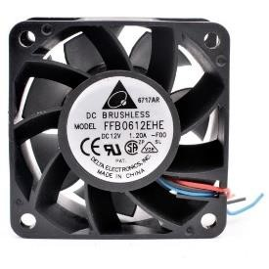
Fig.4: Axial Fan
- SMPS - A switched-mode power supply (SMPS), known as a switching-mode power supply, switch-mode power supply, switched power supply, or switcher, is an electronic device that utilizes a switching regulator to efficiently convert electrical power.
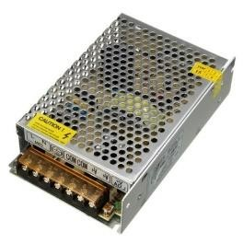

Fig.5: switched-mode power supply

- Upvc pipe-short for unplasticized polyvinyl chloride, is a form of piping manufactured from PVC plastic. It is gaining popularity as a preferred option for water and wastewater systems due to its numerous benefits in comparison to conventional materials such as metal and concrete.

- Diaphram pump -A diaphragm pump, also referred to as a Membrane pump, is a type of positive displacement pump that employs a rubber, thermoplastic, or teflon diaphragm and appropriate valves on both sides of the diaphragm.
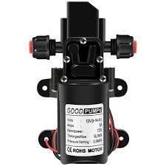

Fig.6 diaphram pump

VI-WORKING OF SYSTEM

In indirect evaporative coolers (IECs), there are two distinct air pathways: the primary or dry pathway, which circulates air to be cooled and supplied to the space, and the secondary or wet pathway, which facilitates evaporation to cool down the heat exchanger. The heart of an IEC is its heat exchanger, which transfers heat but prevents air and moisture from mixing between the two pathways.
During wet channel operation, air from outside, often ambient air, is pulled into the wet channel. This air passes over the wetted side of the heat exchanger, where water is evaporated into the airstream, cooling the heat exchanger in the process. As the water evaporates, it extracts heat from the heat exchanger, causing its temperature to drop. After collecting the moisture and cooling the exchanger, this humidified air is then exhausted outside and not introduced into the conditioned space.
On the other hand, during dry channel operation, separate from the wet air, room air or another source of air passes through the dry side of the heat exchanger without coming into direct contact with water. As this air passes over the cooled heat exchanger, it decreases in temperature without picking up additional moisture. This cooled, dry air is then supplied to the living space or desired area.
To facilitate evaporation, water is pumped from a reservoir and distributed over the wet side of the heat exchanger. Systems are in place to ensure even water distribution and to manage excess water, ensuring optimal evaporative cooling.

VII- SELECTED MATERIALS

Various factors like heat transfer efficiency, cost effectiveness, manufacturability, weight and size considerations for choice of material are considered below mentioned material is selected:
Galvanized Iron Plain Sheet, Material Grade: 90gsm -275 Gsm, Size: 1220mm 1250mm 1500mm, Material Grade. 91GSM -265 GSM, Thickness. 2.00 mm, Size. 1210MM 1240MM 1490MM.

VIII- EXPERIMENTAL WORK

The indirect evaporative cooler operates on 12 V Dc power supply battery operated. It offers advantages such as portability, safety, energy efficiency, and compatibility with renewable energy sources like solar panels for future modifications in the project.

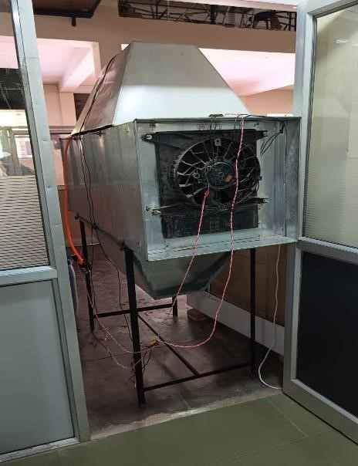

Fig.7: Experimental Setup of indirect evaporative cooler

Table I- Specification of Setup
Parameter | Data
Room up to | 14ft*14ft*14ft
Blower/Fan | Radiator Fan
Cooler dimensions | 62*62*154 cm^3
Fan diameter | 31.6 cm
Speed | 2000 RPM
Power | 220 W
Frequency | 50 hz
Cooling media | Nozzles

1. Mesurement of DBT AND WBT

Table II- Mesurement of DBT AND WBT

Condition | DBT(°C) | WBT(°C)
Outside | T1=33 | T3=23.86
Inside | T2=30.6 | T4=23.05

2. Enthalpies from psychrometric chart
h_{i} = 71.43 kJ/kg
h_{o} =68.34 kJ/kg
3. Measurement of velocity of air
V = 4.0 m/s
4. Volume flow rate of air = Q = V*A
= 4*0.0784
= 0.314 (m^3/s)
5. Calculating Density of Air at outlet = (1.293*273)/ (273+DBT)
= (1.293*273)/ (273 + 30.6)
= 1.162 kg/m^3
6. Mass flow rate M = Q*Density
= 0.314* 1.162
=0.365 kg/s
7. Cooling capacity of the system:
Q_{c} = M*(h_{o} –h_{i}) kW
= 0.365*(71.43 - 68.34) = 1.128 kW
8. Cooling efficiency of Indirect Evaporative Cooler:
= (T_{in,pri}−𝑇_{out,pri})/(𝑇_{in,pri}−𝑇_{wb,in,pri})
= (33 –30.6) / (33- 23.86)
= 26.26 %

IX - CAD MODEL

Computer aided design model was created initially before fabricating our experimental setup. Modelling was carried out in Catia V5 software in order to visualize experimental setup. The utilization of Computer-Aided Design (CAD) modeling, particularly through CATIA V5 software, played a pivotal role in the development of our experimental setup. By creating a virtual representation of the design, we were able to visually conceptualize experimental setup of cooler, identify potential challenges, and modify the configuration before fabrication. CATIA V5's robust features and user-friendly interface enabled us to efficiently model various components and assemble them.

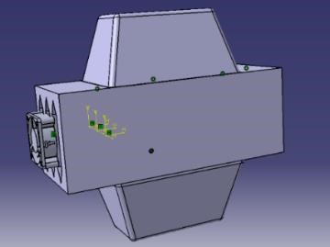

Fig.8: Cad model of Experimental indirect evaporative cooler

X- CONCLUSIONS

In conclusion, the testing of our experimental indirect evaporative cooler indicate a minimal increase in Relative Humidity (RH) compared to direct evaporative coolers. This finding underscores the efficacy of our cooler in maintaining a comfortable RH level while effectively cooling the environment. By minimizing RH fluctuations, our cooler offers a viable solution for environments where high humidity is undesirable. It highlights the potential of our technology to provide both efficient cooling and humidity control, contributing to enhanced comfort. By bridging the gap between direct evaporative cooling systems and mechanical vapor compression systems, this innovative cooler offers an energy-efficient and environmentally friendly alternative. Notably, it eliminates the need for refrigerants, further enhancing its sustainability. Peak performance metrics, including maximum cooling capacity, efficiency, and heat transfer rate, were recorded with values of 4.022 kW, 64.10%, and 2.119 kW, respectively. This suggests that indirect evaporative coolers are effective at maintaining a comfortable RH level without significant increases, making them potentially more suitable for environments where high humidity is undesirable.

ACKNOWLEDGEMENT

The authors are grateful for all the assistance from our guide, Dr. H.G. Nagpure and the alumini mentors Atharva Hiwanj and Arnav Paltewar.

REFERENCES
- Amer, Omar, Rabah Boukhanouf, and Hatem G. Ibrahim. "A review of evaporative cooling technologies." International journal of environmental science and development 6.2 (2015).

- Anisimov, S., & Pandelidis, D. Theoretical study of the basic cycles for indirect evaporative air cooling. International Journal of Heat and Mass Transfer, (2012); 84, 974-989.

- Adam, A., Han, D., He, W., & Amidpour, M. Analysis of indirect evaporative cooler performance under various heat and mass exchanger dimensions and flow parameters. International Journal of Heat and Mass Transfer, (2021); 176, 121299.

- Pandelidis, D., Anisimov, S., Worek, W. M., & Drąg, P. Comparison of desiccant air conditioning systems with different indirect evaporative air coolers. Energy conversion and management, (2016); 117, 375-392.
- Duan, Z., Zhan, C., Zhang, X., Mustafa, M., Zhao, X., Alimohammadisagvand, B., & Hasan, A. Indirect evaporative cooling: Past, present and future potentials. Renewable and sustainable energy reviews, (2012); 16(9), 6823-6850.

