Design and development of automatic center stand for two wheeler
Ashish jyoti¹, Ajit Kumar², Nandlal Pandey³, Abhishek Mishra⁴, Pawan kr. Mahto⁵, Shailendra Kumar⁶, Amit Singh⁷, Piyush Ranjan⁸, Archiman Singh⁹,
Asst.Prof.D.M.Hajare¹⁰
UG Students at Priyadarshini College of Engineering, Nagpur, Maharashtra, India
D.M.Hajare: Asst.Professor, Dept. of Mechanical Engineering, PCE, Nagpur, Maharashtra, India

Abstract- Most modern bikes come with both a side stand and a centre stand. The side stand is easily deployed allowing the bikes to lean to the left side. The bikes must be hoisted up onto the center stand. The difficulties faces with these stands need to be stepped upon and the vehicle needs to be lifted manually. Unless on firm, leveled ground, the side stand on a bikes or any bike cannot be trusted whose wheels cannot be locked in place by setting a brake leaving it in gear. In this paper, an automated centre stand is design and development which uses a linear actuator powered by a battery to lower the stand and lift the vehicle and parks it on the stand. This stand minimizes human efforts to almost zero. In addition, the self balancing mechanism was firmly established which lifts the bikes upright on uneven surfaces. As a result, it has become possible to install this automated centre stand in mass production bikes.
Keywords: Center stand, Automatic, Mechanical linear actuator, battery, Self locking, Switches, etc.

- INTRODUCTION

A center stand is a device on a bicycle or motorcycle that allows the bike to be kept upright without leaning against another object or the aid of a person.^{[1]} A center stand is usually a made of metal that comes down from the frame and makes contact with the ground. It is generally located in the middle of the bike or towards the rear. Some touring bicycles have two: one at the rear, and a second in the front.
Modification in our project of automated center stand is use of mechanical actuator for operating center stand by connecting battery and switches. Now a day’s placing a center stand while parking on the uneven road is difficult and risky, to overcome his problem we are using some mechanical arrangement using rack arrangement which can adjust automatically according to the road surface and the whole system is actuated by mechanical actuator operating through switches.

  - Problem Identification
On surveying, it was found that around 70% males and 30% females drive motorcycle. Among those 70% males, around 30% are oldies and remaining are adults.^{[1]} Most of the females and old people observe that it is very difficult to apply centre stand and hence this made us develop and make it automated. Moreover, applying a side stand;
- Development fatigue in stand
- Increase chances of accident.
- Requires more parking spaces.
- Reduces battery life since the electrolyte is in constant touch with electrode.
Where, applying a center stand manually;
- Requires more manual effort to handle.
- May cause back and/or leg injuries.
Due to above described problems, centre stand is hardly used. However, the centre stand cannot be used on uneven surfaces.
The automated centre stand assembly looks like a metallic rectangular box. It is fixed at the same place as that of the conventional stand. It has two main parts; the lower unit and the upper unit. The upper unit is pivoted to the motorcycle frame and the lower unit is joined to a curved surface for easy lifting. The linear actuator is drive by automobile battery, controlled by toggle DPDT switch which changes the polarities of the supply. The linear actuator is clamped at the centre of the stand assembly which distributes load equally on both the limbs of the stand. A pair of interlocking racks helps to balance the scooter upright.
Since center stand is an integrated parts of two wheeler, but in present time of day, it is very difficult to operate the center stand by older and disable person and ladies. So, it must be modified for the sake of their convenience in all aspects. In our design we modified the existing center by using electrical and mechanical components at optimum cost. The considering these problem we modified our design which has good scope in future by some modification and design of vehicle. Thus, it is more reliable
It is belief that necessity is the mother of invention. Here the necessity lies in reducing the human effort applied during manual operation of the centre stand. And hence the need of the invention in day to day life it is very tedious job to operate the centre stand manually. so, to make it easier for everyone, especially for old and handicapped persons and ladies to provide a safe and simple automatic centre stand without manual effort that can be operated from within the vehicle by the help of mechanical actuator, toggle(DPDT) switch and 24 volt battery. There are certain mechanism are also used which works on the rack and rack mechanism. The complete unit is mounted beneath the engine in such a way, so that it cannot make any damage to the vehicle.

- MAIN COMPONENTS OF PROJECT
- Mechanical linear actuator
- Modified center stand
- Battery
- Toggle switch

  - Components specification
2.1.1. Mechanical linear Actuator
A linear actuator is an actuator that creates motion in a straight line, in contrast to the circular motion of conventional electric motor. In valves and dampers, and in many other places where linear motion is required. Hydraulic or pneumatic cylinder inherently produces linear motion. Many other mechanisms are used to generate linear motion from a rotating motor. Typically operates by conversion of rotary motion into linear motion. Conversion is commonly made via a few simple type of mechanism. A linear actuator of capacity 4000N and 275mm in length is used in this design. The actuator has a stroke length of 100mm which is used to flip the stand up and down.

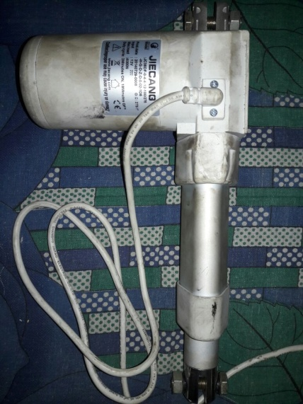
Fig1.Actuator

    - Modified stand
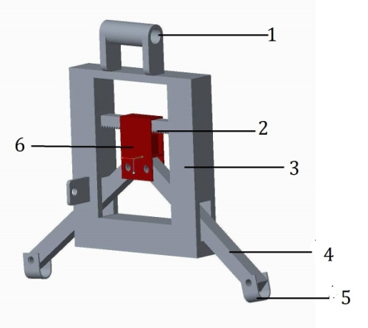
Fig2.Modified stand

- Pivot at vehicle frame
- Rack and rack for balancing
- Primary frame
- Adjustable legs
- Contact pads
- Pivot for Actuator

    - Battery
AN electric battery is a device consisting of one or more electrochemical cells that convert stored chemical energy into electrical energy. Each cell contains a positive terminal or cathode, and a negative terminal or anode, electrotypes allow ions to move between the electrodes and terminal which allows current to flow out of the battery to perform work. Rechargeable12v dc batteries are produced in many different shapes and sizes, ranging from button cells to megawatt systems connected to stabilize an electrical distribution network. Several different combinations of electrode materials and electrolytes are used, including lead–acid, nickel cadmium (NiCd), nickel metal hydride (NiMH), lithium ion (Li-ion), and lithium ion polymer (Li-ion polymer).

    - Toggle switch

DPDT in electrical engineering a switch is an electrical component that can break an electrical circuit, interrupting the current or diverting. IT from one conductor to another. The mechanism of a switch may be operated directly by a human operator to control a circuit. The most familiar form of switch is a manually operated electromechanical device with one or more sets of electrical contacts which are connected to external circuits.


Fig3.Switch
- WORKING OF CENTER STAND
1) When we turned on the switch, the linear actuator pivoted at the centre of the stand assembly actuates and pushes the stand downwards.
2) When the stand touches the ground, it is not possible for the stand to move any further and hence the bikes get lifted gradually.
3) After the full displacement of the actuator, the stand is in applied position.
4) The actuator cannot be displaced manually which gives an additional benefit in respect to safety.
5) When the polarity is reversed, through the toggle switch, the linear actuator starts to displace in reverse direction and hence lifting the stand and lowering the motorcycle back onto the wheels.
6) Following observations are recorded;
Stand rotation angle  (degree) | Lift of bike (cm) | Displacement of actuators (cm)
50  (Ground contact) | 0 | 3
55 | 2.5 | 5
59.5 | 3.4 | 6
65.04 | 4 | 8
74 | 10 | 10

Table1: Observation table

- DESGIN CALCULATION

- Calculations for reaction at support
- Force analysis of lever
- Shear force & Bending moment for lever
- Design of bolt

4.1 Consider the complete weight of body
I.e. weight of body + weight of stand
= (120 + 60) kg
=180 kg ≃ 1800N

∴ RE = W/2 = RF
= 1800/2
= 900N

  - Force analysis of lever

Consider, a lever of L1 & L2
Which have $σ_{B}$= Bending Stress
Z = Section Modules
M = Bending Moment
$τ$ = shear Stress
$σ_{cr}$ = Crushing Stress

Lever (1)
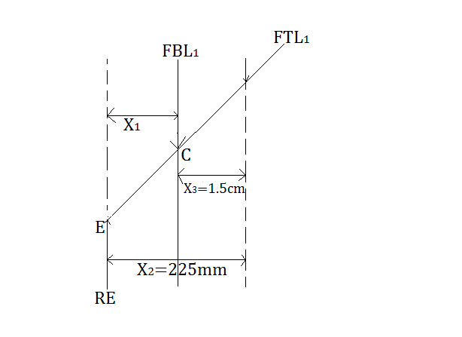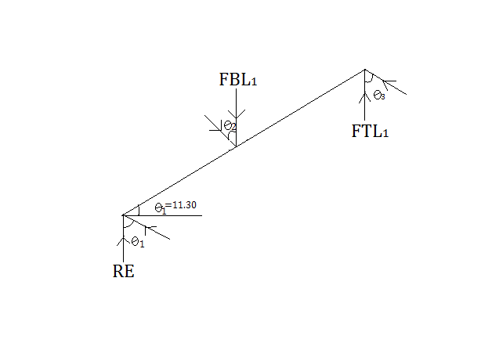
Fig6.Assumed view Fig7.Corrected view
X₁ = 2.5 Cm = 25mm
X₃ = 2 Cm = 20mm
Using equilibrium condition
⇅ƩF_{y} = 0 ⇄ƩF_{x} = 0 ƩM_{R} = 0
R_{E} = F_{BL1} + F_{TL1}
ƩM_{C} =0
R_{E}x$×$X₁ + FTL1$×$ X3 900 = FBL₁ –1500N
900X$×$25 + FTL₁$×$15 = 0 FBL1=1500 + 900
22500 + FTL₁ $×$ 15 = 0 FBL₁ = 2400N
FTL₁ = 22500/15 = -1500N
Lever (2)
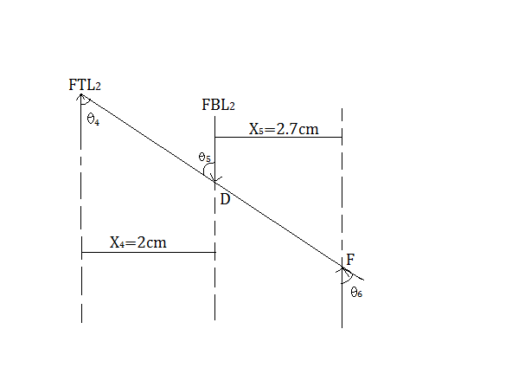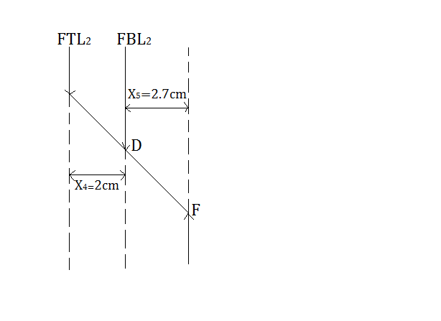
Fig8.Assumed view Fig9.Corrected view
ƩFY =0 900$×$27+FTL2$×$20=0
RF= FDL2 + FTL2 24300+FTL2$×$20=0
ƩMD=0 FTL2=-24300/20= –1215
RF$×$X5+FTL2∗X4=0 900=FDL2–1215
FDL2=1215+900=2115N

4.3.1. Shear force & bending moment for lever1 (L1)
Load diagram
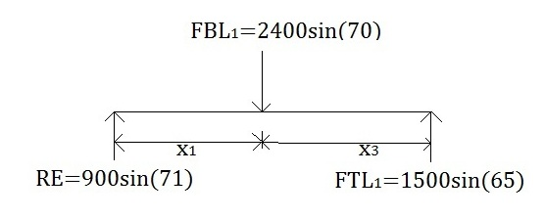
Shear force diagram
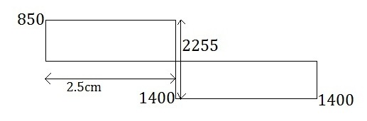
Bending moment diagram
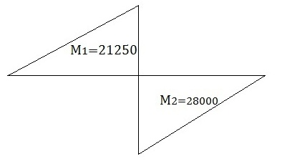
Bending stress calculation for level (1) d = 20mm
$σ$b = M/Z^{[5]} - (a) Moment = 28000
Z = bd²/6 = 20$×$ (20)²/6 = 1333.33 $σ$_{b} = 28000/1333.33 from (a)
Where, $σ$_{b} = 21 N/mm²
b = 20 mm

4.3.2 Shear force & bending moment for lever 2 (L2)

Load diagram
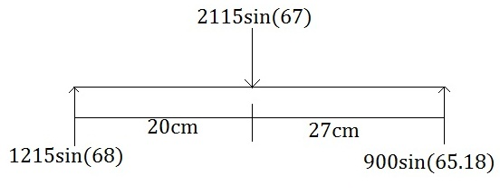
Shear force diagram
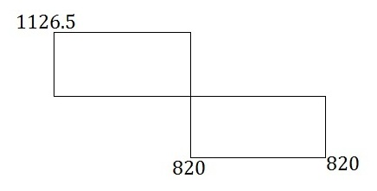
Bending moment diagram
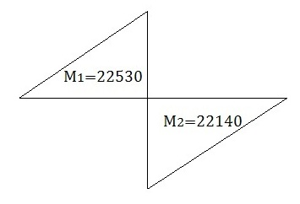

Bending stress calculation d = 20mm
$σ$_{b} = M/2 Moment = 24300 N-mm
Where, $σ$_{b} = 24300/1333.33
Z = bd²/6 = 20∗ (20)²/6 = 1333.33 $σ$_{b} = 16.89 N/mm²
Where,
b = 20 mm
4.4. Design of bolt
Consider, the material of Bolt in SAE 1030 of FOS = 2^{[3]}
Now,
Sys = 183 N/mm²
$τ$ = Sys/FOS^{[3]} = 183/2 = 91.5 N-mm²
$σ$_{cr} (all) = 2∗Sys = 2∗183 = 366 N/mm²
Diameter of Bolt = 8 mm
Shear stress = FBL1/ πdl = 2400/πdl = 3.41 ˂ 91.5
Crashing stress = FBL1/$\frac{π}{4}×d^{2}$ = 2400/$\frac{π}{4}×64$ = 47.74 N/mm²
47.74 < $σ$_{cr}
∴Design in safe for Bolt (1)
Bolt (2)
Shear stress = FDL₁/$πdL$ = 2115/$π×8×28$ = 3 N/mm²
3 < $τ (all)$
Crashing stress = FDL₂/$\frac{π}{4}×(d)$² = 2115/$\frac{π}{4}×64$ = 42 N/mm²
42 < $σ$_{cr} (all)
∴Design is safe for Bolt (2)
- Advantages
1. Requires less human efforts.
2. Requires less parking spaces.
3. Easy to handle for women and old people.
4. Easy to use for handicaps.
5. Easy to install and uninstall.
6. Balances the scooter upright on uneven surfaces.
7. Safe while parking on center stand on uneven surfaces.
8. Center stand can adjust on any uneven surfaces automatically.
- Conclusion
As we know that the centre stand is the integral part of two wheeler vehicle. To make the vehicle in a stable position. That is in a well balanced position we generally apply the centre stand but it is very difficult for old women and handicap person. To use the present centre stand so by considering all the design parameter &above condition. We notified the existing design &make the centre stand automated. Thus it is concluded that the use of this modified centre stand makes the human effortless and make the vehicle in were at optimum cost balanced condition rough surfaces (uneven surfaces) at optimum cost.
7. REFERENCES
1. Vishal Srivastva, Sourabh Kumar, Vinay Kumar, “Automatic side Stand", International Journal of Engineering and Advanced Technology (IJEAT), ISSN: 2249-8958, volume-3, Issue-4, April 2014.
2. Design data book- “B D SHIWALKAR”
3. Analysis on breaking ability of automobile equipped with eddy current retarder. HE Ran, HE Jian-qing(school of Automobile & Traffic Engineering, Jiangsu University, Zhenjiang , Jiangsu 212013, china).
4. Strength of material, 2010-2011 “R K BANSAL”
5. US Patent 3658360 from www.patentscope.com/us
6. US Patent 4095823 from www.Espacenet.com
7. Problems from www.ijmhs.net
BIOGRAPHIES






