Harmonic Reduced 3-phase Thyristor Controlled Reactor for Static VAR Compensators
Utkarsha C. Bakale¹, Prof. M.V.Jape²
¹Mtech. Student,²Assistant Professor
Government College of Engineering, Amravati, India, 444601

Abstract –Controlled power is a fundamental necessity of various sectors and controlling of power is made by Static VAR Compensators (SVC) is used with fast response time characteristics to overcome compensation problems. This paper discuss about one of the FACT device i.e. Thyristor Controlled Reactor (TCR) which is a part of SVC is used to compensate the reactive power in transmission line and meeting the limit on harmonics.. A TCR scheme is presented in this paper in which the total bank is split into one Δ connected reactor bank and one Y connected reactor bank having same kVA rating and also consist of a low kVA rating zigzag autotransformer, into place of the conventional Δ connected reactor bank with a harmonic current filter. This arrangement averts the triple harmonics generated by the Y bank from entering into the supply system because which is circulate in zigzag autotransformer and at the same time, the combination results in cancellation of some major harmonics from the source current. Thus, without using any additional filters, this topology make easy reactive power control over a wide range and also meets the necessary harmonics standards. The scheme is simple and provides an economic solution to the VAR compensation problem.
Keywords- Phase control, Power quality, Reactive power control, Power system harmonics, Static VAR compensators, Thyristor Controlled Reactors, Transformers.
INTRODUCTION
Thyristor Controlled Reactors (TCR) have been used in various FACTS devices as one of its basic Component. The TCR is used in conjunction with Thyristor Switched Capacitors (TSC) in Static VAR Compensators (SVC) to produce a smooth control over the VAR compensation [1]. In various applications, the non-sinusoidal Current drawn by TCR due to the phase angle control strategy used with its thyristor switches, has resulted in its best use as a Delta (Δ) connected bank of inductors with phase current control, such that the triple harmonic currents circulate within the Delta network and not appear in the line currents. Moreover, the presence of other lower order harmonics in the lines had resulted in the need for additional harmonic current filters to be used with such systems in order to meet Power Quality norms [2][3]. Use of this filters makes the system costly and bulky but also creates resonance problem between the filter and the grid components. Due to fast response, high efficiency and low maintenance. SVC’s are finding increasing use in power systems for improvement of voltage regulation and transient stability, and in industrial applications, for power factor improvement. Conventional TCRs generate high THD and need filters to reduce the THD, which are not needed in the new scheme. The topology is simple and provides an economic solution to building a Static VAR compensator using Thyristor Switched Capacitors (TSC) or Fixed Capacitors (FC).
TCR TOPOLOGY
This TCR scheme is shown in Fig. 1, consist of a Static VAR compensation system, using inductors and back to back Thyristor (SCR) static switches. Two separate banks of inductors are connected to the 3-phase supply lines, consisting of one Delta (Δ) connected bank of three inductors with three phase switches and one star (Y) bank of three inductors with three line switches.
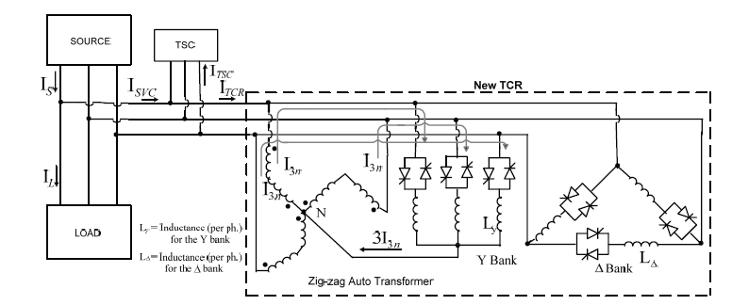
Fig. 1
The star point of the Y bank is connected to the neutral point of a zigzag autotransformer and later the line terminals are connected to the 3-phase supply lines. In this new system, the triple harmonic currents (I_{3n}) generated by the Y bank has a path to circulate through the zigzag transformer without entering the source. The ratings of the Δ and Y banks are selected to be same (i.e., each is half of the total kVA rating), permitting cancellation of several low order harmonics. It is also shown that the additional zigzag autotransformer used in this scheme has a considerably low kVA rating as compared with the composite TCR unit. Thus, this new TCR configuration can be used in conjunction with TSC over a wide range of control without the need for additional filters. It is as an economic solution to dynamic reactive power compensation problem in high power grid.
PRINCIPLE OF OPERATION
The rating of the composite TCR bank is taken as 100 kVAr at 400V 3-ph 50 Hz ac supply, which corresponds to the maximum capacity at triggering angle α = π/2 (90°). Both the Δ and Y banks have same capacity i.e. 50 kVAr each. The voltage fascinated across each of the six windings of the zigzag transformer (V_{w}) and the per phase inductance values for the Δ and Y banks (L_{Δ} and L_{Y}) can be calculated from the following expressions, where V_{L} = Line Voltage, V_{ph}= Phase voltage and f = Supply frequency.
$V_{w}=\frac{V_{ph}}{\sqrt{3}}=\frac{V_{L}}{3}$ (1)
$L_{Δ}$ = $\frac{3×V_{L}^{2}}{kVAr×{10}^{3}×2πf}$ (2)
$L_{Y}$ = $\frac{3×V_{Ph}^{2}}{kVAr×{10}^{3}×2πf}=\frac{V_{L}^{2}}{kVAr×{10}^{3}×2πf}$ (3)
The Y-connected bank can be considered as a set of three independent phases operating separately across the 3-phase lines with zigzag auto transformer generate an artificial neutral. The Y bank produces harmonic currents in the line supply, with triple harmonics. The zigzag autotransformer has two similar windings in each phase, which are wound in opposite directions. Such arrangement offers higher impedance to the normal phase currents and at the same time provides a low impedance path to the triple currents. Thus, the triple harmonics circulate within the Y connected bank and zigzag autotransformer and which are not reflected onto the supply lines. The Δ-connected bank can be considered to be operating separately across the 3-phase lines, producing its harmonic currents in each phase in same as the Y bank. The Δ bank phases are triggered with respect to the line voltages (instead of phase voltages in Y bank). Hence, the phase current in the Δ bank is phase shifted by π/6 (30°) with respect to the phase current in the Y bank. However, the phase current wave shape would be similar to that of the Y bank and hence have the similar nature of harmonic content. The line currents will contain harmonics, but without any triple harmonics, the latter circulating only within the Δ bank. The current functions become odd and there will be only sine terms in the Fourier expression, which can be expressed as:
$i(t)=\sum_{n=1,3,5}^{∞}{b_{n}sinn}ωt$ (4)
Expression for the coefficient b_{n} for the Y bank line current can be obtained by integrating the following expression:
$b_{n}$ = $\frac{2}{π}\int_{α-\left(\frac{π}{2}\right)}^{α-\left(\frac{π}{2}\right)+σ}{\frac{\sqrt{2}.V_{ph}}{ωL_{Y}}} \left(cosα-\cos\left(ωt+\frac{π}{2}\right)\right)sinnωt.d\left(ωt\right)$
(5)
Where n = (2m + 1), m = 1, 2, 3…
α = Triggering Angle
σ = Conduction Angle
The coefficient bn for a Δ bank line current can be calculated using similar expressions as for the Y bank as:
$b_{n}$ = $\frac{2}{π} [\int_{α-(2π/3)}^{α-(2π/3)+σ}{\frac{\sqrt{2}.V_{L}}{ωL_{Δ}}}(cosα-cos(ωt+\frac{2π}{3})) sinnωt.d(ωt)$
+ $\int_{α-(π/3)}^{α-(π/3)+σ}{\frac{\sqrt{2}.V_{L}}{ωL_{Δ}}}(cosα-cos(ωt+\frac{π}{3}))sinnωt.d(ωt)$] (6)
From eq. (5) and (6), the RMS value of the n^{th} harmonic current for the Δ and Y bank can be obtained as presented in (8) and (9). As present in this work, since the inductor banks in Y and Δ have the same kVAr capacity, from (2) and (3)
$\begin{matrix}L_{Δ}=3L_{Y}\end{matrix}$ (7)
The n^{th} harmonic of the resultant TCR current (RMS) will be the component summation of the currents drawn by the Δ and Y bank. With eq. (7) being valid, identical triggering angle, same line voltage & frequency, the resulting nth harmonic RMS current drawn by the combined TCR is expressed in (10).
$I_{∆}\left(rms\right)=\frac{2V_{L}}{πωL_{Δ}}\left(sin\frac{nπ}{3}+sin\frac{2nπ}{3}\right)\left[\frac{\sin\left(n+1\right)α}{n}+\frac{\sin\left(n-1\right)α}{n}-\frac{\sin\left(n+1\right)α}{\left(n+1\right)}-\frac{\sin\left(n-1\right)α}{\left(n-1\right)}\right]$ (8)
$I_{Y}\left(rms\right)=\frac{2V_{Ph}}{πωL_{Y}}sin\frac{nπ}{2}\left[\frac{\sin\left(n+1\right)α}{n}+\frac{\sin\left(n-1\right)α}{n}-\frac{\sin\left(n+1\right)α}{\left(n+1\right)}-\frac{\sin\left(n-1\right)α}{\left(n-1\right)}\right]$ (9)
$I_{n\left(res\right)}\left(rms\right)$=$\frac{2V_{L}}{πωL_{Δ}}\left(sin\frac{nπ}{3}+sin\frac{2nπ}{3}+\sqrt{3}sin\frac{nπ}{2}\right)\left[\frac{\sin\left(n+1\right)α}{n}+\frac{\sin\left(n-1\right)α}{n}-\frac{\sin\left(n+1\right)α}{\left(n+1\right)}-\frac{\sin\left(n-1\right)α}{\left(n-1\right)}\right]$
(10)
From eq. (10), it will be noted that the specific nth harmonic line current is zero (for any triggering angle) if:
$(sin\frac{nπ}{3}+sin\frac{2nπ}{3}+\sqrt{3}sin\frac{nπ}{2})=0$ (11)
n=6(2k+1)±1, where k=0,1,2,… , i.e.
For n=5, 7, 17, 19, 29, 31…
Thus, the results obtained from the harmonic expressions for the total line currents of the two banks combined show that all [6(2k+1)±1] harmonics (k = 0, 1, 2,) are eliminated from the resultant line current due to mutual cancellation effect between the Y and Δ banks, both having the same triggering angle. Of these, the most dominant are the 5th and 7th harmonics.
However, the remaining harmonics in the combined line current, i.e., the [12k±1] harmonics (k = 1, 2,), or the 11th, 13th, 23rd, 25th, etc., add up. In spite of this, the total THD is reduced due to the elimination of the dominant lowest order harmonics 5th & 7th.Since only the triple harmonics flow through the zigzag autotransformer, the total kVA rating S _{z-z} of the autotransformer windings can be derived from the following expression,
$S_{z-z}=6×V_{w}×I_{3n(max)}×{10}^{-3}$ (12)
Where V_{w} is the autotransformer voltage per winding, which is V_{ph}/√3 = V_{L}/3. A zigzag autotransformer of total 8 kVA (equivalent to 4kVA two-winding transformer) is selected (neglecting any kVAr drawn by the transformer itself).
CONTROLLER CIRCUIT
Reactive Power control using the new TCR include detail detection of the reactive component of load current. The proposed control circuit is depicted in Fig .2 The Point of Common Coupling (PCC) instantaneous voltage is monitored and the PLL block is used to synchronize a set of variable frequency with the line voltages. The ‘sine’ and ‘cosine’ calculation are provided by PLL driven positive sequence fundamental value block and output is given to the transformation block. Three phase instantaneous load current I_{Labc} is monitored and transformed to d-q components (i_{d} &i_{q}) in the synchronous reference frame. As only the fundamental reactive power component is needed, i_{q}* (the dc component of i_{q}) is obtained by using a Low Pass filter with suitable gain. The required fundamental reactive current to be supplied by the compensator can be found through inverse transformation (dq→abc).
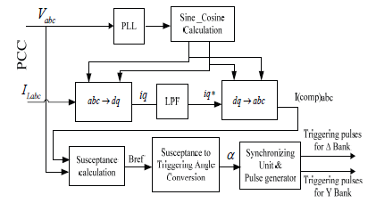
Fig. 2
B_{ref} is calculated by this formula
$\begin{matrix}B_{ref}=[2(π-α)+sin2α]/(πωL)\end{matrix}$ (13)
Where L is to be considered as per-phase inductance for the Delta bank and Y bank separately. Susceptance to triggering angle conversion block has input as B_{ref} and output as α and also consist of distribution unit to determine TCR firing angle which is implemented by look up table as α is function of B_{ref}. However, since reactive power is same for both the banks, both computations will yield the same value of α. The two sets of triggering pulses for the Y and Δ banks are separately fed to the gate of the corresponding thyristor.
SIMULATION ANALYSIS
A MATLAB/Simulink based model is developed for the proposed 100 kVAr TCR unit. The model include thyristor switches with associated snubber circuitry and pulse generator. Results show that this composite TCR bank yields a lower THD value compared to the conventional TCR for 100°, 120° and 140°.
When compared to the conventional 12 pulse TCR, the new TCR is slightly inferior at higher triggering angles only but it does not use any full power rated isolation transformers as in the former TCR. Thus this TCR bank can be successfully utilized in conjunction with TSC for controlling VAR in a high power grid without any additional filter. However, the THD values applicable as per standards are at PCC, where the resulting THD can become significantly reduced due to the presence of normal load current with low THD. Simulated waveforms for the Star and Delta bank line currents at different triggering angles (α = 100°, 120° and 140°) are shown in Fig. 3 and 4 respectively. The line current waveforms for the Y bank are discontinuous pulses with distortion which is caused mostly due to the presence of the triple harmonic components.
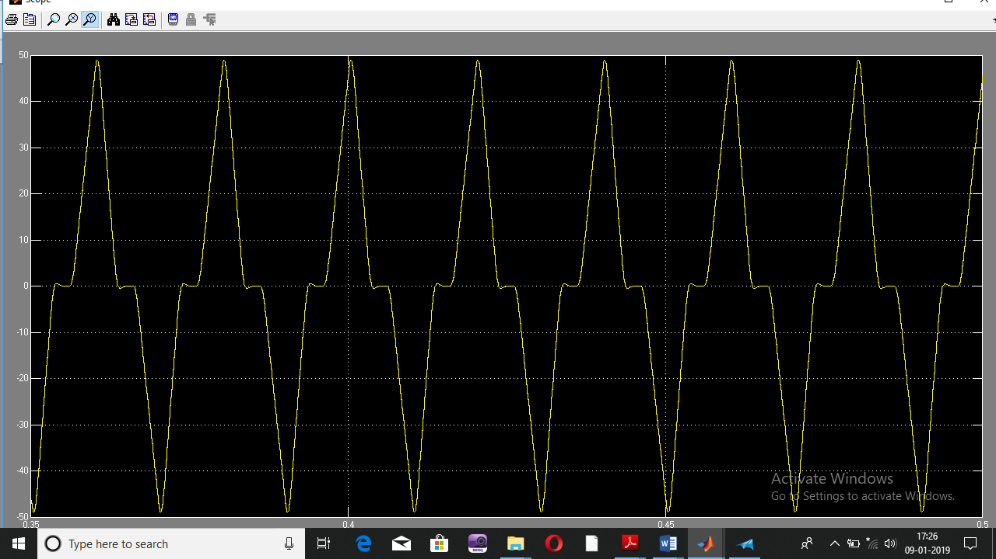
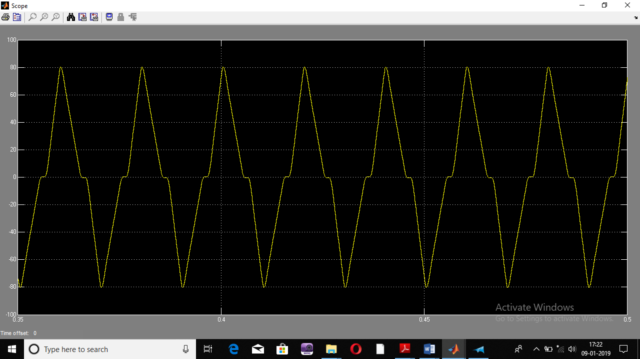

Triggering angle=100º

Triggering angle=120º

Fig. 3. Simulated Star bank line current
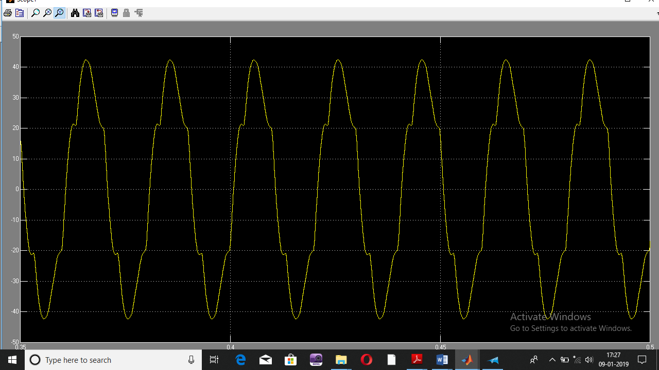
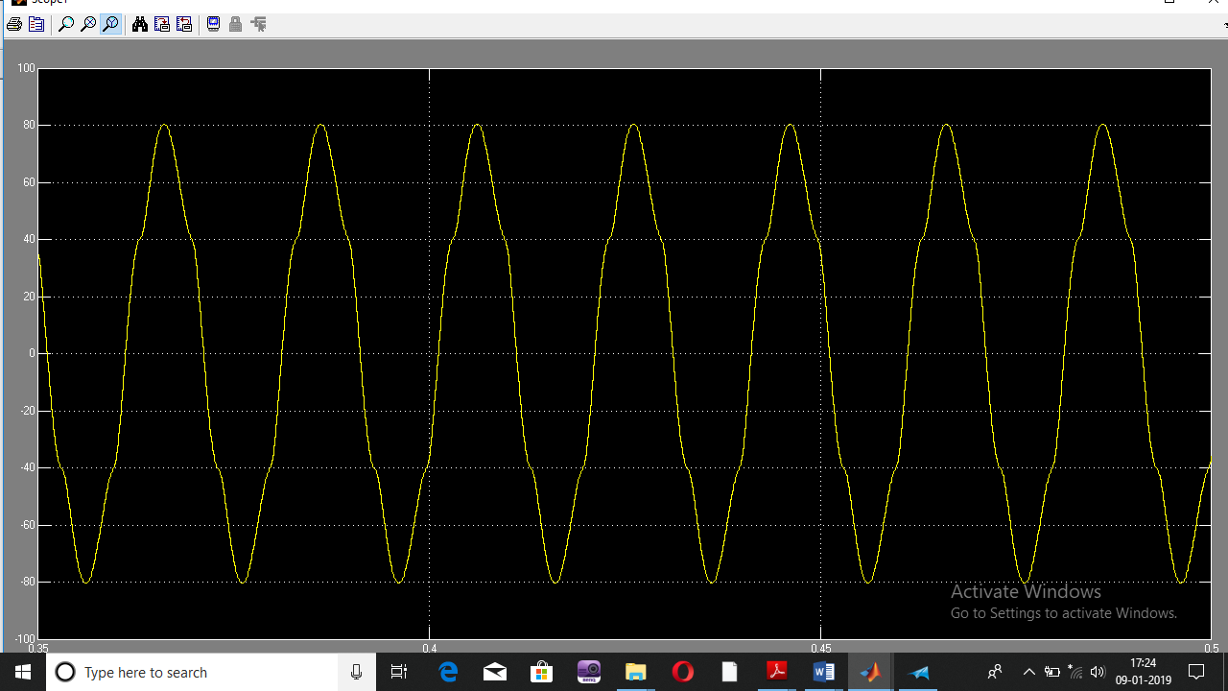

Triggering angle=100º

Triggering angle=120º

Fig. 4. Simulated delta bank line current
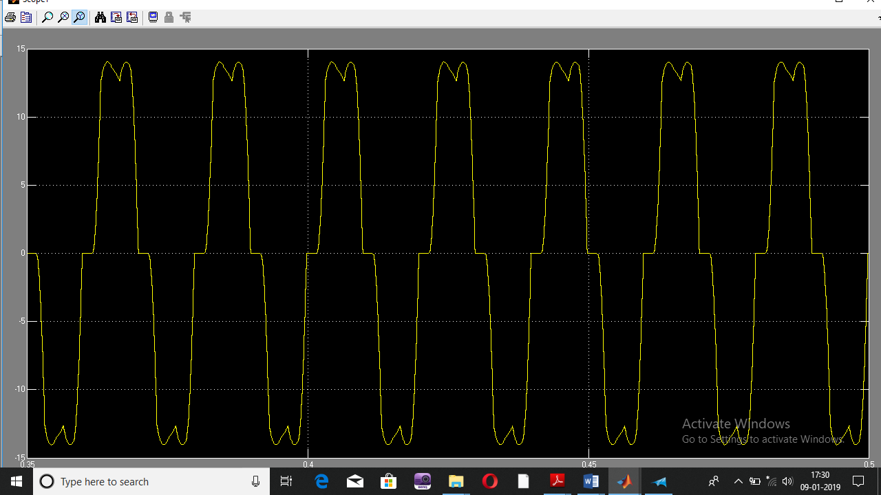
The Δ bank line currents are found to be continuous in nature but suffers from distortion mainly due to the presence of 5th, 7th, etc. harmonic components. As the triple harmonic currents circulate within the Δ bank so the line current of the Δ bank shows a much reduced THD value as compared to the Y bank. The resultant TCR current with zigzag autotransformer is shown in Fig. 5. Resultant current waveforms at different triggering angles show reasonable sinusoidal currents due to mutual cancellation effect, resulting in absence of the dominant 5th and 7th harmonic components in the source current. With the incorporation of the zigzag autotransformer, the triple harmonic current circulates within the zigzag transformer and the Y bank and therefore the major characteristic harmonics present in the resultant TCR current are only 11th, 13th, 23rd, and 25th.
Triggering angle=140º

.

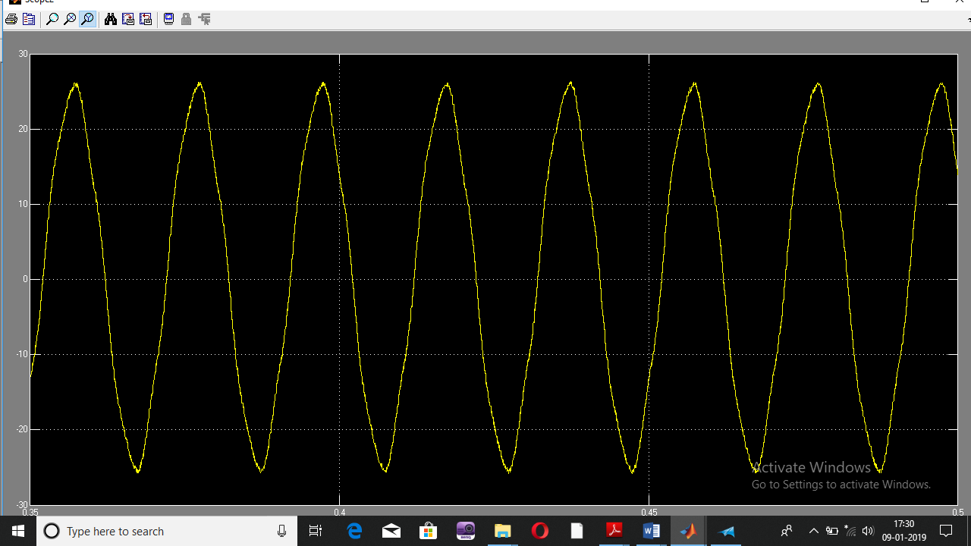
Triggering angle=140º

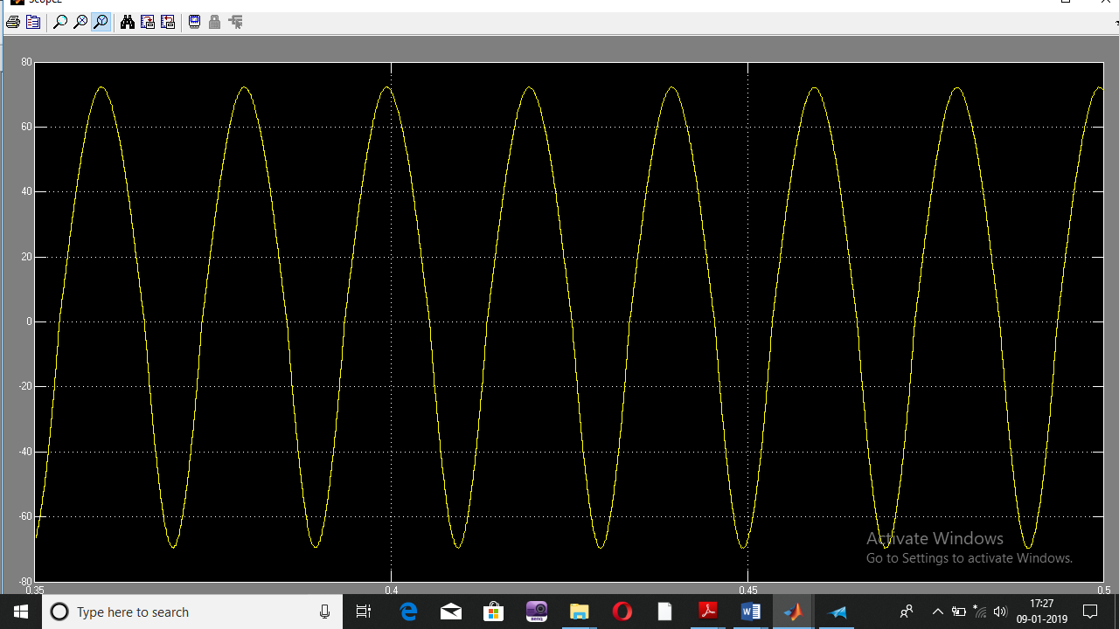
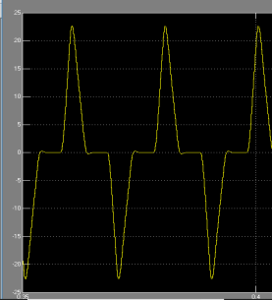
Triggering angle=140º

Triggering angle=100º

Triggering angle=120º

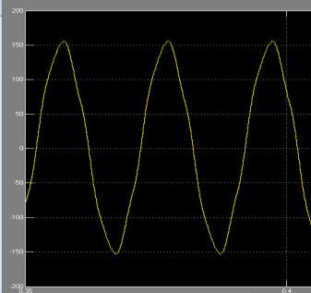

Fig.5Simulated TCR current
. CONCLUSION
A TCR topology is presented in this paper which is basically a combination of a Δ and Y connected thyristor controlled reactor banks to cater to the same kVAr earlier handled by a single Δ connected bank with the addition of a low rating zigzag autotransformer. Analytical, simulation and experimental results are presented to show that the proposed TCR maintains a low current THD level throughout its typical 10:1 operating range without the use of a harmonic filter or full power rated isolated phase shifting transformers. The total cost of the new scheme is only marginally higher than the existing Δ connected scheme while the cost of additional filters in the latter are removed here.
REFERENCES
- N. G. Hingorani, L. Gyugyi, Understanding FACTS concepts and technology of Flexible AC Transmission System, Wiley India private Ltd., New Delhi ,2015
- Rohan S. Khonde , Prof. M. V. Palandurkar, “Simulation Model of Thyristor Controlled Reactor”, International Journal of Engineering Research & Technology (IJERT) Vol. 3 Issue 4, April - 2014
- M. Imran, Ajaz Fatima “A Comparative Study on Single Phase TCR Reactive Power Compensator”, MJCET EEE Department, Hyderabad, India.
- A. Luo, Z. Shuai, W. Zhu and Z. Johnshen, “Combined system for harmonic suppression and reactive power compensation”, IEEE Trans. Industrial Electronics, Vol.56, no.2, 2009, pp.418-428
- Dipten Maiti , Susovan Mukhopadhyay , Ambarnath Banerji,Sujit K. Biswas,K. Deb, “Harmonic Cancellation in a Three-Phase Thyristor Controlled Reactor Using Dual Banks”, IEEE transactions on industrial electronics, vol. 64, no. 12, 2017
- J. E. R. Alves, L. A. S. Pilotto, and E. H. Watanabe, "Thyristorcontrolled reactors nonlinear and linear dynamic analytical models", IEEE Trans. Power Delivery, vol. 23, no. 1, 2008, pp. 338-346
- H. B. Mutluer, “Design, implementation and engineering aspects of TCR for industrial SVC systems”, PhD thesis, Electrical and Electronics Eng. Dept., Middle East Technical University, Mar 2008
- L. Yunbo, Y. Han, C. Zhengpai and Z. Jianhua, “Development of dynamic VAR compensator based on 12 pulse thyristor controlled
reactor”, Proc. of IEEE 32nd Annual Conference on Industrial Electronics (IECON), 2006, pp. 2454-2458
- D. Thukaram, H. P. Khincha and B. Ravikumar, “Harmonic minimization in the operation of static VAR compensators for unbalanced reactive power compensation”, Proc. of International Conference on Power System Technology (POWERCON), 2004, Vol.1, pp. 328-334
- J. C. Montano, J. Gutierrez, A. Lopez, and M. Castilla, “Effects of voltage-waveform distortion in TCR-type compensators”, IEEE Trans. Industrial Electronics, Vol.40, no.3, pp. 373-383, 1993
- M. M. Khan and A. Rana, “Thyristor-controlled susceptance design based on reduced power switching compensator”, IET Power Electronics, vol. 7, no. 12, 2014, pp. 3159 – 3168.

