Thermo-Mechanical Analysis of Restored Molar Tooth using Finite Element Analysis
Prof. Nagraj Dixit¹ , Prof. Pankaj Firake ²
^{1, 2} Assistant Professor, Department of Mechanical Engineering, JSPM’s R.S.C.O.E., Pune, India
E-mail: ¹ nagraj.dixit@gmail.com, ² pankaj.firake@rediffmail.com

Abstract
Objective: This study describes the Thermo-Mechanical analysis of restored molar tooth crown for determination of the stress levels due to thermal and mechanical loads on restored molar toothusing Finite Element Analysis on 3-D model generated using MIMICS 9.11.

Methods: A molartooth was digitized with a micro-CT scanner. Molar tooth surface contoursof enamel and dentin were fitted in bone, segmentationwas done based on pixel densityusing athresholding in interactive medical image control software MIMICS 9.11.lis file was imported in a finite element softwareANSYS14.0 (Ansys, Inc., USA) to create 3D solid model, where different temperature and boundary conditions were applied considering different materials for molar tooth crown.

Results: The potential use of the 3-D model was demonstrated and analyzed using different materials for crown. Thermal strain, Stress and deformation was measuredat hot and cold conditions in ANSYS and correlated with analytical calculation and existing experimental data for model validationand optimization.

Conclusion:The described method can generate detailed and valid three dimensional finite element model of a molar tooth with four different layers crown, adhesive cement, tooth and bone considering different restorative materials.Among different materials Stainless steel, Porcelain, Ceramic. Porcelain with resin cement layer present safe stress and deformation at cold and hot condition.

Keywords: Thresholding, Segmentation, Thermal strain, Dental restoration, Finite Element Method.

- Introduction
The placement and replacement of crowns comprises a substantial proportion of routine dental care provided in general dental practice. So there is an increasing demand for dental restorations that visually match the tooth and which bond to dental tissue effectively. A recent review of the literature confirmed the view that dental restorations do not last forever. Over 60% of all restorative dentistry involves the replacement of restorations [1].
As the human being consumes Tea, Coffee, Ice-creams, Cold drinks there is a temperature variation. This hot and cold conditions in the mouth create cyclic changes that could lead to thermal fatigue of the adhesive process. Heating of a tooth crown result in softening of the bonding adhesive. The restored molar tooth crown faces different loading conditions and stresses under different temperatures. These loading conditions constitutes a major factor in weakness of the tooth structure. In addition, these cyclic loads will generate a fatigue failure for the tooth. Considering all this clinical application, heat generation parameters and heatpropagation on biological tissue, implant tooth, metal crown are to be considered under a thermo-mechanical effect.The field of biomedical research raises specific problems due to the fact that today’s research may prove extremely expensive and ethically questionable when performed on live subjects. Tolimit the costs and risks involved in live experiments, virtualmodels and simulation approaches have become unavoidable. The restoration systems using adhesive cements like resin allows dentists to restore teeth. The restoration systems using these materials are based on adhesive dentistry, requiring an effective and durable connection to the dental tissues.
Different crown material with adhesive cements restorations promise to go some way towards the goal if their strength and accuracy of fit are adequate. A concern is that ceramics, although theoretically strong, tend in practice to be relatively weak, particularly under tensile loads [2].
Metal crown connected to the dental structure with adhesive cements are subjected to a number of different mechanical loads. Additional interfacial stresses are subsequently superimposed by mechanical loading on the tooth during mastication and by the thermal loading at drinking of hot and cold liquids [3]. The investigation of the effects of these thermal changes on restored teeth, and the associatedbond failure and micro leakage, either in vitro or in vivo, present serious experimental difficulties. Mathematical modeling of the process using finite element method offers an alternative approach to the problem [2]. The analysis of the effect of thermal fluctuations on restored toothshould be considered, as it has direct impact on the stress in the interface due to the difference between the thermal properties in the tooth and in the restoring materials, affecting durability of the interface. The clinical consequences of cracks in the adhesive layer are marginal leakage, postoperative sensitivity and the occurrence of recurrent caries.
In the present paper, numerical analyses using the commercial finite element program ANSYS were performed and described, comparing the response of a sound human molar tooth with different crown materials restored directly with adhesive cements like resin. Initially, a simple geometry tooth model was analyzed to obtain the thermal loading due to temperature distribution at different temperature conditions and materials. Afterwards, thestresses arising from both thermal andthermo-mechanical loading were computed. Attention was given to the restoration–tissue interface, where problems are observed in clinical practice.

  - Characteristics of dental tissues and their influence on heat propagation

The tooth is composed basically for enamel, dentin, pulp and cementum. Enamel, dentin and cementum are called “dental hard tissues” shown in figure 1. Dentin and cementum have higher water and organic compound percentage when compared to the enamel and, due to this composition they are more susceptible to heat storage than the enamel [4]. Dental pulp is a connective and vital tissue, and the higher vascularization makes this tissue strong susceptible to thermal changes.
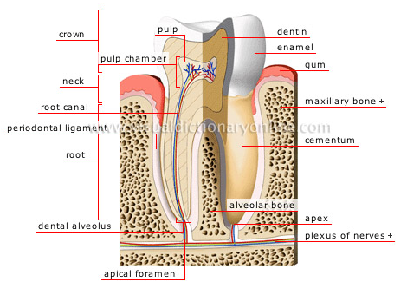
Fig.1 Representation of a molar tooth, evidencing the macroscopic structures

  - Thermal and Mechanical properties

Considering the thermal effect on dental hard tissues, it is necessary to know and to understand the thermal behavior of these tissues and crown materials when submitted to heating. For that, the evaluation of the heat conduction phenomenon is extremely necessary.
Several studies about thermal parameters measurement in hard dental tissues have been published [5]. Results of these studies are summarized in table 1.

Table 1-Mechanical and thermal properties of tooth tissue and crown material

Material/Tissue | Density  (x10^{-6 Kg}/mm³) | Thermal conductivity (x 10⁻³ w/cm⁰C) | Coefficient. Of thermal expansion (x10⁻⁶/⁰C) | Young’s modulus (GPa) | Poisson’s ratio | Tensile strength (MPa) | Compressive strength (MPa)
Enamel | 2.97 | 9.34 | 16.96 | 84.1 | 0.33 | 45 | 385
Dentine | 2.14 | 5.69 | 11 | 18.6 | 0.31 | 51 | 300
Cortical bone | 1.8 | 3 | 27.5 | 14.8 | 0.30 | 130 | 220
Stainless steel | 7.75 | 0.151 | 17 | 193 | 0.31 | 820 | 262
Porcelain | 2.3 | 15 | 7.1 | 74 | 0.19 | 50 | 149
Ceramic | 2.52 | 45 | 12.6 | 66.9 | 0.29 | 140 | 345
Resin | 1.58 | 2.61 | 35 | 25 | 0.24 | 70 | 300

1.3 Analytical calculation for thermal strain and stress in dental structure

As the restored molar tooth is considered under thermal effect, initial calculations are done on simple geometry of molar tooth.

Calculation for thermal strain and stress [6]
Thermal Strain= ε^{th} = α( T - T_{ref} )
Thermal Stress= σ^{th} (MPa)
For thin plate stress in Y and Z direction is zero.
σ_{y} = σ_{z} = 0
σ_{x}= σ ^{th} = E xα ( T - T_{ref} )
Where
E= Modulus of Elasticity (GPa)
T= Temperature (⁰ C)
T_{ref} = Reference temperature (37⁰C)
α = Coefficient of thermal expansion (x 10⁻⁶ / ⁰C)

- Methodology
2.1 Finite Element Analysis (FEA)
In finite element analysis, a large structure is divided into a number of small simple shaped elements, for which individual deformation (strainand stress) can be more easily calculated than for the whole undivided large structure. By solving the deformation of all the small elements simultaneously, the deformation of the structure as a whole can be assessed. It allows the researcher (i) to reduce the time and cost required to bring a new idea from concept to clinical application, (ii) to increase their confidence in the final concept/project by virtually testing it under all conceivable loading conditions.
In this study a 3-D Finite Element (FE) model of a molar tooth was built using the MIMICS 9.11. The four layer model also includes a representationof the enamel, adhesive cement, dentine and bone, which was based on Computer Tomography (CT-scan) images. Different crown materials were considered withthismodel. Enamel, dentin andpulp are the basic tissues that constitute a sound human tooth. Stainless steel, Porcelain and ceramic are the restorative crown materials. Effect of mechanical loading and temperature were considered. Figure 2 shows the sequential procedure to generate a 3-D model of a human molar toothfrom CT-scan data for Finite Element Analysis.

Fig. 2-Sequential procedure used to generate the 3D FE molar tooth model

  - Mesh generation for Finite Element model

First the tooth was scanned with high resolution Micro-CT scanner. The exposure time was 7.2 s per frame. Only few slices (one slice out of every 14 slices) were used for the modeling. Second, the different hard tissues visible on the scans were identified using an interactive medical image control system (MIMICS 9.11). MIMICS imports CT and MRI data in a wide variety of formats and allows extended visualization and segmentation functions based on image density thresholding shown in figure 3. 3-D objects (enamel and dentin) are automatically created in the form of masks by growing a threshold region on the entire stack of scans.

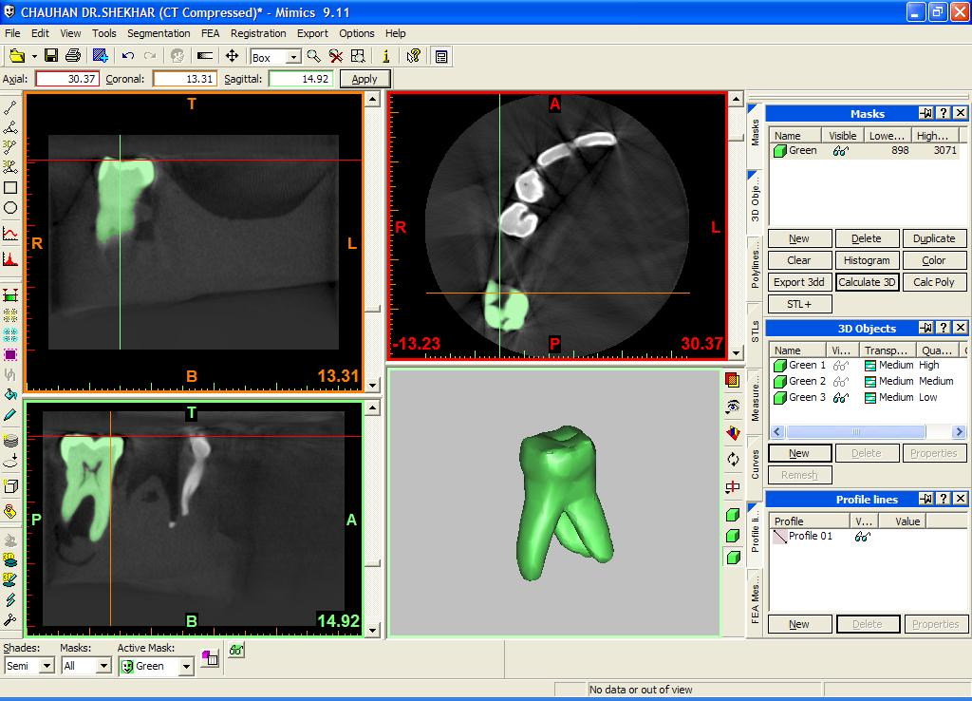

Fig.3 Three-dimensional model of Molar tooth in MIMICS

The REMESH module attached to MIMICS was therefore used to automatically reduce the amount of triangles and simultaneously improve the quality of the triangles while maintaining the geometry shown in figure4. After this. lis file can be imported in the finite element analysis software without generating any problem.

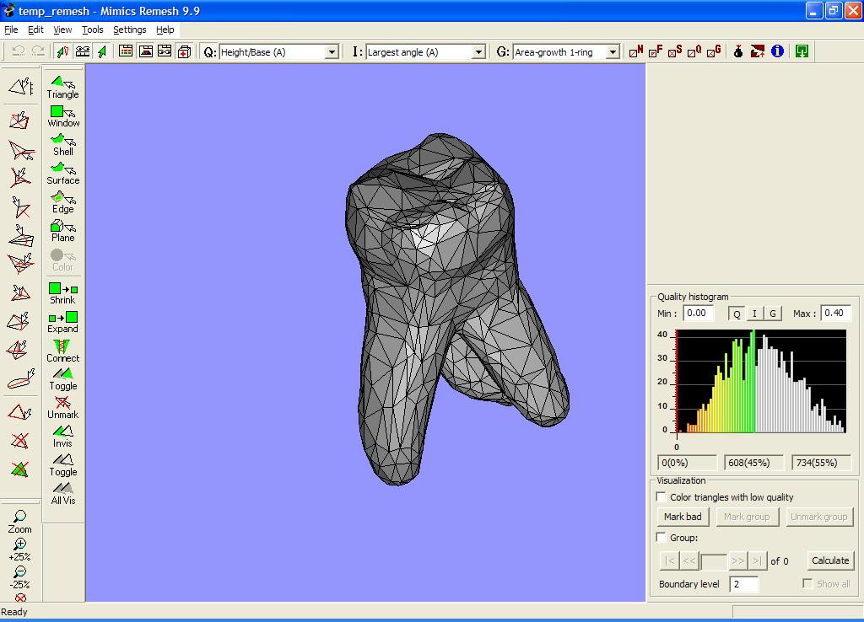
Fig. 4 Remesh model of Molar tooth
Third, .igs and .stp files were imported in CATIA software in order to reestablish the congruence of the interfacial mesh between enamel and dentin using Boolean operations (addition, inter section or subtraction of volumes). Then four-layer molar tooth assembly model is prepared (Figure 5).

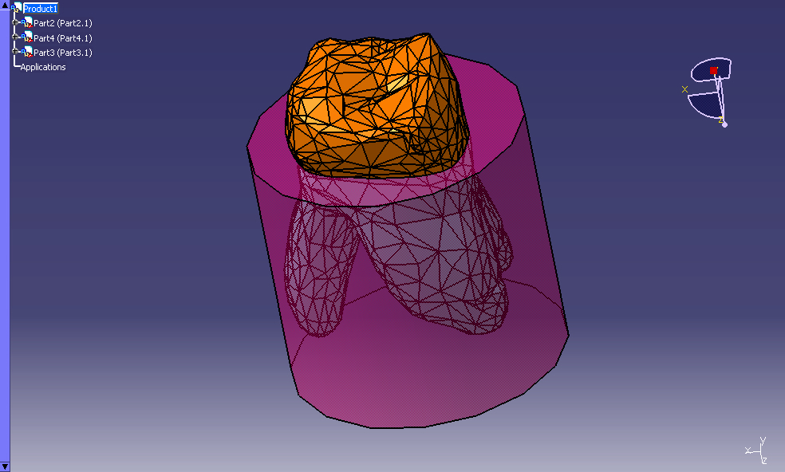
Fig.5 Molar tooth and bone assembly
Fourth, the .cat product files of the segmented enamel, dentin and bone assembly were then imported in a ANSYS for the applying boundary conditions and attributing of material properties (Table 1).

2.3 Boundary conditions for thermal analysis
Fixed zero-displacement in the three spatial dimensions was assigned to the nodes of bone at the bottom surface. The tooth and restorative materials were taken as bonded, which simulate usage of adhesive cements (Figure 6).

Fig. 6 Molar tooth assembly in ANSYS
Thermal analysis was performed, followed by a analytical analysis. First, the initial temperature of the entire model was set to 37°C, normal oral temperature of human body and thermal loads resulted from coefficients of thermal expansion.

Case | Maximum temperature | Load
I | 4°C | Cold load
II | 60°C | Hot load

These temperature ranges werebased on the work of Palmer, Barco, and Billy [7] describing the temperature measured in the oral environment. Figure 7shows the finite element models used for both sound and restored tooth. In the sound human tooth, the restoration domain is considered enamel and for restored tooth different materials for crown is assigned.

Fig.7 Molar tooth in ANSYS

2.4 Stress analysis during thermal loading

In the steady state thermal analysis quadratic tetrahedral element was used for meshing.Themesh was testedfor convergence of temperatures and stresses generated by cold and hot load in sound human tooth. The finite element method was thus used to calculate thethermal stress distribution caused by a temperature changein restored and sound human tooth. Thermal strain and stress distribution withtemperature change were calculated shown in figure 8. Tooth tissuesand restorations were assumed to be isotropic, homogeneousand stress free when at a uniform temperature at 37°C.

Fig.8 Thermal strain in model of molar tooth assembly

2.5 Thermo-mechanical stress analysis

In next step, coupling of the effects of temperature variation and mastication loading was considered. To simulate mastication, vertical forces were distributed on the occlusal surface, using tetrahedral elements, representing the tooth behavior under mastication loading.
The mechanical load considered was 180 N, distributed over the crown in the occlusal contact points, as shown in figure9. Tooth with different crown materials were compared to sound human tooth. The mechanical and thermal properties of each material and tooth tissue are given in Table 1. The available data describing the materials thermo- mechanical properties is not comprehensive, and an effort was done to supplement it with laboratory verification of density and conductivity of the considered materials: stainless steel, porcelain, ceramic, composite resin cement.
Fig. 9 Mechanical loading (180 N) distributed on molar crown at occlusal contact points

- Results

3.1 Stress distribution for thermal loading
Results corresponding to the four different models: sound (healthy) human tooth, metallic stainless steel crown restored with adhesive cement like resin, ceramic crown with resin and porcelain crown with resin are presented. Temperatures for cold condition varies from 4°C to 37°C and for hot condition varies from 37°C to 60°C taken for the thermal analysis. Under cold condition, tensile stresses appeared on the surface of the restoration and dental surface. However, in the internal structure, on the dentine-restoration interface, compression stresses were verified shown in figure 10.
Fig.10 Stress distribution on molar tooth crown
On the other hand, for hot condition, the opposite was verified: compression stresses were found on the surface of the restoration and dental surface and tensile stresses were verified in the internal structure, on the dentine-restoration interface. Table 2 quantitatively summarizes these findings for thermal strain and normal stress in x-direction. It can be observed that the stress level found on the porcelain was lower than ceramic and stainless steel for this case.

Table 2. Thermal strain and stress for cold and hot condition

Temperature |  | Sound tooth | Stainless steel | Ceramic | Porcelain
For Cold  4°C to 37°C | Thermal Strain | 0.0004125 | 0.000525 | 0.00051 | 0.0005
For Cold  4°C to 37°C | Stress  (MPa) | 106.93 | 174.81 | 58.066 | 39.163
For Hot  37°C to 60°C | Thermal Strain | 0.0007192 | 0.000663 | 0.00051 | 0.0005
For Hot  37°C to 60°C | Stress  (MPa) | 27.019 | 67.062 | 15.112 | 19.673

3.2 Stress distribution for combined thermo-mechanical loading

Similar stress patterns were found for combined thermo-mechanical loading. The stress level found on the porcelain and ceramic was lower than stainless steel at this coupled load case. Thermal strain and stress for combined cold temperature and hot temperaturecoupled with mechanical loads are shown in Table 3.

Table 3. Thermo-mechanical strain and stress for cold and hot condition

Temperature |  | Sound tooth | Stainless steel | Ceramic | Porcelain
For Cold  4°C to 37°C | Thermal Strain | 0.00049 | 0.000525 | 0.00051 | 0.0005
For Cold  4°C to 37°C | Stress  (MPa) | 84.643 | 166.24 | 53.308 | 34.864
For Hot  37°C to 60°C | Thermal Strain | 0.000662 | 0.000663 | 0.00051 | 0.0005
For Hot  37°C to 60°C | Stress  (MPa) | 28.251 | 72.045 | 15.815 | 13.381

- Discussion

This investigation describes a rapid method for the generation of finite element models of dental structures and restorations from CT-scan data. The use of finite element analysis to simulate a 3-D model of molar tooth for thermal variations and mechanical loads that occur in the mouth showed to be quite efficient. In clinical practice, the occurrence of spots and leaks noted at the borders of indirect aesthetic restorations is common, and the choice of a specific restorative material should be done with care. The success of a restoration is a consequence of the choice of a material with appropriate biological and mechanical properties, along with the desired aesthetic considerations.
The thermal and mechanical stresses are essentially dependent of the material properties. The superposition of tensile stresses due to the two effects, mechanical and thermal loads, in the adhesive interface can lead to cracking of the borders of the restorations, eventually resulting in micro leakage.
The finite element simulations showed that, under coupled thermo-mechanical loading, metallic crown result in higher stress levels than ceramic restorations. Therefore, clinical practitioners should keep this fact in mind when choosing the material for restoring teeth. The obtained results for hot and cold loading conditions are compared to results from analytical calculation. As to the numerical values for the obtained stresses, they should not be considered as exact, as the properties of dental tissues and restoring materials available in the literature have a wide range of variation, and tooth geometry also varies from individual to individual.

- Conclusion

Occurrence of maximum stress and thereby deformation at the crown-dentine junction results into loosening of crown which further leads to failure of restoration due to fatigue.
From this work, it can be concluded that simultaneous mechanical and thermal loading is a clinically relevant condition, which may contribute to tooth and restoration cracking. Under cold conditions, tensile stresses appeared on the surface of the restoration, while in the internal structure, on the dentin–restoration interface, compressive stresses were verified. On the other hand, for hot conditions, compressive stresses occurred on the surface of the restoration, and tensile stresses were verified in the internal structure, on the dentin–restoration interface.
Furthermore, hot and cold conditions in the mouth create cyclic changes that could lead to thermal fatigue of the adhesive process. Consequently, itis necessary to control this surface roughness by polishing it thoroughly in order to prevent points of stress concentration and fatigue crack initiation, which can eventually lead to fracture.

6. References

[1] Neil A Wilson, Shaun A Whitehead, Ivar A Mjor and Nairn HF Wilson. Reasons for the Placement and Replacement of Crowns in General Dental Practice. Primary Dental Care 2003; 10(2):53-59.
[2] Toparli M, Aykul H, Sasaki S. Temperature and Thermal stress analysis of crowned maxillary second Premolar tooth using three-dimensional finite element method. J Oral Rehabil 2003; 30(1):99-105.
[3] Tulimar P. M, Cornacchia, Estevam B. Las Casas. 3D finite element analysis on esthetic indirect dental restorations under thermal and mechanical loading. Med BiolEngComput 2010; 48:1107–1113.
[4] Denise M. Zezell, Patricia A. Ana. Heat Generation and Transfer on Biological Tissues Due to High-Intensity Laser Irradiation.IPEN – CNEN/SP, Sao Paulo- SP 2010; 13: 227-246.
[5] Boari HGD, Ana PA, Eduardo CP, Powell GL, Zezell DM. Absorption and thermal study of dental enamel when irradiated with Nd:YAG laser with the aim of caries prevention. Laser Phys 2009; 19(7): 1463-1469.
[6] K.J.Bathe, 2006. Finite Element Procedures, Cambridge, MA:Klaus-Jurgen Bathe,ISBN 0-13-301458-4, PRENTICE HALL, New Jersey.
[7] Palmer DS, Barco MT,Billy EJ. Temperature extremes produced orally by hot and cold liquids. J Prosthet Dent 1992; 67(3):325–327
[8] Pascal Magne.Efficient 3D finite element analysis of dental restorative procedures using micro-CT data. University of Southern California 2007; 23:539-548.
[9] Isis A.V.P. Poiate, Adalberto B. Vasconcellos, Matsuyoshi Mori, EdgardPoiate Jr. 2D and 3D finite element analysis of central incisor generated by computerized tomography. Computer methods and programs in biomedicine 2011; 104:292–299
[10] Hamza A. Ghulman, and Mohammed W. Al-Hazmi. Finite Element Analysis for Molar-Tooth Under Different loading conditions. J Biomech 2007; 6:443-449.
[11] Fenner DN, Robinson PB, Cheung PM-Y. Three-dimensional finite element analysis of thermal shock in a premolar with composite resin MOD restoration. Med EngPhys 1998; 20(4): 269–275.
[12] Adison O, Marquis PM, Fleming GJP. Resin elasticity and the strengthening of all-ceramic restorations. J Biomech 2007; 86(6):519-523.

