Geometric Design of Road

Vivek Mahure¹, Sarang Motghare²,Divyanshu Dashriya³Shubham Parate⁴, Purva Ghodam⁵

Prof.HemantSangodkar
Dept. of Civil Engineering, M.I.E.T Shahapur, Bhandara-441906

Abstract –The study of redesign the existing rural road into more wider road for heavy traffic and safe transportation. The road from ganeshpur to wainganga river is located in bhandara city in india . This road for transportation of goods, sand, brick etc. form wainganga river. The studies involves collection of details such as road gradient, width ,deflection angle, radius of curve and length of curve and design them to the formal standards of IRC code. The curve parameters have been measured using survey compass by traversing along center line of the curve.

Keywords—Gradient, compass, deflection angle, IRC code.
- INTRODUCTION
India is a vast country and to connect its different parts with a good network of road is essential. The deficiency in agriculture and economic progress in India is also due to the lack of good roads specially in villages. In villages mostly fair weather road are there i.e. those road, which can be used only in fair weather and disconnect the villages from towns and railway station during rainy season. Hence for the uplift of villages and economic development of country good and upto date road are very essential. Because of roadway we can travel easily from one place to another place.
The Government of India launched the PRADHANMANTRİ GRAM SADAK YOJANA (PMGSY) on 25h December, 2000. The primary objective of the PMGSYis to provide connectivity by way of an all weather road to the eligible un-connected habitations in the rural area, in such a way that all un-connected habitations with a population of 500 persons and above are to be covered in plain area.
The physical features of road are known as road geometrics. This physical features have direct connection with highway users. These are provided according to their geometrical design in order to facilitate safe and economical operation of vehicles.
As per available space we have designed a single lane road The road comes under the village i.e. village road. We have designed the village road As per IRC recommendation.
The physical features of road are designed as follows:-
(a) RIGHT OF WAY
The area of land acquired and reserved for construction development of a road along it's alignment is known as right of way.
b) CARRIAGEWAY
The portion of roadway constructed for movement of vehicular traffic is called carriageway. The width of carriage way Depends on the width of traffic lane and number Of lane required.
As per I.R.C.
SR. NO. | CATEGORY OF ROAD | CARRIAGE WIDTH IN METER FOR SINGLE LANE ROAD
1 | NH& SH | 3.75
2 | MDR | 3.75
3 | VILLAGE ROAD | 3.0

Sr. No. | Category of Road | Open area and agriculture Country
Sr. No. | Category of Road | Land width |  | Building line | Control Line
 |  | Normal (m) | Range (m)
1. | State highway and National Highway | 45 | 30 to 60 | 80 | 150
2. | MDR | 25 | 25 to 30 | 50 | 100
3. | Village Road | 12 | 12 to 18 | 25 | 30

(c) SHOULDER
The portion of the roadway between outer edge of the pavement and edge of the top surface of embankment or inner edges of the side drain incutting are known as shoulder.
Objects of shoulder:
As per I.R.C

1. To provide lateral stability to the carriageway.
2. They provide space for erecting road signals
Minimum shoulder width as per I.R.C. recommendations
Sr. No. | Category of Road | Shoulder width in meter
Sr. No. | Category of Road | Plain Area | Hilly Area
1. | Village Road | 2.25m | 5m

(d)ROAD MARGIN
The portion of land width on either side of the roadway of a road is Known as road margin. Road margin are secured and reserve to meet the future demand of the development of the road.
(e)ROAD WAY WIDTH
The top width of a highway embankment or bottom width of highway cutting excluding the side drain is called as road way width. Road way width is decided and constructed to meet the present traffic requirement, topographical feature, design needs and ultimate economy of the road.
I.R.C. Recommendation
Sr. No. | Category of road | Roadway width in mater
Sr. No. | Category of road | Plain and rolling terrain
1. | Village Road | 7.5m (single lane)

(f) SIDE SLOPE
The slope given to the side of earth work of road in embankment or in cutting for its stability is called as side slope.
As per I.R.C. specification for side slope:
In embankment -2:1
In cutting: In ordinary soil 1:1
1 2:1 & 1:1 side slopes for embankment
(g) BERMS
The portion of land width left in between in the toe of a road embankment and the inner edges of barrow pits on the portion in between the top edge of the road cutting and nearest edge of soil banking either side are known as berms.
(h)FORMATION LEVEL
The reduce level of the finished surface of earth work for a road in embankment or in cutting is known as the formation level. Formationlevel of highway should be decided such as to provide economical earthwork inroad project.
G) CAMBER
The convexity provided to the surface of carriageway or the rise given to the center of carriageway above it's edge on straight portion of the road is called as camber.
1. To regulate the vehicles to their proper lanes
2. To improve architectural appearance of the roadway
Types of camber:-
1. Composite camber
2. Sloped or straight camber
3. Two straight line camber
4. Barrel camber
We have adopted slope or straight type camber

b
fig:- Slope or straight camber
As per IRC specification
SR. NO. | TYPES OF ROAD SURFACE
1 | THIN BITUMENOUS SURFACING | 1IN 50 TO 1 IN 40  (2 TO 2.5%)

(j)GRADIENT
The rate of rise or fall provided to the formation ofa road along its alignment is called as gradient. It is a horizontal slope provided to theformationof the road along it's alignment it is expressed as the ratioof rise or fallto the horizontal distance.
Objects;-
1. To connect terminal station situated at different level.
2. To make earthwork of road project economical.
3. To construct side drain economically with convenient depth below to ground level
Different types of road gradients
a. Limiting gradient
b. Exceptional gradient
c. Average gradient
d. Floating gradient
e. Minimum gradient
f. Ruling gradient
(k)DESIGN SPEED
The maximum speed of vehicle assume for geometrical design of road is known as design speed.
The overall geometrical design of any road depends on design speed. It is essential that the assumed design speed should be in for conformity with the high standard of mobility. Safety and efficiency desired on different categories of road.

Design speed of village road as per IRC recommendation.
Sr. No. | Category of road | Design speed in kmph
Sr. No. | Category of road | Plain area
1. | Village road | Ruling | Minimum
1. | Village road | 50 | 40

‘

(l) SIGHT DISTANCE
The distance along the center line of a road at which a driven has visibility of an object, stationary or moving at a specified height above the carriage way is known as sight distance.
AS PER I.R.C.

speed | Perception and break reaction |  | breaking |  | Safe S.S.D (meter)
V(Km/hr) | Time (s) | Distance D1=0.278vt | Coefficient of friction (f) | D d2=v/2 54f | (d1+d2) | Design value
50 | 2.5 | 35 | 0.37 | 27 | 62 | 60
40 | 2.5 | 28 | 0.38 | 17 | 45 | 45

- OVERTAKING SIGHT DISTANCE
The minimum sight distance needed by a driver on a two way road to enable him to overtake another vehicle a head with safety against the traffic from opposite direction is called overtaking sight distance.
AS PER I.R.C.
Intermediate sight distance for 50km/hr speed
Speed (Km/hr) | Intermediate sight distance
50 | 120
40 | 90

In SSDthe values are based on perception and break reaction time of 2.5sec, and coefficient of longitudinal friction varying from 0.4 at 20 km/hr to35 at 100 km/hr.
(m) CURVES
The geometrical arcs provided on the change in alignment or gradient of a road is known as curve. Curve play important role in geometrical design of road.
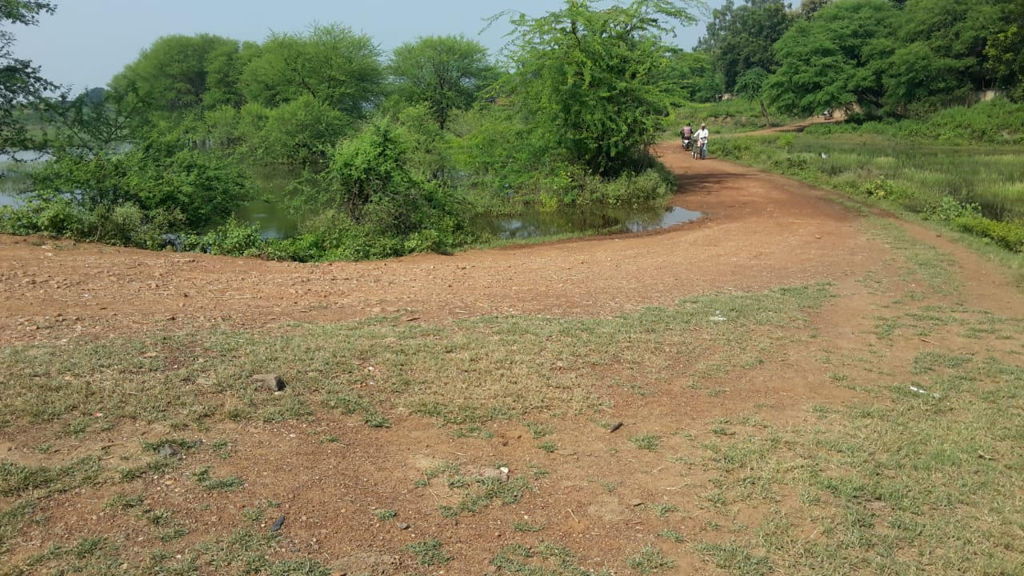

Fig: Curve

Types of curve
1. Horizontal curve
2. Vertical curve
Types of horizontal curve
a. Simple curve
b. Compound curve
c. Reverse curve
d. Transition curve

AS PER I.R.C
Sr.no | Category or road | Minimum radii of horizontal curve in meter
Sr.no | Category or road | Plain terrain |  | Ruling terrain
Sr.no | Category or road | ruling | absolute | ruling | absolute
1 | Village road | 90 | 60 | 60 | 45
Minimum radii of horizontal curve for different terrain condition.

(n)SUPER-ELEVATION
The inward transverse inclination provided to the cross section of the carriageway at horizontal curve portion of a road is called as super-elevation cant or banking.
AS We know,
e+f-v'/127R
e+0.15-50/127*90
e= 0.068
(o)Widening of carriageway on curve
The provision of extra pavement width of sharp horizontal curve is known as widening of carriageway on curves.
Radius of curve | Up to 20m | 21 to 40 m | 41 to 60 m | 61 to 100m | 101 to 300m | Above 30m
- Two lane | 1.5 | 1.5 | 1.2 | 0.9 | 0.6 | nil
- Single lane | 0.9 | 0.6 | 0.6 | nil | nil | nil
Extra pavement width at horizontal curve as per recommendation of IRC

II – METHODOLOGY
Planning is essentially needed for to do work effectively, so we can reduce much necessary time and effort of achieving the goals.In planning methodology we had done the following works:-
1. Selection of road alignment
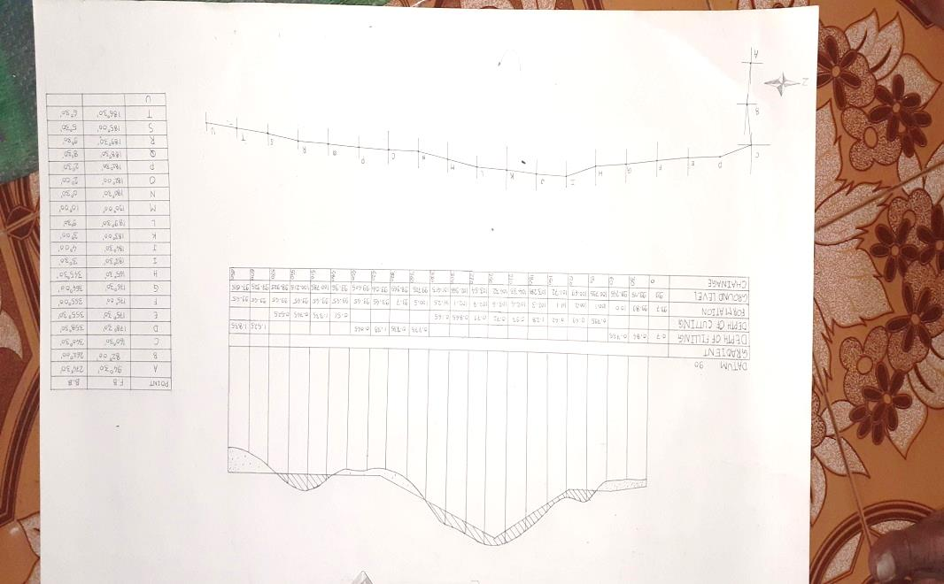
Fig: road Alignment
2. Survey work:
a. Reconnaissance survey
b. Preliminary survey
c. Detailed survey
SELECTION OF ROAD ALIGNMENT
The position of center line of the road on the ground is called as road alignment.
It should be-
a. Shortb.Easy C.Safe
b. Economical
For selecting a alignment we have taken the following points into consideration such as:-
a. Obligatory points. b. Traffic c. Geometric design d. Economics e. Other consideration
(a)Reconnaissance survey
Before starting the actual survey work, a reconnaissance survey is conducted along the selected alignment with the help of reconnaissance survey. From this survey, we collected the details of obstructions along the route which are not available on the map.
(b) Preliminary survey
The art of finding the details of alternative alignment found suitable during the reconnaissance survey is known as preliminary survey. In preliminary survey the survey instrument to be used are chain, metallic tape, prismatic compass, leveling instrument theodolite.
(C)DETAILED SURVEY
It includes following survey work
1. Profile leveling
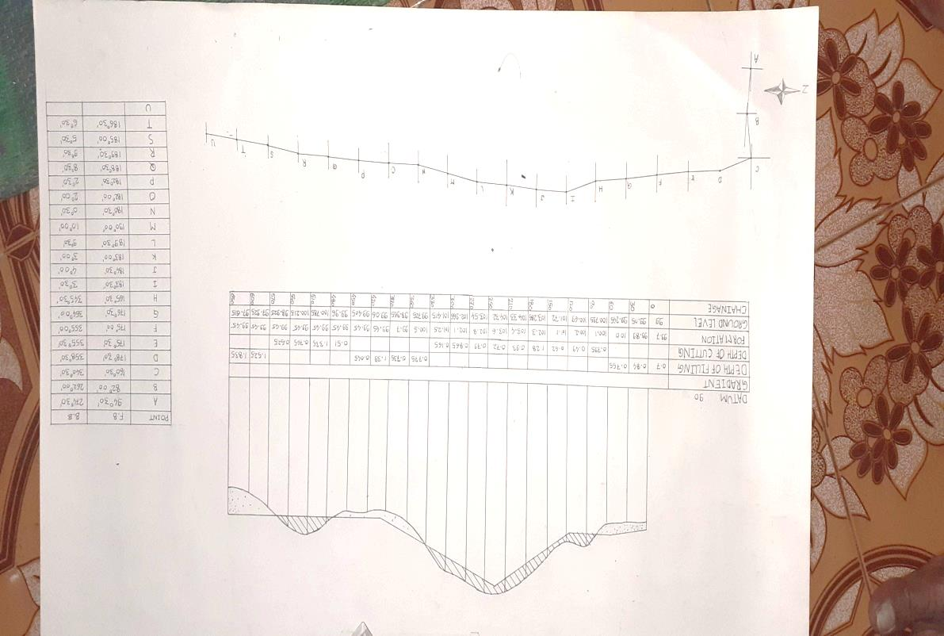
Fig: Road Profile
2. CROSS SECTIONING:
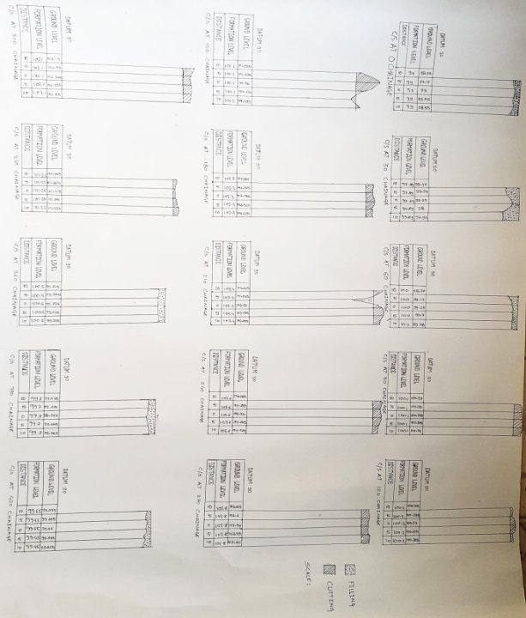
Fig: Cross Sections
III) CONCLUSION
- Geometric design must be give optimum efficiency for traffic movement and safety purpose at reasonable cost.
- Proper sight distance and vertical alignment can consume less propulsive force leads to low fuel consumption.
- Horizontal curves at great separation are more dangerous and cause 30% accidents more.
- Curves are provided according to the topography of the area to avoid excessive cutting and filling.
- For all curves below the desirable standards, warning signs are proposed to restrict the speed of vehicles.

REFERENCES:-
[1] Indian Roads Congress, Recommended practice for sight distance on rural highways, IRC: 661976.
[2] Indian Roads Congress, Recommendations about the alignment, survey and geometric design of hill roads, IRC: 52-1981.
[3] Indian Roads Congress, “Geometric design standards for rural (Non Urban) highways”, IRC: 73-1980.
[4] Highway engineering by S.K. Khanna and C.E. Justo.
[5] Transportation Engineering by N.L. Arora.
[6] Survey and Leveling by N.N. Basak III

