Identification of Plant Leaf Disease and Provision of Treatment using CNN

Kalyani Pendke¹, Neha Pawar², Akanksha Pawar³, Sakshi Gawande⁴,
Prachi Chauhan⁵, Dikshita Balvir ⁶

¹Professor, ²³⁴⁵⁶Student
Department of Computer Science and Engineering
Rajiv Gandhi College of Engineering and Research, Nagpur, India,441110

pendke@gmail.com

Received on: 11 June ,2022 Revised on: 06 August,2022, Published on: 09 August,2022

Abstract- Disease, and defects found in plants and crops greatly impact the agriculture industry. Inappropriate weather conditions, bacterial, fungal, and viral infections seriously impact crop health and introduce diseases that affect the growing produce. To avoid the destruction of crops it is necessary to detect crop diseases at an early stage. Manually it is difficult to detect an accurate disease in very less time. Due to advanced technologies, it became possible to make an automated system for the detection of diseases in crops. This paper proposes a model which detects leaf disease using a Convolutional neural network and provides the solution for the detected disease. We have used the leaf image dataset to train the convolution neural network to identify three types of tomato diseases.
Keywords- CNN, deep learning, leaf disease.

I –INTRODUCTION
The agriculture industry is one of the most vital sectors for contribution to national income in many countries. Disease and defects found in plants and crops have a large impact on production in the agriculture industry and lead to remarkable economic losses[1]. Insect infestation along with bacterial, fungal, and viral infections are an important contribution to diseases that exist in plants. Changes in climate and temperature are also a few components that may contribute to an acceleration in diseases found in plants [2]. Once a plant has been infected, symptoms develop on separate segments of the plant, degrading the growth of subsequent fruit or vegetables[3]. For the aim of decreasing losses existing in defective plants, it is important to detect the disease at an early stage so that it can be treated early-stage[4]. However, manual detection of crop disease is a primary approach used by farmers, due to a large number of diseases sometimes they may fail to detect the accurate disease. To find the accurate disease farmers need to take the leaf samples to the nearby agriculture research center. To detect the proper disease on a leaf, the research center will take days or weeks. Once the disease is identified farmers need to find a solution to

will help farmers[5]. Throughout the years, a lot of agriculture components and processes have become robotic to ensure faster production and to ensure products are of the highest quality standards. Several solutions have been proposed to overcome the above problems, including the use of various types of feature sets for the classification of diseases in plants and crops by machine learning. SVM, K-means clustering, and Artificial neural networks are some of the famous algorithms that are used [5]. A Convolution neural network is one of the special types of Artificial neural network which is specifically used for image recognition. This paper describes the use of CNN in leaf disease detection. Our proposed system involves training CNN using a leaf images dataset which involves diseased and healthy leaf images of Tomato crops. We have designed a system where users have to first register or login into the image recognition. This paper describes the use of CNN in leaf disease detection. Our proposed system involves training CNN using a leaf images dataset which involves diseased and healthy leaf images of Tomato crops. We have designed a system where users have to first register or login into the system. After that user has to upload the query leaf image. CNN then extracts the feature of the leaf image and matches the features with the extracted features of dataset images. If the leaf is diseased then the name of the disease will be treat the crop and this process takes a lot of time and human effort. Hence there is a need for an automated system that displayed with the solution over it. If the leaf is healthy then it will display as a healthy leaf. This paper is divided into five sections, introduction, literature review, methodology, result and discussion, conclusion, and references.
II- LITERATURE SURVEY

In this paper, the author implemented CNN models to identify the disease in plants from their leaves. They replaced the standard CNN model with depth = separable convolution to reduce parameter number and computational cost. They trained the model with the dataset to detect the 14 different plant species, 38 different diseases, and healthy plant leaves. The implemented model achieved an accuracy of 98.42%, 99.11%, 97.02%, and 99.56% using InceptionV3, InceptionResNetV2, MobileNetV2 and EfficientNetB0 respectively [5]
In this paper, the author has reported the classification of 26 diseases in 14 crops. They have used the CNN approach to detect the disease. They used AlexNet and GooogLeNet architecture. AlexNet has five convolution layers, three fully connected layers, and a softmax layer at the end. GoogleNet architecture consists of 22 layers. They analyzed the performance of both architectures on the dataset. Among the AlexNet and GoogLeNet, GoogLeNet performed better. They used a public dataset of 54306 images and trained the model. An accuracy of 99.35% was achieved by the model [2].
In this paper, the author has proposed a mathematical model of plant disease and recognition based on deep learning, which improves accuracy, generality, and training efficiency. First, they used the Regional Proposal Network (RPN) to recognize the leaves in complex surroundings. Then, they segmented the images based on the result of RPN and then they provide a segmented image as input. The model was examined with Black rot, Bacterial plaque, and Rust diseases and the accuracy was 83.57% [4].
In this paper, the author has used Back propagation networks as classifiers to identify grape and wheat diseases. They used two kinds of grape diseases and two kinds of wheat diseases as research objects. The optimal recognition results for grape disease and wheat diseases were both 100% when the dimensions of feature data were not reduced by using PCA(Principal Component Analysis). When dimensions were reduced they got the accuracy of 100% for grapes and 97.14% for the wheat[6].
III-METHODOLOGY
There are various steps in the process of detection of crop diseases.
- Dataset
Dataset is required to train the CNN algorithm. For the best performance of CNN, we require a huge image dataset. We have collected the dataset of 3000 images from Kaggle, we have targeted the three types of tomato leaf diseases (Early blight, Late blight, and Bacterial spot). To distinguish the diseased leaves from healthy leaves, we collected both healthy and diseased leaf image datasets.
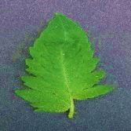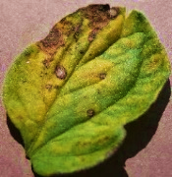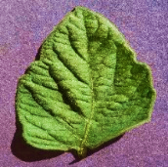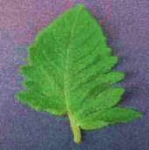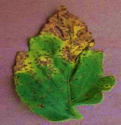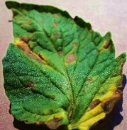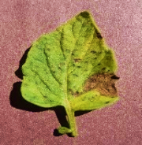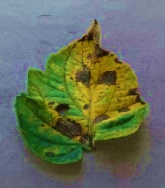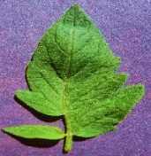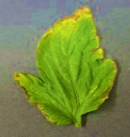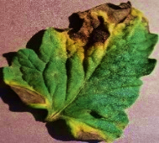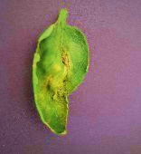
Fig. 1- fig shows sample images from the tomato leaf image dataset, it contains healthy leaves, early blight, late blight, and bacterial spot leaves.
B) Image Preprocessing And Labeling
To extract the features from images, images are preprocessed. Image preprocessing is removing noise and background objects from the images. Resized all the images in 96 x 96 pixels and set the color channel as 3. Then created 4 classes of leaf images. 3 classes were diseased image classes and one class of healthy images. After creating the classes labeled them according to disease name.
C) Training
To teach an algorithm how to recognize objects in images, we have to train the algorithm using a dataset. We have used the Convolution Neural Network algorithm which is a specific type of Artificial Neural Network that is widely used to recognize the image.
Convolution neural consists of several networks such as a convolution layer, RELU, pooling layer, and fully connected layer.
C.1 Convolution Layer
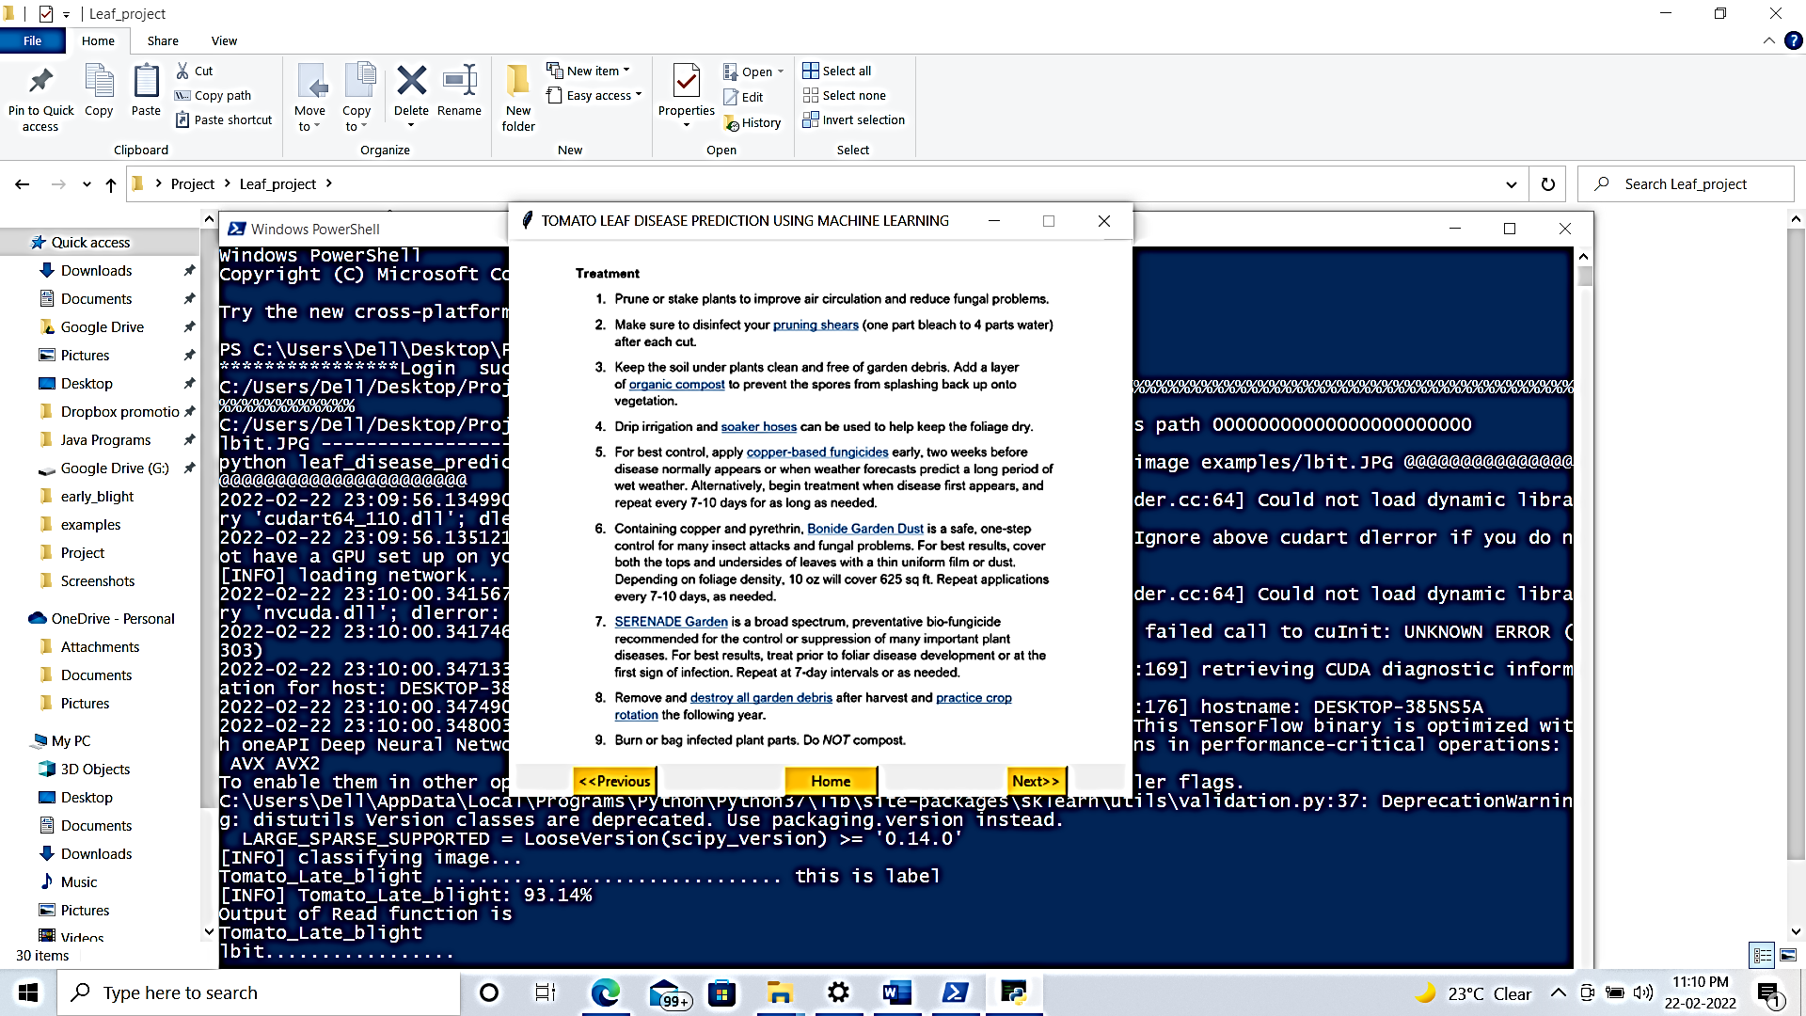
Convolution in 2D begins with the kernel. The kernel is a small matrix of weights. In this operation, the kernel slides over 2D input data, performing an element-wise multiplication with the part of the input, and sums up the result into a single output pixel. Every time the kernel slides over a location, it converts a 2D matrix of features into the new 2D matrix of the features [7].
C.2 Rectified Layer Unit
RELU (Rectified Layer Unit)is the most commonly used activation function in deep learning models. The function returns 0 if the input is negative; otherwise, it returns the positive value. It is common practice to apply an activation layer after each convolution layer[8]. The purpose of this layer is to introduce nonlinearity to a system that has just been computing linear operations during the convolution layers. All the values in the input volume are affected by the RELU layer which applies the function f(x)= max(0,x) [9]
C.3 Pooling Layer
A pooling or sub-sample layer is usually used after the convolutional layer to reduce the computational complexity. Some programmers may choose to apply after RELU. The most popular layer in this category is max-pooling. This takes a filter normally of size 2x2 and astride of the same length. This is then applied to the input volume and the maximum value is output whenever sub-regions are filtered. The pooling layer serves two purposes, first is that the number of parameters or weights is reduced by 75%, thus lessening the computation cost. The second benefit is that it will prevent overfitting, which is when a model is tuned to training examples so tightly that it is not able to generalize well to validation and test cases [9].
C.4 Fully Connected Layer
A fully connected layer takes an input volume and outputs an N-dimensional vector which is the number of classes that the program has to choose from. An individual number in an N-dimensional vector represents the probability that a certain class will occur [10]
The way fully connected layers work is that it looks at the output of previous layers and determines which features most correlate to a particular class. Fully connected layers determine which high-level features are most strongly correlated with a certain class and place particular weights on them so that when your computer adds the weights to the previous layer, it gets the probabilities for every class.
We set the batch size as 32, that is there will be 32 images in each batch and set the epochs as 100 that is all the images will be passed 100 times through the algorithm. After that various layers are applied and features were extracted from the images.

IV-RESULT
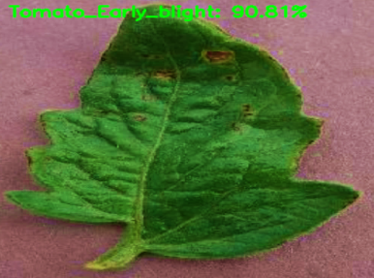
Fig.2 – fig shows the detected the disease(Tomato Early blight))with 90.81% of accuracyand treatment over the detected disease.

The results of leaf disease detection are shown in figure 2. These results are obtained using CNN. We trained the model using three types of tomato disease Tomato early blight, Tomato late blight, and Bacterial spot. CNN estimated the accuracy of 90.81% with an accurate result of about 50 seconds with an image of a leaf that is infected by the Tomato early blight and represents the treatment and prevention methods provided after the detection of the disease.
V. CONCLUSION
The proposed concept focuses on Lead disease detection by using a Convolutional Neural Network. It is helpful to farmers and agronomists to detect accurate diseases in very less time. We have used the tomato leaf image dataset to train the CNN algorithm. To train the CNN more images are required either it will not give the desired results. We used approx. 3000 images to detect the three types of tomato leaf disease(Early blight, Late blight, and Bacterial spot) and healthy leaf. We preprocessed all the images and divided them into batches. We divided all the images into batch sizes 32 and passes them to CNN. After the training of CNN, it was able to detect the disease from the input image with an accuracy of 90%.In recent years there have been important advancements in Machine Learning techniques. Finding more features and extracting that from query images is a very complex term but because of CNN it becomes a little bit easy and so we have used CNN for more accurate results.

REFERENCES
[1] J. Amara, B. Bouaziz, and A. Algergawy, “A Deep Learning-based Approach for Banana Leaf Diseases Classification,” B. Mitschang et al. (Hrsg.): BTW 2017 – Workshopband, Lecture Notes in Informatics (LNI), Gesellschaft für Informatik, Bonn 2017, pp. 79–88, 2017.
[2] S. P. Mohanty, D. P. Hughes, and M. Salathé, “Using deep learning for image-based plant disease detection,” Frontiers in Plant Science, vol. 7, no. September, Sep. 2016, DOI: 10.3389/fpls.2016.01419.
[3] S. D. Khirade and A. B. Patil, “Plant disease detection using image processing,” in Proceedings - 1st International Conference on Computing, Communication, Control and Automation, ICCUBEA 2015, Jul. 2015, pp. 768–771. DOI: 10.1109/ICCUBEA.2015.153.
[4] Y. Guo et al., “Plant Disease Identification Based on Deep Learning Algorithm in Smart Farming,” Discrete Dynamics in Nature and Society, vol. 2020, 2020, DOI: 10.1155/2020/2479172.
[5] S. M. Hassan, A. K. Maji, M. Jasiński, Z. Leonowicz, and E. Jasińska, “Identification of plant-leaf diseases using CNN and transfer-learning approach,” Electronics (Switzerland), vol. 10, no. 12, Jun. 2021, DOI: 10.3390/electronics10121388.
[6] Haiguang Wang, Guanlin Li, Zhanhong Ma, and Xiaolong Li, “Image Recognition of Plant Diseases Based on Backpropagation Networks,” 2012 5th International Congress on Image and Signal Processing (CISP 2012), 2012.
[7] Irhum Shafkat, “Intuitively Understanding Convolutions for Deep Learning,” towardsdatascience.com, Jun. 22, 2018. https://towardsdatascience.com/intuitively-understanding-convolutions-for-deep-learning-1f6f42faee1 (accessed Jan. 07, 2022).
[8] Chandra Shekhar, “Simple Text Multi Classification Task Using Keras BERT,” www.analyticsvidhya.com, Aug. 31, 2020. https://www.analyticsvidhya.com/blog/2020/10/simple-text-multi-classification-task-using-keras-bert/ (accessed Jan. 06, 2022).
[9] Adit Deshpande, “A Beginner’s Guide To Understanding Convolutional Neural Networks Part 2,” Jul. 29, 2016. https://adeshpande3.github.io/A-Beginner’s-Guide-To-Understanding-Convolutional-Neural-Networks-Part-2/ (accessed Jan. 06, 2022).
[10] Julie Derumeaux, “It’s training cats and dogs,” ml2grow.com, Apr. 29, 2019. https://ml2grow.com/its-training-cats-and-dogs/ (accessed Jan. 07, 2022).

