Numerical Analysis Of Pipe Cleaning Machine
Dr. Anil H. Ingle¹, Sagar Pimpalshende², Sandip Pandit³, Ratul Chakraborty⁴
- Associate Professor, Department of Mechanical Engineering
Smt. Radhikatai Pandav College of Engineering
Anilingle75@gmail.com
- U.G.Student, Smt. Radhikatai Pandav College of Engineering
Sagarpimpal2016@gmail.com
- U.G.Student, Smt. Radhikatai Pandav College of Engineering
Sandip1996pandit@gmail.com
- U.G.Student, Smt. Radhikatai Pandav College of Engineering
Ratulchakraborty007@gmail.com

Abstract – Now a day inspection and cleaning of inner side of pipes quiet difficult Because pipelines are frequently hidden underground they are contact with the soil subjected to corrosion where pipes made up steel are effectively oxidizing and get corroded. Although its less common corrosion also occurs on the inward surface of the pipe and lower the strengthy of the pipe. If crack goes undiscovered and becomes sunder therefore by the pipe cleaning machine the serveillance of innermost of the pipe cleaning can be done by using surveillance camera and cutting cleaning mechanism robot can move inner horizontal and vertical pipe has been design and fabrication. The robot consists of a motor for propulsive and camera for investigation and by which lie streaming of cutting action can be seen on android and IOS software.
Keywords- Pipe Inspection; pipe cleaning; robot; PIR, Audit, Miniature.
INTRODUCTION
The robotics is a fastest growing field in engineering and Now a they are used in wide range in many field to easier the work. Generally robots are used in many industries. Due to this application they are varies in sizes and work easily at any condition and atmosphere where manually operations are impossible. Due to this applications of robot in oil and gas industries and pipelines caries fluids cracks and corrosion are occur and leakage of fluids explode will happens and because these pipes are hidden underground they are difficult to
inspect and cleaning. For that Hoon Jong Kim & Gokarna sharma proposed a “Pipe Inspection autonomous mobile exploration robot” for 150mm pipeline and which can control independently called FARMER ‘ A Fully Autonomous Mobile Robot for Pipeline Exploration’[1]. Also Mihita Horodinca and Loan Doroftei proposed a miniature of inspection Robot, with a stator rotor and universal joint used for mobility of robot[5] , Zhelong wing and Hong Gu prosed a Brush pipeline robot used to clean a pipeline with stubby bristles between a diameter of 9 to 15 called ‘A Bristle-Based Pipeline Robot.[3]. Hyouk Ryeol Choi and se-Gon Roh proposed a miniature of in pipe inspection MRINSPECT series robot for used in practical application.[4]

OBJECTIVE

  - To make an flexible robotic design so as to regulate according to the pipeline parameters.
  - To add gripper to robot which can contract and enlarge according to the pipeline parameters.
  - To regulation the whole system with remote.
  - The cleaning and surveillance of interior of pipe by mechanism.

WORKING PRINCIPLE
Working principle used in this robot is Inversion of Four bar chain mechanism or GROSEFF Law.

Condition for four bar Kinematic chain or GROSEFF Law

“It states that the sum of the shortest and longest link in the kinematic chain must be less than the sum of other two remaining links.”

Inversion of Mechanism
A mechanism is a kinematic chain with one link fixed. The fixed is called as frame. Distinctive mechanisms are obtained by fixing distinctive link in a kinematic chain. The process of choosing different link in a kinematic chain for the frame is known as invasion.

Inversion of Four bar chain Mechanism
Various types of inversions are;
- Coupled wheels of Locomotive(Double crank Mechanism)
- Pentograph (Double Lever Mechanism)

For inserting robot in the pipe we have to pull the translation element backward there by compressing the spring as shown in fig A. due to the arrangement of links according to four bar mechanism the outer most link move inward. After introducing robot in pipe we have to leave the translation element, then spring expand and due to the fore of spring and arrangement of link again the outmost link move outward and robot get hold in the pipe.

KINEMATICS OF MECHANISM
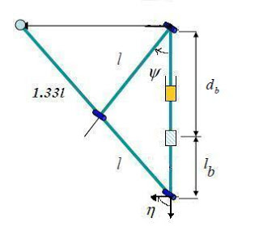

Fig :- Kinematics of Mechanism
This is a four-bar mechanism consisting of three revolute joins and one shimmering as depicted. Thus, the passage of all revolute joints can be specify in terms of the movement d_{b}.
A Static analysis
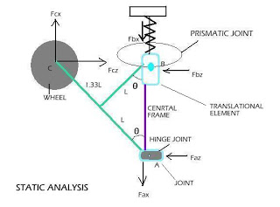

Fig; Static analysis

$δW=Fczδz-Fbxδx=0$where F_{bx} is a spring force.
This is because only F_{cz} and F_{bx} manipulation work. The comparable coordinates of these forces analogous to the coordinate located at the A hook are expressed as
$$δW=Fczδz-Fbxδx=0$$
$$δW=Fczδ\left(2.33lsinθ\right)-Fbxδ\left(-2.33lcosθ\right)$$
$$=>Fcz*2.33lcosθδθ-Fbx*2.33lsinθδθ=0$$
Rearranging gives
$$Fbx=Fcz*cosθ/sinθ$$
Thus, the spring force at the shimmering joint B is related to the regular force F_{cz} by
$Fbx=Fcz*tanθ$
And total weight W of robot is the sum of the six suction forces strive on the belt. Thus, each suction force F_{cx} is one six of the whole weight of the robot structure. Thus, dimensions o f the actuator boxed-in within the wheel is compured by F_{cx}*R=WR/6
Where R is that the radius of wheel. From the top of static analysis .it’s additionally known that the massive weight of mechanism doesn’t influence the folding motion of the linkage .The spring stiffness is found to be 0.9N/mm and also the spring force to be 4.5 . so we tends to came the conclusion that the mechanism ought to have atleast 3kg torque . So,we used 3 actuators with 1.5kg torque(total 4.5kg torque).It’s safe to use an actuator with additional torque than the desired torque.

- Basic construction Design

Fig:- Basic construction Design

METHODOLOGY

The principle of this project is to audit various pipes and provide its actual picture to operator. Robot works on the chuck jaw mechanism. Robot is draft in such a way that lower human efforts while audit the industrial pipes. Various steps carried out to lower weight of robot. Hence audit of pipes is done by robot to get vital data.
CONSTRUCTION

This robot comprise of following parts
- Central Body Parts
- Interpretation Element
- Connections
- Motors
- Wheel
- circuit
- battery
- spring
Central body is the casing of robot. On this edge joints are brazed at 120 degree, spring and interpretation is mounted on it combined with principle frame of focal body toward one side of spring by packing the spring . The connections are appended the joints on focal components and interpretation with the assistance of nut and fasteners engine is mounted on the furthest connection through an opening penetrated on it.
Fig :- Spring

- Central Body Element
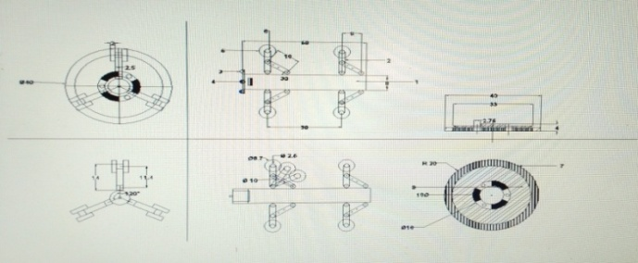
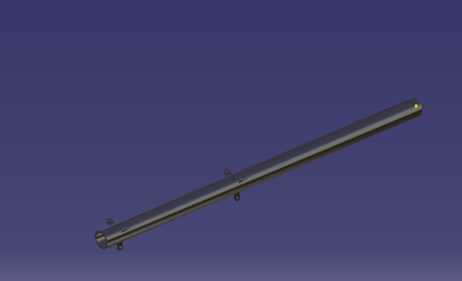
Inner dia - 12mm
Outer dia - 15 mm
Length of body- 625mm
Material – mild steel

Fig :- central Body Element

- Translation Element

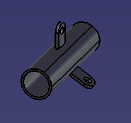
Inner dia- 17mm
Outer dia- 20mm
Length of Body- 70mm
Material- Mild Steel
Fig :- Translation Element

- Spring
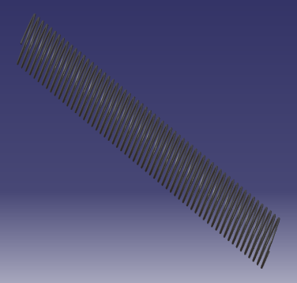
Spring dia -2mm
Free
Length-300mmCompressive Length-240mm
Material – Mild steel

Links

      - Cutter

The conte, , ,
- Link
Length-63mm
Width-20mm
Thickness-2mm
Material -Aluminium

- Cutter
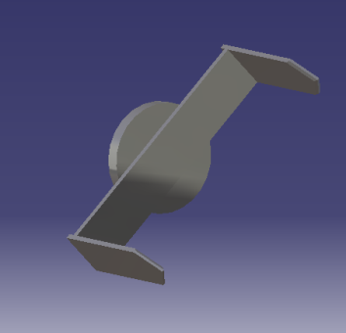

Material Used For Cutter is High Speed Steel

f) DC motor
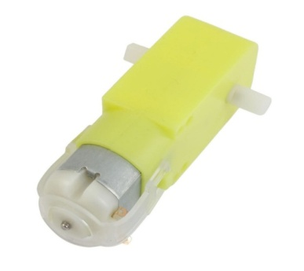
50 rpm 12 volt dc
along with gear box for enhanching torque

              - g)
Fig :- DC Motor
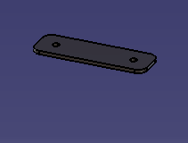
g) Wheel

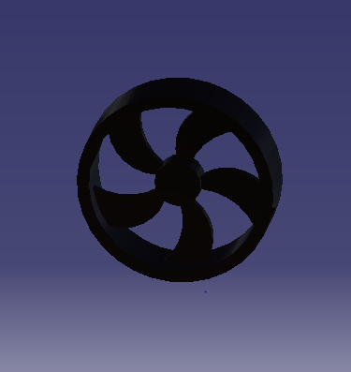
Diameter-70mm
Thickness-4 mm

Fig :- Wheel
h) Actual Design of Construction
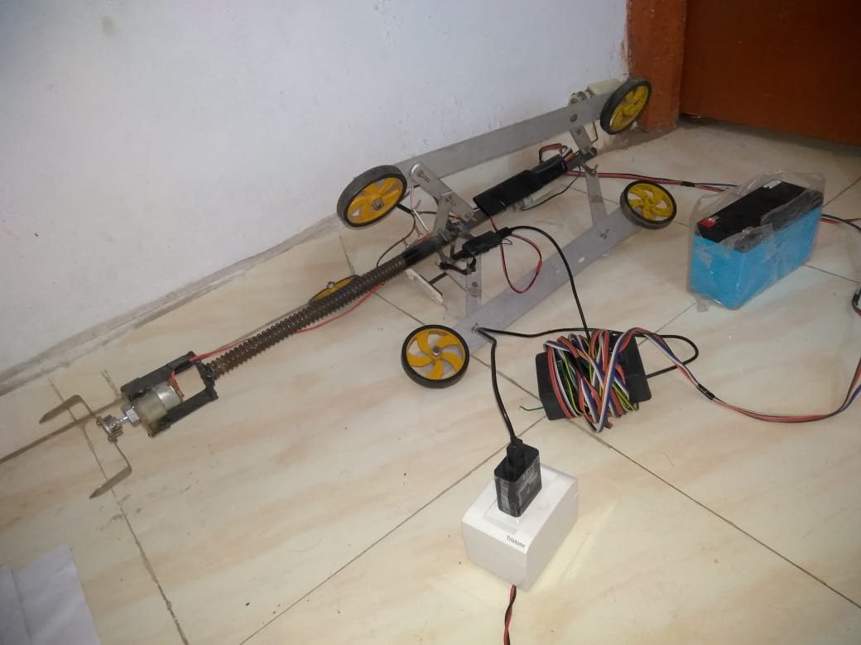
Fig :- Actual Design Of Construction.

ADVANTAGES

- It will alter itself per specific vary of pipe diameter
- Robot is simplest ,most energy economical and have the simplest potential for long vary
- This will move on pipeline with sensing element
- It may also sight tiny defects and flaws by scanning the surface of pipes.
- Simple in style and construction
- Low maintenance.
- Rechargeable batteries.
- Special varieties of accessories are often mounted on that.

FUTURE SCOPE

- To design the robot with track and wheel.
- To resolve type of flow and fluid employing sensors.
- To improve buckle by mounting autonomous roboti arm.
- To audit and improve flaws in a nuclear reactors pipeline.

CONCLUSION
Pipe cleaning robot is working on the mechanism of four bar mechanism which is to audit the pipe of four bar mechanism which is t audit the pipes of 9 inches to 12 inches horizontal and vertical pipes with maximum crawl of 2 km/hr and for cleaning the cutter sizes can varies as per requirement with Wi-Fi connectivity video monitoring of interior of pipes for inspection and cutting can be seen IOS and android software , also brushing action also allow on cutter mechanism for corrosion and oxide flames inside of pipes due to this inspection and cleaning of pipes done together
Fig :- Wheel

REFERENCES

- Jong-Hoon Kim, Gokarna Sharma, And S. Sitharama Iyengar used for audit of 150mm pipeline. Consists of 4valve compress caterpillers its control independently two provide steering capability to go through 45° elbow and 90° elbow pp. 517-523

- Atul Gargade and Dr . Shantipl S. Ohol made a development of In-Pipe audit Robot which can inspect the straight pipe elbow and T-Joint and in different diameter pipes JOSR, ISSN : 2278-1684, volume 13, pp. 64-72

- Hyouk Ryeol Choi And Se-Gon. Roh, proposed a miniature of in pope inspection MRINSPECT series robot for used in practical application school of mechanical engineering singkyunkwan university korea pp. 336-399
.
- Zhelong Wing and Hong Gu Proposed a Brush pipeline robot used to clean a pipeline with stubby bristles between diameter of 9 to 15 called “ A Bristle-Based Pipeline Robot for constraint pipes IEEE pp. 383-390

- Mihita Horodinca and Loan Doroftei Proposed a miniature of In-Pipe audit robot with a stator , rotor , and universal joint recycled for the mobility of robot.

Details of Authors

1 |  | Dr. Anil H. Ingle  (Associate Professor),  Department of Mechanical Engineering Smt. Radhikatai Pandav College of Engineering, R.T.M.N.U
2 |  | Sagar G. Pimpalshende  (U.G. Student) Department of Mechanical Engineering, Smt. Radhikatai Pandav College of Engineering, R.T.M.N.U

