Biodegradable Food Packing
Nishat Qureshi, Gauri Dalwankar
Laxminarayan Institute of Technology, Nagpur,India, 440012

Abstract – Currently , the packaging sector is a major consumer in most of the industries. It has experienced various advances since many years to improve the product quality and safety. Amongst the frequently used packaging materials plastics are highly desired in the packaging of goods but their extensive use imposes a negative impact on the environment, because of their non biodegradable nature. Therefore efforts are being taken to develop the packaging materials from renewable and bio based sources. The biodegradable polymers used for food packing create almost negligible toxic emissions,their raw materials are sustainable, renewable and widely grown. The biodegradable polymers serves all the functions of a package and disintegrates into eco-friendly products at the end of their life. ,The natural polymers and the synthetic polymers cam be used to prepare biodegradable packaging. The synthetic polymers include: polylactic acid , polyglucolic acid and nylon 6. Whereas the natural polymers include: polysaccharides such as starch cellulose,chitin and chitosan. Among these the polylactic acid has emerged to be one of the most promising biopolymers. Furthermore, better manufacturing have improved the economics of producing lactic acid monomer with the help of some renewable sources. Natural polymers derived from agricultural products such as starch, proteins, cellulose and plant oils are the major resource for developing renewable and biodegradable polymer materials. The polylactic acid is targeted for use in the food industry as packaging material. Biodegradable food packaging was once a novelty, but is now widely used and available in various standard and custom products. The explosion of interest in these materials explains the growing consumer concern about sustainability and the environment.

Keywords- Sustainability, bio-based, polysaccharides, polylactic acid.
INTRODUCTION

Packaging- a science, art and technology used to protect ,distribute and store the product, carry nutritional values and present the product to consumer. Consumption of packaging is higher in field of food packaging than the non-food and tobacco items according to Indian Brand Equity Foundation. The current key materials for packaging is glass, paper, plastic, cardboards, and laminates. Amongst the frequently used packaging materials plastics are highly desired. Most food packaging is plastic or contains plastic. According to this Treevolution, only 17% of plastic gets recycled. Some ends up in landfills where it stays for generations and the rest pollutes our environment and our seas. Plastic is not biodegradable, which means it is not possible for the earth to naturally absorb this material back into the soil. Rather, the light breaks down the plastic into small pieces that contaminate the soil .In biodegradable food packing, the materials or the polymers used for food material such packing are made of natural composites. Biodegradable polymers are classified under two categories:
1. Natural biodegradable polymers: polysaccharides such as starch, cellulose, chitin and chitosan.
2. Synthetic biodegradable polymers: a)polylactic acid,polyglucolic acid and nylon 6.

METHOLOGY
80 g of the product of distillation lactic acid, 1% stannous octoate (Sn (Oct)2) catalyst and 200ml m-xylene (Sovlent) were added into 500 ml glass reactor and the reaction mixture was heated. The reaction was continued at 160ºC for 12-16 hrs. Then, the catalyst was filtered off, and the resulting polymer was dissolved in chloroform, and then was precipitated twice in excess of methanol. The product was dried in a vacuum until constant weight was attained. The monomer used for PLA is lactic used is obtained from corn by converting corn to dextrose and then dextrose to lactic acid.
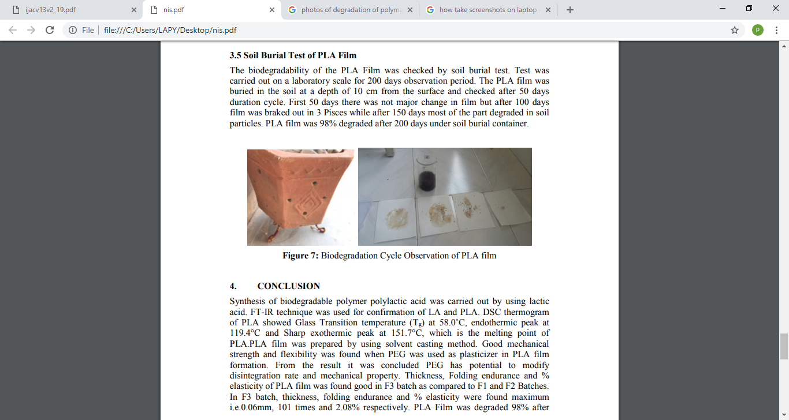

CONCLUSION
Synthesis of biodegradable polymer polylactic acid was carried out by using lactic acid . It has good mechanical strength and melting point of 151.7 degree Celsius. PLA Film was degraded 98% after 100-150 days. Therefore, it shows that PLA Film is eco-friendly and biodegradable polymer. Certainly, the biodegradable food packing will benefit our environment by easily decomposing and not leaving any harms behind.

REFERENCES
- https://en.wikipedia.org/wiki/Biodegradation
- Mrosovsky N. et al.: Mar. Pollut. Bull., 2009, 58, 28.
- Mascarenhas R. et al.: Mar. Pollut. Bull., 2004, 49, 354.
- Clapp J. and Swanston L.: Environ. Polit., 2009, 18, 315.
- Helbling C., Abanilla M., Lee L. and Karbhari V.: Composites A, 2006, 37, 1102.
- Buchanan C., Pearcy B., White A. and Wood M.: J. Environ. Polym. Degr., 1997, 5, 209.
- Krzan A., Hemjinda S., Miertus S. et al.: Polym. Degrad. Stabil., 2006, 91, 2819.
- Krasowska K., Hejmowska A., and Rutkowska M.:ibid, 21.

