Billing System With GST

Prof. N. Y. Choudhary¹, Vaibhavi Naphade², Snehal Patil³, Nutan Patil⁴, Madhuri Patil⁵
¹Asst Prof. ²Student(BE), ³Student(BE), ⁴Student(BE), ⁵Student(BE)
¹²³⁴⁵ Department Of Computer Engineering, Godavari Foundation’s Godavari College Of Engineering, Jalgaon-425003, India,

Abstract:-In our Project we have developed the software to manage the bill submission process in shop or organization. Manually it’s very difficult to calculate different types of item with different GST value. This process is very difficult and time consuming. That’s why we need to develop a system which can calculate GST value of each and every item. The Inventory Maintenance & Billing using GST do these types of calculations as well as save bills for further requirement & also print hardcopy for customers.
Keywords-Goods and Service Tax, Billing.
1. Introduction

This software is developed to manage the bill submission process in shop or organization. Using this system shop employee can generate bill with GST calculation for customer for his purchase and can also print its bill copy for customer. In Inventory Maintenance & Billing using GST system employee can save bill & its details. Employee can submit bill of various amount. The main propose of this Inventory Maintenance & Billing using GST system project is developing a system that automate the bill submission and GST calculation with bill print. In retail, wholesale shop or buy and sale goods organization bill submission and GST billing calculation are very tiresome work and maintaining the record of bill is very difficult and time consuming. In present system, user has to work manually to maintain bill

records and it is very difficult to know the status of the submitted bill and bill calculation with GST.

2.3 Current System:-
Currently in most of our shops or market does not use computers for performing their daily tasks. There are a limited number of shop that use Microsoft Office products, such as Ms. Word and Ms. Excel for performing their daily inventory tasks. Most of them do not even have the Information that computers can make a great difference in the way they are doing their tasks when they are programmed to do so. In the existing system all transactions, dealings of products, purchasing of products were done Manually which time consuming? Reports are prepared manually as and when needed. Maintaining of reports is very tedious task.[1]
2.4 Problem Statement:-
In today’s fast paced society, it’s very hard to be competitive without using cutting-edge technology available in market. After years of business, the data has grown much. It is becoming a challenge for person to manage that data in an effective way. To be more productive in order processing, he needs a solution which can facilitate their current processes with use of technology and software. With increased amount of orders, it is becoming difficult for salesperson to manage orders in effective and efficient manner. It is very hard to go through all paper work and backtracking orders. If there is any complain or review of any order, it takes large amount of effort and time to backtrack and fix the problem. These results in loss of resources.[4]
2. Literature Survey
2.1 Analysis Of Current System:-
It is used to define and understand the current method of implementation, such as a system, a product, etc. From this analysis, it is not uncommon to discover there is actually nothing wrong with the current system or product other than some misunderstandings regarding it or perhaps it needs some simple modifications as opposed to a major overhaul.[2]
2.2 Billing System With GST:-
This System is aimed to provide information to the customer about the product, its GST values & its calculation
of the country.[1]
3. Proposed System
The proposed system is intended to provide the facility of automating the inventory tasks such as Item management and customer billing with GST for the Shop or market. To reduce the bottlenecks of the existing system there is a need to develop a new system. The new system should concern the requirements of the customer and the sellers. This project is designed with a goal to making the existing system more informative, reliable, fast and easier. There are many reasons for the starting of the project because in the selling of items through the manual system of salesperson faces a lot of inefficiencies. It requires handling of large items that consist of both irrelevant and important information’s thus making it difficult to find out the required information as per necessity. To overcome these problems in existing system we develop “Inventory Maintenance & Billing with GST”.
3.1 Benefits of proposed system:-
1. Save time and energy: This system facilitates the admin person to know items that are added in the store or shop. Also system will facilitate customers to make order of items they need and paying the money for their ordered items.
2. It can provide Quality of service to customers and store details of customer bill for further feedback.
3. Speed and Efficiency: A computerized inventory maintenance system makes everything from inputting information to taking inventory easier. Doing a hand count of inventory can take days, but with a computerized inventory maintenance & billing with gst system, the same process can be done in a matter of hours.
4. Document Generation: Once the computerized inventory maintenance & billing with gst system is in place, managers and sales person can use it to automatically generate all kinds of from purchase items and generate bill statements.
3.2 Scope Of System:-
Scope of this project is to investigate and design a software solution which can facilitate both customer and salesperson in performing their daily tasks, improving efficiency, and helping them to be more productive. This project will provide a solution through which salesperson can easily manage, handle and generate all required information in their respective format when needed. This system covers stock control, management and tends to correct anomalies in business. It analysis adding of new item, generate bill with GST and ability to view existing ones. It provides quick way of operation by capturing the manual process and automating them.
It will help them to manage new item details, financial data, and historical data and also in producing bill of GST formats for different customers. This solution will help salesperson in reducing effort spend on managing orders. It will also provide them opportunity to explore possibility of generating documents, managing financial details.
3.3 Objectives:-
1) This project is a software application which is designed in vb.net for managing sales, purchases, item details which are going out in to market. Details are maintained in centralized database.
2) The main objective of our project is to make efficient transaction management system which is user friendly and at the same time powerful.
3) Making the system reliable, easier, fast, and more informative.
4) It has capability to keep the complete information of a transaction.
5) System plays an important role in achieving the desired plant availability at an optimum cost.
6) To produce software which manages the sales activity done in a market, maintaining the item details, maintaining the records of the sales.

4. Methodology
Data were collected from different markets which some half of them use manual system while others use computerized system and customers of both type of markets. Interviewing the people who worked and have experience how to manage market (Ordering, Purchasing, Selling, Storing Items, Payment, & Receipt).To know the quality and the intensity of the information we need.[5]
Following are the modules of this Bill management system.
1.Administration
2.ItemDetails
3. Item Sale
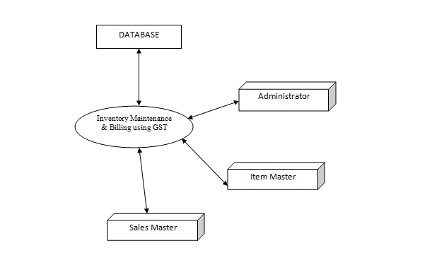
Fig 1:- DFD Of Billing System With GST
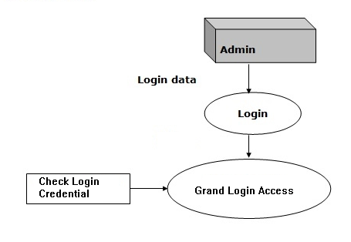
Fig 2:- DFD For Admin Login
4.1 Entity Relationship:-
An entity-relationship also called (ER) diagram, a graphical representation of entities and their relationships to each other, typically used in computing in regard to the organization of data within databases or information systems. An entity is a piece of data-an object or concept about which data is stored.[4]

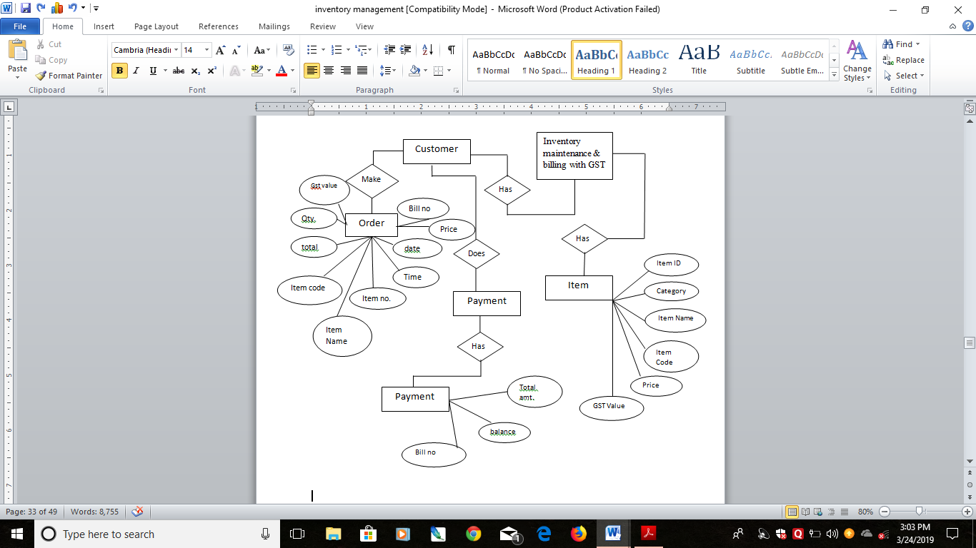 Fig 3:- Entity Relationship Diagram

5. Result & Discussion
5.1 Login Form:-
A Login form is used to enter authentication credentials to access a restricted page or form. This login form contains a field for the username and another for the password.
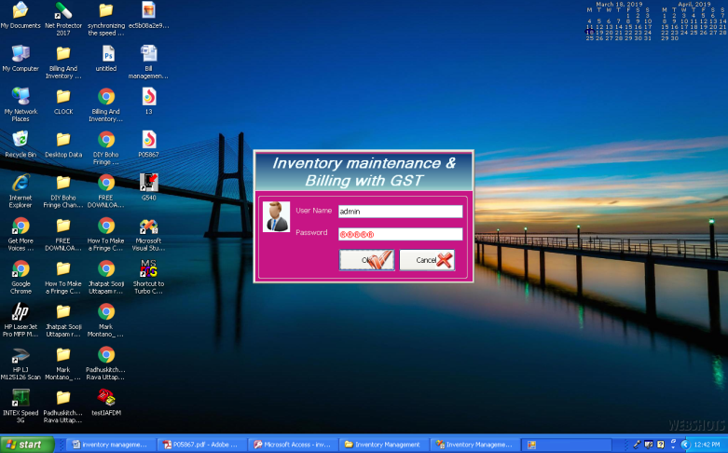
Fig 4:- Login Form
5.2 Home /Main page:-

Fig 5:- Main Page
5.3 Item Master Details Form:-
Is where Items are added and keep their details.
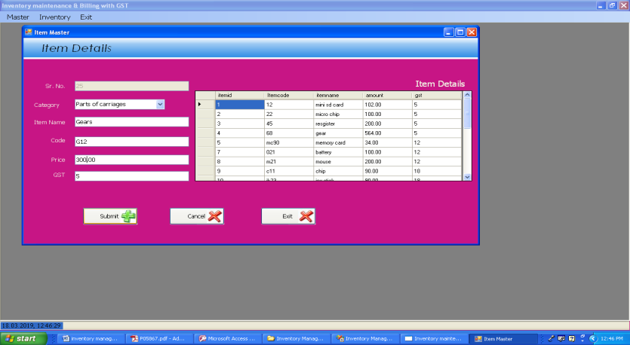
Fig 6:- Item Master Details Form
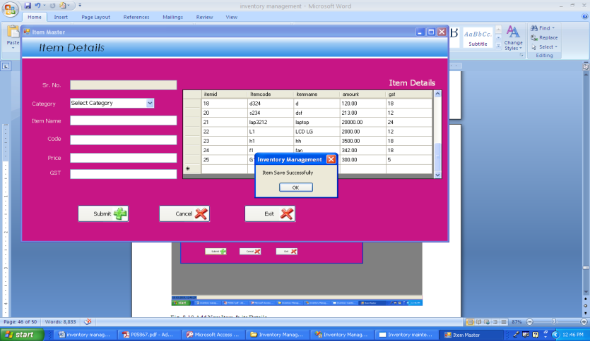
Fig 7:- Add New Item & its Details

5.4 Bill Form:-
This form adds purchase items with its details like item no. item name, price, quantity, GST value and generate bill with GST value.
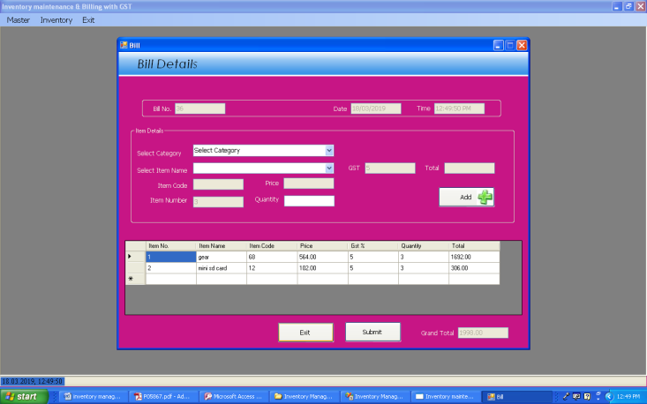
Fig 8:- Bill Form

5.5 Bill Print Form:-
This form will print the final bill of the items.

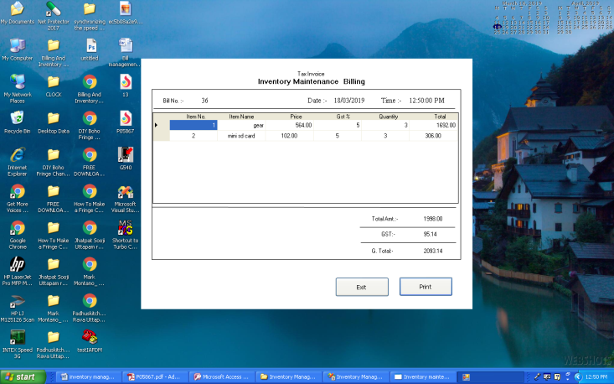
Fig 9:- Bill Print Form

This is the result we have so far and we are still trying to add something new points that will helpful.

6. Conclusion
In this system we implement the automatic GST report generation software for purchase and sales. We develop a system which calculates the GST reports and also generate excel sheets of the reports which needs to submit to the government. To do manual calculation is a difficult task so we design a system which will reduced the manual work as well as save the time and generate reports efficiently. It is designed to replace an existing manual record system for reducing time taken for calculations and for storing data. The system is strong to handle daily operations where the database is cleared over certain time. This system will reduce manual work, calculations and will also provide periodic reports any time.

REFERENCES

[1] Apurva Rewatkar, Akshata Birelliwar, Hemlata R. Kosare, “GST Billing System” (International Conference on Emanations in Modern Engineering Science & Management)2018
[2] Girish Garg, “Basic Concepts and Features of Good and Service Tax In India”, International Journal of scientific research and management (IJSRM) Volume: 2, 2014.
[3] Mrs. Poonam, “Goods and Service Tax in India : An introductory study”, International Journal of science and technology management (IJSRM)Volume: 06, January2017.
[4] Monika Sehrawat , Upasana Dhanda “GST In India: A Key Tax Reform” , International journal of research-granthaalayah ISSN-2350-0530(O) ISSN- 2394-3629(P) December, 2015.
[5] Dr. R. Vasanthagopal , “GST in India: A Big Leap in the Indirect Taxation System” International Journal of Trade, Economics and Finance, Vol. 2, No. 2, April 2011.

