“Seismic Performance of RC Structures Considering Foundation Flexibility”
Miss Arzoo Rewatkar¹
Assistant Professor G.B. Bhaskar² Assistant Professor Laxmikant Vairagade³

¹M.Tech Student (Structural Engineering), Department of Civil Engineering, GHRAET, Nagpur, Maharashtra, India
²Guide, Department of Civil Engineering, GHRAET, Nagpur, Maharashtra, India
³Co-Guide, Department of Civil Engineering, GHRAET, Nagpur, Maharashtra, India

Abstract –Modeling plays a very important role in design and analysis of structures. Generally, the effect of soil is neglected in structural design and the superstructure is considered fixed base. This assumption is true only if the structure is located on rock/hard type soil. In the present study, a typical plan of building with 5 storey is considered and is assumed to be located on medium soil condition and seismic zone V. Linear and nonlinear modeling of the soil-foundation system is carried out along with the superstructure. The fixed and flexible base models are analyzed by using response spectrum analysis method. Non-linear static procedure i.e. static pushover analysis as per ASCE-41 is performed for all the models and their performances are compared. Further, the response reduction factor (R) of considered models is also evaluated. The results show the performance of flexible-base model, considering linear soil-foundation system is in agreement with the fixed base model. The response reduction factor (R) is significantly affected by the incorporation of foundation-flexibility. It can therefore be concluded that the type of soil and the foundation on which the structure is resting is very important for design purpose.

Keywords- Nonlinear Static Procedure, Soil-Structure Interaction, Seismic Performance

INTRODUCTION
The seismic response of an engineering structure is affected by the medium on which it is founded. On solid rock, a ‘fixed-base’ structural response occurs which can be evaluated by subjecting the foundation to the ‘free-field’ ground motion that would occur in the absence of the structure. On a deformable soil, however, a feedback

loop exists—the structure responds to the dynamics of the soil while, simultaneously, the soil responds to the dynamics of the structure. Structural response is then governed by the interplay between the characteristics of `the soil, the structure and the input motion. Soil–structure interaction (SSI), as this phenomenon has become known, has been of research interest for the past 30 years. Compared with the counterpart fixed-base system, SSI has two basic effects on structural response. Firstly, the SSI system has an increased number of degrees of freedom and thus modified dynamic characteristics. Secondly, a significant part of the vibration energy of the SSI system may be dissipated either by radiation waves, emanating from the vibrating foundation–structure system back into the soil, or by hysteretic material damping in the soil. The result is that SSI systems have longer natural periods of vibration than their fixed-base counterparts.
Generally, elastic method is used to analyse and design buildings for all types of load including seismic and wind loads. Nonlinear analysis is essential to estimate the response of buildings subjected to seismic loads, as the buildings designed for code, respond in-elastically due to earthquake loads. Simplified procedures for incorporating the SSI effects i.e. flexible foundation effects, kinematic effects and foundation damping effects have been included in FEMA 440 (2005) and ASCE 41-13(2013) for nonlinear static procedure. Hokmabadi et al. (2014) and Fatahi et al. (2014) reported that the incorporation of SSI effects may shift the performance level of the structure from life safety to near collapse or even collapse levels. Methods for the analysis of soil-structure can be divided into two main categories: direct methods and multistep methods.

- Direct Method: In the direct method, the entire soil-foundation-structure system is modelled and analysed in a single step accounting for both kinematic and dynamic interaction. Dynamic or inertial interaction develops in structure cause displacements of the foundation relative to free field due to own vibrations give rise to base shear and base moments. Kinematic interaction causes foundation motion deviate from free field motions due to presence of stiff foundation elements on or in soil.
- Multistep method: Multistep method uses the principle of superposition to isolate the two primary causes of soil-structure interaction: the inability of foundation to match the free-field deformation and the effect of dynamic response of the structure-foundation system on the movement of the supporting soil.
In the present study, effect of foundation flexibility has been considered over the fixed base structures. A regular building of 5 storey has been considered in the present study. To consider the effect of foundation flexibility on seismic response of these structures, two conditions are considered. In the first case both the buildings are assumed to be situated on hard soil or fixed at the base and in the second case, the buildings are assumed to be located on medium soil condition, thereby, incorporating soil-foundation flexibility.
MODELLING AND ANALYSIS
The 5-storey building having 3 m storey height has been selected to evaluate the effect of foundation flexibility (Fig. 1 and Fig. 2). The building plan is symmetrical about both longitudinal as well as transverse direction as shown in Fig. 1. Three equi-spaced bays of five meter along longitudinal direction and three bays along transverse direction have been considered. Building is regular in plan and elevation. Preliminary sizes of the frame members have been considered based on the deflection criteria given as per Indian standard IS 456-2000 and IS 13920-2016. Response spectrum analysis of structure has been performed as per IS 1893 part 1 (2016). Building is assumed to be situated on medium soil in seismic zone V, having zone factor 0.36. Structure is subjected to gravity loads as per the clauses mentioned in Indian standards (IS 456, IS 875 part I and II). In the proposed structure slab thickness and wall thickness is assumed equal to 100 mm and 230 mm (outer) and 115 mm (internal) respectively.
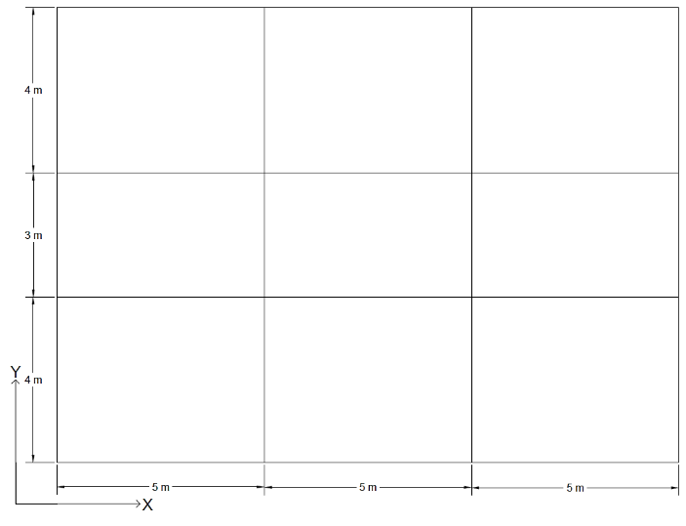
Fig. 1: Plan of building
Structural modeling, analysis and design have been performed in SAP 2000 version 14.2.4. Detailed mathematical model has been prepared to represent the distribution of structural geometry of elements and loading in plan as well as in elevation. Thickness of slab at all floor level and roof level have been assumed to be same and modeled as rigid diaphragm. Archetype building has been analyzed by using response spectrum analysis and designed as special moment resisting frame as per the specifications IS 456:2000 and IS 13920:2016 code. The beams have been assigned with moment (M3) hinges and columns with coupled axial moment (P-M2-M3) hinges at the two ends. To access the performance of building nonlinear static analysis i.e. static pushover analysis has been performed.
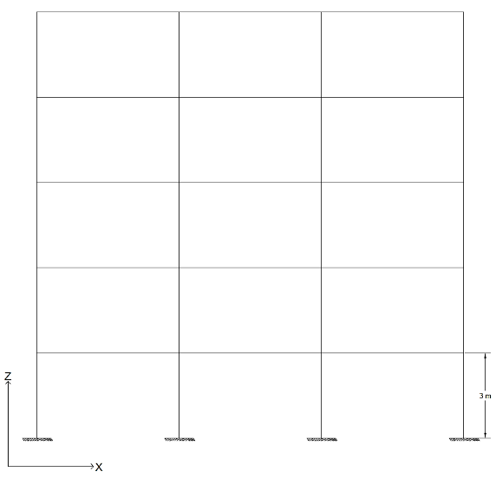
Fig. 2: Elevation of 5-storey in longitudinal direction (XZ-Plane)
In case of 5-storey building, three types of foundation-soil system have been considered. In the first case, all the six degrees of freedoms at the base of the ground storey columns have been restrained which implies that the foundation-soil system is rigid. In the second case, the flexible foundation-soil system is considered and linear soil properties have been modelled using linear elastic spring. In the third case, the flexible foundation-soil system is considered and non-linear soil properties have been modeled using multi-linear plastic spring (Takeda model). As per ASCE 41-17 for shallow bearing footings that are rigid with respect to the supporting soil the foundation stiffness is represented by an uncoupled spring model. Embedment correction factor has also been considered. To determine the property of springs, isolated footing has been designed and the equivalent square area of each footing has been computed using the axial load and bi-axial moment of column and bearing capacity. After computation three sets of foundation sizes have been obtained and their corresponding spring stiffness has been applied as three translational and three rotational springs at each foundation level in case of linear spring foundation system. In case of non-linear spring foundation system, in addition to spring stiffness their respective lumped-plasticity models for calculated capacity (as shown in Fig. 3) has also been assigned.

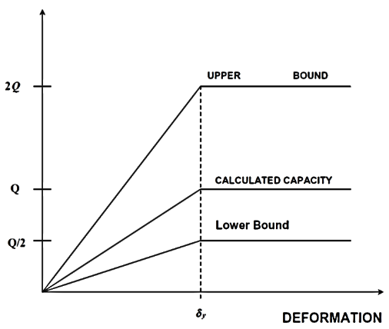
Fig. 4 : Idealized elasto plastic load-deformation behavior for soils (ASCE 41-17)
RESULTS AND DISCUSSION
The results of modal analysis for 5 storey building with fixed and flexible base have been tabulated in Table 1. Soil beneath the footing provides partial fixity instead of full restrained condition. Hence, due to flexible foundation overall structure becomes relatively more flexible than fully restrained support condition as reflected from modal analysis result. The time period of flexible base models is more than fixed base models which shows that reduction in seismic force demand but the target displacement of the structures increase, showing that the structure yields at higher displacement and results in less ductile structure. The nonlinear performance of the models has been assessed using nonlinear static pushover analysis. The capacity curve results and ductility of fixed base model has been compared with flexible base model. The capacity curves of 5-storey building in both longitudinal and transverse direction has been shown in Fig. 5 and Fig. 6.
Table 1: Modal analysis results
Models | Time period (sec)
 | Tx | Ty
Fixed | 1.98 | 1.56
Linear Spring | 2.09 | 1.9
Non-linear Spring | 2.09 | 1.9
Pushover analysis is performed for the considered model under study. The different pushover curves in terms of base shear and roof displacement in longitudinal as well as transverse directions has been obtained. Capacity curves of building model are linear initially, after certain point it start deviating from linearity to non-linearity. Non-linearity comes in picture due to inelastic action start takes place in structural elements. All curves are approximated by means of bi-linearization method as per FEMA 356.
The nonlinear performance of structure is depends on stiffness, strength and ductility of structure. The approximate estimation of aforementioned parameters can be found from the capacity curve result of building obtained from nonlinear static pushover analysis. Pushover analysis also gives insight of weak links present in the structure or highlights the region of inadequate capacity. In the present case the comparative study of change in over strength, storey displacement, yield and ultimate base shear capacity of structure due to foundation flexibility scenario has been performed.
Fig. 5: Capacity curve in longitudinal direction
Fig. 6: Capacity curve in transverse direction
In Figure 5, it is noted that the performance of 5-storey building in longitudinal direction with fixed base and flexible base (with linear soil foundation system) is more or less same, but the ultimate base shear of flexible base with nonlinear soil foundation system is reduced by 40% as compared with fixed base model. The stiffness of flexible base model with nonlinear soil foundation system is 1.56 times less than the fixed base model. As in case of flexible base model, due to the assimilation of substructure in modeling, the local flexibility in base makes the superstructure globally flexible. The flexible base structure becomes unstable at higher displacement which numerically interprets less ductile structure than fixed base model. This shows that the strength and ductility of flexible base model (Non-linear Spring) model decreases due to incorporation of foundation. Fully restrained support condition consideration in the mathematical model does not reflect realistic behavior of footing and hence the obtained results from such mathematical model may interpret the unrealistic nonlinear behavior of structure. If the soil beneath the structure is medium or soft then the foundation modeling should be consider in structural design
CONCLUSIONS
A numerical study has been performed to find out the response of buildings considering soil-foundation nonlinearity, and capacity curves have been compared for all considered cases. It was observed that in case of flexible base model with nonlinear soil foundation system, due to the assimilation of substructure in modeling, the local flexibility in base makes the superstructure globally flexible. Due to which the stiffness and capacity of structure reduces. The response reduction factor (R) is significantly affected by the incorporation of foundation-flexibility which shows that the strength and ductility reduces. Consideration of fully restrained support condition in the mathematical model does not reflect realistic behavior of footing and hence the results obtained from such mathematical model may interpret the unrealistic nonlinear behavior of structure. Hence, the assumption of considering fixed base condition in mathematical modeling may result in reduced strength of the structure. It can therefore be concluded that the type of soil and the foundation on which the structure is resting is very important for design purpose and seismic safety.
REFERENCES
- ASCE 41-13, 2014. Seismic Evaluation and Retrofit of Existing Buildings. American Society of Civil Engineers, Virginia.
- El Ganainy, H. and El Naggar, M.H. 2009. Efficient 3D Nonlinear Winkler Model for Shallow Foundations. Soil Dynamics and Earthquake Engineering, 1236-1248.
- Fatahi, B., Tabatabaifar, S. H. R., and Samali, B. 2014. Soil-Structure Interaction vs Site Effect for Seismic Design of Tall Buildings on Soft Soil. Geomechanics and Engineering, 6(3):293-320.
- Federal Emergency Management Agency (FEMA 440), 2005. Improvement of Nonlinear Static Seismic Analysis Procedures. Washington, D.C., USA
- Gerolymos, N., and Gazetas, G. 2006. Static and Dynamic Response of Massive Caisson Foundations with Soil and Interface Nonlinearities-Validation and Results. Soil Dynamics and Earthquake Engineering, 26 (5):377-394.
- Hokmabadi, A. S., Fatahi, B., and Samali, B. 2014. Assessment of Soil–Pile–Structure Interaction Influencing Seismic Response of Mid-Rise Buildings Sitting on Floating Pile Foundations. Computers and Geotechnics, 55:172-186.
- Jeremic, B., Kunnath, S., and Xiong, F. 2004. Influence of Soil–Foundation–Structure Interaction on Seismic Response of the I-880 Viaduct. Engineering Structures, 26 (3):391-402.
- Mylonakis, G., and Gazetas, G. 2000. Seismic Soil-Structure Interaction: Beneficial or Detrimental? Journal of Earthquake Engineering, 4 (3):277-301.
- Tabatabaiefar, S. H. R., Fatahi, B., and Samali, B. 2012. Seismic Behavior of Building Frames Considering Dynamic Soil-Structure Interaction. International Journal of Geomechanics, 13 (4):409-420.
- Viladkar, M. N., Godbole, P. N., and Noorzaei, J. 1994. Modelling of Interface for Soil-Structure Interaction Studies. Computers & Structures, 52 (4):765-779

