Experimental Analysis Of Heat Transfer Characteristics Through Aerofoil Shaped Pin-Fin With Circular Holes Using Python

Suhas Autade¹, Viraj Kanade², Omkar Deshmukh³, Shailesh Prajapati⁴, Kavita Dhanawade⁵
^{1,2,3,4} Department of Mechanical Engineering, Student
Lokmanya Tilak College of Engineering, Mumbai, India
⁵Associate HOD in Department of Mechanical Engineering
Lokmanya Tilak College of Engineering, Mumbai, India

Kavitadhanawade2@gmail.com
Received on: 29 March,2023 Revised on: 21 April,2023 Published on: 23 April,2023

Abstract – This report presents the results of an experimental analysis of heat transfer enhancement using different sizes of aero foil Pin-fin with circular holes by forced convection. The project aimed to investigate the thermal performance of various types of aero foil shape fins with circular slots of aluminum material, in terms of heat transfer coefficient, Nusselt number, friction factor, and effectiveness of fins. The experiment was conducted on a test section with an internal cross-section along the direction of flow. The experiment was carried out for 12 Pin Fin sets with variations in parameters such as height, number of holes, and diameter of these holes, and velocity was varied from 3m/s to 12m/s. The report outlines the methodology used in the experiment and provides a detailed analysis of the results. Overall, the report concludes that the aero foil Pin-fin with circular holes is a highly efficient heat transfer component with the potential for application in various industrial fields.
Keywords- Aero foil Pin-fins, forced convection, thermal performance, heat transfer coefficient, Nusselt number, friction factor, aluminum material, velocity.
INTRODUCTION
The heat removal is crucial to prevent equipment from burning or overheating. To achieve this, heat sinks are commonly used. Heat sinks are chosen based not only on their thermal performance but also on other design parameters. For industrial applications, high-performance heat transfer components that are lightweight are typically required. The focus of this project is to report on an experimental analysis that investigates heat transfer enhancement using aero foil Pin-fins with circular holes through forced convection. The study will examine 12 Pin Fin sets, each with variations in parameters such as height, the number of holes, and the diameters of these holes.
The proposed experiment will consist of two control panels, a test section, effuser, and diffuser. The length of the duct will be 2800 mm. The internal cross-section of the test section will be 200-80 mm, and it will have a length of 260 mm along the direction of flow. The experiment will be conducted by varying the velocity from 3m/s to 12m/s. An electric heating coil will be used as the heat source. The pressure drops over the test section will be measured using a differential pressure transmitter. Digital temperature indicators will be used to measure the temperatures at various locations.
The experiment will be conducted using various types of aero foil-shaped fins with circular slots made of aluminum. Data from the experiment will be used to calculate the heat transfer coefficient, Nusselt number, friction factor, effectiveness of fins, and other relevant parameters. The results of this experiment will help identify the best performing Pin-fin set for industrial applications. The study will help in selecting an optimal Pin-fin set with the highest heat transfer coefficient, lowest pressure drops, and highest effectiveness. The findings of the study will contribute to the improvement of heat transfer components for industrial use, resulting in the efficient and safe operation of equipment.
The aim of this project is to improve/enhance the heat transfer rate over the surface by increasing the surface area with the help of extended surfaces, particularly Pin Fins. The project will focus on analyzing the Pin Fins, which involves natural convection analysis and forced convection analysis using computational fluid dynamics (CFD) simulation. The project will use ‘PYTHON’ to find the correlations in heat transfer characteristics of the Pin Fins. The project aims to experiment with different parameters of Pin Fins to find the setup with the best efficiency of heat transfer. This includes reducing the cost of material used to manufacture Pin Fins and experimenting with reduced height and diameter to reduce the space required for Pin Fins. Additionally, the project aims to improve heat transfer rate by varying the surface area and porosity.
To increase the heat transfer rate, we need to increase the thermal conductivity (k) which depends upon the material used. However, using materials with high thermal conductivity can be expensive. Moreover, increasing the temperature gradient is not an environmentally feasible solution. Therefore, we need to increase the surface area (A) to enhance the heat transfer rate. The design of the Pin Fins will be optimized to achieve the best heat transfer efficiency while reducing the cost of material used to manufacture them. The optimization will involve experimenting with reduced height and diameter of the Pin Fins. The fabrication process will involve the use of 3D printing technology to create the Pin Fins. The experimental setup will be used to validate the correlations found through the CFD simulation. The setup will involve the use of a wind tunnel to provide the forced convection and a heat source to provide the heat to the Pin Fins. The experimental setup will measure the heat transfer rate over the surface of the Pin Fins to validate the correlations.
The expected outcomes of the project include finding the best parameters for the Pin Fins to achieve the best heat transfer efficiency while reducing the cost of material used to manufacture them. The project also aims to find the correlations in heat transfer characteristics of the Pin Fins with circular holes. Additionally, the project expects to validate the correlations found through the CFD simulation on an experimental setup.
LITERATURE REVIEW
Viveksheel Yadav (2019) [1] analyzed methods to improve heat transfer rates from fins with notches made of different materials. Jain and Auranga badkar explored fin optimization by varying geometry, including rectangular, circular, and triangular fins with rectangular and trapezoidal extensions, to study heat transfer.
Hari Raghavan. J (2017) [2] studied and analyzed the thermal performance of a porous pin fin heat sink compared to a traditional pin fin heat sink with a square cross-sectional shape. The study utilized numerical analysis under steady-state conditions to investigate the heat sink’s natural convection.
Raghu Ram Mohan Reddy (Sep 2020) [3] examined six different materials (Cu, Brass, Al 3003, Al 1050, Al 6061, Al 6082) for their thermal efficiency and effectiveness in heat dissipation through pin fins. Cu performed the best, but Al is preferred for its lower cost and weight. MAT LAB software was used for evaluation
Dr. KV Mali (Nov 2018) [4] compared plate and pin-type micro-fins under natural convection conditions. Pin micro-fins outperformed plate micro-fins with better thermal properties, using less material, and reducing weight. The study also evaluated the impact of orientation on thermal characteristics.
Nitish Kumar's June 2019 [5] review paper examines methods to enhance the heat transfer rate with pin fins. The paper notes that researchers have not made significant efforts to improve this process in recent decades, despite examining parameters such as fin spacing, geometry, temperature distribution, height, and length. The paper focuses on efficiency improvements.
Ravi Warkhedkar (Jan 2011) [6] discusses cooling methods for equipment and devices, including pin fin heat sinks, in response to the challenges posed by increased system power and reduced size. The paper covers experimental analyses, numerical modeling, and advanced cooling techniques.
Md. Shamim Hossain, J. U. Ahamed, Farzana Akter, Debdatta Das and Santoshi Saha (Dec 2013) [7] analyzed heat transfer in a pin fin array, considering parameters such as size, material, and design to meet project requirements. They constructed a fin array and a fin box, conducted multiple experiments to measure efficiencies, and activated forced convection with a fan at different speeds.
Pin fin Heat Transfer Experiment by U S Gawai, Mathew V K, Murtuza S D (Jan 2013) [8] used a setup including a blower, nozzle flow meter, LabView data acquisition system, and test section with a 132 mm long fin made of 10 mm-thick material. The configuration tripped the boundary layer and had low inlet turbulence and uniform velocity field.
Pankaj N. Shrirao, Rajeshkumar U. Sambhe, (Sept 2019) [9] conducted an experiment involving a rectangular duct, a blower, an electric heater, thermocouples, an orifice meter, and a micro manometer. The fin was heated at one end and air was circulated perpendicular to its axis. The blower speed was adjusted to alter air flow rate and the apparatus panel had a voltmeter, ammeter, digital temperature indicator, and heat regulator.
Ramendra Singh Niranjan, Onkar Singh, J. Ramkumar, (Feb 2022) [10] designed and evaluated the heat transfer characteristics of square-shaped micro pin fins under forced convection. They tested twenty-five heat sinks across different heat loads and Reynolds numbers, finding that increasing pin fin height and Reynolds number increased the heat transfer coefficient, while increasing fin spacing decreased it. The study found micro pin fin heat sinks had better cooling performance than plate fins, with closely matched numerical predictions to experimental results.
Aashish Kumar, Usha Dasari, Manoj Kumar Mondal, (July 2019) [11] compared the thermal characteristics of perforated and non-perforated copper and aluminum pin fin heat sinks using Computational Fluid Dynamics (CFD) analysis. The study found that both copper and aluminum heat sinks exhibited improved heat transfer rates with increasing numbers of perforations.
Dr. Kavita Dhanawade and Mainak Bhaumik, (March 2022) [12] reviewed the development and implementation of pin fins and micro pin fins for heat transfer enhancement. They discussed the materials used and fabrication techniques, and how pin fins can be used in gas turbine blades and heat exchanger tubes. The performance of pin fins was evaluated by testing them in arrays or as heat sinks, and it was found that staggered pin fin arrays had a higher heat transfer rate than inline arrays. Key parameters for testing pin fin performance were Reynold’s number, Nusselt number, and friction factor, and empirical data correlation was used to validate experimental data.
Kavita H. Dhanawade, Vivek K. Sunnapwar, Hanamant S. Dhanawade (2018) [13] investigated the thermal performance of rectangular fin arrays with different perforation shapes for forced convection using both experimental and computational methods. The results showed that fins with circular and hexagonal perforations had better heat transfer enhancement and reduced weight compared to solid fins, with a weight reduction of almost 18%. The CFD simulation results were validated with experimental results and good agreement was observed.
Kavita H. Dhanawade, Vivek K. Sunnapwar, Hanamant S. Dhanawade (July 2014) [14] investigated the heat transfer enhancement over vertical rectangular fin arrays equipped with lateral circular perforations using an experimental study. The study used the Taguchi experimental design method to optimize the design parameters, including fin thickness, size of perforations, and Reynolds number range. Results showed that the Reynolds number and maximum porosity had a larger impact on the average Nusselt number, and the optimum design parameters were found through experimentation.
The paper by Shuang Han, Hongbin Dong, Xuyang Teng, Xiaohui Li, Xiaowei Wang (2021) [15] proposes a novel correlational graph attention-based Long Short-Term Memory network (CGA-LSTM) to improve the prediction accuracy of multivariate time series models. The proposed model nests the correlational attention mechanism in the graph attention mechanism to capture both spatial and temporal correlations. The performance of the model was tested on 4 datasets and showed higher prediction accuracy compared to state-of-the-art methods. The study was published in Applied Soft Computing.
After conducting a thorough literature review, it was observed that there has been no exploration of aero foil perforated pin fins. Consequently, this paper has shown experimental analysis of heat transfer characteristics through Aero foil shaped Pin-fin with circular holes using Python.
METHOLOGY
To obtain a better outcome, the project will be using the following methodology shown in Figure 3.1 below. The methodology for the project involves analyzing the Pin Fins through natural convection analysis and forced convection analysis using computational fluid dynamics (CFD) simulation.
The simulation will help in finding the correlation in heat transfer characteristics of the Pin Fins with the change in their shape, particularly with circular holes. After finding the correlations through simulation, the project will check those correlations on an experimental setup.

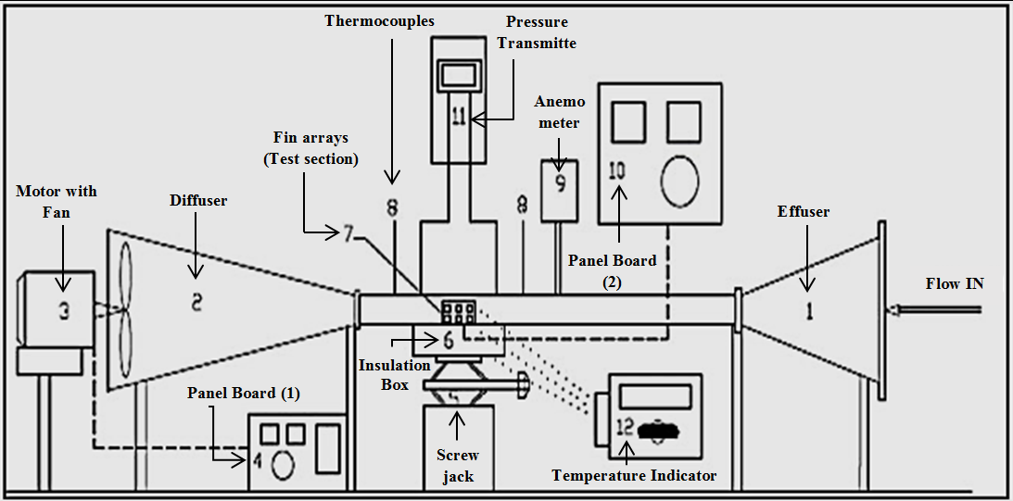
Fig. 3.1 - Methodology Flow Chart
Figure 3.1: Methodology Flow Chart

Figure 3.1: Methodology Flow Chart

Figure 3.1: Methodology Flow Chart

Fig. 4.1 - Proposed Schematic of experimental setup

PROPOSED EXPERIMENTAL SETUP AND FIN ARRAY
The experimental set will be as shown in the schematic in figure 4.1 given below. The motor is switched on which turns on the fan, the air is sucked through the fin array and the readings are taken with the help of thermocouple, anemometer, and other tools/equipment. There are a total of 12 set of fins, each set with different parameters. All of them are thoroughly analyzed with the help of setup.
The shape of aero foil perforated pin fins is as shown in the figures below. Figure 4.2 shows the top view of the fin while the Figure 4.3 shows the front view of the fin. The parameters of each set of fins are different, these parameters are mentioned in the Table 4.1 with their formulas. The 3D model created with Fusion360 showcases how an actual set of fin looks, which is shown in Figure 4.4.
Table 1 - Parameters and their Formulae
Parameters | Formula
Volume of Hole | π x (radius of hole)² x Average Width/thickness
Volume of Single Fin | Top Surface Area x Height
Porosity | Volume of fin with hole / Volume of fin without hole

CONCLUSION
Aero foil Pin-fin with circular holes is a highly efficient heat transfer component with the potential for application in various industrial fields. The study focusses on identifying the best performing Pin-fin set for industrial applications.
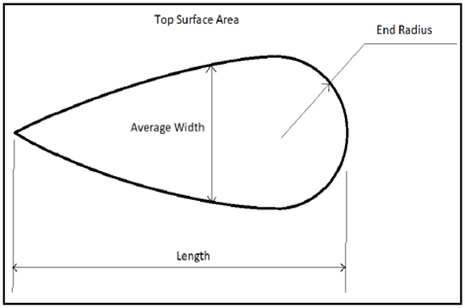
Fig. 4.2 - Top View of Pin Fin
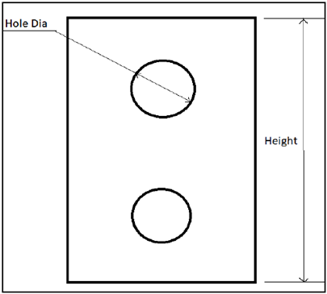
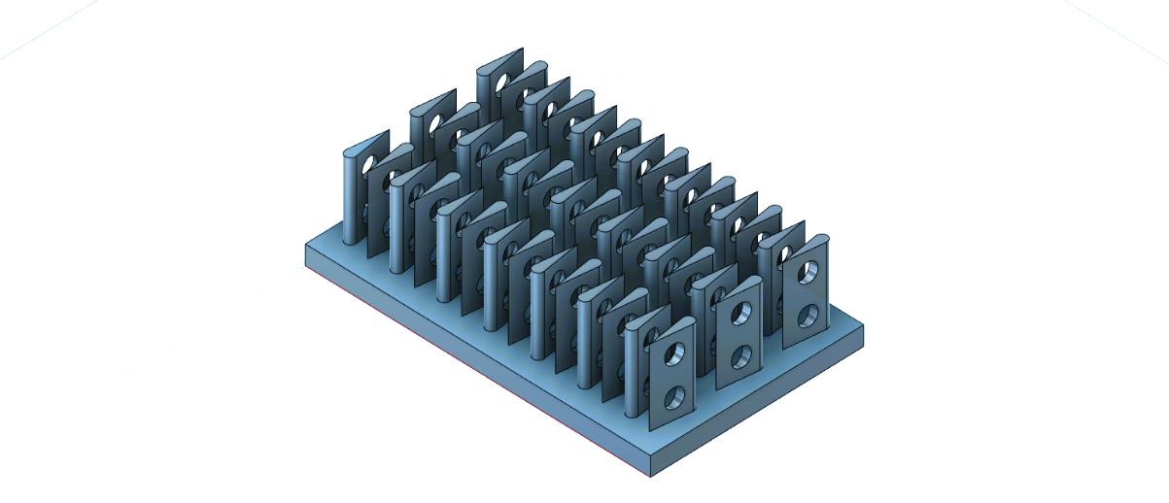
Fig. 4.3 - Front View of Pin Fin
Fig. 4.4 - Aero foil perforated pin fin

The study contributes to the improvement of heat transfer components for industrial use, resulting in the efficient and safe operation of equipment. The study's findings are significant in selecting an optimal Pin-fin set with the highest heat transfer coefficient, lowest pressure drop, and highest effectiveness. The literature review suggests that the aero foil Pin-fin with circular holes is a promising option for enhancing heat transfer in various industrial fields.

ACKNOWLEDGEMENT
I acknowledge my deep gratitude to Mr. Rakesh of Prince Engineering, And Dr. Kavita Dhanawade for inspiration, guidance, and valuable suggestions for this Research Paper. Also special thanks to ASHRAE for project equipment grant.
REFERENCES
Figure 4.1: Proposed Schematic of experimental setup

- Viveksheel Yadav., 6 November 2019, “Heat transfer from different types of fins with notches with varying materials to enhance rate of heat transfer,” Volume.3 Issue
- Hari Raghavan.J., 5 May 2017, “A Study and Analysis on the Thermal performance of a Pin Fin,”Vol. 8 Issue
- Raghu Ram Mohan Reddy.,17 September 2020, “Evaluation Of Thermal Properties On Pin-Fin Material,”Vol. 1 Issue
- Dr KV Mali., 6 November 2018, “Performance evaluation of plate-fins and pin-fins under natural convection,”
- Nitish Kumar., 26 June 2019, “Review Paper on Pin Fin Efficiency Enhancement,” Vol. 6 Issue.
- Ravi Wakhedkar., 25 January 2011, “Thermal performance of pin fin heat sinks,” Vol. 5 Issue.
- Md. Shamim Hossain, J. U. Ahamed, Farzana Akter, Debdatta Das, Santoshi Saha ., 24-27 December 2013, “HEAT TRANSFER ANALYSIS OF PIN FIN ARRAY,” Vol. 7 Issue.
- U S Gawai Mathew V K Murtuza S D Asst.Prof JSPM’s ICOER, P., 7 January 2013, “Experimental Investigation of Heat transfer by PIN FIN,” Volume-2 Issue.
- Pankaj N. Shrirao, Rajeshkumar U. Sambhe., 3 September 2019, “Enhancement of Heat Transfer Characteristics using Aerofoil Fin over Square and Circular Fins,” Volume-8 Issue.
- Ramendra SinghNiranjan, OnkarSingh, JRamkumar., February 2022, “NUMERICAL STUDY ON THERMAL ANALYSIS OF SQUARE MICRO PIN FINS UNDER FORCED CONVECTION,” Vol. 4 Issue.
- Aashish Kumar, Usha Dasari, Manoj Kumar Mondal., 24 july 2019, “Thermal performance of perforated pin fin heat sinks: A simulation-based study,” Vol. 6 Issue.
- Dr. Kavita Dhanawade, Mainak Bhaumik, March 2022, "Pin Fins to Micro Pin Fins Development, Implementation, Novel Investigation and Heat Transfer Enhancement Characteristic".
- Kavita H. Dhanawade, Vivek K. Sunnapwar, Hanamant S. Dhanawade, 2018 "Thermal analysis of rectangular fins with different shapes of lateral proportions by forced convection".
- Kavita H. Dhanawade, Vivek K. Sunnapwar, Hanamant S. Dhanawade, 22 July 2014. "Optimization of Design Parameters for Lateral Circular Perforated Fin Arrays under Forced Convection".
- Shuang Han, Hongbin Dong, Xuyang Teng, Xiaohui Li, Xiaowei Wang, 2021. "Correlational graph attention-based Long Short-Term Memory network for multivariate time series prediction".

