Coagulation Of Dairy Waste Water By Using Natural Coagulants

Vikash R. Agrawal¹, Prashant T. Dhorabe², Pratiksha P. Shastrakar³,
Abhinav R. Khanorkar⁴, Pooja M. Chandrawanshi⁵, Bomblesh P. Kamdi⁶, Sandeep S. Tiwari⁷

^{1, 2}(Assistant Professor, Civil Department, Priyadarshini College of Nagpur)
^{3, 4, 5, 6, 7(}Student, Civil Department, Priyadarshini College of Nagpur)

Abstract: The chemical coagulants are widely used for turbidity removal in water but they have health’s problems associated with them and are additionally uneconomical for use in developing countries. The present work aimed to the assessment to the coagulation efficiency of natural coagulants in water. In this study the powder of seed Moringa olifera (MO) used as natural coagulants. The efficiency of MO as a coagulant for dairy waste water purification was investigated by using the Jar Test apparatus. The optimum dosage of MO seed powder was observed to be at 90 mg/L. After the treatment of waste water following results are obtained :- pH (9.34), conductivity (1.63 s/m), dissolved oxygen (0.64mg/l), turbidity and hardness (119.78 ppm, 107.06 ppm and 12.72 ppm) respectively. Analysis of some metals such as copper, chromium, lead, calcium, magnesium, cobalt and zinc were performed before and after treatment of the water sample with the Moringa oleifera seed. The metals analyzed (Cu, Zn, Ca, Cr, Pb, Co, and Mg) before and after coagulation showed that concentration of Zn, Cu, Co, Pb and Ca as increased in the most optimally purified water containing 90mg/L MO seed Powder from, 1.12 to 2.54mg/L, 0.18 to 0.39mg/L, 0.00 to0.19mg/L, 0.00 to 0.08mg/L and 1.02 to 2.10 mg/L respectively. And magnesium concentration decreased from 36.32 to 27.89 mg/L.The efficiency of the results will be compared to that of Alum at doses 10, 20, 30 and 40mg/l and national drinking water quality (India).

Keywords: Coagulant, Hardness, Metals, Moringa oleifera, Turbidity, and Water treatment

- INTRODUCTION
Water is a key factor for economic development worldwide because it is widely used in different productive sectors—such as industry, livestock and agricultural production, and urban supply— which has led to water overuse. According to UNESCO, reduced water quality contributes to water scarcity. Factors such as rapid urbanization, increased farming activities, pesticide use, land degradation, high population density, and unsuitable waste disposal are affecting the quality of available fresh water sources. One of the main challenges of this century will be achieving water recycling processes to ensure worldwide water supply. Effective water resource management and contamination control are required to fulfill this water challenge. To accomplish these requirements, investment in a sustainable sanitation system is needed that includes technical, economic, social, and ecological approaches.
In recent years, several studies have been developed to search for sustainable and eco-friendly natural coagulants as an alternative to inorganic and synthetic coagulants to obtain drinking water. Despite the performance and cost-effectiveness of these coagulants, they require pH and alkalinity adjustments, they generate high volumes of sludge, and their residuals in treated water (e.g., aluminium) are linked with neurodegenerative diseases such as Alzheimer’s, as well as neurotoxic and carcinogenic effects. Moreover, aluminium is not biodegradable and can cause environmental problems during the treatment and disposal of the generated sludge. Therefore, natural origin materials have been applied for water clarification especially in the treatment of high-turbidity waters (>100 NTU). Moringa oleifera (MO) seeds are one of those coagulants, as they contain water-soluble proteins that can be used either in drinking water clarification or wastewater treatment. MO is a tropical plant that belongs to the Moringaceae family.
MO is the most widespread species, which grows quickly, even in medium soils having relatively low humidity. It is a fast-growing, drought-resistant tree native to the southern foothills of the Himalayas in north-western India, and it is widely cultivated in tropical and subtropical areas, where its fresh seed pods and leaves are used as vegetables.
MO seed was reported to contain an active bio-coagulation compound [10] and be able to reduce high turbidity and microorganisms in water. The use of MO seed powder contributes to the increase in organic matter in treated water.
This study aims to evaluate the performance of MO seeds and MO seeds with a reduced amount of oil as coagulants in a water treatment process used to remove cyanobacteria from model natural waters with low to high turbidity. The idea is to study the seed completely, thereby considering the interaction of the various compounds present in the seeds, not only the protein, since it will be easier for use in water treatment. Previous studies have suggested that MO is an effective coagulant, but none have been carried out to determine its impact on low turbidity waters, cyanobacteria and natural organic matter. Therefore, in this study, low-turbidity waters (5 and 10 NTU) were studied and compared with high-turbidity waters (30 and 60 NTU).

- MATERIAL AND METHODS

2.1. Sample collection: -
The MO seeds used in this study were acquired from local markets, the raw waste water used in tests of coagulation/flocculation originated from the AMUL Industry.

2.2 Moringa Oliefera (Drum stick):-
Moringa oliefera is the most widely cultivated species of Monogenetic family, the moringaceae that is native to the sub-Himalayan tracts of India, Pakistan, Bangladesh and Afghanistan, it is already an important crop in India.

2.3. Preparation of coagulants seeds powder:-
The extract was prepared from the seeds: Moringa Oliefera and cactus origin materials were obtained from the market. M. O. seeds and cactus were removed from the pod and sun dried for 24hours at an ambient temperature of about (23⁰C-25⁰C). The dried seeds were grinded using a Pestle and mortar to obtain in powdered form. The powder was sieved and stored in a sterile bottle in a refrigerator.

2.4. Preparation of coagulants stock solution:-
1 g of powder was weighed in a beam balance and mixed with 100 ml distilled water to form 100 ml of suspension, resulting in 10,000mg/l Concentration(1%). The suspension was then thoroughly mixed using a clean magnetic stirrer for 5 min to extract the active component, followed by filtration of the solution through a piece of clean white muslin cloth so as to remove the residue. The obtained stock solutions from each of these methods were preserved at -4°C until analyzed.

2.5 Determination of Some Physiochemical Parameters:-

2.5.1 Turbidity: This test was determined by Nephelometric method using Naphla – HACH 2100N turbidimeter, before and after treatment of the water sample.

2.5.2 PH: The test was carried out using pH meter model 400.

2.5.3 Conductivity: The test was determined using conductivity meter model inolab cond 720. Temperature: The test was determined using the mercury-in-glass thermometer.

2.5.4 Dissolve Oxygen (Do): 200ml of water sample was measured and transferred into a bottle, covered and incubated in the dark at a temperature of 20oC for a period of five days, and then the sample was removed and read in order to get the difference between the Dissolved Oxygen concentration in the sample before and after the incubation period.

2.5.5 Determination of Some Heavy Metals: Both the most optimally purified water sample of 90mg/L dosage and the untreated raw water sample were digested using the standard method of Association of Official Analytical Chemistry (AOAC) for further analysis of some metals (Zn, Cu, Pb, Mg, Ca, Cr, and Co) using Atomic Absorption Spectrophotometer (AAS).

2.5.6 Alkalinity: Take 50 ml of given sample in a conical flask and add 2-3 drops of phenolphthalein indicator to it if a pink colour develops then titrate it against std. H₂SO₄ solution till the pink colour changes to colorless. This is the end point indicating pH 8.3. Note the volume of H₂SO₄ required, this the ‘P’ end point (if pink colour does not appear after addition of phenolphthalein then ‘P’ end point is absent in such case add methyl orange directly)
Now to the same add methyl orange indicator to 2-3 drops and continue the titration with H₂SO₄ pH comes down to 4.5 i.e., colour changes from yellow to orange indicating the end point. This is the ‘T’ end point (total alkalinity). Note the total volume of H₂SO₄ required from the beginning of titration.

2.5.7 Hardness
For total hardness, take 50ml (or desired vol.) of sample in a conical flask. Add few ml. of buffer solution to it to maintain the PH. Add 2-3 drops of Erichrome Black T. titrate with std. EDTA sol. till wine red colour turns blue. Note the reading.
For calcium hardness, hardness due to magnesium is removed by increasing pH of the sample above 10 so that magnesium ions get precipitated. For this purpose, add few ml. of NAOH to the 50ml sample in the conical flask and add murexide as an indicator. Titrate with std. EDTA till pink colour changes to purple. Note the reading.

2.5.8 Dissolve Oxygen (DO)
Fill the BOD Bottle (300 ml capacity) with the sample upto the rim. Tap the bottle from the side to remove air bubbles inside the bottle and stopper the bottle. Then take out the stopper and add 2ml of MnSO₄ solution followed by 2ml of alkali-iodide-azide reagent (the additions by dipping pipette inside the bottle. Use separate pipettes for each reagent). Stopper the bottle carefully to remove the air bubbles and mix by inverting the bottle a few times. Allow the precipitate formed to settle. When the precipitate has settled sufficiently, add 2ml of conc. H₂SO₄.
Restopper the bottle and mix by inverting several times until the precipitate goes into the solution. Take 200 ml of the solution in a conical flask and add Na₂S₂O₃ titrate till pale yellow colour appears. Then add starch indicator and titrate till blue to colourless.

2.5.9 Biochemical Oxygen Demand (BOD)
Preparation of dilution water: - Aerate required amount of distilled water for 24 hours and keep it at 20⁰c overnight. Then add 1ml each of phosphate buffer, magnesium sulphate, calcium chloride and ferric chloride solution per liter of dilution water. Seed the dilution water by adding 1-10 ml of raw settled sewage(24-36 hours) per liter generally 1ml/l sewage is added (seed should not exceed more than 5mg/l of depletion of DO in blank ). Seeded dilution water should be used the day it is prepared.
Dilution of sample: - when the BOD is more than 5mg/l dilution of sample is necessary. Neutralize the sample to pH 7. The sample should be free from residual chlorine. If it contains chlorine, sodium sulphite (Na₂SO₃) is to be added. Make several dilution of the prepared sample so as to obtain the required depletions in DO. Depletion in DO should not be less than 2mg/l and DO. After 5 days should not be less than 1mg/l.
Procedure for BOD setup: - prepare required dilution (such as 0.5%, 1%, 2.5% etc.) by adding calculate amount of sample to the seeded dilution water taken in 1 lit. With dilution water without entrainment of air. Now note the bottle numbers. Transfer the diluted sample from the cylinder preferable by siphoning into three BOD bottles. Stopper the bottles immediately and keep them for incubation in BOD incubator at 20⁰c for days under water sealed condition. Similarly prepare blank BOD bottles by using only seeded dilution water without adding sample. Calculate zero day DO of the blank. On the 5th day remove the bottles from the incubator and find dissolve oxygen (DO) in all the blank as well as sample bottles.

2.5.10 Chemical Oxygen Demand (COD):-
1) For Sample - Wash a 300 ml capacity round bottom refluxing flask with ground glass joint and rinse it 2 times with distilled water. Put one spatula mercuric sulphate in it. Take 10 ml sample in the flask. Then add 5 ml potassium dichromate to it. After this, add 15 ml conc. H₂SO₄ very carefully with continues shaking. Then add small amount of silver sulphate. (The total volume of sample+ dichromate should be equal to total volume of H₂SO₄ added.). Shake well and reflux for 2 hours. Cool and add little amount of distilled water to the flask through the condenser. Titrate the solution in the flask against FAS using ferroin indicator till the colour changes to reddish brown from intermediate green colour.
If before or while refluxing the solution in the flask turns green then it indicates that the concentration is high. Hence in this case discard the sample and perform COD test with diluted sample.
2) For blank: - add 10ml distilled water instead of sample rest of the procedure is same.
3) Standardization of FAS: take 10ml of distilled water in flask and add ml potassium dichromate solution to it then add 1ml concentrated H₂SO₄ and titrate against FAS using ferroin indicator.

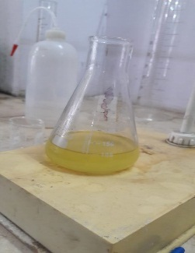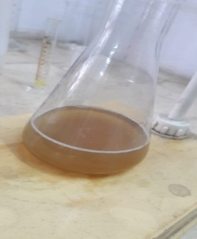

fig.2.1:- alkalinity

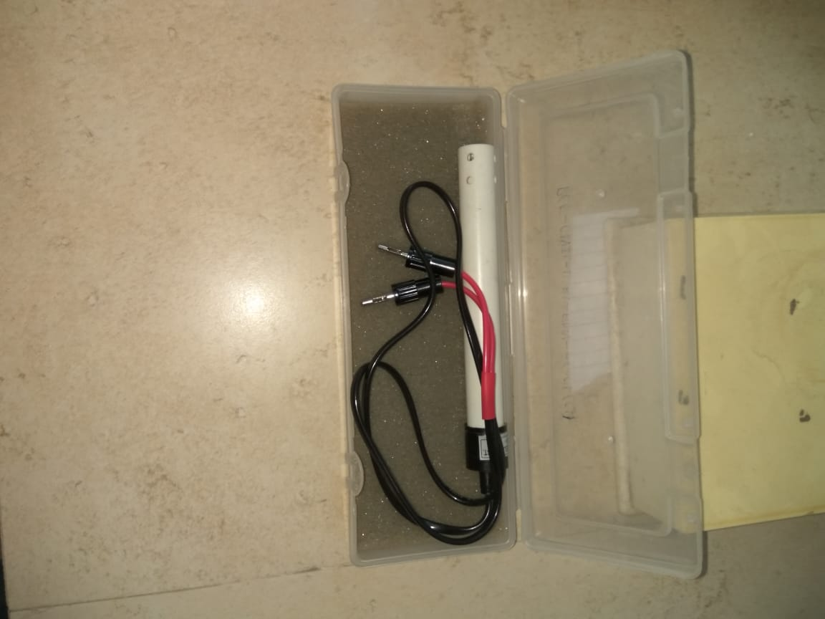
Fig.2.2:- Conductivity
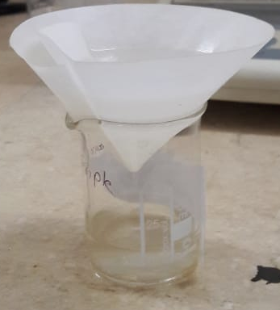
Fig. 2.3:- Total solids
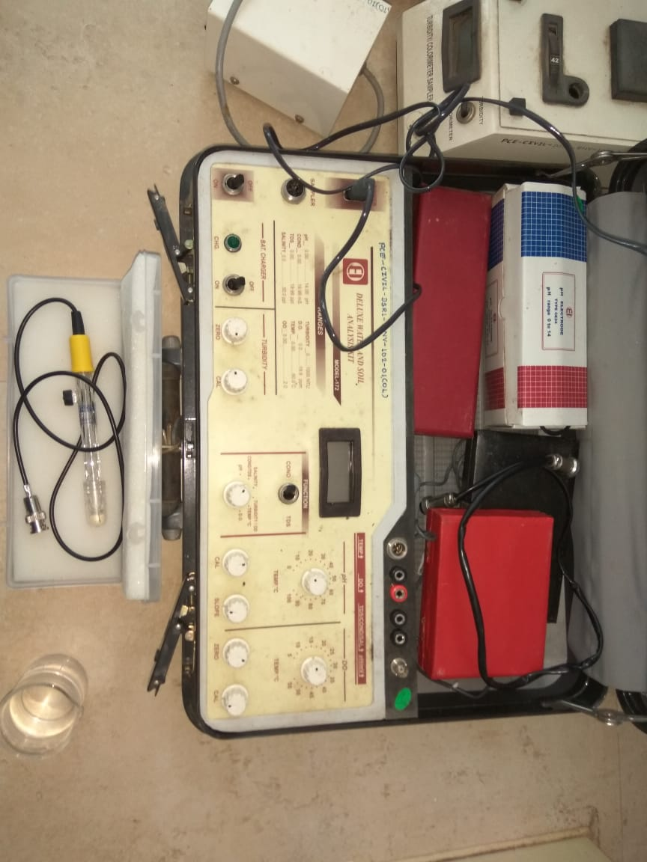
Fig. 2.4:- pH
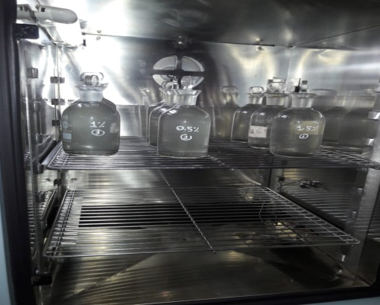
Fig 2.5:- biological oxygen demand
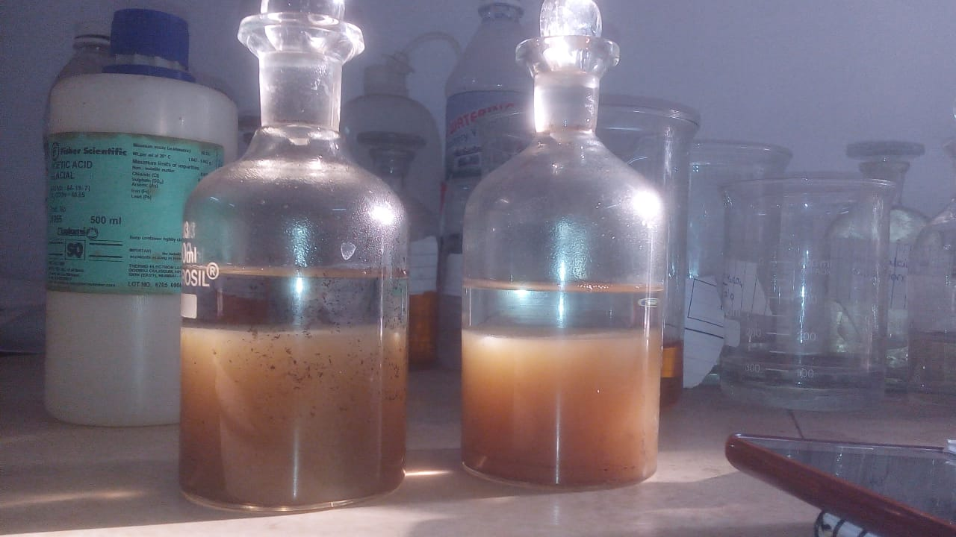
Fig. 2.6:- dissolve solids
- RESULT AND DISCUSSION
Table 1: Results of Raw water sample
S/N | Parameters | Raw waste water  characteristics | Indian standard of drinking  water quality limits  Desirable/permissible
1 | Turbidity(NTU) | 18.15 | 1.00/5.00
2 | Total dissolves solids(mg/l) | 2130 | 500/200
3 | Total suspended solids (mg/l) | 343 | <30
4 | Total solids (mg/l) | 3670 | -
5 | pH | 9.34 | 6.5-8.5
6 | Hardness (mg/l) of caco₃ | 119.78 | 200/600
7 | Chloride (mg/l) | 30.14 | 250/1000
8 | Alkalinity (mg/l) | 104.18 | 200/600

Table 2: Results of Moringa Oliefera
S/N | Parameters | 100mg/l | 150mg/l | 200mg/l | % of highest
 |  | dosage | dosage | dosage | removal
1 | Turbidity(NTU) | 4.95±0.02 | 4.23±0.01 | 4.37±0.03 | 77%
2 | Total dissolve | 269±1 | 230±1.5 | 240±2.0 | 46%
 | solids(mg/l)
3 | Suspended | 235±1.44 | 219±0.57 | 227±3.39 | 38%
 | solids (mg/l)
4 | Total Solids | 504±2.38 | 449±1.47 | 460±2.64 | 43%
 | (mg/l)
5 | pH | 7.63±0.04 | 7.53±0.01 | 7.58±0.04 | 11%

Table 4: Results of Alum treatment
S/N | Parameters | 10mg/l dosage | 20mg/l dosage | 30mg/l dosage | 40mg/l dosage | % of Highest removal
 | Turbidity (NTU) | 4.28 | 4.04 | 3.61 | 3.75 | 80%
 | Total dissolve solids (mg/l) | 235 | 221 | 211 | 215 | 45%
 | Suspended solids (mg/l) | 200 | 207 | 190 | 197 | 44%
 | Total solids (mg/l) | 435 | 428 | 401 | 412 | 40%
 | pH | 7.54 | 7.52 | 7.50 | 7.50 | 11%

Table 5: Results of Sludge Analysis

S/N | Parameters | 10 mg/l | 20 mg/l | 30 mg/l | 40mg/l | 100 mg/l | 150 mg/l | 200 mg/l | 250 mg/l
 | M.O. seeds(g) | - | - | - | - | 4.01 | 4.23 | 4.13 | -
 | Cactus | - | - | - | - | 3.90 | 4.10 | 4.05 | -
 | Alum | 5.52 | 5.63 | 5.75 | 5.71 | - | - | - | -

Table 6: shows different coagulants Dosages in Turbidity graph
Dosages (mg/l) | 0 | 1 | 2 | 3 | 4
Moringa seeds | 18.15 | 100 | 150 | 200 | -
Cactus | 18.15 | 150 | 200 | 250 | -
Alum | 18.15 | 10 | 20 | 30 | 40
The turbidity value was observed to be 18.15(NTU) in the raw waste water sample, which is above both national and international standards. After the treatment with various coagulants, the turbidity decrease to 4.23 (NTU) using Moringa oliefera seeds and 4.40(NTU) on cactus with optimum dosages of 150 and 200mg/l respectively, while Alum is 3.61 with coagulant dosage of 30mg/l. The highest removal efficiency of M. Oliefera is 77% while that of cactus is 75%.
Table 7: Shows different coagulants dosages on suspended solids graph
Dosages (mg/l) | 0 | 1 | 2 | 3 | 4
Moringa seeds | 781 | 100 | 150 | 200 | -
cactus | 781 | 150 | 200 | 250 | -
Alum | 781 | 10 | 20 | 30 | 40

Total solids include all the mobile charged ions present including (fats, salts and the suspended solids). The Total solids was initially found to be 781mg/l in the Dairy waste water sample, and when treated with the natural seeds coagulants of Moringa Oliefera and cactus, it reduces to 449 and 462mg/l, with an optimum coagulant of 150mg/l and 200mg/l respectively and removal of efficiency of 43% on M. oliefera. Upon Alum treatment the Total solids was found to be 421mg/l with optimum coagulant of 30mg/l and removal efficiency of 47%.
- SUMMARY AND CONCLUSION
Moringa Oliefera seeds and cactus act as a natural coagulant, flocculent for water treatment based on the research. Both reduces the level of all tested parameters present in the water sample, although Moringa seed is more effective than alum with the highest purity in turbidity at 77% efficiency and 75% that of cactus, and optimum coagulant dosage of 150mg/l and 200mg/l respectively. While Alum has 80% efficiency at 30mg/l but produces more sludge than the natural coagulants.
REFERENCES

- Yong, M. Y., & Ismail, N. (2016). Optimization of hibiscus sabdariffa as a natural coagulant to treat Congo red in wastewater. Journal of Engineering Science and Technology, 11(Special Issue onthefourtheureca2015), 153–165.
- Deepthi, P., Sarala, C., & Mukkanti, K. (2015). Application of Natural adsorbents for Wastewater treatment. International Journal of Research, 2(07), 2348–6848. Retrieved from http://internationaljournalofresearch.org
- Mukhtar, L. W., & Abba, S. I. (n.d.). Evaluation of Coagulation Efficiency of Natural Coagulants (Moringa Oliefera, Okra) and Alum, for Yamuna Water Treatment, 2763–2771.
- De Souza Fermino, L., De castro Silva Pedrangelo, A., De Matos Silva, P. K., De Azevedo, R. E. C., Yamaguchi, N. U., & Ribeiro, R. M. (2017). Water treatment with conventional and alternative coagulants. Chemical Engineering Transactions, 57, 1189–1194. https://doi.org/10.3303/CET1757199
- Kebaili, M., Djellali, S., Radjai, M., Drouiche, N., & Lounici, H. (2018). Valorization of orange industry residues to form a natural coagulant and adsorbent. Journal of Industrial and Engineering Chemistry, 64, 292–299. https://doi.org/10.1016/j.jiec.2018.03.027
- Kakoi, B., Kaluli, J. W., Ndiba, P., & Thiong’o, G. (2016). Banana pith as a natural coagulant for polluted river water. Ecological Engineering, 95, 699–705. https://doi.org/10.1016/j.ecoleng.2016.07.001
- Choy, S. Y., Prasad, K. N., Wu, T. Y., Raghunandan, M. E., & Ramanan, R. N. (2016). Performance of conventional starches as natural coagulants for turbidity removal. Ecological Engineering, 94, 352–364. https://doi.org/10.1016/j.ecoleng.2016.05.082
- Camacho, F. P., Sousa, V. S., Bergamasco, R., & Ribau Teixeira, M. (2017). The use of Moringa oleifera as a natural coagulant in surface water treatment. Chemical Engineering Journal, 313, 226–237. https://doi.org/10.1016/j.cej.2016.12.031
- . Kebaili, M., Djellali, S., Radjai, M., Drouiche, N., & Lounici, H. (2018). Valorization of orange industry residues to form a natural coagulant and adsorbent. Journal of Industrial and Engineering Chemistry, 64, 292–299. https://doi.org/10.1016/j.jiec.2018.03.027
- Boulaadjoul, S., Zemmouri, H., Bendjama, Z., & Drouiche, N. (2018). A novel use of Moringa oleifera seed powder in enhancing the primary treatment of paper mill effluent. Chemosphere, 206, 142–149. https://doi.org/10.1016/j.chemosphere.2018.04.123
- Antov, M. G., Šćiban, M. B., Prodanović, J. M., Kukić, D. V., Vasić, V. M., Đorđević, T. R., & Milošević, M. M. (2018). Common oak (Quercus robur) acorn as a source of natural coagulants for water turbidity removal. Industrial Crops and Products, 117(November 2017), 340–346. https://doi.org/10.1016/j.indcrop.2018.03.022
- Villaseñor-Basulto, D. L., Astudillo-Sánchez, P. D., del Real-Olvera, J., & Bandala, E. R. (2018). Wastewater treatment using Moringa oleifera Lam seeds: A review. Journal of Water Process Engineering, 23(March), 151–164. https://doi.org/10.1016/j.jwpe.2018.03.017
- Keogh, M. B., Elmusharaf, K., Borde, P., & Mc Guigan, K. G. (2017). Evaluation of the natural coagulant Moringa oleifera as a pretreatment for SODIS in contaminated turbid water. Solar Energy, 158(September), 448–454. https://doi.org/10.1016/j.solener.2017.10.010
- de Souza, M. T. F., de Almeida, C. A., Ambrosio, E., Santos, L. B., Freitas, T. K. F. de S., Manholer, D. D., … Garcia, J. C. (2016). Extraction and use of Cereus peruvianus cactus mucilage in the treatment of textile effluents. Journal of the Taiwan Institute of Chemical Engineers, 67, 174–183. https://doi.org/10.1016/j.jtice.2016.07.009
- Baptista, A. T. A., Silva, M. O., Gomes, R. G., Bergamasco, R., Vieira, M. F., & Vieira, A. M. S. (2017). Protein fractionation of seeds of Moringa oleifera lam and its application in superficial water treatment. Separation and Purification Technology, 180, 114–124. https://doi.org/10.1016/j.seppur.2017.02040

