An Approach for apply DVR to Moderate Voltage Sags and Swells
Namrata Gupta¹, Manish Awasthi², Mahesh Ahuja³, Suman Giri Goswami⁴
¹M. tech Student, Department of Electrical Engineering
JNCT College, Rewa, India, 486001
²Assistant Professor, Department Of Electrical Engineering
JNCT College, Rewa, India, 486001
^{3,4}Assistant Professor, Department Of Electrical Engineering
MATS University, Arang- Kharora highway, Arang,Raipur, India,493441

Abstract – Improved and controlled power quality is one of the necessary fundamental in any electrical industry for the utilization of resources. On the other hand critical problems in power quality have been predictable such as sags, swells, harmonic distortions and some of the interruptions. These sags and swells are found and have collision on the electrical devices and electrical machines. So needs to be compensated to failure. The DVR is one of the tradition power device used for the compensation of voltage sag and swell with an advantage of active/reactive power control.
A most important volume of literature reported in past quite a lot of years on different configurations of DVR and different control technique used in it which have been describe in this paper. In context of this a detailed review on DVR has been presented with different possible power circuit topologies and control techniques available to reconcile these power quality issues. In this paper will put in in better selection of control policy DVR for a particular requirement.

Keywords- Dynamic voltage Restorer (DVR), Voltage Sag, Voltage swell, Matlab/Simulink.
INTRODUCTION
Power quality is huge significance in all recent environments where the electricity is involved. Power quality can be affected by some important factor like quality examination. Power quality problems can be categorized by five major factors like- voltage sags, voltage swells, transients, interruptions and harmonics. These problems may mitigate by the uses of Dynamic voltage Restorer (DVR). Deregulating of electric power system market has made power quality a parameter of consideration to achieve a higher price per kilowatt, to increase the revenue and share of the market [1]. The power quality problems originate from various events

ranging from switching events at the end of transmission lines [2].
There are two basic approaches to mitigate power quality problem:
- First is to ensure the process equipment is less approachable to disturbances, allowing it to be carried through the disturbances.
- Second approach is to install a power device to customer end [3].
The DVR is one of most effective power device, which is used in power distribution systems [4]. The DVR is a power electronic device used to insert voltage in series with distribution feeder for compensate of voltage sag/swell and to restore the load voltage, active and/or reactive power [5].

POWER QUALITY

Power quality is simply the dealings of electrical power with electrical equipment. If the operation of electrical equipment is proper and reliable without any interruption, then it will be good quality of electrical power. And if the electrical equipment is unreliable, or an abnormal usage, we would consider that the power quality is poor.
As a general report, any deviation from normal voltage source (either DC or AC) can be classified as a power quality problem. Power quality problem is very high-speed measures for example voltage impulses / transients, high frequency noise, wave shape faults, voltage swells and sags. All type of electrical equipment will be affected by power quality problem.

POWER QUALITY PROBLEMS AND SOLUTIONS

Power Quality problems cover a large range of clashes such as voltage sags, voltage swells, impulse transient, harmonics distortion and interruptions. In the power distribution system, sags/swell is much important in power quality problems. Most important quality problems are voltage sag, swell, transients, and harmonics, so on.
There are several types of power quality problems that may classified according to the voltage waveform is being distorted as transients, short duration of variations like sags, swells, and interruption, long duration variations like sustained interruptions, under voltages, over voltages, voltage imbalance, waveform distortion like harmonics, inter harmonics, notching, and noise, voltage fluctuations and power frequency variations.

POWER QUALITY ISSUE
- TRANSIENT: Transient is generated by sudden changes in non power frequency in steady state condition of voltage and current. It can be caused by surge, Lightning, sudden on or off major equipment and in transient condition power quality effect as Tripping the circuit, Processing error, Data loss, and Hardware reboot required, Component failure.

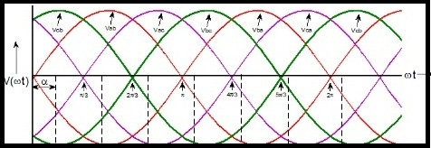
Fig. 1- Transient Condition

- VOLTAGE SAG: Voltage sag is diminishing to between 0.1 and 0.9 pu in rms voltage or current at the power frequency and the durations in cycle from 0.5 cycles in 1 min. It can be caused by the Starting of large Motors, Energization of heavy loads, Incorrect VAR compensation and the Faults on the transmission or distribution network. In Voltage sag power quality effect as Dim lights, Data error, shrinking display screens, Equipment shutdown, and Memory loss.

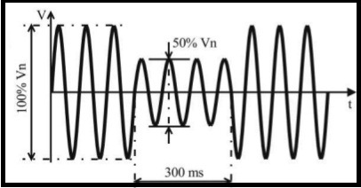
Fig. 2- Voltage Sag Condition
- VOLTAGE SWELL: A voltage swell is boost between 1.1 and 1.8 pu in rms on voltage or current at the power frequency for durations 0.5 cycle to 1 min. It can be caused by the Energizing a large capacitor bank, Switching off a large load, incorrect VAR compensation. In Voltage swell power quality effect as Bright lights, Data error, Racing or blinking of digital clock.

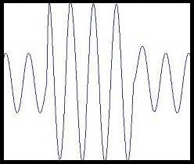
Fig. 3- Voltage Swell Condition
- VOLTAGE INTERRUPTION: “An interruption is occur when the supply voltage or load current is less than 0.1 pu for a period of time not exceeding 1 min”. It can be caused by the Faults, Equipment failures, insulator failure, lightning, Control malfunctions. In Voltage interruption power quality effect as Equipment trips off, Programming is lost, Computer shut down, Disk drive crashes.

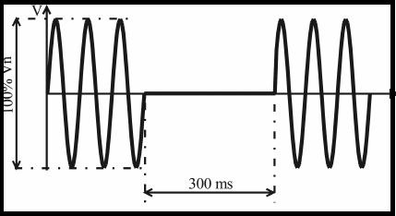
Fig. 4- Voltage Interruption Condition

- HARMONICS: Harmonics are integral multiples of some basic frequency that, when added together, results in indistinct waveform. It can be caused by the Fluorescent lighting and any non linear load such as variable frequency drives, Electro- Magnetic Interference from appliances, SMPS. In Harmonics power quality effect as Line current increases, higher losses Transformer and neutral conductor overheating, leading to reduced equipment life span, instruments malfunctioning.

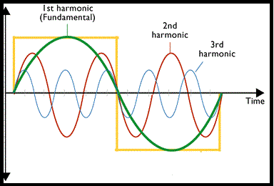
Fig. 5- Harmonic Condition
DYNAMIC VOLTAGE RESTORER

The dynamic voltage restorer (DVR) is a tradition power device which is connected in series with in distribution system as shown in figure 6. The basic components of the dynamic voltage restorer (DVR) are consists of:
- An injection transformer
- Harmonic filter
- Series voltage source inverter
- An energy storage
- Control system (as shown in figure-6)

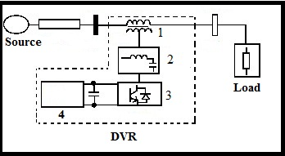
Fig. 6- Dynamic Voltage Restorer

WORKING PRINCIPLE OF DVR
The basic principle of the dynamic voltage restorer is to insert a voltage with necessary magnitude and frequency. It can restore the load side voltage to amplitude and waveform, the source voltage is unbalanced. The DVR can generate the controllable actual and reactive power at the load side. The DVR is made of a solid state switching power converter that inset output voltages in series and synchronic with distribution and transmission line voltages.
The source of the injected voltage is the process for reactive power requires and an energy source for the real power require. The energy source can change according to the design and manufacturer of the DVR. Some examples of energy sources applied are DC capacitors, batteries and that drawn from the line through a rectifier.
In normal conditions the dynamic voltage restorer operates as stand-by mode. In the case of disturbances condition supposed system voltage will be compare with voltage variation. [5]
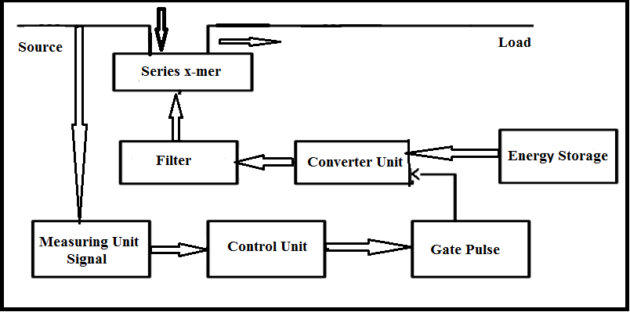
Fig. 6- Block Diagram of DVR

METHODS OF VOLTAGE INJECTION ON DVR
Table 1- Methods Of Voltage Injection On DVR
Sr.No | Parameters | Pre-dip compensation | In-Phase compensation | In-Phase Advanced Compensation
1 | Phasor Diagram |  |  | 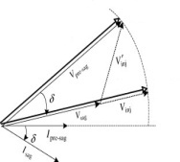
2 | Storage device Rating | superior rated storage device | Low rated storage device | Higher rating of inverter
3 | Voltage injection transformer | voltage injection transformer | voltage injection transformer | Not injection
4 | Injected voltage Magnitude | High | Low | Quick high as compare to Pre-dip compensation
5 | Distortion | Low Distortion | Distortion | --
6 | Active /Reactive power | Both Active and Reactive power required | Both Active and Reactive power required | Only Reactive power required

OUTLOOKS OF DVR
- Cost is low.
- Size is small
- Fast dynamic response in disturbance.
- Control active power flow.
- Higher energy capacity.
- Less maintenance.

ADVANTAGE OF DYNAMIC VOLTAGE RESTORER
A dynamic voltage restorer (DVR) is a FACTS device. It is used in transmission lines to recompense for the voltage sag and voltage swell. FACTS is the short of Flexible Alternating Current Transmission Systems. A DVR is a circuit collected of power electronic components such as diode, thyristors and so on. It is broadly used of small size and efficient operation. It is really important to make sure the voltage level in the transmission line within proper limits.
BRIEF LITERATURE REVIEW (FOR LAST 6 YEARS ONLY) OF THE WORK ALREADY DONE IN THE FIELD
- Kong Shuhong has discussed that in distribution system the mainly power quality problem related to voltage sags. Here also present the principle and control strategies.
- S.V Ravi Kumar has presented that the power quality problem like voltage sag, swell and alleviation technique of convention power electronic device DVR, design and application of DVR at voltage sag and swell by the side of complete result are presented.
- Mahesh Singh established that power quality measures can be functional both at consumer end and also at service end. Work can identifies some significant procedures that can be apply for service end. The representation of convention power equipment DVR is presented and applies to diminish voltage sag which is illustrious as per utilities and control scheme.
- Paisan Boonchiaml Promsak describes a technique of correcting the voltage drop and sag by DVR. The expressions for injected voltage magnitude and angle that minimize the active power injection are also derived.
- C.S Chang has analyzed the concert of the voltage sag alleviation devise such as Dynamic voltage restorer (DVR) in simplify electrical environment consisting of simple line models. The off-putting influences of dynamic motor load on offered voltage disturbance, such as post fault sag, additional fault phase angle deviation, during fault & post fault voltage fluctuation have often been overlooked.
- Mehmet Tumey has presented the modeling and simulation of DVR with SPWM based controller which is developed with MATLAB/SIMULINK. The capability of mitigating the long duration voltage sags on line.
- Mojtaba Nemati has verified the role of different purposeful component of DVR as a compensator of voltage sag.
- T.Devaraju demonstrated a PWM based control scheme for DVR.
- Rosli Omar Presented low voltage DVR based on the application of space vector pulse width modulation (SVPWM) for three phases voltage source converter(VSC) and it is the standard PWM techniques to utilize the DC-AC power conversion.
- V.K Ranachandaramurthy resolute the impact of system issues on the presentation and power rating of DVR. The managerial control scheme is observe to find out the algorithms to renovate arrangement voltage sag and swell to given locate points.
- Marcio Magalhaes release dealt with application of compensator and switches based power electronic in AC transmission and distribution system.
- Chris Fitzer proposed new matrix method, which is able to compute the phase shift And voltage reduction of supply voltage much quicker than the Fourier transform or a PLL.
- Aamir Hanif demonstrated the DVR using the leading series voltage injection LSVI concept for mitigating the voltage sag and swells as well as shares the power in manner which suits the specific customer. Emphasis was put on DVR control strategies that eliminate propagation of voltage sag or phase shift to load.
- Mahinda Vilathgamuwa state that presented open loop control strategy used in DVR to regulate the load voltage can produce poorly damped response due to the presence switching Harmonic filter in restorer. The power quality problem like voltage sag, swell and alleviation technique of convention power electronic device DVR

SIMULATION RESULT
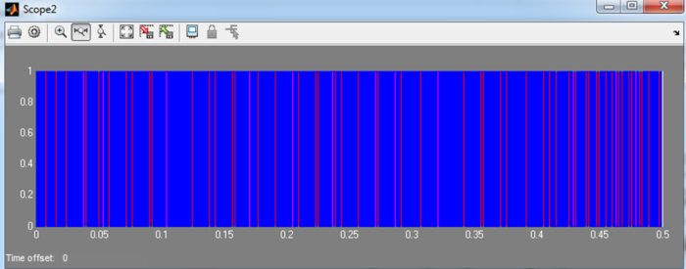
CONCLUSION
It is clear that DVR has been proved that it is suitable for compensate the voltage sag/swell and has huge amount of contribution in improvement of power quality. A control scheme has been applied to retain the voltage level at standard value of sensitive loads. In this paper we applied dqo transformation control scheme for DVR. The anticipated scheme of DVR is effectively tested for power system network with:

- Static Load
- Adjustable Drive Speed Load under Different Fault and Unbalanced Conditions.
REFERENCES
- IEEE Recommended Practice for Monitoring Electric Power Quality," IEEE Std 1159-1995,
- Roger C. Dugan, Mark F. McGranaghan, Surya Santoso, H. Wayne Beaty, “Electrical Power Systems Quality”, Tata McGraw Hills publications, 3rd Edition 2012.
- Bollen, M. H. J., “Understanding power quality problems” Vol. 3. New York: IEEE press, 2000.
- Hingorani, N.G., "Introducing custom power," Spectrum, IEEE , vol.32, no.6, pp.41,48, June 1995.
- Pakharia, A., Gupta, M, “Dynamic Voltage Restorer for Compensation of Voltage Sag and Swell: A Literature Review”, International Journal of Advance in Engineering & Technology, vol 4, issue 1,pp. 347-355, july 2012.
- C. Fitzer V.K. Ramachandaramurthy, A. Arulampalam, C. Zhan, M. Barnes and N.Jenkins, “Supervisory Control of Dynamic Voltage Restorers”, IEE Proceedings Generation, Transmission and Distribution, Vol. 151, Issue: 4, Page(s): 509 – 516, July 2004.
- G.-M. Lee, D.-C.Lee, and J.-K. Seok, “Control of series active power filters compensating for source voltage unbalance and current harmonics,” IEEE Trans. Ind. Electron., vol. 51, no. 1, pp. 132–139, Feb. 2004
- H. Ezoji Electrical & Computer Engineering Department, Babol University of Technology, A. Sheikholeslami, Electrical & Computer Engineering Department, Babol University of Technology, M. Tabasi Electrical & Computer Engineering Department, Babol University of Technology, M.M. Saeednia Electrical & Computer Engineering Department, Babol University of Technology "Simulation of Dynamic Voltage Restorer Using Hysteresis Voltage Control ” in European Journal of Scientific Research ISSN 1450-216X Vol.27 No.1 (2009), pp.152-166.
- Chris Fitzer, Mike Barnes, Member, IEEE, and Peter Green,” Voltage Sag Detection Technique for a Dynamic Voltage Restorer” in IEEE TRANSACTIONS ON INDUSTRY APPLICATIONS, VOL. 40, NO. 1, JANUARY/FEBRUARY 2004
- Mahmoud, A., El-Gammal, Amr Y. Abou-Ghazala and Tarek I. El-Shennawy,,“ Dynamic Voltage Restorer (DVR) for Voltage Sag Mitigation”,International Journal on Electrical Engineering and Informatics, vol.3, no.1, pp.1-11, march 2011
- H Mahesh Singh, Vaibhav Tiwari, “Modeling analysis and solution of Power Quality Problems”, .student of IEEE.
- G. Uppunoori Venkata reddy , paduchuri.chandra babu, “space vector pulse width modulation based dvr to mitigate voltage sag and swell”,International Conference om Computer Communication and Informatics(ICCCI-201)

