Analysis of Pioneer Ship Rates Based on the Ship Operating Costs and the Willingness to Pay (WTP): A Case Study on Route R-12 at Kotabaru Base Port

Saidul Fitri¹, Iphan F. Radam²
¹Graduate Student of Transportation Engineering and Management
Magister Study Program of Civil Engineering, Lambung Mangkurat University, Banjarmasin, Indonesia
²Associate Professor
Study Program of Civil Engineering, Lambung Mangkurat University, Banjarmasin, Indonesia

Abstract – Pioneer ship functions to serve the needs of sea transportation services for the underdeveloped regions and/or remote areas as the effort to support the development of the regions, promote the connectivity and equitable development. This study aims analyze to the subsidy/ compensation of the pioneer ship rates on route R-12 at Kotabaru base port based on WTP and official rates with the analysis of passenger tariffs and freights/mile based on WTP, the amount of Ship Operating Costs in a year, passenger tariffs and freights/mile based on Ship Operating Costs. The data gathering methods used were interviews and questionnaires. The data were analyzed by the using Ship Operating Costs method based on the Decree of the Minister of Transportation of the Republic of Indonesia Number 15 of 2017 and Willing to Pay (WTP). The result showed that the passenger tariffs and the freights per mile based on WTP with the respondent availability of 90 % were IDR 102.79 passenger/mile for the passenger and IDR 89.42 tons/mile for the freights. Based on the analysis results, the Ship Operating Costs of IDR 280,965.71/mile on the existing condition with the implementation of official rates still needs the subsidy/ compensation of IDR 7,216,385,045/year. The tariff can apply without subsidy/compensation if the passenger tariff is IDR 201.75 passenger/mile and the freight tariffs is IDR 175.50 ton/mile.
Keywords-Tariffs, Pioneer Ship, Ship Operating Costs, WTP, Route R-12

I- INTRODUCTION
The Unitary State of the Republic of Indonesia (NKRI) is an archipelago consisting of islands, large islands or small islands, where the islands are separated by the ocean. There are a lot of regions on the islands which are not yet developed economically, so that those regions are left behind by the other regions that have high accessibility. To support the economic development of the remote and underdeveloped regions and connect them to the developed regions the government has made policies and provided sea transportation facilities that connect these regions. According to the Law of the Republic of Indonesia Number 17 of 2008, the implementation of pioneer ship is carried out on the routes that have been set by the Government to serve areas that have not been served by the sea transportation because they are not able to provide commercial benefits [1].
According to data from the Directorate General of Sea Transportation of the Ministry of Transportation, in 2017, there were 96 operating sea transportation routes, consisting of 46 routes operated by PT. PELNI including Route R-12 at Kotabaru base port by using state-owned ships through assignment mechanisms and 50 routes operated by private parties with public auction mechanism. Route R-12 at Kotabaru base port is operated by PT. PELNI with this route: Kotabaru – Batulicin – Marabatuan – Maradapan – Matasiri - Maradapan-Marabatuan - Batulicin - Kotabaru - Majene - Kotabaru by using pioneer ships of KM. Sabuk Nusantara 55 with a distance of 638 miles and the length of 7 days/voyage.
The current pioneer sea tariff is based on the Decree of the Minister of Transportation of the Republic of Indonesia Number 86 of 2002 concerning passenger tariffs and freights mining money [2]. For pioneering sea transportation, although the tariff is very low, the transportation is still unable to trigger an increase of the demand. cost is still not able to optimize demand. With the amount and demand and tax services that are not possible. Because the amount and demand and the economy of the service users are relatively low, the tariffs applied are not only for commercial.
- STUDY OF LITERATURE

2.1 Transportation System
Transportation system is an interaction between several subsystems that are interconnected and influencing each other to achieve the equilibrium [3]. Subsystem in question includes: transportation demand, transportation supply, and traffic. Transportation is defined as activities that move or carry freights from one place to other places [4]. To support a strong economic development, the balance between providers and demand for transportation services needs to be achieved [5]. If the provision of transportation services is smaller than the demand, congestion in the flow of freights that can cause price shocks on the market. On the other hand, if the transportation services offer exceeds the demand, unfair competition will arise, which will cause many transportation companies to lose and stop their activities. Therefore, the transportation service offer is reduced. Furthermore, this will lead to an inconsistency in the flow of freights and price shocks in the market. Transportation is not a goal, but a means to achieve the goal. The success of development is strongly influenced by the role of transportation as the lifeblood of political, economic, socio-cultural and defense security [6].

2.2 Sea Transportation System
Sea transportation is the activity of transporting and or moving passengers and/or freights using a water vehicle that has a certain shape and type, and can be driven by mechanical power, wind power or other forms of energy [7]. Sea transportation mode has its own characteristics, including accessibility and availability of shipping networks in the form of limited port access, low passenger mobility and comfort, high efficiency with low costs for mass cargo transportation by variation [8]. According to the Republic of Indonesia Government Regulation Number 61 of 2009 the port acts as: a node in the transportation network in accordance with its hierarchy; the gateway to economic activity; place of transportation mode transfer activities; supporting industrial and/or trade activities; distribution, production and consolidation of cargo or freights; and realize the archipelago's insight and state sovereignty [9]. Whereas according to the Regulation of the Minister of Transportation of the Republic of Indonesia Number 68 of 2011, shipping lines at the sea are waters which in terms of depth, width and other freeway shipping which are considered safe for the sea transportation to sail [10].
Sea transportation in its operation consists of domestic sea transportation and foreign sea transportation. As part of domestic sea transportation, pioneer ship has the following characteristics [11]:
1. Organized by the Government in the form of compensation/operating subsidies from the State Budget funds.
2. The shipping is carried out regularly (regular linear service).
3. Procurement of pioneer ship services is carried out throughout the year/calendar day starting from January 1 of the current year until December 31 of the following year and continuing until compensation/subsidies decrease and achieve the break event points.
4. Operations in economically weak areas (weak areas and remote areas and on the routes that are not yet commercial).
5. Requires a type of ship that can transport freights and passengers.
6. In addition to being strategic in the distribution of national development, pioneering sea transportation is also cross-sectoral and multi-mode transport and connects several regions or regions.

2.3 The Size of Pioneer Ship
The ship is a waterproof place to fill receive/store/carry something, which operates above/in the water and is able to move at a certain speed and is controlled on it by one or several people. Ship size is an important thing in the operation of a ship. The purpose of the ship measurement is to determine the size and tonnage of the vessel by means of a predetermined measurement for the issuance of a measurement letter in accordance with the Regulation of the Minister of Transportation of the Republic of Indonesia Number 8 of as shown in Table 1.

Table 1- Types of State-Owned Pioneer Ships [12]
Type of Ship | Gross Tonnage | Transport Capacity |  | The Height of Water Level | Speed | Horse Power
Type of Ship | (m3) | Tons | People | (m) | (mile/  hour) | (HP)
350 DWT  500 DWT  750 DWT  1200 GT  2000 GT | 445  745  980  1200  2000 | 143  240  400  500  635 | 234  250  265  400  566 | 2.65  2.85  2.75  2.70  2.90 | 12  12  12  12  12 | 2 X 260  2 X 640  2 X 825  2 X1000  2 X 1400

2.4 Ship Operating Costs
The components of Ship Operating Costs which is calculated by the Government in the implementation of pioneer ship through the assignment mechanism based on the Republic of Indonesia Transportation Minister's Regulation Number 15 of 2017 consist of [13]:
1. Fixed cost, including
1) The salary of the crew and the skipper;
2) Fees for the crew and the skipper benefits;
3) Health / welfare costs for the crew and the skipper;
4) Cost of food for the crew and the skipper;
5) The cost of freshwater for the crew and the skipper;
6) Laundry fees for the crew and the skipper;
7) Ship maintenance costs;
8) Ship insurance costs; and
9) Ship fumigation costs.
2. Variable cost, including:
1) Fuel oil costs;
2) Lubricant costs;
3) Freshwater costs of passengers;
4) Cost of the crew and the skipper insurance premiums;
5) Cost of passenger insurance premiums;
6) Marketing costs;
7) Port services fees; and
8) Overhead.
3. Profit Margin = 10 x (fixed cost + variable cost)
2.5 The Tariff of Pioneer ship
The pioneer ship tariff which has been set by the Government as the tariff for passenger and freights transportation is the price of transportation services that must be paid by service users on a passenger and freight transportation route. Based on the Decree of the Minister of Transportation of the Republic of Indonesia Number 86 of 2002, the pioneer sea freight rates/ tariffs for adult passengers are based on the following calculations [2]:
1. Distance of up to 20 miles = IDR 3,900, - / Passenger
2. Distance of 21 to 100 miles = IDR 3,900, - + (Distance - 20 miles X IDR 94, -)
3. Distance of 101 to 200 miles = IDR 11,400, - + (Distance - 100 miles X IDR 82, -)
4. Distance of 201 to 300 miles = IDR 19,600, - + (Distance - 200 miles X IDR 61, -)
5. Distance of 301 to 400 miles = IDR 25,700, - + (Distance - 300 miles X IDR 52, -)
6. Distance of 401 to 500 miles = IDR 30,900, - + (Distance - 400 miles X IDR 42, -)
7. Distance of 501 to 600 miles = IDR 35,100, - + (Distance - 500 miles X IDR 32, -).
While the pioneer ship rates/tariffs for child and infant passengers are set as follows:
1. Children aged over 23 (twenty-three) months to 11 (eleven) years are charged a rate of 75% (seventy five percent) of the adult passenger tariff.
2. Infants up to 23 (twenty-three) months are charger a rate of 10% (ten percent) of the adult passenger rates.
Pioneer ship tariffs for adult passengers, child and infant passengers mentioned above are not including the mandatory contribution of the insurance fund of a passenger accident from PT. (Persero) Jasa Raharja loss insurance and other additional insurance carried out voluntarily as well as port charges applicable to each passenger who enters the port and the costs of reede (feeder) transport. While the mining money rates for pioneer ship freights are set in ton/m³, the amount of which is 90% (ninety percent) of the adult passenger tariff. The tariff for mining freights does not include the cost of loading and unloading at the port, the amount of which is set in accordance with the applicable regulations.
2.6 The Subsidy/Compensation of the Implementation of Pioneer ship
According to the Regulation of the Minister of Transportation of the Republic of Indonesia No. 35 of 2017, compensation is the obligation of the Government to finance the assignment of the implementation of public service obligations for the service of pioneer ships owned by the state, the amount of the difference between production costs and tariffs determined by the Government and/or Regional Government [14]. The term compensation or subsidy has the same meaning. The difference is only the mechanism whether it uses an assignment mechanism or public auction. The term compensation/subsidy can also be interpreted as payments made by the government to companies or households to achieve certain objectives that can make them produce or consume a product in a larger quantity or at a cheaper price. Economically, the aim of compensation/subsidy is to reduce prices or increase output.
Uneven population distribution causes several regions have relatively fewer populations (low population density) compared to other regions, resulting in isolated areas called remote areas. According to the Government Regulation of the Republic of Indonesia Number 20 of 2010, the criteria for areas that are still left behind and/or undeveloped remote areas include [15]:
1. Areas that have not been served by the implementation of transportation activities on waters that operates regularly.
2. The area is not commercially profitable for transport services; or
3. Areas with a low per capita income level.
In general, the purpose, objectives and targets of pioneer ship activities can be explained [16]. The purpose of pioneer ship activities is to serve the needs of sea transportation services for areas that are still left behind and/or remote areas.
The aim of pioneer ship activities is to encourage the regional development, improve inter-island connectivity and even distribution of development and its results and the realization of strong and dynamic national stability within the framework of the Republic of Indonesia. While the target of pioneer ship activities is the implementation of pioneering sea transportation services that are fixed and regular, smooth, safe, comfortable, met the aspects of shipping safety and with affordable transportation rates in the context of smooth mobility of citizens, freights transportation, government administration, development and trade whose implementation is integrated with other modes of transportation.
2.7 The Determination of the Tariff based on WTP Method
Willingness to Pay (WTP) is a person's willingness to spend money for the services they get. Therefore, in the matter of transportation, WTP is the people's purchasing power in paying tariffs. Many factors influence the occurrence of conditions where the WTP can be done by the community using pioneer ship services, among others:
1. Production of transportation services provided by transportation entrepreneurs;
2. Quality and quantity of services;
3. Applicable tariffs;
4. Monthly income of the pioneer ship users;
5. The importance of the trip.
To get the WTP value, direct survey at the pioneer ship port at Kotabaru district was done by giving questionnaires to transportation service users. The formula that was used to calculate the rates that can be accepted by public in financing public transportation for one-time pioneer ship at Kotabaru base port, can be explained by the user perception approach model to determine the WTP.
The following is the step to calculate WTP:
1. Calculate the distance of trip by using pioneer ship of each respondent (miles/person), that is by measuring the origin distance to the destination of the movement/transportation.
2. The amount of the tariff for the trip done by the respondent is based on the perception of the respondent in the questionnaire (IDR/person).
3. The amount of WTP is to divide the amount of tariff according to perception with the distance of the respondent's trip (IDR/Mile).
- RESEARCH METHOD
3.1 The Steps of the Research
In accordance with the objectives to be achieved, the research steps are shown in the research flowchart as in Figure 1.
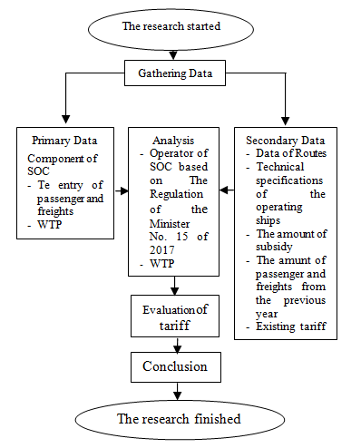

Fig. 1- The Flowchart of the research

3.2 Data Gathering Technique
The data were gathered by using survey technique, questionnaires and interviews. The research instrument uses a perceptual approach to the use of pioneer ship services to determine the size of WTP. The statement in the questionnaire was made to describe the purpose of the respondent's trip and the respondent's perception of the applicable rate. The interviews are done with the regulators and the operators of pioneer ship to obtain the route data, ship specifications, number of subsidies, number of passengers and tariff data to be able to get the information of the Ship Operating Costs of the operators based on the Republic of Indonesia Transportation Minister's Regulation Number 15 of 2017 [13]. The sample selection in this study uses sample selection method by accidental sampling. Respondents must complete all questionnaires distributed directly and then submit them to the researcher. The sampling locations were at Kotabaru base port and the port of pioneer ship on Route R-12 of South Kalimantan Province. The number of samples used was 90 of the respondents' questionnaires.
3.3 The Analysis Step
The analysis and discussion are done after obtaining the data from the field, the operators and the regulators of the pioneer ship.
1. The data from the questionnaire were to find out the WTP value of the passenger of the pioneer sea transport vessels on Route R-12 of Kotabaru base port.
2. The data from interviews were to find out the amount of operating costs of the ship on Route R-12 at the Kotabaru base port of South Kalimantan Province. Ship Operating Costs are adjusted according to calculations based on the Republic of Indonesia Transportation Minister's Regulation Number 15 of 2017 concerning the components of income and costs calculated in the pioneer sea transport activities through the assignment mechanism [13].
3. From the value of the Ship Operating Costs and the value of the WTP of passengers and freights of pioneer ships on Route R-12, Kotabaru base port of South Kalimantan Province, the amount subsidy for pioneer ship tariff on Route R-12 can be evaluated.
IV- RESULT AND DISCUSSION
The data of the respondents were obtained from the number of passengers and freights departing and arrived at each port, stopped at the 15th voyage that served Route R-12 of Kotabaru base port in South Kalimantan Province as shown in Table 2.

Table 2- The Service Users that Departed and Arrived at Voyage 15 of 2018
Depart |  |  |  |  | Arrive
Departure Port | Freights |  | Passenger |  | Arrival Port | Freights |  | Passenger
Departure Port | M | B | N | T |  | M | B | N | T
Kotabaru | 0 | 0 | 77 | 0 | Batulicin | 0 | 0 | 0 | 0
Batulicin | 0 | 0 | 71 | 0 | Marabatuan | 0 | 0 | 0 | 78
Marabatuan | 0 | 0 | 0 | 0 | Maradapan | 0 | 0 | 0 | 33
Maradapan | 0 | 0 | 0 | 0 | Matasirih | 0 | 0 | 0 | 37
Matasirih | 0 | 0 | 29 | 0 | Maradapan | 0 | 0 | 0 | 0
Maradapan | 0 | 0 | 5 | 0 | Marabaruan | 0 | 0 | 0 | 0
Marabatuan | 0 | 0 | 133 | 0 | Batulicin | 0 | 0 | 0 | 56
Batulicin | 0 | 0 | 13 | 0 | Kotabaru | 0 | 0 | 0 | 88
Kotabaru | 0 | 0 | 263 | 0 | Majene | 0 | 0 | 0 | 299
Majene | 44 | 0 | 308 | 0 | Kotabaru | 0 | 44 | 0 | 308
Total | 44 | 0 | 899 | 0 |  | 0 | 44 | 0 | 899
Table 2 shows the number of passengers and freights when departing and arriving at each port stop. The number of the departed and arrived passengers and loaded and unloaded freights at voyage 15 were 899 people and 44 ton/m³.
The characteristics of respondents who used pioneer ship services on Route R-12 in Kotabaru base port in South Kalimantan Province can be explained as follows:
The distribution of samples by sex was consisted of 82.22% of men and 17.78% of women. The biggest type of occupation was as a fisherman which was 27.78% and entrepreneur which was 20.00%. Then, the smallest was as a student which was 7.78%. The education of the respondents was high school graduates and below level which was 75.56% and the bachelor graduate which was 17.78%. The frequency of respondents traveling which was very rarely to travel was 54.44% and often to travel was 3.33%. The most purpose of the vacation trip was for family/vacation which was 40.00% and the least was for other purposes which was 15.56%.
The data used in calculating the Ship Operating Costs of KM. Sabuk Nusantara 55 is described in Table 3 and Table 4.

Table 3 The Data of Ship Specifications (Doc. of KM. Sabuk Nusantara 55 2018)
No. | Description | Information
1.  2.  3.  4.  5.  6.  7.  8.  9.  10.  11.  12.  13. | Length Over All (LOA)  Length Between Perpendicular (LBP)  Width (B)  Deck Height (H)  Draft Height (T)  Experiment Speed  Main Engine Power  Auxiliary Machine Power  Number of Passengers  Loading Space Capacity  Crews  Lifeboat capacity  Other Facility:  - Clinic | 58.50 m  52.20 m  12 m  4.50 m  2.75 m  12 Knot  2 x 829 HP  2 x 103 HP  265 people  400 Ton  21 people  2 x 40 people  available
 | - Air Conditioner | Split AC

Table 4 Route Data According to Ports, Distance, Time, Speed (KM.Sabuk Nusantara 55 2018).
Trip |  | Distance  (Mile) |  | Time  (hour) |  |  |  | Av.  Speed  Knot
From | To |  |  | voyage |  | stop |  | Av.  Speed  Knot
Kotabaru | Batulicin | 22 | 2.00 |  | 7.59 |  | 10.91
Batulicin | Marabatuan | 62 | 6.00 |  | 2.00 |  | 10.16
Marabatuan | Maradapan | 22 | 2.00 |  | 2.00 |  | 10.91
Maradapan | Matasiri | 20 | 2.00 |  | 2.00 |  | 9.86
Matasiri | Maradapan | 20 | 1.59 |  | 2.00 |  | 9.92
Maradapan | Marabatuan | 22 | 2.00 |  | 11.00 |  | 10.13
Marabatuan | Batulicin | 62 | 6.00 |  | 3.00 |  | 9.66
Batulicin | Kotabaru | 22 | 2.00 |  | 5.00 |  | 936
Kotabaru | Majene | 193 | 19.00 |  | 15.00 |  | 9.75
Majene | Kotabaru | 193 | 19.00 |  |  |  | 10.00
Total |  | 638 | 61,59 |  | 49.59
WTP analysis is the expected average rate. The increasing cost interval will cause a fluctuation in the decline also in the willingness to pay for passenger and freight rates. To get the fluctuations in decline, it is shown in Figure 2, Figure 3, Figure 4, and Figure 5.
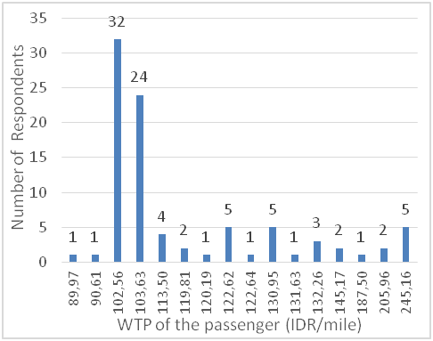

Fig. 2- The Calculation of Passenger’s WTP
In Figure 2, it can be seen that the minimum value of the respondents’ Passenger's WTP is IDR 89.97 passenger/mile and the maximum value is IDR 245.16 passenger/mile. The highest respondent's WTP tariff is 32 respondents at a rate of IDR 102.56 passenger/mile. If the tariff is set between IDR 89.97 passenger/miles and IDR 245.16 passenger/mile, the willingness to pay of the respondents is 100%. The average of the willingness to pay of the respondents is IDR 119.98 passenger/mile. Then the chart of WTP of the respondents for pioneer ship on route R-12 in Kotabaru base port of South Kalimantan Province can be illustrated.
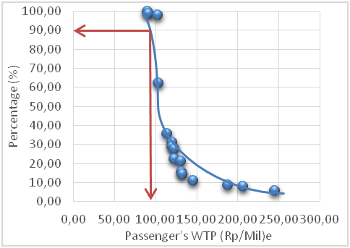

Fig. 3- The Percentage of the Passenger’s WTP
In Figure 3, it is found that the percentage of (WTP) of the respondents of pioneer ship on Route R-12 in the Kotabaru base port of South Kalimantan Province is 90% with the tariff of IDR 102.79 passenger/mile.
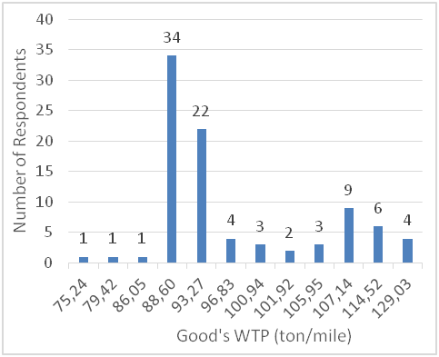

Fig. 4- The Calculation of Freights’ WTP
In Figure 4, it can be seen that the minimum Good's WTP of the respondents is IDR 75.24 ton/mile and the maximum is IDR 129.03 tons/mile. Most respondents which were 34 respondents were at the freights' WTP tariff of IDR 88.60 tons/mile. If the tariff is set between IDR 75.24 tons/mile and IDR 129.03 tons/mile, the willingness to pay of the respondents is 100%. The average willingness to pay of the respondents is IDR 97.57 tons/mile. Then, the chart of WTP of the respondents for the pioneer ship on route R-12 in the Kotabaru base port of South Kalimantan Province can be illustrated.
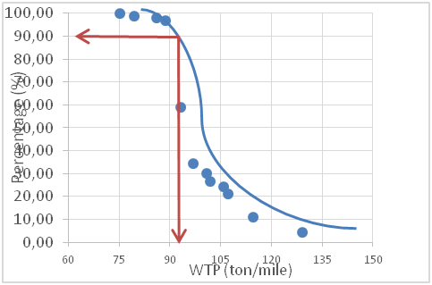

Fig. 5- The Percentage of the Freights’ WTP
In Figure 5, it is seen that the level of willingness (WTP) of the freights of pioneer ship on Route R-12 in Kotabaru base port of South Kalimantan Province is 90% at the tariff of IDR89.42 tons/mile.
The cost component calculated by the Government in the implementation of pioneer ship in a year through the assignment mechanism is the Ship Operating Costs based on the Regulation of the Minister of Transportation of the Republic of Indonesia Number 15 of 2017 which consists of fixed costs, variable costs and profit margins as shown in Table 5.

Table 5- The Description of Ship Operating Costs
Variable | Costs on Year (IDR/Year)
Fixed Costs | 3,819,614,720.00
- The salary of the crew and the skipper; | 1,877,518,720.00
- Fees for the crew and the skipper benefits; | 123,200,000.00
- Health / welfare costs for the crew and the skipper | 123,200,000.00
- Cost of food for the crew and the skipper; | 215,600,000.00
- The cost of freshwater for the crew and the skipper; | 65,296,000.00
- Laundry fees for the crew and the skipper; | 8,800,000.00
- Ship maintenance costs; | 750,000,000.00
- Ship insurance costs; and | 646,000,000.00
- Ship fumigation costs. | 10,000,000.00
Variable Costs | 3,350,630,321.06
- Fuel oil costs; | 256,525,147.16
- Lubricant costs; | 150,983,707.55
- Freshwater costs of passengers; | 299,428,800.00
- Cost of the crew and the skipper insurance premiums; | 13,003,329.14
- Cost of passenger insurance premiums; | 12,705,146.06
- Marketing costs; | 13,003,329.14
- Port services fees; and | 110,000,000.00
- Overhead | 190,980,736.00
Profit Margin | 717,024,504.11
Total of Ship Operating Costs | 7,887,269,545.16
In Table 5, it is known that the Ship Operating Costs of KM. Sabuk Nusantara 55 on Route R-12 at Kotabaru base port in South Kalimantan Province was IDR 7,887,269,545.16 in 2017.
Here is the analysis of the movement of passengers and freights based on distance. To get the total movement of passengers and freights in 1 (one) year, a matrix was made which describes the number of passengers and freights movement from the origin to their respective destinations. The total number of passengers/freights and distance is obtained by the number of movements of the passengers and freights in 1 (one) year. As for the number of passengers transported (person/year) x trip distance = 6,004,109 Passenger Mile. The number of freights transported (ton/year) x trip distance = 79,967 Ton Mil. The relationship between the cost of freights and passengers is:
Cost, Passenger Mile + Goods Cost, Mile = SOC
Passenger Mile x (a) + Ton Mile x (b) = SOC
Passenger Mile x (a) + Ton Mile x (0,9 a) = SOC
a (6,004,109 + 79,967 x 0,9) = 7,887,269,545.16
a = 7.887,269,545.16/6,004,109 + 79,967 x 0.9
= IDR 1,298.09 Mile/Passenger
b = IDR 1,168,28 Mile/Tons
SOC/Mile = SOC/Distance X Total Voyage
= 7.887,269,545.16
638 x 44
= IDR 280,965.71/mile

SOC is the operational cost of the ship per year, Passenger Mile is the number of passengers transported (person/year). Tons Mil is the amount of transported freights (Ton/year). b is the freight rate which is 90% of the passenger tariff. Then, it can be seen that the passenger tariff is IDR 1,289.09 miles/passenger and the freights is IDR 1,168.28 miles/ton.
The relationship between the load factor of the pioneer ship passengers on Route R-12 at Kotabaru base port and the amount of subsidy/compensation provided by the Government for the operator of the pioneer ship of KM.Sabuk Nusantara 55 namely PT.Pelni Batulicin Branch, is shown in Table 6.
Table 6 The Relationship Between the Load Factors and the Amount of Subsidy/Compensation
Load Factor of Passenger and Freights (%) | Subsidy/Compensation (IDR)
Load Factor of Passenger and Freights (%) | WTP | Official | Planned
32.29-0.28 | 7,262,963,933 | 7,216,385,045 | 6,661,945,229
40 | 6,101,232,975 | 6,028,003,682 | 4,381,816,414
50 | 5,654,723,833 | 5,563,187,216 | 3,505,453,131
60 | 5,208,214,691 | 5,098,370,751 | 2,629,089,849
70 | 4,761,705,548 | 4,633,554,285 | 1,752,726,566
80 | 4,315,196,406 | 4,168,737,819 | 876,363,283
90 | 3,868,687,263 | 3,703,921,354 | 0
100 | 3,422,178,121 | 3,239,104,888 | -876,363,283
Table 6 shows the relationship between the passenger load factor and the amount of subsidy/compensation on Route R-12 of Kotabaru base port in South Kalimantan Province can be seen as in Figure 6.
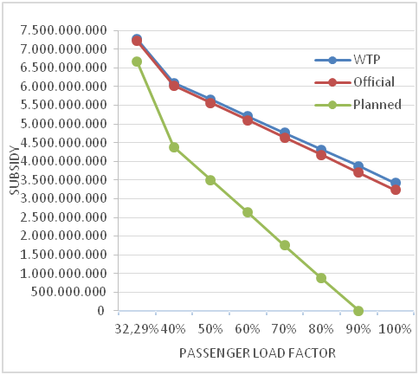
Fig. 6- The Relationship Between the Load Factor and the Subsidy/Compensation
V- CONCLUSION
Based on the results the analysis of pioneer ship on Route R-12 of Kotabaru base port in South Kalimantan Province, which was operated by PT. PELNI through the mechanism of assignment by the Government with KM. Sabuk Nusantara ship, it is obtained that the passenger and freight tariffs per mile based on the willingness to pay (Willingness To Pay: WTP) with a willingness rate (WTP) of 90% was IDR 102.79/mile for passengers and IDR 89.42/mile for the freights.
The amount of the Ship Operating Cost of KM. Sabuk Nusantara 55 in schools was IDR 7,887,269,454.16 with a sail time of 2709.96 hours (113.08 days). The time to stop at the port was 2181.96 hours (91.08 days) and the time at the base of the port was 2499.20 hours (103.84 days).
The passenger and freight tariffs per mile after the Ship Operating Cost was obtained were IDR1,298.09.09 million/passenger for the passenger tariff and IDR1,168.28 million/ton for the freight tariff with a load factor of 32.29% and freight load factor of 0.28% in 2017.
The amount of subsidy/compensation on Route R-12 of Kotabaru base port in South Kalimantan Province based on WTP was IDR 7,277,265,231/year and based on the official tariffs was IDR 7,230,905,645/year.
With the load factor of passengers and freights of 90%, the amount of subsidy/compensation can be eliminated if the applied tariff for passengers is increased by an average of 74.71% of the existing tariff to IDR 201.75 passenger/mile and for the freight tariff is increased by an average of 63.51% from the previous tariff which is IDR175.50 tons/mile.
REFERENCES

- Ministry of Transport of Republic of Indonesia. (2002). Law Number 17 of 2008 on Shipping. Ministry of Transportation of Republic of Indonesia. Jakarta.
- Ministry of Transport of Republic of Indonesia. (2002). Decree of Minister of Transport of Republic of Indonesia Number 86 of 2002 On The Tariff of Cargo and Passenger on Subsidized Sea Freight. Ministry of Transportation of Republic of Indonesia. Jakarta
- Tamin, O. Z. (2000). Perencanaan dan Permodelan Transportasi (Planning and Modelling of Transportation). ITB. Bandung.
- Gunawan, H. (2014). Pengantar Transportasi dan Logistik (Introduction of Transportation and Logistics). Jakarta; Raja Grafindo Persada.
- Nasution, M. (2004). Manajemen Transportasi:Edisi Kedua (Management of Transportation:Second edition). Jakarta: Ghalia Indonesia.
- Muslihati. (2011). Formulasi Tarif Angkutan Penyeberangan Perintis (Tariff Formulation of Subsidized Crosing Transport). Theses On Postgraduate Program Of Hasanudin University Makassar.
- Jinca, M. Y. (2001). Eksistensi Transportasi Laut Pelayaran Rakyat (Existence of Sea Transport of People Shipping). Journal of FSTPT University of Udayana Bali.
- Khristy, C.J & Lall, B.K. (2003). Transportation Engineering: An Introduction/Third Edition. Jakarta: Erlangga
- Ministry of Transport of Republic of Indonesia. (2009). Government Regulation Number 61 of 2009 on Port Affairs. Ministry of Transportation of Republic of Indonesia. Jakarta.
- Ministry of Transport of Republic of Indonesia. (2011). Minister Regulation Number 68 of 2011 on The Sea Lanes of Shipping. Ministry of Transportation of Republic of Indonesia. Jakarta.
- STMT Trisakti. (2011). Kajian Kinerja Pelayanan Angkutan Laut Perintis Dalam Upaya Penataan Pelayan Angkutan Laut Perintis (Study Kasus Trayek R-15 Pelabuhan Pangkal Tanjung Pinang) (Research on Service Performance of Subsidized Sea Freight For Service Management of Subsidized Sea Freight (A case Study of Rute R-5 Pangkal Tg. Pinang Port)). Research Report of LP3MT STMT Trisakti. Jakarta.
- Directorate of Sea Freight and Traffic. 2012. Subsidized Shipping Budget Year 2012. Report on National Coordination Meeting. 22 Mei 2012. Jakarta; Directorate General of Sea Transportation - Ministry of Transportation of Republic of Indonesia.
- Ministry of Transport of Republic of Indonesia. (2017). Minister Regulation Number 15 of 2017 on Component Of Earnings And Cost Calculated In Subsidized Sea Freight . Ministry of Transportation of Republic of Indonesia. Jakarta.
- Ministry of Transport of Republic of Indonesia. (2017). Minister Regulation Number 35 of 2017 on Organising of Public Service In State Own- Subsidized Ship. Ministry of Transportation of Republic of Indonesia. Jakarta.
- Ministry of Transport of Republic of Indonesia. (2010). Government Regulation Number 20 of 2010 on The Transport on Waters. Ministry of Transportation of Republic of Indonesia. Jakarta.
- Directorate of Sea Freight and Traffic. 2016. Subsidized Shipping Budget Year 2016. Report on National Coordination Meeting. 14 November 2016. Jakarta. Directorate General of Sea Transportation - Ministry of Transportation of Republic of Indonesia.

